Ivanus Sorin
ID Student 1906170
BMSW4002_LON (G4)-Term 2
Anita Nan
Resit: 10/24/2020

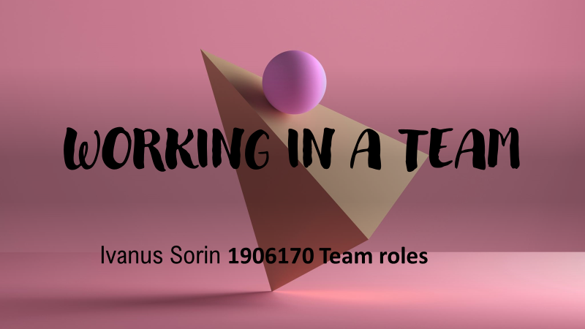

Team Roles in my perspective are the interactions between the team members and refers to the behaviour that each member possesses. Dr Meredith Belbin defines a team role as: "A tendency to behave, contribute and interrelate with others in a particular way." He discovered that they are nine types of behaviours.

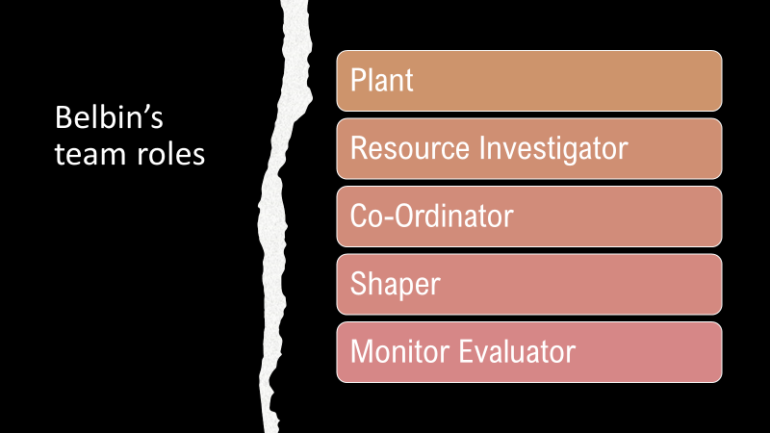

THE PLANTS
They believe in overcoming complex intellectual challenges with creative solutions. They are introverts in nature that is why them communication skills are low.
Strengths: Creative, problem-solvers, individualists, free-thinkers.
Weaknesses: Poor communications skills, prefer to work alone

THE RESOURCE INVESTIGATOR
They are enthusiastic and possess good skills like negotiating and networking. Because of them skills it is easy for them to develop external contacts for the team resources.
Strengths: Enthusiastic, extroverted, optimistic, inquisitive.
Weaknesses: Easily distracted, may lose interest

THE CO-ORDINATOR
The co-ordinators are mature and confident on what they are doing, and they possess great listening skills. They are good to delegate the duties.
Strengths: Mature, confident, good organiser and role distributer.
Weaknesses: They might become manipulative

THE SHAPER
The shapers are the people with good mental attitude that are pleased to motivate the others for better results.
Strengths: Extroverts, possess great communications skills, motivational.
Weaknesses: They might get irritated easily

THE MONITOR-EVALUATOR
These members are thinking the most in the team before taking any decision. They prefer to analyse all the information’s that they have before making any conclusion.
Strengths: They are thoughtful and strategic.
Weaknesses: They are losing energy to motivate other team members and are deemed to be slow in making decisions.

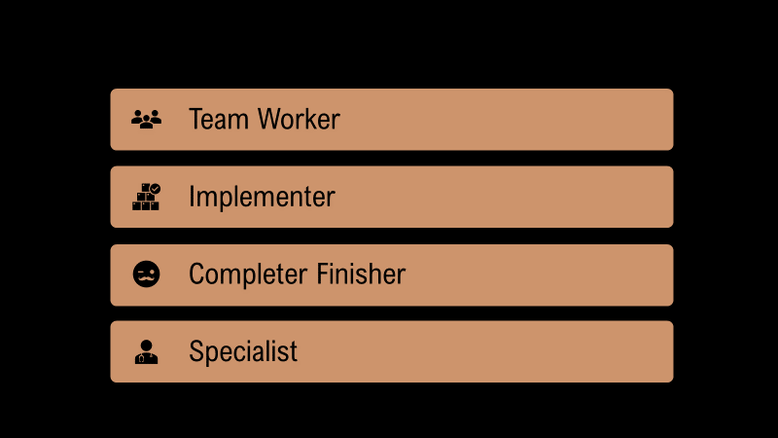
THE TEAM-WORKER
The team-workers are the people who are making sure that the team is united. They do not like conflicts, and they are trying to solve all the problems that occurs between members. They are supportive and that is why they are so popular.
Strengths: Co-operative, emphatic, diplomatic
Weaknesses: There performance is affected under pressure; they avoid taking important decisions.

THE IMPLEMENTER
The implementers are the members that like to get the things done in the team. He is sharing his ideas by briefing.
Strengths: Practical, well-organised, efficient.
Weaknesses: Rigid, slow to accept change, lack of flexibility

THE FINISHER
These members have great eye for the details so they like the perfection and they not going to let any error come in them work.
Strengths: Self-conscious, perfectionists.
Weaknesses: They prefer to do alone the job than to share it and to do not be well done.

THE SPECIALIST
The Specialists are good just in them area of knowledge that is why them contribution to the team is limited. They are indispensable for the team.
Strengths: Knowledge, professional standards, dedicated.
Weaknesses: Isolated, they show little or no interest in the expertise of others.



