
Module: Community Care and Management of Longer-term Conditions
[Date]

STUDENT NAME: SHARON MCDERMOTT
STUDENT NUMER: 2243145
Lecturer: Muhammad Khan
Module code: LCHS7003
Contents
Introduction 2
1: Explanation and Evaluation of Asthma as a Long-Term Condition 3
Definition of Asthma 3
1.2 Burden and Prevalence 4
Worldwide Statistics 4
1.3 Risk Factors and Aetiology 5
Section 2: Impact of Asthma on Individuals and Families 6
2.1 Physical Impact 6
2.2 Psychological Impact 7
2.3 Social Impact 7
2.4 Impact on Families and Carers 8
Section 3: Evidence-Based Treatments Available through the NHS 9
Pharmacological Management 9
Reliever Medication 9
Preventer Medication 9
Combination Therapies 9
Advanced Treatments 9
Non-Pharmacological Management 10
Section 4: Theoretical Perspectives and Models for Improved Outcomes 11
4.1 UK Model: The House of Care Model 11
4.2 International Model: Chronic Care Model (CCM) 11
Critical Evaluation 12
Section 5: Political Health and Social Care Agendas 12
5.1 National Health and Social Care Agendas 12
5.2 Local Health and Social Care Agendas 13
Section 6: Recommendations for Improvement in Person-Centred Care 13
6.1 Strengthening Person-Centred Care 13
6.2 Enhancing Self-Management 14
6.3 Addressing Health Inequalities 14
Conclusion 14
Useful resources and support 15
References 15

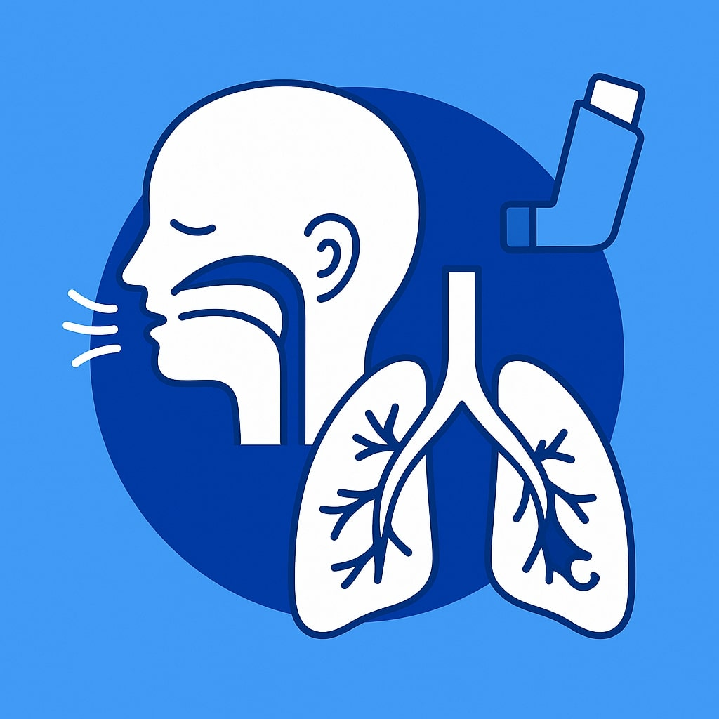
Leaflet: Asthma as a Long-Term Condition: Impact, Management, Policy, and Person-Centred Care

INTRODUCTION
Asthma is a common chronic respiratory disease that features chronic inflammation of the airways and obstructed airflow, which leads to symptoms like wheezing, breathlessness, chest tightness, and coughing. It poses a significant public health problem, with around 363 million people suffering from asthma worldwide (World Health Organization, 2026).
Management of asthma encompasses more than medication; rather, it should be based on a patient-centred approach and self-management support, as well as a combination of health and social care services (O’Keefe et al., 2024). In this assignment, the issue of asthma as a long-term condition will be critically discussed by considering its prevalence, burden, and risk factors. The assignment will assess the physical, psychological, and social impacts of asthma, review evidence-based treatments for asthma provided by the NHS, examine models of long-term condition management both in the UK and internationally, and discuss current health and social care policies influencing asthma care before making recommendations to improve person-centred outcomes.

1: EXPLANATION AND EVALUATION OF ASTHMA AS A CHRONIC DISEASE

DEFINITION OF ASTHMA
Asthma is defined as a chronic inflammatory disease of the airways that involves airway obstruction, which is associated with symptoms like wheezing, shortness of breath, chest tightness, and coughing (National Institute for Health and Care Excellence (NICE), 2024). There is variability in the occurrence of symptoms and their intensity, which may become an urgent matter when not properly controlled. The National Health Service (NHS, 2025) states that asthma is a chronic disease that is manageable through adequate medication and monitoring. According to both NICE (2024) and NHS (2025), the two major features of asthma are chronic airway inflammation and variable airway obstruction.

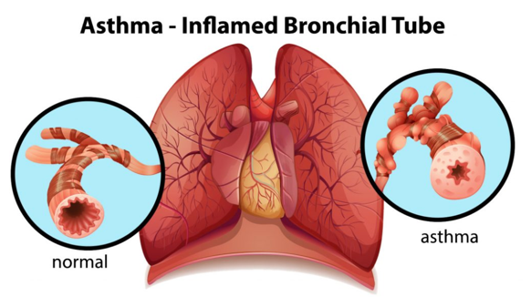

(Schochet and lie, no date)

However, NICE provides a more comprehensive clinical definition by emphasising the need for accurate diagnosis, ongoing assessment, and evidence-based management to reduce exacerbations and improve long-term outcomes. This highlights that effective asthma management requires not only pharmacological treatment but also regular review, patient education, and support for self-management to achieve optimal disease control.

1.2 ASTHMA BURDEN AND PREVALENCE

WORLDWIDE NUMBERS

Asthma is one of the most prevalent chronic respiratory diseases globally, and it poses a great challenge to the public health system. According to the WHO (2026), about 262 million individuals are affected by asthma, causing up to 455,000 deaths each year; however, many such deaths could be prevented through prompt diagnosis and adequate treatment (Zhang et al., 2025).
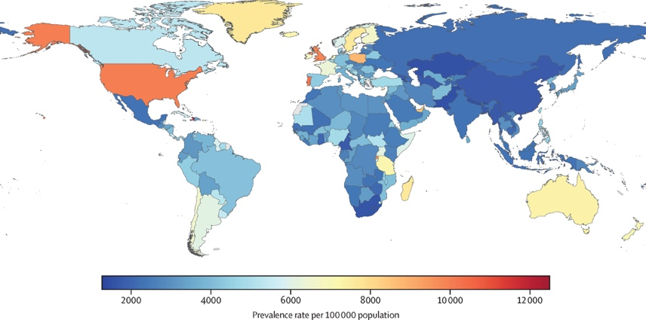
(Jayasooriya et al., 2025)

Asthma affects people of all ages and is one of the most common chronic diseases in childhood (Global Asthma Network, 2022). Beyond its health impact, asthma contributes to

substantial healthcare expenditure, reduced productivity, and increased school and workplace absenteeism, particularly in low- and middle-income countries where access to diagnosis and treatment remains limited (Wang et al., 2024).

In the UK, asthma continues to place a considerable burden on individuals and healthcare services. Approximately 5.4 million people receive treatment for asthma, including around 1 in 12 adults and 1 in 11 children, while more than 8 million people have been diagnosed with the condition during their lifetime (Asthma + Lung UK, 2026). Asthma accounts for over 100,000 hospital admissions annually, approximately 1,000 asthma-related deaths each year, and substantial healthcare costs, estimated at more than £1 billion annually (Jacobs et al., 2023; Mukherjee et al., 2016).

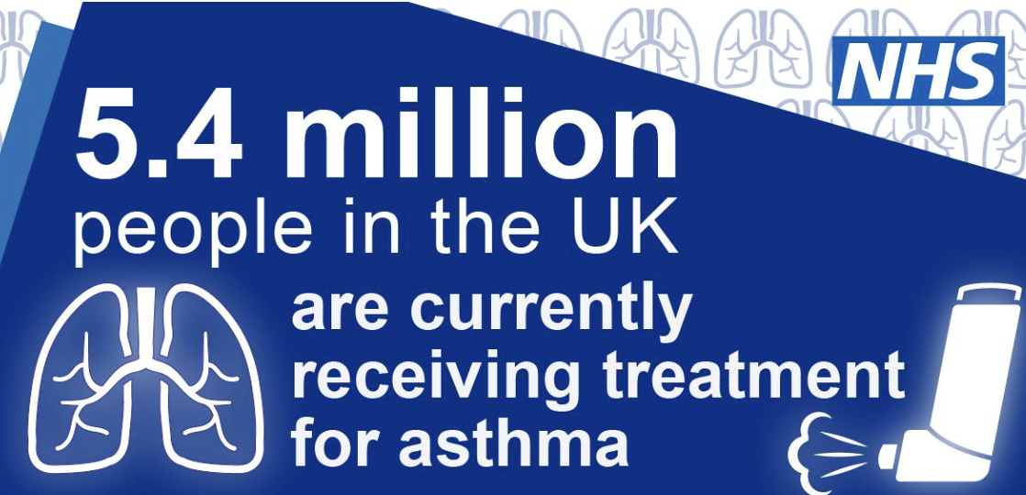
(NHS England, 2023)
Despite the availability of effective evidence-based treatments, asthma continues to impose a significant burden globally and within the UK. The relatively high prevalence in the UK suggests that access to healthcare alone is insufficient to achieve optimal disease control. Poor adherence to inhaled corticosteroids, incorrect inhaler technique, and continued exposure to environmental triggers such as tobacco smoke, air pollution, and poor housing remain important contributors to asthma exacerbations (NICE, 2024). Furthermore, socioeconomic deprivation and health inequalities are associated with poorer asthma outcomes, including higher rates of emergency admissions and mortality. Therefore, reducing the burden of asthma requires not only effective clinical management but also public health interventions that address wider environmental and social determinants of health (Aegerter et al., 2022).

1.3 Risk Factors and Aetiology
Asthma has no single cause; it develops through interactions between genetic susceptibility, early-life experiences, environmental exposures and social conditions. A personal or family history of asthma or atopic conditions, including eczema and allergic rhinitis, increases susceptibility. Other recognised risk factors include premature birth, childhood respiratory infections, prenatal or childhood exposure to tobacco smoke, obesity and occupational exposure to dust, chemicals and fumes (NHS England, 2023; World Health Organization, 2026).

Environmental allergens and irritants, including house dust mites, mould, pollen and indoor and outdoor air pollution, may contribute to the development of asthma and trigger worsening symptoms. Socioeconomic disadvantage can intensify these risks through poor housing, greater pollution exposure and barriers to preventive healthcare (Achakulwisut et al., 2019).
Risk factors may be classified as non-modifiable, such as family history and atopy, or modifiable, including smoking exposure, obesity and occupational irritants. However, this distinction should be treated critically because individuals may have limited control over poor housing, workplace conditions or neighbourhood air pollution. Consequently, asthma prevention cannot rely solely on individual behaviour change. It also requires public health, housing, environmental and workplace interventions that address the wider determinants of respiratory health (NHS Inform, 2026).
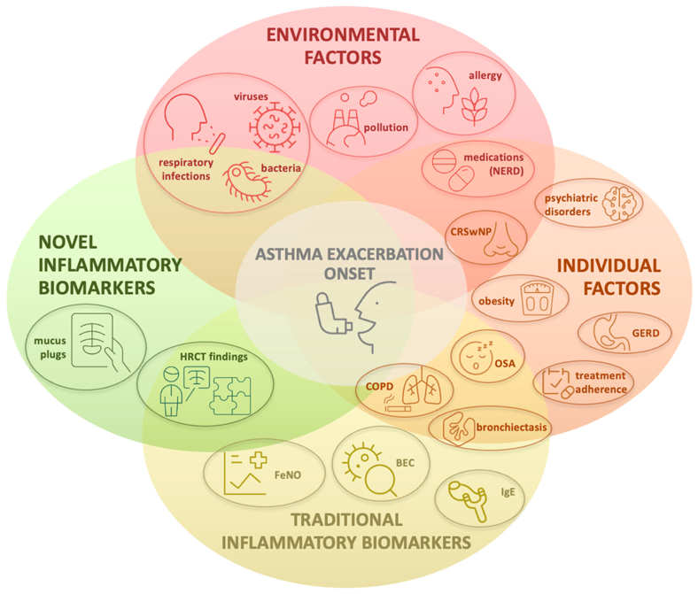

(Paredes et al., 2026)

Section 2: Impact of Asthma on Individuals and Families

2.1 Physical Impact
Asthma can significantly affect physical health and daily functioning through recurrent symptoms including breathlessness, wheezing, chest tightness, coughing and fatigue. Symptom severity varies considerably between individuals and may fluctuate over time, with poorly controlled asthma restricting physical activity, reducing exercise tolerance and impairing quality of life (Papi et al., 2018). Nocturnal symptoms frequently disrupt sleep, contributing to daytime fatigue, impaired concentration and reduced productivity, while acute exacerbations may require emergency treatment or hospital admission (Bupa, 2023).

The physical consequences of asthma extend beyond symptom burden. Recurrent exacerbations increase healthcare utilisation and may accelerate airway remodelling, resulting in irreversible structural airway changes and progressive decline in lung function (Papi et al., 2018). Poor adherence to inhaled corticosteroids, incorrect inhaler technique and continued exposure to environmental triggers are recognised contributors to poor disease control and increased exacerbation risk (NICE, 2024). Consequently, optimal asthma management requires regular clinical review, effective pharmacological treatment, patient education and support for self-management to minimise exacerbations, preserve lung function and improve long-term health outcomes (NICE, 2024).
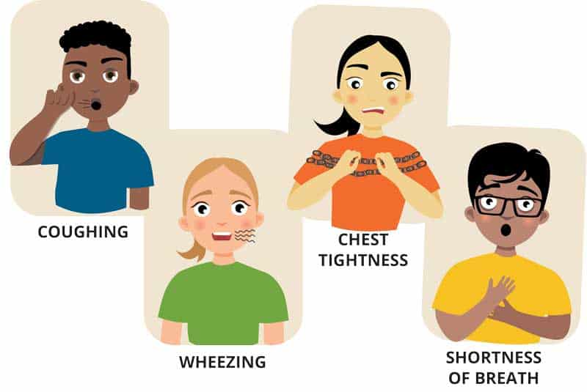
(Allergy & Asthma Network, no date)

2.2 Psychological Impact
Asthma can have a considerable psychological impact, particularly when symptoms are poorly controlled or unpredictable. Individuals commonly experience anxiety, fear of exacerbations and depression, which may reduce confidence, restrict participation in physical and social activities, and negatively affect overall quality of life (Freitas and Novais, 2025). Recurrent symptoms and previous hospital admissions may heighten emotional distress, while the need for continuous symptom monitoring and trigger avoidance can further increase psychological burden.
There is a bidirectional relationship between asthma and mental health. Anxiety and depression are associated with poorer symptom perception, reduced adherence to prescribed medication and self-management strategies, leading to an increased risk of exacerbations and hospital admissions. Conversely, persistent asthma symptoms and frequent exacerbations can worsen psychological distress, creating a cycle that negatively affects disease control and quality of life (Freitas and Novais, 2025; National Institute for Health and Care Excellence (NICE, 2024). Consequently, effective asthma management should adopt a holistic, person-centred approach that integrates psychological assessment and support alongside evidence-based medical treatment to improve long-term outcomes.

2.3 Social Impact
Asthma can adversely affect social participation, education and employment. Poorly controlled asthma is associated with increased school and workplace absenteeism, reduced productivity and restrictions on physical and social activities, which can diminish quality of life (Nunes et al., 2017). Children may experience disrupted education and reduced participation in sport, while adults may face employment challenges, particularly in occupations involving exposure to respiratory irritants.

The social burden of asthma is strongly influenced by health inequalities. Individuals living in socioeconomically deprived communities are more likely to experience poor housing, greater exposure to air pollution and reduced access to healthcare, contributing to poorer asthma control and increased hospital admissions (NICE, 2024). Therefore, reducing the social impact of asthma requires not only effective clinical management but also public health strategies that address the wider social determinants of health.

2.4 Impact on Families and Carers
Asthma affects not only the individual but also family members and carers who often play a key role in disease management. Caregiver burden may arise from monitoring symptoms, administering medication, attending healthcare appointments, and responding to asthma attacks.
The unpredictable nature of asthma can cause significant emotional stress, particularly for parents of children with severe or poorly controlled asthma. Concerns about symptom deterioration and emergency hospital admissions may increase anxiety and worry within the family (Foronda et al., 2020).
Asthma can also have financial implications, including travel costs for appointments, prescription expenses, and loss of income due to time taken off work to provide care. In some cases, families may experience role changes, with caregivers taking on additional responsibilities to support the affected individual (Soares et al., 2022).
Research suggests that parents of children with asthma often report higher levels of stress and anxiety, particularly when asthma control is poor or frequent exacerbations occur. This can negatively affect parental wellbeing and family functioning.
A family-centred approach is essential in asthma management. Involving family members in education, care planning, and self-management support can improve treatment adherence, asthma control, and overall health outcomes. Such approaches recognise the family as an important partner in long-term asthma care rather than focusing solely on the individual (Kharaba et al., 2022).

Section 3: Evidence-Based Treatments Available through the NHS

Pharmacological Management
Pharmacological treatment aims to control symptoms, reduce exacerbations, and improve quality of life. The NHS follows a stepwise approach, with treatment adjusted according to symptom severity and asthma control. (Crossingham et al, 2021)

Reliever Medication
Short-acting beta-agonists (SABAs), such as Salbutamol, provide rapid relief by relaxing airway muscles and improving airflow. They are used during acute symptoms but do not treat underlying airway inflammation. (Reddel, et .al, 2015)

Preventer Medication
Inhaled corticosteroids (ICS) are the cornerstone of asthma management. Medications such as Beclomethasone reduce airway inflammation, improve symptom control, and lower the risk of exacerbations. They are intended for regular long-term use. (Dyson et al, 2026)

Combination Therapies
For individuals whose symptoms remain uncontrolled, ICS/LABA combinations may be prescribed. These combine an inhaled corticosteroid with a long-acting beta-agonist to improve symptom control and reduce the frequency of asthma attacks. (Gibson et al, 2023)

Advanced Treatments
Patients with severe asthma may require biologic therapies, which target specific inflammatory pathways. These treatments can significantly reduce exacerbations and improve quality of life in selected patients but are usually reserved for specialist care.

Pharmacological treatments have substantially reduced asthma-related morbidity and mortality. Inhaled corticosteroids are particularly effective in preventing exacerbations and improving long-term disease control. However, treatment effectiveness depends heavily on patient adherence.
Poor adherence remains a major challenge, with many patients overusing reliever inhalers while underusing preventer medications. Incorrect inhaler technique can further reduce treatment effectiveness.
Although generally safe, medications may cause side effects. Inhaled corticosteroids can lead to oral thrush and hoarseness, while excessive SABA use is associated with poorer asthma control and increased risk of severe exacerbations. Therefore, regular reviews and patient education are essential to optimise treatment outcomes.

Non-Pharmacological Management
Non-pharmacological interventions are important in supporting asthma control and reducing the risk of exacerbations. Smoking cessation is strongly recommended, as tobacco smoke worsens airway inflammation and reduces the effectiveness of asthma medications. Weight management may improve symptom control in individuals with obesity by reducing respiratory strain and inflammation (Tong et al., 2024).
Trigger avoidance is also essential and may involve reducing exposure to allergens, air pollution, tobacco smoke, or occupational irritants. In some cases, pulmonary rehabilitation and structured exercise programmes may help improve physical fitness and overall respiratory health, particularly for individuals with severe asthma.
Patient education plays a central role in asthma management. Education on inhaler technique, symptom monitoring, and personalised asthma action plans can empower individuals to manage their condition effectively (Clemente-Suárez et al., 2023).

Evidence suggests that self-management interventions, particularly asthma education and written action plans, improve symptom control and treatment adherence. Patients who are actively involved in managing their condition are more likely to recognise worsening symptoms early and seek appropriate treatment.
Effective self-management has been associated with reduced emergency admissions, fewer hospitalisations, and improved quality of life. However, the success of these interventions depends on patient engagement, health literacy, and ongoing support from healthcare professionals. Therefore, education should be tailored to individual needs and delivered as part of a person-centred approach to care.

Section 4: Theoretical Perspectives and Models for Improved Outcomes

4.1 UK Model: The House of Care Model
The House of Care Model, developed by NHS England, is a person-centred framework designed to improve outcomes for people living with long-term conditions such as asthma. The model emphasises person-centred care, where patients are actively involved in decisions about their treatment and care.
Key components include collaborative care planning, which encourages healthcare professionals and patients to work together to identify goals and develop personalised care plans. The model also promotes shared decision-making and self-management support, enabling individuals to gain the knowledge and confidence needed to manage their condition effectively. (McCartney, 2016)

A major strength of the House of Care Model is that it encourages patient involvement, leading to improved engagement, treatment adherence, and self-management. It is particularly suitable for long-term conditions such as asthma, where successful management depends on patient participation.
However, implementation can be resource intensive, requiring time, staff training, and effective communication between healthcare professionals. In addition, the model is not applied consistently across all healthcare settings, resulting in variable implementation and differences in patient experiences and outcomes. Therefore, while the framework supports high-quality asthma care, its effectiveness depends on adequate resources and organisational commitment.

4.2 International Model: Chronic Care Model (CCM)
The Chronic Care Model (CCM) was developed by Edward Wagner to improve the management of long-term conditions. The model focuses on creating productive interactions between informed patients and proactive healthcare teams.
Key components include community resources, which link patients to support services; self-management support, which encourages patients to take an active role in managing their condition; delivery system design, which promotes coordinated and planned care; and clinical information systems, which use patient data to support monitoring and decision-making (Gleeson and Curtis, 2026).

Critical Evaluation
A major strength of the CCM is its widespread international use and strong evidence for improving outcomes in chronic diseases. By promoting coordinated care and patient self-management, the model can help reduce hospital admissions and improve quality of life for people with asthma.
However, successful implementation often requires significant organisational change, including workforce training and service redesign. There are also cost implications associated with developing information systems and integrated care services. As a result, implementation may be challenging in healthcare settings with limited resources.

House of care Chronic care Model
UK focused |  | International
Person-centred emphasis
  System redesign emphasis
Shared decision-making |  | Organisational integration

Section 5: Political Health and Social Care Agendas

5.1 National Health and Social Care Agendas

Several UK policies guide asthma management by promoting prevention, early diagnosis, person-centred care and the reduction of health inequalities. The NHS Long Term Plan prioritises integrated, community-based care, digital health technologies and early intervention to reduce avoidable hospital admissions and improve outcomes for people with long-term conditions (NHS England, 2019). The National Institute for Health and Care Excellence (NICE) provides evidence-based guidance for the diagnosis, monitoring and management of asthma, supporting consistent, high-quality care across healthcare settings (NICE, 2024). In addition, the Core20PLUS5 initiative seeks to reduce health inequalities by improving access to healthcare for deprived and underserved populations, including those at greater risk of poor asthma outcomes (NHS England, 2023).

These national strategies have strengthened asthma care by promoting prevention, standardised clinical practice and equitable access to services. However, variations in service provision, workforce shortages and resource constraints continue to limit consistent implementation. Consequently, achieving the objectives of these policies requires sustained investment, multidisciplinary collaboration and continued efforts to address health inequalities.

5.2 Local Health and Social Care Agendas

At a local level, Integrated Care Systems (ICSs) coordinate services across the NHS, local authorities and voluntary organisations to improve the management of long-term conditions such as asthma. Community respiratory services provide routine asthma reviews, inhaler technique assessments, smoking cessation support and self-management education, while local public health initiatives promote cleaner air and respiratory health (NHS England, 2023).

Local services improve continuity of care and can reduce exacerbations and avoidable hospital admissions. However, access to specialist respiratory services varies across England, and workforce shortages and financial pressures continue to affect service availability. Therefore, strengthening community respiratory services and ensuring equitable access remain essential to improving asthma outcomes and reducing regional health inequalities.

Section 6: Recommendations for Improvement in Person-Centred Care

6.1 Strengthening Person-Centred Care
Improving person-centred care is essential for achieving better asthma outcomes. Healthcare professionals should promote shared decision-making, enabling patients to participate actively in treatment choices and care planning. The use of individualised asthma action plans can support symptom monitoring and guide patients in responding appropriately to worsening symptoms. In addition, routine reviews of patient goals can ensure that care remains aligned with individual needs, preferences, and lifestyle factors (Hodkinson et al., 2020).

6.2 Enhancing Self-Management
Effective self-management should be supported through digital monitoring tools, telehealth consultations, structured asthma education, and regular inhaler technique reviews. Evidence suggests that asthma education and personalised action plans improve treatment adherence, symptom control, and self-confidence. Digital technologies and remote consultations can increase access to care and support early identification of deteriorating symptoms. Regular inhaler technique assessments are also important, as incorrect use of inhalers remains a common cause of poor asthma control.

6.3 Addressing Health Inequalities
Efforts to reduce asthma-related health inequalities should focus on improving access to healthcare in deprived communities. Targeted education programmes can help increase awareness and self-management skills among high-risk groups. Furthermore, culturally sensitive care should be provided to ensure healthcare information and support are accessible and appropriate for diverse populations. Addressing social determinants such as housing conditions and environmental exposures is also essential for improving outcomes (Lo et al., 2024).

Conclusion
Asthma is a common long-term respiratory condition that affects millions of people worldwide and continues to place a significant burden on individuals, healthcare services, and society. Despite advances in diagnosis and treatment, asthma remains associated with considerable morbidity, hospital admissions, and preventable deaths, highlighting its ongoing public health importance.
The condition can have substantial physical, psychological, and social impacts. Symptoms such as breathlessness, wheezing, and fatigue can restrict daily activities and reduce quality of life. Furthermore, anxiety, fear of asthma attacks, and social limitations may negatively affect mental wellbeing, employment, education, and family life. These effects demonstrate the complex and multidimensional nature of asthma as a long-term condition (Elendu et al., 2025).

Effective management relies on evidence-based treatments, including pharmacological therapies such as inhaled corticosteroids and non-pharmacological interventions that support self-management and lifestyle modification. The House of Care Model and Chronic Care Model provide valuable frameworks for improving outcomes by promoting patient involvement, coordinated care, and self-management support (Sharma et al., 2025).

National policies, including the NHS Long Term Plan, NICE asthma guidelines, and Core20PLUS5 initiative, have strengthened asthma management through prevention, standardised care, and a focus on reducing health inequalities. However, challenges remain in ensuring consistent implementation and equitable access to services.
Overall, improving asthma outcomes requires a strong emphasis on person-centred care, shared decision-making, and effective self-management support. Effective asthma management depends on integrated, patient-centred, evidence-based care that addresses both medical and wider social needs, ultimately improving health outcomes and quality of life for individuals living with asthma.

Useful resources and support
- Asthma + Lung UK – The UK's leading lung charity providing evidence-based information on asthma, treatment, self-management, asthma action plans, support groups, and a confidential helpline for patients, families, and carers.
- NHS – Asthma – Information on asthma symptoms, diagnosis, treatment, inhaler use, and when to seek urgent medical care.

References:

Achakulwisut, P., Brauer, M., Hystad, P. and Anenberg, S. (2019) ‘Global, national, and urban burdens of paediatric asthma incidence attributable to ambient NO2 pollution: estimates from global datasets’, The Lancet. Planetary health, 3 4, pp. e166-e178. Available at: doi: 10.1016/s2542-5196(19)30046-4.

Aegerter, H. and Lambrecht, B. (2022) ‘The Pathology of Asthma: What Is Obstructing Our View?’, Annual review of pathology. Available at: doi: 10.1146/annurev-pathol-042220-015902.

Allergy & Asthma Network (no date) Asthma symptoms and triggers. Available at: https://allergyasthmanetwork.org/asthma/asthma-symptoms-triggers/ (Accessed: 10 July 2026).

Asthma + Lung UK (2026) Asthma facts and statistics. Available at: https://www.asthmaandlung.org.uk/conditions/asthma (Accessed: 8 July 2026).

British Thoracic Society (2026) Asthma. Available at: https://www.brit-thoracic.org.uk/clinical-resources/asthma/ (Accessed: 8 July 2026).

Bupa (2023) Asthma: types, symptoms, causes and treatment. Available at: https://www.bupa.co.uk/health-information/lungs-breathing/asthma (Accessed: 10 July 2026).

Clemente-Suárez, V. J., Mielgo-Ayuso, J., Ramos-Campo, D., Beltrán-Velasco, A. I., Martínez-Guardado, I., Jiménez, E. N., Redondo-Flórez, L., Yáñez-Sepúlveda, R. and Tornero-Aguilera, J. F. (2023) ‘Basis of preventive and non-pharmacological interventions in asthma’, Frontiers in Public Health, 11. doi: 10.3389/fpubh.2023.1172391.

Crossingham, I., Turner, S., Ramakrishnan, S. et al. (2021) “Combination fixed‐dose beta agonist and steroid inhaler as required for adults or children with mild asthma,” Cochrane database of systematic reviews, 2021(5), p. CD013518. Available at: https://doi.org/10.1002/14651858.CD013518.pub2.

Dyson, J. Cummings, H., Williams, G. et al. (2026) “Barriers and facilitators to practitioner prescribing and patient adoption of anti-inflammatory maintenance and reliever therapy (MART) for adult asthma: a qualitative study,” BMC primary care [Preprint]. Available at: https://doi.org/10.1186/s12875-026-03443-x.

Elendu, C., Amaechi, D. C., Elendu, T. C., Amaechi, E., Elendu, I. D., Joseph, M. C., Ajakaye, A. A., Ansong, S. O., Tyagi, V., Anukam, L. I. and Oguoma, C. O. (2025) ‘Guideline-driven and dependable management of asthma: an evidence-based systematic review’, Annals of Medicine and Surgery, 87, pp. 5153 - 5164. https://doi.org/10.1097/MS9.0000000000003491

Foronda, C. L., Kelley, C. N., Nadeau, C., Prather, S., Lewis-Pierre, L., Sarik, D., & Muheriwa, S. R. (2020) ‘Psychological and Socioeconomic Burdens Faced by Family Caregivers of Children with Asthma: An Integrative Review’, Journal of pediatric health care : official publication of National Association of Pediatric Nurse Associates & Practitioners. Available at: https://doi.org/10.1016/j.pedhc.2020.02.003

Freitas, J. and Novais, F. (2025) ‘Review on the relationship of asthma and mental disorders’, Personalized medicine in psychiatry, 51–52. Available at: https://doi.org/10.1016/j.pmip.2025.100157.

Gleeson, M. and Curtis, S. (2026) ‘Empowering Asthma and COPD Patients Through Collaborative Self-Management Strategies: Leveraging Partnerships for Enhanced Care’, International Journal of Integrated Care. doi: 10.5334/ijic. icic25145.

Global Asthma Network (2022) The Global Asthma Report 2022. Auckland: Global Asthma Network. Available at: https://globalasthmareport.org/resources/Global_Asthma_Report_2022.pdf (Accessed: 10 July 2026)

Gibson, P.G., McDonald, V.M. and Thomas, D. (2023) “Treatable traits, combination inhaler therapy and the future of asthma management,” Respirology (Carlton, Vic.), 28(9), pp. 828–840. Available at: https://doi.org/10.1111/resp.14556.

Hodkinson, A., Bower, P., Grigoroglou, C., Zghebi, S., Pinnock, H., Kontopantelis, E. and Panagioti, M. (2020) ‘Self-management interventions to reduce healthcare use and improve quality of life among patients with asthma: systematic review and network meta-analysis’, The BMJ, 370. doi: 10.1136/bmj.m2521.

Jacobs, A., Wu, R., Tomini, F., De Simoni, A. and Mihaylova, B. (2023). Strong and graded associations between level of asthma severity and all-cause hospital care use and costs in the UK. BMJ open respiratory research, 10(1), p.e002003. doi: https://doi.org/10.1136/bmjresp-2023-002003.

Jayasooriya. S. et al. (2025) ‘Asthma: epidemiology, risk factors, and opportunities for prevention and treatment’, The Lancet Respiratory Medicine, 2025; 13, 725-738.
National Health Service (2025) Asthma. Available at: https://www.nhs.uk/conditions/asthma/ (Accessed: 8 July 2026).
Kharaba, Z., Feghali, E., Husseini, E. F., Sacre, H., Selwan, C. A., Saadeh, S., Hallit, S., Jirjees, F., Alobaidi, H., Salameh, P., & Malaeb, D. (2022) ‘An Assessment of Quality of Life in Patients With Asthma Through Physical, Emotional, Social, and Occupational Aspects’, A Cross-Sectional Study. Frontiers in Public Health, 10. Available at: https://doi.org/10.3389/fpubh.2022.883784
Lo, D., Lawson, C., Gillies, C., Shabnam, S., Gaillard, E. A., Pinnock, H. and Quint, J. (2024) ‘Association between socioeconomic deprivation, ethnicity and health outcomes in preschool children with recurrent wheeze in England: a retrospective cohort study’, Thorax, 79. Available at: doi: 10.1136/thorax-2023-221210.
National Institute for Health and Care Excellence (2024) Asthma: diagnosis, monitoring and chronic asthma management (NG245). Available at: https://www.nice.org.uk/guidance/ng245 (Accessed: 8 July 2026).
NHS England (2023) RightCare asthma scenario. Available at: https://www.england.nhs.uk/publication/rightcare-asthma-scenario/ (Accessed: 10 July 2026).
NHS inform (2026) Asthma. Available at: https://www.nhsinform.scot/illnesses-and-conditions/lungs-and-airways/asthma/ (Accessed: 10 July 2026).
Nunes, C., Pereira, A.M. and Morais-Almeida, M. (2017) “Asthma costs and social impact,” Asthma research and practice, 3(1). Available at: https://doi.org/10.1186/s40733-016-0029-3.

O’Keefe, A., Connors, L., Ling, L. and Kim, H. (2024) ‘Asthma. Allergy, Asthma, and Clinical Immunology’, Official Journal of the Canadian Society of Allergy and Clinical Immunology, 20. Available at: https://doi.10.1186/s13223-025-00949-4 .

Paredes, M. et al. (2026) ‘Severe Asthma Exacerbations: From Risk Factors to Precision Management Strategies’, Journal of clinical medicine, 15(2), p. 857. Available at: https://doi.org/10.3390/jcm15020857.

‌Reddel, H.K., Sawyer, S. M., Everett, P. W. et al. (2015) “Asthma control in Australia: a cross‐sectional web‐based survey in a nationally representative population,” The medical journal of Australia., 202(9), pp. 492–496. Available at: https://doi.org/10.5694/mja14.01564

Schochet, P. and Lie, H. (no date) Severe asthma in children. Pediatric Pulmonologists. Available at: https://www.pedilung.com/pediatric-lung-diseases-disorders/severe-asthma-children/ (Accessed: 8 July 2026).

Sharma, R., Brandse, S.K. and Riffle, T.L. (2025) “Collaborative quality improvement initiative to enhance adult asthma management,” BMJ open quality., 14(2). Available at: https://doi.org/10.1136/bmjoq-2024-003265.

Soares, L.O.N., Theodoro, E. E., Angelelli, M. M., Lin, L., Carchedi, G. R., Silva, C. C., Da Rocha, D. G. and Ponte, E (2022) “Evaluating the effect of childhood and adolescence asthma on the household economy,” Jornal de pediatria., 98(5), pp. 490–495. Available at: https://doi.org/10.1016/j.jped.2021.12.010.

Tong, X., Zhang, X., Wang, M., Wang, Z., Dong, F., Gong, E., Zuberbier, T. and Li, Y. (2024) ‘Non‐pharmacological interventions for asthma prevention and management across the life course: Umbrella review’, Clinical and Translational Allergy, 14. Available at: doi: 10.1002/clt2.12344.

Zhang, L., Jiang, H., Yang, G., Zhang, J., Yuan, S., Chen, J., Tang, M., Lin, J., Yuan, J. and Yin, Y. (2025) ‘Global, regional and national burden of asthma from 1990 to 2021: a systematic analysis for the Global Burden of Disease Study 2021’, BMJ Open Respiratory Research, 12. Available at: doi: 10.1136/bmjresp-2025-003144.

Wang, Z., Li, Y., Gao, Y., Fu, Y.-L., Lin, J., Lei, X., Zheng, J. and Jiang, M. (2023) ‘Global, regional, and national burden of asthma and its attributable risk factors from 1990 to 2019: a systematic analysis for the Global Burden of Disease Study 2019’, Respiratory Research, 24. Available at: doi: 10.1186/s12931-023-02475-6.

World Health Organization (2026) Asthma. Available at: https://www.who.int/news-room/fact-sheets/detail/asthma (Accessed: 8 July 2026).

McCartney, M., 2016. Patient-centred care: Abandoning ‘doctor knows best’. British Journal of General Practice, 66(645), pp. e288–e290. doi: 10.3399/bjgp16X684745. Available at: https://pmc.ncbi.nlm.nih.gov/articles/PMC4809714/‌

