
An Evaluation of validity and viability of the Sugar Tax

Alison Ismail
Student ID: P132184

Thesis submitted in part fulfilment of the Master’s Degree
In
Business Management

Masters of Business in Management and Leadership
April 2016

Declaration
DECLARATION

This work has not previously been accepted in substance for any degree and is not being concurrently submitted in candidature for any degree.

Signed ...................................................................... (candidate)

Date ........................................................................

STATEMENT 1

This work is the result of my own investigations, except where otherwise stated. Where correction services have been used, the extent and nature of the correction is clearly marked in a footnote(s).

Other sources are acknowledged by footnotes giving explicit references. A bibliography is appended.

Signed ..................................................................... (candidate)

Date ........................................................................

STATEMENT 2

I hereby give consent for my work, if accepted, to be available for photocopying and for inter-library loan, and for the title and summary to be made available to outside organisations.

Signed ..................................................................... (candidate)

Date ........................................................................

Acknowledgements
It is my immense appreciation to acknowledge the support I have received throughout my dissertation. Firstly, my supervisor Stephen Griffiths, who has continually supported and encouraged me during this dissertation process, even in difficult times.
I would also like to thank Caroline Jawad, who has always been a great support over the past couple of years, towards the end of my BA and starting my integrated Master’s. Her flexibility and open door policy meant I could always turn to her for any additional guidance.
I would also like to thank Zara Raja for her continuous support and encouragement throughout the past few years at university. We established a support system with one another and this has really got us through plenty of late night library sessions.
Lastly, I would like to thank all participants who took their time to attend the focus group meeting. Without them the research would not have come together.

Contents Page
Declaration 2
Acknowledgements 3
List of Figures 7
List of Equations 8
List of Abbreviations 8
Abstract 9
Chapter One 10
1.0 Introduction to the research 10
1.1 Introduction to research rationale 10
1.2 History of sugar 12
1.3 Agenda of change 12
1.4 Overview of Sugar Tax 13
1.5 Research rationale 14
1.6 Aim 15
1.7 Objectives 15
1.8 Research design 16
Chapter Two 17
2.0 Literature Review 17
2.1 Market failure theory 17
2.2 Regulation 18
2.3 Academic perspective to regulation 18
2.4 Different forms of regulation 21
2.5 Effectiveness of regulation within the sin industry 22
2.6 The Sugar Tax debate 23
2.7 An analysis of the Sugar Tax as an effective solution 26
2.8 Government regulation in the sugar industry globally 28
2.9 Economic arguments 30
2.10 The Model 33
2.11 Rationale choice theory 37
2.12 Ethical debate 38
2.13 Chapter conclusion 41
Chapter Three 43
3.0 Methodology 43
3.1 Research paradigm 43
3.2 Research method 45
3.3 Data collection method (focus group) 46
3.4 Times scale for research 47
3.5 Question design 47
3.6 Pilot focus group 50
3.7 Data analysis 50
3.8 Reliability and validity 51
3.9 Limitations 51
3.10 Ethical considerations 52
Chapter Four 53
4.0 Analysis and discussion of results 53
4.1 introduction 53
4.2 Question One 53
4.3 Question two 55
4.4 Question three 57
4.6 Question five 60
4.7 Question six 61
4.8 Question seven 62
4.9 Question eight 63
4.10 Question nine 65
4.11 Question ten 66
Chapter Five 68
5.0 Conclusion and recommendations 68
5.1 Introduction 68
5.2 Limitations 68
5.3 Conclusion 69
5.4 Achievement of Aims and Objectives 72
5.5 Recommendations 73
5.6 Government regulations 73
5.7 Sugar Industry regulations 78
5.6 Research recommendations 80
Bibliography 81
7.0 Appendices 96
7.1 BMI ranged used to define BMI status 96
7.2 focus group participants 97
7.3 Focus group questions 98

List of Figures
Figure 1: UK statistic for obesity (February 2016) 10
Figure 2 Proportion of disease caused globally by key causes of ill-health 11
Figure 3 Regulation - an ever-expanding concept 20
Figure 4: Taxation model 27
Figure 5:- Impact of taxes on price and consumption of soft drinks 29
Figure 6: Reflects goods with external costs 30
Figure 7: The diagrams illustrate how indirect tax will affect the price elasticity demand 31
Figure 8: Taxation a negative consumption externality (alcohol) 32
Figure 10: Question one results 53
Figure 11: Question two results 55
Figure 12: Question three results 57
Figure 13: Question four results 58
Figure 14: Question five results 60
Figure 15: Question seven results 62
Figure 16: Question ten results 65
Figure 17: Complex taxation model 70
Figure 18:- food and drinks and their activity equivalence 75
Figure 19:- Health Belief Model 77
Figure 20: Summary of marketing and promotional activity to encourage sales of food and drinks high in sugar 78

List of Equations
Equation 1: 34
Equation 2: 34
Equation 3 35
Equation 4 36
Equation 5 36
Equation 6 36

List of Abbreviations
BMI: - Body Mass Index
SES: - Socio-economic status
OECD: - Organisation for Economic Co-operation and Development
IEA: - Institution of economic affairs
ABA: - American Beverage Association
HSCIC: - Health and social care information centre
NMES: - Non-milk extrinsic sugars
WHO: - World health organisation
SMC: - Social marginal cost
SMB: - Social marginal benefit
CSR: - Corporate social responsibility
IFC: - Institute for Fiscal Studies

Abstract
The aim of this research is to identify if there is validity and viability for a Sugar Tax in order to reduce the obesity rate within children in the UK. Also analyses the effect the government’s intervention has on consumers and the organisations.
Chapter two provides the reader with the background and theoretical information available which was gather from academic Journals, Books, websites and news articles. The literature revealed that when Taxation is used as a form of governmental regulation, there tends to be unintended consequences and creates a substitute effect which results in no change within the obesity rate. Even though, Taxation has worked previously on Tabaco this does not mean it will have the same effect on Sugar, as Sugar is not as harmful as Tabaco. Jamie Oliver (2015), proposal of a Taxation on foods high in sugar was suggested in order to reduce obesity however the literature will contradict the proposal of the Tax, from a literature perspective but also in the primary research.
A focus group Methodology was used in order to gather the opinions of consumers who are also parents. The research was based on parents because they are responsible for what they eat and also their children. This enabled the researcher to gather information as to why consumers choose food high in sugar. The focus group consisted of 3 Males and 7 Females as research suggest that 70% of females are still responsible for buying the grocery in UK households.
The research showed that a small majority of participants were for government regulations and believed that if market failure occurs then the government should intervene. However only minority thought a Tax is the correct form of regulation to use in order to reduce obesity. The research revealed that there Market failures within the sugar industry which need to be corrected through self-regulation, education and better CSR practices.
In conclusion, there is no real desire for a tax or evidence that it would be effective. However, there is a concern for the health of the national. However, the regulation approved is in form of education, information and advice on lifestyle choices, so that consumers are able to make sensible choices for themselves.

Chapter One

1.0 Introduction to the research

1.1 Introduction to research rationale
According to Bonita and Beaglehole (2009), the rate of obesity in the United Kingdom (UK) is the highest in Europe and is continuing to increase greatly (see Appendix 7.1). According to the Health and Social Care Information Centre (HSCIC, 2015), 20% of the UK population are suffering from obesity. Therefore, it is costing the UK economy approximately 3 billion pounds per year. Moreover, according to a recent briefing paper released to the House of Commons library (2016), 24% of adults in England suffer from obesity and 36% are currently overweight. These numbers have encouraged medical professionals to announce the obesity epidemic to be a national crisis (Figure 1) (Baker and Bate, 2016).
The obesity epidemic has captures the attention of various organisations and bodies such as the World Health Organisation (WHO), the European Union commission, national governments, national health services, and other non-governmental institutions such as the media. According to Parlinska and Grazyna (2014), the problem with obesity is that it does not only affect adults, it is an increasing problem with children and teenagers in developing and developed countries globally
Figure 1: UK statistic for obesity (February 2016)
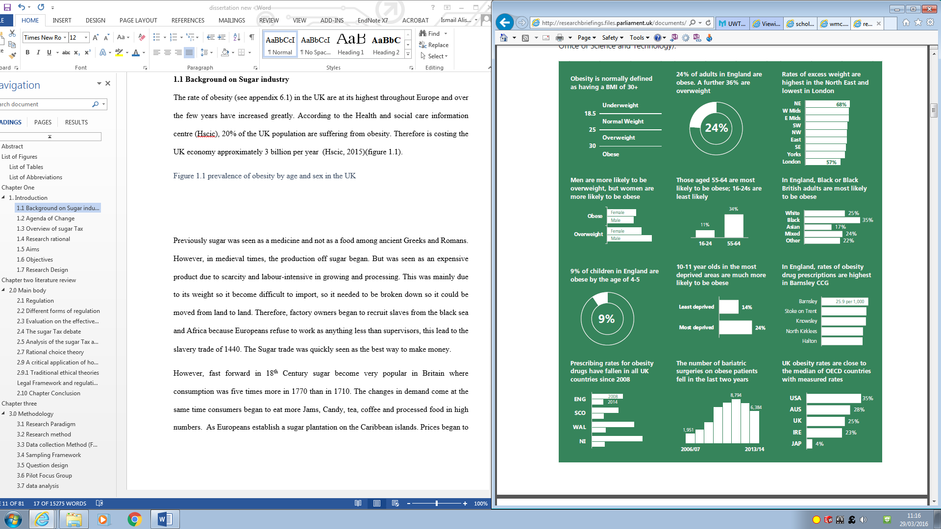
According to, British Journal of Sports and Medicine (2015), poor diets create more disease than alcohol and smocking combined (see Figure 2). The Journal article written by Dr Malhotra (2015), suggests that obesity is costing the NHS more than dementia. Sugar initially come to the attention of the media in 2013, when Dr Robert Lustig, suggested that 75% to 85% of obesity is to due sugar intake (Boseley, 2013). This also led to more recently Jamie Oliver proposing a tax on sugary foods. The campaigns against sugar has led the independent and the daily mail to label “sugar as the new tobacco” (NHS UK, 2015).
However, this is Misleading statement. According the British nutrition foundation (BNF, 2014) Sugar is a form of carbohydrate which provides the body with energy in form of glucose. Glucose is needed for the brain to function effectively. There are many food that naturally contain sugar such as fruits, veg and milk which also provide essential nutrition’s that the body needs. However some foods contain added sugar which are added during processing which are known as non-milk extrinsic sugars (NMES). These foods tend to have a greater amount of added sugars which provide calories without substantial amounts of micronutrients. As a result people become overweight during their lifetime (Carter, 2011).
It is debated that there is some form of necessity for natural sugar in the body in order to function properly, many experts would agree that the comparison with tobacco and sugar is completely inaccurate. Additionally, experts continue to bring forward evidence against NMES types of carbohydrates, which has brought forward the rationale of a Sugar Tax. It has come to the researcher understand that there need be a separation in the way sugar is referred to. This literature will not be discussing natural sugars and will be referring to NMES foods (BNF, 2014).
Figure 2 Proportion of disease caused globally by key causes of ill-health
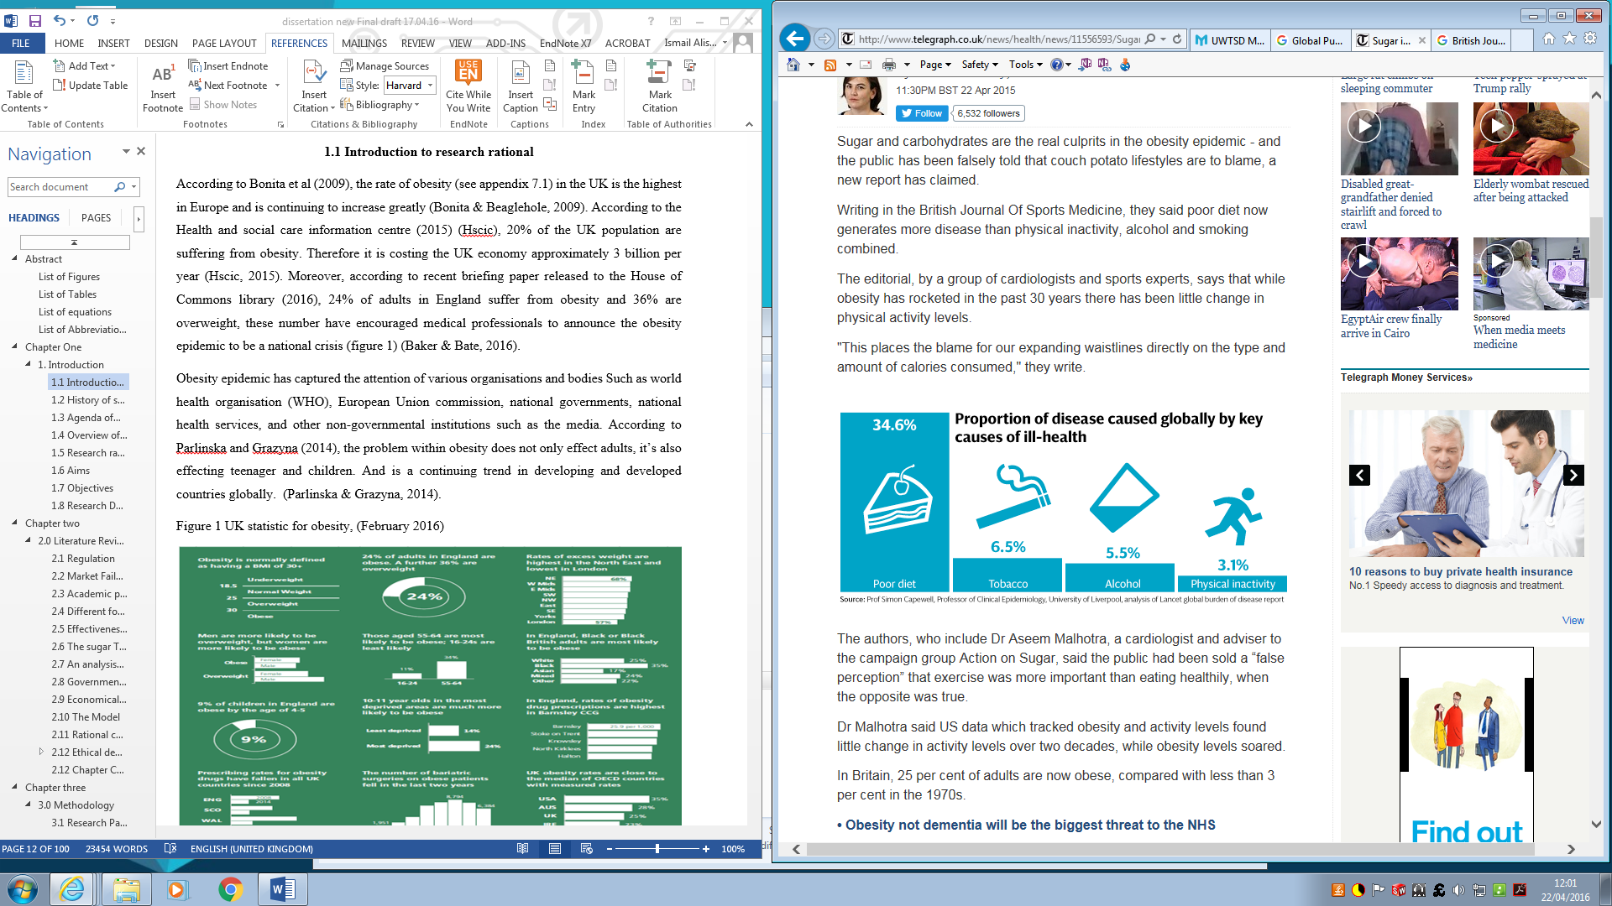
(Newton, 2015)

1.2 History of sugar
According to Davidson (1983), sugar was previously seen as a medicine and not as a food among the ancient Greeks and Romans. Therefore, the production of sugar began in medieval times. However, in those times, only the rich could afford sugar as it was seen as an expensive product due to its scarcity and labour-intensive in growing and processing the commodity. Due to its weight it was difficult to import. It needed to be broken down so it could be moved from land to land. This led to factory owners recruiting slaves from the Black Sea and Africa because the Europeans refused to work as anything less than supervisors; this lead to the slavery trade of 1440 and the sugar trade was quickly seen as the best way to make money (Ortega, 2007).
However, fast forward to the eighteenth century when sugar became very popular in Britain; consumption was five times more in 1770 than in 1710. The changes in demand came at the same time consumers began to eat more jams, candy, tea, coffee and processed foods in high numbers. Europeans even established sugar plantations on the Caribbean islands. Prices began to decline significantly in Britain and sugar which was known as a luxury product; it became a common product in a consumer’s day to day life (Wilfred, 1985).
Moreover, sugar which was once a valued product with a luxury status within its history is now seen as a necessity due to the industrial age with lower cost prices. This has allowed consumers to overindulge leading to health risks. This shows a correlation between price and necessity as sugar was seen as a valuable product, only the rich could afford.

1.3 Agenda of change
Sugar is a common substance in the modern era. However, people until recently were still convinced it was simply an attractive substance, and is one of our diets many carbohydrates that the body needs. According to the Harvard School of Health (2014), the body only requires natural sugars from fruit and vegetables, and does not need added sugars. Moreover, since humans are relying more on processed foods as opposed to hunting or gathering food, diets are now filled with carbohydrates. The replacement of natural food with processed food means that people are replacing their natural sugars with added sugars (Lustig, 2013).
John Yudkin in 1972 published a book titled ‘Pure White and Deadly’. Yudkin was one of the first scientist to claim that sugar was a major cause of obesity and heart disease (Yudkin, 1972). However, it wasn’t until recently that the book become a collector’s item. People have begun to debate the seriousness of sugar to the body.
According to Yudkin, sugar does not only cause obesity and tooth decay but causes other life-threating illnesses such as cancer, Alzheimer’s and diabetes. However, the sugar industry believes they have made enough changes and believed that sugar is not solely responsible for the rise in obesity (Joseph, 2015).
According to Dr Sally Norton, sugar is also seen as an addictive substance. In a recent study, she compared sugar with the new crack cocaine in an article for the Daily Mail (Norton, 2016). Often, experts speak about addiction to caffeine, sleeping pills and alcohol; however, until recently, the sugar industry was not referred to as an addictive substance. A study undertaken on mice was conducted by a French scientist, whereby, mice chose sugar as opposed to cocaine; even though the mice were addicted to cocaine. However, research using brain scans showed that a milkshake full of sugar triggered the same reward censors as cocaine. What’s more, when adding more fat to the milkshake, this had no effect (Bennett, 2011).

1.4 Overview of Sugar Tax
Policymakers have disputed and put policies in place in order to decrease the consumption of food which is high in sugar. Among the policies which are being considered is the use of price penalties and incentives such as a Sugar Tax. This incentive aims to push consumers to follow a healthier diet resulting in a lower obesity rate (Wijdeveld, 2011).
Utilising the historical narrative in 1.2 parallels may be drawn with the “Gin Tax “of Regency Britain, whose objectives was to price gin out of the pockets of the poor. Whether sugar represents the same “sin” category as smocking and alcohol, can be debated.
The Sugar Tax was initially brought to the government’s attention by Jamie Oliver and Cancer Research UK (2015) in order to reduce the obesity rate within children. Campaigners continue to put pressure on David Cameron (prime minister) in order to introduce the Sugar Tax as it is said to reduce the obesity rate by four million by 2025. Reports brought forward by Cancer Research UK and the UK health forum have calculated that an application of a 20% tax could see a fall in the obesity rate by 5% by 2025. However, David Cameron has rejected information from the health experts which backs the idea for a tax on sugary food and drinks and said that he does not ‘see the need’ for the taxation (ITV News, 2015).

However, more recently, Mr George Osborne (2016) (Chancellor of the Exchequer) has announced that Britain will introduce a sugar drink Levy by 2018. The government has targeted the Levy at drink companies as it wants manufacturers to self-regulate and reduce the amount of sugar it puts in drinks (Cooper and Gander, 2016). This has created a growing urgency within the food and drink industry to make healthy eating more desirable, now that it is becoming harder to convince consumers to buy products that are high in sugar.
Furthermore, studies analysing the taxation of foods find that its effects on consumption are more limited than anticipated, especially in the short-term. This is mainly due to food demand; the price is elastic and the substitution of foods leads to an excessive high calorie consumption. Moreover, the tax on food tends to be regressive, this is because low-income consumers tend to spend more money on ‘luxury foods’ than high-income consumers (Cash et al., 2005).

1.5 Research rationale
The purpose for the chosen topic is that it affects a large population and is something that is still being debated and a resolution has yet to be made. The main area of research is regulation. Selznick (1992) and Hunts (1999), contradicting concept on regulation will be discussed in the research topic. It is important to be aware that when the government oppose a regulation, it is the general public which are affected. It is important to clarify what form of regulation works best and which have worked previously as regulations can lead to negative outcomes; not just for consumers but also for organisations. According to Archie Carroll (2010, p.99), ‘an organisation need to adapt a long-range self-interest view, whereby the organisation needs to take actions now to sustain a long future.’ The long-range self-interest view will ensure societies’ needs are met. If their needs are not being met, the organisational role may then be altered by the public through government regulations (Rahim, 2013). Carroll, also believed that if an organisation is being socially responsible and taking care of all their stakeholders, this wards off governmental intervention. Due to the current debate on governmental intervention within the food industry, Carroll and Buchholtz (2014) would have you believe that this is because they were not upholding their societal obligations.
In addition, Norman Bowie (2013) believed that consumers will not react to cost and the use of environmentally friendly products and action. Then it is not the organisations’ responsibility to correct the market failures. Therefore, if an organisation has procedures already in place, and the sugar industry has made changes with calories, labelling and advertising, then according to Bowie they are not responsible for market failures.
However, Bowie did point that an organisation should not go against the government’s process to set regulations (Arnold and Harris, 2012). However, Ronald Duska (2007), had a contradicting opinion and disagreed with Bowie and believed that it is the organisation’s responsibility to correct market failures and believed that the organisation should take more responsibility. This would mean the sugar industry is to blame for government interventions due to market failures.
The rise of health conditions within the UK is becoming a national concern so the need for intervention is necessary. There are also other factors which are affecting the rise of obesity. Such as the rise of technology; more people are spending time at home rather than going out. However, there is no evidence to link obesity with the rise in technology, although very few studies have attempted to make this link.
Furthermore, some studies have shown that children who watch numerous hours of television tend to be bigger in weight (Kehler, 2010). This leads to a further question: ‘Is sugar really the problem or should health organisations be looking at other factors instead of blaming the sugar industry?’ In addition, with the government focusing solely on the sugar industry, this gives substitute products, which may also have an effect on obesity, to rise in the consumer market.

1.6 Aim
An evaluation of validity and viability of the Sugar Tax

1.7 Objectives
By the end of this study, it is hoped to achieve the following objectives:
- To evaluate underpinning models and frameworks for regulating the sugar industry.
- To analyse whether the sugar industry is being socially responsible, and what changes need to be made by the industry to improve their ethical performance.
- To analyse the rationale of the Sugar Tax proposal, and if consumers believe it is an effective solution.
- To generate logical recommendations for the regulation of the sugar industry.

1.8 Research design
Chapter One: This chapter will provide the reader with an introduction to the research topic and also give the reader a clear understanding of the aim and objectives which the research will attempt to achieve.
Chapter Two: The reader will be provided with secondary research data available on the research topic and analyse the rationale for a Sugar Tax. The research in this chapter was gathered from a wide range of sources; mainly textbooks, journal articles, websites and newspapers.
Chapter Three: This chapter looks at the research methodology and will explain why a phenomenological paradigm approach was chosen for this research. Furthermore, this chapter will give the reader an understanding as to why a focus groups were the chosen method of data collection followed by a discussion on the benefits and limitations to the chosen research method.
Chapter Four: This chapter will analyse the data collected from the data collection method in chapter three. The analyses of the primary research will make reference to the secondary research found in chapter two.
Chapter Five: This chapter will draw up a conclusion from the information provided in chapters two, three and four. The conclusion will then allow for appropriate recommendations to be made.

Chapter Two

2.0 Literature Review

2.1 Market failure theory
The financial crisis of 2007 to 2009 has dramatically changed the attitude towards the role of the government in society. The government has begun to impose and enforce regulations more frequently. According to Moss and Cisternino (2009, p.7), ‘The market failure theory was a core part of government intervention’. Basic economics will suggest that a rationale individual will typically maximise their welfare of the whole society simply by pursuing their own self-interest. For example, drinking an excessive amount of fizzy drinks will cause tooth decay, but the fizzy drink manufacture does not take into account medical costs. Negative externalities have become a core rationale for government regulations. Therefore, the market failure theory has been used in order to justify regulations.
The market failure theory will inevitable continue to be a pillar of any modern approach to regulation. Generally, market failure occurs when either the quantity or quality for a good product with an unregulated market is different from its private cost, and the benefit derivative from those goods and the market solution results in inefficient resource allocation (Belkaoui, 2004). However, according to John Cistemino et al. (2009, p.7), ‘Market failure should not be the only foundation for a new era in regulatory engagement.’
Influential research has come to light since the 60s, researching government failures have attempted to bring forward the movement for deregulation and privatisation (Dolfsma, 2013). Economists believe that governments should only intervene when the market fails, making the role of the government more limited. However, Buchanan (1986) believed that a government will inherently fail under the hypothesis of what drives the individual’s behaviour, such as government officials, because they are in a distinctive position and their behaviour can be failure prone. This suggests that just because the market fails, this does not mean that the government can also do what is right, as governmental failures do also occur.

2.2 Regulation
Regulation is often referred to as a discrete mode of governmental activities. However, the term regulation can be defined in many different ways (refer to figure 3). Regulation is often understood as ‘a specific set of commands’ (Baldwin et al., 2012). Regulation comprises of promulgation, whereby a set of rules are brought forward which are applied by a group devoted to a particular cause (Head, 1991). Moreover, regulation can also be understood as a ‘deliberate state of influence’ – this form of regulation is more relevant to this study, as this regulation is a broader term which covers all government actions which are brought forward in order to influence businesses or social behaviour. These changes can be enforced through command-based regimes and through different models of influences such as the use of economic influence (e.g. tax or subsidies), contractual powers, and the use of resources (e.g. education) (Braithwaite, 2008). In the case of the sugar industry, Jamie Oliver has recently brought forward the incentive for a Sugar Tax in order to reduce the amount of sugar consumed by consumers throughout the UK (Triggle, 2015).

2.3 Academic perspective to regulation
Julia Black (2002) recognised two notions of regulations: ‘regulatory state’ and ‘new regulatory state’. However, another notion which needs to be familiarised with is ‘regulatory society’. ‘Regulatory society’ established that regulation is not only based on the government but it decentred and defused throughout society. Decentred regulation is clearly linked to the globalisation debate; however, a decentred regulation can still be linked to governmental regulations. Moreover, organisations which act against the government may be bound in the ‘design of hybrid or post-regulatory mechanisms,’ so that the government can debate on what actions can be taken to force public policies.
Two contradicting notions are Selznick (1992) and Hunts (1999) perspective to regulation. At first sight, it may appear that Hunt is supporting Selznick’s wider concept, but through a closer analysis, Hunt (1999), appears to have a broader perspective on regulation. Selznick’s (1992), notion of regulation focuses mainly on an organisational theory; while using the community as the example, Selznick’s main focus is on the difference between management and governance. Selznick’s sociological perspective saw regulation as a ‘sustained and focused control exercised by a public agency over activities that are valued by a community’ (Boorsma et al., 2012).
Selznick, 1992, p.365, believed that governance needed to accept ‘responsibility for the whole life of the institution.’ Furthermore, to ‘take into account all that are interested that affect the variability, competence and moral character of an enterprise.’ Therefore, it is a vital part of governance to be in charge of the care of the community. Selznick’s theory views the organisation as children who need to be guided and advised, and believed that the organisation needed to have laws and regulations bestowed upon them in order for change to happen.
However, Hunt (1999) criticised Selznick’s notion and said it was ‘biased’. Hunt claimed that Selznick’s notion restricts outcomes. Hunt believed that self-regulations and governance need to go hand in hand in order to be able to have an effect. He also believed if the perspective of social control is not applied, the concept of regulation may produce a less effective approach, which will limit any particular result (Sammeck, 2011). Hunt believed an organisation needed to adapt self-regulations and impose their own licensing restriction. Self-regulation comes under different forms.
Self-regulation is seen as a systematic process whereby the entire industry, not just one firm, works together against the very problem that affects the industry. In principle, self-regulation is where the organisation will engage in some form of self-governance, whereby they set and maintain rules and standards which enforces ethical behaviour among them. This then prevents governmental intervention. An example of self-regulation is the regulation of marketing products and how products are produced or changes made to labelling (Demortain, 2011). Hunt and Selznick latter, recognised the importance of bringing together government and self-regulation in order to bring together the most effective results.
According to Maria Minniti et al. (2006), government intervention is based on the theory of market divergences or market failures. This theory suggested that when a market is left to itself, this will then reflect the true cost/benefits of the output of the sector which can then be internalised. However, the social supply and demand curve will move from being a private curve, which will then make it ineffective. This this leads on to government intervention which seeks to correct the source of the divergence. However, according to Marco et al (2013), even though government intervention can be seen as industrial policies, public perception is directed towards the organisation. They also believed that government can fail just as much or even more then markets.

Figure 3 Regulation - an ever-expanding concept
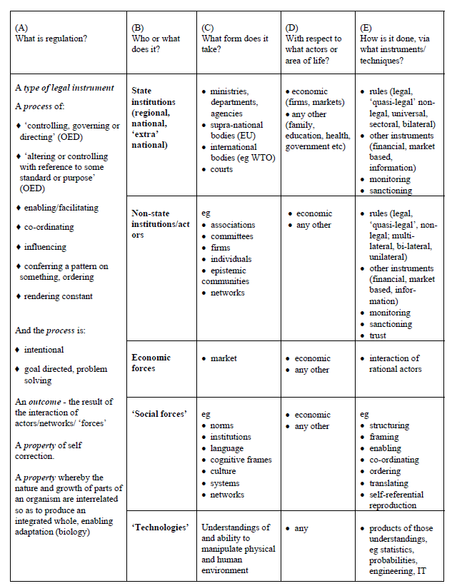
Source: Black (2002)

2.4 Different forms of regulation
Command and control regulations (C&Cs) are applied in order to set standards which are backed up by legal sanctions. Whereby, if the law is not met, the law is therefore used in order to prohibit certain types of behaviour and therefore forces actions to be taken. For example, it is the law to ensure tobacco is stored behind the till and is hidden from the public eye; if the organisation does not abide by the laws set, then legal actions are taken which could lead to the business paying a large fine (Ogus, 2004). Taking such a direct approach to regulations ensure it can be implemented quickly and also sets out clear limitations. It also creates a standard of how an organisation can behave and that organisation is given clear consequences. However, this can come across heavy-handed and is also a more complicated approach to regulating activities; defining what is perceived as acceptable standards can be difficult (Pautz and Rinfret, 2013).
Self-regulation allows organisations to change their own behaviour and set their own standards, which means that there no need for the government to implement costly policies. However, there can be some governmental oversight of regulation. But generally, self-regulation is perceived as a way that a business can take pre-emptive action in order to stop governmental intervention (Boekaerts et al., 2005). This approach to regulation means an organisation needs to be highly committed and well informed of the rules that need to be set. It is also more flexible than the C&Cs. However, this approach can also be seen as undemocratic and can be challenged by outside interests who feel that the change made by the organisation is not reducing unlawful behaviour. In terms of the Sugar Tax, lower-income consumers will be affected the most by the tax but will not challenge the tax because they do not believe it will have an effect on behaviour.
An incentive-based regulation creates policies, rules, pricing mechanisms which attempts to change the behaviour of a person or organisation by changing their marginal costs or marginal benefits in relation to a particular decision. An incentive regulation functions through a concept of penalising ‘bad behaviour’ and rewarding ‘good behaviour’. This form of regulation through punishing and rewarding allows the regulation to operate in a mechanical way. Therefore, reducing the possibility for a regulatory decision (Deketelaere, 2001). This also enables the organisation to be flexible in decision making. However, in contrast, this approach creates rules that are far more complicated and inflexible and do not take into account market realities.

Market-based mechanisms are a range of mechanisms which are used in order to regulate activities. This form of regulation is regarded as cost-effective and reduces interference with the companies’ day to day business. There are many different market-based mechanisms such as: (1) competition laws; these laws are applied in order to control a company’s behaviour in ensuring market delivery (2) regulation contract; this is where the government can implement their buying power, and specify conditions (Gayer and Horowitz, 2006). These conditions vary and are driven to a socially desirable end. However, this is often a short-term solution of regulation. Other regulation mechanisms include action directly applied by the government, regulation through rights and liability laws and can also include regulation through public compensation (Orts and Deketelaere, 2001).

2.5 Effectiveness of regulation within the sin industry
The ‘sin industry’ is used to describe organisations producing products or services which are harmful to consumers and the environment. These organisations have a major impact on the social and physical environment. Organisations who are known under the ‘sin industry’ title tend to be scrutinised by the media and attacked by the stakeholders. These organisations tend to operate in an unethical way and produce products that pose a health risk to consumers; for example, the tobacco industry. The effects of tobacco have been widely documented therefore, public policy and the government employed regulations in order to reduce the amount people who are smoking. In order to regulate the tobacco industry, the following regulations were put in place: (1) Placed restrictions on sales and changing the legal age to purchase cigarettes to 18; (2) Imposed an excise tax on sales; (3) The UK government introduced pictures warning of the danger on cigarette packs; (4) All forms of advertising and promotions are banned in the UK; and (5) Banned smoking in public places (Brancaccio, 2000).
According to Robert D. Tollison et al. (2012), there is a clear link between the tax and the reduction in consumption; for example, economic research has confirmed that the taxation of cigarettes reduced smoking. Many studies have documented that a price increase reduces both adult and underage smoking. However, when the government enforces a regulation there tends to be unintended consequences. This led to smokers going to lower-tax countries and smuggling cigarettes into the country. Other evidence which reflects the negativities of regulations is the ‘national prohibition’ of alcohol in America. During the 1920s, alcohol was banned throughout the US; alcohol was no longer allowed to be sold, produced or imported in order to reduce negative effects on health, behaviour and morals in America (Czinkota, 2006).
However, the unintended consequences of this was there was more crime, many drinkers switched to illegal unsafe alcohol, marijuana, patent medicines, cocaine and other harmful substances which may not have happened if not for the absence of prohibition. Therefore, regulations itself can have a negative consequences.
The research shows that when regulation is enforced, the government is not always able to achieve their aims and may do more harm than good. Taxing unhealthy lifestyle choices, is seen as a way for the government to create revenue (Milakovich and Gordon, 2013). Products within “Sin” the industry have a clear need to be regulated due to the seriousness these products have on the individual’s health and others around them. There is no link between the sugar industry and the sin industry as sugar is only harming the individual consuming the product. Therefore, there is no consensus on sin products and whether sugar us be, there no certainty that regulation works and there definite impact on choice which will skew what would have happened, however this can be a negative or a positive impact.

2.6 The Sugar Tax debate
The debate for the introduction of a Sugar Tax started towards the end of 2015 when Jamie Oliver brought the tax to David Cameron’s attention. Cancer Research UK and a panel of MPs have backed the rationale for a Sugar Tax who believe it is ‘bold and urgent’ in the re-enforcement of tackling childhood obesity (Campbell, 2015). The health committee attempted to persuade David Cameron by referring to the ‘success’ of the Sugar Tax in Mexico back in 2010, where Mexico saw a 10 per cent decrease in sugary drinks (Science and Health, 2015). However, according to the Institute of Economic Affairs (IEA) (2012) who are a ‘free market think tank’, they dismissed the success of the tax in Mexico and suggested that the decrease in sales was due to the failing European economy as sales were down before the introduction of the Tax. The IEA, also found that similar tax forced consumer to buy similar products and some sought cheaper brands/ shop or other switched to other high calorie alternatives.
Another organisation who has advocated of a Sugar Tax is the World Health Organisation (WHO). They say that childhood obesity has become an ‘exploding nightmare’. However, the WHO have suggested that along with a Sugar Tax, the government needs to crackdown on the marketing of sugary products and in addition to tackling the global scourge.

The WHO have also suggested a clearer way of food labelling and educating consumers’ needs to be incorporated. For example, it is not enough to rely on codes for labelling such as the traffic light system. The WHO has also called for further regulations around the marketing of food and drinks to children; for example, reducing the exposure of children to the power marketing of products (Pickles, 2016).Therefore, expecting a Sugar Tax alone to solve the “problem” is too demanding. It needs to be used in a package with other measures. However, evaluating a package is potentially problematic because it is unclear what the impacts of different parts of the package might be.
Consumers often are not aware of the amount of sugar they are consuming; many low fat products tend to have added sugar to their products. Consumers may believe they are taking the healthy option; however, sugar is hidden under different names on the label to confuse consumers such as sucrose, glucose, and fructose or honey (BBC, 2013). Food manufactures are not legally required to separate added sugars from naturally occurring sugar on the nutrition label. It is not illegal, however it does bring to question the organisation’s ethical values.
Moreover, an organisation firmly against the tax is the Tax Payers Alliance (TPA), who believe that the tax will hit those on a lower income the hardest. Therefore, it will increase the cost of living for millions of people which will then add to the hard-pressed taxpayers which comes from high taxes on food and alcohol. Such a regressive effect is contrary to the conventional canons of taxation and the need for equality. Food which is high in sugar tends to be convenient food. Many working professionals prefer convenience. However, If a tax is applied, this will affect them negatively as they will need to pay more for something that they feel is not affecting them (Silvester, 2014). Jamie Oliver was criticised by Wetherspoon’s chairman, Tim Martin, says that the tax would cost restaurants and pubs millions, and thought that Jamie Oliver has lost touch with the majority of people. Jamie Oliver owns a restaurant which caters to a high end clientele therefore will not be affected (Elgot, 2015). Such high income customers have a low elasticity of demand. These consumptions will be unaffected.
The food and drink industry have rejected the idea of a Sugar Tax and believe they have already incorporated many restrictions as they are no longer advertising foods that are high in fat, salt and sugar, especially during children’s TV programmes. The Food and Drink Federation’s Director General, Ian Wright, in response said: ‘steps are already in hand to ensure that high fat, salt and sugar foods will not be advertised to children (Layer, 2015).
Likewise, the industry has already reduced a considerable amount of calories from the food chain and will continue to make progress on this through reformulation and changes to portion/pack sizes.
It may also be possible, by negotiation, to improve the definition of “high sugar foods” as the report suggests. However, we do not agree that the international evidence supports the introduction of a Sugar Tax and for this reason would oppose such a move’ (Roderick, 2015). The sugar industry, rejecting the proposal, believes that there are already self-regulating processes and do not believe any further regulations need to be applied. The British soft drink association (BSA) made a statement to say: ‘There’s no evidence that food taxes have an effect of obesity’ (Ellison, 2016, p. 65).
In addition, the American Beverage Association (ABA) holds a strong stand that government regulations will not make people healthier; however, diet, exercise and nutritional education may be able to reduce obesity. And the ABA agreed with the TPA, they believed that a tax would have a negative impact on the economy especially on the economically disadvantaged and little effect on obesity. However, the debate to oppose a Sugar Tax was shut down by David Cameron who believed a tax on sugar was not needed. Ironically several pharmaceutical companies also write and campaign against the Sugar Tax: while they argue it will be ineffective, like other industry spokesperson there may also be an element of self-interest because if the tax is effective, it might reduce their profits or related goods, which may range from sugary drinks to sliming products (Pharmacy, 2016). However, more recent reports suggest that a sugar drink Levy will become effective by 2018. According to Mr Osborne, the £530 million which is estimated to be raised will be spent on primary school sports in England. In consequence to Mr Osborne’s announcement, there has been a fall in the share prices of soft drinks. The BBC health editor, Hugh Pym, said that the tax has come as a shock because Downing Street initially opposed the idea and was attacked by MPs as ‘nanny state-ism’ (BBC, 2016).
However, in response to the flagship’s budget, the Institute for Fiscal Studies (IFS) said that the Sugar Tax will in fact increase the sugar intake as it leaves ‘a lot to be desired’, and warned that the new Levy could push consumers to the black market and smuggle across borders to cut household bills. In addition, economic experts predict that consumers will then switch to substitute products high in sugar (Dathen, 2016).

Stakeholders, who have a direct effect from the Sugar Tax, have expressed their concerns; the Food and Drink Federation released a statement expressing their disappointment on the new tax on ‘some of the UK’s most successful and innovative companies’; they stated that they have been waiting for a change to be made to tackle obesity but was disappointed with the strategy used and claim that the strategy was a ‘piece of political theatre’. However, The UK’s Faculty of Public Health believe that the majority of the public support the tax as they believe it will send a clear message to industry, that public health is a ‘clear part of the economic recovery’ (Holden-Locke, 2016). Much of the debate is based on the cause of obesity, where most agree that sugar is only one element of the problem.

2.7 An analysis of the Sugar Tax as an effective solution
Taxing sugar has become a growing public interest in order to reduce health risks. A Sugar Tax is meant to raise the price of products which are high in sugar, which should potentially lead to a decline in sales (see Figure 4) (Snowdon, 2016). Furthermore, a decline in sales should mean that people are eating fewer calories, so fewer people will suffer from adverse health conditions. If a tax is applied, the government automatically assumes people will eat fewer high sugary products as it becomes less affordable. However, the model shown in Figure 4 only works if the consumers behave in the way the government expect. When the regulation is imposed, the government do not take into account that the chain on taxation could break down through unintended consequences.
The outcome of applying a tax on sugar to reduce obesity is often limited, and taxing sugar alone can be regressive and can fall disproportionally on the economically disadvantaged (Allais et al., 2010). However, a Sugar Tax or a sugar drink Levy can be effective with additional regulations such as education campaigns. Schroeter et al. (2008) found that when prices increase, consumption reduces; however, they saw that changes in body weight depended on other aspects such as substitutability through high calorie and low calorie foods and thereby had little effect on weight. Research found it may be more effective to apply a tax on fizzy drinks, than targeting the whole sugar industry. Other researchers have found that a tax would be ineffective and found that consumption or diet would not change in relation with a tax (Kuchles et al., 2004).

Even though a tax may not have much of an effect on consumption due to food demand being inelastic, any added taxes could cover NHS costs and provide funding in order to tackle obesity. However, unless the authorities are clear about the objective of the tax, it will be difficult to evaluate whether or not it is successful in reducing morbidity and increase revenue which might or might not be used on health projects.
Figure 4: Taxation model
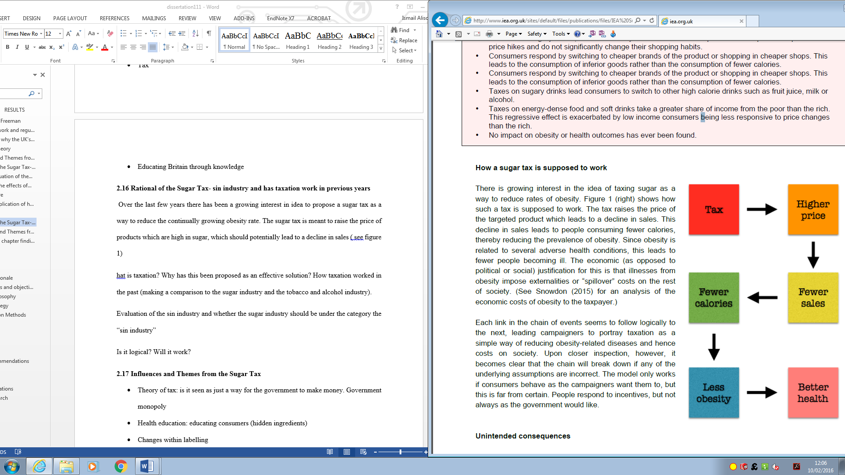
Source: Snowdon, (2016)
The chain of a tax’s impact offered by Snowdon (2016) might be broken at any stage. The taxation model could not be effective potentially if the sugar industry decided to withhold the tax as opposed to passing it on to customers in the form of higher prices. Furthermore, if the sugar industry does not raise their prices, they will see a decline in profits but sales won’t be expected to change. Another scenario could be that consumers will switch to cheaper products or shop in cheaper stores. In previous years, consumers have had to turn to the black market if the tax is charged at a high rate, therefore, no fewer calories will be consumed. An important, however somewhat neglected aspect of the rationale for a tax, is a possibility for a trade-off between sugar and fat, which will then see no decrease in the calorie intake when the tax is applied. Researchers Smed et al. (2007), showed that when a Sugar Tax is applied, people tend to eat less food that is high in sugar; however, the amount of saturated fat consumed increases. Thereby cutting the final link in the potential beneficial impact.

2.8 Government regulation in the sugar industry globally
In recent years, many countries have introduced a tax on sugary drinks, products high in saturated fat, confectionery, chocolate and other high sugary products. In the United States (US), thirty-three states have implemented a ‘Soda Tax’ and ‘Fizzy Drink Tax’ in 2012. Furthermore, other countries have implemented the Sugar Tax; Hungary and Finland tax high calorie food products as well as sugary soft drinks. However, consumers are different and not all people who have a high sugar diet are obese and a Sugar Tax will not differentiate between consumers by their weight. Furthermore, a recent study shows that exerting a Sugar Tax, mainly light versus heavy demand. Whereby, a Sugar Tax had more of an effect on the consumers who consume the product less frequently, as opposed to individuals who consume high sugary products more frequently (Marlow, 2011). Furthermore, the government is likely to make it appear like the ‘eat less, exercise more’ campaign for there is no longer an effective way of controlling weight, therefore justifying the rationale for a Sugar Tax. The evidence of these real-world experiments of the implementation of a tax shows that unintended consequences are inevitable and the taxation chain Figure 4 is rare (Snowdon, 2016). (See figure 5)
A basic economic theory will lead the government to believe that higher prices will lead to less demand (Gwartney et al., 2014). However, there are a number of factors which affect this theory. If sugary products make up a high proportion of the consumers’ budget, in theory this means their income has been reduced also, therefore they will make decisions to change their habits as a result. These habit changes may offset the direct effect of higher prices. The relationship between the rise in prices and decrease in the consumption of sugary products depends on the importance of the product to consumers (Snowdon, 2016). On average, in the UK, food and drink are the core of the household budget and most people are reluctant to change their consumption habits.
Evidence shows that it is unusual for a tax on food or drinks to have an effect on consumption; however if there have been effects, it has usually been quite trivial. Previously, the Danish Fat Tax applied a 13.1% tax increase; however, the results only showed a 5.5% decline in sales. In addition to this evidence, in Finland there was a 14.8% increase on confectionery; however, Finland only saw a drop of 2.6%.

Finland also applied a tax of 7.3% on sugary drinks for two years and sales rates fell by less than 1% in the first year and by 3.1% in the second year. Mexico who was one of the lower economically disadvantaged countries to apply such policies applied a 10% tax and saw a 6% decline (Snowdon, 2016).
However, there is no way of linking these declines with the tax regulation due to the time frame that these were applied. As in 2010, the European economy was in decline. However, what the evidence does show is that the demand for food and soft drinks, regardless of the effects, are inelastic and that taxes applied to them tend to have minimal to no effect (Lavin and Timpson, 2013). Kuchles et al. (2004) who conducted a study based on householders in 1999 found that the consumers’ response to tax increase ranged from 0.4% to 30% and would only see a reduction in consumption by 0.19 to 13.89 ounces. Therefore, this linked changes within consumption which suggests that an increase in tax on goods would be linked with a negligible overall change in consumption. Though the evidence is inconclusive, the automatic effectiveness of the benefits of a Sugar Tax must be questioned.
Figure 5:- Impact of taxes on price and consumption of soft drinks
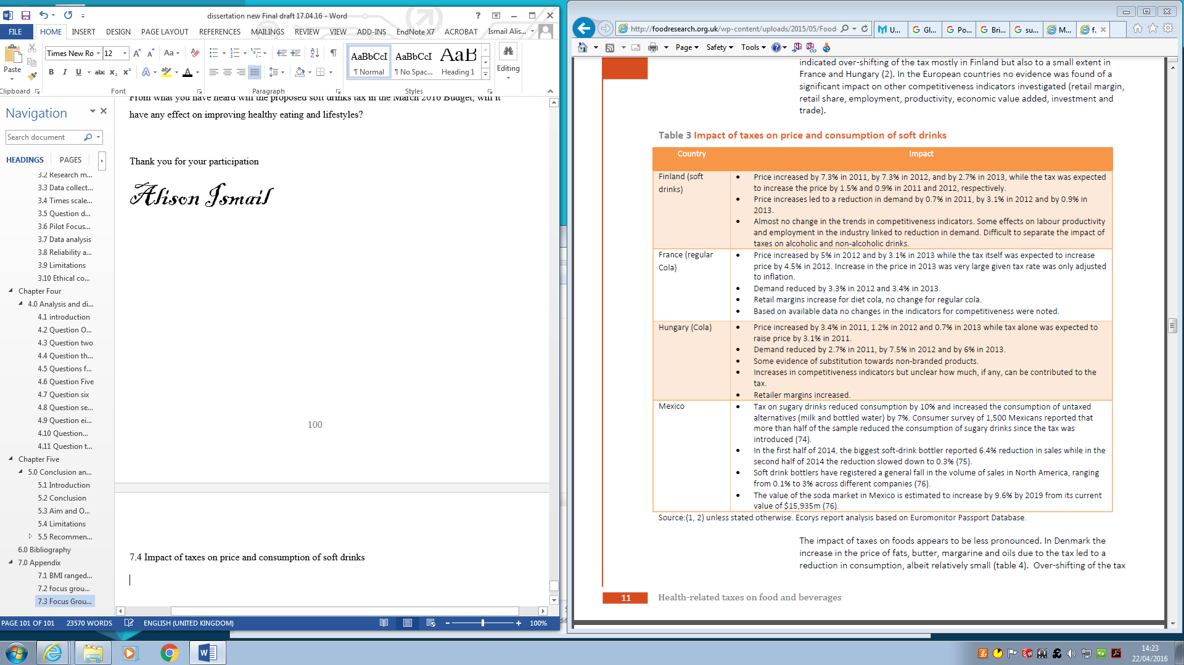
Kuchles et al. (2004)

2.9 Economic arguments
The debate regarding the application of a Sugar Tax raises economic arguments. First of all, the application of a tax needs to be economically efficient. Economic efficiency attempts to achieve an optimal allocation of resources and optimal production and distribution to serve each person the best way, all the while minimising waste and inefficiencies. If this is not achieved, this could lead to market failure (Schultz, 2008).
However, a free market does not always allow this. If there are negative externalities, there will be a stronger case for the rationale of a tax on sugar and consumers will need to pay the full social costs and not just the market price. According the Pettinger (2015), the Sugar Tax should raise revenue for the government to achieve a more socially efficiency level of consumption. Pettinger’s (2015) argument for a Sugar Tax is that food that is high in sugar creates high external costs to the environment, therefore overeating sugar causes health problems. This means external costs will be reflected in the price which illnesses are imposing on the NHS. Additionally, poor health will have an effect on consumers’ work and productivity. Possibly the social cost of sugar consumption is evidently more than the private cost.
Figure 6: Reflects goods with external costs
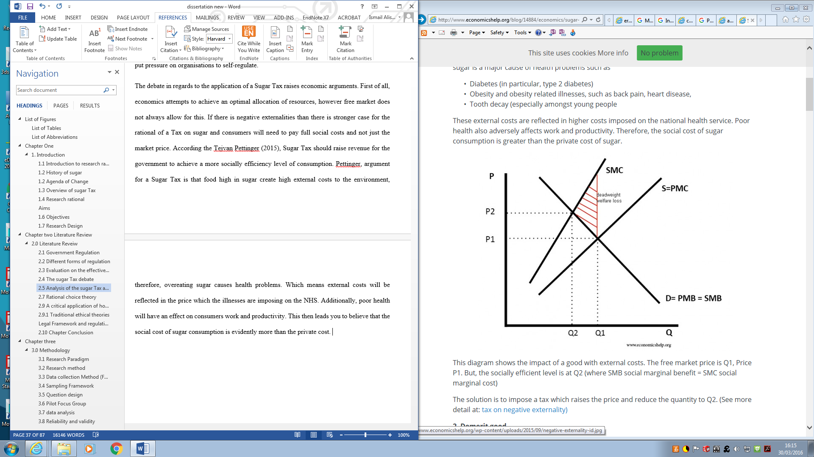
Source: Pettinger (2015)
The diagram reflects the impact of goods which have external costs. Q1 = the market price, P1 = the price, Q2 = social efficiency level, also social marginal benefit (SMB) = social marginal cost (SMC). The diagram reflects a solution which suggests that if the price is raised through taxation, this should have an effect on quantity (Q2).
Moreover, sugary foods and drinks are seen as de-merit goods and the consumption of de-merit goods can lead to negative externalities. According to Cullingworth (2004, p, 24), consumers are not always aware of the negative externalities that are in certain goods, this is due to information failure about long-term damages to their health. Additionally, consumers tend not to be open to reduced consumption due to addiction. On average, a household within the UK consumes 238 teaspoons of sugar per week (Pettinger, 2015). This may be due to not realising how much sugar is hidden in soft drinks which has now led to the government to intervene in de-merit goods through imposing a sugar drink Levy.
The law of demand states that in theory, consumption for a product will fall as the price of the good rises. However, what is often not taken into consideration is that consumers will look for a substitute product, this is called the ‘substitution effect’ (Gerhard, 2009). The consumer theory focuses on price and if the price is attractive consumers will tend to go for the lower prices (Lancaster, 1991). However, a free market approach does not take into account the negative externalities of consumption, this is because social cost tends to exceed private costs with de-merit goods.
Figure 7: The diagrams illustrate how indirect tax will affect the price elasticity demand

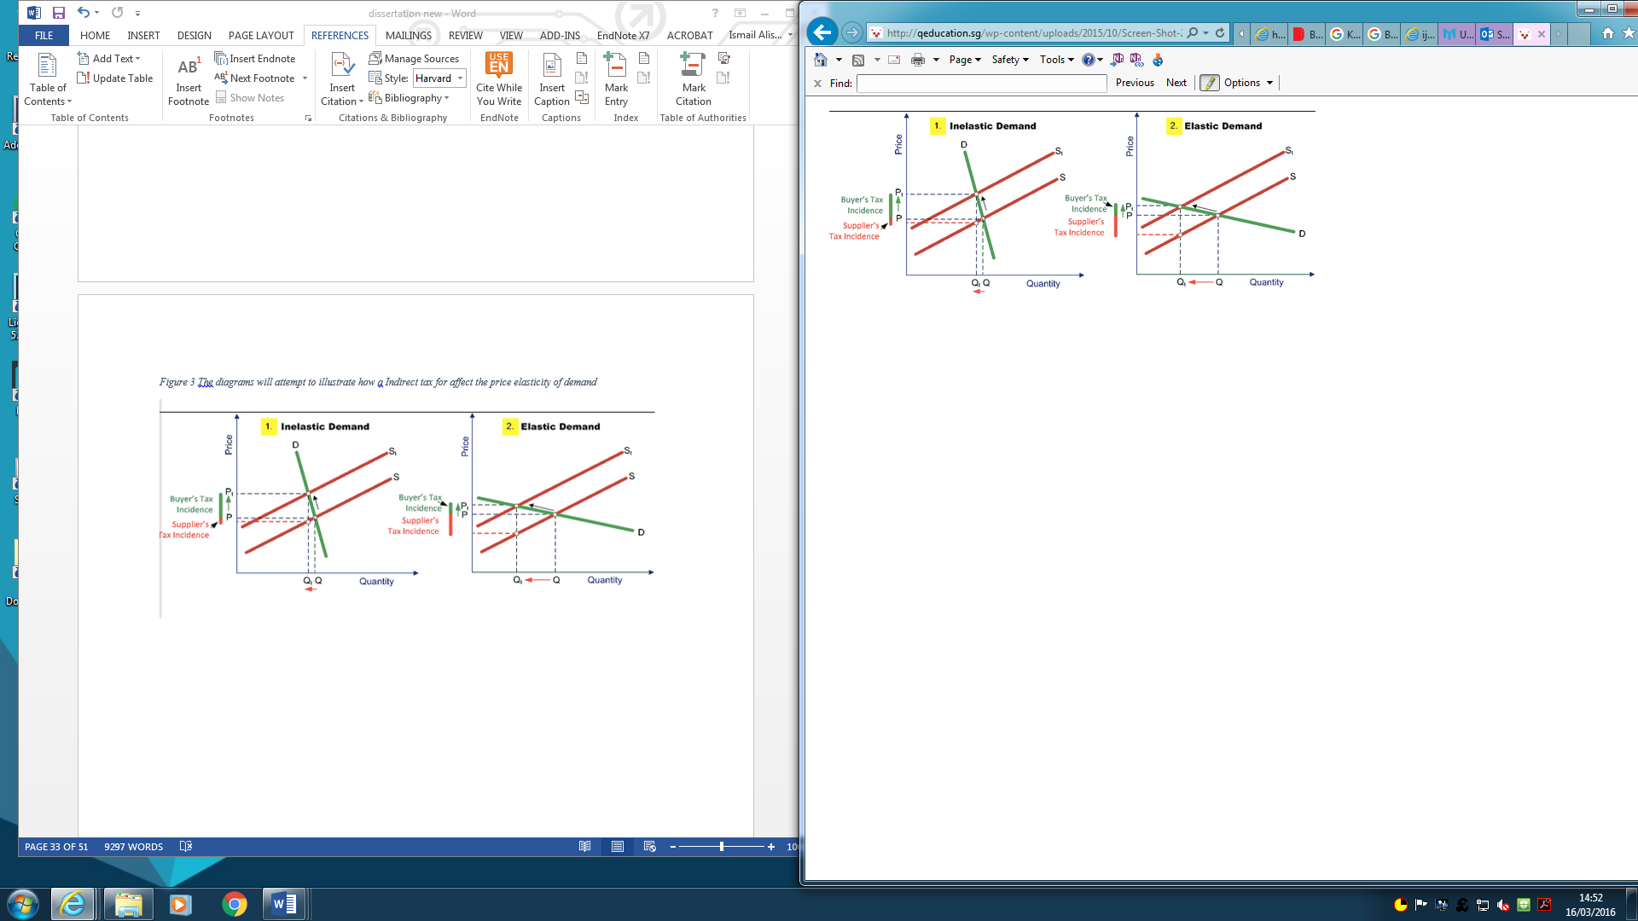Source: Pettinger (2015)

Market failure occurs when the price mechanisms fail to distribute scarce resources economically or when the operation of market forces lead to a new social welfare loss (refer to section 2.2). Taxation attempts to solve market failures through internalising the external costs of production and consumption. This then forces private individuals to pay for external costs. For example, the diagram below shows the reason why the market fails, it is because of the price mechanism has fallen due to internalisation of the external costs to producers and consumers (Lancaster, 1991). The result of this is over-allocation and welfare losses in certain items. The diagram below shows the examples of market failures and mechanism in terms of alcohol.
Figure 8: Taxation a negative consumption externality (alcohol)
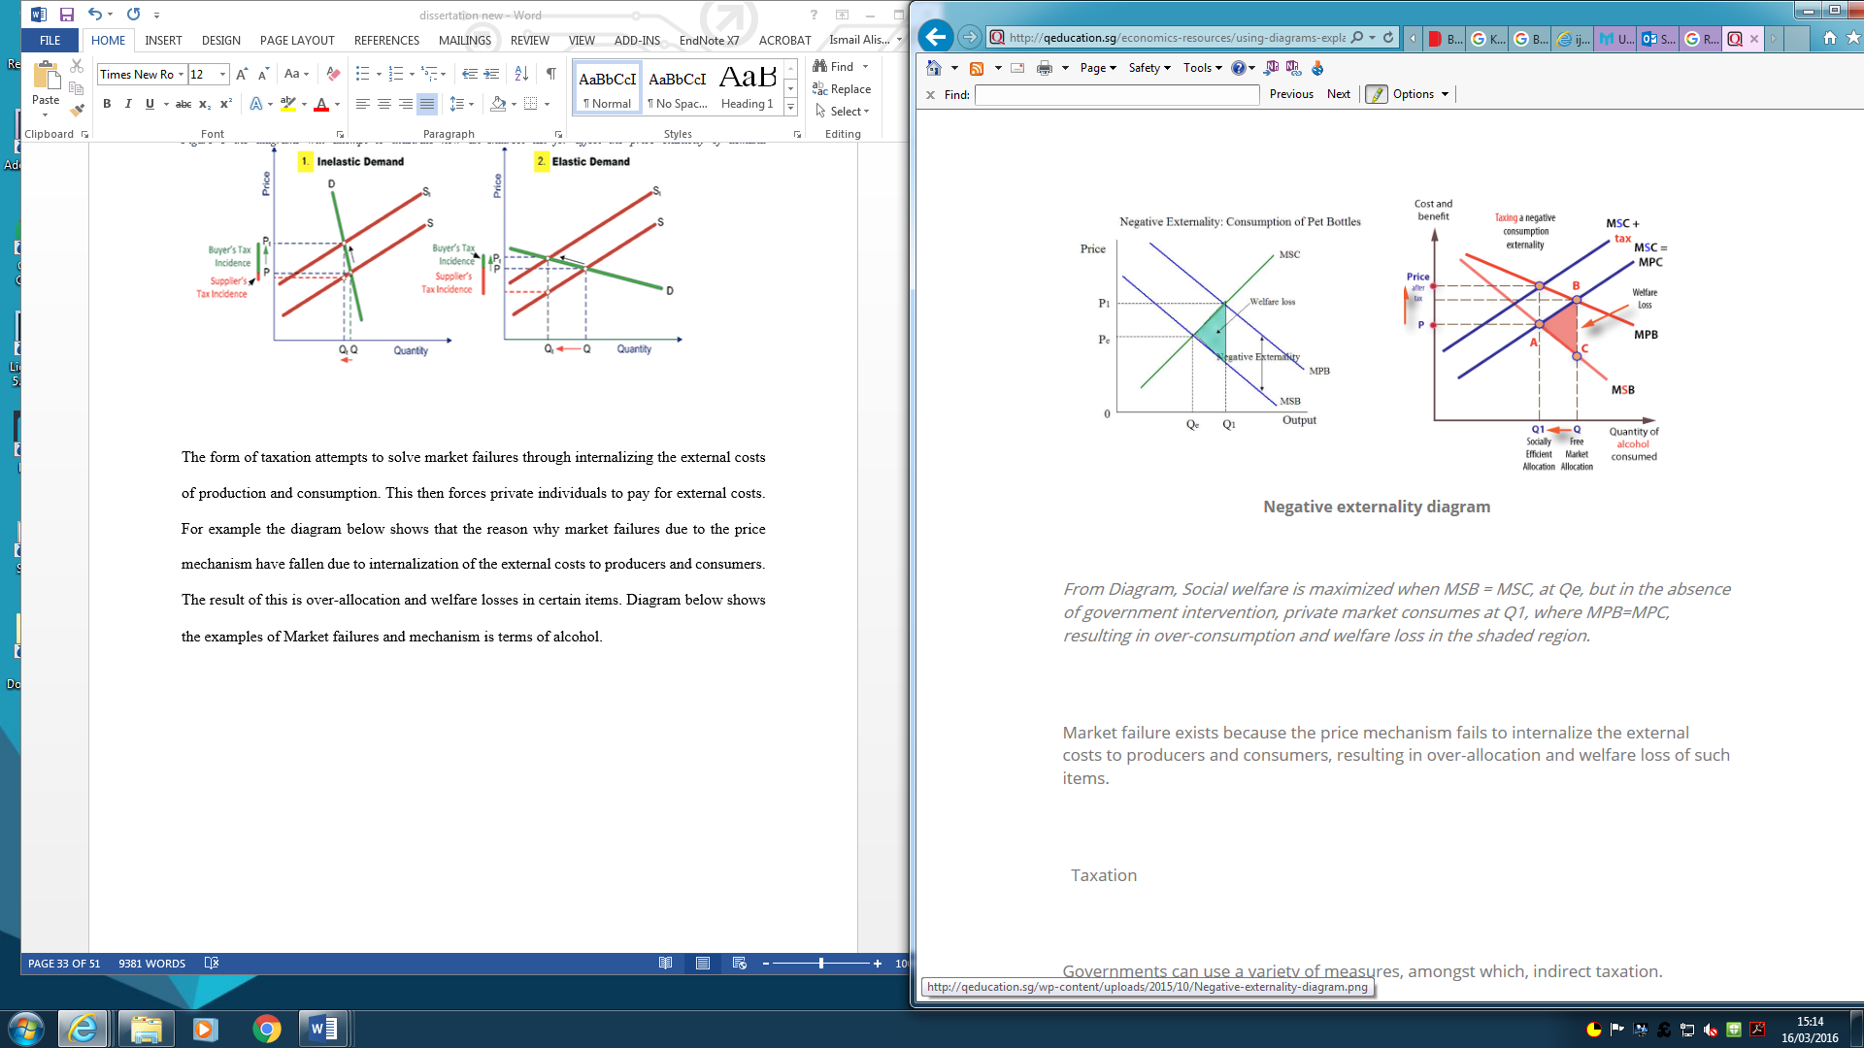
Source: Pettinger (2015)

2.10 The Model
Research tends to depend on a multi-market, partial equilibrium displacement model surrounding the sugar market, and consumer groups who differentiate in terms of their income level. This approach has been utilised within many different policy analysis (Mullen et al., 1988). Added sugar is just an input added into foods, therefore, the assumption is there is an infinite supply of sugar within the sugar industry which means that the price of sugar before the application of tax is parametric.
The research considers a tax imposed on sugar input at the production level of processing. When a tax is applied at the production level, the cost that is added and the extent that it is passed to consumers is determined by the degree of competition within the market and the ability to substitute among inputs (Garcia, 2002). The government assumes that Tax will be fully passed on to consumer under perfect competition. If this is correct the calculation of consumer expenditure and welfare change will provide an upper bound of the possible liability of the tax on consumers.

2.10.1 Producer side:
The 20% tax is based on upper bound assessments related to price changes because any market power factors would decrease with the introduction of a tax. The “Linquad demand system” will become more sensitive to price as consumer demand decreases with the application of a tax (Garcia, 2002). This is why price mark-ups become smaller when there is changes in elasticity which leads to reduced prices in relation to proportional changes in the unit cost at the margin (see equation 2)
Within every food manufacturing industry, the total cost of producing the products depends on the cost share of each input and the inputs price. With the food manufacturing industry$‘i’$, the input of price is referred to as ‘$W_{ik}$the letter $‘k’$ represents before tax input on price ${\hat{W}}_{ik}$ and when tax is inputted${ t}_{ik}$, so that $W_{ik}$ = ${\hat{W}}_{ik}$ (1+$t_{ik}$).

Assuming that there is a continuous return to scale and the marginal cost will equal the average cost, the assumption is that the total cost will continue to increase in direct proportion to output.
The changes within the marginal costs will be comparative in the changes within the input prices (d in $W_{ik}$= d $In$(1+$t_{ik}$) which is then:
Equation 1:
$$d\left(In{MC}_{i}\right)=\sum_{K}{S}{ik}^{d}InW_{ik}=\sum_{k}{S}{ik}^{d}In(1+t_{ik})$$
Equation developed by: (Miao, 2012)
Within the equation, MC is referred to as marginal cost of production for the sugar industry$i$, and $S_{ik}$ means the cost share of input $k$ in total, and input price is$W_{ik}$. The sugar industry is a competitive industry with many different brands competing against one another. Therefore, changes within prices ${PP}_{i}$ will equal to changes within marginal costs. Moreover, the abstraction is made for the retail sections, and the assumption is made that production and consumer prices will change in proportion to one another (Beghin, 2001).
Changes within the price due to tax need to reflect the relative changes within input prices and measured against their respective cost share within the market; this is the equilibrium stage (Beghin, 2001). If there is a 100% increase in sugar prices against the cost share of sugar $S_{ik}$in retail will result in a$S_{ik}$ to increase in ultimate food prices. Therefore, in inputting a tax on sugar will be pushed onto the consumers through higher prices, this means the output prices change:
Equation 2:
$$d In{ PP}_{i }=d In{MC}_{i}=\sum_{K}{ }S_{ik}d In W_{ik}= \sum_{K}{ }S_{ik}d In \left(1+t_{ik}\right)$$
Equation developed by: (Miao, 2012)
When the sugary drink Levy is applied, this leads to a reduction in demand for a sugary drink production input, which may have an increased demand for alternative products.

However, applying the tax on only one product that in high is sugar causes substitution among the sugar industry, which could raise the production cost of sugary products (equation shown below).
The shift in sugar drink demand $h$ caused by the application of a tax $k$ is shown as:
Equation 3
$$d In X_{ih}=d In Y_{i}+ \sum_{K}{S_{ik} }σ_{ihk}d {Inw}_{ik}=d In Y_{i}+\sum_{K}{ }δ_{ink} d In (1+t_{ik})$$
Equation developed by: (Miao, 2012)
Within the equation $X_{ih}$ is in reference to the quantity of sugar input $h$within the industry$i$. $Y_{i}$, in reference to the amount of output produced within the industry $i$.and lastly $δ_{ink}$ refers to the cross price of elasticity within input of $h$ and $k$ in the whole industry $i$ which gratifies the condition that$δ_{ink}= δ_{ink}σ_{ihk} and δ_{ink}= σ_{ihk}$.

2.10.2 Consumer side:
LaFrance (1998), develop the LinQuad demand system approach in order to create a consumer demand equations and welfare evaluations. His system is linear in income and quadratic in price (LaFrance, 1998). LaFrance demand system fits well with the research on tax because only sugar is under analysis. This system is more flexible and has the ability to reflect consumer preferences by utilising the quadratic price terms.
D= $[D_{1,…,}D_{m}]$ is referred to as the demand of Sugar products, P =$[ P_{1},…,P_{m}$] is equivalent to the price direction,$P_{o}=[P_{01},…,P_{oz}]$’ is reference to consumer price for all remaining food $O=[O_{1},…,O_{2}]$ and “I” are the income levels. These prices can also include “ad valorem tax”, which is based on the value of a transaction (OECD, 2014). Therefore, the consumers and producers prices are linked together through the identity$P_{i}={PP}_{i}( 1+T_{i})$, within the equation, $T_{i}$ is reference to consumer tax imposed on sugar (the final good “i”). The tax imposed on consumer “T” is second of the two instruments that is consider to decrease sugar consumption.

The consumer’s utility growth problem under the budget restriction is
Equation 4
$$\frac{Max}{D.O} U \left(D,O\right) s.t. P^{'}D+ P_{o}\underline{<} I,$$
Equation developed by: (Miao, 2012)
The representation of U is for utility function. The Marshallian demands (does not take in to account wealth) (Deaton & Muellbauer, 1980) $D=D (P^{'}, P_{o}^{'}, I)$, in fulfilling the above maximization problem, it then satisfies the usual goods. Which are:
Equation 5
$$D= ε+VP+ χ \left(I-ε^{'}P-\frac{1}{2} P^{'}VP\right),$$
Equation developed by: (Miao, 2012)
In the equation$χ$, $ε$ and V are constraints to be rectified. Slutsky Matrix is related to Marshallian demand in changes, which is known as it compensated in order to maintain fixed level of utility. The equation shows that the change in demand for a good which is caused by price can result in a substitute effect (Deaton & Muellbauer, 1980). The Marshallian “own- and cross-price elasticities” are:
Equation 6
$$η{}_{ii}^{M}= \left[V_{ii}-χ_{i} \left(ε_{i}+\sum_{k}{ }V_{ik} P_{k}\right)\right] \frac{P_{i}}{D_{i}}, and η{}_{ii}^{M}= \left[ V_{ii}-χ_{i} \left(ε_{i}+\sum_{k}{ }V_{ik} P_{k}\right)\right]\frac{P_{j}}{D_{i}}.$$
Equation developed by: (Miao, 2012)
With the utilization of values of elasticities, income, Price and consumption levels, the demand co-ordination can be completely recover. The equation identify that when a Tax is applied to sugar products or fizzy drinks, the negative effects of taxation is opposed on to consumer’s consumption and welfare. In theory consumers will lose from higher prices on sugar as consumer surplus is decreased but consumer health improve if they choose healthier substitutes (Beghin, 2001). The research in this section is based on the negative effects from a market perspective, which does not include the health status in the representation in the utility. The abstract is based on consumer’s health condition and assuming it is an important part of their utility function.

2.11 Rationale choice theory
The rationale choice theory is an economic principle whereby it is assumed that individuals always make cautious and rational decisions which gives them the most fulfilment and highest self-interest. For example, in theory, the rationale consumer has the knowledge, intelligence and has their own best interest in the long run. In relation to governmental regulations, the rationale theory would have you believe that regulation is not needed and that consumers have the right information and intelligence to make their own decisions (Bray, 2002). However, what is not taken into account is that information can be misinterpreted by the consumer or there is not enough information at hand in order to make informed choices and at times the consumer may ignore information that is given and continue to make bad choices. Behavioural economics is based on the idea that consumers make irrational decisions which are based on feelings in the short run. Therefore, government regulations then argue that they are serving the people in order to minimise short term decisions to maximise their benefits for the long run.
In addition, the theory of consumer choices is a branch from microeconomics which links consumer preferences with consumption expenditures. This theory analyses how consumers exploit their needs of consumption in relation to their preferences taking into account the limitation on their expenditures (Maresova, 2009).
Nicholas Bernoulli, John Von Neumann and Oskar Morgenstern based consumer behaviour on the ‘Utility Theory’, which suggest that a consumer will base their rational decisions on the expected outcome. Consumers under this theory are viewed as rationale decision makers who have a high self-interest (Bray, 2002).
However, consumer behaviour has continuously changed, consumer behaviour has started to respond with conception and growth of modern marketing to reflect the more holistic range of activities which impact on consumer decision.
The problem with allowing a free-market rational choice approach to sugar could be that consumers cannot be rational because
- They do not have enough information
- Humans are physiologically predisposed to eat and over indulge in consuming certain products for evolutionary survival reasons
- Some aspects of “addiction” can be observed for sugary products removes full rationality from consumers’ behaviours to their goods

2.12 Ethical debate
Corporate Social Responsibility (CSR) has become an increasing issue within the UK-regulated industry sector. CSR within the food sector has become increasingly important due to its importance to customers and society. According to Crane and Matten (2008), corporate social responsibility is often introduced by an organisation as a way of forestalling legislation or is seen as a way to replace government regulations with self-regulations Many organisations do not believe that CSR is relevant. Friedman (1970, p.35) once said: ‘We should not have CSR because the constraints should be given by the government, so a company should maximize profits as much as it can, and the law should provide it with constraint.’ The basis of this view of CSR debates that there is tension between profitable arguments and the need for business, public corporation and shareholder value. Additionally, their argument suggests that organisations need to establish their ethical obligations which are either going to be restricted or core part of the business objectives. It is important to understand the role of CSR within an organisation as it has the potential to ward of governmental regulations.
Friedman (1970) argued that ‘few trends could so thoroughly undermine the very foundations of our free society as the acceptance by our corporate officials of a social responsibility other than to make as much money for their stockholders as possible.’ He believed that people are responsible and not the business, an organisation is an artificial body created by people therefore, a business cannot be expected to act in a way that people do.
Corporate social responsibilities (CSR) are extremely relevant within the food industry as this has a high impact on the economy, the environment and society. CSR is incorporate throughout organisations in many different countries (Heckelei, 2011). CSR is a growth that has grown in response to failures or limitation of governmental regulations. Society and the media continue to put pressure on organisations to uphold their social and environmental position especially in consequences for unlawful activities and therefore pressure must be put on them to ensure transparency. In relation to CSR, the food sector faces many challenges as the food industry has a high impact on society and in addition the food industry depends on natural, human and physical resources. Furthermore, the food industry covers a basic human need and people have strong views about what they eat. But people also care about the environment and animal welfare, therefore an effective CSR strategy needs to be in place (Hingley and Lindgreen, 2001).
According to Amaeshi et al. (2013 ), for CSR to be successful as a corresponding, private governance approach to a government intervention mechanism, then society needs to enable the environmental self-regulation to thrive.
In highlighting the importance of consumers making healthy decisions as opposed to the organisations role in creating an unhealthy environment, the sugar industry highlights personal responsibility as opposed to corporate responsibility. The sugar industry believes that their responsibility is to provide health information to consumers only, by making consumers aware of the calories on labels and by showing nutritional information on the front of packaging. In response to the Sugar Tax, the sugar industry believes that consumers are responsible for themselves through effective labelling. The Coca-Cola response was: ‘You’ll know exactly how many calories are in beverages before making a purchase - whether at a store, one of our vending machines or fountain machines - this makes for easier informed choices and live a healthy, active lifestyle.’ (Coca-Cola Journey, 2015)
It is clear that the sugar industry do not believe that they are responsible for their stakeholders and therefore utilise a Friedman approach to CSR. Friedman’s stockholder theory believed that ‘there is one and only one social responsibility of business - this is to use its resources and engage in activities designed to increase its profits so long as it stays within the rules of the game, which is to engage in open and free competition without deception or fraud’ (Friedman, 1962). However, it is clear that this approach is going against them as the sugar industry is facing public scrutiny and continues to face public pressure to make changes in order to be more responsible.

2.12.1 Traditional ethical theories
This Ethical theory offered by Aristotle, Epicurus, Locke, Smith and Stuart-Mill. A core part of the traditional ethical theory is that it is based on a normative theory which adjusts to opinions on ethics (Krantz, 2002). The traditional ethical theory is based on two theories: teleological and deontology. The teleological theory believes that an action is justified whether it is right, wrong, obligatory or correct depending on who is involved. This theory believes that an action can be measured and balanced against one another in a quantitative and mathematical way in prioritising the consequences of actions. In relation to the sugar industry, their actions under this theory is not seen as ethically wrong because their actions are measured against each other; for example, even though they know that food is high in sugar and is harmful, they have made adjustments through lowering the calories in products and additionally reducing their advertising campaign (Dyer, 1988).
Therefore, because they have attempted to rectify the harm that can be caused, they are being an ethical industry. The teleological theory is more concerned with the action as opposed to the consequences (Dyer, 1988).
On the other hand, the deontology approach to ethics is more concerned with rules and principles of actions and their consequences. Deontological theories establish the difference between good and bad with the decision that is made. Therefore, an organisation or an individual must ensure they do the right thing. The Kantians theory creates a fundamental principle for morality. In addition, Kantian claims that his method is more important than utilitarianism because he talks about the rights and wrong as opposed to just value (Rasmussen, 2005). In relation to the sugar industry, deontology would have you believe the organisation’s ethical morality is based on what they do right or wrong (Gorcum, 2001). The sugar manufacturers who mislead consumers by convincing them that they are having a healthy product even though the calories in the product are less, or the amount of sugar which they are hiding under different names means that their actions are wrong and they are being unethical.
Edward Freeman’s view on teleological and deontological approaches to ethics is that if an organisation pays more attention to the customers’ needs they will then have an effective, long term business process. However, the Kantian’s business ethics approach pays attention to the customers’ needs as an end result as opposed to focusing on the customers throughout.
However, Norman Bowie (2013) disagrees with both ethical theories. Firstly, the teleological theory believes that organisations should not think about their actions but just be concerned with the consequences. If organisation abide by this theory which is what happened previously when the food industry was not as regulated as it is now, consumers were targeting young children through advertising campaigns and television adverts and were being played any time of day without any concern for the effect it may have on consumers, has now led to continuous regulations to be reformed within the food industry. If organisations were initially concerned with the outcomes and self-regulation from the start, the sugar industry may not be under public scrutiny.
Therefore, an ethical case can be made for and against the Sugar Tax, for, because it could result in good consequences and reduce “exploitative” power of big business. And against, because it could interfere with freedom of choice and contribute to reducing moral choice from consumers/citizens who should exercise ethical choice for themselves.

2.13 Chapter conclusion
This chapters bring forward the debate for government intervention through taxation to reduce the obesity rate in the UK. The research was brought together with academic theories and expert journals. In reviewing the literature, it is clear that the rationale for a tax as an effective solution is still being investigated. The prospect of a Sugar Tax continues to be an ongoing debate among brands, politicians and consumers who are concerned with tacking the obesity rate in the UK. Due to the public scrutiny, organisations are beginning to self-regulate. Organisations are able to manage the change if regulations are applied internally and therefore will not affect profits; whereas a tax can have an effect on the organisation’s profits (Drake, 2005). The literature brought forward an economical debate on the effects a tax may on consumers and producers, it is clear that when a government intervenes unintended consequences occur. A common theme which occurs throughout the literature is the information failure and the lack of information that is available.
The research brought forward evidence to suggest that when the tax comes into force, the government is unable to predict what consequences may occur and what substitute products consumers may beg to use. This would lead you to believe that the application of a tax will have little to no effect on consumer behaviour. However, the money raised could still be utilised to better Britain through better education.
This chapter also brought forward an ethical debate, linking regulations with CSR and bringing forward a theoretical perspective on the ethical debate within regulations. There is a clear link between CSR and self-regulation. Whereby, if an organisation disregards CSR, then the government must intervene to fix the market failures. This then means that the sugar industry is disregarding CSR and that is why the government is intervening. Research has shown that the application of a 20% tax increase could raise one billion a year as part of a government-led overhaul which will lead to banning advertisements featuring products containing a high quantity of sugar, and also stopping the promotion of sugary products such as the ‘2 for 1’ deals (Seb, 2016).

Organisations such as Coca-Cola, Pepsi and Kellogg’s have already spoken out in regards to reducing the sugar content in their products ahead of the government’s decision to tax sugar. So the prospect of a tax has clearly had an effect on organisational behaviour to self-regulate. However, does this then mean that the government should no longer intervene? Chapters Four and Five will bring forward primary research from a consumer perspective.
The research illustrated that a tax on sugar may be met with opposition from the industries and stakeholders who have a vested interest in the manufacturing and sales of these products.
Even though the government still wavers on how they will implement the taxation, there is a limited finding to suggest that the tax will have an effect on obesity prevalence. However, it may make little difference for very high cost in administration and disruption of the market.

Chapter Three

3.0 Methodology
The aim of this research is to investigate whether a tax on sugar will reduce the obesity rate in the UK. The researcher will conduct a focus group on order to gather relevant opinions and perspectives on the topic. This method will be used along with the literature review which provided the background on taxation and governmental intervention. The research will attempt to provide the government and all those affected by the Sugar Tax with recommendations in order to minimise unintended consequences in terms of the government’s regulations. The research will also bring forward recommendations with participants who the researcher believes have affective forms of regulations.

3.1 Research paradigm
Before doing any research, it is important to identify the research topic as this will determine the research methodology. Research comes under many definitions, Sharps (1996) described research as a mythological process which collects their own body of knowledge by researching non-inconsequential facts and insights. In addition, Finn (2000) described research as a systematic process which gathers and analyses data in order to create a prediction or conclusion.
Collins and Hussey (2013) believed that a methodology is concerned with the following:
- The reason behind the data collection
- What data was collected and where from
- How the data was collected
- How the data will be analysed.

When undergoing any type of research, it is important to establish the difference between the positivist and the phenomenological paradigms of research. Collins and Hussey (2003) believe that the research paradigm chosen is essential in retrieving the relevant data. It is important to establish the difference between paradigms. The phenomenological paradigm incorporates qualitative methods and positivism incorporates a quantitative approach to research (Dana, 2004).
Reichardt and Cook (1983) state: ‘the quantitative paradigm is said to have a positivistic, hypothetical-deductive, particularistic, objective, outcome-oriented, and natural science world view. In contrast, the qualitative paradigm is said to subscribe to a phenomenological inductive, holistic, subjective, process-oriented and social anthropological world view’.
The methods of research gathered by the researcher will be based on the phenomenological paradigms approach to research, as this method of research is based on qualitative methods. Qualitative data is mainly focuses on exploratory research; this method of research can often be used to provide insight into a problem or it helps to create a hypotheses for potential quantitative research (Hennink, 2014). Qualitative data collection techniques vary from focus groups, individual interviews and observation. However, the use of qualitative data tends to be less structural, therefore, leaves more room for errors. Because qualitative data is based more on opinion and feeling, you are less likely to be able to predict responses. However, what you are able to do with it is steer a discussion in the right direction to ensure you get the most relevant information.

3.2 Research method
Throughout this chapter, the researcher will critically evaluate the methodology. The research method chosen to collect the qualitative data was focus group as it allows for discussion and debating of the information in the literature review (chapter 2) in order to obtain the most reliable results for the research. The researcher brought together a group of parents who are the biggest influence of children’s lives and who do the food shopping in households. The focus groups will consist of ten people, both male and female and they will be of different ages. According to the Independent’s (2014) statistics, 70% of women and 30% of men are responsible for the food shopping in UK households (Dungan, 2014). Therefore, this research will consist of six females and four males in order to get the most reliable data. Focus groups will allow more in-depth information, and also allow the research to ask probing questions if the information required is not collected (Appendix 7.2).
The research will attempt to obtain a vast range of opinion on the ongoing ‘Sugar Tax’ debate, and whether or not there is a validity for the tax. According to research conducted in 1995, only 17% of consumers believed that an effective form of regulation is taxation (Mangan, 2013).
The research will establish whether consumers believe that sugar even needs to be regulated; and whether consumers are concerned by the effects of sugar; and whether consumers are even aware of the effects. In addition, the research will attempt to gather information on what regulations would work best in order to reduce the conception of sugar. The focus group will allow people to debate their thoughts and get a more consumer opinion and be able to make a comparison with information provided by health campaigns or governmental bodies (Michael, 2014).

3.3 Data collection method (focus group)
The reason focus group were used as the data collection method is that there is interaction when there is a group of people; they generate a particular type of research results because you are able to acquire a wider opinion on a particular topic and opinions differ from different age group. This means there will be an extensive data collection which will allow the researcher to establish opinions across age group. Hughes and DuMont (1993) described focus groups as a group interview, they are ‘focus groups are that hold in-depth group interviews employing relatively homogenous groups to provide information around topics specified by the researcher’ (1993) However, Beck (1998) described them as group discussions, that is, ‘an informal discussion among selected individuals about specific topics.’ Beck, Hughes and DuMont’s definitions showed a clear link between participant-researcher relations and communication between participants (Smithson, 2000).
The group members were decided based on the shared interest in the topic, as it had an immediate effect on themselves and their children. The key advantages to using a focus group is that the researcher will be able to ask more in-depth questions, follow up questions, probe more deeply when the correct information is not found, and also to be able to gather non-verbal responses from individuals through body language and facial expressions. The data tends to be easier to understand when the information is gather quicker, rather than individual interviews (Krueger and Casey, 2014). However, focus groups tend to be a small sample, and they may not be the opinions of the general public. People may not want to be as honest as possible due to peer pressure of the group and the researcher’s skill in phrasing the question may affect the responses from individuals or can limit their opinions (Litosseliti, 2012).The use of a focus group allows the researcher to be able to get a broad perspective on the ‘Sugar Tax’, for it is the consumers who are the ones who will be directly affected by potential regulations. The use of a focus group will allow for direct responses as to what regulations could have an effect on behaviour.

3.4 Times scale for research
In a project of this size, it is essential to have a framework in order for the research to be carried out. For this project, the secondary research was carried out during the months of November 2015 until February 2016. However, literature continued to be added as the project progressed. Following on from the theoretical background on the topic, a pilot focus group was conducted in order to predict any errors which may occur and can be minimised when the final focus group was conducted; this was done early in March 2016. Once the pilot focus group was conducted and amended, the focus group was conducted in the middle of March 2016. The data was then collected and analysed throughout the remaining days of March which then allowed the research to make relevant conclusions and recommendations.

3.5 Question design
The beginning of the focus group is essential as it will establish how the conversation is going to progress. Therefore, a thoughtful and non-judgemental atmosphere needs to be created, clear rules need to be created and a tone for discussion needs to be set. The success of most focus groups depends on the development of a good open environment.
According to Krueger (2002), the following rules need to apply in the introduction of the discussion group:
- Welcome: give a clear introduction, introduce the researcher, the research for the research, inform the participants that the discussion is being recorded, and ensure that full consent has been given.
- Overview of the topic: overview of the effects sugar has had on children; overview of the proposal of a Sugar Tax.
- Group rules: take turns in talking, there are no wrong answers.
- First question.
Questions in a focus group need to be carefully planned; the question need to yield powerful information. Therefore, questions need to be open questions such as ‘What did you think or feel?’ or ‘Where do you get information from?’ or ‘What do you like or dislike most?’ These types of question ensure you avoid dichotomous questions therefore avoiding a ‘Yes’ or ‘No’ answer. In addition, the use of ‘think back’ in a question enables the participant to think back to an experience and not to the future; therefore, one is able to get informed answers.
It is also important to use questions that get participants involved through reflection, examples, choices and/or drawings.
There are five different types of questions:
- Opening questions
- Introductory questions
- Transition questions
- Key questions
- Ending Questions
Question one: How concerned are you by recent studies which show that obesity and tooth decay are on the rise due to food that is high in sugar? This question can be referred back to section 1.1 where the research underlines current public concerns in relation to obesity and tooth decay.
Question two: How do you feel about governmental intervention to change excess sugar consumption? Examples for illustration: for example: government intervening through taxation and/or banning, Comparisons with taxation on cigarettes and alcohol to reduce conception. Is this a fair comparison?
This question can be linked back to literature found in section 2.3, where the researcher analysed the effectiveness of government intervention, and evaluates the link between the sugar industry and the sin industry.
Question three: In recent months, it has been recommended by Jamie Oliver that a 20% tax should be added to products high in sugar. Such a tax will raise the prices of many foods we buy often. What are your thoughts on the introduction of such a tax? This question can be linked back section 2.4, where the research brought forward a debate for and against a Sugar Tax
Question four: Do you think a 20% tax on sugar will change your eating habits? Please explain for sugar-related products. (Example given: see Appendix 7.3 for full questions). This question is linked back the research found in 2.9 where the effectiveness of a tax is analysed in terms of the business environment and how a Tax effects consumer behaviour.

Question five: How much will the price of products have to rise in order for the taxation to have an effect on your behaviour? (Please see examples in Appendix 7.3 for full questions).
Question six: What forms of regulation would change your eating habits and why? (Examples given in Appendix 7.3 for full questions). This can be linked back to section 2.2 which discusses the different forms of regulations.
Question seven: Are you aware of how much sugar you are eating? For an example, a can of beans has 16 grams of added sugar, but is ‘one of your five a day’. How do you feel about manufacturers hiding sugars under different names, when you assume that you are having a healthy product? This question is in reference to section 2.7, which brings forward an ethical debate.
Question eight: We have a lot of health information. Do you take it in? Explain how you access such information and what would give you the information you need. Probing question: Why is it easier to consume food high in sugar as opposed to healthier products?
Question nine: Do you think food businesses should be more responsible in selling products that have negative effects? This question is also in reference to sections 2.7, as it will attempt to bring an understanding on whether organisations believe that the sugar industry is responsible.
Question ten: How much freedom of choice should we have in buying what we like? What products would you like controls on? What products would you resent being controlled?
From what you have heard, will the proposed soft drinks tax in the March 2016 budget have any effect on improving healthy eating and lifestyles? The first part of this question can be linked back to section 2.6 which discusses the rationale consumer, whereby consumers should be left to make their own choices.

3.6 Pilot focus group
In order to achieve a more in-depth understanding of the research and in order to dig deeper into what is to be discussed within the focus group, a pilot focus group will be held. The pilot focus group will be created in order to develop a better understanding of the potential comments and attitude, including the group’s individual questions and the group questions in order to compare the participant’s truthfulness throughout the discussion. This will allow participants to share anything that couldn’t share within the group (Hennink, 2014). This means the researcher can establish a link with what people say and do. According to Gibbs (1997), if participants have a range of understandings and meanings on the topic, it means the participants’ attitudes can be articulated.

3.7 Data analysis
The analysis of the focus group data requires the researcher’s full attention and care, just as any other approach to a research requires. The main challenge within the analysis is putting together a structure. Once the structure has been produced, the analysis becomes easier to reflect on and make comparisons to the literature review (Klenke, 2015). The answers retrieved within the focus group should, in theory, answer the questions opposed by the objectives. According to Stewart and Shamdasani (2014), focus group data is more difficult to interpret; however, the analysis and interpretation of a focus group can be analysed the same way as any other research method. However, there is no best method or approach in analysing a focus group compared with other research methods, the research analysis is determined based on the research questions and the purpose of the data that was collected. The main reason for a focus group is to provide an in-depth exploration into a particular topic, identifying issues, opportunity and problems. This type of research is a simple descriptive narrative and is most appropriate as you are able to compare opinions easier.

3.8 Reliability and validity
Joppe (2000, p.56) defended reliability as ‘the extent to which results are consistent over time and an accurate representation of the total population under study is referred to as reliability and if the results of a study can be reproduced under a similar methodology, then the research instrument is considered to be reliable’. According to Sprenkle and Piercy (2005, p.96), the basic notion of reliability is not important within a focus group research, as focus group results may be heuristic, which may raise the possibility of what might be effective for others, as well as giving directions for further quantitative research. The reliability of procedures within focus groups is more important, as a focus group needs to follow a standard when conducting the research and throughout the analysis of the data. The protocol needs to be also published in a written documentation, which this chapter aims to do. Belgrave et al. (2002) stated that consistency has to ensure that the focus group’s procedure is more accountable and trustworthy. Validity is the degree at which the data accurately reflects the aims. As a focus group, it is best used to gather opinions on a particular topic from the participants. A valid focus group needs to reflect accurately on participants’ views. The researcher aims to tap into perceived reality of participants (Sprenkle and Piercy, 2005).

3.9 Limitations
Kitzinger (1995) argued that a key part of a focus group is interactions, this is because interaction between participants tend to be based on their values and beliefs on the situations. When undergoing any research, there are bound to be limitations when conducting the research and analysing the data. Firstly, when conducting a focus group, participants need to be selected based on their relevance to the study, and participants will need to have knowledge of the group topic and need to have a shared interest in the outcome of the research. A focus group will stop you from reaching your goal if there is a barrier of interest between the participants and the researcher’s topic. Therefore, the participants need to share some common characteristics. The focus group requires adequate time and resources for organising and conducting the group effectively.

Additionally, the focus group can be costly and time-consuming and in order for the focus group to run effectively if there is a lack of experience in handling and leading a group of people, therefore researcher requires elements of leadership. Another limitation that could affect the research is the data gathering, it can be potentially biased and manipulated for focus groups can analyse what participants say they do or believe; however, people may not say what they actually do or believe (Gibbs, 1997).
Often participants may tell you what they think you want to hear. In addition, people often do not want to share things with a group of people, especially if they have perceived the topic to be embarrassing or personal. In the case of the Sugar Tax, questions will be based on what food parents give to their children, this can come across as personal and people may not want to share that particular piece of information with a room full of people. For example, a reason could be affordability; this is personal and people may not want to disclose true personal feelings. However, Langford and McDonagh (2003) argued that participants who feel part of the group may in fact share more when they realise others share the same opinion or are in the same position.

3.10 Ethical considerations
When doing any research, the researcher must take into consideration any ethical risks which may arise. A primary consideration which needs to be taken into account when conducting focus groups is, you are not always able to be guarantee confidentiality of the information discussed due to ethical responsibility. Privacy and confidentiality is essential in conducting focus group-based research (Pavlish and Pharris, 2011). Wilkinson (1998) discussed a potential concern in conducting focus groups, that is, bullying or intimidation between members (Hesse-Biber and Leavy , 2010). Focus groups can be subject to group pressure, to feel or act a certain way, or disclose information which a member may not want to disclose, as the ‘Sugar Tax debate’ is based on children’s obesity, this may be a touchy subject for parents as they do not want to come across as bad parents, therefore they feel pressured to respond with the minority. Therefore, the researcher needs to attempt to get a generalised opinion as oppose to personal opinions; for example, avoid personal storytelling. Another ethical consideration is the researcher needs to create a safe environment, because in a focus group environment people tend to disclose more. In addition, a focus group environment tends to have a group narrative, discussing what to share to the outside world all the while being sensitive to member’s privacy can be problematic.

Chapter Four

4.0 Analysis and discussion of results

4.1 introduction
This chapter will analyse the research data collected and research findings. A focus group was conducted in order to identify a consumer perspective on a government regulation, and whether there is a rationale for a Sugar Tax. Due to the time constraints placed on the research, it was decided that only one focus group of ten people would be conducted.
For the purpose of the research, the focus group is going to consist of parents from the ages 18-50+ (Appendix 7.2). The reason for aiming the research at parents is because they are responsible for what they eat and also their children; therefore, it was decided these participants would have a wider opinion on the subject.

4.2 Question One
How concerned are you by recent studies which show that obesity and tooth decay are on the rise due to food which is high in sugar?
Figure 10: Question one results

Figure 10, indicates that the majority of participants are concerned with the current health concerns. Studies brought forward showe that the UK has the largest obesity rate in Europe and according to a recent study, over half of the children have tooth decay due to sugar (Gregory, 2015) (refer to section 1.1). Many health organisations have brought this national concern to the government’s attention.
Research shows that five out of the ten participants were either unaware or unconcerned because they are not directly affected by obesity and tooth decay. #J: ‘I am not affected by obesity or tooth decay, nor was I aware sugar was the cause.’ However, many did show concerns for the future. The Health belief model states that consumers will only begin to change their behaviour if they are being personally affected. The little knowledge consumers have in relation to the effects of sugar is an indication that there is information failure (Carter, 2011).
Participant’s #B, #D and #F acknowledged the national health concerns; however, they disregarded sugar as the cause. ‘Products high in sugar don’t affect obesity; overeating is the cause.’ The argument that these participants made is that obesity is caused through a number of factors and one industry should not be targeted. Their views can be linked back to the ABA and BSA (chapter 2.6), whereby the ABA and BSA believe that there are other issues affecting obesity and sugar should not take the sole blame (Ellison, 2016).
Moreover, #A made the link between obesity and tooth decay with the price of food. ‘Many can only afford food which is high in sugar, this then leads on to health concerns, and it is not the consumers fault.’ Participant #A identified the link between the inequalities within people’s diets is as a result of the inequalities within people’s health. Consumers suffering from lower incomes tend to suffer from poor diets (Faculty of Public Health, 2015). According to Sally Peck (2013) at The Telegraph, the subsidising of vegetables within the taxation of junk food will fight off obesity within the lower class socio status. Peck, Believed that a tax should be applied to all junk food and recommends healthy food should become affordable to all types of income level families.

4.3 Question two
How do you feel about governmental intervention to change excess sugar consumption?
Figure 11: Question two results

Figure 11, shows that seven out of the ten participants thought that government intervention was necessary in reducing sugar consumption; only two out of the ten were against it. The results show a clear trend that the participants agreed with government regulations. However, only a minority believed that a tax would have any effect on health concerns. #B believed that regulation through taxation is a way to increase flow of money to the state. According to the statistics, the Levy on sugar drinks is set to raise around £520 million pounds a year (TheGov, 2016) (refer to section 2.6). However it is not possible for the tax to reduce consumption and increase better health and raise that amount. This leads people to believe that it is just a form of government monopoly. Participants tend agree with the IEA, and believe in a free market perception. They argue that government intervention should be restricted because when the government intervenes, this tends to cause an inefficient allocation of resources (refer to section 2.9).
#B, identified that the “government is unable to make a link between the tobacco industry and the sugar industry because the consumption of sugar only affects the individual but tobacco affects others through second-hand smoking”. According to Friedman (2010), participants who do not believe in free market don’t believe in freedom itself.

However, Freeman believes that a situation where a solution to a stakeholder problem is imposed by a government agency or the courts, this must be seen as a managerial failure. Therefore, he believed organisational managers are failing to self-regulate so the government has to step in. However, Freeman believes it has nothing to do with freedom but believes when an organisation fails to do the right thing then someone needs to step in and regulate (Freeman, 2010).
The majority of participants do have a Freeman approach to regulation, and believe that government intervention is warranted when there is market failure. However, they do not agree that tax is effective in terms of regulation. Minority of participants have Friedman approach to regulation, where they believe in free market solution; the free market solution is based on supply and demand with no governmental intervention (Friedman, 2010) (refer to section 2.12).
Moreover, participants against government regulation can be referred to as a rationale consumer (refer section 2.11). In theory, a rationale consumer has the intelligence to make decisions for their own best interest, therefore government regulation is not needed.
Overall, Participants feel that there is a need for regulations. However, participants do not think taxation is an effective way for the government to intervene. For the government to attack consumers with higher prices, this then minimises the results because the message of what they are trying to achieve gets lost. An introduction to health campaigns and better labelling maybe more effective. Participants also questioned the government’s motive especially because, as of late, other taxes have been cut. For example, the corporate tax’s - this will lead consumers to think that the government is more concerned with the rich as opposed to the economically disadvantaged.
This can be linked back to Aristotle et al traditional ethical theory (2.12), which bring forward the Teleological and Deontological debate to ethics. The Teleological theory would suggest that the motive behind their decisions to implement a tax is not what matters if the consequences are ultimately good (Krantz, 2002). This would suggest that the government are being ethical and doing the right thing as the Tax will either better health, or raise money which will supposedly be used for schools. However, Deontology is concerned more with the consequences, therefore, if the consequence of the Tax has a direct effect on the economically disadvantaged, this is poor judgement on the government part and they are being unethical and not taking in to account equality.

4.4 Question three
In recent months, it has been recommended by Jamie Oliver that a 20% tax should be added to products that are high in sugar. Such a tax will raise the prices of many foods we buy often. What are your thoughts on the introduction of such a tax?
Figure 12: Question three results

The research shows that seven out of ten participants believe that a Sugar Tax would be an effective form of regulation and assumed that the tax alone would have little to no effect on sugar consumption. #B said that ‘the most important form of regulation is better health education campaigns because people need to truly understand how and to what extent the sugar in their food is affecting their health. Also clearer labels are a great method that will allow people to know what they are eating and those control the proportions and consumption of the product. Finally, it is important to decrease the amount of sugars in products or reduce their portion size.’ Participants agreed with government regulation but they do not believe this will be effective alone.
Linking this back to Selznick’s (1992) notion of regulations (refer to section 2.3), it is believed that participants would disagree with his notion and would agree more with Hunts (1999), who believed that governmental intervention alone would restrict outcomes and believed that self-regulation and governmental regulation would work hand in hand. Hunts also believed that if social control is not applied, regulation will then be less effective, which will then lead to a limitation within the results of a Sugar Tax (Sammeck, 2011).

In conclusion, participants believed that a Sugar Tax will have little to no effect on obesity, and believed that the government needs to regulate other aspects in the food industry in order to see a real difference. Applying a taxation without an organisational restructure will have little effect, since people will always find alternative cheaper products or may, in fact, turn to other products that are high in fat; this will then have no effect on the amount of calorie intake. Participants believe that in order to have a real effect on obesity, organisational regulation needs to go hand in hand with governmental regulation. Moreover, participants do not believe that tax is an effective form of regulation but believe that educating Britain is more applicable so that consumers can make rational decisions; this idea is more effective.
4.5 Questions four
Do you think a 20% tax on sugar will change your eating habits? Please explain for sugar- related products.
Figure 13: Question four results

The results reveal that participants do not believe a 20% tax will be an effective form of regulation. The same participants who agreed with government regulation also thought that a tax would have no effect on consumer eating habits.
Nine out of ten believed that a small price change will not have an effect especially if consumers are not fully aware of the implications of consuming in excess. This contradicts Dr Tollison et al (2012), link between price change and consumption (2.5), as he suggested that when price goes up consumption goes down.
However, responses from participants does not reflect his assumption. Moreover, this also breaks Snowdens (2016) Taxation model, as the majority of participants believed the 20% tax would have no effect on their consumption, so right away the model is broken and the price rise would have no effect on health.
However, this question did start a debate among participants when #D said: ‘I don’t think it will change eating habits nor do I think it will change the amount of fizzy drinks the public will consume, it is just an excuse to tax the economically disadvantaged.’
However, in response, #E said: ‘The Sugar Tax is not a tax on the economically disadvantaged. It is just a tax on poor parenting. If you don’t want to pay it, don’t give your kids food high in sugar; it is that simple.’ This participant believed you can only be affected by the tax if you consume the products that are high in sugar frequently. They also went on to say this should not strike up an ‘economically disadvantaged versus rich debate’ because sugar is consumed by everyone.
However, George Orwell would have disagreed with #E. He stated that a rich person is able to afford the finer things in life such as luxury holidays, and other luxuries that an economically disadvantaged person cannot. Therefore, someone with a lower economic status tends to use cheaper products as luxuries such as smoking or consuming food high in sugar as pose to luxury holidays. In making these products out of an economically disadvantaged person price range, this will only cause unintended consequences. Thereby making substitute products a luxury product (refer to 2.5, Equation 3).

4.6 Question five
How much will the price of products have to rise in order for the taxation to have an effect on your behaviour? Example: family bar of chocolate currently costs £1.50, at what stage does it become not affordable?
Figure 14: Question five results

The basic economic theory would predict that if the price goes up, this would lead to less demand (refer to section 2.7) (IEA, 2012). However, the results show a split in opinions. Four out of ten consumers said that once the price of a bar of chocolate increased to £4.00. This would then change their behaviour as the product becomes out of their price range and the price no longer reflects its desire. However, four out of ten people also said that if the price of a chocolate bar went up, they would then refer to substitute products. Moreover, only two out of ten participants believed it would have no effect on their behaviour. However, this may be due to their financial situation.
There a strong link between affordability and consumption even if a tax was applied and the prices would only go up by 20%. Therefore, this shows that the application of a 20% tax would have no effect on consumption and consumers will continue to purchase the products they desire unless the price goes up dramatically.
Participants stated that if price goes up beyond their affordability, this will stop them from purchasing the bar of chocolate. However, they would look for a substitute product. This then indicated that the tax will not have an effect on consumer health but will in fact effect the manufacturers revenue (refer to section 2.10, Equation 2) (Miao, 2012).
The results show that the taxation model for better health in Figure two could break down when unintended consequences occur. For example, if consumers stop buying a family bar of chocolate, they may start drinking fizzier drinks, or vice-versa.
The results would suggested that in fact consumers are not always “rational consumers” (refer to section 2.11). Under the rational choice theory, consumers base their decisions on their best-interest in the long-run. However, participants suggested that their decisions are based on short-term feelings. Micro economic theory makes the link between consumer’s preferences and consumption expenditure. However, expenditure is not of a great concern as even if price rises behaviour will only change if the price changes dramatically.

4.7 Question six
What forms of regulation would change your eating habits and why?
The research results show that seven out of ten participants believed that the first step in order to change people’s behaviour is to introduce better health education campaigns. Participants believed that the application of a tax will have no effect if consumers are not fully aware of the health concerns. Consumers need to be told why they should not be doing something, and then given the freedom to make their own choice. Friedman (1970) believed that people are responsible and not the business. An organisation is an artificial body created by people; therefore, a business cannot be expected to act in a way that people do (refer to section 2.12). Therefore, when consumers are given the right information and better health education campaign are available to consumers, they are then able to make their own rational decisions (refer to sections 2.11). Additionally, participants believe that the government should utilise their contractual powers, and the use of resources in order to make consumers more informed in order to make a better decision and minimise nanny state-ism.
However, three out of ten people believed that sugar does not need to be regulated and it is their choice what they want to consume. These participants could understand the rationale for an alcohol tax or a tobacco tax as both these products can indirectly harm others (refer to section 2.7). Moreover, these consumers believed that there are bigger issues affecting the public that need to be addressed by the government who are attempting to divert attention away from the cuts that are being made to disability benefits.

These participants have a Friedman (1962) perspective to regulation; they believe in freedom and capitalism. However, participants do believe that organisations should attempt to reduce sugar in their products and clear up labels so that consumers are fully aware of what they are consuming (Duska, 2007). Self-regulation is the best form of regulation as it still allows for a free market and consumers are trusted to make rational decisions. Duska, would suggest that it is the organisation’s fault to correct market failures and consumers should not suffer through higher prices.

4.8 Question seven
Are you aware of how much sugar you are eating? For example, a can of beans has 16 grams of added sugar, but it is also ‘one of your five a day’. How do you feel about manufactures hiding sugars under different names, when you assume that you are having a healthy product?
Figure 15: Question seven results

Figure 15, results show that nine out of ten participants were unaware of the amount of sugar that goes into a tin of beans. However, these participants also made reference to life style, due to working and other commitments, they tend to make the assumption that certain products are automatically healthy and tend not to check the label. #J said: ’Due to living in a fast-paced society where studying and working take most of our time, we forget to pay attention to our health or the bad habits that we do. The idea that manufacturers hide sugars under different names makes me really angry because they are lying. The contents of the product should be clear for the consumer.’
From the reaction of participants, it is clear that participants were unaware that manufacturers are hiding particular ingredients under different names; without the knowledge of nutrition consumers are not fully aware of what they are consuming. Participants believe that organisations are not being responsible in deceiving consumers. However, manufacturers do not legally have to separate ingredients. Participants feel that organisations who are not fully transparent with consumers are acting in an unethical way (refer to section 2.6).
The results indicate the participants would prefer if the organisation utilised Freeman’s stakeholder theory (2010) (2.12), which believed that an organisation is responsible for conducting business in an ethical way ensuring that all stakeholders are happy; a key stakeholder of any organisation is a customer. Therefore, it is in the organisations best interest to ensure they are happy. If an organisation is lying to their stakeholders then they are being unethical and are not abiding by their CSR. However, the teleological theory (2.12.1) believes an actions consequences can be measured and balanced against one another, therefore manufacturers are not being ethically wrong, as manufacturers have already attempted to modify products to make them healthier through reducing the calorie intake. Therefore, because they have attempted to rectify the harm that is caused, they are being an ethical industry. The teleological theory is more concerned with the action as opposed to the consequences. This suggested that traditional ethical theories ignore the wider concept of moral decision-making and is deficient as a result (Dyer, 1988).

4.9 Question eight
We have a lot of health information. Do you take it in? Explain how you access such information and what would give you the information you need.
Probing question: Why it is easier to consume food high is sugar as oppose to healthier products?
Participants stated that they do not go out their way to look for health information, and did not believe that there was not enough health information available in relation to the effects of sugar. In question one (section 4.2), five out of ten people were unconcerned or unaware of the health problems related to sugar. Informational failure is an identified problem as people have inaccurate, incomplete and misunderstood information at hand. This may be why the government has decided to intervene within the sugar industry, when informational failures become more serious.
However, it is clear that the government is failing to communicate with consumers effectively. This could then be due to governmental failure within communication, when the government is failing to inform consumers through enforcing regulation on the organisation, this is then not the consumers fault, as how can consumer make rational decisions if the right information is not available.
Participants were aware that there are some health campaigns available, for example ‘Change 4 Life’ and ‘Five a Day’. However, these health campaigns are not based on Sugar, which has led to consumers being unaware of the effects of sugar or how much sugar they are actually consuming per day. Participants did go on to say that it is cheaper to buy food high in sugar as opposed to healthy food. According to a recent study in the NHS (2014), buying healthy food is three times more expensive than buying junk food. Fruit and vegetables are more expensive per calorie than food that is high in fat and sugar, such as junk food which is why people are put off buying healthy food for their children.
The average price of both more and less healthy food has risen to 35%. Participants put the blame onto the government for not regulating the food industry. #J commented: ‘It is the governments fault because they are making it harder for people to become or stay healthy due to the increase of price. I do not think this is fair at all. People should have the choice to eat what they want, not eat junk food because that’s all they can afford.’
This can be linked back to governmental failure, participants believe that the reason for the obesity epidemic is the governments fault. Therefore, the industry should not be punished for governmental failure. The government has failed to identify failures in the market before it turned in to a crisis.

4.10 Question nine
Do you think food businesses should be more responsible selling products that have negative effects?
Figure 16: Question ten results

Figure 16, shows that within the focus group, eight out of ten participants believed that organisations are responsible for the negative effects. However, two participants did think that consumers are responsible for what they choose to consume when given the right information.
The fizzy drink, sweet and chocolate industry tend to show their profits every ninety days, this shows that their aim is to make as much profit as possible in a short amount of time. Therefore, their concern is not with who they are affecting by selling as much as possible but solely with their shareholders. It is clear that these organisations follow a Friedman (2010) stockholder theory. However, this approach has done them no justice as the organisations are currently being publicly scrutinised and are under attack through governmental regulations (refer to section 2.7).
Participants believe that organisations need to be legislated into changing their business practice and be punished for the way they manufacture, market and sell their products. This can be linked back to Kohlberg’s four stages of the principle morality model, which will refer to sugar manufacturers as children who need to be punished. Kohlberg’s model (1958), believes everybody needs rules and regulation in place in order to behave in a responsible way (Denhardt et al., 2015).

Sugar manufacturers are not behaving accordingly and are only concerned with their profits, therefore they should be punished. However, under the labelling laws, manufacturers are not legally obligated to separate added sugars and as far as they are concerned they are doing everything required of them within the law. The sugar industry are abiding by the law, therefore, they cannot be punished unless no laws came in to place.
Friedman (1962) believed that organisations should do everything they can to maximise profits within the law which is what the sugar industry is doing. Additionally, market forces have the power to ruin an organisation’s reputation when unethical behaviour is being conducted, this can only be done when the consumers care or have the knowledge to do so. Participants seemed unaware that the sugar industry have such an effect on health, therefore how can they be concerned with the companies’ social responsibility. Additionally, consumers at times tend to be more concerned with convenience. This brings forward the virtue of an ethics debate which states that consumers will use their morality and stop buying products or services if society disapproves with the actions of the organisations. However, it is debatable whether consumers believe that the organisation has their own principle or beliefs as oppose to following society, this will give the organisation a unique selling point that will differentiate them from their competitors (Oakley and Cocking, 2001).

4.11 Question ten
How much freedom of choice should we have in buying what we like? What products would you like controls on? What products would you resent being controlled? From what you have heard, will the proposed soft drinks tax in the March 2016 Budget have any effect on improving healthy eating and lifestyles?
The research results show that participants believed in Free Market solution, and they should have the freedom to buy what they like. The participants concluded that as long as they have the right health information available they should have full freedom to buy what they like. According to Schwartz (2009, p. 56), ‘the more choices people have, the more freedom they have’. There are much more choices out there for consumers, therefore, when attempting to eliminate a product a consumer can look to another product to fill their similar desires. Therefore, participants believe there is too much choice out there to be able to control what consumers are consuming. #B remarked: ‘If I cannot buy a bar a chocolate, I’ll get some flour and sugar and make a cake.’ Therefore, if sugar is more expensive, it would be easy to find equally harmful cheaper substitutes.
However, the consumers did agree that particular products which affect not only themselves but others around need to be controlled, such as the drugs, alcohol and the tobacco industries. #A stated: ‘When an individual is doing harm to a third party, this then becomes a public issue and governmental control needs to be enforced in order to minimise risks to others.’ According to the Dalai Lama XIV: ‘You must do what you can to stop those who are doing wrong or harmful things, for they are harming themselves as well as those who suffer from their actions’ (Chandra, 2013).
The participants also came to the conclusion that the proposal of a sugar Levy in 2018 will have little or no effect, as the price will only increase by a small amount. Many consumers who see fizzy drink as an addiction will continue to purchase fizzy drinks. The participants believed that action needs to be taken against the whole industry in order to put pressure on manufacturers to self-regulate through a reduction in the amount of fat and sugar in products.

Chapter Five

5.0 Conclusion and recommendations

5.1 Introduction
This chapter will bring forward a conclusion and a recommendation for the research. It will also discuss the limitation of the research and how the researcher was able to overcome the limitation that may have arisen. Furthermore, the researcher will identify what will be done to eliminate the limitation in the research going forward.

5.2 Limitations
The core strength of the research can be found in chapter two. The use of the focus group allowed for flaws within the research. According to Wimmer (2010), a focus group should be conducted by a trained researcher in order to obtain reliable data and minimise the wrong questions being asked. However, the researcher used a pilot focus group on friends and family to illuminate errors before engaging participants in the actual focus group. Moreover, when bringing together the questions that were to be asked in the focus group, the researcher ensured that they refer back to the literature found in chapter two. The questions were also confirmed by the supervisor.
Another limitation in the conducting the focus groups as participants needed to be selected based on their relevance to the study. The participants will need to have knowledge in the group topic and will also need to have a shared interest in the outcome of the research (refer to section 3.9). However, the research topic has a direct effect on all consumers, so it was easier to select the participants. The participants were selected based on their interest in the research topic, and were recruited through an advertisement on social media. The focus group consisted of parents who were aware of the topic that is being discussed prior to the meeting and therefore, if they were not interested then they could let the researcher know.
Moreover, another limitation of the research was the sample size; it tended to be too small, and a focus group tended to be used alongside other research tool such as questionnaires or surveys. However, the research was only based on a focus group consisting of ten people, which meant the research could not prove anything.
Due to a time restriction people did not want to take a significant time out of their day to participate in the focus group. The researcher had to get through the questions as swiftly as possible but at the same time ensuring the objectives were being met. The research ensured that there was not a great number of question and attempted to limit the question to just ten so that participants would not get bored or irritated.
Another limitation is that the researchers needed to have some form of leadership skills in order to handle and lead the group from question to question ensure the objectives are met. The researcher is currently studying a management and leadership integrated masters. Therefore was able to utilise skills learnt within their degree in to conduction the focus group.
The research may be biased and manipulated, as people may not say what they actually think or feel due to the group dynamic. However, the researcher ensured that participants felt comfortable and open to share their thoughts and ensured participants were aware that their names would not be used in the research analysis, and they would remain anonymous.
Lastly, the participants in the focus group are not economist, therefore no reference to the theory but a good reflection of general attitudes.

5.3 Conclusion
The research shows that in theory a taxation as a means of reducing obesity should effectively work according to the basic economic theory, it is believed that if the prices rise the demand should decrease (section 2.8). However, as discussed within the research, there are a number of factors which affect this theory. There is strong evidence to suggest that something needs to be done in terms of health concerns. However, the primary and secondary data both indicated that government intervention triggers unintended consequences as four out of the ten participants suggested that there was an indication to look to other products should the prices rise (section 4.6, Q5). Which suggest that the Sugar Tax will be ineffective or will not have an effect on all consumers but Persuasive information, education are good examples of regulations are preferred to economic intervention. Tax is unlikely to be effective on the level it is imposed. Such behaviours are inadequate and sugar is cheap to start off with. Therefore, the taxation model shown in section 2.7, Figure 2 becomes more complex due to the substitute effect and unintended consequences which need to be accounted for (Figure 17).

According to Shemilt et al. (2013, p.11), ‘the public health case for using economic instruments to promote dietary and physical activity behaviour change may be less compelling than some proponents have claimed’ (Shemilt et al., 2013). However, according to research by Kim and Kawaschi (2006), who conducted a study between 1991 and 1998, they suggest that a country without tax on food that is high in sugar and calories are four times more likely to have a higher percent in obesity prevalence (Bray, 2002).
The research suggests that a tax on sugar or the fizzy drink Levy may have a consumption of these particular products. However, it will have no effect on obesity as consumers do not believe that a Tax should be imposed and government should incorporate better policies. Moreover, according to the IEA, such taxes hit the economically disadvantaged the most, which fuels inflation, creates unnecessary bureaucracy and places a dead weight cost on consumers (Snowdon, 2016).
The research also indicated that the consumers’ response requires a better and softer regulation from the government, such as educational campaigns and better labelling. Therefore, the research would suggest that a different approach be taken in order to reduce the obesity rate within the UK, and focus on the larger picture as opposed to just Sugar. It is clear that organisation need to adapt to better self-regulation in order to ward off governmental regulations. There a clear indication that manufacturers are being unethical as they are not being fully transparent with their stakeholders. There is a strong indication that regulations may not be necessary if organisations uphold their CSR and do right by consumers.
Figure 17: Complex taxation model
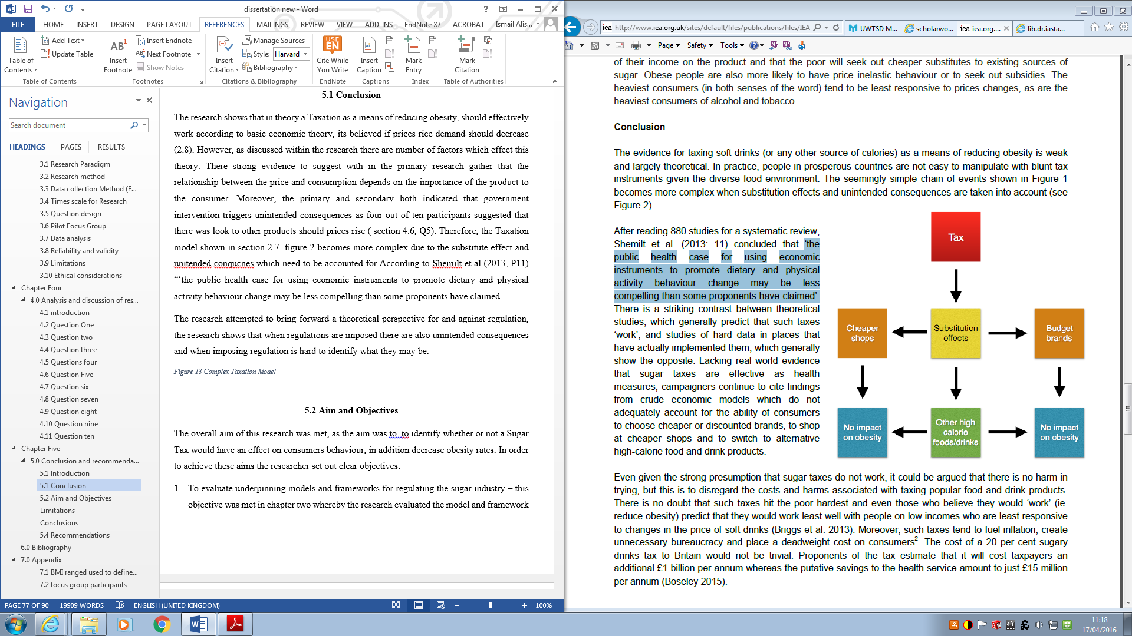
Source: Snowdon (2016)
The focus groups showed that the majority of participants believed that some forms regulations need to be put in place to better the health of the UK citizens. However, only three out of the ten participants believed that a 20% tax would have an effect on the UK’s obesity rate as sugar is not the only problem affecting obesity.
One issue throughout the research is informational failure. As consumers had little knowledge about the national health concern, participants also believed that there is not enough health information available. This suggests that instead of the government raising prices, what may have more of an effect is investing in more education campaigns and making healthy food and exercise cheaper. These forms of regulation would have a better effect on the obesity rate.
Even though the sugar manufacturers are fully aware of the effects their products have on consumption, they continue to advise consumers to self-regulate their consumption by advising moderate consumption. However, more recently due to the public scrutiny many organisations such as Coca-Cola. Pepsi and Kellogg’s have publicly declared they will be reducing sugar levels within their products (Lavin and Timpson, 2013). In addition, hospitals and other public places have also said to be incorporating the tax on all foods high in sugars in their cafes and vending machines.
The Power of the big food business, means that the Sugar Tax could potentially have little to no effect on consumption. As organisation may choose to hold the tax a pose to passing it on to consumers, which will result in the government failing to achieve their aims.

5.4 Achievement of Aims and Objectives
The overall aim of this research was achieved, as the aim was to identify whether or not a Sugar Tax would have an effect on consumers’ behaviour; this was done through a primary and secondary research. The objective was to gather information and establish that a tax would have no effect on the obesity rate, therefore would not achieve the governmental objectives.
In order to achieve these aims the researcher set out clear objectives:
- To evaluate underpinning models and frameworks for regulating the sugar industry – this objective was met in chapter two whereby the research evaluated the model and framework surrounding the regulation and whether the regulation was an effective way to regulate harmful products. The secondary literature identifies there is no clear case for the Sugar Tax and in theory, the tax will make little difference but will have very high costs and unintended consequences.
- To analyse whether the sugar industry is being social responsible, and what changes need to be made by the industry to improve ethical performance; chapter two brought forward a relevant framework for CSR, and the primary research allowed the research to gather the opinions of consumers. The literature identified that that organisation operate in there self-interest, they want to make as much money as possible and sale as much sugar or sliming tablets possible. On the surface the sugar industry may appear that they are not being responsible, however, they are not being as “evil” as sin products such as Tabaco or alcohol.
- To analyse the rationale of the Sugar Tax proposal, and if consumers believed that it is an effective solution. Chapter four brought forward a consumer perspective as to whether or not the Sugar Tax was an effective solution and consumers believe there are better more effective way in order to regulate behaviour. The jury is still out in terms out the Sugar Tax as the theory suggest that it can do more harm than good. Consumers believed there’s a clear need for regulation within the food industry, however, believe that the Sugar Tax is a partial solution at best and prefer other forms of regulation such as health education and self-regulation.
- To generate logical recommendations to regulate the sugar industry to improve the CSR, the literature throughout the research allowed for the recommendation within this chapter to be made.

5.5 Recommendations
This research has allowed for key recommendations to be made in order to better the health of the country’s citizens and to bring forward recommendations to produce better regulations throughout the UK.

5.6 Government regulations

5.6.1 Bettering the knowledge and education of consumers to make better choices
Shining a light on health education campaigns in order to better the education within Britain is essential. Health marketing is important as it is a motivator and enabler for consumers to change family eating habits. It can also help bring attention to the food industries’ actions. According to the European commission (2012), the implementation of the European 2020 strategy, required “smart, sustainable and inclusive growth”. This strategy emphasise the importance of consumer empowerment in efficiently of a “smart, sustainable and inclusive environment.” When further information is given to consumers this enables them to make better informed choices. However, today’s society gives consumers missed message, and consumer’s cognitive capacities is often limited. Many of the decision made by consumers are made subject to time which means cognitive efforts can be difficult. In the short-term, there is a limit to how much informational is absorb by consumers at different stages of the purchasing process and more information is not always better (Eurpean Commission, 2012). However, the government need to incorporate information specific information to consumers which meet the regulatory information requirements in order to empower consumers to make better choices.
Consumer education which aims to influence social attitudes is best aimed in school, at adolescence and young adults, this is where most behaviour attitudes are formed. The best ways to ensure that health education purpose is herd, is to include it in regular school curricula. According to Bayarsaikhan and Muiser (2007), even though health education campaigns are the cost-effective to reduce obesity, it the most effective results and in the long term can save the health system money (Bayarsaikhan & Muiser, 2007).

5.6.2 Regulation of the food supply
Many consumers within the UK have the knowledge to understand how to maintain a healthy balanced diet for themselves and their children. However, the average diet within the UK is poor. This is mainly because food choices tend to be habitual and automatic, consumers have to apply a little self-control over what and how much is eaten. Even though there is information available on food labels, few consumers actually read them unless they have health circumstances (Okezie, 2006). It is clear that if there were healthier choices available to consumers within a shop or restaurant more than foods that are high in sugar, consumers would be more be more likely to make better choices. In addition, evidence suggests that if regulations are applied in order to reduce the sugar content across products, consumers would be more likely to reduce their sugar intake.
Sugar reduction could be achieved through, three recommendations:
- Reformation and changing portion sizes
- Universal public health procurements, provision and sales of heathier foods
- Creating an organised and well monitored programme which gradually reduces the sugar content within food and drinks.

5.6.3 Better labelling system
The British Medical Journal suggests that food and drinks need to have exercise labels on them which will show consumers how long it will take to walk or run the calories off which they have consumed. The current traffic light system which is being incorporated is not incorporated throughout all food manufacturers (NHS Choice, 2016). However, consumers have not yet been given enough information in order to understand the traffic light system. The consumers need to be given the knowledge in order to change. Providing further health information on labels is crucial in bettering the health of Britain. However, this scheme may take many years to implement on a European level. Organisations, however, could use this as a form of self-regulation and, in the process, make consumers fully aware of what the effects are of consuming a particular product could be (Example figure 18).

Figure 18:- food and drinks and their activity equivalence
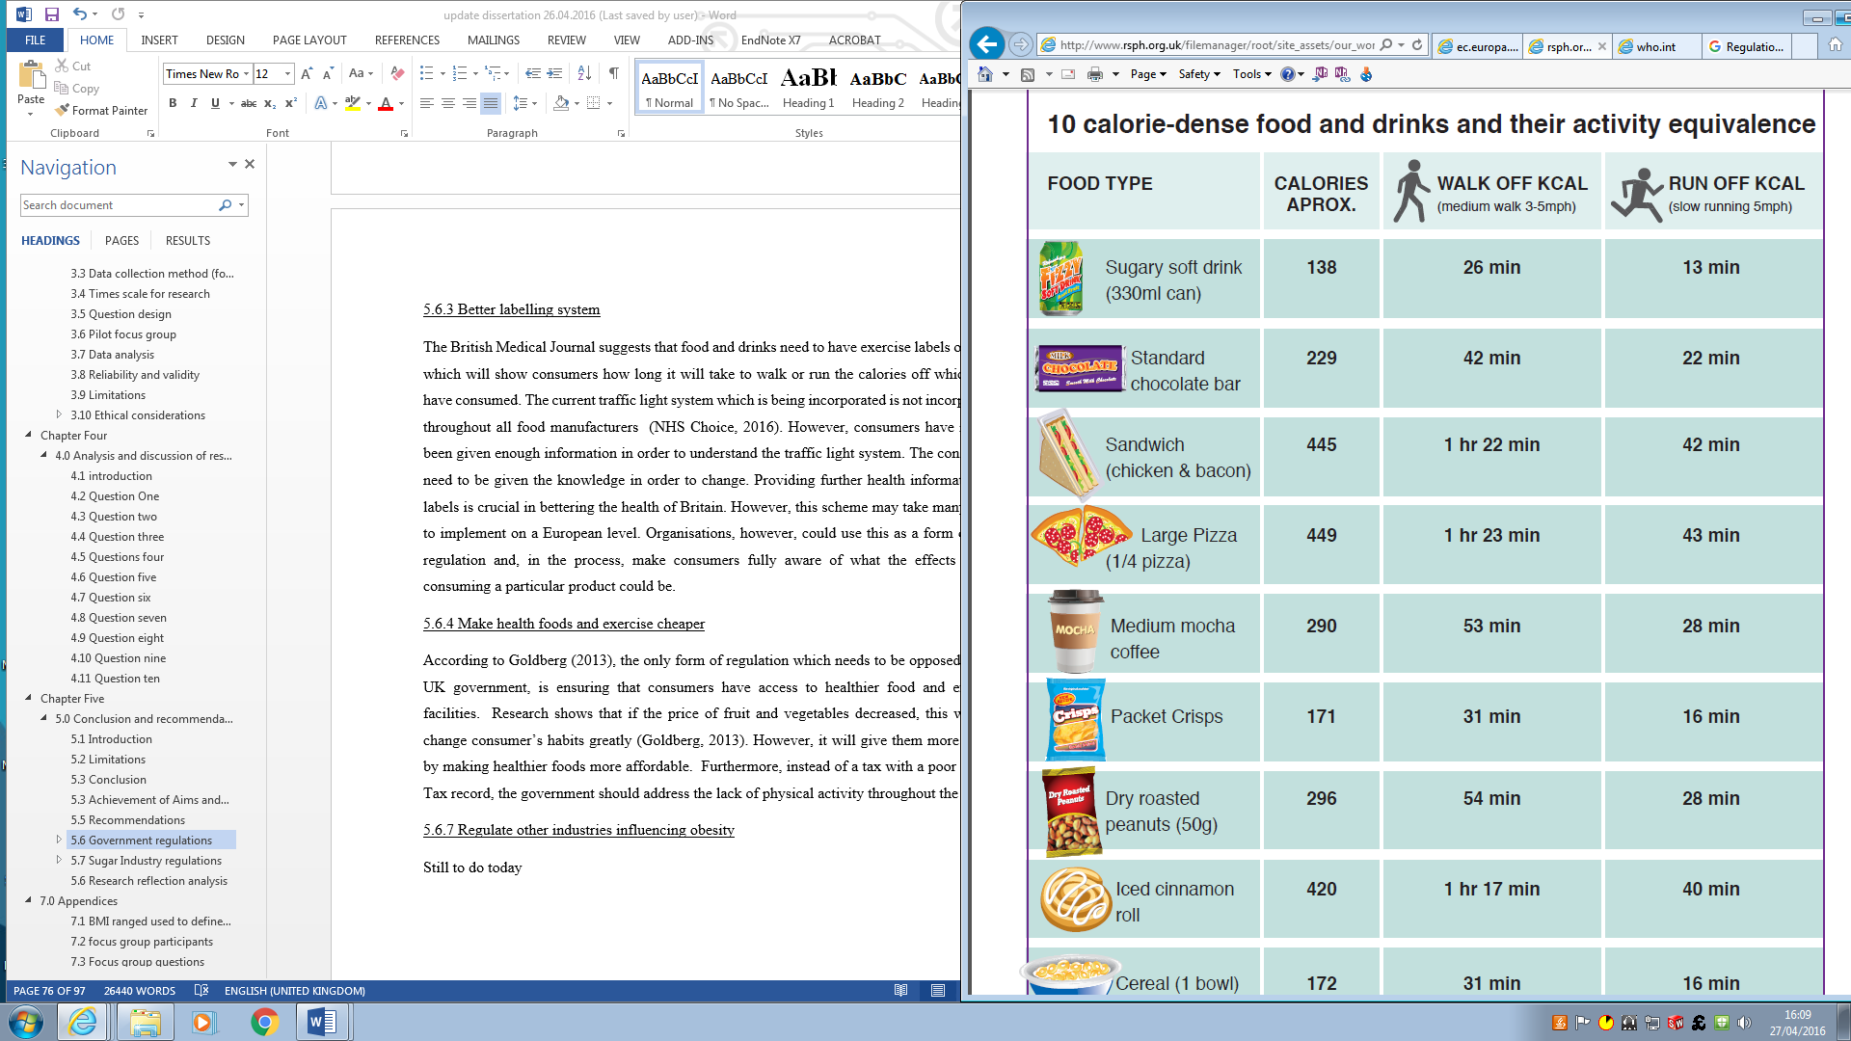

5.6.4 Make health foods and exercise cheaper
According to Goldberg (2013), the only form of regulation which needs to be opposed by the UK government, is ensuring that consumers have access to healthier food and exercise facilities. Research shows that if the price of fruit and vegetables decreased, this will not change consumer’s habits greatly (Goldberg, 2013). However, it will give them more option by making healthier foods more affordable. Furthermore, instead of a tax with a poor proven Tax record, the government should address the lack of physical activity throughout the UK. According to Modern Health Care (2013), in previously year South Africa’s largest health insurer have created an innovative program caked “HealthFood” for its members. Participants within the programme received a 25% rebate on healthy goods. Approximately 300,000 middle-income South African participated, the results showed lowering the cost of healthy foods in supermarkets increased the amount of fruits, vegetables and whole grains that people consumers but if also reduce consumption of processed food (Sturm & Yach, 2013).

5.7.5 Put Pressure on consumers to change their behaviour
The government need to implement the same regulation techniques enforced in the tobacco industry. The use of market pressures could potentially reduce consumption. Consumer research suggests, that many smokers feel strong social pressures not to smoke and this pressure increased through smocking restrictions. Therefore, pressure needs to be put on consumers in order to change behaviours (Freda, 2002)
The health belief model is one of the earliest models used to explain differential behaviours. The model originated in the 1950’s in order to explain the likelihood of action to health problems, is dependent on four stages of beliefs or perception. This needs to be taken in to account by the government and organisation before enforcing any regulation or self-regulating. This model predicts that health promotion actions depend on the degree to which individuals (Becker, 1979):
Susceptibility: Believe they are susceptible to the problem, government need to show consumer how they are effected by Sugar and demonstrate to consumers that they are also effected, this put pressure on them to change as it demonstrates that they are susceptible to the problem.

Severity: whether the problem has server consequences, the government should make consumers fully aware of the consequences of consuming sugar in excess. The sugar industry can establish the same model as the tobacco industry by putting photos on front of products which effect consumer’s health.
Benefits: can see benefits to changing their behaviour, the government can also put further pressure on consumers by re-enforcing the benefits of reducing sugar consumption through educating them about the benefits of eating healthier and exercising.
Barriers: consumer can see that benefits to actions outweigh the perceived cost, consumers need to be able to identify that the benefits outweighs the cost, therefore, if consumers can see that healthier food are cheaper and will make their health better, this will then increase the likely hood of consumers changing their behaviour.
Figure 19:- Health Belief Model
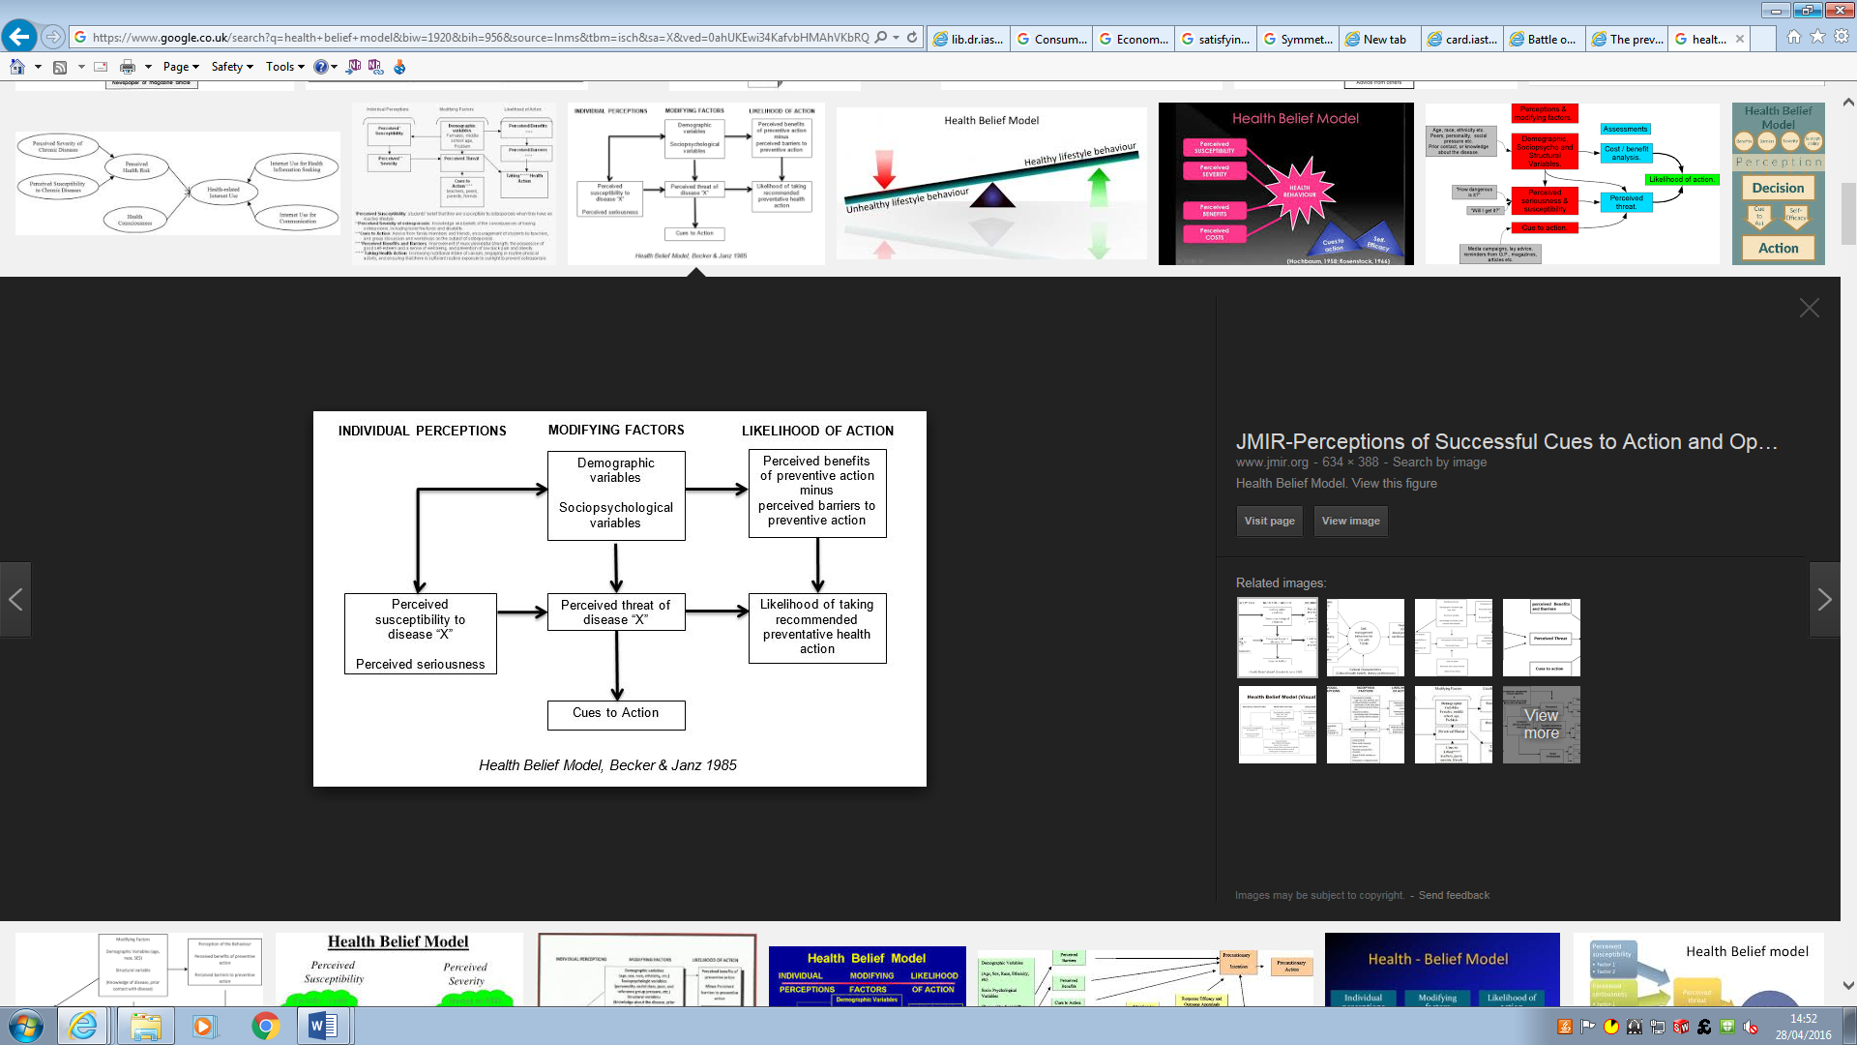
(Becker, 1979)

5.7 Sugar Industry regulations

5.7.1 Regulating influences
Further regulations need to be brought forward in order to minimise promoting and advertising products which affect consumer purchasing and consumption pattern. There are many effects which influence the consumers buying pattern such a price promotion and marketing (Tedstone and Targett, 2015). In 2014, the UK food industry invested £256 million in order to promote unhealthy foods (see Figure 19). Food high in sugar are promoted heavily within the UK in comparison with other foods. Promotion increases the amount of food people buy by about one-fifth. Moreover, around 6% of the total sugar purchases could be prevented if promotion on these products did not occur.
Figure 20: Summary of marketing and promotional activity to encourage sales of food and drinks high in sugar
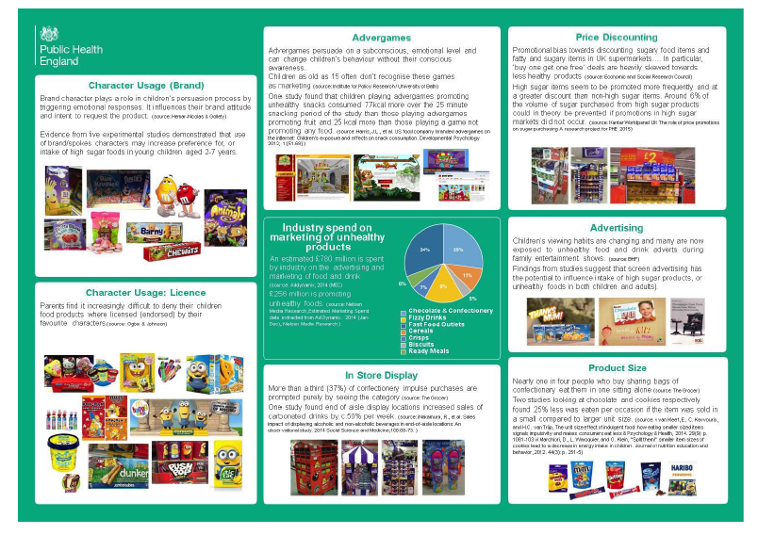
Source: Tedstone and Targett (2015)

5.7.2 Full transparency to consumers
Consumers are becoming more concerned about the food process and concerned about what information is hidden from them. According to Charlie Arnot (2016), manufacturing CEO, ‘Transparency is no longer optional. It is a basic consumer expectation.’ This is frustrating for consumers and should be the government’s main priority. Ensuring a company is behaving responsibly in terms of transparency of what goes into the processing of their food is an essential expectation; not a basic expectation. This should be regulated and ensured by the government and punishment needs to be established if organisations continue to lie to consumers. Consumers require clear, simple and transparent information, this information need to be provided to consumers openly and not hidden under different labels and names. This is the only way for consumers to make rational choices. The traditional economic approach suggests that the better information consumers have available to the better consumer empowerment.

5.6 Research recommendations
The research brought together relevant recommendation for the government and the sugar industry. However, in order to make the recommendation viable further research needs to be conducted. The primary research was based on the focus group, which indicates that more research needs to be conducted in order to bring forward a wider perspective. For example, along with the focus group, the research needed to have incorporated another form of research. One research area that could have been incorporated is a research poll to establish the number of people for and against the Taxation of sugar, this would make the research more viable as it will be based on a wide range of people.
Moreover, a questionnaire can be conducted in order to gather further opinions of consumers, whereby participants can give their opinion without feeling the pressure of other participants in the focus group. The questionnaire will also be able to reach a wider range of people, the focus group consisted of parents which means the research is limited, as it does not incorporate the opinions of students, young adults and working professionals who are also effected by the incorporation of a tax.
Another form of research method that can be utilised is interviews, the research can interview various people, from different age groups, different jobs and different social status to see if these factors affect their opinions on tax as a form of regulation.
These research method, can find out if incorporation of health education campaigns would actually change the behaviours of consumers and how much information is too much.
The time constraints on the research has limited the investigation, should the researcher have been given more time, more research methods in order to gather further opinions and perspective would have been utilised. A questionnaire would have been conducted and a research poll. A longer time constraint would have allowed for the research to be more viable and would give more viability of the recommendation made would be based on a larger group on opinions, across different research methods.

Bibliography
Allais, O., Bertail , P. & Nichelle, V., 2010. The effects of a fat tax on French households' purchases: a nutritional approach. American Journal of Agricultural Economics , 92(45), pp. 228-45.
Amaeshi, K., Nnodim, P. & Onyeka, O., 2013 . Corporate Social Responsibility, Entrepreneurship, and Innovation. 2 ed. New York : Routledge.
Anon., n.d. s.l.:s.n.
Arnold, D. G. & Harris, J. D., 2012. Kantian Business Ethics. Illistrated ed. Northampton: Edward Elgar Publishing,.
Arnot, C., 2016. Consumers want transparency, not just see-through packaging. [Online]
Available at: http://www.foodsafetynews.com/2016/03/124509/#.VxOKw03luUk
[Accessed 14 03 2016].
Bailey, S., 2014. Market Realist. [Online]
Available at: http://marketrealist.com/2014/11/role-branding-advertising-soft-drink-industry/
[Accessed 20 11 2014].
Baker, C. & Bate, A., 2016. Obesity Statistics, London: House of Commons Library.
Baldwin, R., Cave, M. & Lodge, M., 2012. Understanding Regulation: Theory, Strategy, and Practice. Second Edition ed. New York: OUP Oxford.
Bayarsaikhan, D. & Muiser, J., 2007. Financing health promotion. Department "Health System Financing, 30(4), pp. 5-22.
Becker, M. H., 1979. The Health belief model and personal health behavior. 1 ed. Michigan: C. B. Slack.
BBC, 2016. Sugar tax surprise in Budget - but growth forecasts cut. BBC News, 16 03, pp. -.
BBC, B., 2013. How much sugar is hiding in your food?. BBC Science, 22 03, p. 1.
Beck, N., Janathan, K. N. & Richard, T., 1998. Taking Time seriously: time-series-cross- section Analysis with Binary dependent variable. 1998, 42(4), pp. 1260-1288.
Beghin, J. C., 2001. The Cost of the U.S. Sugar Program Revisited, Lowa: CARD Working Papers.
Belgrave, L. L., Zoblotsky, D. & Guadagno, M. A., 2002. Writing Qualitative Research for Quantitative Readers. Qualitative Health Research, 12(1), p. 1427.
Belkaoui, A. R., 2004. Accounting Theory. 5th ed. Chicago: Cengage Learning EMEA.
Bennett, C., 2011. The Rats Who Preferred Sugar Over Cocaine, -: Huffporst Healthy Living.
Black, J., 2002. Critical reflections on regulations. London School of Economics and political science, 35(1), p. 29.
BNF, 2014. British Nutrition Foundation. [Online]
Available at: https://www.nutrition.org.uk/nutritioninthenews/headlines/sugartobacco.html
[Accessed 09 01 01].
Boekaerts, M., Pintrich, P. R. & Zeidner, M., 2005. Handbook of Self-regulation. illustrated ed. Mount Carmel: Elsevier.
Bonita, R. & Beaglehole, R., 2009. Global Public Health: A New Era. 2nd ed. Oxford: OUP Oxford, .
Boorsma, P., Aarts, K. & Steenge, A. E., 2012. Public Priority Setting: Rules and Costs. - ed. Norwell: Springer Science & Business Media.
Boseley, S., 2013. theguardian. [Online]
Available at: http://www.theguardian.com/society/2013/mar/20/sugar-deadly-obesity-epidemic
[Accessed 20 03 2013].
Bowie, W. R., 2008. Engineering Ethics: Outline of an Aspirational Approach. 1st ed. Swansea: Springer Science & Business Media.
Bowie, N. E., 2013. Business Ethics in the 21st Century. 2nd ed. Minnesota: Springer Science & Business Media.
Braithwaite, J., 2008. Regulatory Capitalism: How it Works, Ideas for Making it Work Better. 1 ed. Northampton: Edward Elgar Publishing.
Brancaccio, D., 2000. Squandering Aimlessly: My Adventures in the American Marketplace. Simon and Schuster, -(-), p. 288.
Bray, J., 2002. Consumer Behaviour Theory: Approaches and Models. Jornal Marketing, 17(1), pp. 26-33.
Brownsword, R. & Yeung, K., 2008. Regulating Technologies: Legal Futures, Regulatory Frames and Technological Fixes. 1 ed. Oxford: Bloomsbury Publishing.
Buchanan, J. M., 1986. The Constitution of Economic Policy,". American Economic Review, , 77(3), pp. 243-50.
Campbell, D., 2015. Cameron under pressure as public backs sugar tax. Obesity the Obeserver, 24 10, p. 1.
Carrol, A. B. & Shabana, K. M., 2010. The Business Case for Corporate Social. International Journal of Management Reviews, 1(3), pp. 86-105.
Carroll, A. B., 1991. The pyramid of corporate social responsibility: Toward the moral management of organizational stakeholders. Business Horizons, 34(4), pp. 39-48.
Carroll, A. B., 2010. The Business Case for Corporate Social Responsibility: A Review of Concepts, Research and Practice. International Journal of Management Reviews, 12(1), pp. 85-105.
Carroll, A. B., 2014. Business and Society: Ethics, Sustainability, and Stakeholder Management. 9th edition ed. Georgia: Cengage Learning,.
Carroll, A. B. & Buchholtz, A. K., 2014. Business and Society: Ethics, Sustainability, and Stakeholder Management. 9 ed. Calhoun: Cengage Learning, 2014.
Carter, J., 2011. Knowledge and attitudes towards healthy eating and physical activity:. NHS, 01 05, pp. -.
Cash, S., Sunding, D. & Zilberman, D., 2005. Fat taxes and thin subsidies: prices, diet, and health outcomes. 1 ed. California: Acta Agriculturae Scand Section C.
CEFS, 2010. CEFS Factsheets. [Online]
Available at: http://www.comitesucre.org/factsheets/e1de9c4e7849230dea4efac2eb3136db_1248083191.pdf
[Accessed 25 04 2016].
Chandler, D. & Werther, W., 2013. Strategic Corporate Social Responsibility: Stakeholders, Globalization, and Sustainable Value Creation. 1 ed. New York: SAGE Publications.
Chandra, R., 2013. Inspirational Quotes of Dalai Lama. 1 ed. India: BookRix GmbH & Company.
Cisternino, J., Moss, D. A. & Mclean, J., 2009. New Perspectives on Regulation. 1 ed. London: Tobin Project.
Clevenger, J. K., 2009. Experiences of Providing Nontraditional Community Mental Health Services in Urban Los Angeles. 1 ed. California: ProQuest,.
Coca-Cola Journey, 2015. The Coca-Cola Foundation. [Online]
Available at: http://www.coca-colacompany.com/our-company/the-coca-cola-foundation/
[Accessed 25 04 2016].
Collis, J. & Hussey, R., 2003. Business Research. 2 ed. New York: Palgrave Macmillan.
Collis, J. & Hussey, R., 2013. Business Research: A Practical Guide for Undergraduate and Postgraduate Students. Fourth ed. New York: Palgrave Macmillan.
Control, C. f. D., 2005. CDC.GOV. [Online]
Available at: http://www.cdc.gov/nchs/products/hestats.htm
[Accessed 01 02 2005].
Cooper, C. & Gander, K., 2016. Independent. [Online]
Available at: http://www.independent.co.uk/news/uk/politics/sugar-tax-seven-things-you-need-to-know-about-the-levy-a6935336.html
[Accessed 16 03 2016].
Crane, A. & Matten, D., 2008. CSR or regulation for food advertising?. [Online]
Available at: http://craneandmatten.blogspot.co.uk/2008/01/csr-or-regulation-for-food-advertising.html
[Accessed 22 01 2008].
Cullingworth, N., 2004. Edexcel Btec National Public Services (Uniformed). 2nd ed. Cheltenham: Nelson Thornes LTD.
Czinkota, M., 2006. International Marketing. Business & Economics , 06(8), p. 720.
Dana, L. P., 2004. Handbook of Research on International Entrepreneurship. 1 ed. Northhampton: Handbook of Research on International Entrepreneurship.
Dathen, M., 2016. Sugar tax could INCREASE our sugar intake and the sweetest drinks will attract LESS tax per gram, experts warn as they tear apart George Osborne's flagship Budget measure. [Online]
Available at: http://www.dailymail.co.uk/news/article-3497105/Sugar-tax-INCREASE-sugar-intake-sweetest-drinks-attract-tax-gram-experts-warn-tear-apart-George-Osborne-s-flagship-Budget-measure.html
[Accessed 17 03 2016].
Davidson, A., 1983. Food in Motion: The Migration of Foodstuffs and Cookery Techniques : Proceedings : Oxford Symposium 1983, Volume 1. 1 ed. London: Oxford Symposium.
Deaton, A. & Muellbauer, J., 1980. Economics and Consumer Behavior. 1 ed. Oxford: Cambridge University Press,.
Deketelaere, K., 2001. Incentive based Mechanism. Illustrated ed. London/ The Hague/ Boston: Kluwer Law International,.
Demortain, D., 2011. Scientists and the Regulation of Risk: Standardising Control. 1 ed. Marne-La-Vallee: Edward Elgar Publishing.
Denhardt, R. B., Denhardt, J. V. & Aristigueta, M. P., 2015. Managing Human Behavior in Public and Nonprofit Organizations. 4th ed. US: SAGE Publications.
Dolfsma, W., 2013. Government Failure: Society, Markets and Rules. 2nd ed. Northampton: Edward Elgar Publishing.
Drake, W. J., 2005. Reforming Internet Governance: Perspectives from the Working Group on Internet Governance (WGIG). - ed. -: United Nations Publications.
Dungan, E., 2014. Majority of British women are still responsible for cooking and food shopping, research finds. The independant, 14 06, pp. -.
Duska, R. F., 2007. Contemporary Reflections on Business Ethics. 4th ed. Netherlands: Springer Science & Business Media.
Dyer, A. R., 1988. Ethics and Psychiatry: Toward Professional Definition. 3rd ed. Chicago: American Psychiatric Pub.
Economist, 2012. The economist. [Online]
Available at: http://www.economist.com/news/special-report/21568064-food-companies-play-ambivalent-part-fight-against-flab-food-thought
[Accessed 25 04 2016].
Elgot, J., 2015. Jamie Oliver 'expects kicking' over sugar tax. The Guardian, 22 2015, pp. -.
Ellison, C., 2016. Sugar Debate Getting Sticky: Industry Responds to Sugar Measures. Public Health Leader: Oliver Wyman, 19 01, pp. -.
Eurpean Commission, 2012. COMMISSION STAFF WORKING DOCUMENT ON KNOWLEDGE-ENHANCING ASPECTS OF CONSUMER EMPOWERMENT. [Online]
Available at: http://ec.europa.eu/consumers/eu_consumer_policy/our-strategy/documents/swd_know-enhan_cons-empwrmnt_2012_en.pdf
[Accessed 27 04 2012].
Faculty of Public Health, 2015. Food Pover ty and Heal th. Faculty of Public Health Briefing Statement, 1 05, pp. 1-6.
Finn, M., 2000. Research Methods for Leisure and Tourism Data Collection, Analysis and Interpretation. 3 ed. Harlow: Pearson Education Limited.
Freda, M. C., 2002. Perinatal Patient Education: A Practical Guide with Education Handouts for Patients. 1 ed. Philadelphia: Lippincott Williams & Wilkins.
Freeman, E. R., 1984. Strategic Management: A Stakeholder Approach. Lastest Edition ed. Boston: MA: Pitman.
Freeman, E. R., 2010. Strategic Management: A Stakeholder Approach. 2nd ed. Cambridge: Cambridge University Press.
Friedman, M., 1962. Capitalism and freedom. 1 ed. Chicago: University of Chicago Press.
Friedman, M., 1970. The counter-revolution in monetary theory: first Wincott memorial lecture, delivered at the Senate House, University of London, 16 September, 1970. 1 ed. Rutgers: Published for the Wincott Foundation by the Institute of Economic Affairs.
Friedman, M., 2010. Price Theory: A Provisional Text. - ed. -: Martino Fine Books .
Friedrich, N., Clark, M. & Leiter, B., 1997. Nietzsche: Daybreak: Thoughts on the Prejudices of Morality. - ed. Cambridge : Cambridge University Press.
Garcia, C. I., 2002. The Department of Agricultural Economics and Agribusiness, Zamarano: Louisiana state University.
Gayer, T. & Horowitz, J. K., 2006. Market-based Approaches to Environmental Regulation. Illustrated ed. George Town: Now Publishers Inc.
Gerhard, A., 2009. Science 2.0. [Online]
Available at: http://www.science20.com/gerhard_adam/blog/economic_theory_%E2%80%93_supply_and_demand
[Accessed 10 07 2009].
Gibbs, A., 1997. Focus Groups. Department of Sociology, 2(19), pp. -.
Goldberg, C., 2013. Tax Soda? How About Making Fruits And Veggies Cheaper, Too?. [Online]
Available at: http://commonhealth.wbur.org/2013/01/fat-tax-thin-subsidy
[Accessed 28 01 2013].
Gorcum, U. V., 2001. Corporate Social Responsibility. 1st ed. Amerstedam: Buisness and economics .
Gregory, A., 2015. Half of children have tooth decay - with poverty and sugar blamed for epidemic. Mirror, 1(1), pp. -.
Gwartney, J. D., Stroup, R. L., Sobel, R. S. & Macpherson, D. A., 2014. Macroeconomics: Private and Public Choice. 15 ed. Florida: Cengage Learning.
Havard School of Public Health, 2014. Havard T.H CHAN, School of public Health. [Online]
Available at: http://www.hsph.harvard.edu/nutritionsource/carbohydrates/added-sugar-in-the-diet/
[Accessed 12 03 2014].
Head, B., 1991. Deregulation Or Better Regulation?: Issues for the Public Sector. 1 ed. Melbourne: Macmillan Education AU.
Heckelei, T., 2011. Corporate social responsibility in the food sector. European Review of Agricultural Economics, 12(38), p. 07.
Hennink, M. M., 2014. Understanding Focus Group Discussions. 3rd ed. New York: OUP USA.
Hesse-Biber, S. N. & Leavy , P., 2010. Handbook of Emergent Methods. 1 ed. New York: Guilford Press.
Hingley, M. & Lindgreen, A., 2001. British Food journal. Public Policy & Environmental Management , 115(1), pp. 108-123.
Holden-Locke, D., 2016. Stakeholder Reaction and media analysis. [Online]
Available at: http://cdn2.hubspot.net/hubfs/458431/2016-03-18_Budget-Reaction-Summary.pdf?t=1458296229209&utm_medium=email&_hsenc=p2ANqtz-9SkTKHX9Z9ADLw7RVEy-P5BDWS7E4CPQ4YNivM7J5UeLLFlNCLx7oy___RDOHQDyoWe8nReurMmJd3w_IFG36r1-vM8Q4bVlUCZH1-AsjFUQdlUtU&_hsmi=27439422&ut
[Accessed 30 03 30].
Holmann, L., 2015. Exploring Corporate Social Responsibility. [Online]
Available at: http://pure.au.dk/portal-asb-student/files/85276945/SPECIALEAFLEVERING.pdf
[Accessed 25 04 2016].
Hscic, 20145. Statistics on Obesity, Physical Activity and Diet. england, National statistics.
Hscic, 2015. Health and social care information centre. [Online]
Available at: http://www.hscic.gov.uk/catalogue/PUB16988/obes-phys-acti-diet-eng-2015.pdf
[Accessed 03 03 2015].
Hughes, D. & Dumont, K., 1993. Using focus groups to facilitate culturally anchored research. American Journal of Community Psychology, 21(6), pp. 775-806.
Hunt, A., 1999. Governing Morals: A Social History of Moral Regulation. 1 ed. Cambridge: Cambridge University Press.
Ian, J., 2012. The 'nutrition gap' between Britain's rich and poor is vast – and wicked. [Online]
Available at: http://www.theguardian.com/commentisfree/2012/nov/23/rich-poor-food-nutrition-gap-ian-jack
[Accessed 23 11 2012].
IEA, I. o. E. A., 2012. Sugar taxes: A Briefing, -: IEA.
ITV news, 2015. Cameron rejects calls for 'sugar tax' after major report. ITV, 22 10, p. 1.
Janet, S., 2000. Using and analysing focus groups: limitations and possibilities. Social Research Methodology, 03(02), pp. 103-119.
John, C., Moss, D. A. & Mclean, J., 2009. New Perspectives on Regulation. 1 ed. London: Tobin Project .
Joppe, M., 20002. The research process. School of Hospitality, Food and Tourism Management, 7(1), pp. 395-450.
Joseph, S., 2015. Sugar industry responds. theDrum, 15 11, pp. -.
Kawaschi, A. & Kim, A., 200. Metabolic Basis of Obesity. - ed. -: Springer Science & Business Media.
Kehler, M., 2010. Boys' Bodies: Speaking the Unspoken. 46 ed. New York: Peter Lang, 2010.
Kitzinger, J., 1995. Qualitative research. Introducing focus groups. British medical journal , 311(1), p. 299.
Klenke, K., 2015. Qualitative Research in the Study of Leadership. 2nd ed. Bingley: Emerald Group Publishing.
Krantz, S. F., 2002. Refuting Peter Singer's Ethical Theory. 1 ed. oxford: Greenwood Publishing Group.
Krueger, R. A., 2014. Focus Groups: A Practical Guide for Applied Research. 1 ed. Singapor: SAGE Publications.
Krueger, R. A. & Casey, M. A., 2014. Focus Groups: A Practical Guide for Applied Research. Unknown ed. Singapore: SAGE Publications.
Kuchles, F., Tegene, A. & Harris, K., 2004. Taxing snack foods: What to expect for diet and tax revenues.. 6 ed. Washington, D.C: Economic Research Serivce.
LaFrance, T. J., 1998. The LINQUAD incomplete Demand Model. Department of Agricultural and Resource Economics, 37(2), pp. 147-66.
Lancaster, K., 1991. Modern consumer theory. 1 ed. -: Edward Elgar Publishing, Incorporated.
Langford, J. & McDough, D., 2003. Focus grops: supporing effective product development. 1st ed. London and New York: CRC Press.
Langford, J. & Mcdough, D., 2003. Focus Groups: Supporting Effective Product Development. 1 ed. London and New York: CRC Press.
Lavin, R. & Timpson, H., 2013. Exploring the Acceptability of a Tax on Sugar-Sweetened Beverages, Liverpool: Applied Health and Wellbeing Partnership.
Layer, F., 2015. Food and Drink Federation appoints Tim Rycroft as corporate affairs director. [Online]
Available at: http://www.prweek.com/article/1358162/food-drink-federation-appoints-tim-rycroft-corporate-affairs-director
[Accessed 28 02 2016].
Litosseliti, L., 2012. Using Focus Groups in Research. 2 ed. London: A&C Black, .
Lustig, R. H., 2013. Fat Chance: Beating the Odds Against Sugar, Processed Food, Obesity, and Disease. 1 ed. New York: Penguin Group USA,.
Malachowski, A. R., 2001. Business Ethics: Critical Perspectives on Business and Management. 3 ed. London & New York: Taylor & Francis.
Malhotra, A., Noakes, T. & Phinney, T., 2015. It is time to bust the myth of physical inactivity and obesity: you cannot outrun a bad diet. British Journal of Sports Medicine, 10(1).
Mangan, H., 2013. CNN Forbes. [Online]
Available at: http://www.moneycrashers.com/fair-tax-act-explained-pros-cons/
[Accessed 15 05 2013].
Marco , T. & Schweitzer, S. O., 2013. Industrial Policy in America. 2nd ed. Cheltenham UK, Northampton, MA, USA: Edward Elgar Publishing.
Marco, T. & Schweitzer, S. O., 2013. Industrial Policy in America. 2nd ed. Nothampton: Edward Elgar Publishing.
Maresova, P., 2009. Research of the Behavior of Consumers. Fakulta informatiky a managementu, 14(1), pp. 35-45.
Marlow, M. L., 2011. The Myth of Fair and Efficient Government: Why The Government You Want Is Not The One You Get. 1 ed. California : ABC-CLIO, .
Miao, Z., 2012. Three essays on tax policies addressing the obesity epidemic and associated calorie intake, Iowa: Digital Repository @ Iowa State University.
Michael, B., 20014. Focus Groups in Social Research. 1 ed. -: SAGE.
Milakovich, M. E. & Gordon, G. j., 2013. Public Administration in America. Education , 11(11), p. 672.
Milton Friedman. 2010. [Film] Directed by Milton Friedman. America: Common Sense Capitalism.
Minniti, M., Zazharakis, A. & Spinelli, S., 2006. Entrepreneurship: The Engine of Growth. illustrated ed. London: Greenwood Publishing Group.
Moss, D. & Cisternino, J., 2009. New Perspectives on Regulation. 1st ed. Cambridge: The Tobin Project.
Mullen, Wohlgent & Farris, 1988. SOME OLD TRUTHS REVISITED. 1 ed. Canberra: Agricultural Economics Society.
Neumann, J. V. & Margenstern, O., 1944. Theory of Games and Economic Behavior. 1st ed. Princeton: Princeton University Press.
News Desk, 2016. Consumers want transparency, not just see-through packaging. [Online]
Available at: http://www.foodsafetynews.com/2016/03/124509/#.VxOKw03luUk
[Accessed 14 03 2016].
Newton, J., 2015. The burden of disease and what it means in England. [Online]
Available at: https://publichealthmatters.blog.gov.uk/2015/09/15/the-burden-of-disease-and-what-it-means-in-england/
[Accessed 28 04 2016].
NHS Choice, 2016. 'Exercise labels' should be added to food packets, expert argues. [Online]
Available at: http://www.nhs.uk/news/2016/04April/Pages/Exercise-labels-should-be-added-to-food-packets-expert-argues.aspx
[Accessed 07 04 2016].
NHS UK, 2015. NHS choices your health, your choices. [Online]
Available at: http://www.nhs.uk/news/2014/01January/Pages/sugar-obesity-qa.aspx
[Accessed 15 01 2015].
NHS, N., 2014. NHS. [Online]
Available at: http://www.nhs.uk/conditions/obesity/Pages/Introduction.aspx
[Accessed 03 06 2014].
Norton, S., 2016. Sugar 'is the new crack cocaine': Doctor warns growing addiction to the sweet stuff is 'as dangerous as drugs and alcohol', -: Daily Mail.
Oakley, J. & Cocking, D., 2001. Virtue Ethics and Professional Roles. 1 ed. Cambridge : Cambridge University Press.
OECD, 2014. Consumption Tax Trends 2014 VAT/GST and excise rates, trends and policy issues: VAT/GST and excise rates, trends and policy issues. - ed. -: OECD Publishing.
Ogus, A., 2004. Regulation. Legal Form and Economic Theory, 2(-), p. 380.
Okezie, A., 2006. The impact of food regulation on the food supply chain. Toxicology, 221(1), pp. 119-127.
Ortega, J. G., 2007. The Cuban Sugar Complex in the Age of Revolution, 1789--1844. 1 ed. Los Angeles: ProQuest, .
Orts, E. W. & Deketelaere, K., 2001. Environmental Contracts:Comparative Approaches to Regulatory Innovation in the United States and Europe. 4th ed. London: Kluwer Law International.
Parlinska, A. & Grazyna, R., 2014. COMPARISON OF APPROACHES TO REDUCE AND PREVENT FROM CHILDREN OBESITY WITHIN THE CONTEXT OF UK AND POLAND. .. Buisness Source Complete, - -, pp. P135-146.
Pautz, M. C. & Rinfret, S. R., 2013. The Lilliputians of Environmental Regulation. The Perspective of State Regulators, 12(03), p. 147.
Pavlish, C. P. & Pharris, M. D., 2011. Community-Based Collaborative Action Research. 3 ed. Ontoria: Jones & Bartlett Publishers.
Peck, S., 2013. Tax junk food and subsidise vegetables to fight ‘poor obesity crisis’. The Telegraph, -(-), pp. -.
Pettinger, T., 2015. Economics Help. [Online]
Available at: http://www.economicshelp.org/blog/14884/economics/sugar-tax-debate/
[Accessed 23 10 2015].
Pharmacy, O. O., 2016. Will the new sugar tax affect your lifestyle?. [Online]
Available at: https://www.oxfordonlinepharmacy.co.uk/blog/will-the-new-sugar-tax-affect-your-lifestyle?utm_source=infusionsoft&utm_medium=email&utm_campaign=w1604-sugar-end5
[Accessed 26 04 2016].
Pickles, K., 2016. World Health Organisation backs 'sugar tax' campaign to curb childhood obesity - and says schools should ban unhealthy food. Daily Mail, 26 01, p. 1.
Power, F. C., Higgins, A. & Kohlberg,L, 1989. Lawrence Kohlberg's Approach to Moral Education, Columbia: University press .
Quadruples, O., 2014. Obesity Quadruples, -: -.
Rahim, M. M., 2013. Legal Regulation of Corporate Social Responsibility: A Meta-Regulation Approach of Law for Raising CSR in a Weak Economy. - ed. Queensland: Springer Science & Business Media.
Rasmussen, K. L., 2005. Deontology, Responsibility, and Equality. 1st ed. Chicago : Museum Tusculanum Press,.
Reichardt & Cook, 1983. Deshpande. 1 ed. -: Deshpande.
Roderick, L., 2015. Food and drinks industry rejects calls for tighter sugar marketing. Marketing Weekly, 22 10, pp. -.
Ruddick, G., 2015. Budget 2015: Big business to fund corporation tax cut. [Online]
Available at: http://www.telegraph.co.uk/finance/budget/11727728/Budget-2015-Big-business-to-fund-corporation-tax-cut.html
[Accessed 08 06 2015].
Sammeck, J., 2011. A New Institutional Economics Perspective on Industry Self-Regulation. 1st ed. -: Springer Science & Business Media.
Saukko, P., 2008. The Anorexic Self: A Personal, Political Analysis of a Diagnostic Discourse. - ed. New York: SUNY Press.
Schroeter, C., Lusk, J. & Tynew, W., 2008. Determining the impact of food price and income changes on body weight. Journal of health economics , 27(1), pp. 45-68.
Schultz, W. J., 2008. The Moral Conditions of Economic Efficiency. 3rd ed. New York: Cambridge University Press.
Schwartz, B., 2009. The Paradox of Choice. `1 ed. New York: Harper Collins.
Science and health, 2015. Sugar tax: MPs back levy, but would it solve obesity crisis?, -: The Week.
Seb, J., 2016. Brands look to healthy marketing as prospect of sugar tax looms. The Drum, 29 01, p. 1.
Selznick, P., 1992. Focusing Organisational Research on Regulation. Regulatory Policy and the Social Sciences, 5(1), pp. 363-364.
Selznick, P., 1992. Leadership in Administration: A Sociological Interpretation. - ed. Califormia: University of California Press.
Sharps, L., 1996. Understanding Quantitative and Qualitative Research in Early Childhood Education. 1 ed. -: Teachers College Press.
Shemilt, I., Hollands, G. J. & Marteau, T. M., 2013. Economic Instruments for Population Diet and Physical Activity Behaviour Change: A Systematic Scoping Review. Research Article, 1(1), pp. 5-35.
Silvester, A., 2014. TPA to campaign against sugar Tax plans, New York: Corporate press.
Smed, S., Jensen, D. & Denver, S., 2007. Socio-economic characteristics and the effect of taxation as a health policy instrument. Food Policy, 32(5-6), pp. 624-639.
Snowdon, C., 2016. Economics at the Institute of Economic Affairs. [Online]
Available at: http://www.iea.org.uk/sites/default/files/publications/files/IEA%20Sugar%20Taxes%20Briefing%20Jan%202016.pdf
[Accessed 11 01 2016].
Sobal, J. & Maurer, D., 1999. Weighty Issues: Fatness and Thinness As Social Problems. 1 ed. New York: Transaction Publishers .
Sprenkle, D. H. & Piercy, F., 2005. Research Methods in Family Therapy. 2nd ed. New York/ London: Guilford Press,.
Steward, D. W. & Shamdasani, P. N., 2014. Focus Groups: Theory and Practice. 3rd ed. London: SAGE Publications,.
Sturm, R. & Yach, D., 2013. Modern Healthcare. [Online]
Available at: http://www.modernhealthcare.com/article/20130525/MAGAZINE/305259951
[Accessed 2016 04 28].
Tedstone, A. & Targett, V., 2015. Public health England. [Online]
Available at: https://www.gov.uk/government/uploads/system/uploads/attachment_data/file/470179/Sugar_reduction_The_evidence_for_action.pdf
[Accessed - 10 2015].
TheGov, 2016. HM Treasury. [Online]
Available at: https://www.gov.uk/government/publications/budget-2016-documents/budget-2016
[Accessed 03 03 2016].
Tollison, R. & Wagner, R. E., 2012. The Economics of Smoking. 2nd ed. New York: Springer Science & Business Media.
Triggle, N., 2015. Be bold on sugar tax, Jamie Oliver says, -: BBC News.
Wagenaar, H., 2012. Government Institutions: Effects, Changes and Normative Foundations. 2nd ed. -: Springer Science & Business Media.
Wijdeveld, E., 2011. The different economic consequences of introducing a fat tax.”. Could Economic Policy Help To Reduce Healthcare Costs?, 1(1), pp. 3-34.
Wilfred, S. M., 1985. Sweetness and power: the place of sugar in modern history. 1 ed. London: Viking.
Wilkinson, S., 1998. Focus groups in feminist research: Power, interaction, and the co-construction of meaning. Women's studies international forum , 21(1), pp. 111-125.
Wimmer, M. A., 2010. Electronic Government: 9th International Conference, EGOV 2010, Lausanne, Switzerland, August 29 - September 2, 2010, Proceedings. 1 ed. Lausanne: Springer Science & Business Media.
Woermann, M., 2012. On the (Im)Possibility of Business Ethics: Critical Complexity, Deconstruction, and Implications for Understanding the Ethics of Business. 2 ed. New York: Springer Science & Business Media.
Yudkin, J., 1972. Pure, White And Deadly. 1 ed. San Francisco: Penguin UK.

7.0 Appendices

7.1 BMI ranged used to define BMI status
Appendix, BMI ranges

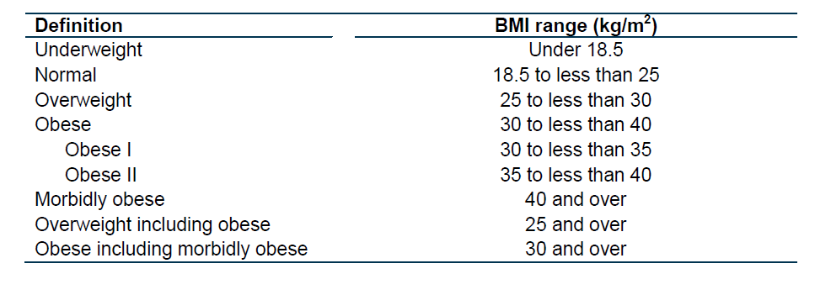 Source: HSCIC (2015)

7.2 focus group participants
This will allow participants to be able to stay anonymous and allow for the data to still be analysed effectively. Participants were fully aware of what letter they would be and the researcher gathered the data accordingly.
Participants | Description
#A | Mother, British, age 18-25
#B | Mother, British, age 18-25
#C | Mother, Middle Eastern, age 35-50
#D | Father, British, age 35-50
#E | Father, British, age 25-35
#F | Mother, Caribbean, age 25-35
#G | Father, Middle Eastern, 50 +
#H | Mother, British, age 18-25
#I | Father, Asian, age 18-25
#J | Mother. Asian, Age 18-25

7.3 Focus group questions
Research conducted by: Alison Ismail, University of Wales Trinity Saint David
E-mail: aismail.132184@student.uwtsd.ac.uk
This research project is taking place as part of a dissertation for a Master’s in Management and Leadership degree. The aim of the project is to investigate the validity and viability of the Sugar Tax.
The data collected from the focus group will be analysed and informed by the academic literature in order to establish whether a Sugar Tax will have an effect on consumers and national health.
The questions are based on the ongoing Sugar Tax debate, and how consumers feel about governmental regulations. The questions will also attempt to gather information about how concerned consumers are about the current health issues and the effects sugar has on the nation’s health. The questions will attempt to get an understanding of what forms of regulation consumers will react to most in terms of change.
Note that by participating in the focus group, you are giving your consent for the information collected to be used within this study only. Your information will not be shared with any third parties. Any information shared will remain anonymous.
The credibility of the researcher as a student can be verified by the dissertation supervisor:
Steve Griffiths
Assistant Dean, Faculty of Business and Management,
Swansea Business School,
University of Wales Trinity Saint David, High St, Swansea, SA1 1NE,
E-mail: steve.griffiths@uwtsd.ac.uk, Tel: +44 (0) 1792 481118.

Focus Group Prompt Questions
Question one:
How concerned are you by recent studies which show that obesity and tooth decay are on the rise due to food which is high in sugar?
Question two:
How do you feel about governmental intervention to change excess sugar consumption?
Examples for illustration:
- For example: government intervening through taxation and/or banning
- Compare with taxation on cigarettes and alcohol to reduce conception. Is this a fair comparison?
Questions three:
In recent months it has been recommended by Jamie Oliver that a 20% tax should be added to products high in sugar. Such a tax will raise the prices of many foods we buy often. What are your thoughts on the introduction of such a tax?
Question four:
Do you think a 20% tax on sugar will change your eating habits? Please explain for sugar- related products
See Example of changes that will come into effect in 2018: (BNF, 2014)
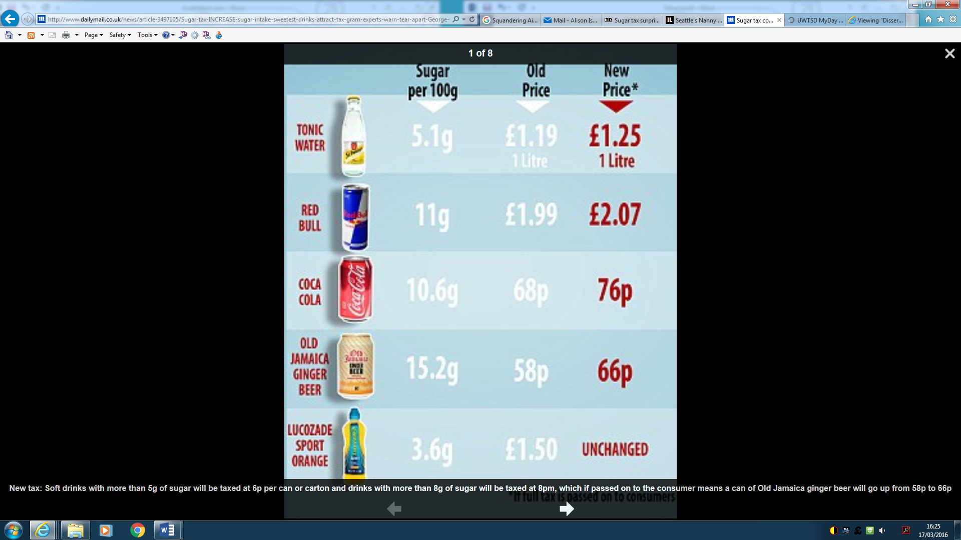

Question five:
How much will the price of products have to rise in order for the taxation to have an effect on your behaviour?
Example: Family bar of chocolate currently cost £1.50, at what stage does it become not affordable?
- £2.00
- £3.00
- £4.00
- Other price
- Or is it something you will also buy no matter the price
- Or will you just find a more affordable product that is in your price range
Please explain.
Question six:
What forms of regulation would change your eating habits and why?
Examples:
- Better health education campaigns
- Clearer labels showing calories or additives
- Organisation self-regulation, e.g. reducing their portion size or putting less sugars in products
- Rationing: you can only buy a certain amount
- Restricting outlets: only certain stores can sell products high in sugar
- Or you do not believe sugar is harmful enough to be regulated.
Question seven:
Are you aware of how much sugar you are eating? For example, a can of beans has 16 grams of added sugar, but is ‘one of your five a day’.
How do you feel about manufacturers hiding sugars under different names, when you assume that you are having a healthy product?

Question eight:
We have a lot of health information. Do you take it in? Explain how you access such information and what would give you the information you need.
Probing question:
Why is it easier to consume food which is high in sugar as opposed to healthier products?
Question nine:
Do you think food businesses should be more responsible selling products that have negative effects?
Question ten:
How much freedom of choice should we have in buying what we like? What products would you like controls on? What products would you resent being controlled?
From what you have heard, will the proposed soft drinks tax in the March 2016 Budget have any effect on improving healthy eating and lifestyles?

Thank you for your participation
Alison Ismail

