Data Security and Compliance (ACCA5034)

SECURING THE MODERN ENTERPRISE
Implementing Zero Trust and Building a Resilient Security Function for Aegis FinTech Innovations Ltd

Student name: Simon Hounslow
Student ID: 2427638

Research and case scenario

Abstract
Modern enterprises no longer operate behind one stable network boundary. Cloud services, hybrid work, software supply chains and artificial intelligence have spread access across users, devices and workloads. This report evaluates Zero Trust Architecture as a response to that change and applies the findings to Aegis FinTech Innovations Ltd. The evidence includes recent peer-reviewed studies, public standards, government guidance, industry reports and two primary incident disclosures. Zero Trust can reduce implicit trust, restrict lateral movement and improve visibility, but it is not a single product and cannot compensate for weak governance, incomplete asset knowledge or impractical policies. A workable approach requires phased delivery, strong identity governance, managed devices, per-application access, segmentation, resilient identity services and continuous monitoring. These findings inform a twelve-month proposal for Aegis covering its security team, priority policies, GDPR and DORA compliance, NIST CSF 2.0, a high-level technical design, major risks and ransomware recovery. The report concludes that Zero Trust should be treated as a continuing risk-management programme rather than a one-off technology replacement.

Contents
Abstract 2
Acronyms 4
Introduction 4
TASK 1 – RESEARCH IN DATA SECURITY AND COMPLIANCE 5
I. Research Aim and Method 5
II. Why Perimeter-Based Trust Is Inadequate 5
III. Core Principles and Architecture 5
IV. Technological Enablers 5
V. Comparison with Adjacent Security Approaches 6
VI. Benefits and Critical Limitations 6
VII. Research Synthesis and Findings 6
TASK 2 – CISO PROPOSAL AND IMPLEMENTATION PLAN 8
1. Work-Stream 1: Organisational Design and Resourcing 8
2. Work-Stream 2: Policy Framework Development 8
3. Work-Stream 3: Regulatory Compliance Strategy 9
4. Work-Stream 4: Technical Standards and Architecture 10
5. Work-Stream 5: Strategic Risk Assessment 10
6. Work-Stream 6: Incident Response and Business Continuity 11
7. Work-Stream 7: Governance and Strategic Roadmap 12
Overall Conclusion 12
References 13
Appendix A – RACI for Key Security Activities 15

Acronyms
Acronym | Meaning
AI | Artificial Intelligence
CISO | Chief Information Security Officer
CNAPP | Cloud-Native Application Protection Platform
CSPM | Cloud Security Posture Management
DLP | Data Loss Prevention
DORA | Digital Operational Resilience Act
DPIA | Data Protection Impact Assessment
DPO | Data Protection Officer
EDR | Endpoint Detection and Response
GDPR | General Data Protection Regulation
IAM | Identity and Access Management
IGA | Identity Governance and Administration
KMS | Key Management Service
MDR | Managed Detection and Response
MFA | Multi-Factor Authentication
PAM/PIM | Privileged Access/Identity Management
RPO | Recovery Point Objective
RTO | Recovery Time Objective
SASE | Secure Access Service Edge
SIEM | Security Information and Event Management
SOAR | Security Orchestration, Automation and Response
XDR | Extended Detection and Response
ZTA | Zero Trust Architecture
ZTNA | Zero Trust Network Access

Introduction
Cybersecurity is now a business-resilience issue as much as a technical one. A serious disruption can affect revenue, regulatory duties, customer confidence and the delivery of essential services. Aegis FinTech Innovations Ltd faces several connected risks because it plans to expand into the EU, relies on a cloud-based AI analytics platform and depends on external technology providers. Compliance provides an important baseline, but passing an audit would not by itself show that the business could withstand and recover from an attack.
This report uses Zero Trust Architecture (ZTA) as the research foundation because it is directly relevant to Aegis's hybrid access, cloud services and ransomware concerns. Task 1 evaluates its principles, enabling technologies, evidence, benefits and limitations. Task 2 converts the findings into a board-level proposal covering the seven required work-streams. The plan is intended for a growing fintech rather than a large bank. Specialist 24-hour monitoring is initially provided through a managed service, while ownership, risk acceptance and accountability remain within Aegis.

TASK 1 – RESEARCH IN DATA SECURITY AND COMPLIANCE
Implementing a Zero Trust Architecture: Principles, Challenges and Technological Enablers

I. Research Aim and Method
The review asked whether ZTA is an effective and realistic security model for a cloud-first fintech and what conditions are needed before it can work. A structured narrative review was used because the task requires critical synthesis and case application rather than statistical comparison. Searches used Google Scholar, DOI and publisher lookup, and official repositories including NIST, NCSC, CISA, ENISA, EUR-Lex, the SEC and ISO. Example strings included "Zero Trust Architecture" AND implementation AND cloud, "Zero Trust" AND workload identity, and "Zero Trust" AND organisational barriers OR resilience. The evidence set comprised nine peer-reviewed studies, eight standards or guidance sources, three regulations, two threat reports and two primary incident disclosures.
Sources were included where they defined architecture, evaluated implementation, evidenced threats or established duties relevant to Aegis. Unsourced vendor marketing, duplicate summaries and material without clear provenance were excluded. Appraisal considered authority, method, recency, relevance and commercial bias. No PRISMA record or quantitative quality score was maintained, so this is not a systematic review and may omit relevant studies. Reviews provide breadth but inherit variation between included studies; expert and platform-specific evidence assists prioritisation but cannot demonstrate universal effectiveness. Task 2 therefore uses pilots, local baselines and decision gates.

II. Why Perimeter-Based Trust Is Inadequate
Traditional security placed strong controls at the network edge and treated activity inside that boundary as relatively trusted. That assumption is weak where employees connect remotely, applications span several cloud and software-as-a-service platforms, and service accounts communicate without human involvement. NIST defines Zero Trust as a shift from static, network-based perimeters towards protecting users, assets and resources, with no implicit trust granted because of physical or network location [1]. The NCSC principles, reviewed in January 2026, reinforce this position by requiring knowledge of assets, identities and service flows before policy can be enforced [2].
Recent threat evidence supports this change. The 2025 Verizon DBIR reported increased vulnerability exploitation and greater third-party involvement, while ENISA described a broad and converging threat environment [13], [14]. These are industry and agency reports rather than controlled studies, so they should not be treated as proof on their own. Their scale and operational focus are still useful when read alongside academic research. The main point is straightforward: an authenticated session, an internal address or a supplier connection cannot be treated as permanently trustworthy.
Real incidents show how quickly misplaced trust can become a business problem. MGM Resorts estimated that its September 2023 cyber incident caused an approximately $100 million negative impact on Adjusted Property EBITDAR, alongside operational disruption and separate response costs [15]. UnitedHealth Group reported widespread disruption and substantial response and restoration costs following the Change Healthcare attack [16]. Neither case proves that a complete ZTA would have prevented the initial compromise. They do show how identity abuse, connected services and weak containment can allow one event to affect a much larger business area. The practical test is therefore not whether Zero Trust makes attacks impossible, but whether it reduces reachable assets, identifies abnormal use and limits damage.

III. Core Principles and Architecture
ZTA is best understood as a decision model. Every request to use a protected resource is evaluated using identity, device health, workload identity, location, behaviour, data sensitivity and current threat intelligence. The policy engine decides whether access should be allowed; the policy administrator creates or ends the session; and a policy enforcement point applies the decision [1]. Access is least-privileged, scoped to a specific resource and re-evaluated when context changes. Figure 1 illustrates this continuous feedback loop.
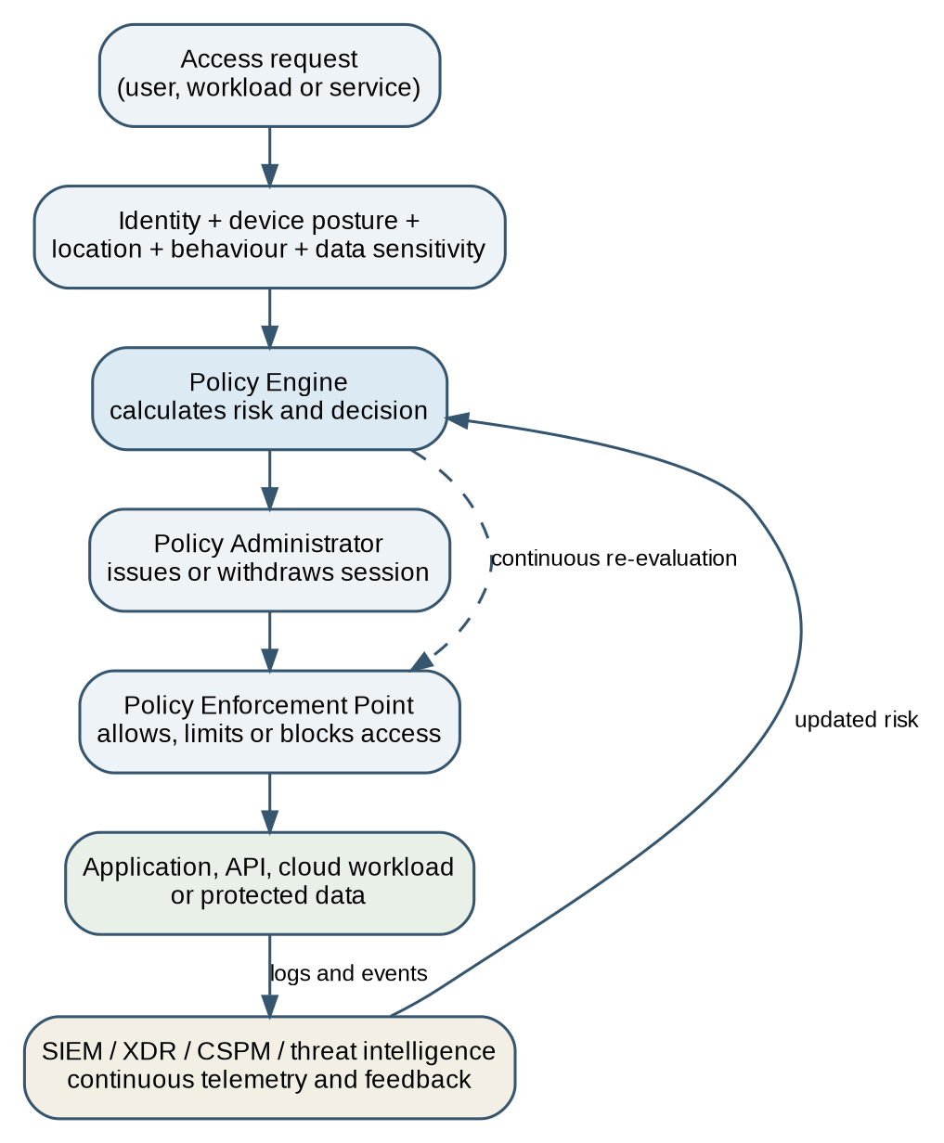
Fig. 1. Zero Trust continuous policy decision and feedback loop (author design based on NIST SP 800-207 [1]).
Three principles are central. First, verify explicitly: authentication should be supported by device posture and other contextual risk. Second, use least privilege: users and services receive only the access needed for a defined task and period. Third, assume breach: the design should stop a compromised account or endpoint from moving freely between systems. NIST, NCSC and CISA express these ideas in slightly different ways, but all reject permanent trust based only on location or an earlier login [1]-[3].
The model also has to protect non-human identities. Modern applications use APIs, containers, automation accounts and cloud roles at high volume. Research on cloud Zero Trust shows that identity and policy controls must extend to service-to-service communication, not just employees [4], [8]. This is relevant because Aegis's AI platform is likely to involve substantial automated and service-to-service activity. Workload identity, short-lived credentials, secrets management and mutual authentication are therefore core design requirements rather than optional additions.

IV. Technological Enablers
Identity governance is the primary control plane. A central identity provider should support phishing-resistant multi-factor authentication, joiner-mover-leaver automation, periodic access certification and privileged access management. Authentication alone is insufficient: stolen sessions, consent phishing and excessive privileges can still produce valid-looking access. Conditional access must therefore combine identity confidence with device compliance, risk signals and resource sensitivity. This replaces broad network admission with specific, monitored entitlement.
ZTNA and Secure Access Service Edge technologies can enforce per-application access for hybrid workers and partners. This reduces the exposure created by a VPN that places a remote device onto a broad internal network. The NCSC cautions that ZTNA is not automatically Zero Trust; identity, device management, service discovery and workable policy must already be understood [2]. A practical migration would keep narrowly controlled legacy access where an application cannot yet support modern controls. Forcing a sudden replacement could create more disruption than security.
Microsegmentation and software-defined policy can reduce lateral movement between workloads. It only works properly when application dependencies are known. Poorly mapped rules may interrupt services, while broad exceptions can make the control largely cosmetic. Migration studies therefore recommend starting with a defined protected surface, known transaction flows and the most important administrative paths [10]-[12]. Aegis should not try to segment every connection at once.
Continuous visibility provides the feedback. EDR, XDR, SIEM, CSPM and vulnerability data can inform policy and incident response. Useful signals include abnormal logins, new administrative privileges, suspicious scripting or a public cloud storage policy. More telemetry is not automatically better. Duplicated alerts, false positives and weak tuning can overwhelm a small team, and organisational studies identify skills and operating capacity as real constraints [5], [6]. Automation is suitable for repeatable containment, but high-impact decisions still need human oversight.
Data-centric controls complete the model. Encryption in transit and at rest, managed keys, classification, tokenisation and data loss prevention protect information when a network control fails. Comparative Zero Trust research also shows that access, encryption, applications and data controls must be designed together [8], [11]. For a fintech platform, one unmanaged interface or supplier connection could undermine otherwise strong authentication and cryptography.

V. Comparison with Adjacent Security Approaches
Zero Trust is not a choice between a modern architecture and every earlier security control. Defence in depth is still needed, but the emphasis changes. A firewall can block unwanted paths, encryption can protect data and EDR can interrupt malware; ZTA decides whether a particular subject should reach a particular resource under the current conditions. Organisations sometimes label a stronger VPN or identity provider as "Zero Trust" even when broad network trust and static permissions remain. The NCSC makes the same distinction between the security philosophy and the controls used to deliver it [2].
The evidence types do not provide the same level of assurance. NIST, NCSC and CISA are authoritative for architecture and maturity expectations, but they do not prove that a specific deployment will reduce losses [1]-[3]. The mixed-methods study [5] adds organisational evidence but cannot establish causation. The Azure study [7] is less transferable outside that platform, expert prioritisation [9] reflects judgement rather than tested outcomes, and the smart-environment review [12] applies to fintech only by analogy. Broader reviews [4], [6], [8], [11] improve coverage but combine heterogeneous designs and may reproduce publication bias. The evidence therefore supports controlled migration and local measurement, not a guaranteed benefit.
SASE and security service edge capabilities are therefore enablers rather than substitutes for governance. Policy still depends on identity lifecycle, asset classification and business ownership. ISO/IEC 27001 can support repeatable management and assurance, but it does not continuously authorise individual sessions. A more defensible combination is for NIST CSF 2.0 to govern security outcomes, Zero Trust to shape access and segmentation, ISO/IEC 27001 to support management assurance, and GDPR and DORA to define applicable legal obligations [17], [20], [21], [24]. The frameworks overlap, but they answer different questions and should not be presented as interchangeable.

VI. Benefits and Critical Limitations
The clearest security benefit is containment. Continuous authorisation, per-resource access and segmentation make it harder for an attacker to turn one stolen account into organisation-wide control. ZTA can also improve auditability because access decisions are linked to identity and context rather than only an IP address. Recent review evidence indicates that effective implementation combines identity, device, network, application, data and monitoring capabilities with governance [6]. That is more convincing than a vendor model that reduces Zero Trust to remote access.
A second benefit is closer alignment between security and business risk. Policies can separate normal collaboration from high-risk administration, and access can change without redesigning the entire network. An open-access Azure study reports reduced attack surface and stronger access control, but also identifies expertise, configuration and user-experience demands [7]. Its platform-specific design limits generalisation, and it does not prove a guaranteed financial return. Aegis should therefore establish its own baseline and measure privileged accounts protected, critical applications behind per-resource enforcement, access-revocation performance, support demand and user experience.
Availability receives less attention, but it matters. A central identity or policy service can become a critical dependency, while cloud-focused research identifies integration, scalability and performance trade-offs [8]. Aegis therefore needs redundant identity services, tested emergency access and recovery arrangements that do not become a permanent bypass. Otherwise a strict policy could improve confidentiality while reducing resilience.
Privacy and workforce acceptance also need attention. Continuous assessment may involve location, device and behavioural data. Opaque or excessive monitoring can damage trust and conflict with data-minimisation principles. Aegis should explain why information is collected, retain only necessary telemetry, separate security monitoring from productivity surveillance and involve the DPO in the design [20]. Organisational evidence also indicates that leadership, communication and staff acceptance influence whether Zero Trust works in practice [5].
ZTA does not correct unknown assets, poor ownership or unsafe software. Policy can only be precise when systems, data, service flows and identities are known. Legacy applications may not support modern authentication, and repeated exceptions can recreate the broad trust that the programme was intended to remove. Studies consistently identify leadership, migration planning, skills and prioritisation as implementation problems [5], [9], [10]. The order of work must therefore reflect Aegis's own risks and dependencies rather than a vendor maturity score. The sensible objective is steady, evidenced risk reduction rather than an instant 'Zero Trust' state.

VII. Research Synthesis and Findings
The evidence supports ZTA as a suitable strategic model for a cloud-first fintech, subject to six conditions. Governance must define ownership, risk appetite and measurable outcomes. Identity, asset and service-flow information must be reliable. Controls must cover users, managed devices and non-human workloads. Monitoring and response must be able to alter access when risk changes. Identity and policy services must be resilient, with controlled emergency access. Finally, delivery must be phased around business-critical services and include training, consultation and fallback arrangements. Weakness in any one condition can reduce the value of the others.
Evaluation should focus on business outcomes. Useful measures include the proportion of privileged and machine identities under strong control, the number of critical applications using per-resource enforcement, time taken to revoke a compromised identity, unauthorised paths found during segmentation tests, access-related support demand and recovery performance during exercises. Licences purchased or alerts collected mainly show activity; they do not demonstrate reduced exposure. Technical measures should therefore be combined with independent testing, incident exercises, exception trends and user feedback. Targets should be agreed after a baseline is established rather than copied from a generic maturity model.
The research does not support replacing every existing control or relying on one vendor platform. Firewalls, encryption, secure development, backups, vulnerability management and incident response remain necessary. Compliance is also not the same as resilience. ZTA works best as the access and segmentation model within a wider governance system. These findings shape the CISO proposal: NIST CSF 2.0 provides the operating framework; Zero Trust informs identity, remote access and segmentation; regulatory evidence is organised around GDPR and DORA; and telemetry supports incident response. The implementation order gives priority to reliable identity and asset information, cloud posture, supplier risk, workforce adoption and recovery before more complex automation.

Table 1. Task 1 evidence synthesis and Task 2 traceability.
Evidence theme | Task 1 supported judgement | Task 2 application and remaining limitation
Architecture | Standards and surveys support continuous, contextual and resource-specific decisions that reduce implicit trust [1]-[4]. | Conditional access, per-application ZTNA and policy feedback apply this finding. Results still depend on accurate identity, asset and service-flow data.
Implementation | Effective ZTA combines identity, devices, workloads, networks, applications, data, monitoring and governance [4], [6], [8], [11]. | Work-Streams 1, 4 and 7 combine ownership, workload identity, monitoring and decision gates; actual coverage must be established in Q1.
Business value | Security value must be balanced against complexity, skills, user impact and platform dependence [5], [7]. | MDR, fractional roles and provisional KPIs support proportionality. Affordability cannot be judged without Aegis budget, headcount and current capability.
Resilience | Segmentation and continuous monitoring can constrain reachable assets and support response [8], [10]-[12]. | Identity failover, emergency access, immutable backups and exercises are included; supplier concentration and control-plane dependence remain.
People and governance | Leadership, prioritisation, communication and privacy safeguards affect adoption [5], [9], [20]. | DPO oversight, staff explanation, pilot feedback and committee governance are included; user impact and exception trends require review.

TASK 2 – CISO PROPOSAL AND IMPLEMENTATION PLAN
Aegis FinTech Innovations Ltd
The scenario does not state Aegis's headcount, existing controls, regulatory permissions, cloud provider, legacy estate, data volumes or budget. The proposal therefore assumes a growing cloud-first fintech with a small IT function and no established 24-hour SOC. These assumptions limit the precision of cost, staffing and implementation estimates. Q1 must validate them before the board commits to later phases; role numbers, service levels and the pace of delivery should change where the baseline differs.
NIST CSF 2.0 is mapped to GDPR, DORA, ISO/IEC 27001:2022 and NIST AI RMF 1.0, which is voluntary and should be checked for version changes before implementation. No framework alone proves compliance or resilience. The numerical measures are provisional first-year targets and require approval after Aegis establishes its baseline, risk appetite, contractual duties and available resources.

1. Work-Stream 1: Organisational Design and Resourcing
Figure 2 places the CISO under the CEO with direct access to the Board Risk Committee, supporting the Govern function of NIST CSF 2.0 [17]. A GRC Lead coordinates regulatory mapping, records, evidence and supplier assurance. Where a statutory DPO is required, the DPO's advisory and monitoring role must remain independent from operational control ownership, potentially through a separate or outsourced appointment.
The Cloud Security Architect owns cloud posture, identity integration, segmentation and key-management design. DevSecOps embeds dependency, secret and infrastructure-as-code checks. The Security Operations Lead manages detection, incidents and the MDR provider. The AI Security and Data Governance Specialist covers inventory, data provenance, lifecycle records, testing and assessments. This capacity may initially be fractional: the AI RMF is voluntary, while EU AI Act duties depend on the system's legal classification [22], [23].
An MDR provider is proportionate because fully internal 24-hour cover would require several analysts, longer recruitment and greater fixed cost. Outsourcing can weaken business context and create supplier dependence, so Aegis must retain ownership of detection priorities, escalation, logs, testing rights and risk decisions. Q1 should compare managed, fractional and permanent options by cost, recruitment lead time, retained expertise and exit risk. Initial priorities are GRC and cloud security, followed by operations and DevSecOps; AI Security and Data Governance capacity should expand only with production-system risk.
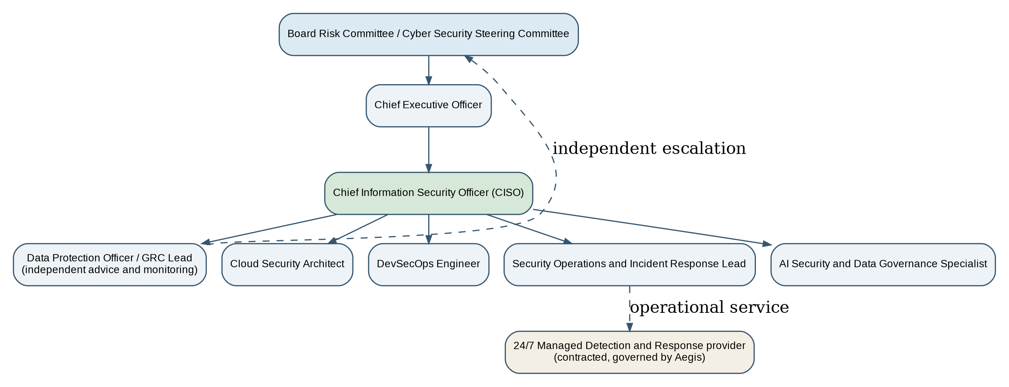
Fig. 2. Proposed Aegis Information Security Unit. Dashed lines indicate independent escalation or contracted service relationships.

2. Work-Stream 2: Policy Framework Development
The three policies are executive summaries. Each requires a named owner, procedures, staff communication, annual review, breach consequences and a documented exception process. Exceptions must be time-limited, risk-assessed and approved by the control owner and CISO. Controls that change everyday work should be piloted and reviewed with staff; permanent informal exceptions would recreate implicit trust.
Policy | Purpose and mandatory controls | Ownership and assurance | Task 1 justification
Acceptable Use of AI and Cloud Services | Use only approved cloud and AI services. Maintain inventories and owners; classify data; prohibit confidential or source-code data in unapproved public AI; apply encryption, least privilege, secure development, human oversight, output validation and logging. Complete DPIA and AI risk assessment before high-impact use. | Owner: Chief Product Officer. The AI Security and Data Governance Specialist and Cloud Architect operate controls; the DPO advises and monitors privacy. Quarterly inventory and high-impact decision review. | ZTA links access to resource sensitivity. The AI RMF supports voluntary lifecycle risk management; the EU AI Act supports risk management, data governance, records, human oversight, robustness and cybersecurity where applicable [22], [23].
Hybrid Work and Remote Access Security | Use managed, encrypted and patched devices with EDR, phishing-resistant MFA, conditional access and ZTNA. Grant per-application access, prohibit shared accounts, restrict BYOD and local customer-data storage, provide role-based training and maintain tested revocation. | Owner: CISO. IT and Cloud Security operate controls. Monthly risk review, quarterly privileged-access certification, device reporting and pilot-user feedback. | A VPN or valid login should not create broad trust. Context, device posture and least privilege reduce credential risk; communication supports adoption [1], [2], [5].
Third-Party and Cloud Vendor Risk Management | Risk-tier suppliers before onboarding. Assess security, privacy, resilience, subprocessors, location, concentration and exit risk. Contracts require notification, audit and testing rights, recovery objectives, secure deletion and DORA cooperation. Limit access and test exit plans. | Owner: CFO/Procurement, consulting the CISO and DPO. Review critical suppliers annually and after material change or incident. Residual supplier risk follows the approved risk-acceptance process; accountability is shown in Appendix A. | Third-party involvement is increasing [13]. Zero Trust restricts supplier access, while DORA requires lifecycle governance of ICT dependencies for organisations within scope [21].
Table 2. Executive summaries of the three priority policies.

3. Work-Stream 3: Regulatory Compliance Strategy
Aegis should manage GDPR and DORA through a coordinated evidence and remediation programme while retaining distinct legal decision paths, reporting thresholds and accountable roles. GDPR requires lawful processing, privacy by design, appropriate security, records, impact assessments and notification within 72 hours where Article 33 applies [20]. DORA has applied since 17 January 2025 to organisations within scope and sets requirements for ICT governance, incident reporting, testing and third-party risk [21].
Aegis must record its confirmed regulatory position. It may be a regulated financial entity, an ICT provider to regulated customers, or both. Direct duties depend on its activities and group structure. Even indirect exposure is likely to create customer requirements for contracts, evidence, incident cooperation and exit support. Legal advice should document the conclusion and assumptions.
Table 3 establishes data and ICT registers, DPIAs, incident classification, testing and board reporting. GDPR and DORA activity should run in parallel so the same service, supplier or incident is not assessed through conflicting processes. Aegis must document and exercise the reporting thresholds and timeframes that apply to its final status [20], [21].
Period | Key milestones | Primary evidence | Lead roles | Exit criterion
Months 0-3 | Confirm DORA scope; appoint owners; map data, systems, subprocessors and critical services; create RoPA, ICT asset and supplier registers; complete GDPR/DORA gap assessment. | Scope opinion; maps and registers; control baseline; funded remediation plan. | DPO, CISO, Legal, CTO | Board approves scope, owners and funded priorities.
Months 4-6 | Embed privacy and AI assessments; remediate high-risk contracts; implement retention, access and incident-classification procedures; map CSF controls to GDPR/DORA. | Assessment templates; remediated clauses; control matrix; incident decision tree. | DPO, GRC Lead, Procurement | Critical processing and suppliers have owners, tier and evidence requirements.
Months 7-9 | Exercise incident reporting, identity failover, backup restoration and continuity; verify regulator and customer channels; test vulnerabilities and cloud controls. | Exercise, failover and restoration results; notification drafts; remediation tracker. | CISO, Operations Lead, DPO | Approved RTO/RPO and reporting clocks are demonstrated.
Months 10-12 | Independent compliance and resilience review; close high findings; complete board report and assurance pack; decide on ISO/IEC 27001 certification. | Independent review; residual-risk decisions; evidence pack; year-two roadmap. | Board, CISO, Internal Audit | Every high risk has an owner, treatment or approved acceptance; evidence is repeatable.
Table 3. Twelve-month GDPR and DORA compliance roadmap.

4. Work-Stream 4: Technical Standards and Architecture
NIST CSF 2.0 is the core framework because it is scalable, outcome-focused and places Govern alongside Identify, Protect, Detect, Respond and Recover [17]. This is more practical for first-year board reporting than leading immediately with certification. ISO/IEC 27001:2022 remains a later assurance objective; its public overview describes requirements for establishing and continually improving an ISMS [24]. This paper does not use restricted clause wording, and certification planning must confirm the current licensed text and amendments. Aegis still needs an approved control crosswalk, evidence register and named owners.
Figure 3 applies the Task 1 findings. Identity governance, phishing-resistant MFA, privileged access and device posture feed policy decisions; ZTNA/SASE grants per-application access. Workload identities, short-lived credentials and API policy protect non-human activity, while CSPM/CNAPP, SIEM and XDR provide feedback. Identity and policy services require redundancy, recovery objectives and monitored emergency accounts. Backups use a separate identity boundary.
Implementation starts with administration, source code, production cloud, customer data and backups because they combine privilege with high business impact. Collaboration follows when identity lifecycle, device management and emergency access are stable. Temporary legacy exceptions require an owner, expiry date and compensating control.
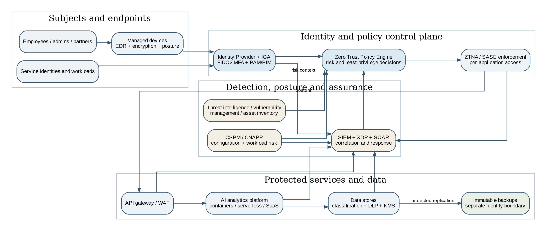
Fig. 3. Proposed high-level Zero Trust architecture for Aegis. Telemetry informs policy and response; backups use a separate trust boundary (author design based on Task 1 findings and [1]-[3], [8], [10]-[12]).

5. Work-Stream 5: Strategic Risk Assessment
Table 4 records inherent risk before treatment. Likelihood and impact are scored from 1 to 5 and multiplied: 1-4 Low, 5-9 Moderate, 10-16 High and 17-25 Critical. The scores support prioritisation rather than precise probability. Because the scenario lacks baseline control data, each provisional residual target is expressed as a reduction of at least one risk category after controls are tested; Aegis should set numerical residual scores, treatment dates and acceptance decisions during the Q1 review. Risk is reviewed quarterly and after material incidents, supplier changes or failed tests [13]-[16], [22].
Risk scenario | L | I | Score | Current exposure | Priority mitigation | Owner, measure and residual review
Human or machine identity compromise enables data theft or ransomware. | 5 | 5 | 25 Critical | Hybrid work, privileged roles and production service identities create high-value paths. | Phishing-resistant MFA for people; PAM/PIM; workload identity; token revocation; segmentation; XDR testing. | CISO: all human privileged accounts protected; all production service identities owned. Target: reduce at least one category after tested controls; review quarterly.
Cloud misconfiguration or vulnerable deployment exposes data or production services. | 4 | 5 | 20 Critical | Rapid cloud delivery, excessive permissions and insecure code or secrets can outpace review. | CSPM/CNAPP; policy-as-code; secret and dependency scanning; secure KMS; deployment gates. | Cloud Architect: all production cloud subscriptions, accounts and tenants monitored; critical issues closed to SLA. Target: reduce at least one category; review quarterly.
Critical supplier compromise, outage or concentration interrupts Aegis or exposes information. | 4 | 5 | 20 Critical | Provider access, subcontractors and limited exit options may create single points of failure. | Supplier tiering; least-privilege access; notification and audit rights; resilience evidence; tested exit and fallback. | CFO/Procurement: all tier-1 suppliers assessed and the most critical exit tested. Target: reduce at least one category; review after material change and quarterly.
AI data or model compromise causes privacy, integrity, unfair-output or intellectual-property harm. | 4 | 4 | 16 High | Data, prompts, models and outputs cross cloud and development environments. | Inventory and provenance; approved data; isolated access; security tests; DLP; monitoring; human oversight; DPIA and AI assessment. | AI Security and Data Governance Specialist: all production AI systems registered, owned and assessed before release. Target: reduce at least one category; review quarterly.
Table 4. Strategic risk register using a five-by-five likelihood and impact scale.

6. Work-Stream 6: Incident Response and Business Continuity
Table 5 follows NIST and CISA incident-response guidance [18], [19]. Preparation requires named decision-makers, out-of-band communications, an offline plan, dependency data, retained logs, clean rebuilds and separately administered immutable backups. Identity, DNS and policy services also need tested failover and controlled emergency access because their loss could obstruct both normal work and recovery.
The Incident Commander activates the plan. Technical staff isolate identities and assets without destroying evidence, while recovery staff restore essential services in order. The DPO and Legal team assess reporting duties and communications remain factual. The starting position is not to pay a ransom because payment does not guarantee restoration or deletion of stolen information [19]. Any exception requires legal, sanctions, law-enforcement, safety and recovery analysis.
Recovery uses known-clean infrastructure. Credentials, sessions, tokens and keys are reset, persistence is removed and services are restored against approved RTO and RPO. Emergency accounts and identity failover are tested before wider restoration. Lessons learned must create owned, dated changes to controls, policies, training and risk records.
Phase | Immediate actions | Lead roles | Communication / compliance | Recovery evidence
Prepare | Offline plan; service map; retained logs; EDR/XDR/SIEM; separate backup identities; immutable backups; clean images; identity failover; emergency accounts and contacts. | CISO, SOC/IR Lead, Operations | Approved templates, regulator/customer contacts and out-of-band channel. | Quarterly restore and emergency-access tests; annual exercise; current map and identity RTO/RPO.
Detect and triage | Validate, record and scope affected identities, data and services; identify likely TTPs and preserve evidence. | SOC/IR Lead, MDR, Cloud Architect | Notify Incident Commander, DPO, Legal and owner; share details only as needed. | Timestamped log, preserved evidence, initial severity and regulatory assessment.
Contain | Disable risky identities, revoke sessions, isolate affected assets and paths, block indicators and protect backups. | Technical Lead with Incident Commander | Out-of-band staff instructions and board situation report. | Containment decisions, affected-asset list and evidence that spread has stopped.
Notify and communicate | Classify GDPR/DORA duties, meet deadlines, coordinate law enforcement and insurer, and issue factual updates. | DPO/Legal and Communications Lead | GDPR notification within 72 hours where required; documented DORA workflow and applicable deadlines [20], [21]. | Approved notification, decision rationale and consistent stakeholder log.
Eradicate and recover | Remove persistence, patch root cause, rotate credentials and keys, validate identity services, rebuild clean systems and restore in order. | Technical Lead, Recovery Manager | Report verified recovery status, not unsupported deadlines. | Integrity and failover checks; RTO/RPO result; security and owner sign-off.
Learn and improve | Review root cause; assign actions; update risk, policies, training and detections; report residual risk. | CISO and Steering Committee | Share appropriate lessons with staff, customers and suppliers. | Lessons report with owners, dates and closure evidence.
Table 5. Ransomware response and recovery playbook.

7. Work-Stream 7: Governance and Strategic Roadmap
The Cyber Security Steering Committee should meet monthly in year one and quarterly once controls are stable. Members include the CEO, CISO, CTO, CFO, DPO or Legal Lead, product, engineering, operations and HR, with periodic independent assurance. It approves risk appetite and exceptions, resolves cross-functional issues and escalates residual risk. It also leads change: affected staff need role-based training, clear monitoring explanations, practical support and a route to report access problems. User feedback and exception trends should accompany technical measures.
Table 6 sequences facts and urgent identity controls in Q1, cloud and workforce controls in Q2, resilience testing in Q3 and independent assurance in Q4. KPIs measure coverage and outcomes rather than products. They remain provisional until the Steering Committee confirms definitions, denominators, owners and achievable thresholds after the Q1 baseline.
Period | Priority initiatives | Key deliverables | Success measures / KPIs | Decision gate
Q1: Govern and establish trust data | Create committee and risk appetite; inventory critical human and machine identities, assets, data and suppliers; deploy phishing-resistant MFA for human privileged accounts; procure MDR; test backups and emergency access. | Charter; prioritised inventories; metrics baseline; privileged-access baseline; MDR runbook; restore/emergency-access report. | All human privileged accounts use phishing-resistant MFA; all critical assets and production service identities have owners; restore and emergency access are demonstrated. | Proceed when identity ownership and recovery evidence are credible.
Q2: Protect cloud and delivery | Roll out device posture and conditional access; pilot ZTNA; deploy CSPM/CNAPP and pipeline gates; publish policies/training; control workload identities; remediate critical suppliers. | ZTNA pilot; CSPM baseline; pipeline gates; training; service-identity register; tier-1 supplier register and clauses. | At least 90% of workforce devices are compliant; 100% of production cloud subscriptions, accounts and tenants are monitored; all critical datasets are classified and owned; all tier-1 suppliers are assessed. | Expand after user, accessibility, performance and false-positive issues are resolved.
Q3: Detect, contain and prove resilience | Integrate identity, endpoint, cloud and application logs; tune detections; segment admin/production paths; run ransomware and regulatory exercises. | SIEM/XDR use cases; segmentation; exercise and restoration reports; updated incident templates. | Exercise MTTD under 30 minutes; containment within 60 minutes; RTO/RPO met; all actions owned and dated. | Board accepts residual risk before broader automation.
Q4: Assure and improve | Independent assessment; expand ZTNA/least privilege; close high findings; issue assurance pack; plan year-two ISO and AI assurance. | Independent report; residual-risk register; customer evidence pack; maturity score and roadmap. | No high finding lacks treatment; 100% of leaver access is disabled by the approved termination time; at least 95% of scheduled access reviews are completed on time; year-two funding is approved. | Committee confirms sustained ownership and measurable improvement.
Table 6. Twelve-month security roadmap and measurable success criteria.

Overall Conclusion
This report evaluated Zero Trust Architecture and found that it is a suitable strategic model for a cloud-first fintech, but not a complete security solution. Its main value is removing location-based trust, making access resource-specific, limiting lateral movement and using current telemetry to change decisions. Practical limits remain: legacy systems, poor asset knowledge, central identity dependencies, alert overload, privacy concerns and staff resistance can all weaken the intended benefit. Successful adoption depends on governance, dependable identity and asset data, secure development, resilient services, trained people and phased delivery.
The proposed Aegis programme applies those findings through accountable leadership, proportionate resourcing, three enforceable policies, a coordinated GDPR and DORA compliance roadmap, NIST CSF 2.0 governance, a Zero Trust design, a defined risk method and a tested ransomware playbook. The first year prioritises privileged and machine identities, cloud posture, supplier visibility, workforce adoption and recovery because these reduce the clearest routes to business disruption. The board should require quarterly evidence of control coverage, incident readiness, user impact and residual risk. This gives Aegis a practical base for EU growth while recognising that security maturity comes from repeated testing and improvement rather than a one-off compliance exercise.

References
[1] National Institute of Standards and Technology, Zero Trust Architecture, NIST SP 800-207, Aug. 2020. [Online]. Available: https://doi.org/10.6028/NIST.SP.800-207. [Accessed: Jul. 28, 2026].
[2] UK National Cyber Security Centre, "Zero trust architecture design principles," reviewed Jan. 16, 2026. [Online]. Available: https://www.ncsc.gov.uk/collection/zero-trust/architecture-design-principles. [Accessed: Jul. 28, 2026].
[3] Cybersecurity and Infrastructure Security Agency, Zero Trust Maturity Model, Version 2.0, Apr. 2023. [Online]. Available: https://www.cisa.gov/resources-tools/resources/zero-trust-maturity-model. [Accessed: Jul. 28, 2026].
[4] N. F. Syed, S. W. Shah, A. Shaghaghi, A. Anwar, Z. Baig and R. Doss, "Zero Trust Architecture (ZTA): A comprehensive survey," IEEE Access, vol. 10, pp. 57143-57179, 2022. [Online]. Available: https://doi.org/10.1109/ACCESS.2022.3174679. [Accessed: Jul. 28, 2026].
[5] A. Pigola and F. de S. Meirelles, "Zero Trust in practice: A mixed-methods study under the TOE framework," Journal of Cybersecurity and Privacy, vol. 5, no. 4, Art. no. 99, 2025. [Online]. Available: https://doi.org/10.3390/jcp5040099. [Accessed: Jul. 28, 2026].
[6] S. Mushtaq, M. Mohsin and M. M. Mushtaq, "A systematic literature review on the implementation and challenges of Zero Trust Architecture across domains," Sensors, vol. 25, no. 19, Art. no. 6118, 2025. [Online]. Available: https://doi.org/10.3390/s25196118. [Accessed: Jul. 28, 2026].
[7] V. Dakić, Z. Morić, A. Kapulica and D. Regvart, "Analysis of Azure Zero Trust Architecture implementation for mid-size organizations," Journal of Cybersecurity and Privacy, vol. 5, no. 1, Art. no. 2, 2025. [Online]. Available: https://doi.org/10.3390/jcp5010002. [Accessed: Jul. 28, 2026].
[8] S. Sarkar, G. Choudhary, S. K. Shandilya, A. Hussain and H. Kim, "Security of Zero Trust networks in cloud computing: A comparative review," Sustainability, vol. 14, no. 18, Art. no. 11213, 2022. [Online]. Available: https://doi.org/10.3390/su141811213. [Accessed: Jul. 28, 2026].
[9] F. Santucci, G. Oliva, M. T. Gonnella, M. E. Briga, M. Leanza, M. Massenzi, L. Faramondi and R. Setola, "Implementing Zero Trust: Expert insights on key security pillars and prioritization in digital transformation," Information, vol. 16, no. 8, Art. no. 667, 2025. [Online]. Available: https://doi.org/10.3390/info16080667. [Accessed: Jul. 28, 2026].
[10] P. Phiayura and S. Teerakanok, "A comprehensive framework for migrating to Zero Trust Architecture," IEEE Access, vol. 11, pp. 19487-19511, 2023. [Online]. Available: https://doi.org/10.1109/ACCESS.2023.3248622. [Accessed: Jul. 28, 2026].
[11] P. Dhiman, N. Saini, Y. Gulzar, S. Turaev, A. Kaur, K. U. Nisa and Y. Hamid, "A review and comparative analysis of relevant approaches of Zero Trust Network Model," Sensors, vol. 24, no. 4, Art. no. 1328, 2024. [Online]. Available: https://doi.org/10.3390/s24041328. [Accessed: Jul. 28, 2026].
[12] S. Kulkarni, A. Mylonas and S. Vidalis, "Using the Zero Trust five-step implementation process with smart environments: State-of-the-art review and future directions," Future Internet, vol. 17, no. 7, Art. no. 313, 2025. [Online]. Available: https://doi.org/10.3390/fi17070313. [Accessed: Jul. 28, 2026].
[13] Verizon Business, 2025 Data Breach Investigations Report, 2025. [Online]. Available: https://www.verizon.com/business/resources/reports/2025-dbir-data-breach-investigations-report.pdf. [Accessed: Jul. 28, 2026].
[14] European Union Agency for Cybersecurity, ENISA Threat Landscape 2025, Version 1.2, Oct. 2025, revised Jan. 9, 2026. [Online]. Available: https://www.enisa.europa.eu/publications/enisa-threat-landscape-2025. [Accessed: Jul. 28, 2026].
[15] MGM Resorts International, Current Report on Form 8-K, U.S. Securities and Exchange Commission, Oct. 5, 2023. [Online]. Available: https://www.sec.gov/Archives/edgar/data/789570/000119312523251667/d461062d8k.htm. [Accessed: Jul. 28, 2026].
[16] UnitedHealth Group Inc., Annual Report on Form 10-K for the year ended Dec. 31, 2024, filed Feb. 27, 2025. [Online]. Available: https://www.unitedhealthgroup.com/content/dam/UHG/PDF/investors/2024/UNH-Q4-2024-Form-10-K.pdf. [Accessed: Jul. 28, 2026].
[17] National Institute of Standards and Technology, The NIST Cybersecurity Framework (CSF) 2.0, NIST CSWP 29, Feb. 2024. [Online]. Available: https://doi.org/10.6028/NIST.CSWP.29. [Accessed: Jul. 28, 2026].
[18] National Institute of Standards and Technology, Incident Response Recommendations and Considerations for Cybersecurity Risk Management: A CSF 2.0 Community Profile, NIST SP 800-61 Rev. 3, Apr. 2025. [Online]. Available: https://doi.org/10.6028/NIST.SP.800-61r3. [Accessed: Jul. 28, 2026].
[19] Cybersecurity and Infrastructure Security Agency, StopRansomware Guide, updated Mar. 2025. [Online]. Available: https://www.cisa.gov/stopransomware/ransomware-guide. [Accessed: Jul. 28, 2026].
[20] European Parliament and Council, Regulation (EU) 2016/679 (General Data Protection Regulation), Apr. 27, 2016. [Online]. Available: https://eur-lex.europa.eu/eli/reg/2016/679/oj. [Accessed: Jul. 28, 2026].
[21] European Parliament and Council, Regulation (EU) 2022/2554 on digital operational resilience for the financial sector (DORA), Dec. 14, 2022. [Online]. Available: https://eur-lex.europa.eu/eli/reg/2022/2554/oj/eng. [Accessed: Jul. 28, 2026].
[22] National Institute of Standards and Technology, Artificial Intelligence Risk Management Framework (AI RMF 1.0), NIST AI 100-1, Jan. 2023. [Online]. Available: https://doi.org/10.6028/NIST.AI.100-1. [Accessed: Jul. 28, 2026].
[23] European Parliament and Council, Regulation (EU) 2024/1689 laying down harmonised rules on artificial intelligence (Artificial Intelligence Act), Jun. 13, 2024. [Online]. Available: https://eur-lex.europa.eu/eli/reg/2024/1689/oj/eng. [Accessed: Jul. 28, 2026].
[24] International Organization for Standardization, ISO/IEC 27001:2022—Information security, cybersecurity and privacy protection—Information security management systems—Requirements, public overview, 2022. [Online]. Available: https://www.iso.org/standard/27001. [Accessed: Jul. 28, 2026].

Appendix A – RACI for Key Security Activities
The RACI below clarifies first-year ownership. R = Responsible, A = Accountable, C = Consulted and I = Informed. Each activity has one accountable role; an A/R entry means that the same role is both accountable and responsible.
Activity | Board | CEO | CISO | DPO/GRC | CTO/Engineering | Security specialists | Business owners
Risk appetite and material risk acceptance | A | R | R | C | C | C | I
Security architecture and Zero Trust roadmap | I | I | A | C | C | R | C
GDPR/DORA interpretation and evidence | I | I | C | A/R | C | C | C
Cloud and DevSecOps controls | I | I | C | C | A | R | I
Incident command and technical containment | I | I | A | C | C | R | I
Business continuity and service recovery | I | A | C | C | C | C | R
Third-party risk acceptance | I | A | C | C | C | C | R
Table A1. RACI for key security activities.

