TYNDALL
HIGH SCHOOL

THE LAW
There is legislation in place that protects transgender individuals. The Gender Recognition Act (2004) allows for individuals to be considered by law as their acquired gender (Fairbairn, C. et al, 2020).
The Equality Act 2010 protects people with protected characteristics from discrimination, and Gender

WHAT ARE THE LEGAL RISKS?
Transgender people are particularly vulnerable to discrimination. In section 66 of the Act (Sentencing Act, 2020) says that if a crime was motivated by hostility based on transgender identity it should be treated as aggravating factor when sentencing.
In 2021 – 2022 9 cases in relation to transgender employees reached decision stage of employment

reassignment is a protected characteristics (Fairbairn, C. et tribunals, compared to 4 in 2019-2020, showing an

UNDERSTANDING TRANSGENDER
WHAT YOU NEED TO KNOW

WHAT IS TRANSGENDER?

Trans sexual was a term used previously to describe people whose gender is different from the gender assigned to them at birth, the term was later replaced by “transgender or gender diverse” to include people who are non-binary (Fairbairn, C. et al, 2022).
al, 2020). You are protected if you are proposing to undergo, undergoing or have undergone surgery to reassign your send then you are protected (Equality and Human Rights Commission, 2023). Acts of discrimination don’t need to be intentional to be seen as unlawful.
The Department for Education provides guidance on the
Equality Act in relation to Transgender individuals within schools (Fairbairn, C. et al, 2020).
The Commons Library published a research briefing, The gender recognition process, which focused on the legal process for gender recognition in December 2019 (Fairbairn, C. et al, 2020). In the case of Ms R Taylor V JLR Ltd (2018), the ET found that people who are gender fluid, non-binary or transitioning are covered and protected by gender reassignment in accordance with the Equality Act 2010.

PHILOSOPHICAL BELIEFS
increase in numbers (Baker, 2023).
To be treated unfairly because you're a transgender person, is called 'discrimination because of gender reassignment' (Citizen Advice, 2023).
There are 4 different types of gender discrimination:

Direct Discrimination
This is when someone treats a person worse than another person in a same or similar situation because they are transgender (Equality and Human Rights Commission, 2023). The Equality act says you shouldn’t directly discriminate against someone if they do or think they do, this is known as discrimination by perception (Equality and Human Rights Commission, 2023). If someone is treated unfairly if they are connected to a person who has a protected characteristic of gender reassignment, known as ‘associative discrimination’ (ACAS, 2020).
If absent from work due to gender reassignment the

employer can’t treat the person differently than if they were

Approximately 200,000-500,000 trans people in the UK (Gov.uk, 2018)
·
Although transgender people are protected under the
Equality Act 2010, gender critical views can also be protected as a philosophical belief as a protected characteristic. However this doesn’t defend discrimination
absent from work due to illness (Equality and Human Rights Commission, 2023).
In the case of 'Miss A de Souza E Souza v Primark Stores
Ltd.' (2017) Miss Souza applied for a job at Primark and

67% of trans respondents avoid being open about
against transgender people in the case of 'Forstater V
told them that she was a transgender person. Her passport

their gender identity for fear of negative reactions from CGD Europe and others' (2021), whereby Forstater
stated her name was ‘Alexander’ but wanted to be called ‘

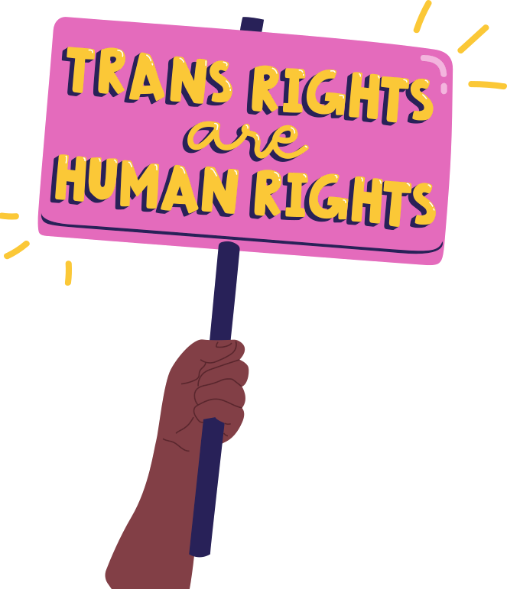others (Gov.uk, 2018)
tweeted comments about gender identity which some transgender people found offensive, Forstater claimed that her views were protected by her philosophical belief. The tribunal concluded that that Forstater’s belief was not a ‘Philosophical belief’ under section 10 of the Equality Act 2010. A similar case was Mackereth v DWP (2022) whereby a Doctor refused to address patients by their preferred pronouns, the Doctor claims failed because his belief was seen as harmful to transgender people and his beliefs were not covered by the philosophical belief.
Alexandra’. HR changed the name on the HR system to Alexander and from Miss to Mr , despite using her preferred name for weeks. She also claimed that colleagues sprayed her with men’s aftershave, called her evil and a joke. The tribunal found that Primark had failed to deal with the matter appropriately, and that it was direct gender reassignment discrimination (Miss A de Souza E Souza v Primark Stores Ltd, 2017).

Indirect Discrimination
Indirect Discrimination would occur if a transgender person is treated less favorably indirectly, for example if the school had a particular policy that disadvantaged people with the

WHAT WE CAN DO TO SUPPORT?
Transgender individuals are vulnerable to discrimination

Training
The school will be providing training on equality, diversity and inclusion to increase awareness of transgender people so that they are better prepared to be able to

protected characteristic of gender reassignment (Equality and and employers are under added pressure to
accommodate them (PHR Solicitors, no date; CIPD,

Human Rights Commission, 2023).
If there is a good reason for the school indirectly discrimination against gender reassigned people then this is allowed and known as ‘objective justification’ (ACAS, 2020). In the case of ‘Bisson V Condor’, a transgender person won a case for indirect discrimination, she claimed that using words like ‘ladies’ and ‘gents’ of toilet doors is indirectly discriminating against the gender community, and when she
accommodate all individuals in their workplace to follow the law and promote a place of work where no one is rejected based on their gender identity. Support and precautions should be taken to ensure this doesn’t happen (PHR Solicitors). Trans gender people face negative reactions to their gender identity in society and can become victims of hate crimes, domestic abuse and harassment simply because of their gender identity
2022). There may be pupils who go through the gender
reassignment so teachers will need to be trained on how to support this, as it is unlawful for schools to discriminate against pupils. Schools have safeguarding responsibilities to pupil’s wellbeing and should have anti- bullying policies (Fairbairn, C. et al, 2020), this should apply to the teachers as well. HR and managers should work together to lead by example and champion trans

asked a member of staff what toilet to use was advised to use (Gov.uk, 2018). It is unlawful for schools to treat pupils
people and encourage inclusion (CIPD 2022). As a

the disabled (Simpson, 2016).

Harassment
If a person is made to feel humiliated, offended or degraded (Citizen Advice, 2019; ACAS, No date- a) due to a person’s gender reassignment this would be considered as harassment. Harassment within the school is not justified and the school should do what it can to prevent staff in the school
less favourably because of their gender reassignment (Gov.uk, 2014).
Organisations need to take steps to ensure transgender
individuals feel safe in the workplace (PHR Solicitors, no date) so we should make changes and adjustments that may create obstacles for trans people:

Policies
teacher you are supposed to be treating pupils right from
wrong.

Inclusive workplace
The school should create an inclusive workplace which allows for discussion and to create a multi-faced workforce which can have a positive effect on the school by bringing new ideas and innovation, it also reflects the

from harassing anyone who is transgender. If a claim is raised Amend existing policies to ensure they’re inclusive,
population by ensuring all individuals are given an equal

by the transgender and the school has done everything it
including material for equality training to ensure reference
opportunity (PHR Solicitors (no date), This should also

could to prevent their staff from harassing transgender people is made to transgender (Goodman, 2018). This should
include an inclusive recruitment process. Staff are more

the claim will be against the individual (Equality and Human
Rights Commission, 2023).
include creating a transgender policy and a HR toolkit that looks at how to deal with new or existing staff who are
likely to be productive in an inclusive workplace and feel valued and potentially increase retention (PHR Solicitors

transgender or are going to undergo gender reassignment (no date). A key measure that can be put in place would

Victimisation
If transgender person makes a complaint of gender reassignment discrimination and they are then treated badly because of the complaint this would be victimisation. As well as if someone is treated less favourable for supporting someone who has made a complaint of gender reassignment discrimination (Equality and Human Rights Commission, 2023).
(Goodman, 2018). Set out the behavioural expectations for the staff (CIPD, 2022). The Harassment and Bullying policy should ensure anything in relation to transgender individuals should be dealt with the same as any case of Harassment and Bullying (PHR Solicitors (no date). The social media policy will be implemented to ensure when staff use social media they're aware that the way they present themselves could have repercussions on the school. All policies will be clear and that the correct
be providing an inclusive toilets with pictures and not just words, especially in response to the Bisson V Condor Case (Simpson, 2016)

When is it ok to treat someone differently?
pronouns are used. These should also be used in person

There are occasions when it is lawful to treat someone
and in email signatures, encourage all staff to outline their

differently due to their gender reassignment for example in
preferred pronouns in their email. At all points ensure

competitive sport, excluding transgender people and a
confidentiality and anonymity is maintain if requested by

For further information please contact us on

service provider that provides single-sex services
the trans person and keep up to date with legislation and

b.wilson@tyndallhighschool@ac.uk

(Equality and Human Rights Commission, 2023)
law in regards to transgender, terminology evolves as the

(01232) 987654

term transgender could change (CIPD, 2022)

Bethan Wilson Word Count - 1627

References
ACAS (2020), Discrimination at work – Equality Act 2010, Available at: https://www.acas.org.uk/discrimination-and-the-law/direct-and- indirect-discrimination (Accessed on 10th April 2023)
ACAS (No date- a), If you’re treated unfairly at work, Available at: https://www.acas.org.uk/if-youre-treated-unfairly-at-work/being- harassed (Accessed 11th April 2023)
ACAS (No date-b), If you’re treated unfairly at work, Available at: https://www.acas.org.uk/if-youre-treated-unfairly-at-work/being- victimised (Accessed 11th April 2023)
Baker, C. (2023), Disputes relating to discrimination of transgender employees more than double in past year – News & Views, Available at: https://www.gqlittler.com/resources/news-and-views/disputes-relating-to-discrimination-of-transgender-employees-more-than- double-in-past-year.htm (Accessed 29th April 2023)
CIPD (2022), Sexual Orientation, Gender identity and Gender reassignment, Available at: https://www.cipd.co.uk/news- views/viewpoint/sexual-orientation-gender-identity#gref (Accessed 29th April 2023)
Citizen Advice (2019), If you’re being harassed or bullied at work, Available at: https://www.citizensadvice.org.uk/work/discrimination- at-work/discrimination-at-work/checking-if-its-discrimination/if-youre-being-harassed-or-bullied-at-work/ (Accessed on 12th April 2023)
Citizen Advice (2023), Gender Reassignment Discrimination, Available at: https://www.citizensadvice.org.uk/law-and- courts/discrimination/check-if-youre-protected-from-discrimination/gender-reassignment- discrimination/#:~:text=The%20Equality%20Act%202010%20says,characteristics%20under%20the%20Equality%20Act. (Accessed 18th April 2023)
Equality and Human Rights Commission (2023), Gender reassignment discrimination, Available at: https://www.equalityhumanrights.com/en/advice-and-guidance/gender-reassignment-discrimination (Accessed 14th April 2023) Fairbairn, C, , Pyper, D. , Gheera, M. , Loft, P. (2020), Gender recognition and the rights of transgender people, Available at: https://commonslibrary.parliament.uk/research-briefings/cbp-8969/ (Accessed 16th April 2023)
Fairbairn, C. , Barton, C. , Pyper, D. , Lipscombe, S. (2022) , Non- binary gender recognition: law and policy, Available at: https://commonslibrary.parliament.uk/research-briefings/cbp-9515/ (Accessed 16th April 2023)
Forstater V CGD Europe (2021), Rolls Building London, UKEAT/0105. Gov.uk. Available at: https://assets.publishing.service.gov.uk/media/60c1cce1d3bf7f4bd9814e39/Maya_Forstater_v_CGD_Europe_and_others_UKEAT0105_ 20_JOJ.pdf (Accessed 15th April 2023)
Gov.uk (2014), The Equality Act and Schools, Available at: https://assets.publishing.service.gov.uk/government/uploads/system/uploads/attachment_data/file/315587/Equality_Act_Advice_Fin al.pdf (Accessed 17th April 2023)
Gov.uk (2018), Trans People in the UK, Available at: https://assets.publishing.service.gov.uk/government/uploads/system/uploads/attachment_data/file/721642/GEO-LGBT-factsheet.pdf (Accessed 17th April 2023)

Mackereth v Department for Work and Pensions (2022), 2019- 001051, Gov.uk, Available at: https://www.gov.uk/employment-appeal-

tribunal-decisions/dr-david-mackereth-v-the-department-of-work-and-pensions-1-advanced-personnel-management-group-uk- limited-2-2022-eat-99 (Accessed 17th April 2023)
Miss A de Souza E Souza V Primark Stores Ltd (2017), London, 2206063/201, Gov.uk, Available at: https://assets.publishing.service.gov.uk/media/5a7aed66ed915d670dd7f91e/Miss_A_de_Souza_E_Souza_v_Primark_Strores_Ltd_-

_2206063-2017_-_Final.pdf (Accessed 29th April 2023)
Ms R Taylor V JLR Ltd (2018),Birmingham, 1304471. Gov.uk. Available at: https://assets.publishing.service.gov.uk/media/5f68b2ebe90e077f5ac3bb5a/Ms_R_Taylor_V_Jaguar_Land_Rover_Ltd_-

_1304471_2018_-_judgment.pdf (Accessed: 14th April 2023)
PHR Solicitors (no date), The Laws on Transgender Rights in the Workplace, Available at: https://www.phrsolicitors.co.uk/resources/laws-transgender-rights- workplace#:~:text=The%20law%20on%20transgender%20acceptance,they%20were%20assigned%20at%20birth. (Accessed 12th April 2023)
Sentencing Act 2020, c.17. Available at: https://www.legislation.gov.uk/ukpga/2020/17/section/66) (Accessed 29th April 2023) Simpson, S (2016), Gender reassignment transgender toilet sign claim, Available at: https://www.personneltoday.com/hr/gender- reassignment-transgender-toilet-sign-claim/ (Accessed 17th April 2023)
Simpson, S. (2016), Gender reassignment: trans customer wins toilet sign claim, Available at: https://www.personneltoday.com/hr/gender-reassignment-transgender-toilet-sign-claim/ (Accessed 16th April 2023)
Warner Goodman (2018), Employment Law update De Souza e Souza V Primark Stores Ltd, Available at: https://www.warnergoodman.co.uk/site/blog/news/employment-law-case-update-de-souza-e-souza-v-primark-stores-ltd (Accessed 28th April 2023)

