
Applied Computing
Wales Institute of Science and Art (WISA)

Network Operating Systems and Services (NOSS)
(ACCA5023)
Worksheet 2

Task 1: MANAGING AND MAINTAINING NETWORK RESOURCES USING NETWORK POLICY AND SECURITY PRACTICES

Building on the network established in worksheet one, the first objective in this continued network development exercise is to create a local drive and build various permission sets around access and sharing of data in the network hierarchy.
Firstly, the utilisation of NTFS permissions.
This needs to be set up from a network administrator account.
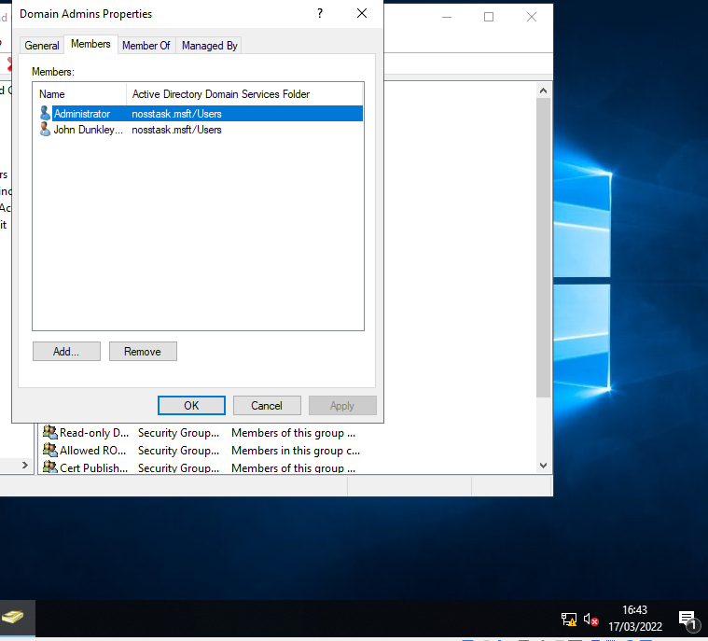
A folder is created with the name Share_Files_NOSS and a text document created within. To set NTFS permissions, we utilise the folder Properties.
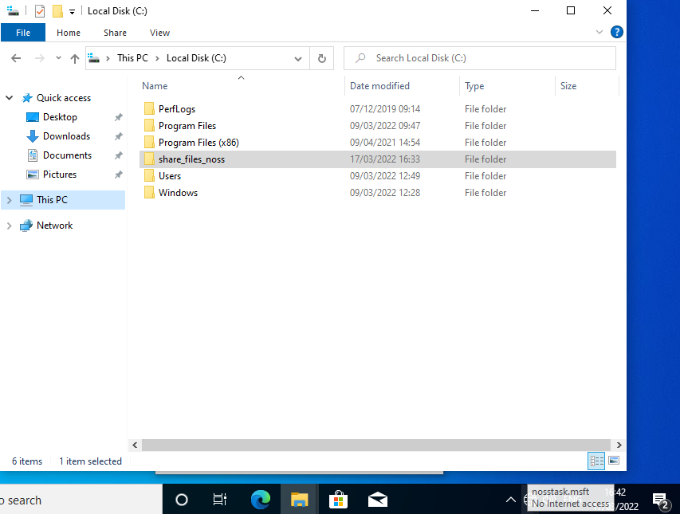
In the security tab, access permissions can be configured. From here, it can be set that only a specific network user can freely use the file, while the remaining users on the network will only have permission to read the file. To achieve this, firstly the default users with permissions are removed. Inherited permissions may need to be removed to this end.
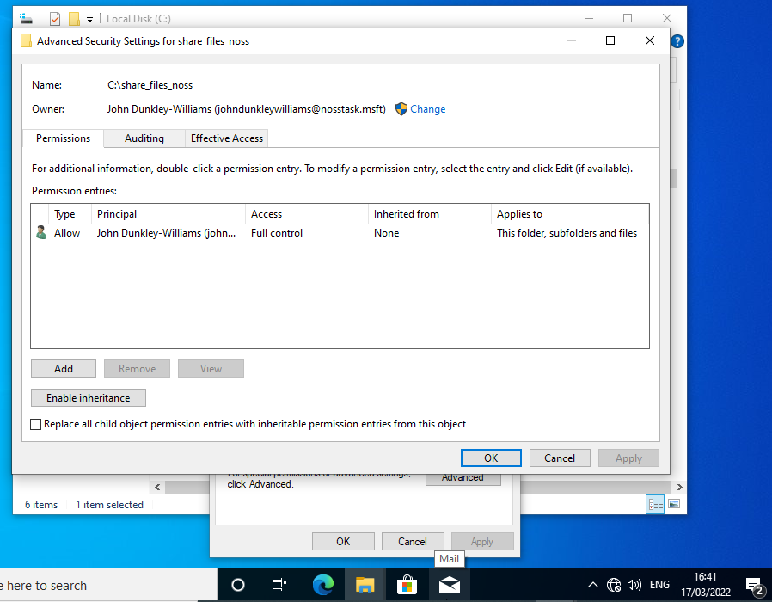
This screenshot shows that inheritance is disabled, and the permitted users has been reduced to the single admin account.
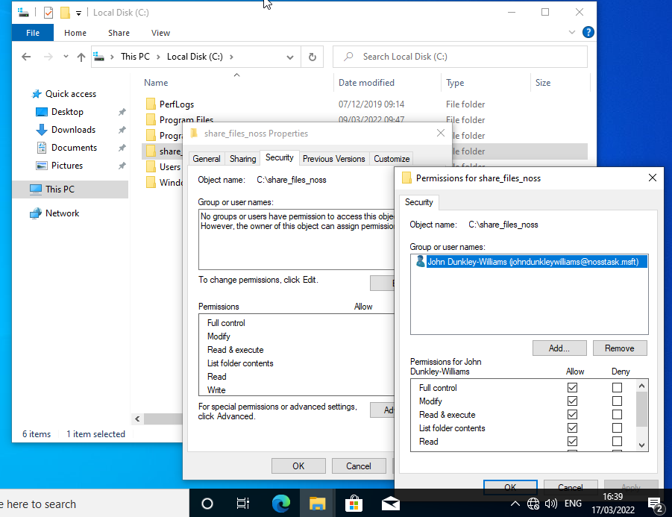
This screenshot shows that the single permitted account has been set up with full control permissions.
For the next part of the exercise, a second user is added, but this time with more restricted permissions.
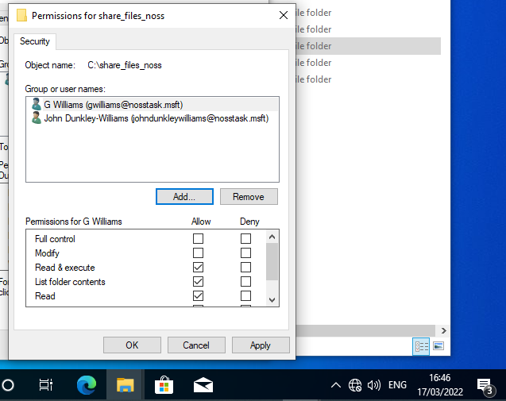
This user will have permission to “Read & execute” but will be unable to modify the file. Such method can be used to prevent accidental edit or deletion of a file that needs to remain as it is. To evidence the success, when logged in as the second named user we can see that modification of the file is not permitted.
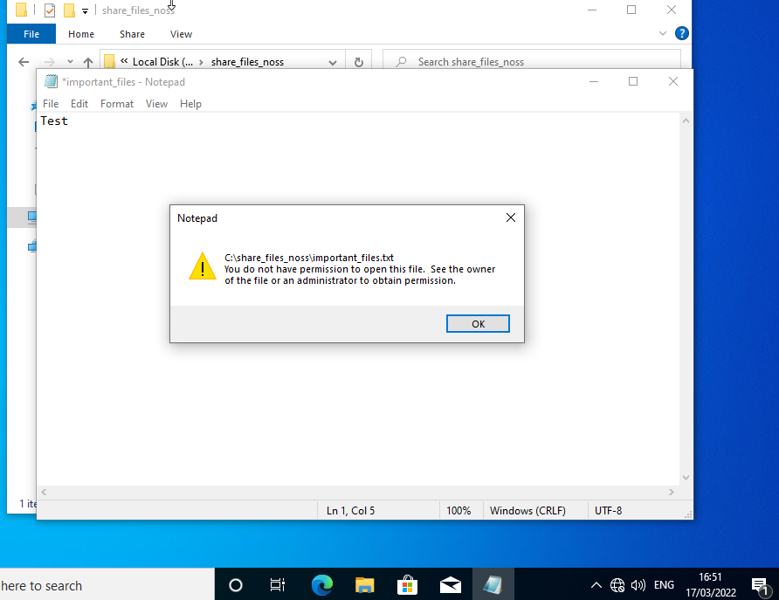
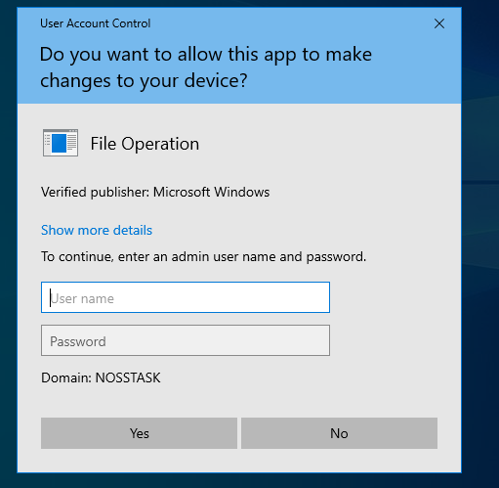
If the user wishes to make modifications to the file, they will require the log in credential of an empowered administrator with higher permission settings.
The next objective will be around share permissions. These are managed alongside NTFS, since they can compromise network security if not properly managed.
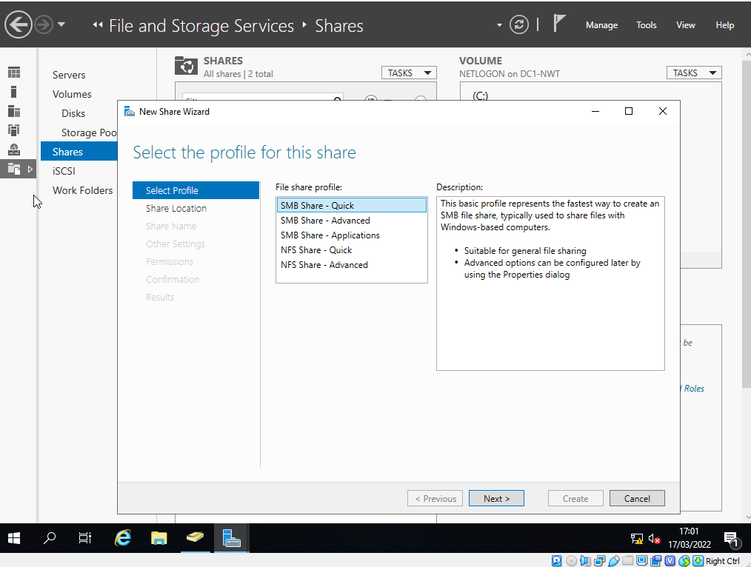
File and Storage Services are used to set up a new file share. The Quick setup in the Wizard will suit the needs of this objective.
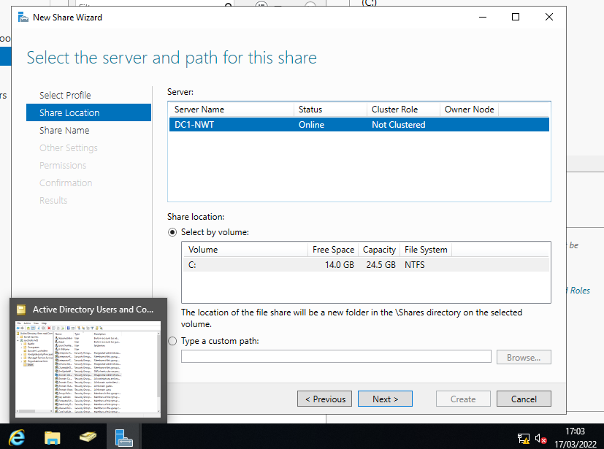
The appropriate server is selected for the file share. The previously created destination folder needs to be specified (C:\shares\Share_Files_NOSS or with \DC1_NWT for the remote path).
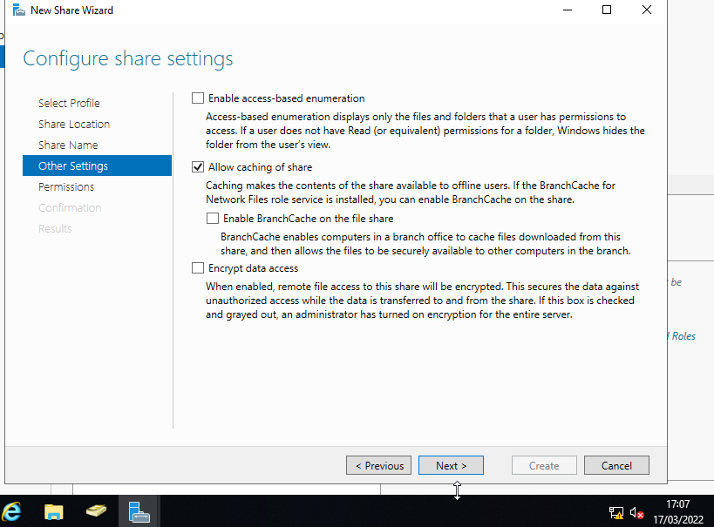
The configuration we require from the Wizard is for access-based enumeration and Allow caching. These settings will mean users can only see the files that they have rights to access, and allow for offline viewing of permitted files.
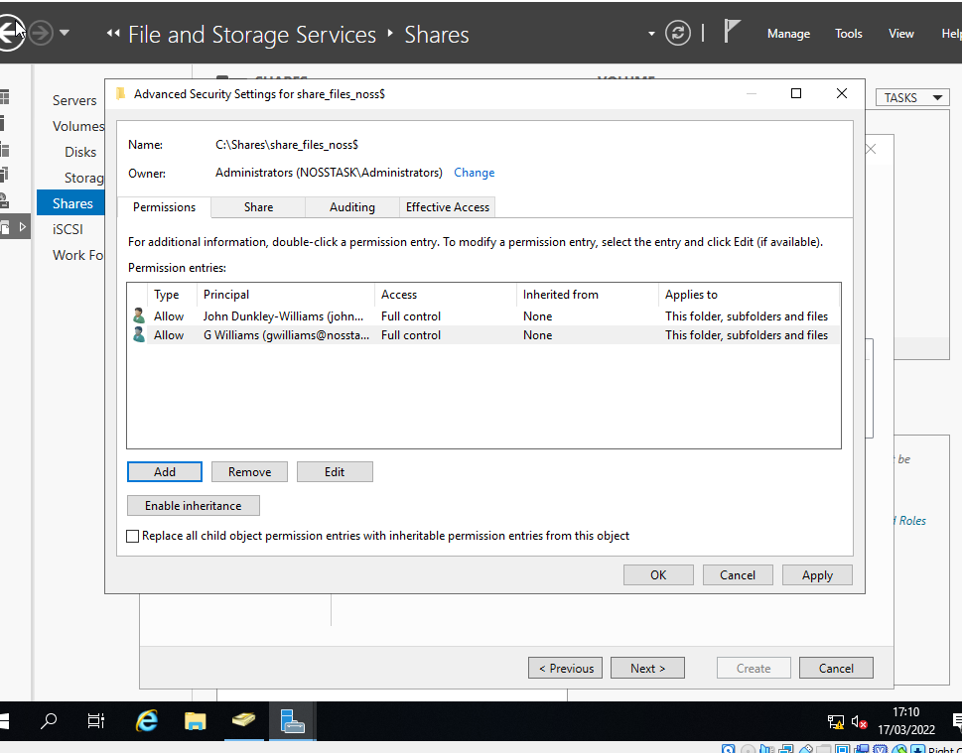
As per the brief, two network users are added with full control.
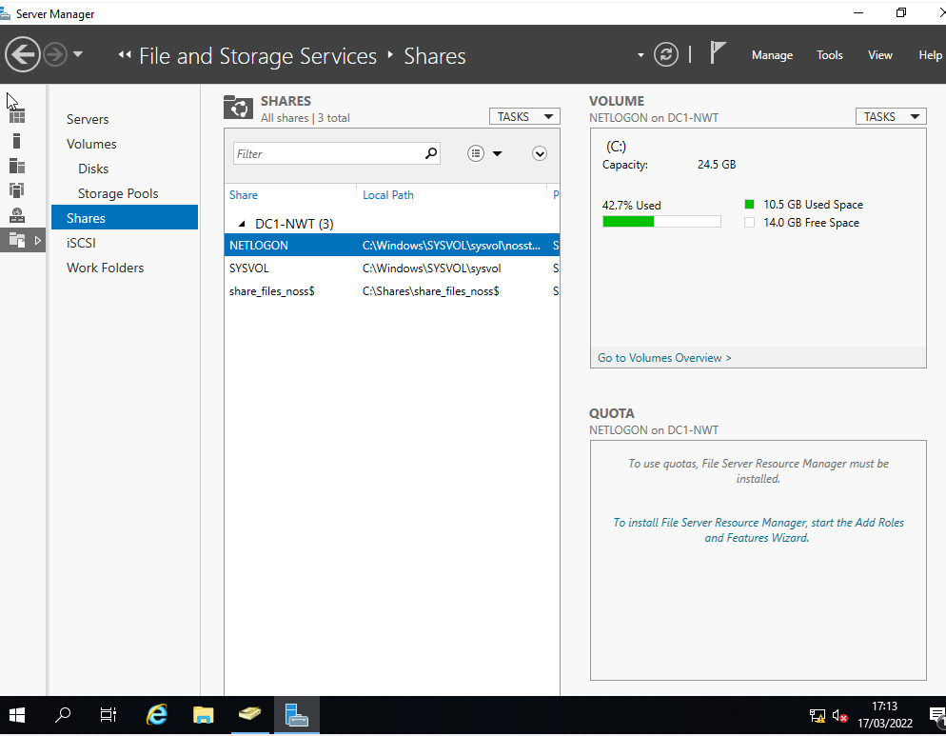
Once the create button is pressed, with the configuration complete the file share is created.
The third objective is to establish access to the file share over the network. This will be done using the Map Network Drive feature.
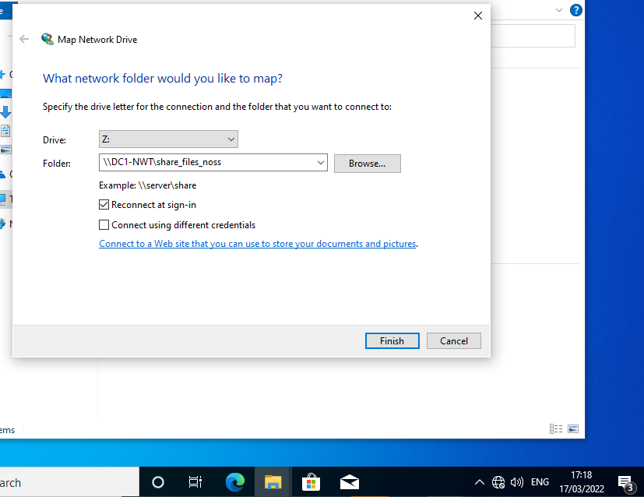
The full destination path is entered for the location we wish to map.
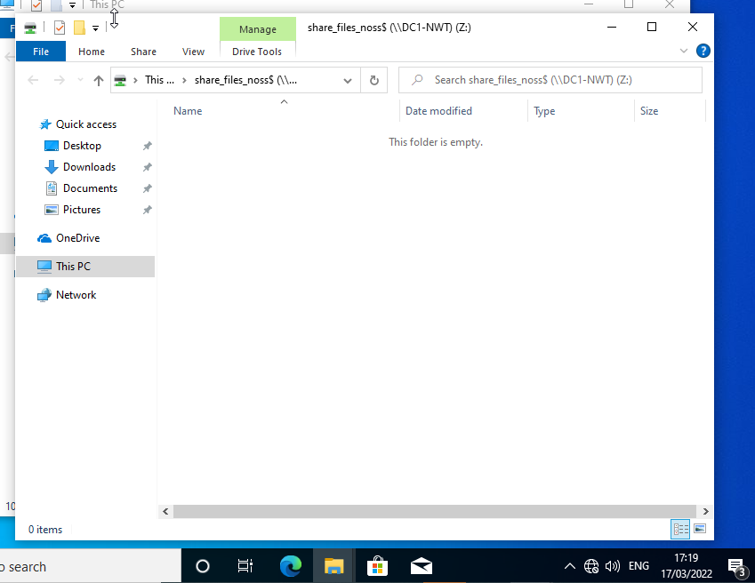
The dollar sign which was included earlier as part of the configuration is essential to the success of this task.
The next stage of the assignment is to utilise Group Policy Management. This is another built-in part of Windows that allows network administrators to manage groups of users at a time, such as students on a university network. These can operate at a number of scales so as to allow for ease of configuration.
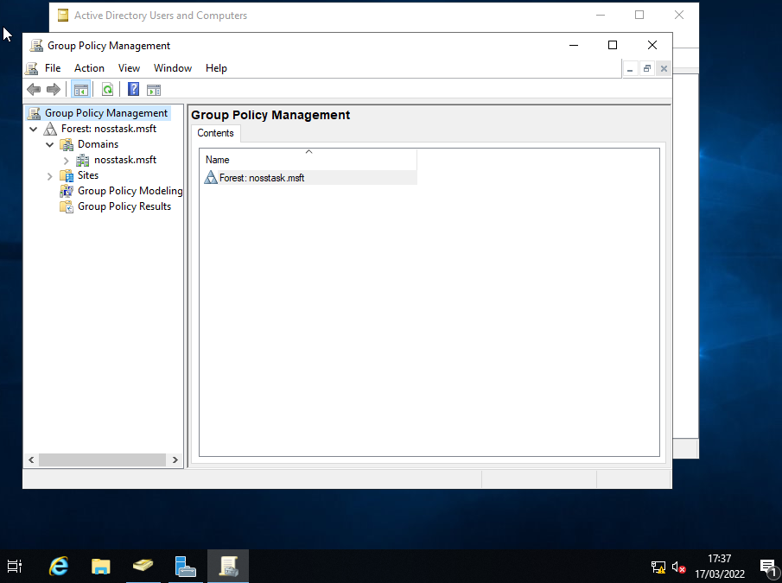
The first objective in this part of the task is to restrict non-admin users from accessing the Control Panel. The first step to this end is to establish a user group, or in these terms, a new Organisational Unit to contain the non-admin users we wish to apply controls to.
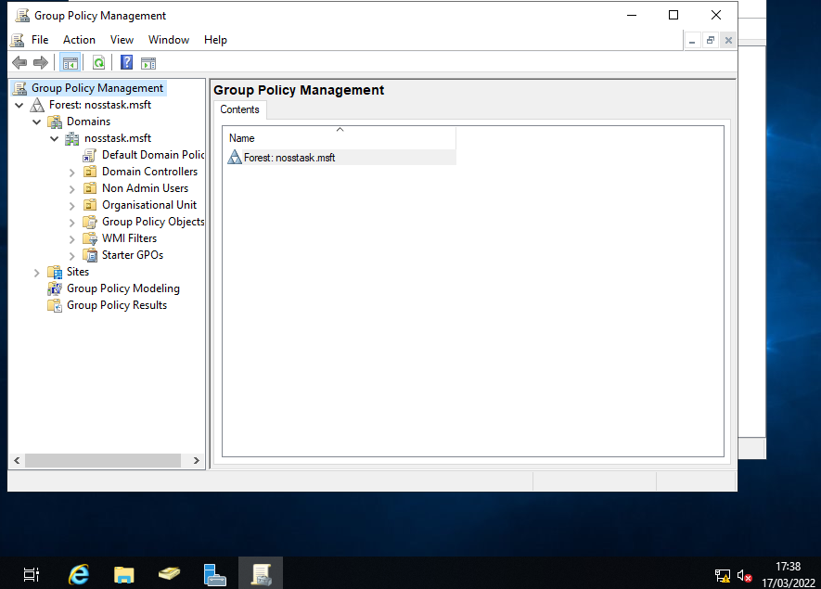
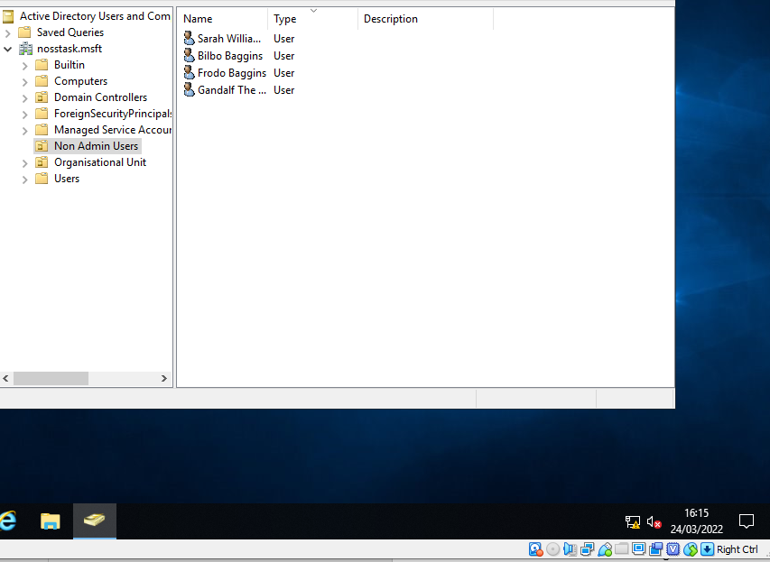
The OU is created, and test accounts created within for the purposes of this exercise.
Next, the GPO needs to be configured.
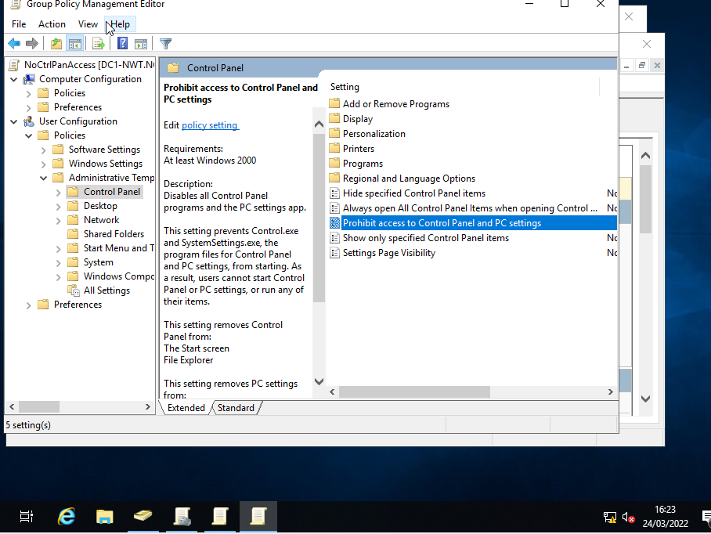
From the Group Policy Management Editor, Non-Admin Users can now be selected, and a new Group Policy Object can be created to restrict access to the Control Panel and PC settings.
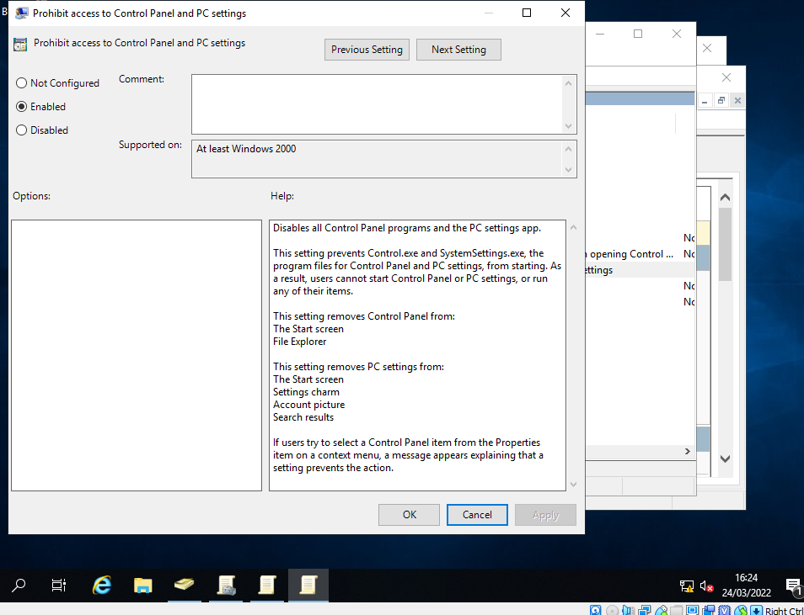
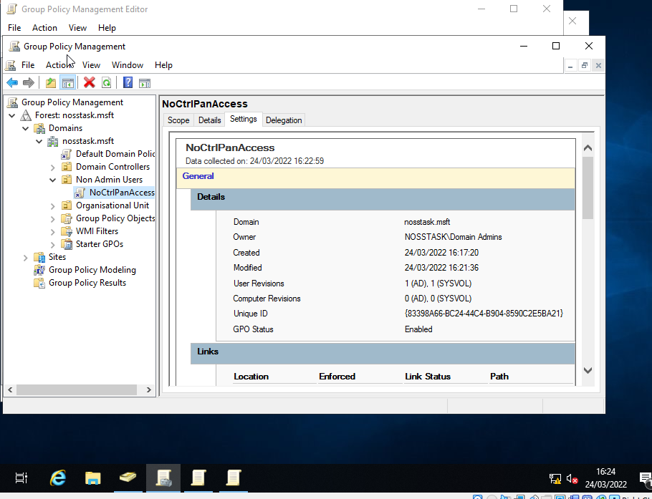
These settings would usually take time to apply, but Command Prompt can be used to force updates immediately.
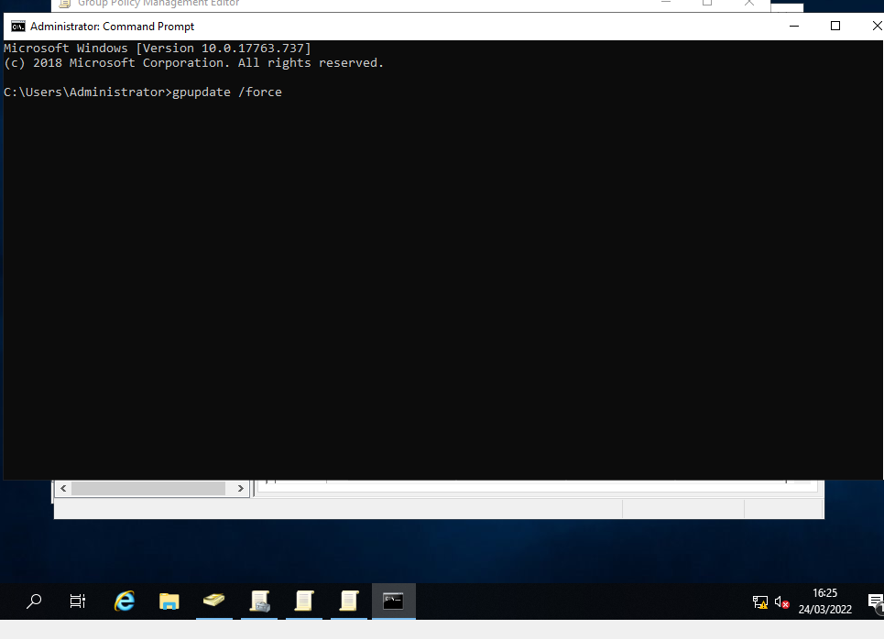
To test that this has worked, we can log in as a non-admin user and try to access the Control Panel.
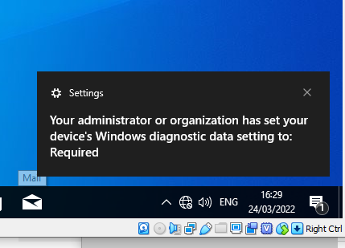
For the next step, access will be removed to the Command Prompt, since this can still be used to exploit the network.
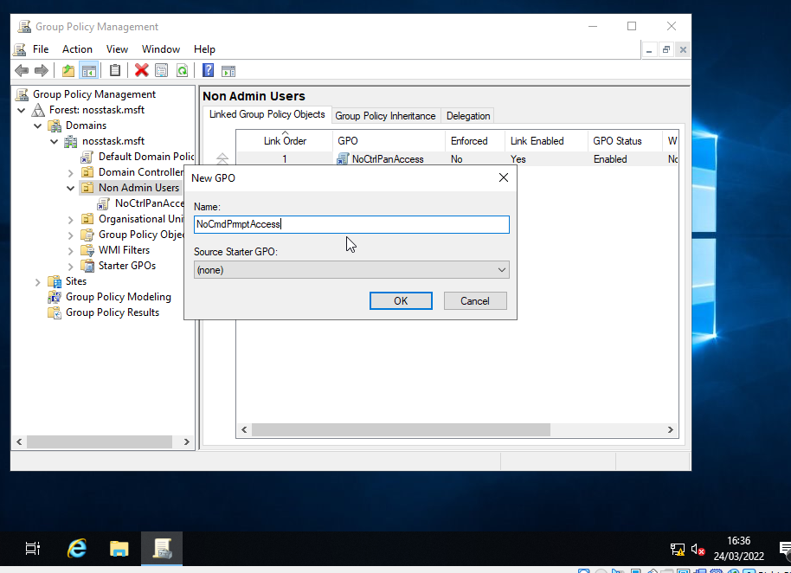
Once again, the Group Policy Management tool is used. The policy, as before, is given a name and then the settings can be applied to our Non-Admin User group.
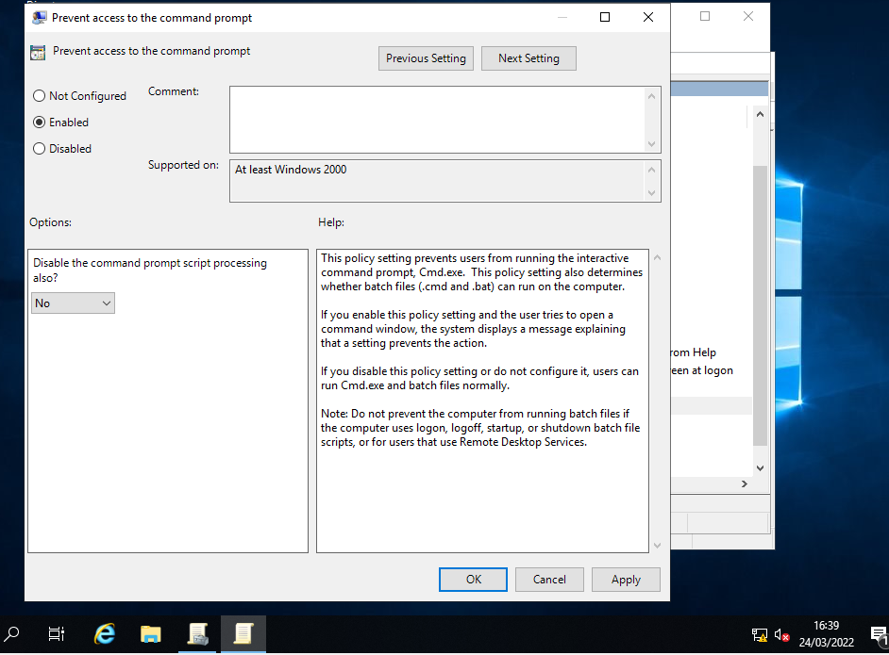
Once this has again been force updated by the administrator account in Command Prompt, we can log in as a non-admin user to evidence that the policy has applied.
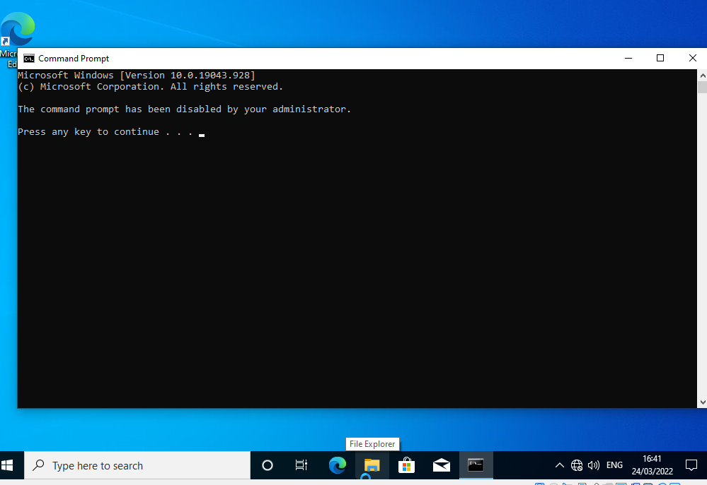
The third step in the Group Policy exercise will be the restriction of removable media devices. These can contain harmful software, and so it is a common practice to outright block these devices on a network.
Following the same steps as before, the policy can be configured and applied.
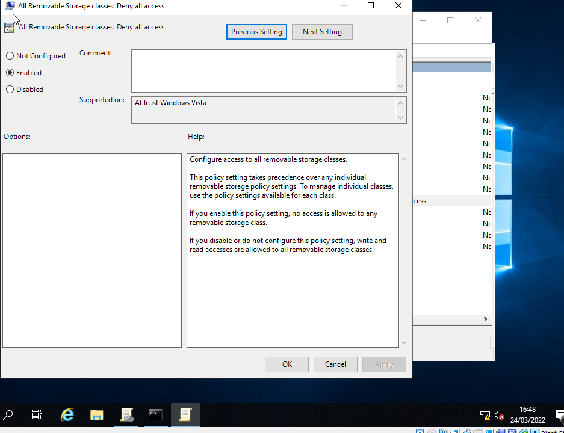
Step 4 will be to restrict software installation for non-admin users. Software can be installed from myriad locations. It could be directly harmful, or accidentally so if compatibility or some other conflicting issue arises with the network.
Instead of applying this to the User group, this will be applied to a computer object. A new Organisational Unit will be created to this end, and the computers we wish to place this restriction on added to that OU.
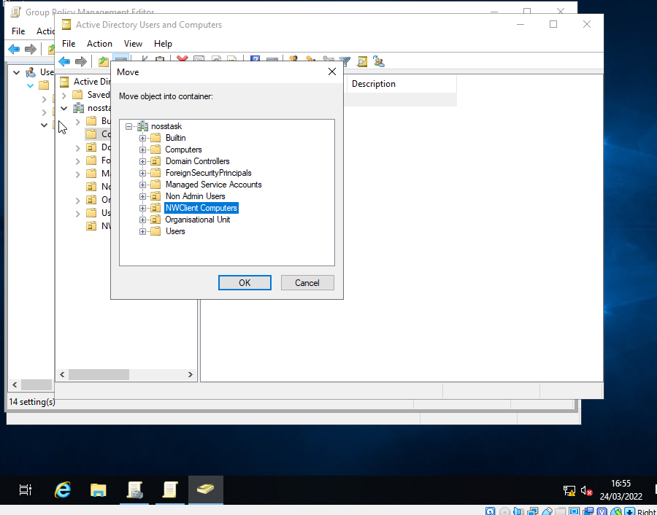
Similar to how policies were applied to user groups, a Group Policy is created and configured.
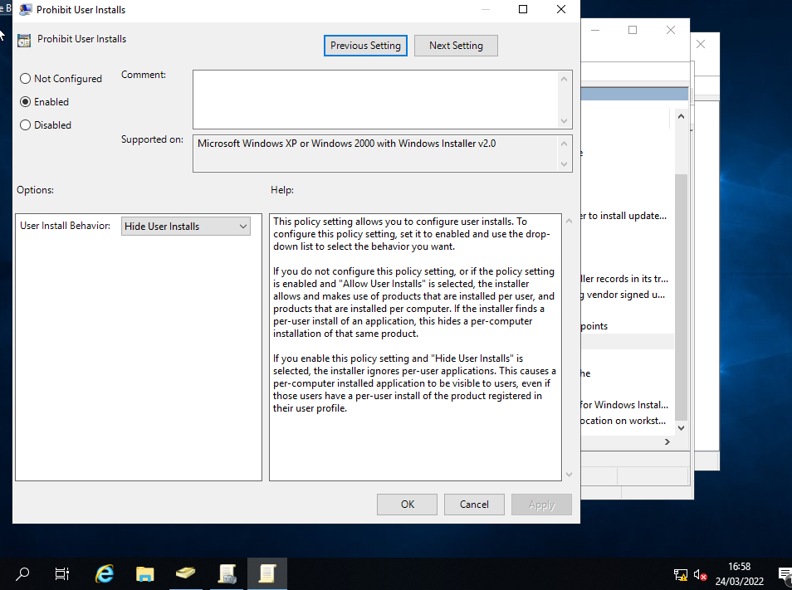
To test that this policy has applied, we will first need to connect our PC to the internet so that we can download some software to test. To this end, we will configure a second adapter to allow the virtual PCs to establish a connection.
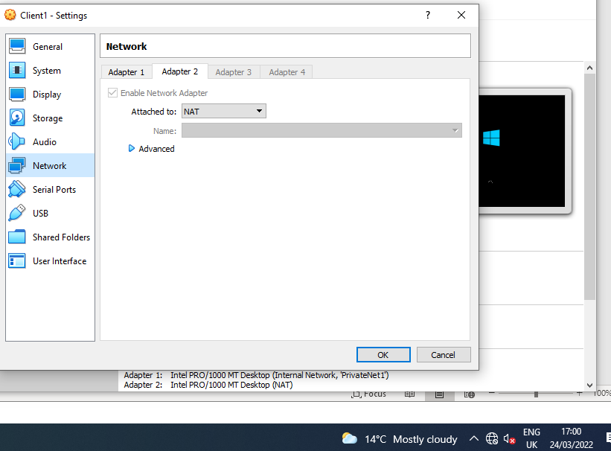
Once the computer can connect to the internet, we can search for a file to download and attempt to install.

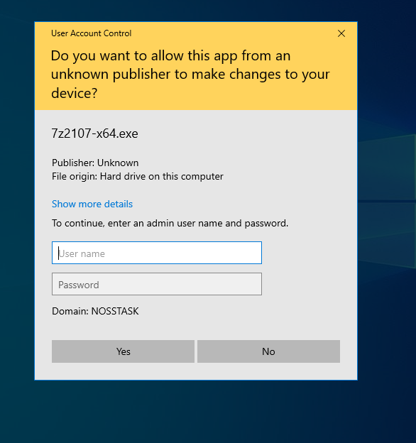
As intended, software installation is blocked and will require the credentials of a network administrator to proceed.
Another common network Group Policy is to enforce password requirements. For the fifth GPO, this will be configured at a domain level. Unlike previously, this will be applied to the whole server, and therefore will not require the establishment of an OU first.
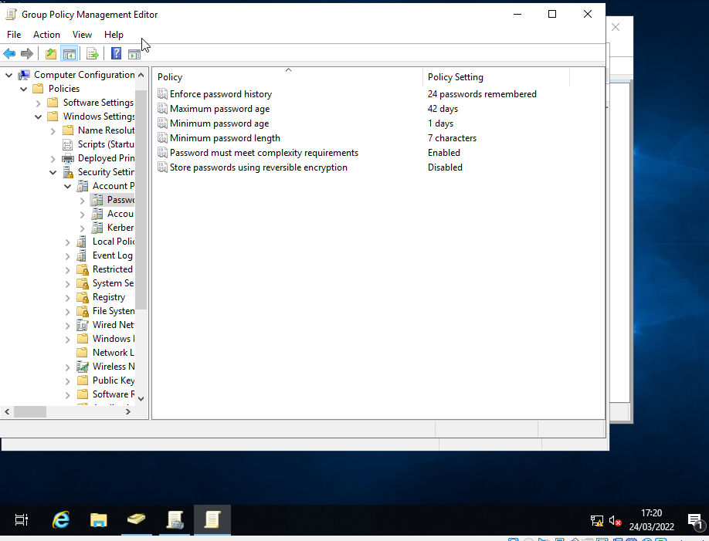
In the Group Policy Manager, this time the configuration is applied to nosstask.msft at a domain level. As demonstrated in the screenshot, different elements can be configured. This gives the network administrator a greater degree of control over what they wish the minimum password requirements on a network to be.
Once the update has again been forced by the administrator in Command Prompt, the policy can be tested.
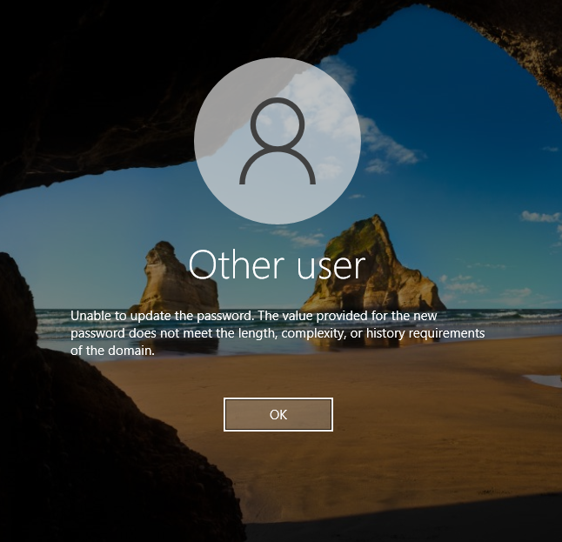

Task 2: ROUTING AND PACKET FILTERING WITHIN CORE TCP/IP SERVICES AND CRITICAL FAILOVER/REDUNDANCY PRACTICES

For the second assignment task, Routing and Remote Access Services will be explored firstly. To begin, using Command Prompt we pull up the ARP table.
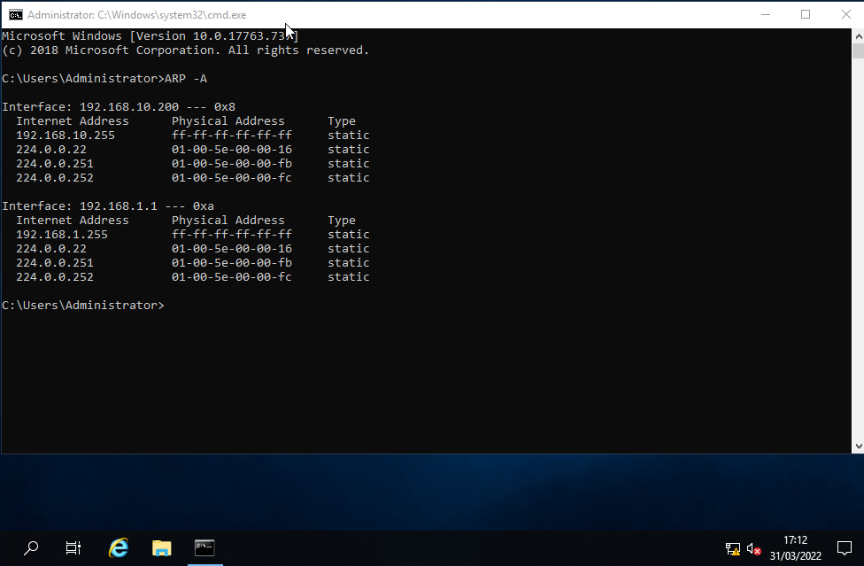
An ARP table is a kind of index, detailing which IP address relates to which physical device on a network.
Currently, the network consists of two separate local networks that cannot communicate. For the next step, an FTP Server will be configured on the network, on Server 2.
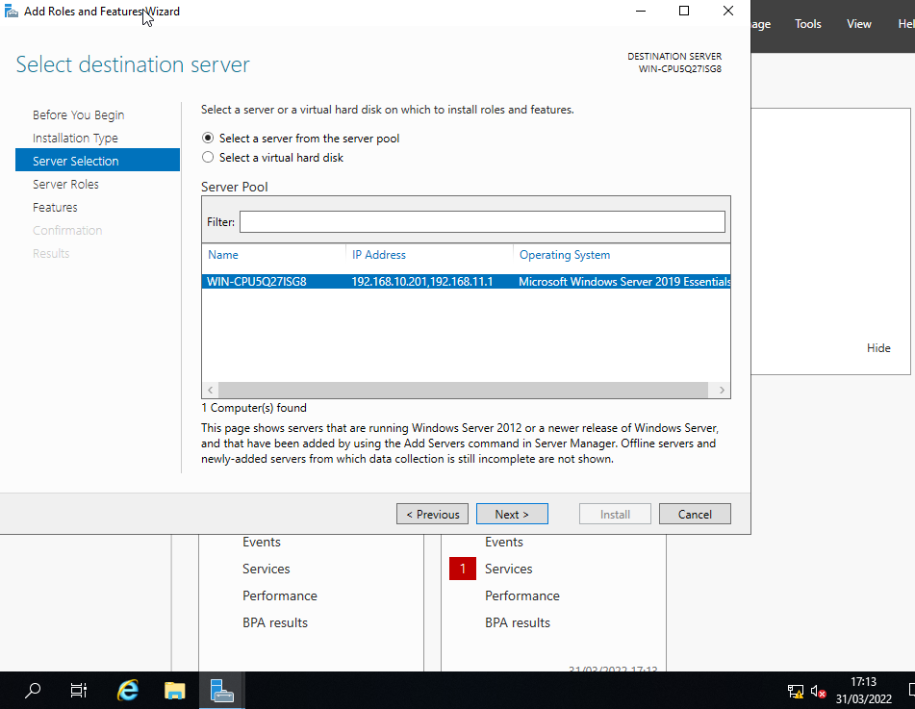
In Server Manager, Add Roles and Features is utilised to set this up. During the setup, we ensure Web Server (IIS) is enabled. As the Wizard proceeds, we make sure to select the desired FTP Server, and install.
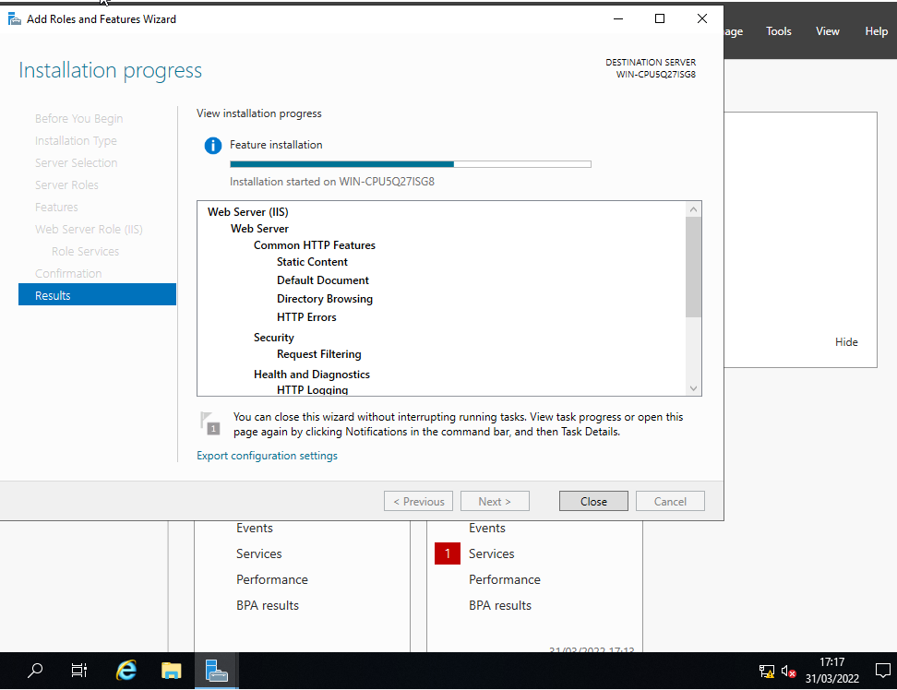
To test, some user accounts must be created on this currently local network.
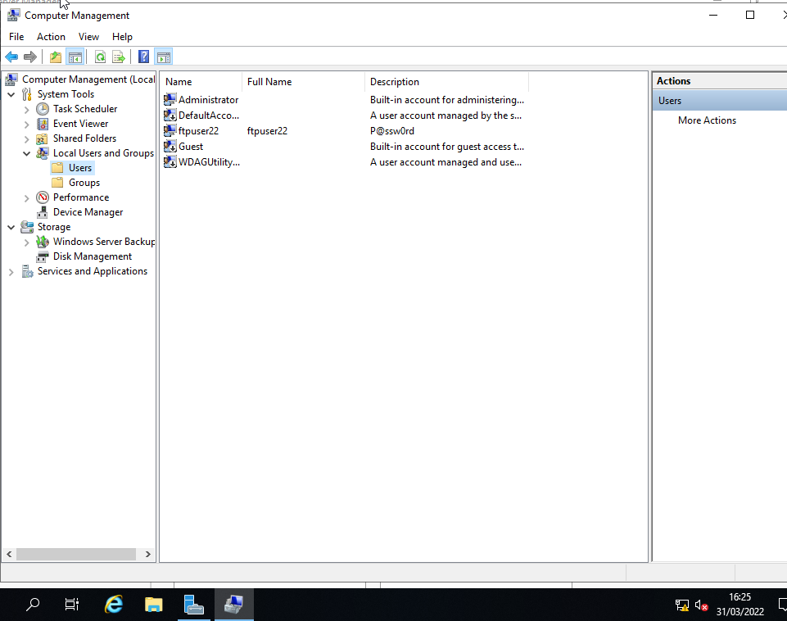
Ftpuser22 is used for the example.
Next, from Server Manager, we navigate to Tools, IIS Manager, and add an FTP site.
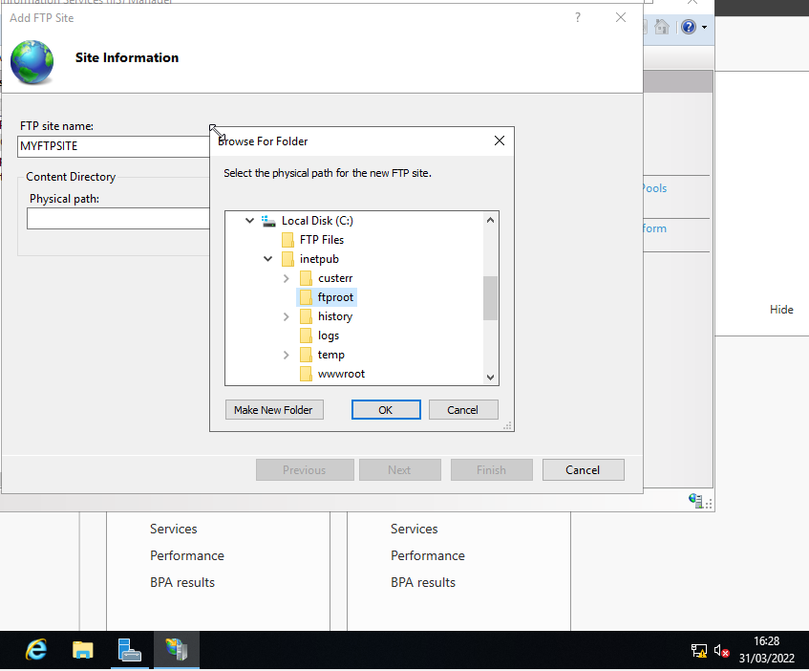
This is given a name and a root drive.
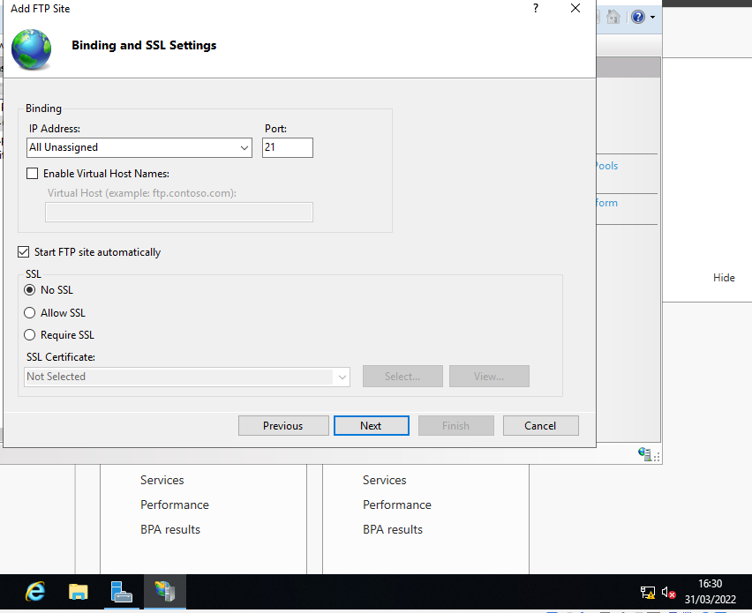
“No SSL” is selected, and Port 21 is used.
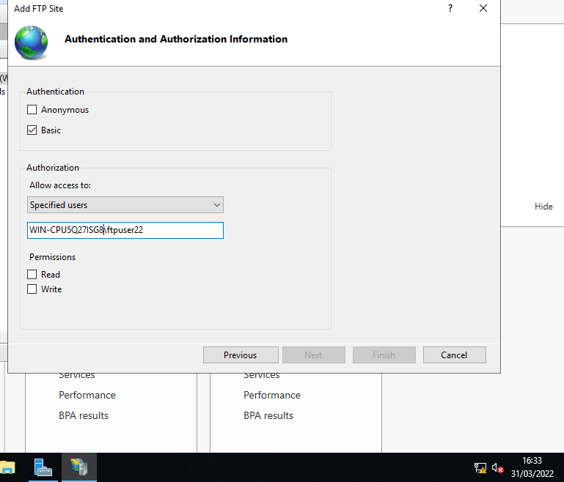
Basic authentication is selected, and permission will be granted to the specified user previously created. Read and Write permissions should both be granted, and with that the setup is complete.
Banners and messages can be setup to greet or inform users. From Server Manager – Tools – IIS, these can be configured.
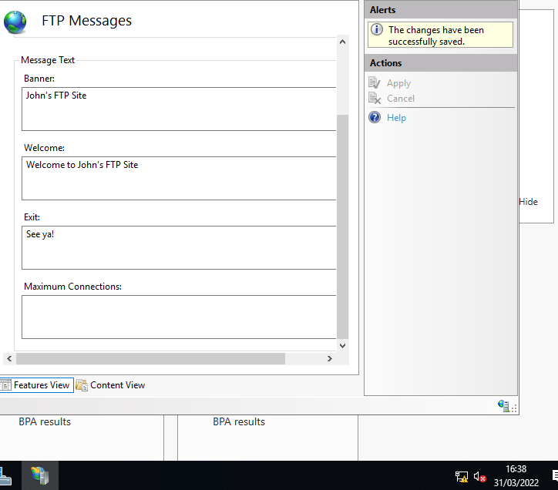
Next, permission must be set for ftpuser22.
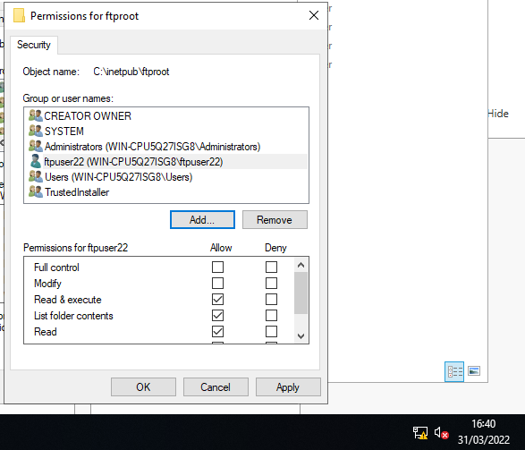
Now that an FTP Service is running on Server 2, a new folder is created (C:\Inetpub\ftproot\MyFtpuploads) and Firewalls are disabled to allow the task to carry out.
On the Client 2 VM (logged in as admin to access Command Prompt) a folder is created (MYFTPFiles) in which a text file is placed. Now, a connection is established with the FTP service.
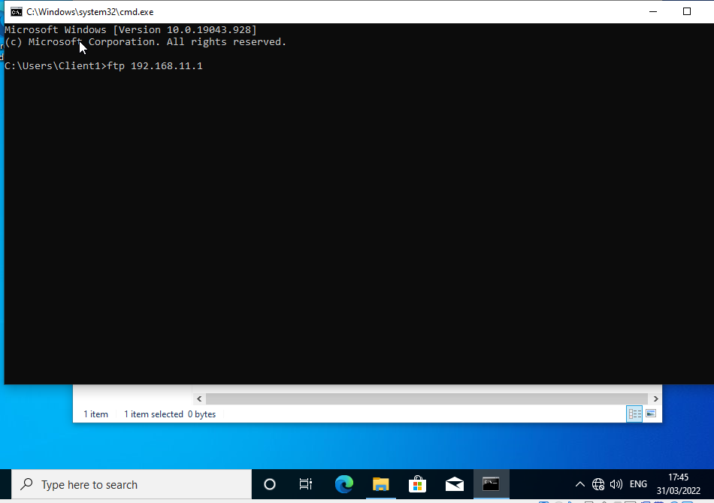
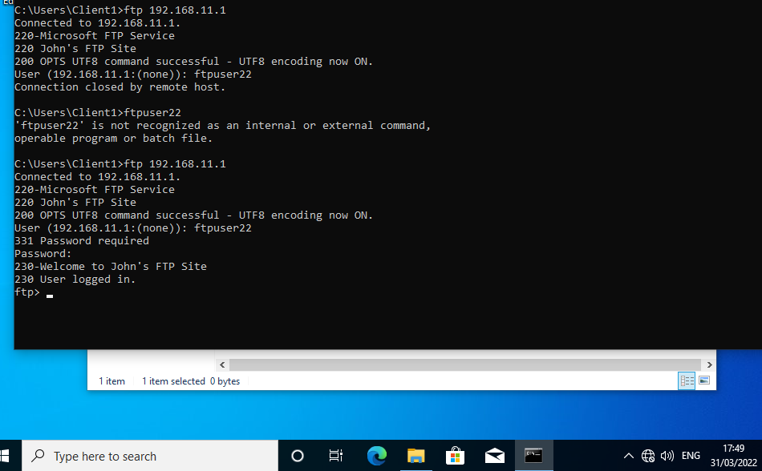
The connection is established as ftpuser22, and the service can be utilised.
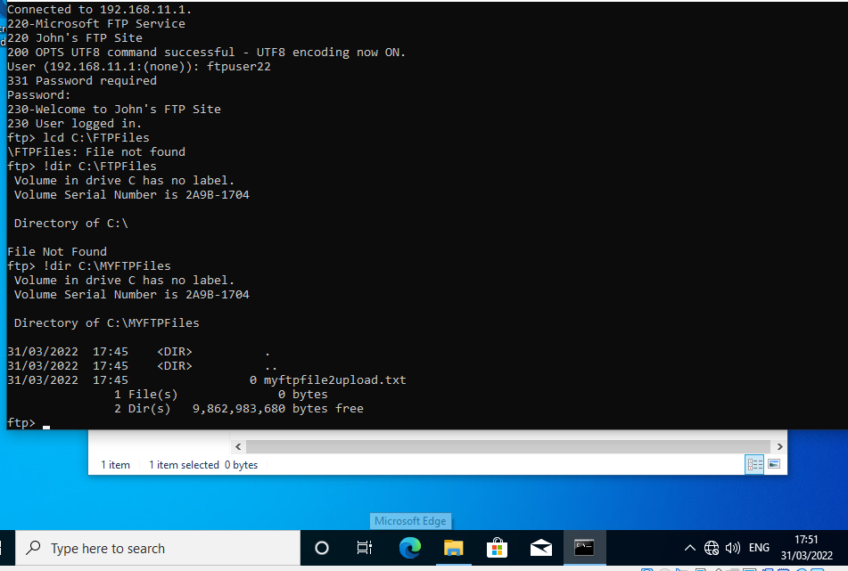
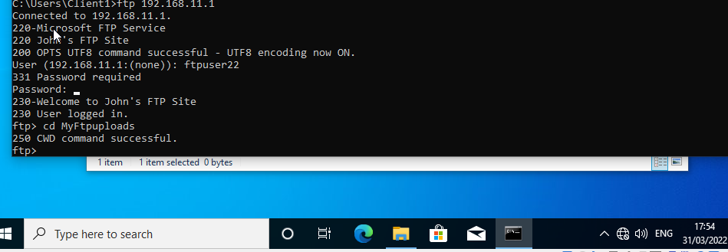
With these steps fulfilled, the file we created has been uploaded.
For the next step of building the network, the two separate local networks will be connected to form a Wide Area Network.
From Server Manager once more, Adding Roles and Features, the next step will be to configure remote access.
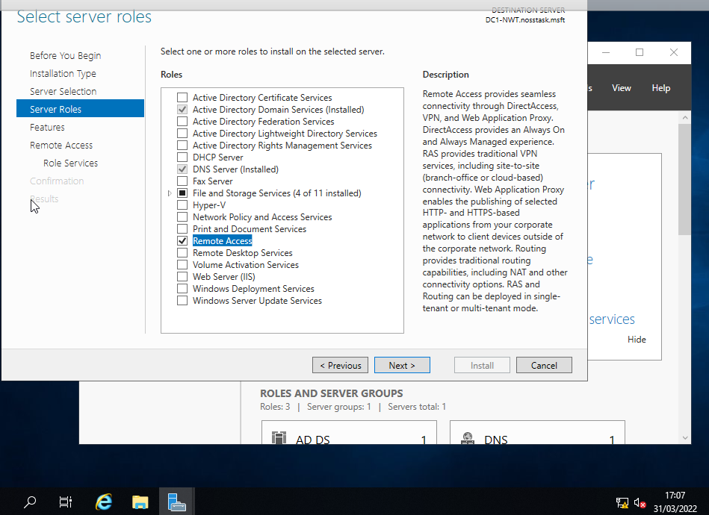
With DirectAccess and VPN checked, the feature can be installed.
Once again, a Window Wizard will walk through the steps of configuration. From here, “Deploy VPN only” will be selected. With the appropriate server then selected, Enable and Configure Routing and Remote Access can be selected, and from there, custom configuration. LAN Routing will be selected next, and the service started.
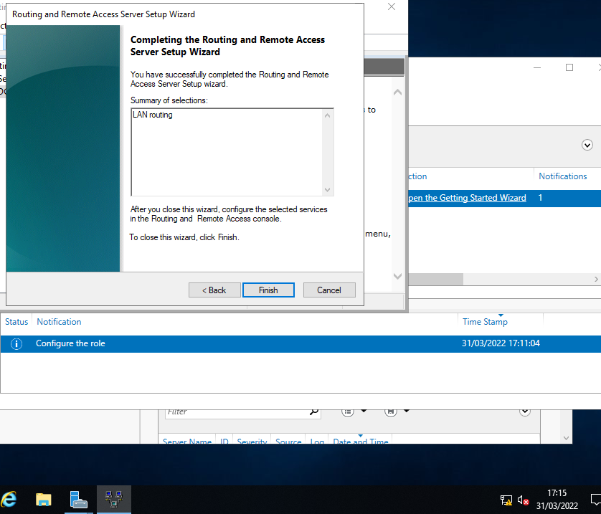
Now Routing Protocols must be enabled. Under the relevant server name, and IPV4, a New Routing Protocol can be established.
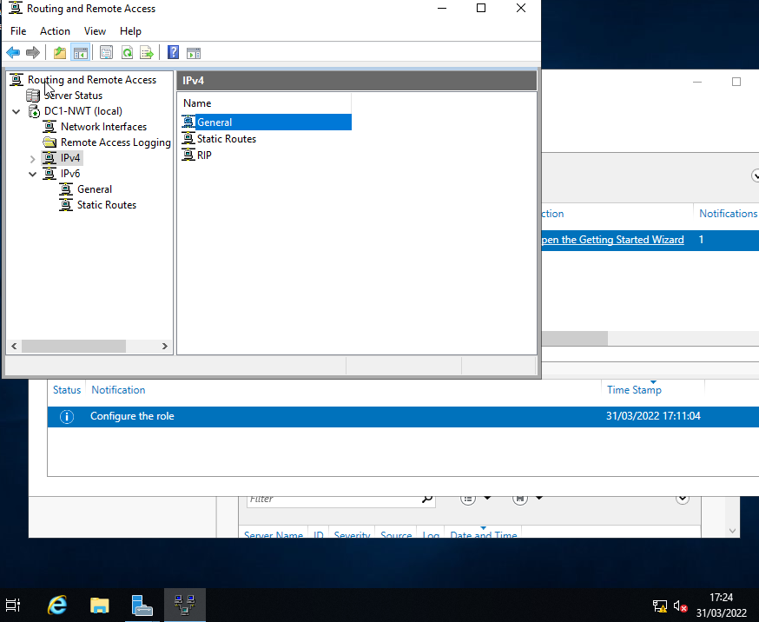
From RIP, New Interface is selected, and the two listed for the server can be selected.
These steps are repeated for Server 2, and then the Wide Area Network can be tested.
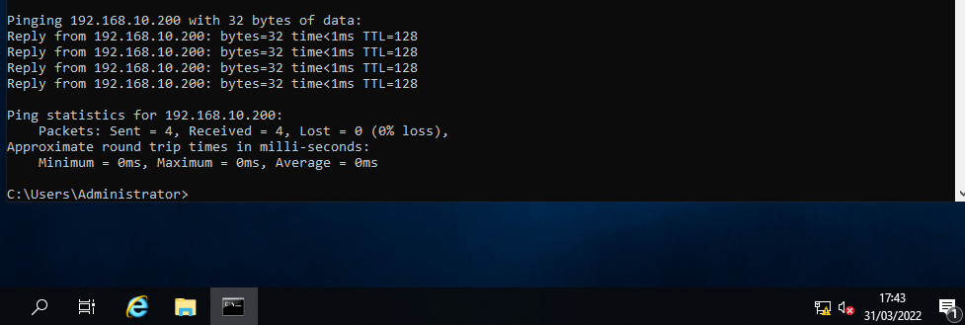
As demonstrated in this PING test, the previously separate networks can now communicate.
Finally, we will look at IP Packet Filtering – Microsoft’s basic firewall configuration service.
From Service Manager; Tools; Routing and Remote Access, IP Routing is selected, then PrivateNet1 selected for configuration.
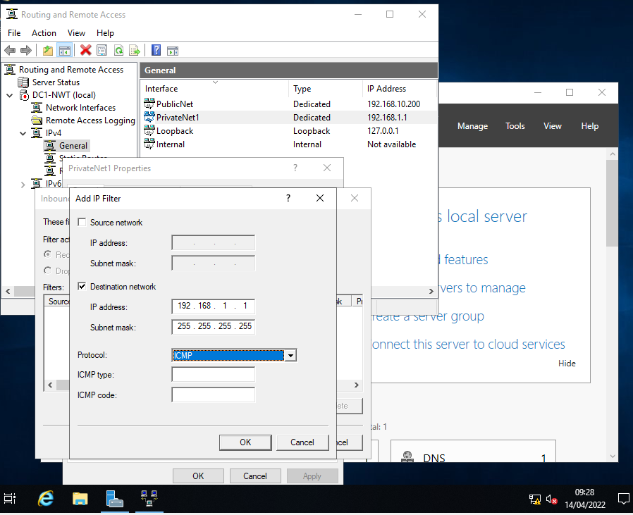
From Properties, a new filter can be set. Once the relevant network destination and IP address have been entered, ICMP should be selected as the protocol. There are two options presented which reduce to fundamentally include or exclude. First, “Receive all packets except those that meet the criteria below” will be selected.
Now, when a Ping test is conducted there is no reply, on account of the filter.
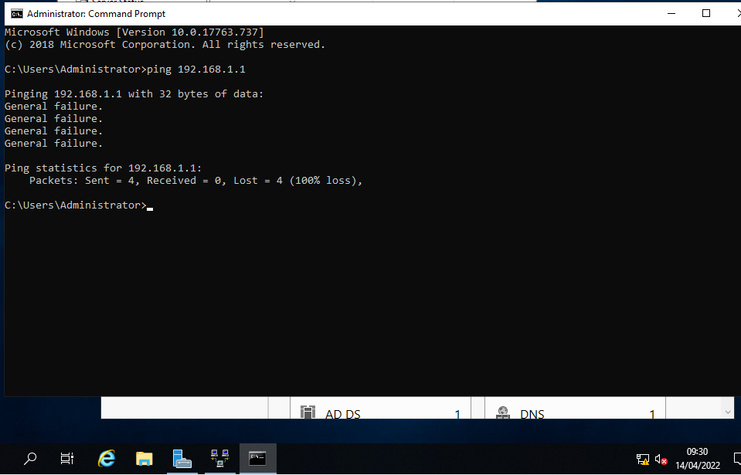
The filter is however specific to that destination, and so the other locations on the network will still function.
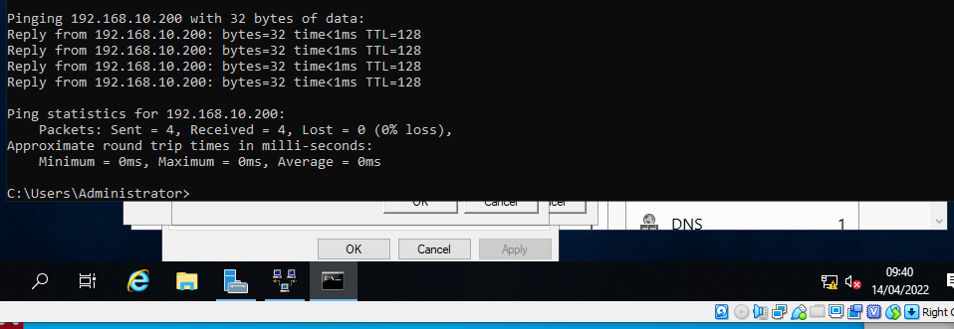
For the next exercise, an Outbound Filter will be established. Starting again from Server Manager, this time PublicNet will be configured. A new outbound filter will be created, and again, the appropriate destination set. This time, the Protocol will be TCP and the destination Port 21. Again, “Receive all packets except those that meet the criteria below”.
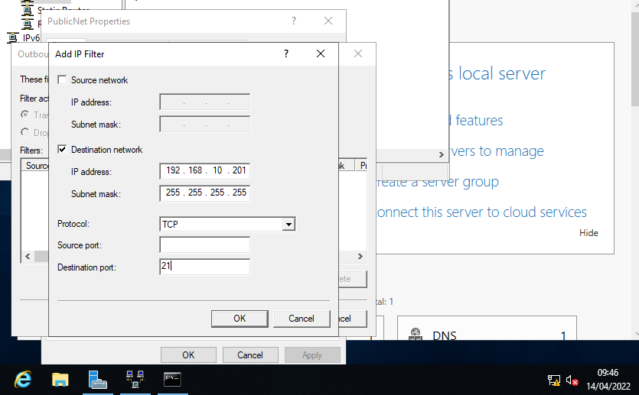
To test this filter, we change to Client 1.
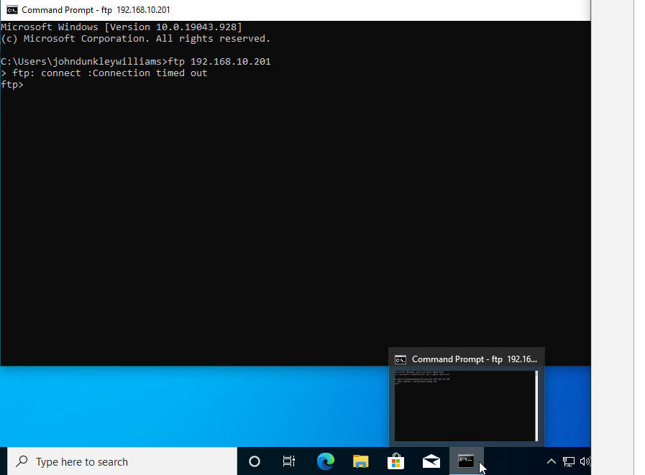
The third filter demonstration will only allow specific users in PrivateNet1 to access the FTP service. For this task, we were left to construct our own “rule” to restrict access to everyone except 192.168.1.1, using any of the methods available.
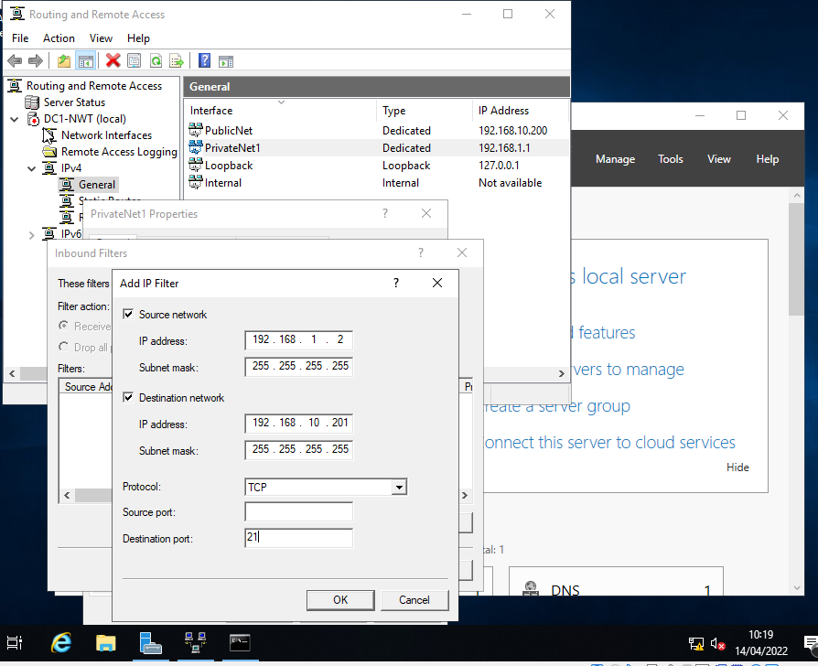
On Server 1, an IP filter is configured to affect the FTP Port (21) specifically, with both a source and destination specified. This is then repeated to specify the other possibility on this network.
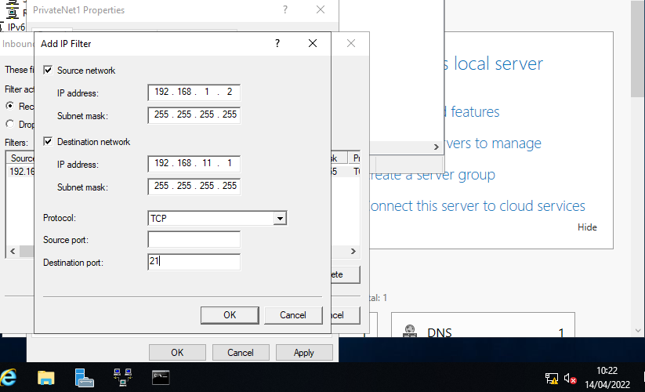
This has designated the specific source to allow, along with the FTP server destination.
This time, “Drop all packets except…” is selected, so that only the specified host is permitted to use the FTP server.
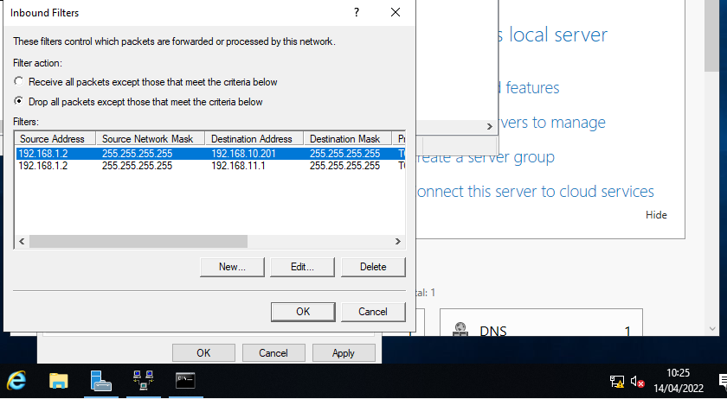

Task 3: Observations
The biggest security vulnerability in any IT system is the human. This is a common statement among IT professionals and can be evidenced in myriad cases, such as the WannaCry ransomware attack. The cybersecurity battlefield is constantly evolving, and there is an ever-present need to minimise risk in any way possible, and this includes training and policies applied to staff to attempt to reduce the risk of the human factor in a network.
One of perhaps the most basic measures is that of a password policy. It’s not even particularly technical by nature, but configuring a network policy to force users to use password of a minimal complexity value is a common way to minimise that human risk to a network.
“User-generated textual passwords suffer from the conflict between security and usability”. [1] From a user perspective, a password needs to be memorable in order to be usable. Most users are aware of the risk of a simple password, but they also need to be able to remember that password without writing it down. In this way, even a strong password becomes weaker by use across multiple platforms.
“ Das et al. (2014) found that approximately 43%–51% of users reused passwords, and approximately 20% of users chose the same strings for generating passwords for different accounts.” [1]
Similarly, stronger passwords are changed less frequently, because the user would need to think of a new strong password. Sometimes users plainly don’t place value on the data behind a password, such as using a date-of-birth to sign up for a newsletter. There are any number of understandable reasons for weak user passwords, but this is still the most common form of authentication, and thus a network administrator must take whatever steps they can to mitigate this vulnerability.
Among the businesses that faced cybersecurity incidents in the past 12 months, one-in-ten (11%) the most serious types of incidents involved careless employees. [2]
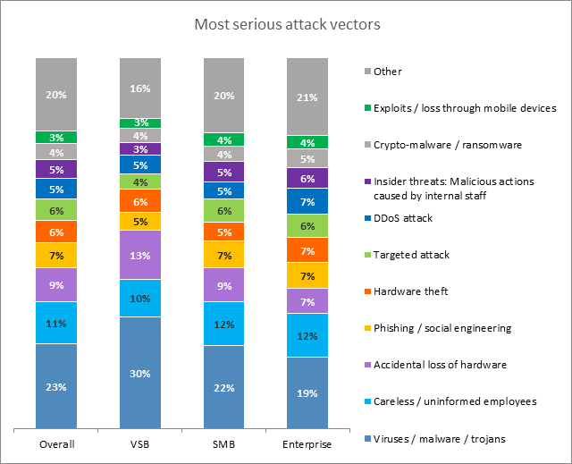
Source: IT Security Risks Survey 2017, global data

Excluding using more expensive technologies, such as biometrics, network administrators can configure a password policy, which will require users to use passwords of minimum length, to include numbers, special characters and so forth. Again, this can be a balancing act. Recommendations from security experts can be extreme:
Keeping in mind the nature of a brute force attack, you can take specific steps to keep the brutes at bay:
- Make it long. This is the most critical factor. Choose nothing shorter than 15 characters, more if possible.
- Use a mix of characters. The more you mix up letters (upper-case and lower-case), numbers, and symbols, the more potent your password is, and the harder it is for a brute force attack to crack it.
- Avoid common substitutions. Password crackers are hip to the usual substitutions. Whether you use DOORBELL or D00R8377, the brute force attacker will crack it with equal ease. These days, random character placement is much more effective than common leetspeak* substitutions. (*leetspeak definition: an informal language or code used on the Internet, in which standard letters are often replaced by numerals or special characters.)
- Don’t use memorable keyboard paths. Much like the advice above not to use sequential letters and numbers, do not use sequential keyboard paths either (like qwerty). These are among the first to be guessed. [3]
A network policy needs to suit the user too. Some example policy measures commonly used include
- No re-used passwords
- A minimum character length of 8-12 characters
- Include an uppercase letter
- Include a number
- Include a special character
Accompanied by routine user education to advise of best practice when it comes to password protection, and with a caveat that more sensitive systems have higher security requirements, such as not using successive or repeated characters (e.g. 123 or 111), this tends to be how most companies currently function, though there is always room to improve. [4]
Failover clustering is a term applied to the practice of at a basic level, providing backup services should the primary service fail. Clustered servers or “nodes” are connected so that if one should fail, the connected nodes take over service provision. [5]
Failover clustering is an essential part of maintaining High or Continuous Availability. In the modern world, we are highly dependent on service availability at all times. In the NHS Wales e-Library all system are required to provide a High Availability (HA) of 99.8%, because the information and evidence provided needs to be accessible to medical professions at any given time to support them in their work. More integral systems, such as those dealing with patient information or hospital systems need to be available 100% of the time. These are some obvious examples, but HA has become the default expectation of any digital service. [6]
The traditional approach to achieving high availability is having a complete copy of the required data on secondary nodes, which is naturally kept up-to-date. [7] The failover is just one aspect of maintaining High Availability, other required elements include
- Redundant components that can perform the same tasks
- Data replication
- Fault tolerance
These are not about providing a high quality service, only providing a constant one. [8]
A Failover Cluster can be created within the Windows OS. Each node must be running the same version of Windows Server. Ensure the hardware also meets necessary requirements to execute. Each server will need to have access to the storage and each node will need to be in the same Active Directory. [9]
From Windows Server Manager; Add Roles and Features, Failover clustering can be selected and installed. Next, it is strongly recommended that the configuration be validated. The Failover Cluster Manager first needs to be installed, then it can be used to run tests on the cluster.
Once the Failover cluster has been created, clustered roles can be added on each node to manage the cluster workloads. A Role can then be configured following the High Availability Wizard.
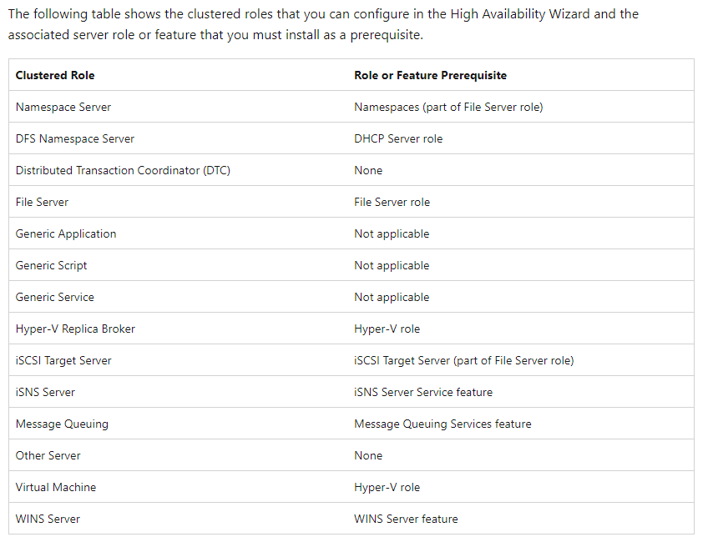
[9]
Whether it’s a healthcare system, automated vehicle sensors or some other system that if offline, has an immediate and severe impact on a persons life, or even a business in the modern economy; what started as a tool of convenience (the internet) has become integral and essential to the execution of numerous tasks that just couldn’t be performed to a appropriate standard by humans manually any more, High Availability has become essential as technology has developed.

Network Policy
The scope of this policy extends to all hardware and software on the network, in addition to all staff and users of IT equipment in the organisation.
Organisational Hierarchy
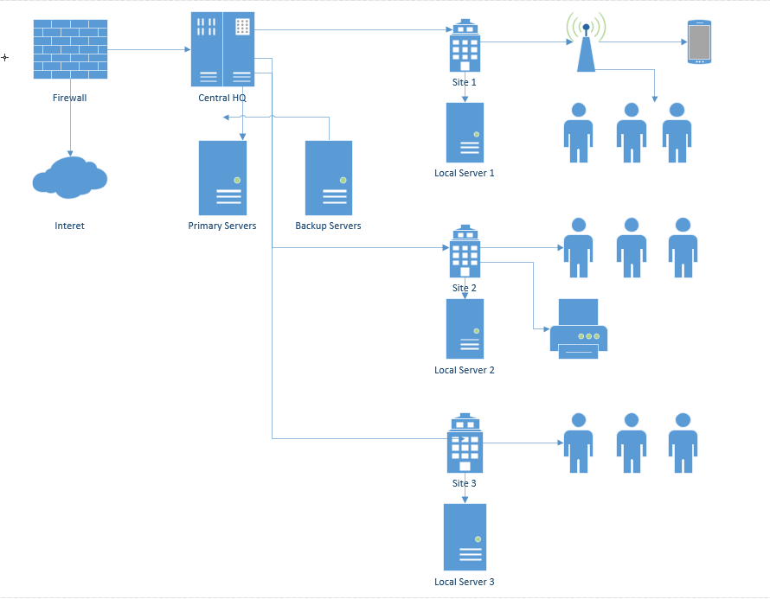
This network will be controlled centrally. Primary and backup servers will exist at separate locations containing organisation directories, databases, etc. The main internet connection for the organisation, as well as nationally utilised services, such as Microsoft Office 365, will be controlled and goverened from here.
National resources will be networked to multiple sites. These sites will each have locally controlled servers for services available locally. Print services, wireless access services and local users can be managed at a site level, while central will have administrator controls for the whole network.
Under the Networks Lead will be;
- Global Administrators
  - Local Administrators
    - Specified Access Administrators
      - End Users
The specificted access administrators would be authorised with specific permissions, such as for network maintenance, but not policy control for example.
Network Management Software (e.g. Solarwinds) will be implemented, and have dedicated administrators monitoring the network status.
Vital services (those requiring High Availability) will be managed by Central HQ.

Password Policy
The global user password policy will be;
- 8 characters minimum
- Must contain a number
- Must contain a special character
- Include an upper-case character
- No re-used passwords
- Must be changed at least monthly

Acceptable Use Policy
Users will be required to sign up to the organisational usage policy, this will include
- No illegal, or unethical use of resources
- Resources must not be used for personal gain, financial or otherwise
- Persons must take all reasonable steps to maintain network security
  - Follow password policy
  - Do not share personal details
  - Do not connect external hardware
  - Resources are to be used to work purposes only
  - Lock the Windows desktop when away from the computer

Network Security
Risk assessments will be carried out regularly to identify and test for network vulnerabilities.
Access to physical network equipment will be restricted to those whose job requires it. Visitors to secure network areas must be logged.
Measures will be in place to detect and protect against risks to the network from malicious software.
Any proposed changes to the network must be approved by the Network Lead, and escalated to directors when necessary.
All IT hardware and software must be risk assessed to identify possible vulnerabilities to the network. Those risks should subsequently be addressed and logged.
Staff should be risk assessed with regards to network access and permissions. Risks should be minimised as far as possible with training and network access restrictions across the organisation.

Disaster Recovery
In the event of physical server loss, the failover system will deploy immediately. Secondary servers are located at separate physical locations to mitigate risk.
In the event of loss of internet, systems can continue to function in “offline mode” and resynchronise when connection is restored. This task should be closely monitored to ensure data integrity upon synchronisation.
Where communication is essential, locally placed mobile devices can be “tethered” in order to restore internet connectivity on an independent network.
In the event of a security breach, the effected system should be immediately disconnected, and failover systems deployed.
In the event of a data breach, all staff must be notified as quickly as possible to change passwords and secure personal data.
Failover systems maintain up to date copies of all server data with daily, weekly, monthly and 3 monthly restore points should the need arise to revert to an earlier version of the data.
Communication channels are detailed in advance in order to maximise the efficiency of communication in the event of a disaster.

Enforcement
Any employee that does not adhere to this policy may face disciplinary action.

[10] [11] [12] [13]

References

[1] | Y. e. a. Guo, “Optiwords: A new passowrd policy for creating memorable and strong passwords,” Computers & Security, vol. 85, pp. 423-435, August 2019.
[2] | Kaspersky, “The Human Factor in IT Security,” Kaspersky, 2018. [Online]. Available: https://www.kaspersky.com/blog/the-human-factor-in-it-security/. [Accessed 22 April 2022].
[3] | Avast, “Strong Password Ideas,” Avast, 19 April 2022. [Online]. Available: https://blog.avast.com/strong-password-ideas. [Accessed 22 April 2022].
[4] | NHS Digital, “Password policy guide,” NHS Digital, 27 October 2021. [Online]. Available: https://digital.nhs.uk/about-nhs-digital/corporate-information-and-documents/password-policy-guide---example-guide#:~:text=As%20a%20best%20practice%20guide,of%20more%20than%204%20characters.. [Accessed 22 April 2022].
[5] | Microsoft, “Failover Clustering Overview,” Microsoft, [Online]. Available: https://docs.microsoft.com/en-us/windows-server/failover-clustering/failover-clustering-overview. [Accessed 22 April 2022].
[6] | B. Lutkevich, “High Availability,” TechTarget, April 2021. [Online]. Available: https://www.techtarget.com/searchdatacenter/definition/high-availability. [Accessed 22 April 2022].
[7] | G. e. a. Graefe, Instant Recovery with Write-Ahead Logging, Second ed., Waterloo: Morgan & Claypool Publishers, 2016.
[8] | Cisco, “What is High Availability?,” Cisco, [Online]. Available: https://www.cisco.com/c/en/us/solutions/hybrid-work/what-is-high-availability.html. [Accessed 22 April 2022].
[9] | Microsoft, “Create a Failover Cluster,” Microsoft, 2 November 2022. [Online]. Available: https://docs.microsoft.com/en-us/windows-server/failover-clustering/create-failover-cluster. [Accessed 22 April 2022].
[10] | theteacher.info, “Network Policies,” theteacher.info, [Online]. Available: http://theteacher.info/websites/gcse_comp/WebPages/A451_CompSys/216_CommsNetworks/Networks/h/h.html. [Accessed 25 April 2022].
[11] | P. Biswas, “Example of Policy on Use of Network Resources and Services,” 1 February 2020. [Online]. Available: https://preteshbiswas.com/2020/02/01/example-of-policy-on-use-of-network-resources-and-services/. [Accessed 25 April 2022].
[12] | NHS England, “Network Security Policy,” 01 January 2015. [Online]. Available: https://www.leedsccg.nhs.uk/content/uploads/2015/01/Network-Security-Policy.pdf. [Accessed 25 April 2022].
[13] | T. Lee, “What might go wrong with LAN design and implementation,” The Journal of Computer Information Systems, vol. 42, no. 2, pp. 51-56, 2002.

