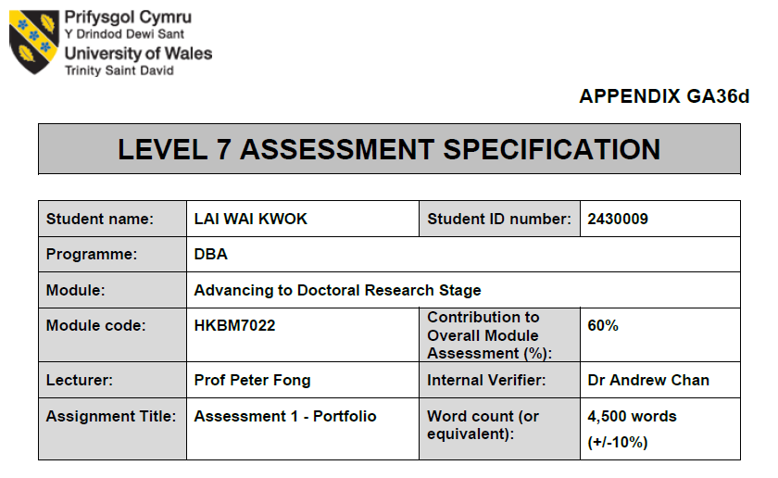

- Summarise research proposal (RP).
There are many non-governmental organisations and government departments in Hong Kong that have youth uniformed teams. Although the missions of each team are different, it is generally believed that participating in uniformed teams can help enhance young people's self-confidence, discipline, leadership skills, teamwork, and community service, and serve as an important platform for cultivating good citizens.

In Hong Kong, there is a certain history of youth uniformed teams established by the civil or government disciplined forces and auxiliary forces. The SAR Government has consistently regarded civilian uniformed groups as important partners in promoting youth development work and has provided them with regular funding. The policy objectives include establishing positive values among young people, deepening their understanding of Chinese cultural traditions, and encouraging them to participate in voluntary work. The goals of youth development work in the government's disciplined forces and auxiliary forces include cultivating young people's law-abiding and patriotic sentiments, so that they can equip themselves and contribute to society.

In terms of the number of youth participants, the total number of members in subsidised civilian youth uniformed groups has remained at around 100,000 in recent years. As of the end of December 2023, there were more than 280,000 youth participants in Hong Kong. Uniformed groups play an important role in Hong Kong's education system. These groups include:
These groups include youth uniformed groups funded by the Home and Youth Affairs Bureau (HAYB.gov.hk, 2023):
1. Scout Association of Hong Kong
2. The Hong Kong Girl Guides Association
3. Hong Kong Sea Cadet Corps
4. Hong Kong Adventure Corps
5. Hong Kong Red Cross Youth
6. Hong Kong St. John Ambulance Brigade Youth Command
7. The Boys' Brigade, Hong Kong
8. The Girls' Brigade Hong Kong
9. Hong Kong Road Safety Patrol
10. Association of Hong Kong Flag-guards
11. Hong Kong Army Cadets Association

The Youth Uniform Team of the Security Bureau includes (Legislative Council, n.d.):
1. Junior Police Call (JPC)
2. Fire and Ambulance Services Teen Connect (FAST Connect)
3. Immigration Department Youth Leaders Corps
4. Customs YES
5. Rehabilitation Pioneer Project of the Correctional Services Department (CSD)
6. Civil Aid Service (CAS) Cadet Corps
7. Hong Kong Air Cadet Corps
8. Auxiliary Medical Service (AMS) Cadet Corps
These groups help students develop leadership, teamwork and social responsibility through various activities and training. With the rapid development of society and the economy, students' career choices have become increasingly diverse, and uniform groups may play a significant role in this process.

This study aims to explore the impact of uniformed groups on students' career choices in Hong Kong and to analyse how these groups influence students' professionalism and career development through various activities and training.

Research questions
1. How do uniform groups affect students' career choices?
2. What is the impact of uniform groups on the cultivation of students' professional literacy?
3. What is the long-term impact of uniform groups on students' career development?

- The strengths, weaknesses, and limitations of the study within the body of literature in the field.
At the current stage of the literature review, this study faces particular difficulties in establishing a comprehensive literature framework.

First, there are relatively few published articles or research results on this topic and subject. At present, it is necessary to try to search on different literature publishing platforms and use different tools in a short period to find suitable and valuable articles and papers, which will help understand the current situation of the research field, master relevant theories and research methods, and establish the research framework on this basis.

Second, due to the relatively small amount of literature reading at this stage, the gaps and problems in the research have not been effectively identified. In the writing stage of this study, the deficiencies and unresolved problems in the research field could not be identified through the comprehensive analysis of existing literature, thereby providing direction and motivation for new research.
Third, the content of this study cannot support the research hypothesis and argumentation. The temporary literature review cannot provide theoretical and empirical support for the hypothesis proposed in this article, nor can it enhance the persuasiveness and credibility of the research.

Fourth, at this stage, repeated research and the resulting findings cannot drive progress. Failure to understand the achievements and limitations of previous research does not help it avoid repeating research and cannot lead to innovations based on existing results.

Fifth, the significance and value of the research cannot be established at this stage. There is insufficient literature review, and the research's contribution to a specific field cannot be clearly demonstrated, nor can its value and importance be highlighted.

Sixth, the design and methods of the research have not been effectively improved. The experience gained from previous studies has not been fully leveraged, and it cannot help choose more appropriate research methods, data collection, and analysis methods to improve the scientificity and effectiveness of the research.

Seventh, the credibility of the research has not been effectively enhanced at this stage. There are insufficient citations of relevant literature, and the academic foundation of the research cannot be adequately demonstrated, which significantly reduces the credibility and persuasiveness of this research.

Although the above difficulties existed at the beginning of this study, it is necessary to continue making efforts and reading the literature review in order for the conclusions of this study to help promote the career development of Hong Kong students.

There are relatively few articles or research results on this research topic and subject, which also means that this study has more room to design the research framework.

The preliminary research framework is conceived as follows:
- Definition and history of uniformed groups
Uniformed groups refer to organisations that require members to wear uniforms and participate in specific activities. These groups typically have clear goals and values, helping members develop various skills and qualities through a range of activities and training. The history of uniformed groups can be traced back to the late 19th and early 20th centuries, when some countries began to establish scouts and other similar organisations to cultivate leadership and social responsibility among young people.

- Development of uniformed groups in Hong Kong
Uniformed groups in Hong Kong have a long history. These groups play a crucial role in Hong Kong's education system and are widely supported by the government and society. Uniformed groups in Hong Kong include Scouts, Girl Guides, Red Cross, and the Flag Raising Team Association. These groups help students develop various skills and qualities through a range of activities and training.

- The impact of uniformed groups on students' career choices
Existing studies have shown that uniformed groups help students develop leadership, teamwork, and social responsibility through various activities and training, and these qualities have an important impact on students' career choices. For example, students who participate in Scouting may be more inclined to choose careers that require leadership and teamwork skills, such as management positions or public service positions.

The limitations of this research proposal are that the data collected may be mainly from teenagers who actively participate in uniformed groups. Most of these teenagers have enthusiasm, family support, or social support, which may lead to overestimating the role of participating in uniformed groups.

Gender, disability, ethnic minorities and other youth groups may not be fully explored in this study.

- Discuss how the use of another method as an alternative approach in research design can be employed to conduct research on the topic and address the shortcomings in the RP. (1,500 words)
Research Methods
3.1 Research Design
This study adopts a combination of qualitative and quantitative research methods to collect data through questionnaire surveys and in-depth interviews. The questionnaire survey will be conducted on Hong Kong secondary school students, and the in-depth interviews will be conducted on students and instructors who have participated in uniform groups.

3.2 Data Collection Methods
The questionnaire survey will design a series of questions covering students' background information, experience in participating in uniform groups, career choices and professional qualities. The in-depth interviews will utilise an interview outline to gain a comprehensive understanding of students' and instructors' views and experiences regarding uniform groups.

3.3 Data Analysis Methods
The questionnaire survey data will be statistically analysed, including descriptive statistics and inferential statistics. The in-depth interview data will be content analysed to identify and analyse themes and patterns in the interviews.

3.4 Research Subjects and Sample Selection
The research subjects include Hong Kong secondary school students and instructors of uniform groups. The sample selection will adopt a combination of random sampling and purposive sampling. The questionnaire survey will randomly select students from multiple schools, and the in-depth interviews will select students and instructors with rich experience.

3.5 Limitations of the study
The limitations of this study include limitations in sample selection and limitations in data collection methods. Due to limitations in sample selection, the research results may not be universal. Additionally, the data collection methods, such as questionnaire surveys and in-depth interviews, may also be subjective and biased.

- The expected findings/results of the research
Research results
4.1 Direct impact of uniform groups on students' career choices
The research results suggest that students who participate in uniform groups are more likely to choose careers that require leadership and teamwork skills. For example, many students who participated in the Boy Scouts said that they were more inclined to choose management positions or public service positions because these positions require the skills they learned in the uniform groups.

4.2 The cultivation of students' professional qualities by uniform groups
Uniform groups can help students develop leadership, teamwork, and social responsibility through various activities and training, and these qualities have a significant impact on students' career choices. For example, students who participated in the Red Cross program said that they learned how to make decisions in emergencies as part of the group, which is very helpful for their future career development.

4.3 Long-term impact of uniform groups on students' career development
The research results suggest that students who participate in uniform groups are more competitive in their career development and are more likely to succeed in their careers. For example, many students who participated in the Youth Army said that the leadership and teamwork skills they learned in the group helped them succeed in their careers.

Contribution of the study
This study examined the role of uniformed groups in Hong Kong's education system and offered valuable insights for education policy and practice. The results suggest that uniform groups have a positive impact on students' career choices and career development, providing valuable insights for education policymakers and practitioners.

This study attempted to explore the impact of uniform groups on the career choices of Hong Kong students. The results may suggest that uniform groups have a significant impact on students' career choices and development through various activities and training. Uniformed groups help students develop leadership skills, teamwork skills and social responsibility, which have a positive impact on students' career choices and career development.

Practical application of the study
The results of this study can provide valuable suggestions for education policymakers and practitioners to help them better utilise uniformed groups to enhance students' professional literacy and career development. For example, education policymakers can strengthen their support for uniformed groups and incorporate them into the education system to enhance students' professional literacy and career development.

Suggestions for policy and practice
Education policymakers should strengthen their support for uniformed groups and incorporate them into the education system to enhance students' professional literacy and career development. For example, more funds and resources can be provided to support the activities of uniform groups, and schools and communities can be encouraged to organise more uniform group activities.

Suggestions for future research
Future research can expand the sample range and adopt more diverse data collection methods to explore further the impact of uniform groups on students' career choices and career development. For example, a long-term follow-up study method can be used to track students' career development after participating in uniform groups.

