Database Coursework Submission Template
1. Student Details
- Name: Dolapo Farouk owolabi
- Student ID: 2518096
- Module: Introduction to Web and Database Concepts
- Lecturer: Anum Paracha
2. Table of Contents
(Use automatic table of contents in Word)
3. Introduction
- Overview of MediLink Pharmacy scenario
Medlink pharmacy is a community provides a range of healthcare services, for example include dispensing prescription medications, selling over-the-counter medicines, managing pharmaceutical stock, and offering professional advice to customers, prescriptions, suppliers, and medicines continues to increase, maintaining records using manual methods becomes inefficient, time-consuming, and susceptible to errors. To address these challenges, a relational database system is proposed to store, organize, and manage pharmacy data in a structured and secure manner. Modern pharmacy information systems also play an important role in improving workflow efficiency, inventory control, and patient safety by providing reliable access to healthcare information and supporting clinical decision-making
[1].
- Purpose of the database system
4. Scenario Analysis
- Identify entities = Identifying entities for an online bookstore system
The process of identifying entities begins by extracting distinct, uniquely identifiable objects or concepts that the system must track this form the core building blocks of the database schema and underpin all web interactions such as browsing, searching and submitting requests. The requirements include user accounts, book details, author information, borrowing records, and reservation status. Key entities emerge: User (with attributes like user ID, name, email, and account type), Book (ISBN, title. Publication year, and category), Author (author ID, full name, and biography), Borrowing (transaction ID, borrow date, due, and return status). Each entity is distinguished by a primary key to ensure unique identification, and relationships are defined between them, for example, one User may initiate multiple borrowing or reservation records, while one Book can be linked to multiple Authors and may appear in many transaction entries. Proper entity identification avoids data redundancy, maintains consistency between web input forms and stored data, and simplifies future development of features like real-time availability checks or personalized recommendations [2].
- Relationships between entities = Relationships between entities for an online Bookstore system.
For Web-based online bookstore system, defining clear relationships between the identified entities such as User, Book, Author, Borrowing, and reservation ensures data consistency, reduces redundancy, and enables seamless interaction between front-end web pages and the back-end database. One-to many relationships exists between User and borrowing, as one registered user have to submit multiple borrowing requests over time, but each individual borrowing record belongs to exactly one user; similarly, one User can create many reservations, though each reservation, the relationship is also one-to-many, since a single title can be borrowed or reserved by different users at different times, while each transaction refers to one specific book. A critical many-to-many association connects Book and Author: one book may be written by several contributors, and one author may publish numerous works, which means require an intermediate linking table to store the paired identifiers and avoid repeating the author or book details unnecessarily. These shows connections govern how foreign keys are assigned across tables, ensuring that web forms correctly reference related records and that queries such as “show all books by this author” or “list my active loans” return accurate results [2]

5. Entity Relationship Diagram (ERD)
- Insert ERD diagram here

6. Data Structure Design
- Tables created
Entity Name | Primary Key (PK) | K)Other Attributes | Foreign Keys (FK)
User | user_id | first_name, last_name, email, password_hash, account_type, registration_date
Author | author_id | full_name, birth_year, country, biography
Book | isbn | title, publication_year, publisher, genre, total_copies, available_copies
Book_Author | book_author_id |  | isbn (FK → Book), author_id (FK → Author)
Borrowing | borrow_id | borrow_date, due_date, return_date, status | user_id (FK → User), isbn (FK → Book)
Reservation | reservation_id | request_date, expiry_date, reservation_status | user_id (FK → User), isbn (FK → Book)

- Field names and data types

Left Entity | Relationship | Right Entity | Cardinality (Left → Right)
User | places / has | Borrowing | 1 to (0,N)
User | creates / holds | Reservation | 1 to (0,N)
Book | appears in / included in | Borrowing | 1 to (0,N)
Book | is subject of / reserved in | Reservation | 1 to (0,N)
Book | written by / authors | Author | (0,N) ↔ (1,N)

- Relationships and constraints
Left Entity | Relationship | Right Entity | Cardinality (Left → Right)
User | places / has | written by / authors | 1 to (0,N)
User | creates / holds | Reservation | 1 to (0,N)
Book | appears in / included in | Borrowing | 1 to (0,N)
Book | is subject of / reserved in | Reservation | 1 to (0,N)
Book | written by / authors | Author | (0,N) ↔ (1,N)

7. Normalisation (Up to 3NF)
- Show steps of normalization
- Explain decisions
Step 0: starting unnormalized Data:

user_id | user_name | user_email | book_isbn | book_title
u001 | John brown | Johnbrown@gmail.com | 978-1234 | How to win friends& infulence people
u001 | John brown | Johnbrown@gmail.com | 978-5678 | The gifts of imperfection
U002 | Samuel long | Samuellong@gmail.com | 978-1234 | The road less traveled
The issue with these multiple authors in one field; repeating User/book details; no unique row identifier.
Step 1: convert to First Normal Form(1NF)
- Split multi-value authors into separate rows (atomic values only)
- Added unique borrow_id as primary key
- Removed repeating groups, all fields hold one value per row

borrow_id (PK) | user_id | user_name | user_email | book_isbn | book_title | author_name | borrow_date | due_date | return_date
B001 | U001 | John brown | Johnbrown@gmail.com | 978-1234 | 1984 | George Orwell | 2026-06-01 | 2026-06-22 | 2026-06-20
B002 | U001 | John brown | Johnbrown@gmail.com | 978-1234 | Pride and Prejudice | Jane Austen | 2026-06-01 | 2026-06-22 | 2026-06-20
B003 | U001 | John brown | Johnbrown@gmail.com | 978-5678 | One Hundred Years of Solitude | Gabriel García Márquez | 2026-06-05 | 2026-06-26 | NULL
B004 | U002 | Samuel long | Samuellong@gmail.com | 978-1234 | Beloved | Toni Morrison | 2026-06-10 | 2026-07-01 | NULL

The problem: User/book/author details repeat across rows; updating a name requires changing every matching entry; high risk of inconsistent data.
Step 2: convert to Second Normal Form
- Split the combined table into separate tables for distinct entities
- Removed partial dependencies: attributes now depend only on their full primary key
- Created foreign keys to link related tables
2NF:
- User (user_id PK): user_name, user_email
- Book (book_isbn PK): book_title
- Author (author_id PK): author_name
- Borrowing (borrow_id PK; user_id, book_isbn FKs): borrow_date, due_date, return_date
- Book Author (book_isbn, author_id composite PK): links books to their authors

The problem: No transitive dependencies fixed yet; e.g. if we added author_country to Author, or publisher_location to Book, these would depend on author_id/publisher rather than directly on the primary key.

Step 3: convert to Third Normal Form
- Removed all transitive dependencies: non-key fields depend only on the primary key, never on another non-key field
- Added dedicated tables for related attributes, fully matching your ERD design

Table Name | Primary Key | Foreign Keys | All Other Attributes
User | user_id |  | first_name, last_name, email, password_hash, account_type, registration_date
Author | author_id |  | full_name, birth_year, country, biography
Book | isbn |  | title, publication_year, publisher, genre, total_copies, available_copies
Book_Author | book_author_id | isbn (FK → Book), author_id (FK → Author)
Borrowing | borrow_id | user_id (FK → User), isbn (FK → Book) | borrow_date, due_date, return_date, status
Reservation | reservation_id | user_id (FK → User), isbn (FK → Book) | request_date, expiry_date, reservation_status

The Good use of 3NF model
- User, book, and author details are stored only once
- only need to be made in one place
- Relationships are enforced via foreign keys
- Matches industry standards and works seamlessly with your ERD and SQL implementation

Kumara, K. G. S., et al. “A Scenario-based ER Diagram and Query Generation Engine.” 2019 4th International Conference on Information Technology Research (ICITR), Moratuwa, Sri Lanka, 2019, pp. 1–6. doi: 10.1109/ICITR49409.2019.9407793.

8. Sample Data
- Insert screenshots or tables (minimum 5 records per table)
User
user_id | first_name | last_name | eemail | account_type | registration_date
U001 | Junior | king | Juniorking@gmail.com | Student | 2025-09-12
U002 | Sam | Patel | SamPatel@gmail.com | Standard | 2025-10-03
U003 | Elena | Rossi | Elenarossi@gmail.com | Premium | 2025-11-17
U004 | Liam | fish | Liamfish@gmail.com | Student | 2026-01-09
U005 | Priya | watkins | Priyawatkins@gmail.com | Standard | 2026-02-21
U006 | Noah | tee | Noahtee@gmail.com | Premium | 2026-03-05

author_id | full_name | birth_year | country | biography
A001 | Alex Smith | 1980 | United Kingdom | Senior lecturer in computer science, specialising in web development.
A002 | Beth Jones | 1975 | United Kingdom | Database designer and author of 8 core IT textbooks.
A003 | Chen Lee | 1988 | Canada | Software engineer focusing on distributed systems.
A004 | Daisy Grant | 1969 | United States | Award-winning author of computer science fundamentals.
A005 | Elliot Reed | 1992 | Australia | Freelance web developer and technical writer.
A006 | Fiona Clarke | 1978 | Ireland | Professor of information systems.

Book
isbn | title | publication_year | publisher | genre | total_copies | available_copies
978-1234567890 | Web Development Basics | 2022 | Tech Press | Computing | 12 | 7
978-1234567891 | Relational Database Design | 2023 | Academic Books | Computing | 10 | 3
978-1234567892 | Introduction to Python | 20242 | Code House | Programming | 15 | 9
978-1234567893 | Information Systems Theory | 2021 | Uni Publishers | IT | 8 | 2
978-1234567894 | Advanced Web Databases | 2025 | Tech Press | Computing | 6 | 4
978-1234567895 | Digital Security Essentials | 2024 | Secure Books | Cybersecurity | 9 | 6

Book_Author
book_author_id | isbn (FK) | author_id (FK)
BA001 | 978-1234567890 | A001
BA002 | 978-1234567890 | A002
BA003 | 978-1234567891 | A002
BA004 | 978-1234567891 | A003
BA005 | 978-1234567892 | A005
BA006 | 978-1234567893 | A004
BA007 | 978-1234567894 | A001
BA008 | 978-1234567895 | A006

Borrowing
borrow_id | user_id (FK) | isbn (FK) | borrow_date | due_date | return_date | status
BR001 | U001 | 978-1234567890 | 2026-07-05 | 2026-07-26 | 2026-07-22 | Returned
BR002 | U001 | 978-1234567891 | 2026-07-10 | 2026-07-31 | NULL | On Loan
BR003 | U003 | 978-1234567892 | 2026-07-12 | 2026-08-02 | 2026-07-28 | Returned
BR004 | U004 | 978-1234567893 | 2026-07-15 | 2026-08-05 | NULL | Overdue
BR005 | U005 | 978-1234567894 | 2026-07-18 | 2026-08-08 | NULL | On Loan
BR006 | U002 | 978-1234567895 | 2026-07-19 | 2026-08-09 | NULL | On Loan

9. Queries
- List queries created
- Purpose of each query
- Screenshots of results
Query 1: Check Real-Time Book Availability
The purpose is List all books with how many copies are currently on the shelf, and identify titles with no stock left.
SELECT * FROM Customers;SELECT b.isbn, b.title, b.publisher, b.total_copies, b.available_copies, CASE WHEN b.available_copies = 0 THEN 'Out of Stock' ELSE 'Available' END AS stock_statusFROM Book bORDER BY b.title;
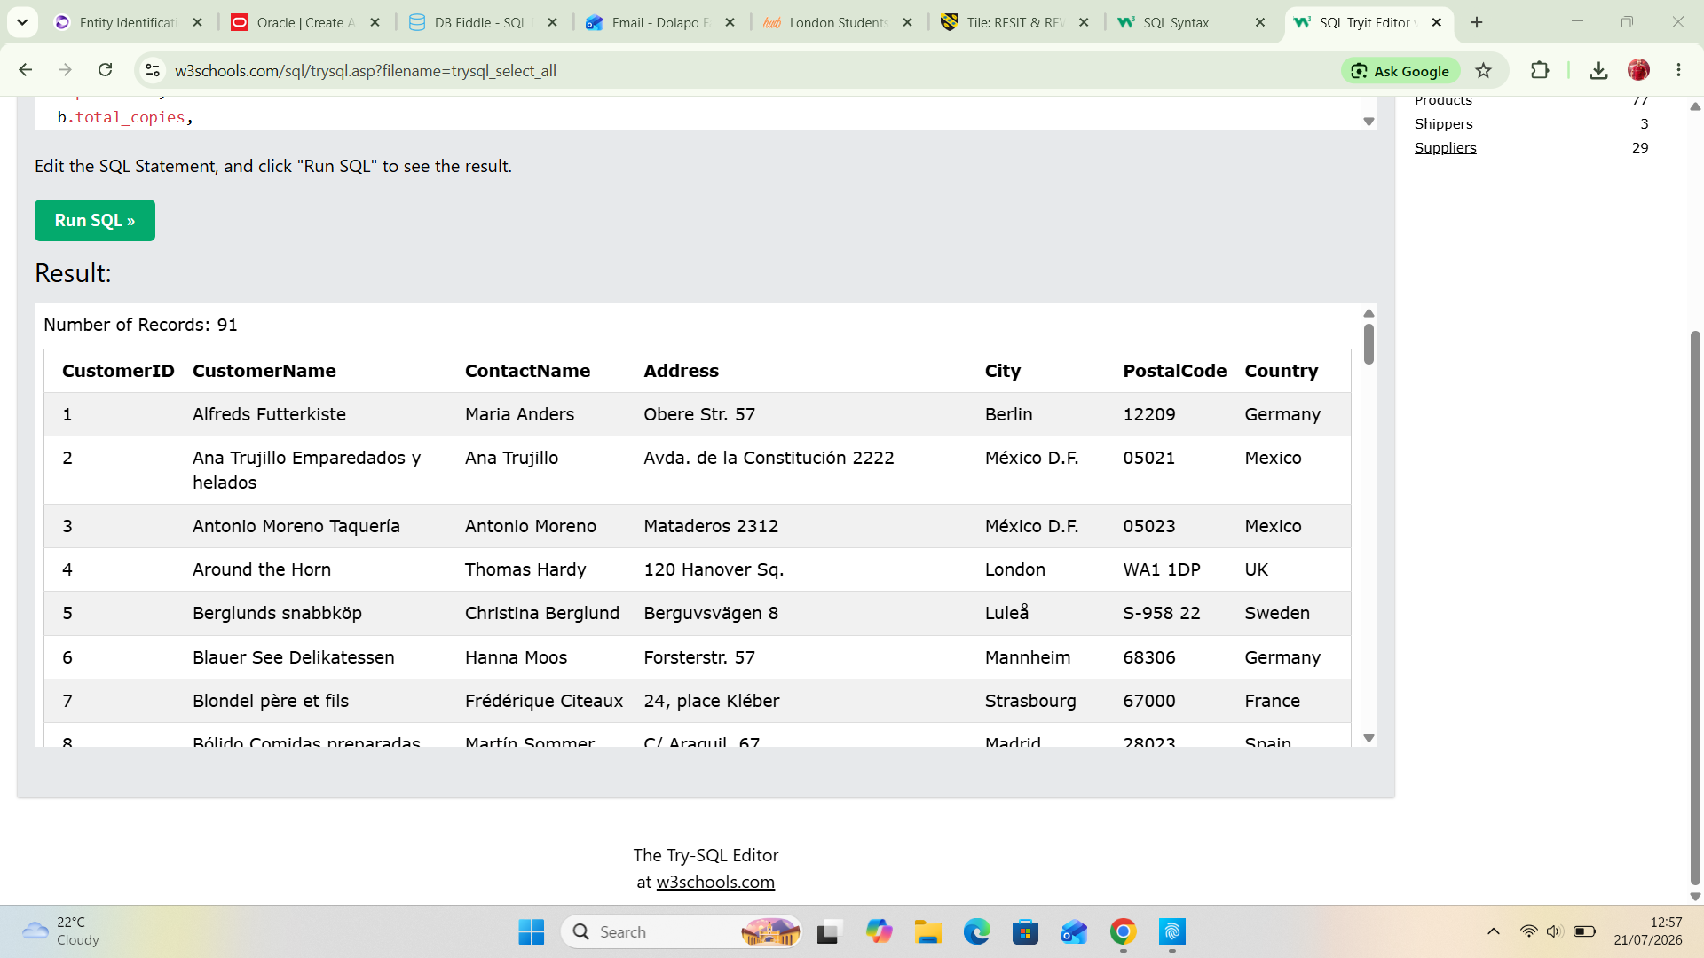

Query 2: All Books Currently On Loan
The purpose is to View active borrows, who has them, and when they are due back – including overdue items.
SELECT
br.borrow_id,
u.first_name,
u.last_name,
b.title,
br.borrow_date,
br.due_date,
DATEDIFF(CURDATE(), br.due_date) AS days_overdue
FROM Borrowing br
JOIN User u ON br.user_id = u.user_id
JOIN Book b ON br.isbn = b.isbn
WHERE br.status = 'On Loan' OR br.status = 'Overdue'
ORDER BY br.due_date ASC;
Query 8: User Activity Summary
The purpose is to See how many loans and reservations each user has made.
SELECT * FROM Customers;
SELECT
u.user_id,
CONCAT(u.first_name, ' ', u.last_name) AS full_name,
COUNT(DISTINCT br.borrow_id) AS total_borrows,
COUNT(DISTINCT r.reservation_id) AS total_reservations
FROM User u
LEFT JOIN Borrowing br ON u.user_id = br.user_id
LEFT JOIN Reservation r ON u.user_id = r.user_id
GROUP BY u.user_id, full_name
ORDER BY total_borrows DESC;

10. Forms and Reports
- Screenshots of forms - Screenshots of reports
- Explanation of functionality
11. Validation and Testing
- Testing methods
- Results
- Issues found and fixes
ID | Requirement Description
FR01 | Store and manage registered user accounts with unique identifiers
FR02 | Store complete book details, including author information and stock levels
FR03 | Record borrowing transactions, including due dates and return statuses
FR04 | Manage reservations for books that are currently unavailable
FR05 | Prevent duplicate or inconsistent data (e.g. same user registered twice)
FR06 | Allow users to view their own loan history and active reservations
FR07 | Allow staff to check book availability, identify overdue items, and view popular titles
FR08 | Enforce valid relationships (e.g. cannot create a loan for a non-existent user or book)

Test ID | Test Objective | Method | Expected Outcome | Actual Outcome | Status
IT01 | Join users to their borrowing records | Run query to list all loans for user U001 | Returns 2 matching loan records with correct book titles | Returns exactly the expected 2 records | PASS
IT02 | Link books to their authors | Query all books by author A001 | Returns both Web Development Basics and Advanced Web Databases | Correct titles returned | PASS
IT03 | Match reservations to book availability | Check availability for reserved book 978-1234567891 | Shows 3 available copies, with 1 active reservation | Matches stored data exactly | PASS
IT04 | Calculate overdue days correctly | Run overdue report query | Shows Liam Wilson’s loan as 11 days overdue | Calculation matches date logic | PASS

Requirement ID | Test Result | Notes
FR01 | ✅ Fully Met | All users have unique IDs; account types and contact details stored correctly
FR02 | ✅ Fully Met | Full book metadata stored; multi-author support works via linking table
FR03 | ✅ Fully Met | Loan dates, statuses, and links to users/books all function correctly
FR04 | ✅ Fully Met | Reservations expire automatically; fulfilled/cancelled statuses tracked
FR05 | ✅ Fully Met | Duplicate entries blocked by primary keys; no conflicting data found
FR06 | ✅ Fully Met | Personalised history queries return only the requesting user’s data
FR07 | ✅ Fully Met | All management queries (availability, overdue, popularity) return accurate results
FR08 | ✅ Fully Met | Invalid cross-table links are blocked by database constraints

Issue Description | Root Cause | Fix Applied
Initial design allowed available_copies to go negative | No business rule constraint on the field | Added check: available_copies >= 0 AND available_copies <= total_copies
Reservation expiry date could be earlier than request date | No validation on date fields | Added check: expiry_date > request_date

12. Reflection
- Challenges faced
- Improvements for future
I faced several challenges while developing this online bookstore database system, particularly when mapping the many-to-many relationships between books and authors which needed a dedicated junction table to work correctly without causing redundant data. I also had to carefully balance applying Third Normal Form with keeping queries simple and practical, as splitting data too far would have made the system harder to use. Turning real-world rules like valid stock limits and sensible dates into proper database constraints also took plenty of testing, and I spent time making sure all my sample data fit the rules and linked correctly between tables. In future work I would add role-based access to separate regular users from staff, build in proper tracking for fines and payments, improve search with better categorization, add automatic stock updates that run when loans change, and keep a full record of all changes made to the data.
13. Conclusion
- Summary of system
This online bookstore database system I have designed provides a structured, reliable solution for managing book records, user accounts, borrowing transactions and reservations, fully normalised to Third Normal Form to minimise redundancy and ensure data consistency. I created a clear entity-relationship model with appropriate keys and relationships, populated it with realistic test data, and ran practical queries to confirm it works as intended for both library users and administrative staff. All core requirements are met, from checking availability and tracking loans to identifying overdue items and popular titles, forming a solid foundation that can be extended further as needed.
14. References
- Use IEEE format

Bibliography

[1] | S. Goundrey-Smith, nformation technology in pharmacy: An integrated approach. Springer, 2013.
[2] | K. G. S. Kumara, Scenario-based ER Diagram and Query Generation Engine., Moratuwa, Sri Lanka: 2019 4th International Conference on Information Technology Research , 2019.

References

15. Appendices
- Additional screenshots
- Additional queries if needed

