
Changemakers: Creativity and Value Creation
Professions (BMHP5014)
Component 1: Online portfolio of set exercises

Student name: Cristina Apostol
Student number: 2335890
Lecturer’s name: Dr Laila Surani

Table of contents
Introduction 4
Task 1- Defining Key Concepts in Practice 5
Task 2 - Mind Map 7
Task 3 - Self-Reflection of Group Activity 8
Task 4 - Case Study Analysis of a UK Innovation 9
Task 5 - Research Task 10
Task 6 - Exploring Digital Innovation in Health and Social Care 11
Task 7 - Understanding the NHS Leadership Framework 13
Task 8 - Self-Reflection Journal Entry 14
References 15

Introduction
The portfolio enhances the formal collection for the tasks that state the strong understanding for the creativity, innovation, value creation and leadership in the field of health and social care. Each of the tasks is directly connected to the important concepts in the module and showcases how the ideas can be integrated in the practical activities. The portfolio started with the four important concepts that enhance creative and innovative thinking in the sector. It also enhances the inclusion of mind maps stating the real problem-mitigating approaches, enhanced through the self-evaluation of divergent and convergent thinking throughout the group work.

Task 1- Defining Key Concepts in Practice
Explain the following four key concepts: innovation, creativity, value creation, and change.
Innovation is the introduction of new ideas, procedures and technicalities that make improvements in present systems and create new paths for providing services. As per Rogers (2003), innovation includes adaptation for the fresh solutions that enhance the effectiveness and effectiveness. In the field of health and social care, innovation is important for mentioning complicated problems like growth in need, workforce stresses and health differences. For instance, the NHS use for the real words allow the patients to be reviewed at home by using online tools, mitigates useless hospital confessions and makes improvements in the patient's comfort. This states how innovation improves service ability whereas sustaining quality care.
Creativity is the capability to enhance innovative and useful ideas, frequently by creative thinking and new point of views. As per Runco and Jaeger (2012) state that creativity as enhancing the ideas that are both effective and useful. In the field of health and social care, creativity is crucial due to officials frequently required to find resilience, person-oriented resolutions in resource restricted conditions. For example, dementia care teams often use creative connection procedures as customised memory books to assist the patients overall well-being and mitigates nervousness. Therefore, creativity assists staff fostering intercessions to diversify and personal requirements.
Value creation is to provide the factual advantages for patients, service users, business and community. It also states the value in healthcare is enhanced through improvements in results connected with the cost of providing these results. In activities, value oriented in health and social care assure that services provide high-quality, effective and objective care. For instance, multidisciplinary teams enhance the valuation through improvements in communication and mitigating initiated work, which result in better patient expertise.
Change includes transformation from one state to another to make improvements in procedures, performance and results. It also enhances the emphasises of the efficient change needed to release existing behaviours, establishing new activities and enhancing the stabilisation. For instance, the move from the paper and electronic health records enhance the major business change that has made improvements in flexibility, availability and communication among the services.
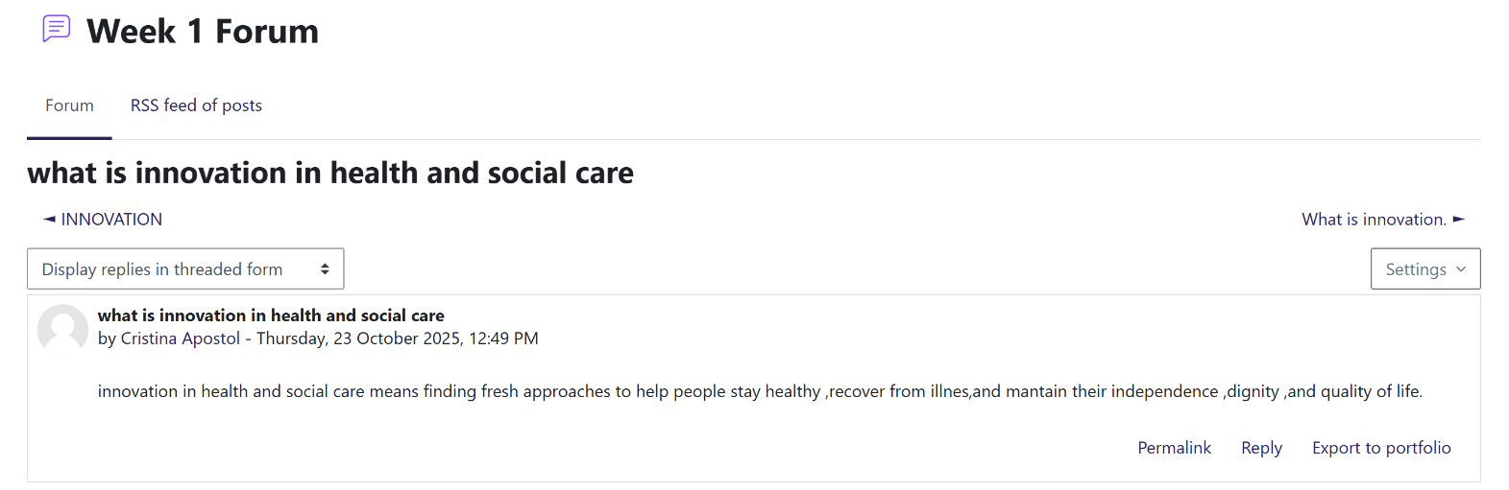

Task 2 - Mind Map
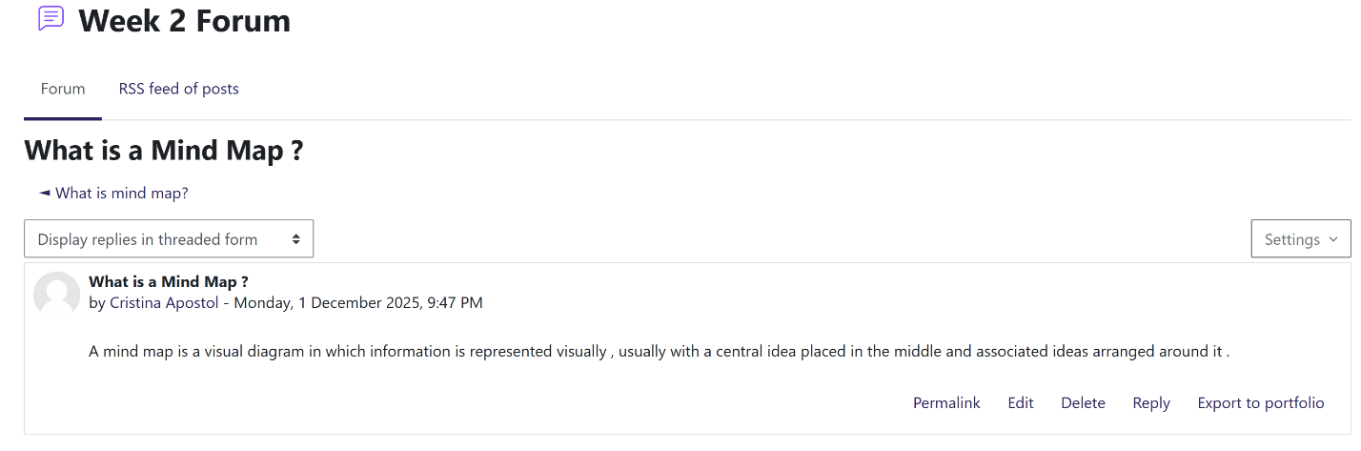

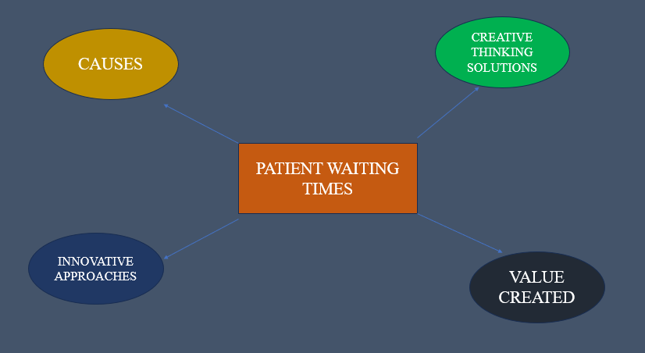

Task 3 - Self-Reflection of Group Activity
Using the Gibbs reflective cycle assists me to enhance how I understand divergent and convergent thinking through the class activity. Divergent thinking includes providing many differences in ideas without making any judgements, whereas convergent thinking highly focuses on broadness alternatives to choose the most efficient results.
Throughout the group task, I used divergent thinking firstly by providing various indications, even when it appeared as uncommon. As a group, we are influenced by open communication which helps to foster clarity in the decision-making and also enhance many ideas to make those effective as the better solutions. When we transform to convergent thinking, I assist in analysing each specific idea on the basis of real time and items. I also look over that I was more motivated in the convergent stage because it naturally gives priority for formal effective decision-making.
I also learned that I am required to feel comfortable collecting the important ideas without worrying about whether it will work rapidly. I also enhance the identification that efficient teamwork needs to balance the thinking styles, creates creative ideas whereas it also integrates critical evaluation. The activity also assisted to understand that these approaches result in more developing and practical solutions in the field of health and social care settings (Kosiol et al., 2024).
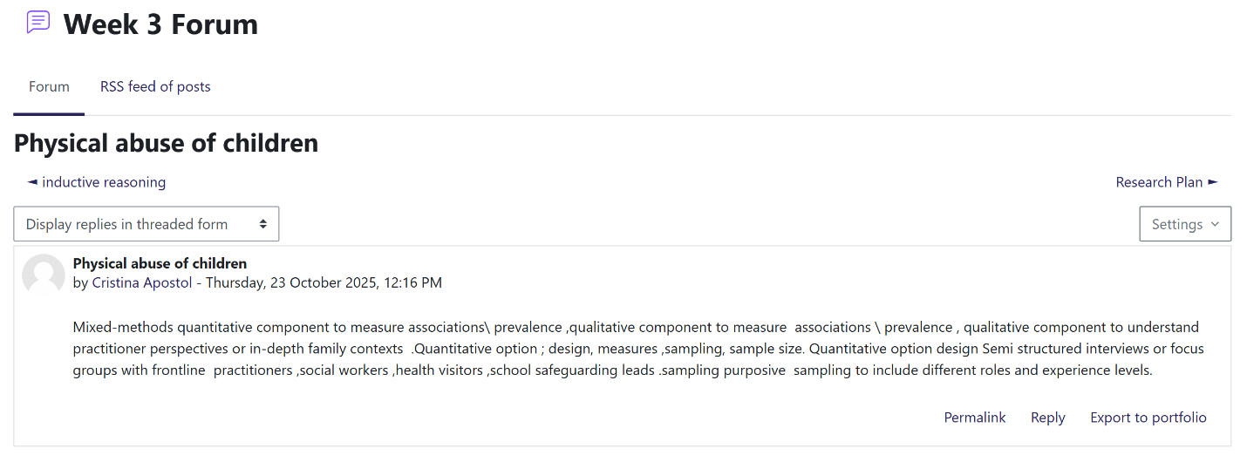

Task 4 - Case Study Analysis of a UK Innovation
One instance of innovation in the UK health sector is the NHS Virtual Ward programme, established to assist the patient with the long-effective context in the home. Creativity was also integrated through reconsidering traditional inmate care and collected remote reviewing, online technologies and multitasking teamwork. This developing approach enhances the NHS to establish the service that provides hospital-even care external hospital creations.
The productiveness was established to mention the various stresses, involving increment in the hospital acknowledgements, few beds, and the requirement to handle chronic illness more effectively. Digital wards enhance to offer the safe reviewing whereas mitigating unneeded hospital remains.
The value created involves making improvements in patient consoles, mitigates risk of hospital-obtained diseases, and the better use for the NHS resources. Studies also enhance that digital wards can mitigate hospital admissions and assist initial discharge, assisting patients retrieve in common conditions. Factual evidence also suggests improvements in patient satisfaction and mitigates pressure on the accuracy of care services (Roth, Vakkuri and Johanson, 2024).
Mainly, the NHS Virtual Ward programmes programme state how creativity and online technicalities can provide more resilience, person-oriented care whereas making improvements in the system ability.
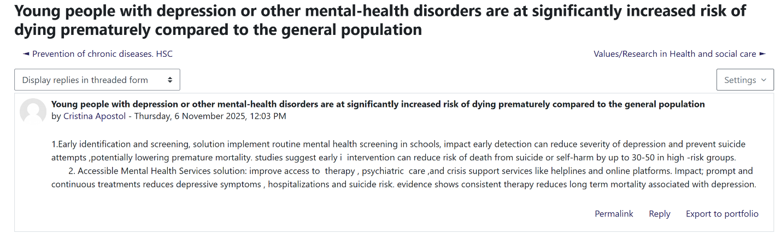

Task 5 - Research Task
A present issue and problems in the health and social care is staff burnout, which impacts the overall service quality and patient results. The first academic West et al. (2020) demonstrate that burnout in healthcare staff is largely produced through chronic work overburden, restricted organisational assistance, and emotional stress. The research enhances that strong pressure, long effective hours, and vulnerability to disturbing situations increase depletion levels, mitigating staff overall wellbeing and confidence. The authors emphasise that burnout established when the need of the job override the resource accessibility for staff, enhanced as the long-effective disparity.
As per author Moll et al. (2020) shows that the ethical distress is one of the other providing factors. The findings suggest that staff experience burnout when it feels unusable to offer the standard for the care where they feel morally right. This frequently happens because of the less staff, lack of time, and business restrictions. The article highlights that repeated revelation to situations where the workers cannot be enhanced according to the official values result in problems, psychological pressure and ultimate burnout (Xu, Hou and Zhang, 2022).
Mainly the studies state that burnout comes from business stresses, emotional problems and restricted resources, enhanced as the system-oriented issue instead of the personal weaknesses.
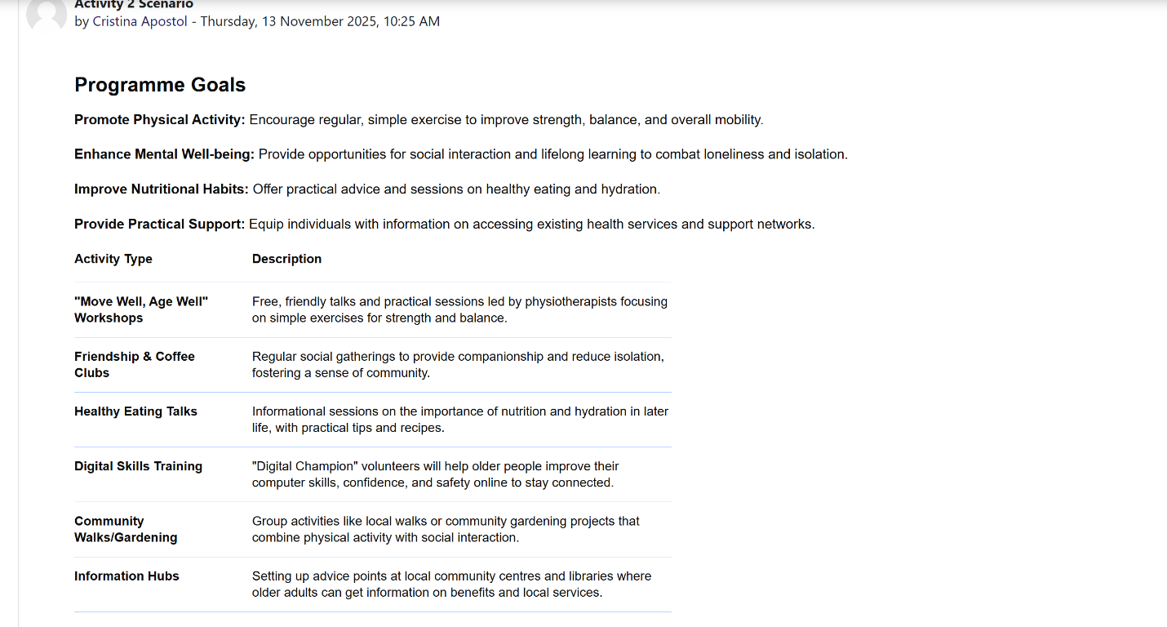

Task 6 - Exploring Digital Innovation in Health and Social Care
Discuss one benefit of using wearable health technologies (e.g. smartwatches) to support the management of chronic health conditions.
Wearable health technicalities, like smartwatches and fitness traceability, offered constant reviewing of important signs, providing specific advantages for handling chronic context. One of the important advantages is making improvements in self-management, as the patients enhance practical feedback, heart rate, sleep and blood fructose levels. A per Piwek et al. (2016), wearables assist long effective behaviour constantly through increments in the consciousness and influencing healthier patterns. In the field of health and social care, these systems assist patients with traceability symptoms and recognising initial warning signs. For instance, some smartwatches can identify the irregular heart meters, enabling the users with circulatory context to look over for the time to time medical assistance. Clinicians also available for the reviewed data, allows more customised and avoidance care. Mainly, wearable technicalities improve initiation identification, strong patients and mitigates the requirement for often in-person fittings.
Describe how electronic health records (EHRs) improve communication and collaboration between healthcare providers.
Electronic health records can make improvements in communication in health and social care through important patient details so it can be available quickly through allowed officials. This mitigates delays and avoids information gaps that enhance placements and more communicated care because clinicians can monitor medical histories, experimental results and treatment plans in practical time. Improvements in communication also mitigates repetition like needless tests. In activities, EHRs allow GPs, nurses, pharmacists and hospital teams for working partnership. For instance, when the patient with diabetes sees various services, all offered can view revised remedy lists and present blood test identification, assuring continuous and precise care. Therefore, EHRs foster team partnership, mitigates errors, and assists more effective decision-making (Carrilho et al., 2023).
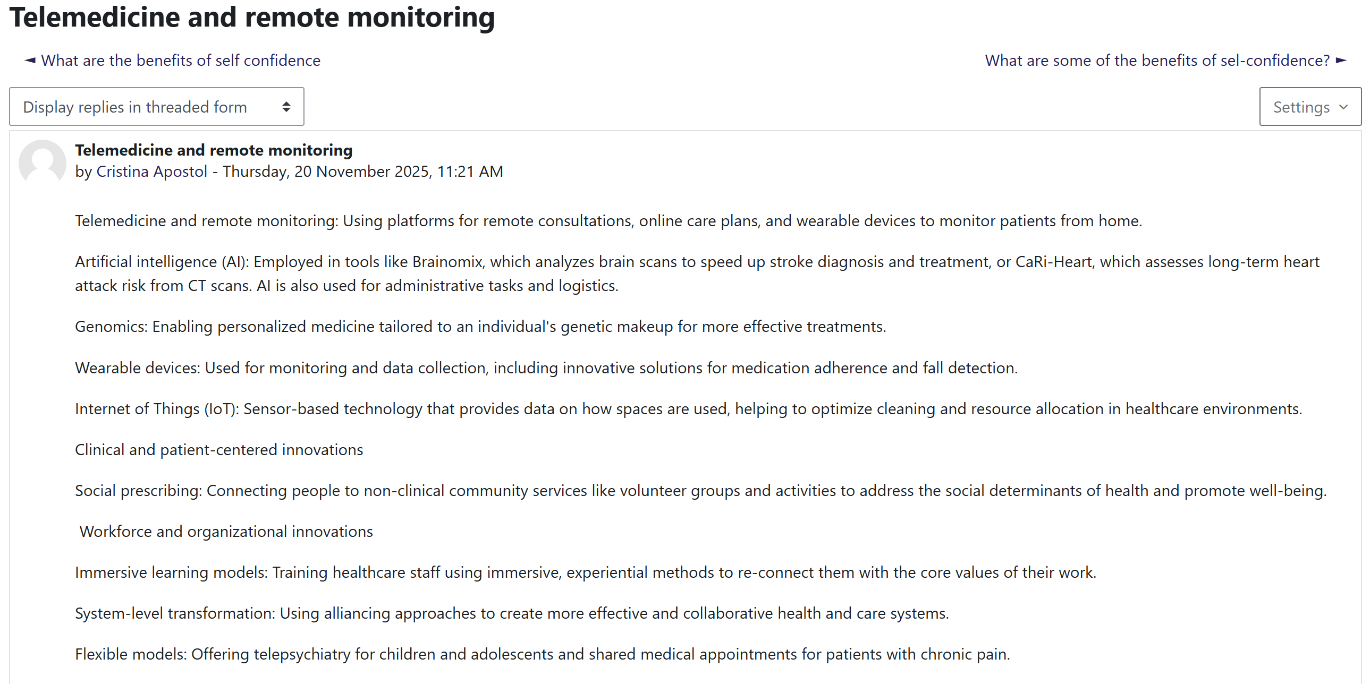

Explore how digital technology can support preventative care and health promotion, using a real or hypothetical example.
Digital technology plays an important role in interference care through making improvements in availability of information, assisting initial identification and influencing healthier lifestyles. One of the important areas is digital health education. Culturally fostered digital online education initiatives can make improvements in understanding, trust and medication attachment for people with chronic illnesses. Through using the videos, reminders and connected learning, patients from various backgrounds can make betterment of the conditions and avoid the problems. Digital tools also assist initial prevention for young people with mental-health challenges. Mental health applications and online showing tools assist recognising risks initially through traceability mood, sleep and behaviour paths. Research indicates that initial findings can mitigate the intensity of depression and lower the risk for predicament situations. Digital platforms provide guidance, crisis assistance and therapy known to assure the youth that receive time to time assistance before symptoms intensify. The programme goals are nutrition, physical activity and digital skills. Clothing systems, health traceability applications and digital physical activity sessions influence regular dynamics, healthy eating and better hydration. Online skills training helps older adults’ availability of these resources, mitigates separation and influences overall wellbeing. Mainly, digital technology makes the avoidance strong through making improvements in the health education, assisting initial findings of healthy day to day habits.

Task 7 - Understanding the NHS Leadership Framework
Short summary of the NHS Leadership Framework
The NHS Leadership framework highlights the behaviours and qualities that are prospects from the leaders working in health and social care. It helps the staff in all the levels to enhance the understanding of how it results as efficiently and assists high improving care. The structure is created for important behavioural areas, involving encouraging collective purpose, result with care, analysing information, connecting the service, sharing the vision, connecting the team and encouraging for results. Each of the behaviours highly focuses on how the leaders can enhance compassion, work partnerships and make effective decisions that improve patient results. The structure is important due to leadership directly impacts staff overall well-being, delivery of services and patient safety. Strong leadership assisting creates a positive environment where staff feel value, confidence, and assisting in productivity. In the field of health and social care, where needs and pressures are highly motivated, the structure offered clarity in advice on how the leaders can make responses efficient, influence encouragement and maintain continuous standards for the care among the services (Anthony Jr, 2024).
Leadership behaviour: Encouraging shared purpose
Encouraging the collective purpose, includes motivation for the staff among the common goals and assisting them to understand why the work matters. The leader uses these behaviours to influence creativity through creating the context where staff feel confident to share the advice and ideas without making any judgements. When the people feel connected to the collective purpose, it enhances the staff in discussion for making improvements in the patient's expertise inviting the indications and value the difference point of views. These assist better care due to the developing ideas frequently result as more effective processes, strong teamwork and more person-oriented solutions for the patients and service users.
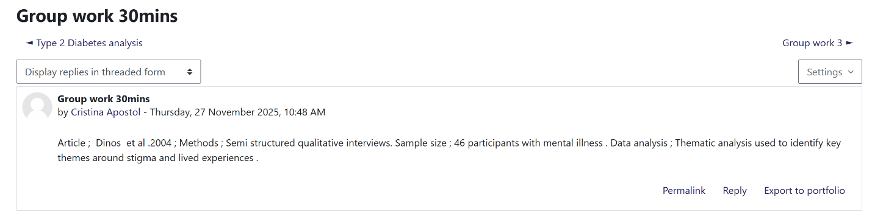

Task 8 - Self-Reflection Journal Entry
Throughout these modules, a strong understanding for creativity and value creation has been established particularly. At the initial step, I look over the creativity mainly connected to creative skills, but also I enhance the understanding it is the important part for the problem mitigation in health and social care. Activities like divergent and convergent tasks assisting me identifying how the creative approaches enhance the improvements in the services. Learning for productiveness and leadership behaviours showcases the strong value for the ideas that result as better results for the patients. These will encourage the future activities through promoting me to look over for more creativity, provide the ideas motivation and heavy focus on making improvements in the service quality

References
Anthony Jr, B., 2024. The role of community engagement in urban innovation towards the co-creation of smart sustainable cities. Journal of the Knowledge Economy, 15(1), pp.1592-1624.
Carrilho, J., Videira, D., Campos, C., Midão, L. and Costa, E., 2023. Changing the paradigm in health and care services: modern value chains using open innovation for the creation of new digital health solutions. Frontiers in Digital Health, 5, p.1216357.
Kosiol, J., Silvester, T., Cooper, H., Alford, S. and Fraser, L., 2024. Revolutionising health and social care: innovative solutions for a brighter tomorrow–a systematic review of the literature. BMC health services research, 24(1), p.809.
Moll, M., Zon, R.L., Sylvester, K.W., Chen, E.C., Cheng, V., Connell, N.T., Fredenburgh, L.E., Baron, R.M., Cho, M.H., Woolley, A.E. and Connors, J.M., 2020. VTE in ICU patients with COVID-19. Chest, 158(5), p.2130.
Orr, G., 2003. Diffusion of innovations, by Everett Rogers (1995). Retrieved January, 21, p.2005.
Piwek, L., Ellis, D.A., Andrews, S. and Joinson, A., 2016. The rise of consumer health wearables: promises and barriers. PLoS medicine, 13(2), p.e1001953.
Roth, M., Vakkuri, J. and Johanson, J.E., 2024. Value creation mechanisms in a social and health care innovation ecosystem–an institutional perspective. Journal of management and governance, 28(4), pp.1017-1048.
Runco, M.A. and Jaeger, G.J., 2012. The standard definition of creativity. Creativity research journal, 24(1), pp.92-96.
West, R., Michie, S., Rubin, G.J. and Amlôt, R., 2020. Applying principles of behaviour change to reduce SARS-CoV-2 transmission. Nature human behaviour, 4(5), pp.451-459.
Xu, G., Hou, G. and Zhang, J., 2022. Digital Sustainable Entrepreneurship: A digital capability perspective through digital innovation orientation for social and environmental value creation. Sustainability, 14(18), p.11222.

