Procurement and Project Management (M5X01876)

Assignment 1

Sean Dugay (P149833)

Your recommendation for the choice of procurement method and an explanation of your recommendation.

As Rosko Pension Group are investing into a profit making scheme it is ideal that a private hospital has been selected due to their high demand. For this I would recommend using open tender procurement route as this is to be primarily a profit making scheme the advantages of an open tender procurement route would help maximise profits. “Open tendering is the preferred competitive public procurement method used for acquiring goods, services and infrastructure works.” (Lynch, 2018). The advantages of an open tender procurement route are as follows;

- An equal opportunity chance for local contractors to submit their tenders and therefore giving more subcontracting companies the opportunity to tender for the contractor. Thus leading to the possibilities for cheaper tenders due to a more competitive market.” High competition in pricing” (Anon., 2016).

- New suppliers are able to tender for on open tender which can lead to a good business deal as a new supplier will want to secure a good relationship by offering the most competitive tenders. “advantage of allowing new or emerging suppliers to try to secure work and so can facilitate greater innovation” (Designing Buildings Wiki, 2018)

- An open tender would require the client (In this case Rosko Pension Group) to build an in house team. This team will include quantity surveyors, architects, engineers and consultants. The in-house team will be made of people from different areas in construction with plenty of experience under their belt to advise the client on the best course of action especially before construction begins.

- An eligibility criteria can be put forward to limit the tendering companies by reducing the number of time wasters can save money. This can be done by a simple statement for example stating that only companies whom have worked on £2million+ contracts will be eligible.

- The open tender route would allow contractors to become friendly with a new client which could lead to future investment opportunities via a successful and profitable previous relationship.

- “All potential contractors and suppliers and must submit their bids within the deadline decided on by the client” (Bid Detail, 2018). This would allow a larger market to apply within a restricted time frame.

The structure of the project team, organisation and control of the project, including expenditure logistics for the whole of the project.

For this procurement route there are two main teams combined to make the project team (After the tender has been awarded). Firstly the design team, this is comprised of the architects, architectural technicians, structural engineers, quantity surveyor (Sometimes) and design consultants. The reason for the design team arises at the point of the projects inception. This is the team that will design the building with specifications in order for it to be sent out to tender. The design team is hired by and works directly for the client and will liaise with both client and construction team once the tender had been awarded.

The construction team is the appointed contractor’s team compromising of quantity surveyors, estimators, project managers, site managers and various sub-contractors that are hired for individual works. The construction teams roll in the overall project team is to provide materials, labour and any plant required to complete the job to the clients design teams specifications and drawings.

Client - The client is the kingpin of a construction project, they are responsible for the designing, building and financing of the project until completion and in this case they will also be responsible for the sale of the building post construction.

Architect - The architect is the designer of the building, everything from the brickwork to the elevator service shafts the architect must incorporate the specification into their design for approval by the client.

Quantity Surveyor - The quantity surveyor plays multiple roles in the life cycle of a construction project they are responsible for pricing up costs, the procurement from start to finish of a project, dealing with payments to sub-contractors and dealing with any issues that arise, and conducting regular valuations to invoice the client and to check the standards of work. Quantity surveyors can work for either the client or the contractor but their roles are not too dissimilar.

Engineer - The engineer, or engineering team are the people who will work closely with the architect, and contractor as their primary job is to ensure the building is safe to use for extended periods of time.

Project Manager - The project manager is the person who runs the project like a sub client but more hands on. The project manager is a key contact for the client as it is their job to know the ins and outs of everything that is happening regarding the project. The project manager will have regular contact with those on site and in the office to ensure the smooth running of the project is successful.

Site Manager - The site manager runs the site, reporting to the project manager on the progress of the project on a daily basis. The site manager is in charge of the construction site. It is their job to organise everything on site from the opening hours, labourers, placement of materials and parking the site manager is instrumental in the smooth running of the building site.

Both of these teams together create the project team, good communication and a strong relationship is key to completing a project on target. The typical structure of a project team can be found in the image below:

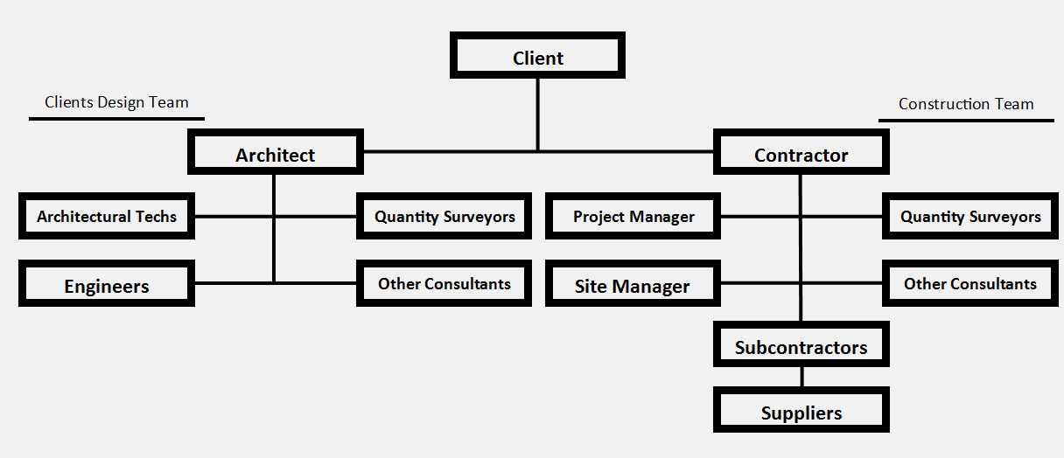
Figure 1

From the figure 1 image, we can clearly see the lines of communication between the client, design team (on the left) and the contractor (on the right). The design team and construction team both use quantity surveyors, the reason behind this is the design team quantity surveyor can put together an estimate of the project and the contractors quantity surveyor will tender for the project by contacting various sub-contractors and suppliers to receive quotations for material and labour. Sometimes the contractor will also have architects, architectural technicians and engineers which would check over the design of the building and could offer the client alternative solutions to issues that may arise.

The stages through which the project will progress up to Pre-Construction (CIOB Stage 4 and RIBA Technical Design Stage 4). You must include in your explanation the influences that BIM and BREEAM may have on the project.

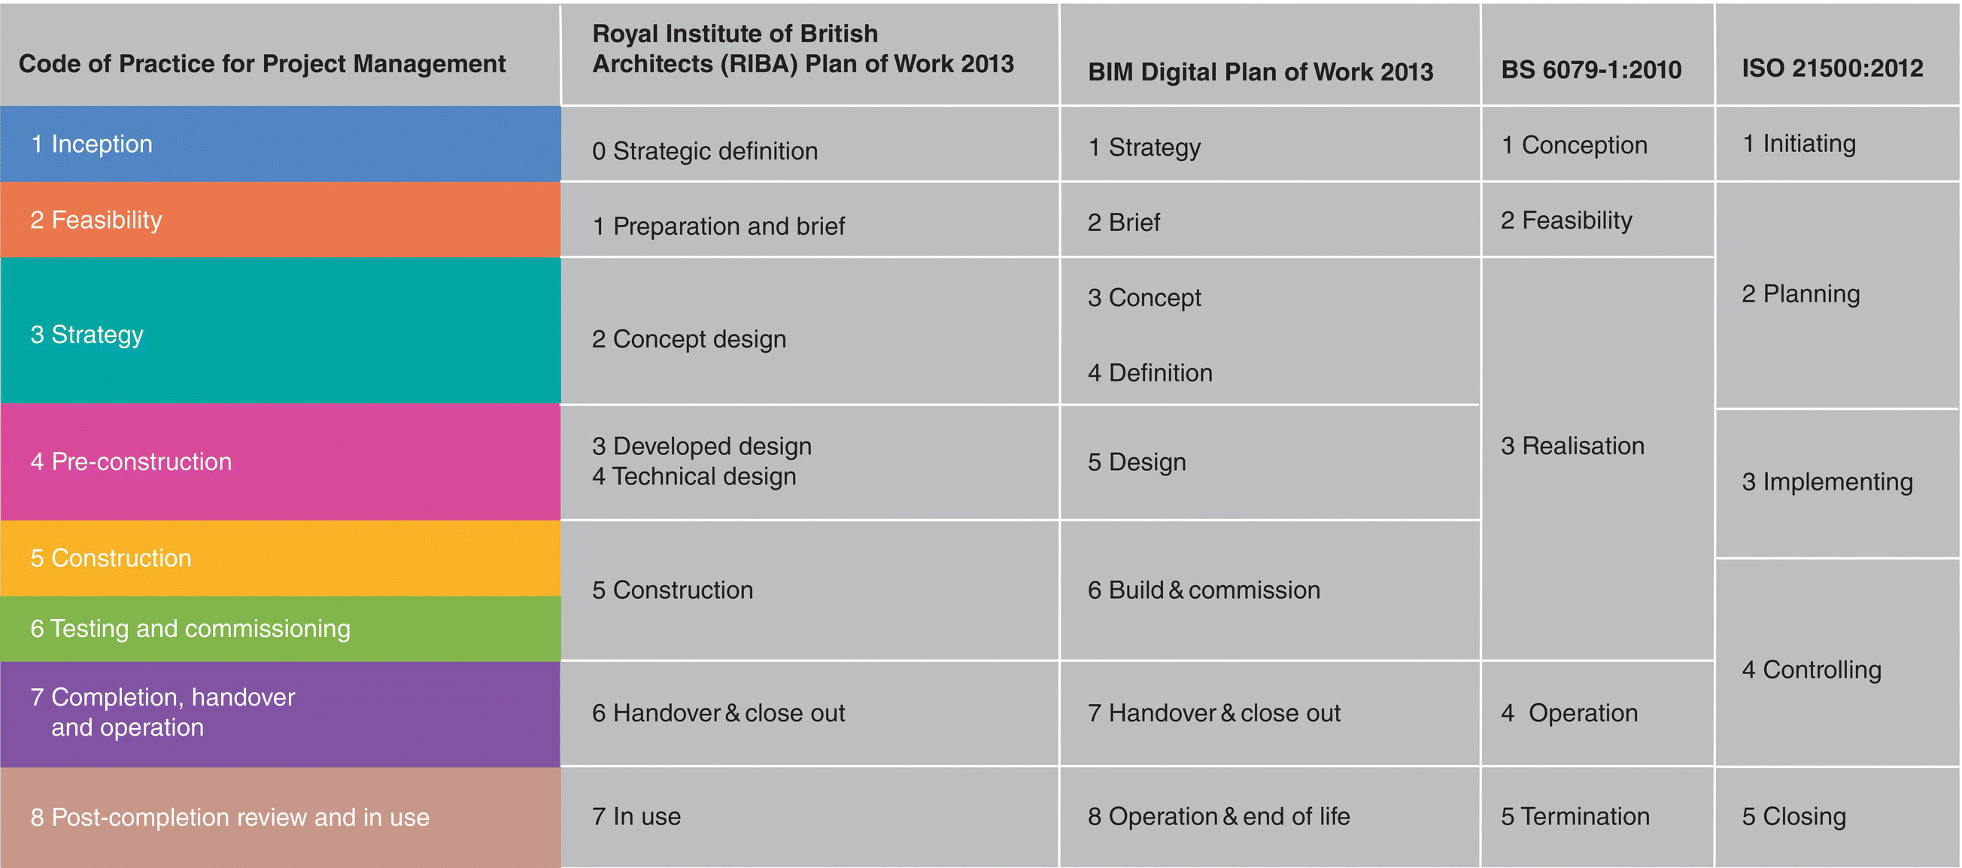
The primary aim of this project is to build a private hospital in a profit making scheme while keeping the build process efficient and environmentally friendly as set out in the CIOB Code of Practice for Project Management (See Figure 2 left hand column), RIBA Plan of Works and the BIM Digital Plan of works.
Figure 2 (CIOB (Chartered Institute Of Building), 2014).
Stage 1
CIOB - Inception
RIBA - Strategic Definition

This stage is the initial start of the whole project, this is the stage where the project is just an idea. From the idea, laying down the guidelines and principles for the project and this is where the clients specifications and the implementation of those specifications come into play in defining the projects overall objectives. “starts with the business decisions by the client that suggest a new construction or development project may be required” (CIOB (Chartered Institute Of Building), 2014).

Stage 2
CIOB - Feasibility
RIBA - Preparation and Brief

This stage is where financial commitment, risk solutions and the scope of works come into play in the project brief. Financial commitment between the client and contractor from some but not all start-up costs, and this would typically also be the stage at which the client and contractor agree payment dates for example (Monthly regular payments) and any terms or punishments for late payments/work but this stage is in essence a chance to sit down with the contractor and see if it possible to build the structure within budget. Risk solutions will also be a key point in the project brief and finding appropriate solutions to limit the risks to labourers, plant and the project.

Stage 3
CIOB - Strategy
RIBA - Concept Design

Once the feasibility stages are complete and the project is found feasible we move onto this stage. This stage outlines the proposals of structural design, services, sustainability and the preliminary costs for running the site. It is within this stage that the final procurement route is chosen for the project.

Stage 4
CIOB - Pre-construction
RIBA - Developed Design and Technical Design

This stage looks at the projects technical, structural and service designs. The overall function and purpose of the building and the logistics of procurement taken from the details of stage 3.

BIM and BREEAM influence

Using BIM, we can allow for the improvement and management and sustainability, the running cots and the environmental impacts of the structure post completion. “Building Information Modelling (BIM) is improving the way projects are delivered and completed assets are managed around the globe. It provides a revolutionary platform for “rethinking” how we design, construct, maintain, and operate our built environment.” (RICS, 2017). BIM can also be very beneficial throughout stages 1 to 4, using BIM on these stages can save time as it can provide quick evaluation of different designs based on cost and sustainability.

As this project is going to be a hospital and I assume it will be built in Wales and have a floor area of over 1000m2 it is required by the Welsh Assembly that the application of BREEAM is used. “BREEAM is the world’s leading sustainability assessment method for master planning projects, infrastructure and buildings. It recognises and reflects the value in higher performing assets across the built environment lifecycle, from new construction to in-use and refurbishment.” (BREEAM, 2019). Using to achieve a BREEAM certification the building must conform to set standards set by BRE to meet good environmental, social and good economic sustainability performance levels. BREEAM 10 was a report that supported the use of BREEAM in construction by showing that it benefitted the life cycle of the building. This is something that must be kept in mind throughout the 4 stages to conform the Welsh Assembly’s requirement for BREEAM.

Describe the Key Resources required at each stage and the involvement of personnel involved. You must describe the reasoning for employing specialist consultants.

Stage 1
Resources - Client + Project Manager
Process - Inception of the project, a basic brief and the project team assembly.
Objective - To identify the project.
Deliverable - Project conception

Stage 2
Resources - Client + Project manager + Specialist consultants
Process - Project Brief, manager selections, feasibility studies,
Objective - To determine whether or not the project is feasible.
Deliverable - Project brief + Feasibility report

Stage 3
Resources - Client + Project manager + Specialist consultants
Process - Project strategy, procurement approach, tender procedures
Objective - Provide a strategy to build the structure with reasonable cause.
Deliverable - Execution plan

Stage 4
Resources - Client + Project manager + Design Team
Process - Project strategy, procurement approach, tender procedures
Objective - Provide a strategy to build the structure with reasonable cause.
Deliverable - Execution plan

References
Anon., 2016. Advantages Of Open Tendering Construction Essay. [Online]
Available at: UKEssays. November 2018. Advantages Of Open Tendering Construction Essay. [online]. Available from: https://www.ukessays.com/essays/construction/advantages-of-open-tendering-construction-essay.php?vref=1 [Accessed 13 February 2019].
[Accessed 13 02 2019].
Bid Detail, 2018. Characteristics and Benefits of the Tendering Process. [Online]
Available at: https://medium.com/@bid.detail01/characteristics-and-benefits-of-the-tendering-process-b5782030d027
[Accessed 13 02 2019].
BREEAM, 2019. What is BREEAM?. [Online]
Available at: https://www.breeam.com/
[Accessed 24 04 2019].
CIOB (Chartered Institute Of Building), 2014. Code Of Practice For Project Managment For Construction And Development. 5th ed. Sussex: Wiley Blackwell.
Designing Buildings Wiki, 2018. Open tendering of construction works. [Online]
Available at: https://www.designingbuildings.co.uk/wiki/Open_tendering_of_construction_works
[Accessed 13 02 2019].
Lynch, J., 2018. Open Tendering. [Online]
Available at: https://procurementclassroom.com/open-tendering/
[Accessed 16 02 2019].
RICS, 2017. Building Information. London: Royal Institution of Chartered Surveyors (RICS).

