
developing relationships and workplace achievement
Nazrin Karim - 1710333

April 17, 2019
University of Wales Trinity Saint David

Executive Summary

The purpose of this report is to critically evaluate development vehicles and their importance in developing an individual. the researcher has looked at how ELton Mayo and Fredrick Taylors theories help in motivated employees and the benefits of using them.
Performance management is vital in developing skills and another way of motivating employees. This report has looked at how managing performance can be measured formally and informally. This could be through appraisals, rewards or general feedback. Organisation like Sainsburys, Asda and Tesco use the performance management cycle, and which has now been taken over by the continues performance cycle. Using stages in these cycles has helped organisations ensure that their employees provide high levels of performance leading to more productivity. These frequent reviews help managers identify weaknesses in their staff and were further training is needed.
Training is also a part of managing performance and helps motivate employees to perform better. This report evaluates different forms on training and how useful they can be. It looks at the difference between on the job training and off the job training. Evidence from case studies shows these are both important but also highlights some disadvantages. The systematic training cycle is a model often used by organisations to approach a systematic way of training.
A case study evaluation on how Tesco have applied some of these methods and how it has helped them develop skills in their employees shows the benefits of using these theories and methods
Using case study’s, a critical evaluation shows the potential benefits of using development vehicles in the workplace for both the organisation and an individual. Kellogg’s have applied Abraham Maslow and Frederick Herzberg’s theory to increase development in their employees and the organisation itself.
A Personal development plan helps an individual target their objectives and work on them to climb the ladder in building a career. Am example PDP shows what objectives someone hoping to pursue a career as a teacher may have. It shows set objectives and actions to work towards improving on their weaknesses to be able to succeed.

Table of Contents
Executive Summary 1
Introduction 3
Main Findings 4
1.1 Motivation………………………………………………………………………………………………………………………………4
1.2 Performance Management……………………………………………………………..………………………..……………5
1.3 Training………………………………………………………………………………………………………………………………….7
2. Benefits of Using Development Vehicles……………………………………………………………………..…………8
2.1 Organisation………………………………………………………………………………………………………………………….8
2.2 Individual………………………………………………………………………………………………………………………….……9
3. Personal Development Plan……………………………………………………………………….……………………….10
Conclusion…………………………………………………………………………………………………………………………………….…14
Reference List………………………………………………………………………………………………………………………………….15
Bibliography…………………………………………………………………………………………………………………………………….20
Appendices……………………………………………………………………………………………………………………………………...27

Introduction

Developing work place relationships are a vital part of development in our jobs (Skills for Justice, 2017). Having good relationships at work can benefit in different ways as they learn and develop new skills. For example, with new and improved skills people are more likely to enjoy work and implement changes to make an individual more creative and innovative (Industrial Personal LTD, 2017). It can also help develop careers and open opportunities for new positions to and employees way up to better pay and other initiatives.
For employers it is important to plan out goals and how to achieve them (Barry, at el, 2015) this can be done through different development vehicles and theories. These methods can give the employer ideas on how to train staff and motivate them while manging their performance to ensure maintenance of knowledge and skills (Skills for Justice, 2017). For employers this can be very beneficial as staff who are well trained and motivated will perform better leading to more productivity and profits for the organisation.

Main Findings

- Development vehicles
There are several development vehicles available for organisations. These include Motivation, Performance management and training.
  - Motivation
Motivation is one of the key factors which helps to get the most out of employees (MSG, 2019). Employee motivation can be done through keeping employees updated, rewards, feedback, and training (Squareup International, 2019).
According to Fredrick Taylors motivation theory, workers were motivated through pay. He Believed workers should be paid on a piece rate. This would motivate employees to produce more. Taylors methods were used by many organisations (Tutor2u, 2018), the most notable user was Henry Ford who used his method to design the first ever production line to make Ford cars. However, workers started feeling like they were being treated like machines as they were given repetitive tasks which were becoming boring (Tutor2u, 2018). Organisations were also starting to reduce workers as productivity was increasing which lead to more strikes and other actions from dissatisfied workers.
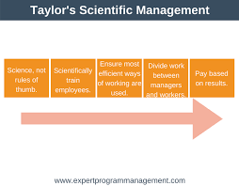(EPM, 2018)
On the other hand, Elton Mayo who was inspired by Taylors theory, believed that even though pay was important workers satisfaction were linked more to social needs (toolshero, 2019). Mayo undertook a set of tests known as the Hawthorne experiment (Dininni, 2017). He found that along with physical variables such as pay, workers would be more motivated through social factors like better communication, greater management involvement, more team work and more care in employee interests. Critics like Clark Kerr did however argue that Mayo’s Theory was extremely manipulative as it makes people think that they are interested in workers when really, they were just interested in productivity by motivating them (Simplify, 2017).
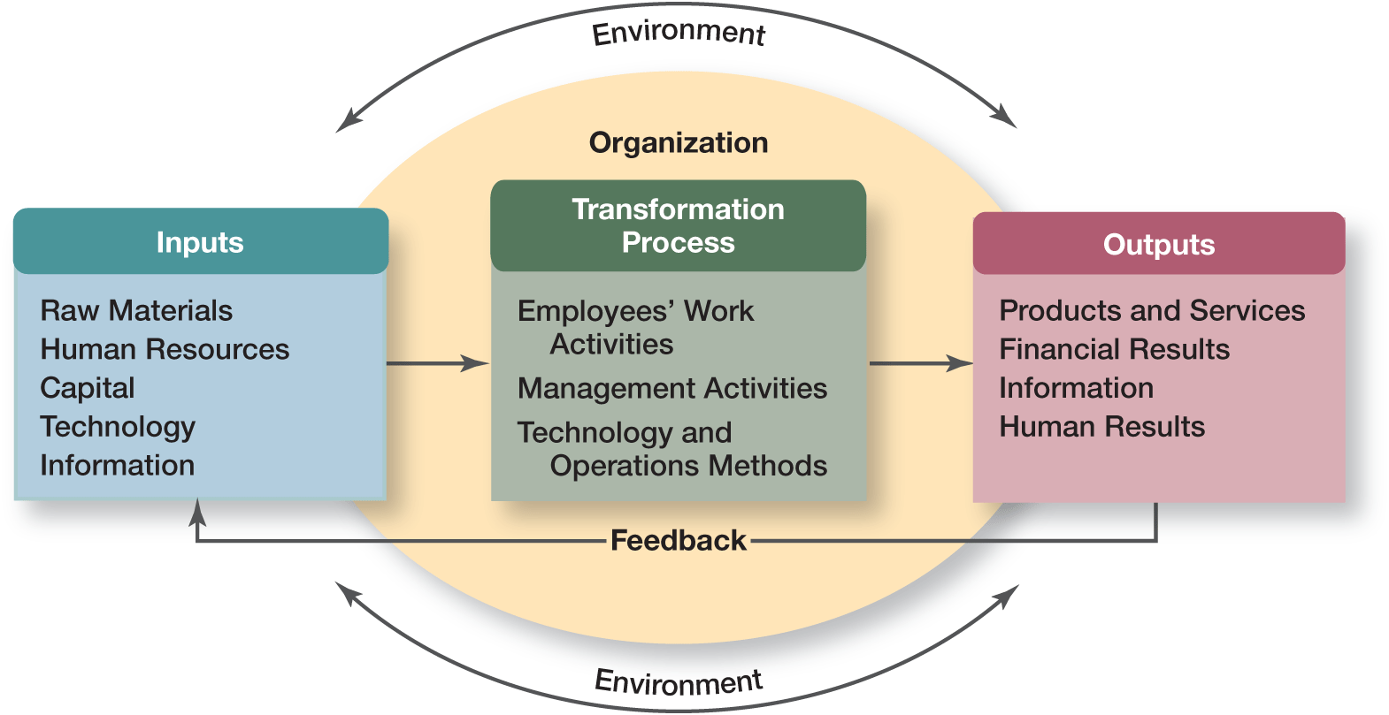
(Air Freshener, 2019).

Both theories look to increase motivation but in two different aspects where one is scientific and the other is more social (Grin, 2011). Taylor approached motivation from a technical level and was more concerned with how the workers were doing rather than the managers or supervisors where Mayo looked at how the managers and supervisors were treating their workers.
As seen in a case study, Tesco’s rewards system is like Taylor’s theory as their financial reward is one of the many motivating factors. However, they believe that there are more to employee motivation then money which is why Tesco go past pay increases and more onto personal and individual benefits. According to Business case study (2019), Mayo’s theory is seen used throughout the company as they say communication is one of the most important factors of motivating employees. Tesco may do this through one to one discussion, newsletters or more formally such as appraisals. Tesco recognises that by maintaining employee motivation by increasing their job satisfaction through training, development and timely rewards it will increase their company growth. This shows that training and performance management are both linked to motivation.
  - Performance Management
Performance management is the process of improving individual’s performance and ensuring goals are met in the most effective and efficient way (Barry et al 2015). It is done through reviewing and assessing progress and developing skills, knowledge and the ability to perform better.
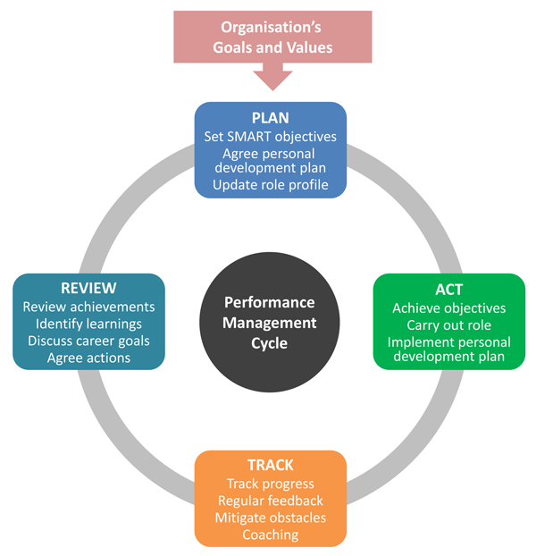

(Hearn, 2017)

Armstrong’s performance management cycle starts from planning. Planning should involve a SMART objective, a personal development plan or an action depending on job requirement. According to Hearn (2017), the ‘Act’ and ‘Track’ stages are the most important as these are the stages were the performance is produced and results are achieved. Staff need be encouraged to work on achieving their goal and in the same way managers need to give individuals regular feedback and coaching to be able to improve on their performance. The last stage is ‘Review’, this was deigned to allow both the employee and manager to look at how they have towards achieving their goal and results gained.
The stages on this cycle do not follow each other as ‘Act’ and ‘Track’ should always be continuing, and reviews can be taken at any point and planning can take place more than once.
However, as stated by Hearn, (2017), since 2015 more organisations are using the ‘Continues Performance Management Cycle’. This cycle is defined as performance management cycle that is ongoing throughout the year. This process includes regular objective goals, feedback and one to ones. People now believe that regular feedback and reviews work better than having a review once a year.
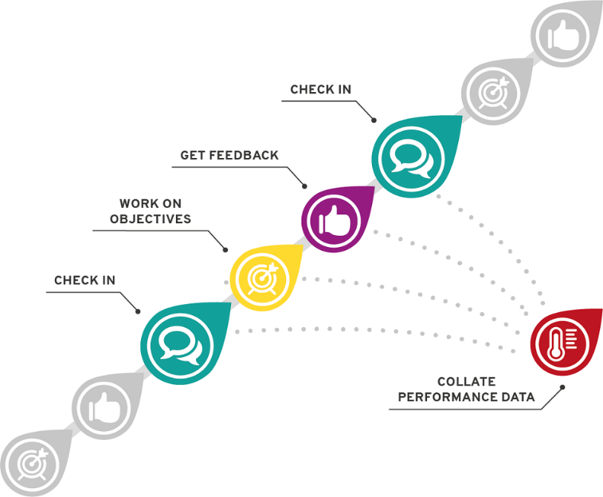
Regular reviews give employees the chance to see what has gone well and how they can continue to succeed in achieving their goals. It gives the opportunity to see where improvements can be made to further develop and improve performance and whether further training is required. This process works better as found in a research 50% of companies where they have monthly reviews are at the top on financial performance where only 24% of companies who have reviews once a year made it to the same bracket (Hearn, 2016).

(Hearn, 2017)

Several case studies state that organisations like Sainsburys, Asda and Tesco continually manage their staff performance through different methods (Business Case studies, 2019). Although much evidence could not be found regarding Sainsburys and Asda, Tesco ensure that goals are met, and the factors used to insure this are using annual goal settings, involving staff, high commitment and support from managers, appropriate training, appraisals and have strong leaders to focus on the path (Business Case Studies, 2019). From this Tesco are clearly following the performance management cycle but as it is continuing through the year, they believe more on the modern continues management cycle as it helps their employees provide high level of performance leading to high productivity.

  - Training
Training is when employees are led by more experienced or someone qualified. It is when they are given instructions from which they improve on skills or behaviour (CIPD, 2019). Training helps expand and develop the knowledge of employees. The systematic training cycle is a training model commonly used by organisations as its four stages helps to act in a structured and controlled manor (Future Learn, 2019). It offers a systematic approach to training and identify weaknesses which need working on. Through training employees can benefit from improved job satisfaction, better performance, more confidence in workers and consistency at work (2020 Business Insight, 2019). The training method used depends on the needs of the task or job role. Training methods include on the job training and off the job training.
(Sultana, A. 2019) 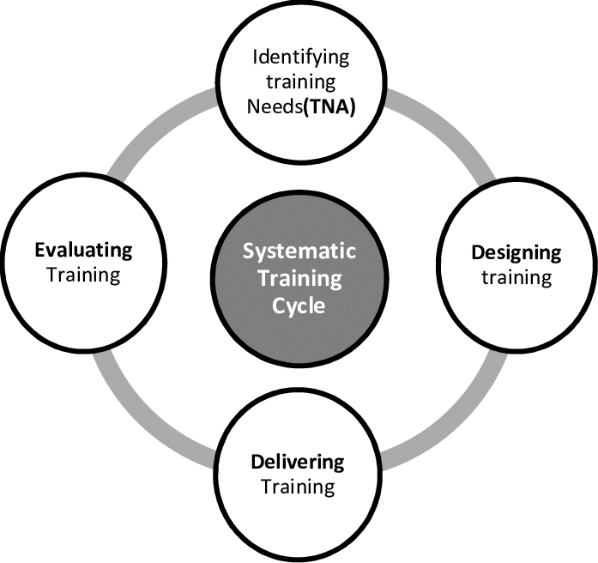
On the job training is a method of learning a job while doing it. A person will do the task or job and at the same time learn and develop skills required by the job role (Heathfield, 2018). This can include, understudy, this is when an employee is trained by their supervisor and called understudy or assistant. Coaching were the employee is given guidance and instructions from a superior or supervisor. As stated in CMOE (2019), it may involve demonstrations and critical evaluation. Mentoring, in this the trainee is supported and given advice from someone with more experience. Secondment, here employees are sent to a different place where they can learn different and useful skills (business Case Studies, 2019). Some companies also offer apprenticeships where an apprentice will do a mixture of formal training, practical work and even informal training along with studying to gain a qualification.
Off the job training is when a person trains and learns while being away from the job (Business Jargons, 2019). Trainees are required to learn skills and get fully equipped with techniques that are needed on their actual job. According to CIPD (2019), off the job training may include doing internal or external courses and attending classes. This will give individuals the opportunity to focus on specific issues relating to the organisation or gain a fresh prospective and develop new and different skills to bring to the workplace. Other methods may include case studies and role playing.
Though both methods are useful, on the job training disadvantage are that quality will depend on the ability of the trainer and bad habits may be passed on for example, according to Glassdoor (2014), ex-employees have stated that new staff were often left alone to complete tasks as the senior staff were too busy to monitor them which can make staff think this is ok to do and they may do the same once in a higher position.
On the other hand it is known to be most effective were off the job training can be expensive and once trainees have learnt new skills they may decide to leave and go for a better job but on the positive side employees may can be more confident when starting the job (HRMP, 2019).
Organisations like Forestry commission, Kellogg’s and Tesco offer both on the job training and off the job training as both are equally important. On the job training is directly relevant to their work where they get to meet the people and become part of the team quicker (Business Case Studies, 2019). Off the job training is more for developing an individual and their skills to work their way up. Providing these training methods helps Tesco build a team of employees who are committed and flexible delivering high standards of customer service increasing customer growth.

- Benefits of Using Development Vehicles

  - Organisation
Organisations that engaged employee development, benefited from sales increases and double profits (Getsmarter, 2019). It helps develop organisations employer brand making it more attractive to potential new and top employees working for competitor companies especially those looking to improve their skills (CFI, 2019). Training programmes are used as a competitive benefit. Motivating employees is very important for an organisation as it helps improve business performance (Napolitano, 2017). Staff turnover will reduce leading to reduction in recruitment costs. Number of absences will reduce which will benefit to higher productivity (NIBusiisnessinfo.co.uk, 2019). According to Getsmarter, (2019), investing in staff development is important for team retention and ninety four percent employee would stay with a company if it invested in their development. Herzberg who developed the two-factor theory which states that hygiene factors would satisfy employees who would become more productive (Business Case Studies, 2019). He believes that organisations need to ensure that hygiene factors reduced to motivate staff to have their full effect. According to another Case study on Linked In, Kellogg’s was included in the top hundred best companies to work for in The Sunday Times. Kellogg’s using Herzberg’s theory has built a business that delivers consistent strong results. According to Business case studies, (2019), Kellogg’s makes work an exciting experience resulting in more productive, profitable and competitive business. However, this can come across as being a bit exaggerated as using Herzberg theory alone, money becomes secondary and if a competitor company is paying more money for the same job employees will not be satisfied resulting in problems for the company for example more staff may leave the organisation for a better paid job (Parikh, 2018), which is why Kellogg’s implement other theories as well as Herzberg such as Fredrick Taylors theory as many employees are motivated by cash alternatives.
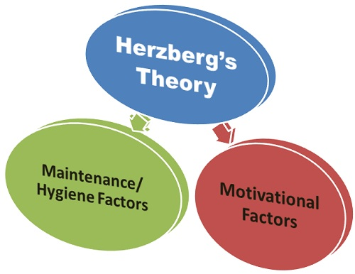(Business Jargons, 2019)
  - Individual
Employees are benefited in numerous ways through using development vehicles. These include learning new skills and knowledge, or existing skills can be enhanced leading to further improvement (The Happy Manager, 2019). Training will help employees become more confident and positive which will result in better performance and pay rises. Ongoing performance management help employees improve their engagement at work whilst giving them a clear picture of their performance. It can also open opportunities to work their way up through promotions (Jones, 2016). Employees feel more at power and valued and will keep them motivated to do better if they are given the right attention (Getsmarter, 2019).
Maslow’s Theory is about motivation and the hierarchy of employee needs. He believes that when an individual is satisfies on one level of need (Linked in, 2016), they will move on to the next level which benefits the organisation but for employees Maslow’s theory is also highly beneficial as organisations who apply the Maslow theory will not only take care of staff pay but also their personal needs. For example, according to a case study on Business Case Studies, (2019), Kellogg’s employees are all motivated through all these levels and this has positive effects on each employee as the are offered completive salaries. They also have benefit programmes where employees can choose the benefits that suit their needs (Business Case Studies, 2019). Theses include child care vouchers, company cars, cash rewards and even discounted life assurance schemes. Employees at Kellogg’s also can choose work patterns that suit them and even take career breaks allowing employees to benefit from choosing a healthy work-life balance. Kellogg’ s also gives employees to take on ownership of projects which give them development opportunity.
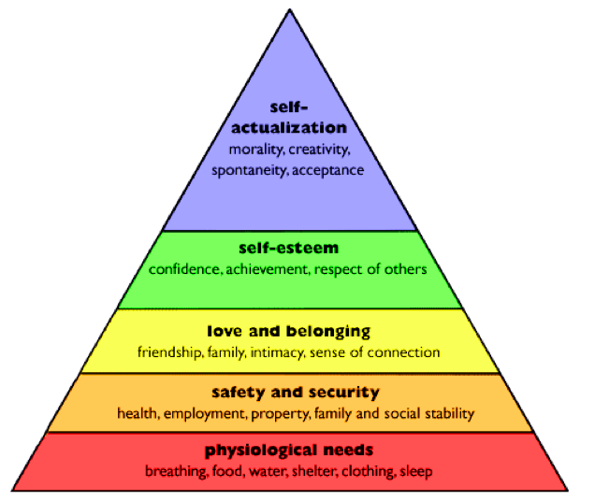(Papertyari, 2019)

For example, Laura Bryant who wanted to move into marketing joined Kellogg’s in 2002 in the sales team (Business Case Studies). Two years later she was promoted to customer marketing manager which helped build her outline her goals. Laura soon became assistant brand manager with her managers support and in 2009 was furthered to manage the marketing plan for Special K and now she is the brand manager of Kellogg’s Cornflakes. Through this Laura was helped by the organisation through motivation, training and performance management to help her move up in the hierarchy of needs and reach her career goal.

- Person Development Plan
Personal development plan is a tool used to set goals and manage an individual’s or an organisation’s learning and growth (Brian, 2019) from which they work on every day to make progress on their development leading to success. Objectives in the PDP should be SMART or else it will, or it will leave everyone unsure of what to do (Parker and Crosby, 2012).
An individual who is aiming to build a career in education and become a teacher may come across objectives listed on this PDP.

Personal Development Plan

Objectives  What do I want to be able to do  or do better? | Success criteria  How will I recognise success?  How will I review and measure my improvement? | Actions  What methods will I use to achieve my learning objectives? | Implementation  How will I practise and apply what I learn?
Improve on numeracy skills as it is an essential part of teaching (Future Learn, 2019). | - GCSE grade B or Above  - Level three award qualification.  - Lecturer feedback  (City and Guilds, 2018) | - GCSE in maths  - Level three award in mathematics for numeracy. This will help develop skills needed for teaching (City and Guilds, 2018). | Take the National Numeracy  Challenge. This will help see help see progress (National Numeracy,2019).  Apply mathematical solutions without using calculators or computers (City University of London, 2019).
Improve leadership skills. This is vital for a teacher. (Lynch, 2019). | - Certificate of completion (UCL, 2019).  - QTS Certificate (UCAS, 2019). | Early Leadership level one.  This will them understand themselves,  understand others and develop good  leadership skills (UCL, 2019). | Postgraduate Teaching Apprenticeship, practice while working in a school with children (UCAS, 2019). Find a mentor for constructive feedback (Randstad,  2019).
Develop better communication skills as teaching is all about communicating through listening, speaking, reading, writing and presenting (Silver, 2018). | Can communicate in a novel way and  engage audience enough where  content of conversation sticks with  them (Patel, 2017). | Listen to others and  think about who the audience are  before speaking (Patel, 2017).  Do more networking through social  media and other networking sites  (Darmody, 2018). | Attend local society debate meetings.  This will help see how the researcher  has developed communication skills  and confidence and put them to practice  (Bright Network, 2019).
Improve on being more patient. As a  teacher it is important to have  patience as they will come across  different characteristics in children,  some who will put in minimal effort  or some who will express anxiety.  (School of Educators, 2011), so | Less stressed and feels happier in what  they are doing this can be marked as  success in being more patient (Power,  2018). | Be more mindful of the things that  make them impatient by writing them  down and focusing on one task at a  time (Power, 2018). | Practice patience levels with own children at home by pausing and reflecting on situations before reacting  (Korpalski, 2019).
Develop their creative ICT skills.  Individual will need knowledge in  modern technology.  (Fort, 2017). | Gain a level two certificate on Information and Creative Technology (Coleg Gwent, 2019). | BTEC in Information and Creative  Technology level two as it will  Help gain broad knowledge on  information technology and develop  creative aspects of ICT  (Coleg Gwent, 2019). | use the computer more often whether it’s for course work or assignment or personal use such as booking holidays and shopping online. Find a part  time job which involves using computer  programmes in which they can apply  the skills (Doyle, 2018).
Develop better teamworking skills  and work better with different  personalities. (Teacher Certification,  2019). | More respected by members of a team where they can rely on them and a positive attitude is kept whether the results are good or bad (Riggio, 2013). | Work with different groups of people  while doing them courses take part in  decision making (Founders Grid, 2014). | Prioritise weaknesses whilst working in  different groups, work on improving  them. Feedback from other members  Teamwork theories like the Belbin  theory which can help identify strengths  and weaknesses of different members  of the team which can help  communicate and work together better  (Belbin, 2019).

Conclusion

To conclude, the researcher has found that developing workplace relationships and achieving skills plays a big part for both the employer and employee. Learning new skills or developing on weak skills can help work towards building an individual’s career and help increase organisation profits and status.
The researcher has found that using different theories in the organisation is important as they help plan goals and how to achieve them. Motivating employees through social factors is just as important as pay to satisfy employees (toolshero, 2019).
On the job training allows workers to learn while working and was found the most effective. Off the job training gives the opportunity to learn new and different skills but can be expensive for the employer. The systematic training cycle gives a systematic approach to training and identifying weaknesses which need to be improved (2020 Business Insight, 2019).
According to Hearn, (2017), performance management helps review progress of staff formally and informally. The researcher found that regular reviews help both the employer and employee see weaknesses and set goals to improve them as well as recognising achievements which can help motivate them. Using a PDP to set goals for those objectives can help plan towards improving them in a SMART way (Brian, 2019).

Reference List

Air Freshener. (2019), ‘Elton Mayo Human Relations Theory’, [Online]. Available: https://airfreshener.club/quotes/elton-mayo-human-relations-theory.html. [Accessed: 30th March 2019].
Barry, N, Cumberland, N, Kamp, D, and Manser. (2015), ‘The Ultimate Management Book’. Great Britain: Hodder & Stoughton.
Belbin. (2019), ‘Why Use Belbin?’, [Online]. Available: https://www.belbin.com/about/why-use-belbin/. [Accessed: 7th April 2019].
Business Case Studies. (2019), (Building an Better Workplace Through Motivation’, [Online]. Available: http://businesscasestudies.co.uk/kelloggs/building-a-better-workplace-through-motivation/maslow.html. [Accessed: 5th April 2019].
Business Case Studies. (2019), ‘How Training and Development Supports Business Growth, A Tesco Case Study’, [Online]. Available: http://businesscasestudies.co.uk/tesco/how-training-and-development-supports-business-growth/conclusion.html. [Accessed: 4th April 2019].
Business Case Studies. (2019), ‘Motivational Theory in Practice at Tesco, A Tesco Case Study’, [Online]. Available: http://businesscasestudies.co.uk/tesco/motivational-theory-in-practice-at-tesco/conclusion.html. [Accessed: 4th April 2019].
Business Case Studies. (2019), Developing People Through Training, A Forestry Commission Case Study, [Online]. Available at: http://businesscasestudies.co.uk/forestry-commission/developing-people-through-training/training-in-action.html. [9th March 2019].
Business Jargons. (2019), ‘Herzberg’s Motivation – Hygiene Theory’, [Online]. Available: https://businessjargons.com/herzbergs-motivation-hygiene-theory.html. [Accessed: 12th April 2019].
Business Jargons. (2019), ‘Off-The-Job Training’, [Online]. Available: https://businessjargons.com/off-the-job-training.html. [Accessed: 12th April 2019].
Caramela, S. (2019), ‘Management Theory of Fredrick Taylor’, [Online]. Available: https://www.business.com/articles/management-theory-of-frederick-taylor/. [Accessed: 30th March 2019].
CFI. (2019), ‘Employee Training and Development’, [Online]. Available: https://corporatefinanceinstitute.com/resources/careers/soft-skills/employee-training-and-development/. [Accessed: 5th April 2019].
CIPD. (2019), ‘Learning Methods’, [Online]. Available: https://www.cipd.co.uk/knowledge/fundamentals/people/development/learning-methods-factsheet#6679. [Accessed: 31st March 2019].
City and Guilds. (2018), ‘English for Literacy and Mathematics for Numeracy Teaching’, [Online]. Available: https://www.cityandguilds.com/qualifications-and-apprenticeships/learning/teaching/6255-english-for-literacy-and-mathematics-for-numeracy-teaching#tab=information. [Accessed: 5th April 2019].
City University of London. (2019), ‘Application of Numeracy’, [Online]. Available: https://experience.city.ac.uk/develop-skills/application-numeracy. [Accessed: 7Th April 2019].
CMOE. (2019), ‘Three Methods of Employee Development for Professional Growth’, [Online]. Available: https://cmoe.com/blog/three-methods-of-employee-development-training-coaching-and-mentoring/. [Accessed: 31st March 2019].
Coleg Gwent. (2019), ‘BTEC Fist Diploma in Information and Creative Technology Level 2’, [Online]. Available: https://www.coleggwent.ac.uk/courses/BTEC_First_Diploma_in_Information_and_Creative_Technology_Level_2%20(BD0028). [Accessed: 7th April 2019].
Crosby, E and Parker, J.A. (2012), ‘Certificate in Team Leading’. Italy: Hodder Education.
Darmody, J. (2018), ‘How to Improve Your Communication Skills in 7 Easy(ish) Steps’, [Online]. Available: https://www.siliconrepublic.com/advice/grief-in-the-workplace-hr. [Accessed: 7th April 2019].
Dininni, J. (2017), Management Theory of Elton Mayo, [Online]. Available: https://www.business.com/articles/management-theory-of-elton-mayo/. [Accessed: 26th March 2019].
Doyle, A. (2018), ‘Five Fee and Easy Ways to Improve Your Computer Skills’, [Online]. Available: https://www.careertoolbelt.com/5-free-and-easy-ways-to-improve-your-computer-skills/. [Accessed: 7th April 2019].
EPM. (2018), ‘Taylors Motivation Theory – Scientific Management’, [Online]. Available: https://expertprogrammanagement.com/2018/05/taylors-scientific-management/. [Accessed: 30th March 2019].
Fort, A. (2017), ‘Eight Computer Skills for Every Teacher to Master’, [Online]. Available: https://elearningindustry.com/8-computer-skills-every-teacher-to-master. [Accessed: 7th April 2019].
Founders Grid. (2014), ‘20Stratergies Start Ups Can Implement Today to Improve Teamwork’, [Online]. Available: https://foundersgrid.com/teamwork/. [Accessed: 7th April 2019].
Future Learn. (2019), ‘Introducing the Training Cycle’, [Online]. Available: https://www.futurelearn.com/courses/7093exq-01/1/steps/421580. [Accessed: 12th April 2019].
Future Learn. (2019), ‘Numeracy Skills for Employability and Workplace’, [Online]. Available: https://www.futurelearn.com/courses/numeracy-skills. [Accessed: 5th April 2019]. Ity
Getsmarter. (2019), ‘Employee Training and Developing: The Benefits and Why it’s Important’, [Online]. Available: https://www.getsmarter.com/blog/employee-development/employee-training-and-development-the-benefits-and-why-its-important. [Accessed: 4th April 2019].
Glassdoor. (2014), ‘Tesco’, [Online]. Available: https://www.glassdoor.co.uk/Reviews/Employee-Review-Tesco-RVW4389745.htm. [Accessed: 12th April 2019].
Grin. (2011), ‘Compare and Contrast Scientific Management and Human Relations Theory’, [Online]. Available: https://www.grin.com/document/205705. [Accessed: 30th March 2019].
Hearne, S. (2016), ‘What is Continues Performance Management?’, [Online]. Available: https://www.clearreview.com/resources/guides/continuous-performance-management/. [Accessed: 4th April 2019].
Hearne, S. (2017), ‘What is an Effective Performance Management System (Explained)’, (Online). Available: https://www.clearreview.com/resources/guides/what-is-effective-performance-management/. [Accessed: 31st March 2019].
Heathfield, S.M. (2018), ‘How On-The-Job Training Brings You Value’, [Online]. Available: https://www.thebalancecareers.com/how-on-the-job-training-brings-you-value-1917941. [Accessed: 12th April 2019].
HRMC. (2019), ‘Advantages and Disadvantages of Off-The-Job Training’, [Online]. Available: http://hrmpractice.com/advantages-disadvantages-of-off-the-job-training/. [Accessed: 12th April 2019].
Industrial Personal LTD. (2016), ‘Why is it Important to Have Effective Working Relationships with Colleagues?’, [Online]. Available: http://www.industrialpersonnel.co.uk/important-effective-working-relationships-colleagues/. [Accessed: 8th April 2019].
Jones, D. (2016), ‘How Ongoing Performance Management Benefits the Employee and the Business’, [Online]. Available: https://blog.shrm.org/blog/how-ongoing-performance-management-benefits-the-employee-and-the-business. [Accessed: 5th April 2019].
Korpalski, B. (2019), ‘Five Easy-To-Implement Strategies for Exercising Patience’, [Online]. Available: https://www.doyouyoga.com/5-easy-to-implement-strategies-for-exercising-patience/. [Accessed: 7th April 2019].
Linked in. (2014), ‘Kellogg’s Strategy (K-Values) of Motivating Employees’, [Online]. Available: https://www.linkedin.com/pulse/20140722081552-40947926-kellogg-s-strategy-k-values-of-motivation-of-employees/. [Accessed: 5th April 2019].
Linked in. (2016), ‘Maslow’s Hierarchy of Needs: The Benefits of Self – Actualised Employees’, [Online]. Available: https://www.linkedin.com/pulse/maslows-hierarchy-needs-benefits-self-actualized-employees-scott-king/. [Accessed: 5th April 2019].
Lynch, M. (2016), ‘Why More Teachers Need a Leadership Mindset’, [Online]. Available: https://www.theedadvocate.org/teachers-need-leadership-mindset/. [Accessed: 7th April 2019].
Mister Simplify. (2017), Mayo’s Hawthorne Effect (Employee Motivation) - Simplest Explanation Ever, [Video]. Available: https://www.youtube.com/watch?v=UUMYVN-4wFw&t=12s. [Accessed: 30th March 2019].
MSG. (2019), ‘Motivating and Employee Development’, [Online]. Available: https://www.managementstudyguide.com/motivation-and-employee-development.htm. [Accessed: 29th March 2019].
My Assignment Help. (2019), ‘Tesco Performance Management: Performance and Productivity’, [Online]. Available: https://myassignmenthelp.com/free-samples/tesco-performance-management-performance-and-productivity. [Accessed: 4th April 2019].
Napolitano, A. (2017), ‘Beyond the Clock: The Benefits of Highly Motivated Employees’, [Online]. Available: https://www.business.com/articles/the-benefits-of-highly-motivated-employees/. [Accessed: 4th April 2019].
National Numeracy. (2019), ‘How to Improve Your Maths’, [Online]. Available: https://www.nationalnumeracy.org.uk/improve-your-maths. [Accessed: 6th April 2019].
NIBusiness info.co.uk. (2019), ‘Lead and Motivate your Staff’, [Online]. Available: https://www.nibusinessinfo.co.uk/content/advantages-leading-and-motivating-your-employees. [Accessed: 4th April 2019].
Papertyari. (2019), ‘Maslow’s Need Hierarchy Theory of Motivation’, [Online]. Available: http://www.papertyari.com/general-awareness/management/maslows-need-hierarchy-theory-motivation/. [Accessed: 12th April 2019].
Parikh, V. (2018), ‘Advantages and Disadvanteges of Herzberg Theory’, [Online]. Available: http://www.letslearnfinance.com/advantages-and-disadvantages-of-herzberg-theory.html. [Accessed: 4th April 2019].
Patel, D. (2017), ’14 Ways to Improve Your Communication Skills’, [Online]. Available: https://www.entrepreneur.com/article/300466. [Accessed: 7th April 2019].
Power, R. (2018), ‘4 Tips to Help You be More Patient, Science Says You Will Be Happier’, [Online]. Available: https://www.inc.com/rhett-power/4-tips-to-help-you-be-a-more-patient-person-science-says-you-will-be-happier.html. [Accessed: 7th April 2019].
Randstad. (2019), ‘Developing Leadership Skills in Teaching’, [Online]. Available: https://www.randstad.co.uk/career-advice/skills/developing-leadership-skills-in-teaching/. [Accessed: 7th April 2019].
Riggio, R, E. (2013), ‘Characteristics of Good Team Members’, [Online]. Available: https://www.psychologytoday.com/us/blog/cutting-edge-leadership/201301/characteristics-good-work-team-members. [Accessed: 7th April 2019].
School of Educators. (2011), ‘Patience Maybe the Most Important’, [Online]. Available: http://schoolofeducators.com/2011/06/patience-may-be-the-most-important/. [Accessed: 7th April 2019].
Silver, F. (2018), ‘Why is it Important for Teachers to Have Good Communication Skills?’, [Online]. Available: https://work.chron.com/important-teachers-good-communication-skills-10512.html. [Accessed: 7th April 2019].
Skills For Justice. (2017), ‘Five Reasons Why Staff Development in the Workplace is Important, [Online]. Available: https://www.sfjuk.com/blog/215-five-reasons-why-staff-development-in-the-workplace-is-important. [Accessed: 8th April 2019].
Squareup. (2019), ’10 Scientifically Ways to Motivate Employees’, [Online]. Available: https://squareup.com/gb/townsquare/how-to-motivate-your-employees. [Accessed: 29th March 2019].
Sultana, A. (2019), ‘Systematic Training’, [Online]. Available: https://www.researchgate.net/figure/Systematic-Training-the-basic-cycle-Cole-Employee-development-and-Training-pp-351_fig1_268382111. [Accessed: 31st March 2019].
Teacher Certification. (2019), '9 Useful Skills for Teachers’, [Online]. Available: http://www.teachercertification.org/a/9-useful-skills-for-teachers.html. [Accessed: 7th April 2019].
The Happy Manager. (2019), ‘Employee Training Development’, [Online]. Available: https://the-happy-manager.com/articles/employee-training-development/. [Accessed: 5th April 2019].
Tools Hero. (2019), Elton Mayo, [Online]. Available: https://www.toolshero.com/toolsheroes/elton-mayo/. [Accessed: 26th March 2019].
Tracy, B. (2019), ‘Turn All Your Dreams Into Reality With a Personal Development Plan’, [Online]. Available: https://www.briantracy.com/blog/personal-success/personal-development-plan/. [Accessed: 7th April 2019].
Tutor2u. (2018), ‘Theories of Motivation (GCSE)’, [Online]. Available: https://www.tutor2u.net/business/reference/theories-of-motivation-gcse. [Accessed: 30th March 2019].
Tutor2u. (2018), ‘Training – Off-The-Job Training’, [Online]. Available: https://www.tutor2u.net/business/reference/training-off-the-job-training. [Accessed: 31st March].
UCAS. (2019), ‘Post Graduate Teaching Apprenticeship’, [Online]. Available: https://www.ucas.com/teaching-option/postgraduate-teaching-apprenticeship. [Accessed: 7th April 2019].
UCL. (2019), ‘Early Leadership (Level 1): Leadership Development Programme (For New and Aspiring Leaders in Education), [Online]. Available: https://www.ucl.ac.uk/lifelearning/courses/early-leadership-level-1-new-aspiring-leaders-education. [Accessed: 7th April 2019].

Bibliography

Air Freshener. (2019), ‘Elton Mayo Human Relations Theory’, [Online]. Available: https://airfreshener.club/quotes/elton-mayo-human-relations-theory.html. [Accessed: 30th March 2019].
Barry, N, Cumberland, N, Kamp, D, and Manser. (2015), ‘The Ultimate Management Book’. Great Britain: Hodder & Stoughton.
Belbin. (2019), ‘Why Use Belbin?’, [Online]. Available: https://www.belbin.com/about/why-use-belbin/. [Accessed: 7th April 2019].
Business Case Studies. (2019), (Building an Better Workplace Through Motivation’, [Online]. Available: http://businesscasestudies.co.uk/kelloggs/building-a-better-workplace-through-motivation/maslow.html. [Accessed: 5th April 2019].
Business Case Studies. (2019), ‘How Training and Development Supports Business Growth, A Tesco Case Study’, [Online]. Available: http://businesscasestudies.co.uk/tesco/how-training-and-development-supports-business-growth/conclusion.html. [Accessed: 4th April 2019].
Business Case Studies. (2019), ‘Motivational Theory in Practice at Tesco, A Tesco Case Study’, [Online]. Available: http://businesscasestudies.co.uk/tesco/motivational-theory-in-practice-at-tesco/conclusion.html. [Accessed: 4th April 2019].
Business Case Studies. (2019), Developing People Through Training, A Forestry Commission Case Study, [Online]. Available at: http://businesscasestudies.co.uk/forestry-commission/developing-people-through-training/training-in-action.html. [9th March 2019].
Business Case Studies. (2019), Developing People Through Training, A Forestry Commission Case Study, [Online]. Available at: http://businesscasestudies.co.uk/forestry-commission/developing-people-through-training/training-in-action.html. [9th March 2019].
Business Jargons. (2019), ‘Herzberg’s Motivation – Hygiene Theory’, [Online]. Available: https://businessjargons.com/herzbergs-motivation-hygiene-theory.html. [Accessed: 12th April 2019].
Business Jargons. (2019), ‘Off-The-Job Training’, [Online]. Available: https://businessjargons.com/off-the-job-training.html. [Accessed: 12th April 2019].
Caramela, S. (2019), ‘Management Theory of Fredrick Taylor’, [Online]. Available: https://www.business.com/articles/management-theory-of-frederick-taylor/. [Accessed: 30th March 2019].
CFI. (2019), ‘Employee Training and Development’, [Online]. Available: https://corporatefinanceinstitute.com/resources/careers/soft-skills/employee-training-and-development/. [Accessed: 5th April 2019].
Chron. (2019), Importance of Motivation and Goal Setting for Business, [Online]. Available: https://smallbusiness.chron.com/importance-motivation-goal-setting-businesses. [Accessed: 16th February 2019].
CIPD. (2019), ‘Learning Methods’, [Online]. Available: https://www.cipd.co.uk/knowledge/fundamentals/people/development/learning-methods-factsheet#6679. [Accessed: 31st March 2019].
City and Guilds. (2018), ‘English for Literacy and Mathematics for Numeracy Teaching’, [Online]. Available: https://www.cityandguilds.com/qualifications-and-apprenticeships/learning/teaching/6255-english-for-literacy-and-mathematics-for-numeracy-teaching#tab=information. [Accessed: 5th April 2019].
City University of London. (2019), ‘Application of Numeracy’, [Online]. Available: https://experience.city.ac.uk/develop-skills/application-numeracy. [Accessed: 7Th April 2019].
CMOE. (2019), ‘Three Methods of Employee Development for Professional Growth’, [Online]. Available: https://cmoe.com/blog/three-methods-of-employee-development-training-coaching-and-mentoring/. [Accessed: 31st March 2019].
Coleg Gwent. (2019), ‘BTEC Fist Diploma in Information and Creative Technology Level 2’, [Online]. Available: https://www.coleggwent.ac.uk/courses/BTEC_First_Diploma_in_Information_and_Creative_Technology_Level_2%20(BD0028). [Accessed: 7th April 2019].
Crosby, E and Parker, J.A. (2012), ‘Certificate in Team Leading’. Italy: Hodder Education.
Darmody, J. (2018), ‘How to Improve Your Communication Skills in 7 Easy(ish) Steps’, [Online]. Available: https://www.siliconrepublic.com/advice/grief-in-the-workplace-hr. [Accessed: 7th April 2019].
Dininni, J. (2017), Management Theory of Elton Mayo, [Online]. Available: https://www.business.com/articles/management-theory-of-elton-mayo/. [Accessed: 26th March 2019].
Doyle, A. (2018), ‘Five Fee and Easy Ways to Improve Your Computer Skills’, [Online]. Available: https://www.careertoolbelt.com/5-free-and-easy-ways-to-improve-your-computer-skills/. [Accessed: 7th April 2019].
EPM. (2018), ‘Taylors Motivation Theory – Scientific Management’, [Online]. Available: https://expertprogrammanagement.com/2018/05/taylors-scientific-management/. [Accessed: 30th March 2019].
Forestry Commision. (2017), ‘What We Do - How We Work’, [Online]. Available: https://www.forestry.gov.uk/website/forestry.nsf/byunique/INFD-9CCC78. [Accessed: 13th March 2019]
Forestry Commision. (2018), ‘Our Apprenticeship Scheme’, [Online]. Available: https://www.forestry.gov.uk/apprenticeships. [Accessed: 13th March 2019]
Fort, A. (2017), ‘Eight Computer Skills for Every Teacher to Master’, [Online]. Available: https://elearningindustry.com/8-computer-skills-every-teacher-to-master. [Accessed: 7th April 2019].
Founders Grid. (2014), ‘20Stratergies Start Ups Can Implement Today to Improve Teamwork’, [Online]. Available: https://foundersgrid.com/teamwork/. [Accessed: 7th April 2019].
Future Learn. (2019), ‘Introducing the Training Cycle’, [Online]. Available: https://www.futurelearn.com/courses/7093exq-01/1/steps/421580. [Accessed: 12th April 2019].
Future Learn. (2019), ‘Numeracy Skills for Employability and Workplace’, [Online]. Available: https://www.futurelearn.com/courses/numeracy-skills. [Accessed: 5th April 2019]. Ity
Getsmarter. (2019), ‘Employee Training and Developing: The Benefits and Why it’s Important’, [Online]. Available: https://www.getsmarter.com/blog/employee-development/employee-training-and-development-the-benefits-and-why-its-important. [Accessed: 4th April 2019].
Glassdoor. (2014), ‘Tesco’, [Online]. Available: https://www.glassdoor.co.uk/Reviews/Employee-Review-Tesco-RVW4389745.htm. [Accessed: 12th April 2019].
Grin. (2011), ‘Compare and Contrast Scientific Management and Human Relations Theory’, [Online]. Available: https://www.grin.com/document/205705. [Accessed: 30th March 2019].
Hearne, S. (2016), ‘What is Continues Performance Management?’, [Online]. Available: https://www.clearreview.com/resources/guides/continuous-performance-management/. [Accessed: 4th April 2019].
Hearne, S. (2017), ‘What is an Effective Performance Management System (Explained)’, (Online). Available: https://www.clearreview.com/resources/guides/what-is-effective-performance-management/. [Accessed: 31st March 2019].
Heathfield, S.M. (2018), ‘How On-The-Job Training Brings You Value’, [Online]. Available: https://www.thebalancecareers.com/how-on-the-job-training-brings-you-value-1917941. [Accessed: 12th April 2019].
Hermann, D. (2017), ‘Tips on Counselling for supervisors: Part2 – The Counselling Session’, [Online]. Available: https://www.fedsmith.com/2017/05/25/tips-counseling-supervisors-part-2/. [ Accessed: 3rd March 2019].
HRMC. (2019), ‘Advantages and Disadvantages of Off-The-Job Training’, [Online]. Available: http://hrmpractice.com/advantages-disadvantages-of-off-the-job-training/. [Accessed: 12th April 2019].
Industrial Personal LTD. (2016), ‘Why is it Important to Have Effective Working Relationships with Colleagues?’, [Online]. Available: http://www.industrialpersonnel.co.uk/important-effective-working-relationships-colleagues/. [Accessed: 8th April 2019].
Jones, D. (2016), ‘How Ongoing Performance Management Benefits the Employee and the Business’, [Online]. Available: https://blog.shrm.org/blog/how-ongoing-performance-management-benefits-the-employee-and-the-business. [Accessed: 5th April 2019].
Korpalski, B. (2019), ‘Five Easy-To-Implement Strategies for Exercising Patience’, [Online]. Available: https://www.doyouyoga.com/5-easy-to-implement-strategies-for-exercising-patience/. [Accessed: 7th April 2019].
Linked in. (2014), ‘Kellogg’s Strategy (K-Values) of Motivating Employees’, [Online]. Available: https://www.linkedin.com/pulse/20140722081552-40947926-kellogg-s-strategy-k-values-of-motivation-of-employees/. [Accessed: 5th April 2019].
Linked in. (2016), ‘Maslow’s Hierarchy of Needs: The Benefits of Self – Actualised Employees’, [Online]. Available: https://www.linkedin.com/pulse/maslows-hierarchy-needs-benefits-self-actualized-employees-scott-king/. [Accessed: 5th April 2019].
Lynch, M. (2016), ‘Why More Teachers Need a Leadership Mindset’, [Online]. Available: https://www.theedadvocate.org/teachers-need-leadership-mindset/. [Accessed: 7th April 2019].
Mister Simplify. (2017), Mayo’s Hawthorne Effect (Employee Motivation) - Simplest Explanation Ever, [Video]. Available: https://www.youtube.com/watch?v=UUMYVN-4wFw&t=12s. [Accessed: 30th March 2019].
MSG. (2019), ‘Motivating and Employee Development’, [Online]. Available: https://www.managementstudyguide.com/motivation-and-employee-development.htm. [Accessed: 29th March 2019].
My Assignment Help. (2019), ‘Tesco Performance Management: Performance and Productivity’, [Online]. Available: https://myassignmenthelp.com/free-samples/tesco-performance-management-performance-and-productivity. [Accessed: 4th April 2019].
Napolitano, A. (2017), ‘Beyond the Clock: The Benefits of Highly Motivated Employees’, [Online]. Available: https://www.business.com/articles/the-benefits-of-highly-motivated-employees/. [Accessed: 4th April 2019].
National Numeracy. (2019), ‘How to Improve Your Maths’, [Online]. Available: https://www.nationalnumeracy.org.uk/improve-your-maths. [Accessed: 6th April 2019].
NIBusiness info.co.uk. (2019), ‘Lead and Motivate your Staff’, [Online]. Available: https://www.nibusinessinfo.co.uk/content/advantages-leading-and-motivating-your-employees. [Accessed: 4th April 2019].
Papertyari. (2019), ‘Maslow’s Need Hierarchy Theory of Motivation’, [Online]. Available: http://www.papertyari.com/general-awareness/management/maslows-need-hierarchy-theory-motivation/. [Accessed: 12th April 2019].
Parikh, V. (2018), ‘Advantages and Disadvanteges of Herzberg Theory’, [Online]. Available: http://www.letslearnfinance.com/advantages-and-disadvantages-of-herzberg-theory.html. [Accessed: 4th April 2019].
Patel, D. (2017), ’14 Ways to Improve Your Communication Skills’, [Online]. Available: https://www.entrepreneur.com/article/300466. [Accessed: 7th April 2019].
Power, R. (2018), ‘4 Tips to Help You be More Patient, Science Says You Will Be Happier’, [Online]. Available: https://www.inc.com/rhett-power/4-tips-to-help-you-be-a-more-patient-person-science-says-you-will-be-happier.html. [Accessed: 7th April 2019].
Randstad. (2019), ‘Developing Leadership Skills in Teaching’, [Online]. Available: https://www.randstad.co.uk/career-advice/skills/developing-leadership-skills-in-teaching/. [Accessed: 7th April 2019].
Reference for Business. (2019), Employee Motivation, [Online]. Available: www.referenceforbusiness.com. [Accessed:16th February 2019].
Riggio, R, E. (2013), ‘Characteristics of Good Team Members’, [Online]. Available: https://www.psychologytoday.com/us/blog/cutting-edge-leadership/201301/characteristics-good-work-team-members. [Accessed: 7th April 2019].
School of Educators. (2011), ‘Patience Maybe the Most Important’, [Online]. Available: http://schoolofeducators.com/2011/06/patience-may-be-the-most-important/. [Accessed: 7th April 2019].
Silver, F. (2018), ‘Why is it Important for Teachers to Have Good Communication Skills?’, [Online]. Available: https://work.chron.com/important-teachers-good-communication-skills-10512.html. [Accessed: 7th April 2019].
Skills For Justice. (2017), ‘Five Reasons Why Staff Development in the Workplace is Important, [Online]. Available: https://www.sfjuk.com/blog/215-five-reasons-why-staff-development-in-the-workplace-is-important. [Accessed: 8th April 2019].
Squareup. (2019), ’10 Scientifically Ways to Motivate Employees’, [Online]. Available: https://squareup.com/gb/townsquare/how-to-motivate-your-employees. [Accessed: 29th March 2019].
Sultana, A. (2019), ‘Systematic Training’, [Online]. Available: https://www.researchgate.net/figure/Systematic-Training-the-basic-cycle-Cole-Employee-development-and-Training-pp-351_fig1_268382111. [Accessed: 31st March 2019].
Teacher Certification. (2019), '9 Useful Skills for Teachers’, [Online]. Available: http://www.teachercertification.org/a/9-useful-skills-for-teachers.html. [Accessed: 7th April 2019].
The Happy Manager. (2019), ‘Employee Training Development’, [Online]. Available: https://the-happy-manager.com/articles/employee-training-development/. [Accessed: 5th April 2019].
Tools Hero. (2019), Elton Mayo, [Online]. Available: https://www.toolshero.com/toolsheroes/elton-mayo/. [Accessed: 26th March 2019].
Tracy, B. (2019), ‘Turn All Your Dreams Into Reality With a Personal Development Plan’, [Online]. Available: https://www.briantracy.com/blog/personal-success/personal-development-plan/. [Accessed: 7th April 2019].
Tutor2u. (2018), ‘Theories of Motivation (GCSE)’, [Online]. Available: https://www.tutor2u.net/business/reference/theories-of-motivation-gcse. [Accessed: 30th March 2019].
Tutor2u. (2018), ‘Training – Off-The-Job Training’, [Online]. Available: https://www.tutor2u.net/business/reference/training-off-the-job-training. [Accessed: 31st March].
Tutor2u. (2018), ‘Training – Off-The-Job Training’, [Online]. Available: https://www.tutor2u.net/business/reference/training-off-the-job-training. [Accessed: 31st March].
Tutor2u. (2018), ‘Training - On-The-Job Training’, [Online]. Available: https://www.tutor2u.net/business/reference/training-on-the-job-training. [Accessed: 31st March 2018].
UCAS. (2019), ‘Post Graduate Teaching Apprenticeship’, [Online]. Available: https://www.ucas.com/teaching-option/postgraduate-teaching-apprenticeship. [Accessed: 7th April 2019].
UCL. (2019), ‘Early Leadership (Level 1): Leadership Development Programme (For New and Aspiring Leaders in Education), [Online]. Available: https://www.ucl.ac.uk/lifelearning/courses/early-leadership-level-1-new-aspiring-leaders-education. [Accessed: 7th April 2019].
UK Essays. (2016), ‘Forgotten Element of the Systematic Training Cycle Management Essay’, [Online]. Available: https://www.ukessays.com/essays/management/forgotten-element-of-the-systematic-training-cycle-management-essay.php. [Accessed: 31st March 2019].

Appendix

Forestry commission training presentation notes

Introduction

Hi everyone, my name is Naz and this is our team, Aleha, Shahida, Thanuma, and Akbar. As a team we have chosen to talk about the forestry commission. The forestry commission are Britain’s largest land managers. As stated in the forestry commission, they harvest almost four million tonnes of wood every year (Forestry Commission, 2017). They also plant millions of trees a year to create new woodland and to replace trees we harvest. The forestry commissions mission is to protect and expand forests and woodlands and increase their value to society and the environment.
Today we will discuss what types of training the forestry commission use on their staff and the importance of training their employees. We have also looked at a case study and will talk about how training has helped in this case study.
On the job training
I will start by looking at on-the-job training. On-the-job training basically means training while at work. It is considered to be the best way to learn practical skills as trainees will learn by following instructions given by a manager, trainer or colleague while doing a real task (Business Case Studies, 2019). Training may include things like how to plant new seedings and how to protect them from the cold and heat.
Different types of on the job training methods include, coaching and mentoring. This is where trainees will be guided and instructed by a coach. A senior member or someone with more experience will provide advice and give trainees support.
Another on the job training type is secondment. Here employees are sent to a different place for a short time so they can learn different useful skills.
They also offer an apprenticeship where the apprentice will combine a mixture of formal training, practical work experience, informal on the job training as well as studying towards their qualification (Forestry Commission, 2018).
I will now pass it on to Aleha who will define off the job training.

Motivation presentation notes
Hi everyone, my name is Naz and I will briefly explain how a business can improve through applying these motivational theory’s.
So how does motivation of employees help a company or organisation to achieve competitive achievements?
There are several reasons why employee motivation in a business is important. As a group we think motivating the staff is one of the most important strategy’s in a business as it helps allow the management team to meet the company goals.
Motivation affects nearly all aspects of a business. If an employee is motivated to do well this automatically shows that they are happy and satisfied at what they are doing and the right motivation will make them feel responsible for their part of the job and will make them work harder and perform better (Reference for Business, 2019).
Working harder will lead to more work done is less time and if one employee is able to do the same amount of work as two or even three workers than this will reduce labour costs for the business which show higher productivity for the company, (NDA).
Motivation can also help build a good team of people who are all aiming for the best and will provide an outstanding service, people who will not waste time, call in sick unless needed or clock out before its time to leave (Chron, 2019).
So as an example, if we look at the NDA who say they have applied different motivation theories to increase motivation in their employees, we can see that it has helped their company as they hold the ‘Investors in People’ status. So, they are a great example of how motivation can help a business.
So basically, if your staff are motivated results will be better and management teams will be happier.

Seminar Notes

Manager/ Employer:
- Go in with a positive approach and start by praising past performances of the employees using examples
- Be transparent as every relationship including work relationships are built on trust.
- Provide sense of security.
- Make it a conversation, listen to what the employee has to say.
- Describe problem in detail. What it is and why it’s a problem, be specific and explain why not using the script will have an impact on not only their performance but other team members. For example, if one person is not using the script others may think its ok to do the same or why should they have to use it when others are not.
- Explains benefits of using the script. For example, being one of the best performers with just by using the script it could increase your sales by a further 10% meaning higher commission.
- Ask the employee why they are finding it difficult to use the script and how they can change this and go on to use the script.
- Ask how you can help, for example further training
- Advise employee that if they still fail to use the script management will have no choice but to hold an official disciplinary.
- Set a review date
(Hermann, 2017)

Employee
- Have ready a summary of employee contribution, past performance and results/ achievements.
- If needed take someone in with you to the meeting
- Sechele meeting in advance with enough time to prepare.
- Go in with a positive approach and start by praising past performances of the employees using examples of specific achievements, like sales awards that have been won.
- Explain your side of the story
- Be specific and explain why you the script will decrease your sales.
- Ask the manager for reasons why you can not just carry on how you have been.
- Articulate your values and accomplishments
- Explain that even though you have had the training you feel that it didn’t help
- Be prepared to listen to the manager understand what is being said
- Try and come to an agreement that can work both ways
(GOV.UK, 2019)

