Software Design and Testing Evaluation
Battleships Web Application
Tyler Bate (2304031)
ACCB5030
Contents
1. Introduction 1
2. Evaluation of the Team Design 2
2.1 User Stories and User Story Map 2
2.2 Reflection on the Team Design Process 3
2.3 Strengths of the Design 4
2.4 Weaknesses of the Design 5
3. User Story Benefit Analysis 6
4. CRC Card Design Approach 9
4.1 Overview 9
4.2 Evaluation of CRC Cards 9
4.3 Limitations 11
5. Importance of Software Testing 13
6. Black-Box and White-Box Testing 14
7. Detailed Black-Box Test Scenarios 14
8. Detailed White-Box Test Scenarios 14
9. Testable Code 15
10. Unit Testing 16
11. Applying Unit Testing 17
12. Critical Evaluation 17
13. Conclusion 18

1. Introduction
Software design plays a crucial role in determining the success of any software system. It acts as the bridge between user requirements and the final implementation, ensuring that the system is structured, maintainable, and capable of meeting both functional and non-functional requirements. Without a well-thought-out design, even simple systems can become difficult to manage, extend, or test. In modern software engineering, design is rarely carried out in isolation; instead, it is a collaborative process supported by modelling techniques such as user stories, diagrams, and object-oriented design tools [1].
This report evaluates the design of a web-based Battleships game developed as part of a team activity. The system is based on the traditional two-player Battleships game but includes additional mechanics such as a drop bomb, which allows a player to destroy an entire ship instantly, and a counter manoeuvre, which enables repositioning of ships. These additions increase both the complexity of the game and the importance of careful system design, particularly in terms of game logic and interaction between components.
The design process involved the creation of several key artefacts, including user stories, a user story map, CRC cards, class diagrams, and sequence diagrams. These artefacts were produced collaboratively during class sessions, allowing ideas to be discussed and refined in real time. This approach reflects Agile development practices, where collaboration and iterative improvement are essential [2].
The aim of this report is to critically evaluate the design produced by the team and reflect on the experience of creating it. It will assess the effectiveness of user stories and CRC cards, analyse how well the design supports implementation and testing, and explore the importance of software testing in ensuring system quality. The report will also demonstrate the differences between black-box and white-box testing through practical examples and examine how unit testing can be applied to the Battleships system. Throughout the report, reference will be made to the design artefacts created by the team, which are included as figures.

2. Evaluation of the Team Design

2.1 User Stories and User Story Map
User stories were used as the primary method for capturing system requirements. They are short, simple descriptions of functionality written from the user’s perspective and are commonly used in Agile development because they focus on delivering value rather than technical detail [3]. Each user story typically follows the format:
As a user, I want to perform an action so that I can achieve a benefit.
This structure encourages developers to think about the purpose of each feature rather than just how it will be implemented. It also helps ensure that the system is designed around user needs, which is considered an important principle in modern software development. By focusing on user goals, developers can prioritise features that provide the most value and avoid unnecessary complexity.
The team created a range of user stories covering gameplay, system management, and administrative functions. These were then organised into a user story map, which visually represents the flow of activities within the system and shows how individual features contribute to the overall functionality of the application. The process of building the user story map also encouraged discussion among team members, helping to clarify requirements and identify any missing functionality.
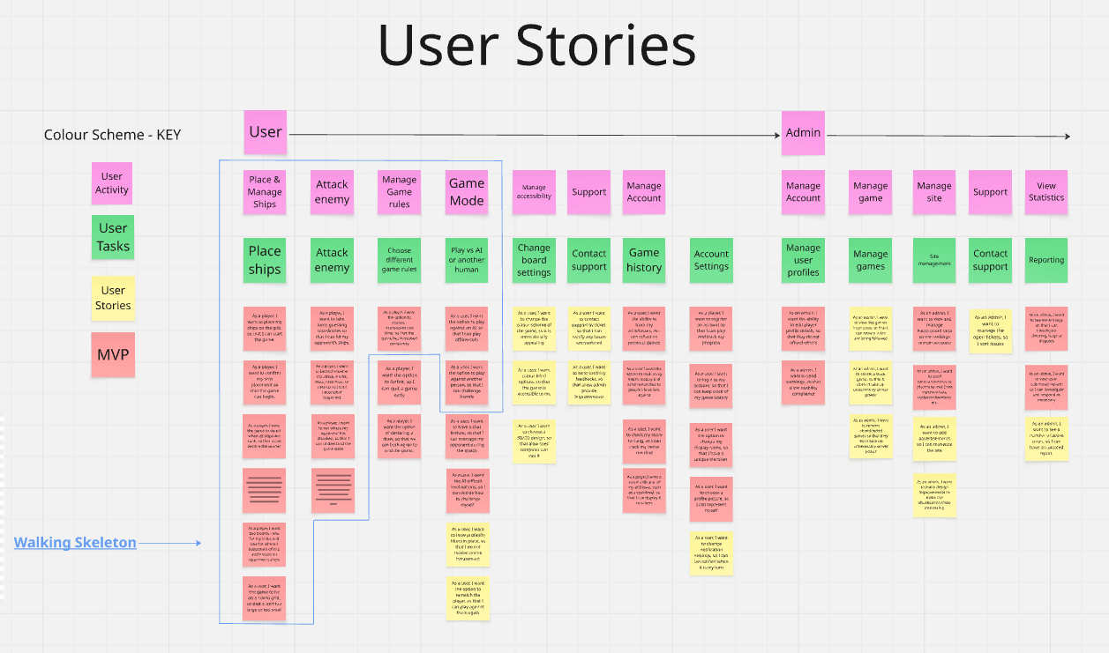
Figure 1: User Story Map
The user story map was particularly useful because it provided a high-level overview of how the system would function. It grouped related stories together and showed the order in which actions would occur during gameplay. For example, core gameplay activities such as placing ships, attacking positions, and checking results were prioritised above secondary features such as reporting and account management. This made it easier to understand which features were essential for the game to operate and which could be developed later if time allowed.
From a design perspective, the use of a user story map helped the team identify the Minimum Viable Product (MVP). This ensured that essential features were implemented first, which is a key principle in Agile development [2]. Without this structure, it would have been easy to focus too much on additional features while neglecting core gameplay functionality. The user story map therefore acted as both a planning tool and a communication tool, helping the team stay focused on delivering the most important aspects of the system.

2.2 Reflection on the Team Design Process
Working in a team had a significant impact on the quality of the design. The collaborative environment allowed ideas to be shared openly, which helped to refine requirements and improve understanding of the system. For example, discussions about how the drop bomb feature should behave led to a clearer definition of its functionality and limitations. This process demonstrated the value of teamwork in software development, as different perspectives can lead to better design decisions.
One of the main strengths of the team process was the ability to identify issues early. For instance, the interaction between the counter manoeuvre and the attack system required careful consideration to ensure fairness in gameplay. By discussing these interactions during the design phase, the team was able to avoid potential problems later in development. Early problem identification is widely recognised as a key benefit of collaborative design because fixing issues during design is generally easier and less costly than fixing them after implementation.
However, there were also challenges. Differences in interpretation sometimes led to inconsistencies in the design. For example, some team members initially had different ideas about how ship movement should be handled. Resolving these differences required additional discussion and clarification, which highlighted the importance of clear communication and shared understanding within a development team.
Another challenge was time constraints. Because the design was completed during class sessions, there was limited time to fully explore all possible scenarios, particularly edge cases such as invalid inputs or unexpected user behaviour. This highlights a common issue in software design, where time limitations can affect the level of detail in the final design. In a real-world development environment, additional time would normally be allocated for reviewing requirements, refining diagrams, and performing risk analysis.
Despite these challenges, the team-based approach provided valuable experience in collaborative problem solving and helped develop a better understanding of how software systems are designed in practice.

2.3 Strengths of the Design
The design demonstrated several important strengths that contributed to the overall effectiveness of the system architecture:
- Clear structure: The use of classes such as Player, Board, and Game created a logical system architecture that was easy to understand. Each class represented a specific component of the system, which helped to organise functionality in a structured way.
- Modularity: Each component had a specific responsibility, making the system easier to develop, test, and maintain. For example, separating the Board logic from the Player logic allows changes to be made to one component without affecting others.
- Scalability: The design allows for additional features to be added without major changes to the system. For instance, new gameplay features such as multiplayer support or score tracking could be implemented by adding new classes rather than modifying existing ones.
- User focus: The use of user stories ensured that the system meets user needs and provides a clear purpose for each feature. This helped the team stay focused on delivering functionality that improves the player experience.
These strengths align with object-oriented design principles, which promote separation of concerns, reusability, and maintainability [1]. A well-structured design also makes it easier to test the system because each component can be evaluated independently.
Another strength of the design was the use of visual modelling techniques, such as CRC cards and diagrams, which made the system easier to communicate and understand. Visual representations of system structure are particularly useful when working in teams because they provide a shared reference point for discussion.

2.4 Weaknesses of the Design
Despite its strengths, the design also had several weaknesses that could affect implementation and testing if not addressed.
- Some user stories lacked clear acceptance criteria, making them difficult to test. Acceptance criteria define the conditions that must be met for a feature to be considered complete. Without them, developers may interpret requirements differently, leading to inconsistent behaviour.
- Limited consideration of error handling, such as invalid coordinates or duplicate ship placement. Error handling is important for ensuring system reliability and preventing unexpected behaviour during gameplay.
- Lack of detailed non-functional requirements, including performance, usability, and security. While the functional requirements were clearly defined, non-functional requirements are equally important because they affect how well the system performs in real-world situations.
- Minimal focus on data validation, particularly for user input. For example, the system should check that coordinates entered by a player are within the valid range of the grid. Without proper validation, the system could produce errors or behave unpredictably.
These issues could lead to problems during implementation and testing, particularly in ensuring system reliability and user satisfaction. Addressing these weaknesses in future development stages would improve the overall quality of the system and reduce the risk of defects.
Overall, while the design provides a strong foundation for the Battleships application, further refinement and additional detail would be required before moving into full implementation.

3. User Story Benefit Analysis
A key requirement of this assignment is to evaluate user stories not only in terms of functionality but also in relation to the benefit they provide to users and the overall system. In Agile software development, user stories are designed to focus on delivering value rather than simply describing technical tasks. The benefit component explains why a feature is important and how it improves the user experience or system performance. This helps developers prioritise features and ensures that development aligns with user needs and project objectives [3].
In the Battleships system, the user stories developed by the team represent both core gameplay functionality and additional features that enhance engagement and usability. Analysing these stories in terms of their benefits makes it easier to understand how each feature contributes to the overall success of the system and supports more effective development decisions.

Example 1 — Core Gameplay: Ship Placement
User Story:
As a player, I want to place ships on the board so that I can start the game.
The benefit of this user story is fundamental, as it enables the core functionality of the Battleships system. Ship placement is required for gameplay to begin, making it a high-priority feature. From a user perspective, it allows players to control their strategy by deciding where ships are positioned, which directly influences their chances of winning and increases engagement.
From a technical perspective, this feature forms the foundation for other system functions such as attacking, win detection, and scoring. It also requires validation to ensure ships do not overlap or extend beyond the grid, improving system reliability. Overall, this is a core requirement that supports both usability and system stability.

Example 2 — Attack System: Targeting Positions
User Story:
As a player, I want to attack a position so that I can sink ships.
The benefit of this user story is progression within the game. Attacking positions allows players to interact with the system and work towards the objective of winning. Without this functionality, the game would lack purpose.
From a gameplay perspective, the attack system introduces challenge and strategy, as players must make decisions based on previous results. Technically, it requires accurate detection of hits and misses by comparing user input with stored ship positions. This ensures responsive and reliable feedback, which is essential for a positive user experience.
The system’s ability to display clear results such as “hit” or “miss” improves usability and communication, while consistent processing ensures fairness between players. Overall, this feature supports both gameplay progression and user satisfaction.

Example 3 — Special Feature: Drop Bomb Mechanic
User Story:
As a player, I want to use a drop bomb so that I can destroy a ship instantly.
The benefit of this user story is increased engagement and strategic variation. The drop bomb introduces an element of unpredictability, allowing players to significantly impact the game in a single move. This makes gameplay more dynamic and maintains user interest.
From a technical perspective, the feature requires logic to detect whether a selected position contains part of a ship and, if so, to destroy all associated positions. This simplifies gameplay while maintaining accuracy.
The limitation of using the drop bomb only once adds strategic depth, as players must decide when it is most effective. However, this feature also requires careful validation to prevent misuse and ensure fairness. Overall, it enhances gameplay by increasing excitement and encouraging strategic decision-making.

Example 4 — Defensive Feature: Counter Manoeuvre
User Story:
As a player, I want to move a ship so that I can avoid being hit.
The benefit of this user story is the introduction of defensive gameplay, adding a new dimension to the system. Unlike traditional Battleships, this feature allows players to respond to threats, making the game more dynamic and less predictable.
From a gameplay perspective, the counter manoeuvre improves engagement by allowing players to adapt their strategy. From a technical perspective, it requires updating ship positions and notifying the opponent of a near miss, demonstrating system flexibility.
Limiting the feature to one use per player maintains fairness and balance. This user story also highlights the importance of adaptable system design, as it allows the game to respond to changing conditions without disrupting gameplay. Overall, it enhances strategic depth and user interaction.

Summary of User Story Benefits
This analysis shows that each user story contributes to the overall effectiveness of the Battleships system. The benefits can be grouped into:
- Functional benefits — enabling core gameplay
- User experience benefits — improving engagement and enjoyment
- Strategic benefits — encouraging planning and decision-making
- System benefits — supporting reliability and accuracy
Focusing on the benefit of each user story ensures that development is driven by value rather than functionality alone. This aligns with Agile principles and helps produce a system that is both effective and user-centred [3].

4. CRC Card Design Approach

4.1 Overview
CRC cards are used to define classes, responsibilities, and collaborators in an object-oriented system. They are particularly useful during early design stages because they provide a simple and visual way to model system structure and identify how different components interact with each other [4]. The acronym CRC stands for Class, Responsibility, and Collaborator, which represents the three key elements needed to describe an object within a system.
One of the main advantages of CRC cards is that they encourage collaboration among team members. During the design process, developers can physically move cards around, discuss responsibilities, and explore how classes communicate with each other. This makes the design process more interactive and helps identify potential design issues before coding begins. In educational and professional environments, CRC cards are often used to introduce object-oriented thinking because they provide a straightforward way to visualise system behaviour without requiring detailed technical knowledge.
In the context of the Battleships system, CRC cards were used to identify the main objects required for gameplay and to define the responsibilities of each component. This helped the team understand how different parts of the system would work together and ensured that each class had a clear purpose within the overall design.

4.2 Evaluation of CRC Cards

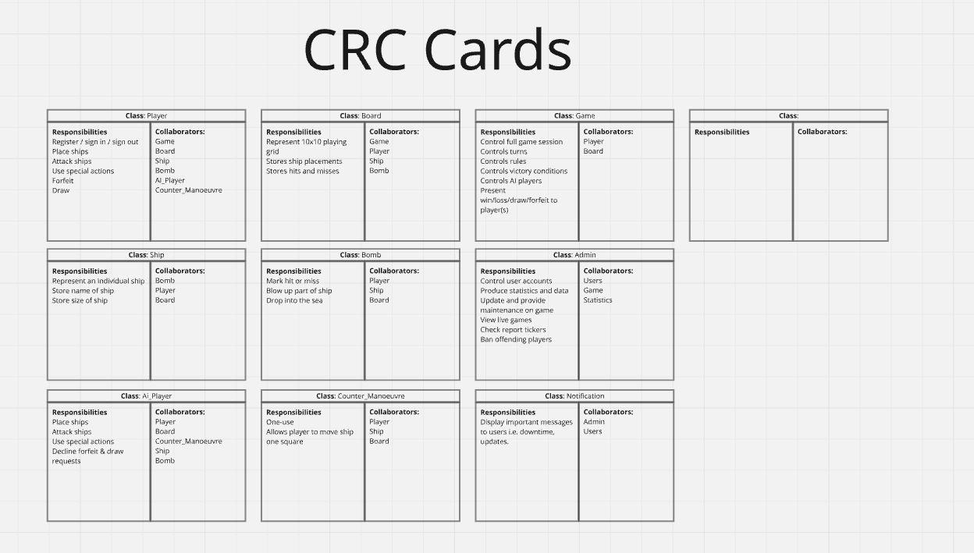Figure 2: CRC Cards
The team created CRC cards for key classes, including Player, Board, Game, Ship, Bomb, and Counter_Manoeuvre. These classes represent the main components of the Battleships application and form the foundation of the system architecture. Each card identified the responsibilities of the class and the other classes it needed to interact with, which helped clarify the relationships between different parts of the system.
These cards clearly define responsibilities. For example:
- The Player class manages actions such as placing ships, attacking positions, and using special features. This class represents the user within the system and acts as the main point of interaction with the game.
- The Board class handles grid data, including ship positions, hits, and misses. It is responsible for maintaining the state of the game board and ensuring that actions are recorded accurately.
- The Game class controls overall gameplay by managing turns, checking win conditions, and coordinating communication between other classes. This class acts as the central controller of the system.
- The Ship class represents individual ships and stores information such as size, position, and status (e.g., intact or destroyed).
- The Bomb class manages the drop bomb feature, including detecting when a ship is hit and triggering the destruction of all associated ship positions.
- The Counter_Manoeuvre class handles ship movement, allowing players to reposition a ship under specific conditions.
From a design perspective, the CRC cards demonstrate a clear application of object-oriented principles, particularly encapsulation and separation of responsibilities. Each class focuses on a specific task, which makes the system easier to understand and maintain. This structure also supports scalability, as new features can be added by introducing additional classes without significantly modifying existing ones.
Another strength of the CRC cards is that they helped the team visualise how classes interact with each other. For example, the Player class collaborates with the Board class to place ships and perform attacks, while the Game class coordinates communication between all components. This understanding of class relationships is essential for developing sequence diagrams and implementing system logic.
However, while the CRC cards provide a useful overview of system structure, they primarily focus on high-level responsibilities rather than detailed behaviour. This means they are most effective as a planning tool rather than a complete technical specification.
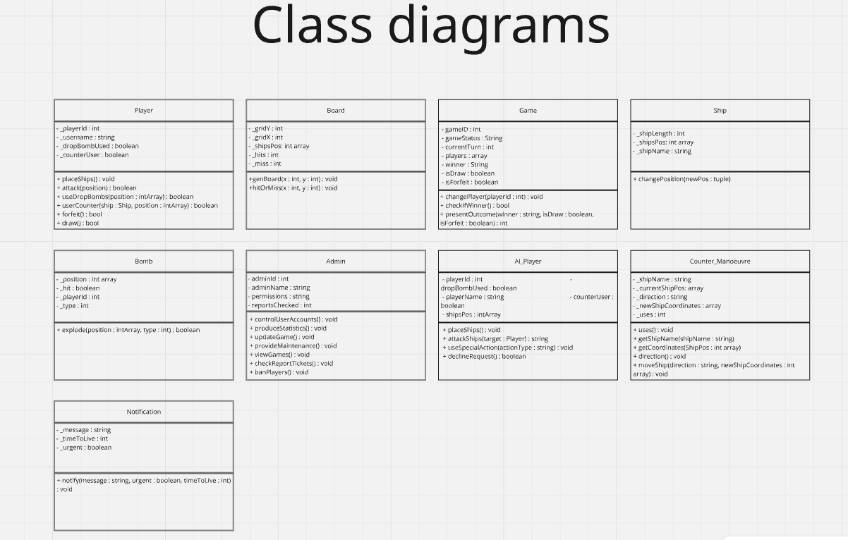
Figure 3: Class Diagram showing relationships between system components
As shown in Figure 3, the class diagram illustrates relationships between key system components.

4.3 Limitations
However, the CRC cards do not include several important details that would be required for full system implementation and testing.
- Detailed algorithms: The cards describe what each class should do but do not explain how tasks should be performed. For example, the Board class is responsible for detecting hits and misses, but the specific logic used to compare coordinates is not defined. Developers would need additional documentation or diagrams to implement this functionality correctly.
- Validation rules: The CRC cards do not specify how the system should handle invalid input, such as coordinates outside the grid or attempts to place overlapping ships. Without clear validation rules, there is a risk that the system may behave unpredictably or produce errors during gameplay.
- Error handling: The design does not clearly define how the system should respond to unexpected situations, such as network failures, incorrect user input, or system crashes. Error handling is an important part of software reliability and should be considered during the design phase.
- Testing considerations: The CRC cards focus on responsibilities rather than measurable outcomes, which makes it difficult to use them directly for testing purposes. For example, a responsibility such as “manage gameplay” does not clearly define what conditions must be met for the feature to be considered successful.
Another limitation is that the CRC cards do not directly link to user story acceptance criteria, which limits their usefulness for testing. Acceptance criteria define the specific conditions that must be satisfied for a user story to be completed. If these criteria are not clearly connected to class responsibilities, it becomes harder to verify whether the system meets its requirements.
In addition, the CRC cards do not include information about performance, security, or usability requirements. These non-functional requirements are important in real-world systems because they affect how well the system operates under different conditions.
Despite these limitations, the CRC cards still provide a valuable starting point for system design. They help establish the basic structure of the application and support communication among team members. To improve the design further, additional documentation such as sequence diagrams, flowcharts, and detailed test cases would be needed before moving to the implementation stage.
Overall, the CRC card approach was effective in identifying system components and responsibilities, but further refinement would be required to ensure the system can be implemented and tested reliably.
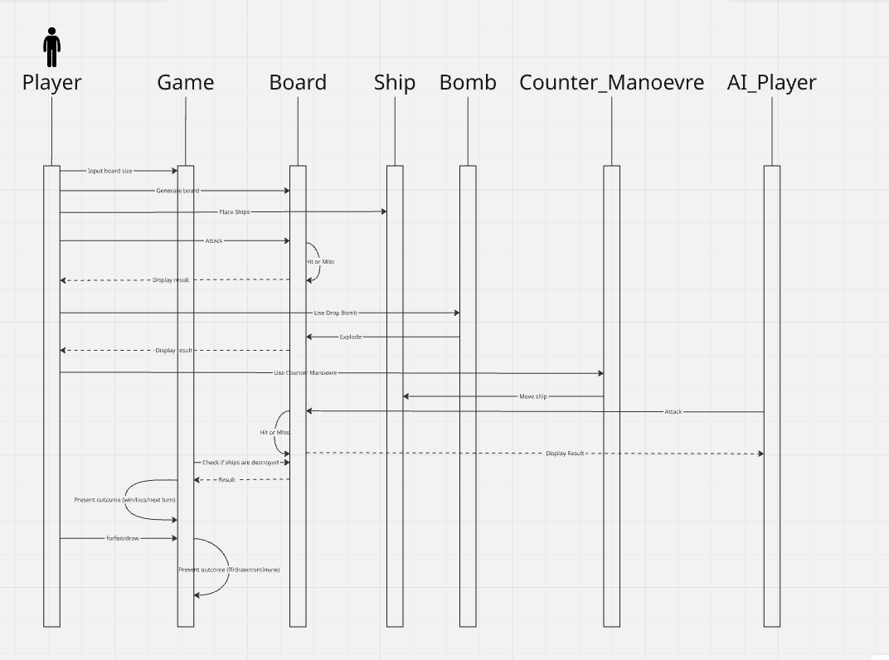
Figure 4: Sequence Diagram illustrating gameplay interaction.

5. Importance of Software Testing
Software testing is essential for ensuring that a system behaves as expected and meets its requirements. It helps identify defects, improve reliability, and enhance user satisfaction. This is particularly important in systems involving user interaction, such as the Battleships application, where incorrect behaviour can negatively affect usability [5].
Testing also plays a key role in maintaining system stability and reducing the likelihood of failures. By identifying issues early, developers can fix problems before they become more complex and costly.
Testing supports:
- Early error detection
- Reduced maintenance costs
- Improved system quality
Overall, testing is a critical part of development, ensuring the system is reliable and performs consistently. [10]

6. Black-Box and White-Box Testing
Black-box testing focuses on system behaviour by testing inputs and outputs without considering internal code. It is useful for checking whether the system meets user requirements.
White-box testing, on the other hand, examines the internal logic of the system, including decision-making processes and code structure. This type of testing is typically carried out by developers. [11]
Both approaches are necessary for a complete testing strategy [6]. Black-box testing ensures correct behaviour from a user perspective, while white-box testing ensures the underlying logic is accurate. [11]

7. Detailed Black-Box Test Scenarios
The following table outlines black-box test scenarios, focusing on system behaviour from the user’s perspective. [12]
Test | Pre-condition | Input | Expected Output | Purpose
Ship Placement | Empty board | Place ship | Ship displayed | Verify placement
Attack | Ships placed | Select position | Hit/Miss | Verify attack
Drop Bomb | Bomb unused | Select position | Destroy ship | Verify feature
Counter Move | Move unused | Move ship | Near miss | Verify movement
Win Condition | All ships hit | Final attack | Game ends | Verify win
These tests confirm that key gameplay features work as expected. In particular, the drop bomb and counter manoeuvre tests ensure that additional game mechanics function correctly, while the win condition test verifies that the system can correctly detect the end of the game. These tests are designed to validate both normal operation and potential edge cases, ensuring the system behaves correctly under different gameplay conditions.

8. Detailed White-Box Test Scenarios
The following table outlines white-box test scenarios, focusing on internal system logic. [12]
Test | Code Area | Input | Expected Output | Purpose
Hit Detection | Board class | Coordinates | Hit/Miss | Verify logic
Ship Destroy | Ship class | All hits | Destroyed | Verify condition
Turn Switch | Game class | End turn | Next player | Verify flow
These tests ensure that key algorithms operate correctly. For example, hit detection verifies coordinate comparison logic, while turn switching ensures that gameplay flows correctly between players.
Overall, white-box testing complements black-box testing by confirming that the internal structure of the system works as intended, resulting in a more reliable application. [11]

9. Testable Code
Testable code is software that is designed so that it can be easily verified through structured testing procedures. It is typically modular, predictable, and organised in a way that allows individual components to be tested independently. When code is testable, developers can quickly identify defects, confirm expected behaviour, and make changes without introducing new errors. This is particularly important in larger systems, where small mistakes can affect multiple parts of the application.
One of the key characteristics of testable code is modularity, which means that the system is divided into smaller, manageable components. Each component performs a specific task and communicates with other components through clearly defined interfaces. This makes it easier to isolate problems and test individual functions without affecting the rest of the system. Testable code also improves maintainability, as developers can update or replace components without rewriting the entire system.
The Battleships design supports testability through its use of separate classes such as Player, Board, Game, and Ship. Each class is responsible for a specific part of the system, which allows developers to test functionality in isolation. For example, the Board class can be tested to ensure that it correctly records hits and misses, while the Game class can be tested to verify that turns are managed correctly. This separation of responsibilities reflects good object-oriented design practice and makes the system easier to debug and maintain.
Another factor that contributes to testable code is clear logic and predictable behaviour. When methods produce consistent results based on given inputs, it becomes easier to write automated tests and verify system performance. In the Battleships system, predictable behaviour is important for gameplay accuracy, as players expect reliable responses to their actions. Designing code with testing in mind therefore improves both system reliability and user satisfaction.

10. Unit Testing
Unit testing involves testing individual components of a system independently to ensure they function correctly before being integrated with other parts of the application. Each unit typically represents a single function, method, or class, and the goal of unit testing is to verify that the unit produces the correct output for a given input. Unit testing is widely used in software development because it helps detect errors early in the development process, reducing the cost and effort required to fix defects later [7]. [8].
One of the main benefits of unit testing is that it improves confidence in the reliability of the system. By testing components individually, developers can confirm that each part of the system works as expected before combining them into a complete application. This approach also supports incremental development, where features are built and tested step by step rather than all at once. As a result, problems can be identified and resolved more quickly.
Unit testing is particularly useful in object-oriented systems like the Battleships application because each class can be tested independently. For example, methods within the Board class can be tested without running the entire game. This makes the testing process more efficient and helps ensure that errors are detected early.
Example:
Testing Board.hitOrMiss() ensures correct behaviour.
In this test, the method would be given specific coordinates as input, and the expected output would be either "Hit" or "Miss", depending on whether a ship occupies the selected position. By comparing the actual output with the expected result, developers can confirm that the method is working correctly.
Additional unit tests could also be created for other parts of the system, such as:
- Testing the Game.checkWinner() method to confirm that the system correctly identifies when all ships have been destroyed
- Testing the Bomb.activate() method to ensure that the drop bomb feature is used only once per game
- Testing the Counter_Manoeuvre.moveShip() method to verify that ships move only within valid grid boundaries
These examples demonstrate how unit testing supports system reliability by verifying the behaviour of individual components. Overall, incorporating unit testing into the development process helps improve software quality, reduce errors, and ensure that the Battleships system performs consistently during gameplay. [9]

11. Applying Unit Testing
Classes that can be tested include:
- Board
- Game
- Bomb
- Player
Each method can be tested independently to ensure correctness and reliability. Unit testing allows developers to isolate specific functions, making it easier to identify and fix errors without affecting other parts of the system. For example, the Board class can be tested to verify accurate hit detection, while the Game class can be tested to ensure correct turn management and win conditions. The Bomb class can be tested to confirm that it only activates once, and the Player class can be tested for correct input handling. Applying unit testing in this way improves system stability and supports efficient debugging.

12. Critical Evaluation
The design demonstrates strong use of object-oriented principles and collaborative design techniques. The use of separate classes, such as Player, Board, and Game, shows effective modularity and clear separation of responsibilities. Additionally, the use of user stories and CRC cards supported communication within the team and helped structure the system effectively.
However, improvements could be made in several areas. Testing detail could be expanded further, particularly with more comprehensive test cases and edge-case scenarios. Error handling was not fully considered, which may affect system reliability. Furthermore, non-functional requirements such as performance, security, and usability were not explored in depth. Addressing these areas would strengthen the overall design and improve system quality.

13. Conclusion
The Battleships system highlights the importance of structured design and testing in software development. The use of user stories, CRC cards, and diagrams provided a strong foundation for understanding system requirements and organising components effectively. These techniques supported collaboration and helped ensure that the system was designed with user needs in mind.
Testing plays a crucial role in ensuring that the application functions correctly and reliably. By applying both black-box and white-box testing, along with unit testing, the system can be thoroughly evaluated. Overall, the project demonstrates how combining design techniques with effective testing strategies leads to a more reliable and well-structured software system.

References
[1] I. Sommerville, Software Engineering, 10th ed. Harlow: Pearson, 2016. [Online]. Available: https://www.geeksforgeeks.org/software-engineering-introduction/. [Accessed: 02-Apr-2026].
[2] Agile Alliance, “Agile 101,” [Online]. Available: https://www.agilealliance.org/agile101/. [Accessed: 02-Apr-2026].
[3] Atlassian, “User Stories,” [Online]. Available: https://www.atlassian.com/agile/project-management/user-stories. [Accessed: 02-Apr-2026].
[4] W. Cunningham and K. Beck, “A Laboratory for Teaching Object-Oriented Thinking,” OOPSLA, 1989. [Online]. Available: http://c2.com/doc/oopsla89/paper.html. [Accessed: 05-Apr-2026].
[5] IBM, “Software Testing,” [Online]. Available: https://www.ibm.com/topics/software-testing. [Accessed: 28-Apr-2026].
[6] Guru99, “Black Box vs White Box Testing,” [Online]. Available: https://www.guru99.com/black-box-vs-white-box-testing.html. [Accessed: 28-Apr-2026].
[7] TutorialsPoint, “Unit Testing,” [Online]. Available: https://www.tutorialspoint.com/software_testing_dictionary/unit_testing.htm. [Accessed: 28-Apr-2026].
[8] Guru99, “Unit Testing Guide,” [Online]. Available: https://www.guru99.com/unit-testing-guide.html. [Accessed: 30-Apr-2026].
[9] ISTQB, “Fundamentals of Software Testing,” [Online]. Available: https://www.istqb.org/. [Accessed: 30-Apr-2026].
[10] Microsoft, “Software Testing Best Practices,” [Online]. Available: https://learn.microsoft.com/. [Accessed: 30-Apr-2026].
[11] GeeksforGeeks, “White Box Testing,” [Online]. Available: https://www.geeksforgeeks.org/white-box-testing/. [Accessed: 1-May-2026].
[12] Guru99, “Test Case Design Techniques,” [Online]. Available: https://www.guru99.com/test-case.html. [Accessed: 1-May-2026].

