

Student Name: Hetvi Rajendrasinh Sangdot
Student ID: 2526007
Programme: MSc Public Health and Social Care in Practice
Lecturer for the module is: Dr Raheela Shaikh
Module: Community Care and Management of Longer-Term Conditions
Module code: LCHS7003

INDEX

1.Introduction: 5
1.1. Definition: 7
1.2. Prevalence of congenital heart disease: 9
1.3. Burden of congenital heart disease: 10
1.4. Risk Factors for Congenital heart defect: 14
2. Causes of Congenital Heart Defects 15
2.2 Aetiology of Congenital Heart Disease: 16
3. Theoretical Perspective and Models for Improved Outcome: 17
3.1. The Chronic Care Model (CCM) Applied to Congenital Heart Disease (CHD): 17
3.2. House of Care (HoC) Model in Congenital Heart Disease (CHD): 21
4. Physiotherapy Management of Congenital Heart Disease: 24
4.1. Key Interventions: 25
4.2. Physical exercise in children with congenital heart disease 29
➢ Benefits of Exercise: 29
→ Improves physical capacity 29
➢ Common Problems 30
➢ Recommendations 30
➢ Conclusion 30
5. End-of-Life Care 32
5. 1. Useful websites: 35
6. References 36


Supporting Children With Congenital Heart Disease :

A Physiotherapy Approach

1.Introduction:
Children with congenital heart disease (CHD) are at risk of delayed motor development with increased risk for those requiring cardiac surgical intervention. We conducted a scoping review to identify the provision and impact of physiotherapy-delivered rehabilitation in children and young people with CHD following cardiac surgery (Clarke et al., 2024))
Congenital heart disease (CHD) is the most prevalent birth defect, impacting approximately 130 million infants annually, and has a rate of 9.4 per 1000 live births, making it a significant contributor to infant mortality. The causes of CHD are complex and include genetic factors, exposure to teratogens, and maternal diabetes, all of which are linked to cases of CHD. (Amir et al., 2021)
Significant progress in pediatric cardiology and surgical techniques over the years has greatly enhanced the survival rates of infants diagnosed with CHD. At present, more than 90% of children born with CHD can expect to survive into their adult years. Exercise training, a key aspect of physical activity (PA), specifically targets the enhancement of certain fitness components, including cardiorespiratory endurance, muscular strength, body composition, and flexibility, and is associated with the capacity to perform these activities (Amir et al., 2021).
The unused multifunctional occluder or Konar framework (Lifetech) may be a modern gadget committed to the adjustment of perimembranous ventricular septal imperfection. Be that as it may, it has multiple facets and has as of now been utilized within the closure of solid VSD or obvious blood vessel conduits (Kuswiyanto et al;2022).
This gadget comprises a plug placed within the left-sided deformity and a maintenance disk put within the right-sided imperfection. Conveyance can be accomplished from both sides; the approach may well be antegraded from the venous side or retrograde from the aortic side (Godart et al;2022).
Show a ponder in connection to the redress of pm VSD with no disappointment at implantation, and they appear that the retrograde approach is the favored course, which is basically related with essentially lower illumination and fluoro scopy time. It ought to moreover be famous than 30% of patients; moreover, had multi-fenestrated absconds counting Gerbode surrenders. Here, the comes about staying great with either full impediment or a modest intra-prosthetic shunt.This gadget appears exceptionally promising and, in this way, helpful for pm VSD closure (Haddad et al; 2022).

ASIAN HEART INSTITUTE;2025

1.1. Definition:
Congenital heart disease (CHDs) are problems with the heart that are present at birth. They include a wide range of problems. Some defects resolve by themselves, and more severe defects require urgent treatment. In most cases the cause of the problem is not known (UK NSC, 2014).
- Congenital heart disease (CHD) refers to a group of structural abnormalities of the heart and/or great vessels present at birth (Sajid et al., 2025).

- These abnormalities arise from developmental disturbances during fetal life and may affect cardiovascular and neurodevelopmental outcomes (Sajid et al., 2025).

- CHD is defined as a structural abnormality originating before birth that may lead to lifelong increased morbidity and reduced long-term survival (Meng et al., 2024).

- CHD is a major category of illness which, when appropriately treated, can restore health and improve quality of life (National Health Service, 2016).

- Adult Congenital Heart Disease (ACHD) affects individuals aged 16 years and over who were born with a heart defect during fetal development (National Health Service, 2016).

- There is an increasing number of adults living with CHD, with a prevalence of more than 4 per 1,000 adults (National Health Service, 2016).

- Approximately 10% of ACHD patients fall into the complex disease category (National Health Service, 2016).

1.2. Prevalence of congenital heart disease: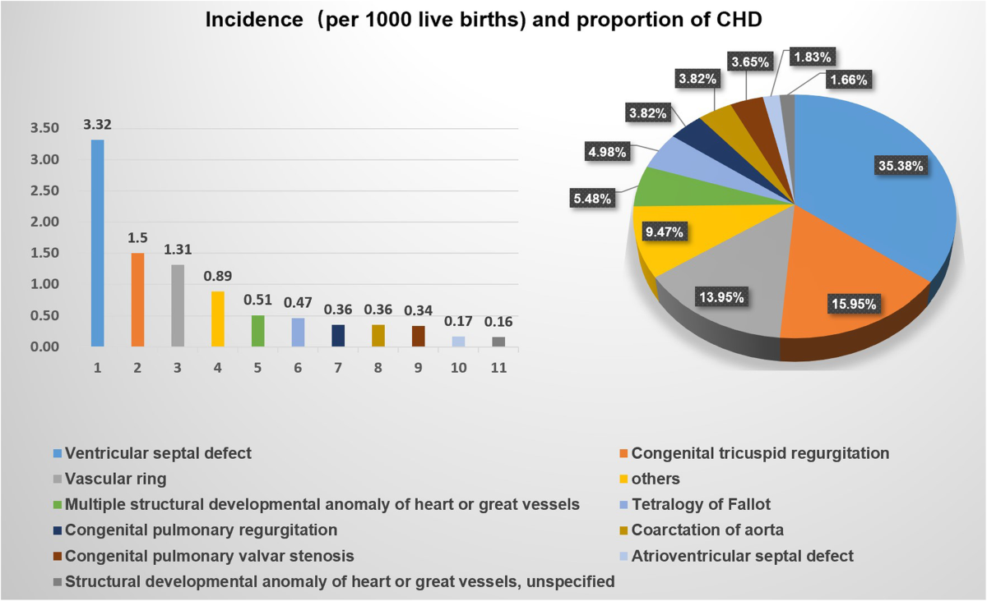
(Jin et al; 2021)

- With a live birth prevalence of about 53–67 per 10,000, CHD is among the most common congenital conditions in the UK, impacting roughly 0.6% of babies born in England (Clarke et al ;2024).
- In the UK, congenital heart disease affects approximately 0.53–0.67% of live births (about 53–67 per 10,000 births) and is a leading congenital condition requiring complex lifelong care; physiotherapy interventions following cardiac surgery have been shown to positively influence functional outcomes and muscle strength in children with CHD( Clarke et al ;2024).
- approximately 9 in 1,000 babies are born with congenital heart disease (CHD) in the UK, while an estimated 250,000 adults are currently living with the condition. Advances in care mean over 90% of children with CHD now survive to adulthood, necessitating long-term, specialized care (Fleming et al; 2024).
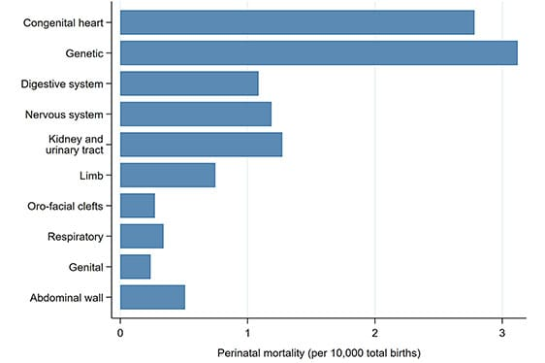
(NHS Digital,2022)

1.3. Burden of congenital heart disease:
Burden refers to the overall impact of a disease on individuals, families, healthcare systems, and society.
It includes:

- Mortality (death rates): Congenital heart disease remains a major contributor to childhood mortality globally, with significant mortality burden among children aged 0–14 years despite overall declines in death rates over recent decades. (Xu et al ;2025).
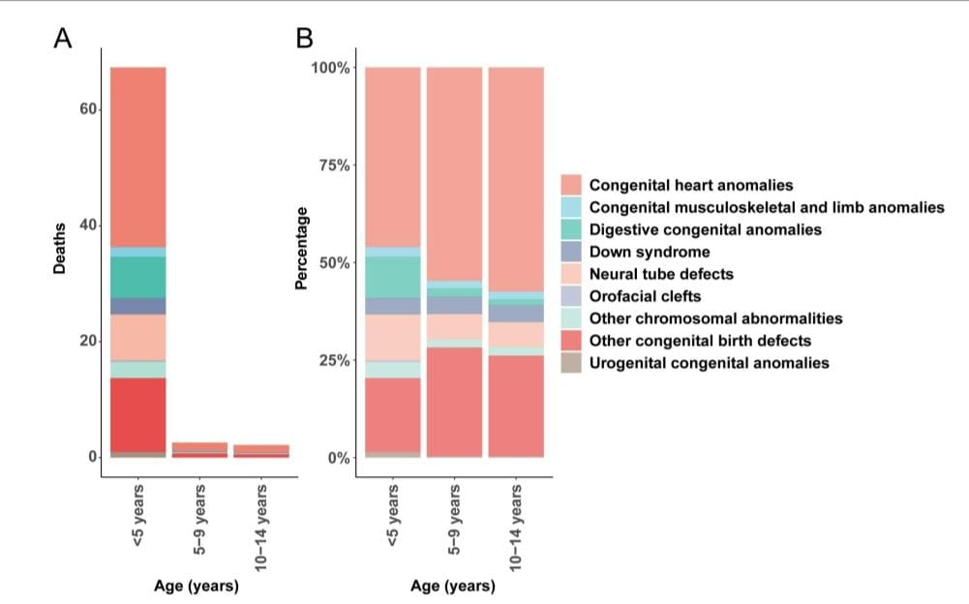
Age-specific mortality rates and proportional contributions of congenital anomalies. (A) Death rate. (B) Death percentage (Xu et al; 2025).
- Morbidity (complications and disability): Congenital heart disease is associated with a substantial morbidity burden throughout life, with long-term chronic disease requiring ongoing healthcare seen in nearly 43 % of patients after surgery, increased cardiovascular events in adults, and elevated neurodevelopmental and health service needs in children compared with peers without CHD(Razzaghi, Oster and Reefhuis;2015)

- Economic cost (NHS expenditure): In the UK, the economic cost of cardiovascular diseases which include congenital and acquired heart conditions is substantial, with recent estimates showing that total costs reached around £29 billion in 2021–22, including about £16.6 billion in direct NHS expenditure on hospital care, medications, and outpatient services, and £12.4 billion in indirect costs such as informal care and productivity losses, reflecting a significant healthcare and societal burden(Shih et al ;2025).
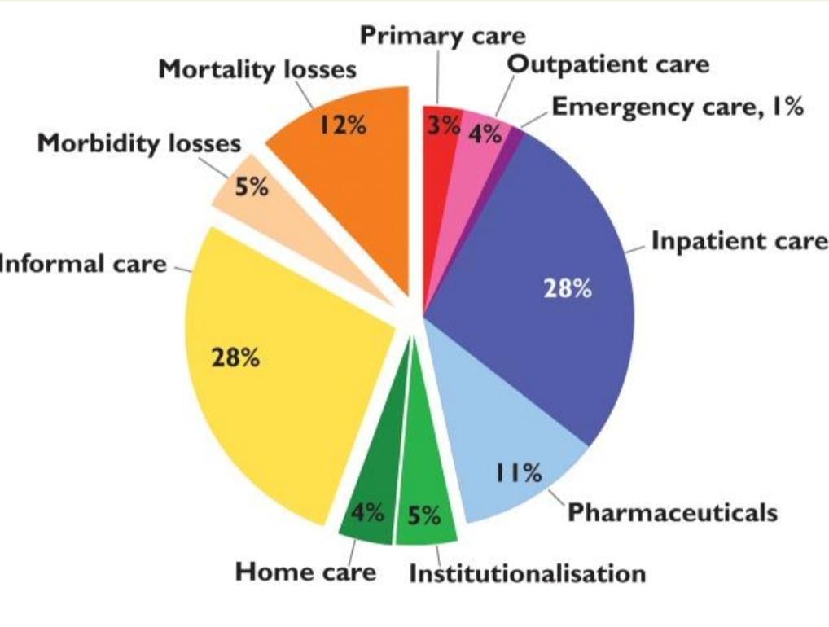
Distribution of cardiovascular disease related total costs across cost categories (European health journal; 2023)

- Psychological and social impact: Congenital heart disease has profound psychological and social impacts: patients often experience anxiety, depression, and lower self-esteem, while frequent hospitalizations and physical limitations can disrupt social development, schooling, employment, and family dynamics, imposing a significant psychosocial burden (Henion:2022).
- Reduced quality of life: adults with congenital heart disease, especially those with heart failure or more complex conditions, experience reduced quality of life, particularly in physical functioning and mental health domains such as anxiety and depression ( Kacar, Flander and Prokselj; 2025).

1.4. Risk Factors for Congenital heart defect:
Congenital heart defects occur in approximately 1% of live births. The risk is increased by (National Heart, lung, and Blood Institute; 2022):
- Family history or genetic predisposition (National Heart, lung, and Blood Institute; 2022)
- Maternal smoking or secondhand smoke exposure (National Heart, lung, and Blood Institute; 2022)
- Certain medications in the first trimester, including ACE inhibitors and retinoic acid derivatives (National Heart, lung, and Blood Institute; 2022)
- Maternal medical conditions such as diabetes, Phenylketonuria, or Rubella (National Heart, lung, and Blood Institute; 2022)
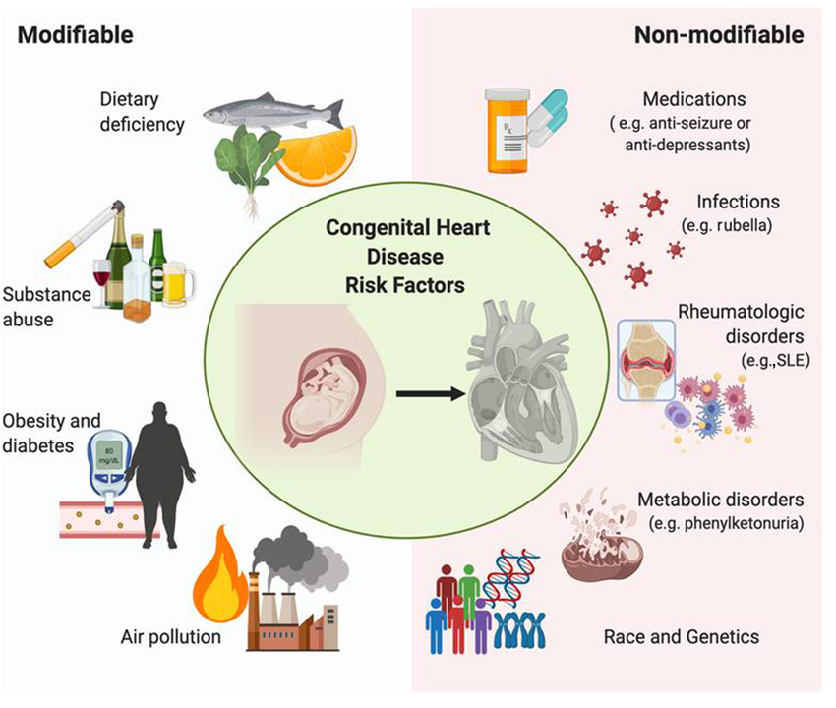
Cardiac differentiation using iPSCs (Mullen et al., 2021)

2. Causes of Congenital Heart Defects
Congenital heart defects occur when the heart does not develop normally during fetal growth. In many cases, the exact cause is unknown. However, genetic factors play an important role (National Heart, lung, and Blood Institute; 2022).
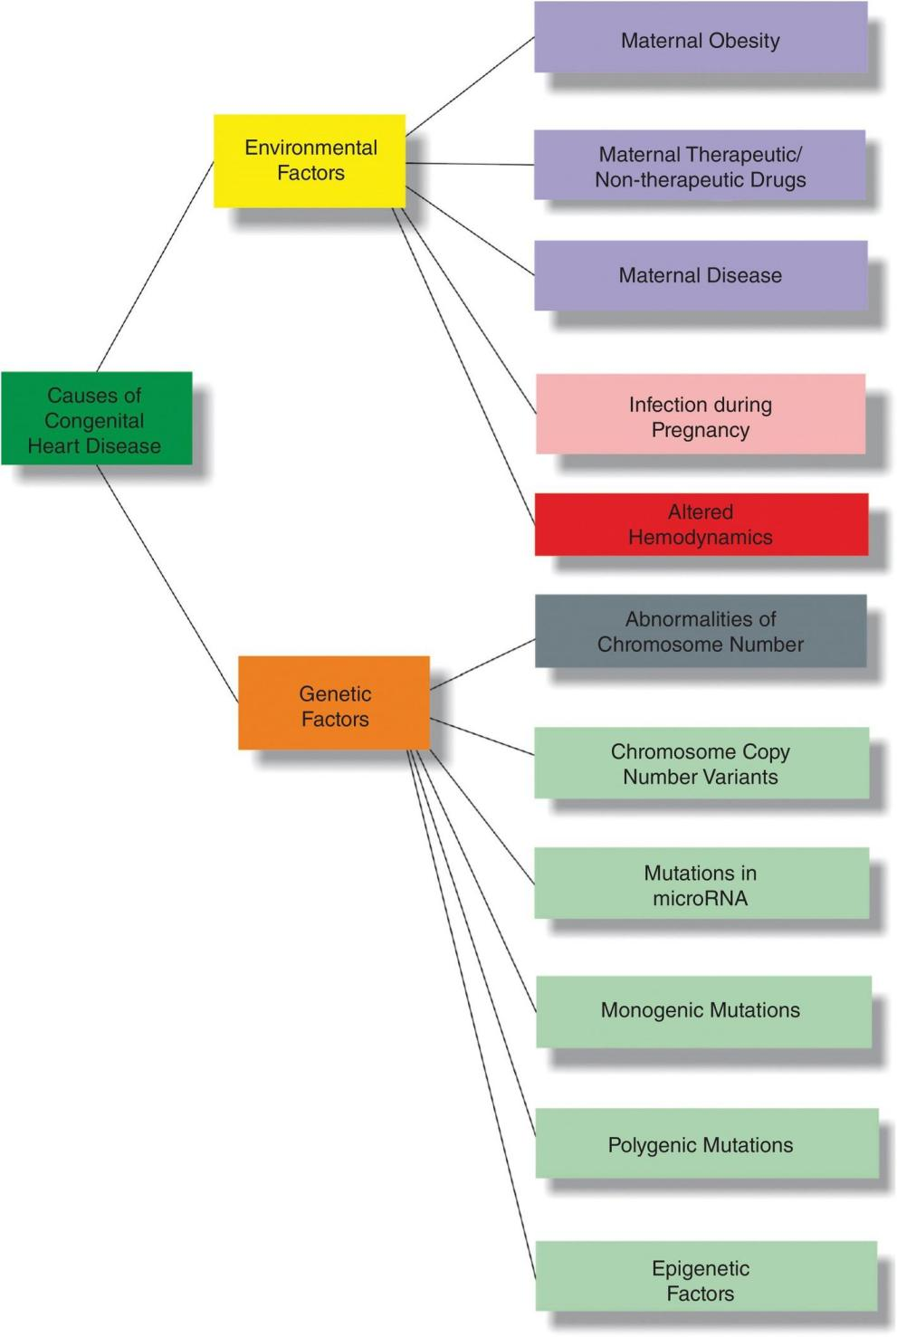
(Cambridge University; 2020)
- DNA mutations can disrupt normal cardiac development (National Heart, lung, and Blood Institute; 2022).
- These mutations may be spontaneous or inherited from one or both parents (National Heart, lung, and Blood Institute; 2022).
- Rarely, specific inherited gene abnormalities increase the likelihood of congenital heart defects (National Heart, lung, and Blood Institute; 2022).

2.2 Aetiology of Congenital Heart Disease:
- Congenital heart disease (CHD) results from abnormal cardiac development during early embryogenesis (first 8 weeks of pregnancy). The aetiology is multifactorial, involving genetic and environmental influences (Meng et al., 2024).

Genetic Factors(Fung et al., 2015) | Environmental & Maternal Factors (Fung et al., 2015)
- Chromosomal abnormalities | - Maternal diabetes
- Single-gene mutations | - Rubella infection
- Copy number variations | - Alcohol or teratogenic drug exposure
- Genetic factors account for approximately 20–30% of cases | - Maternal obesity

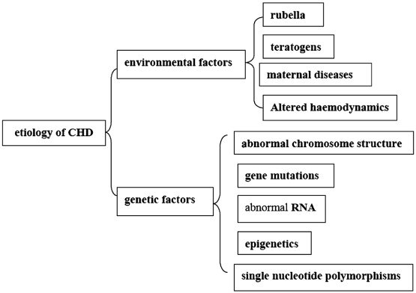
(Jinga, 2018)

3. Theoretical Perspective and Models for Improved Outcome:

3.1. The Chronic Care Model (CCM) Applied to Congenital Heart Disease (CHD):
- The Chronic Care Model (CCM) was developed by Edward H. Wagner to improve long-term condition management (Coleman et al., 2009)
- Shifts care from reactive emergency treatment → proactive, structured management (Coleman et al., 2009)
Highly relevant to CHD because: 90% of children with CHD now survive into adulthood in high-income countries (BHF;2023)
- Most patients are repaired, not cured (BHF;2023)
- Lifelong surveillance is required (BHF;2023)
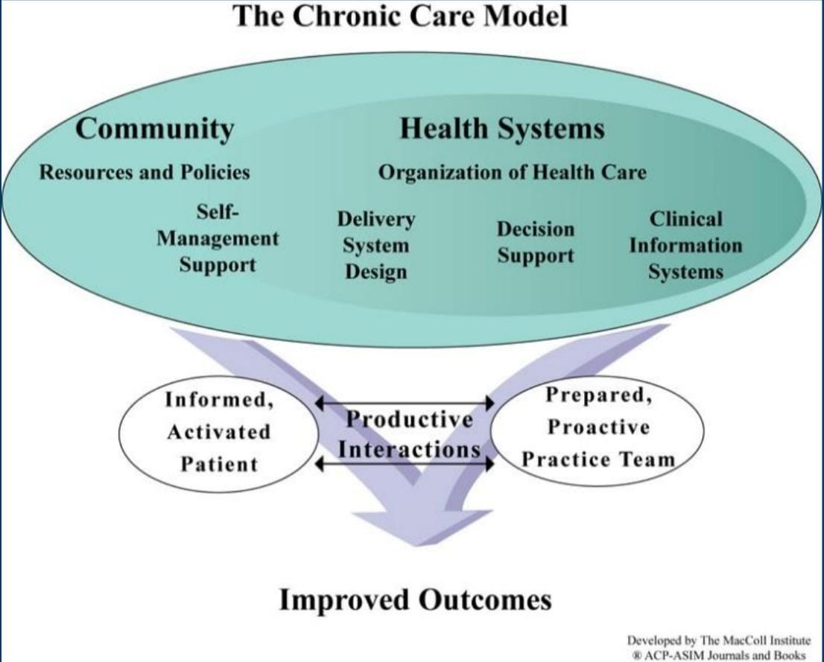
(Wagner, 1998)
Why CCM is Crucial in UK CHD Care:
- Rising adult CHD population (Chaudhry et al., 2024)
- Loss to follow-up during transition remains common (Chaudhry et al., 2024).
- Increasing complexity -arrhythmias, heart failure, pregnancy risk (Chaudhry et al., 2024).
- High economic burden on NHS if complications present late (Chaudhry et al., 2024).

Without structured CCM-based systems:(Izumi et al., 2025) | With CCM: (Izumi et al., 2025)
- Patients represent with advanced disease. | - Early detection
- Emergency surgery and ICU costs increase | - Planned re-intervention
- Mortality risk rises. | - Improved quality of life

- Deliver care via specialist ACHD centres (NHS England, 2018).
- Use hub-and-spoke networks across Integrated Care Systems (ICS) (Chaudhry et al., 2024).
- Provide nurse-led ACHD clinics (Chaudhry et al., 2024).
- Schedule annual surveillance - Echo, MRI, ECG (Chaudhry et al., 2024).
- Conduct MDT meetings cardiology, psychology, physiotherapy (Chaudhry et al., 2024).

Decision Support (Evidence-Based Care):
- Follow 2020 ACHD guidance from European Society of Cardiology (ESC, 2020).
- Align UK practice with National Institute for Health and Care Excellence (NICE) cardiovascular frameworks (NHS England;18).
Use risk stratification tools for:
- Pulmonary valve replacement timing (Chaudhry et al., 2024)
- Arrhythmia risk (Chaudhry et al., 2024)
- Pregnancy risk (Chaudhry et al., 2024)
- Educate GPs to reduce inappropriate discharge (Chaudhry et al., 2024)
Clinical Information Systems & Digital Health:
- Develop national ACHD registries (Nicholson et al., 2024)
- Implement NHS digital recall systems (Nicholson et al., 2024)
- Use remote ECG monitoring for arrhythmia detection (Nicholson et al., 2024)
- Integrate paediatric and adult electronic records (Nicholson et al., 2024)
- Use AI-based risk prediction where appropriate (Nicholson et al., 2024)

Critical Evaluation:
- Improves early detection (NHS England;18)
- Risk of digital exclusion (NHS England;18)
- Data governance and privacy concerns (NHS England;18)
- Cost-effectiveness evidence still emerging (NHS England;18)

Community Resources & Psychosocial Support:
- Refer to cardiac rehabilitation programmes (Elissen et al., 2013)
- Provide NHS psychological therapy support (Elissen et al., 2013)
- Offer specialist pregnancy counselling clinics (Elissen et al., 2013)
- Link patients to British Heart Foundation support services (Elissen et al., 2013)
- Deliver dietetic education (low salt, balanced diet) (Elissen et al., 2013)
- Encourage family involvement (Elissen et al., 2013)

Critical Evaluation
- Improves adherence and psychosocial wellbeing (Baumgartner and De Backer, 2020)
- Mental health services overstretched (Baumgartner and De Backer, 2020)
- Rehabilitation access varies regionally (Baumgartner and De Backer, 2020)
- Socioeconomic inequalities influence outcomes (Baumgartner and De Backer, 2020)
Transition Services:
- Preparation from early adolescence (Xu et al., 2026)
- Education about diagnosis & surgical history (Xu et al., 2026)
- Self-management training (Xu et al., 2026)
- Joint paediatric–adult clinics (Xu et al., 2026)
- Clear referral pathways (Xu et al., 2026)

3.2. House of Care (HoC) Model in Congenital Heart Disease (CHD):
- Developed by the Year of Care Partnerships it Promotes proactive, patient-centred, collaborative care for long-term conditions (LTCs) (NHS England, 2016)
- Shifts from reactive, provider-led care → shared decision-making model
- Widely supported by The King's Fund and NHS England (The King’s Fund, 2013; NHS England, 2016)
- CHD is a lifelong condition requiring continuous specialist follow-up (The King’s Fund, 2013)
- Particularly important in Adult Congenital Heart Disease (ACHD) (The King’s Fund, 2013)
- Encourages holistic, long-term, coordinated management (British Heart Foundation, 2023; NHS England, 2016)

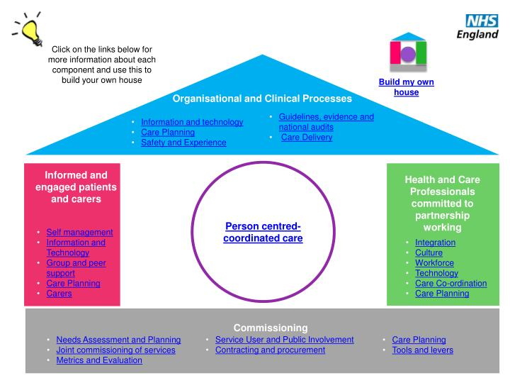(NHS England; 2016)
Components of the House of Care: -
- Core: Personalised Care & Support Planning (CSP)
- Collaborative care planning conversation (British Heart Foundation, 2023)
- Discusses “what matters to the patient”: Exercise capacity, Employment, Pregnancy planning (British Heart Foundation, 2023)
- Patients receive investigation results (ECHO, MRI) before consultation (British Heart Foundation, 2023)
- Encourages shared decision-making (British Heart Foundation, 2023)

- Left Wall: Engaged & Empowered Patients:
- Specific heart defect (National Institutes of Health, 2022)
- Medication adherence (National Institutes of Health, 2022)
- Symptom recognition (e.g., heart failure signs) (National Institutes of Health, 2022)
- Self-monitoring skills development (National Institutes of Health, 2022)
- Structured transition education (paediatric → adult services) (National Institutes of Health, 2022)

- Right Wall: Professionals as Partners Multidisciplinary Team (MDT) approach:
- Cardiologists (British Heart Foundation, 2023)
- CHD surgeons (British Heart Foundation, 2023)
- ACHD specialist nurses (British Heart Foundation, 2023)
- Psychologists (British Heart Foundation, 2023)
- Obstetricians (British Heart Foundation, 2023)
- Shared expertise: Clinician = medical knowledge
Patient = lived experience (NHS England, 2016)

- Roof: Organisational Systems:
Structured transition services (16–18 years) “Hub-and-Spoke” model:
- Specialist surgical centres (hubs) (NHS England, 2016)
- Local follow-up clinics (spokes) (NHS England, 2016)
- Shared electronic patient records (NHS England, 2016)
- Clear referral pathways (NHS England, 2016)

- Foundation: “More Than Medicine”:
Recognises psychosocial impact of CHD Links to:
- Support groups (British Heart Foundation, 2023)
- Mental health services (NIH, 2022)
- Community resources (NIH, 2022)
- Addresses invisible burden of chronic illness (British Heart Foundation, 2023)

- Why Use HoC in CHD? (NHS England, 2016)
- Supports lifelong condition management (NHS England, 2016)
- Improves quality of life (NHS England, 2016)
- Reduces emergency admissions (NHS England, 2016)
- Strengthens transition to adult services (NHS England, 2016)
- Encourages patient autonomy (NHS England, 2016)

- Physiotherapy Management of Congenital Heart Disease:

Physiotherapy is an essential component of rehabilitative and supportive care for children and adults with CHD, particularly post-surgery or for managing developmental delays. It forms part of multidisciplinary care aimed at improving respiratory function, motor development, exercise capacity, and overall functional independence (Clarke et al;2025).

4.1. Key Interventions:
- Post-Operative Respiratory Care: Techniques to clear secretions and improve oxygenation, often initiated in PICU (Clarke & Milburn; 2024).
- Neurodevelopmental Rehabilitation: Addressing motor delays and promoting normal developmental milestones (Vikhe et al; 2024).
- Exercise-Based Cardiac Rehabilitation: Improving cardiovascular fitness, muscular strength, and quality of life (Taylor et al; 2022)
- Functional Training: Tailored exercises to manage fatigue and enhance daily activity (Ubeda Tikkanen et al; 2023).
.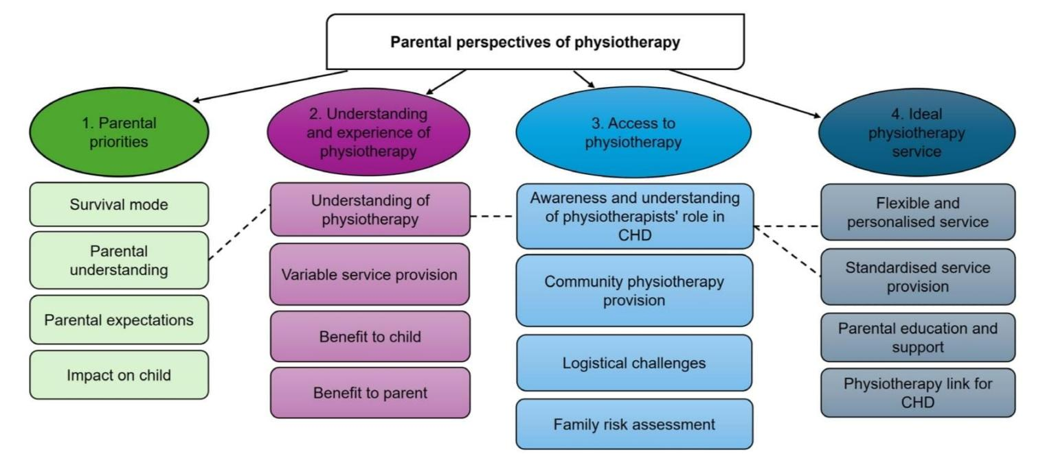
(Taylor et al; 2022)

Improving Interventions
- Ductal stenting vs surgical shunting (Prakoso et al;2024) shorter hospital stay & lower mortality
- App-based interstage home monitoring (IHM) reduces mortality (Rosenthal et al;2025)
- Regarding assessments and interventions in physical therapy (Assessment and Intervention will be unique to each patient; assessments and intervention will include part of all of the following variables depending upon the patient's age, cognition and other needs etc.) (APTA 2014)
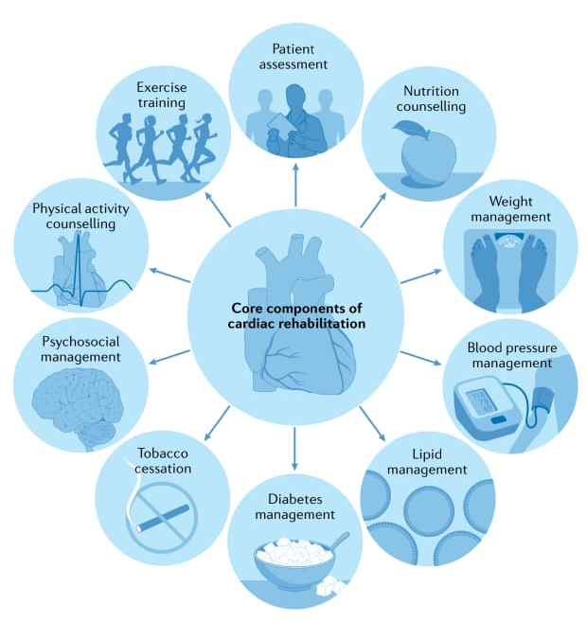
Cardiac rehabilitation and all‑cause mortality trends (Taylor et al., 2022)

Assessment domain | Assessment considerations | Intervention considerations
Aerobic capacity/ endurance (APTA, 2014) | - Utilization of the six-minute walk test as a measure of distance traveled during the six-minute test. This provides an approximation of the individuals VO2 max and helps to evaluate individual's aerobic fitness/endurance level through sub-maximal testing.  - Assess individual's heart rate (HR), blood pressure (BP), rated perceived exertion (RPE), METS, oxygen saturation if required, for each activity.  - Evaluate rate pressure product (RPP) to provide standardized intensity values in different modes of activity.  - Telemetry monitoring if indicated by the cardiologist.
Mobility (Cuello-Garcia et al., 2018) | - Use physical performance scales e.g. the Test of Gross Motor Skill Development - Third Edition (TGMD-3).  - Dynamic Gait Index (DGI): to assess an individual’s ability to adapt their balance during walking with the presence of external forces, or challenges to their balance. | - Gait training  - Depending on an individual's current functional status, therapeutic goals will include sequential performance of: bed mobility, supine to sit; supine to stand; and progressive ambulation.  - Transfer training - as necessary.
Musculoskeletal screen | - Range of motion assessment- evaluate joints for available range of motion passively or actively. Recommended joints to assess for range of motion include: shoulder flexion; lateral trunk flexion; popliteal angle; ankle dorsiflexion with straight knee; | - Postural training  - Breathing mechanics  - Initiate scar tissue mobilization  - Strengthening - Progress to light resistance as appropriate.  - Stretching  - May consist of passive, active, or active-assisted range of motion.

4.2. Physical exercise in children with congenital heart disease:
- Congenital heart disease (CHD) affects 8–9 per 1,000 newborns (Lynge et al., 2018).
- Around 85% survive into adulthood due to advances in paediatric cardiac surgery (Lynge et al., 2018).
- Sudden cardiac death is rare (0.1% per year); only 8% occur during exercise (Lynge et al., 2018).
- Exercise is safe and beneficial when properly supervised (Lynge et al., 2018).

Benefits of Exercise:

Improves physical capacity (Serra-Grima et al., 2011)
- Enhances cognitive function and learning (Serra-Grima et al., 2011)
- Supports social inclusion (Serra-Grima et al., 2011)
- Reduces risk of overweight and inactivity-related fitness decline (Serra-Grima et al., 2011)
- Improves quality of life (Serra-Grima et al., 2011)

Common Problems
- Delayed physiotherapy follow-up after hospital discharge (Serra Grima, 2020)
- Overprotection by parents and teachers (Serra Grima, 2020)
- Children often exercise below their actual capacity (70%) (Serra Grima, 2020)
- Social exclusion from peer activities (Serra Grima, 2020)

Recommendations
- Regular, supervised physiotherapy and training (Serra Grima, 2020)
- Individualised programs adjusted to tolerance (Serra Grima, 2020)
- Cardiopulmonary exercise testing to guide safe intensity (Serra Grima, 2020)
- Encourage participation in normal age-appropriate activities (Serra Grima, 2020)

Conclusion
- Structured, supervised exercise programs help children with CHD achieve better physical fitness, cognitive development, and equal opportunities compared to peers (Serra Grima, 2020).
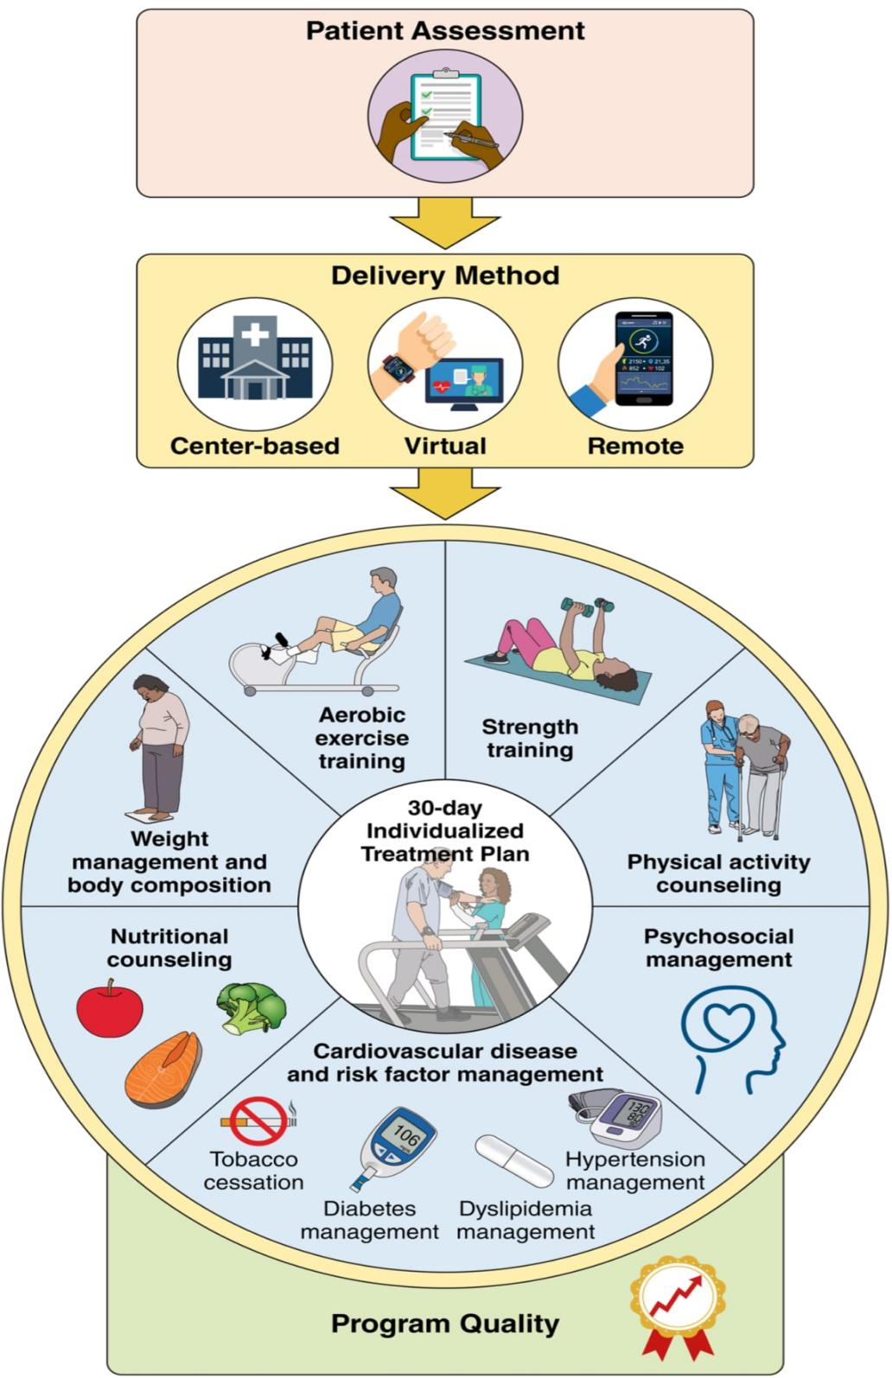
Core components of cardiac rehabilitation (Brown et al., 2024)

End-of-Life Care:

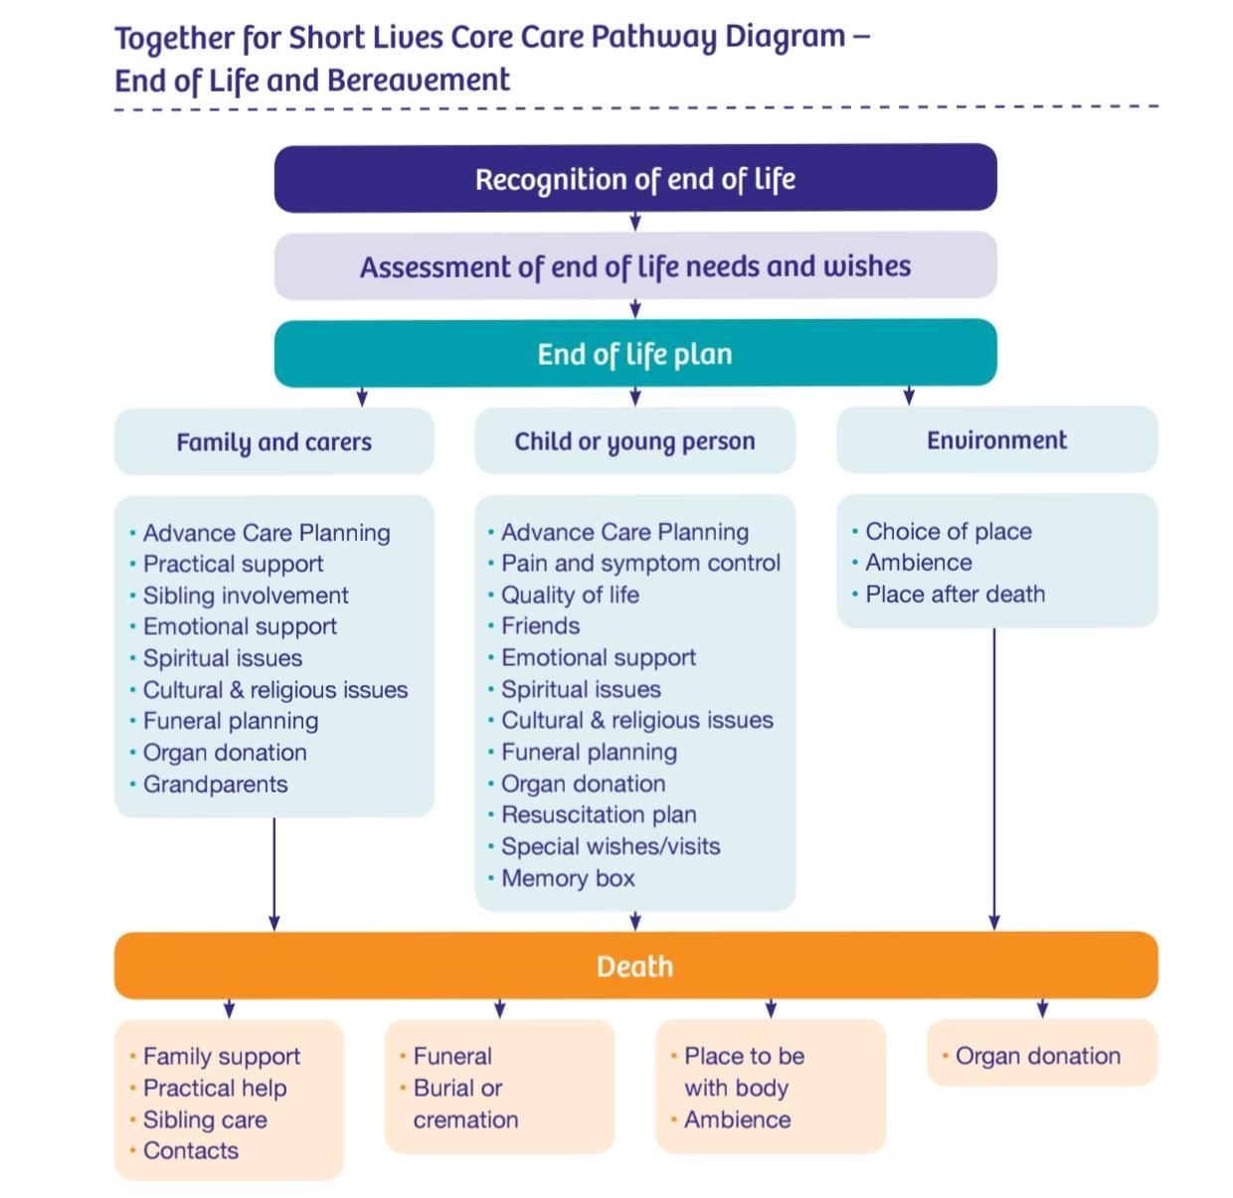
enital heart diseases:End-of-life care pathway for children (Chambers, 2019)

- Policy Framework:Paediatric end-of-life cardiac care should align with:
- NHS England service specifications for congenital heart disease (National Institute for Health and Care Excellence, 2016).
- National Institute for Health and Care Excellence (NICE) guideline NG61: End of life care for infants, children and young people with life-limiting conditions (National Institute for Health and Care Excellence, 2016).
- Together for Short Lives national children’s palliative care framework (National Institute for Health and Care Excellence, 2016).
- UK statutory guidance on organ and tissue donation via NHS Blood and Transplant (National Institute for Health and Care Excellence, 2016).

- Policy Principle:Care must be child-centred, family-centred, coordinated and equitable across regions (National Institute for Health and Care Excellence, 2016).

- Clinical Responsibilities (What Services Must Do)
- Use nationally approved paediatric palliative pathways (NICE NG61).
- Allocate a named lead consultant and specialist nurse (National Institute for Health and Care Excellence, 2016).
- Develop a written, individualised end-of-life care plan (National Institute for Health and Care Excellence, 2016 .p.45).
- Discuss organ and tissue donation sensitively (National Institute for Health and Care Excellence, 2016.p.45).
- Provide 24/7 hospital access for community-managed patients (National Institute for Health and Care Excellence, 2016).
- Coordinate with hospice, community nursing and primary care teams (National Institute for Health and Care Excellence, 2016).

- Offer structured bereavement follow-up:
- Nurse contact within 1 week (Aidoo and Rajapakse; 2019)
- Consultant review offered within 6 weeks ((Aidoo and Rajapakse; 2019).
- After-Death Care (NHS Standards):
- Explain legal processes clearly and sensitively (National Institute for Health and Care Excellence, 2016).
- Provide written and verbal information at the family’s pace (National Institute for Health and Care Excellence, 2016).
- Ensure continuity between cardiac and bereavement teams (National Institute for Health and Care Excellence, 2016).
- Support: Death registration, Body transport, Funeral arrangements ( Bennett; 2012).
- Offer follow-up consultation to discuss clinical circumstances ( Bennett; 2012).
- Ethical Focus: Transparency, dignity, continuity and compassionate communication ( Bennett; 2012).
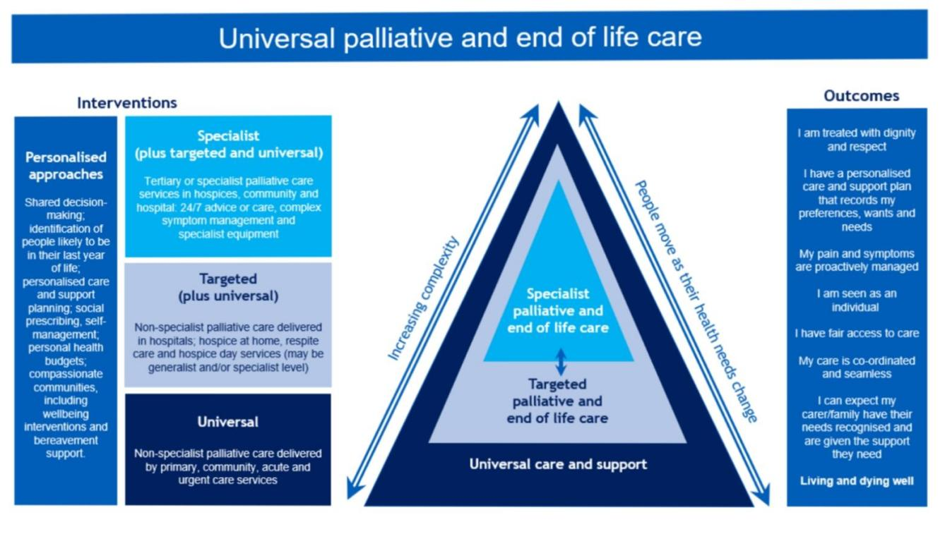
(NHS England;2022)

5. 1. Useful websites:

Cardiac Risk in the Young
Raises the awareness of cardiac risk and offers support to families who have lost a family member through sudden death
(www.c-r-y.org.uk).

Cove Point Foundation
Congenital Heart Disease information for children and adults from Helen B Taussig, Children’s Heart Center, Johns Hopkins University.
(www.pted.org)

Great Ormond Street Hospital for Sick Children (GOSH)
Contains general information, details relating to accommodation, parking, how to get there, etc. Also, a variety of fact sheets for parents.The website has links to other sites relating to health and illness for young people.
(www.gosh.nhs.uk)

Southampton General Hospital
Information for parents and children about the ward in Southampton.
(www.oceanward.co.uk)

Thames Valley and Wessex Congenital
Heart Disease Network
(www.congenitalheartnetwork.org.uk)


6. References
- Aidoo, E. and Rajapakse, D., 2019. Overview of paediatric palliative care. BJA Education, 19(2), pp.60–64. https://doi.org/10.1016/j.bjae.2018.11.001
- Amir, N.H., Dorobantu, D.M., Wadey, C.A., Caputo, M., Stuart, A.G., Pieles, G.E. and Williams, C.A. (2021) ‘Exercise training in paediatric congenital heart disease: fit for purpose?’, Archives of Disease in Childhood. doi:10.1136/archdischild-2020-321390.
- American Physical Therapy Association (2014) Guide to Physical Therapist Practice 3.0. Alexandria, VA: American Physical Therapy Association.
- Bennett, H., 2012. A guide to end of life care: Care of children and young people before death, at the time of death and after death. Bristol: Together for Short Lives.
- Baumgartner, H. and De Backer, J. (2020) ‘The ESC clinical practice guidelines for the management of adult congenital heart disease 2020’, European Heart Journal, 41(43), pp. 4153–4154. doi:10.1093/eurheartj/ehaa701.
- Brown, T.M., Pack, Q.R., Aberegg, E., Brewer, L.C., Ford, Y.R., Forman, D.E., Gathright, E.C., Khadanga, S. and Thomas, R.J. (2024) ‘Core components of cardiac rehabilitation programs: 2024 update: a scientific statement from the American Heart Association and the American Association of Cardiovascular and Pulmonary Rehabilitation’, Circulation, 150(18). doi:10.1161/CIR.0000000000001289.
- Chambers, L. (2019) Caring for a child at end of life: A guide for professionals on the care of children and young people before death, at the time of death and after death. 2nd edn. Bristol: Together for Short Lives.
- Chaudhry, I., Ghassani, A., Wray, J., Chaudhry, B. and Coats, L. (2024) ‘Outpatient care of adults with congenital heart disease in the UK: a qualitative appraisal of the clinician perspective’, Open Heart, 11, e002420. doi:10.1136/openhrt-2023-002420.
- Clarke, S.L., Milburn, N.C., Menzies, J.C. and Drury, N.E. (2024) ‘The provision and impact of rehabilitation provided by physiotherapists in children and young people with congenital heart disease following cardiac surgery: a scoping review’, Physiotherapy, 122, pp. 47–56. doi:10.1016/j.physio.2023.09.001.
- Clarke, S.L., Menzies, J.C., Shkurka, E. et al. (2025) ‘Exploring parental perspectives of physiotherapy in children with congenital heart disease: a qualitative study’, BMJ Paediatrics Open, 9, e003705. doi:10.1136/bmjpo-2025-003705.
- Coleman, K., Austin, B.T., Brach, C. and Wagner, E.H. (2009) ‘Evidence on the Chronic Care Model in the new millennium’, Health Affairs, 28(1), pp. 75–85. doi:10.1377/hlthaff.28.1.75.
- Cuello-Garcia, C.A., Mai, S.H.C., Simpson, R., Al-Harbi, S. and Choong, K. (2018) ‘Early mobilization in critically ill children: a systematic review’, The Journal of Pediatrics, 203, pp. 25–33.e6. doi:10.1016/j.jpeds.2018.07.037.
- Elissen, A., Nolte, E., Knai, C., Brunn, M., Chevreul, K., Conklin, A., Durand-Zaleski, I., Erler, A., Flamm, M., Frølich, A., Fullerton, B., Jacobsen, R., Sönnichsen, A. and Vrijhoef, H.J.M. (2013) ‘Is Europe putting theory into practice? A qualitative study of the level of self-management support in chronic care management approaches’, BMC Health Services Research, 13, p. 117. doi:10.1186/1472-6963-13-117.
- Fleming, M., Athanasopoulos, P., Mackay, D.F. et al. (2024) ‘Educational outcomes among children with congenital heart disease compared to peers: a Scotland-wide record-linkage study of 715,850 schoolchildren’, BMC Pediatrics, 24, p. 405. doi:10.1186/s12887-024-04848-2.
- Fung, W.L., Butcher, N.J., Costain, G. et al. (2015) ‘Practical guidelines for managing adults with 22q11.2 deletion syndrome’, Genetics in Medicine, 17(8), pp. 599–609. doi:10.1038/gim.2014.175.
- Ghoussaini, R., Zareef, R., Makarem, A. et al. (2024) ‘Pulmonary artery banding: a 20-year experience at a tertiary care center in a developing country’, Frontiers in Cardiovascular Medicine, 11, p. 1368921. doi:10.3389/fcvm.2024.1368921.
- Haddad, R.N., Boudjemline, Y., Combes, N., Hadeed, K., Karsenty, C. and Saliba, Z. (2022) ‘Three centers experience with device closure of congenital Gerbode-type perimembranous ventricular septal defects’, Journal of Cardiac Surgery, 37, pp. 2714–2724.
- Henrion, D. (2022) ‘Modulating the immune response to reduce hypertension-associated cardiovascular damage’, Journal of Clinical Investigation, 132(6), p. e158280. doi:10.1172/JCI158280.
- Huang, J.-B., Liu, Y.-L., Sun, P.-W., Lv, X.-D., Du, M. and Fan, X.-M. (2010) ‘Molecular mechanisms of congenital heart disease’, Cardiovascular Pathology, 19(5), pp. e183–e193. doi:10.1016/j.carpath.2009.06.008.
- Izumi, S., Mood, L., Velk, L. et al. (2025) ‘Key components of chronic care management programs: qualitative descriptions of care managers’ practice’, BMC Health Services Research, 25(1), p. 1542. doi:10.1186/s12913-025-13788-1.
- Jinga, M. (2018) ‘Essential in genetic etiology of congenital heart diseases’, in Dumitrescu, S., Ţintoiu, I. and Underwood, M. (eds.) Right heart pathology. Cham: Springer. doi:10.1007/978-3-319-73764-5_13.
- Kacar, P., Flander, M. and Prokselj, K. (2025) ‘Quality of life in adults with congenital heart disease: insights from a tertiary centre’, Journal of Clinical Medicine, 14(20), p. 7451. doi:10.3390/jcm14207451.
- Kuswiyanto, R.B., Gunawijaya, E., Djer, M.M. et al. (2022) ‘Transcatheter closure of perimembranous ventricular septal defect using the Lifetech Konar-multi functional occluder: early to midterm results of the Indonesian multicenter study’, Global Heart, 17(1), p. 15. doi:10.5334/gh.1106.
- Lynge, T.H., Jeppesen, A.G., Winkel, B.G. et al. (2018) ‘Nationwide study of sudden cardiac death in people with congenital heart defects aged 0 to 35 years’, Circulation: Arrhythmia and Electrophysiology, 11(6), p. e005757. doi:10.1161/CIRCEP.117.005757.
- Meng, X., Song, M., Zhang, K. et al. (2024) ‘Congenital heart disease: types, pathophysiology, diagnosis, and treatment options’, MedComm, 5(7), p. e631. doi:10.1002/mco2.631.
- National Institute for Health and Care Excellence (2016) End of life care for infants, children and young people with life-limiting conditions (NG61). London: NICE.
- Nicholson, C., Strange, G., Ayer, J. et al. (2024) ‘A national Australian Congenital Heart Disease registry; methods and initial results’, International Journal of Cardiology: Congenital Heart Disease, 17, p. 100538. doi:10.1016/j.ijcchd.2024.100538.
- NHS Digital (2022) NCARDRS congenital anomaly statistics: annual data, 2020. England: NHS Digital.
- Pitchford, E.A. and Webster, E.K. (2021) ‘Clinical validity of the Test of Gross Motor Development-3 in children with disabilities from the U.S. national normative sample’, Adapted Physical Activity Quarterly, 38(1), pp. 62–78. doi:10.1123/apaq.2020-0023.
- Prakoso, R., Simanjorang, C.N.S., Kurniawati, Y. et al. (2024) ‘Ductal stenting vs. surgical shunting in late presenting duct-dependent pulmonary circulation: a single-center experience’, Frontiers in Cardiovascular Medicine, 11, p. 1382879. doi:10.3389/fcvm.2024.1382879.
- Razzaghi, H., Oster, M. and Reefhuis, J. (2015) ‘Long-term outcomes in children with congenital heart disease: National Health Interview Survey’, The Journal of Pediatrics, 166(1), pp. 119–124. doi:10.1016/j.jpeds.2014.09.006.
- Rosenthal, L.-M., Danne, F., de Belsunce, S. et al. (2025) ‘Application-based remote interstage home monitoring for infants with shunt- or duct-dependent pulmonary perfusion’, Frontiers in Cardiovascular Medicine, 11, p. 1493698. doi:10.3389/fcvm.2024.1493698.
- Sajid, A., Chavez-Valdez, R., Sharp, A.N. et al. (2025) ‘Neurodevelopment in congenital heart disease: a review of antenatal mechanisms and therapeutic potentials’, Pediatric Research, 98, pp. 2483–2490.
- Serra Grima, R. (2020) ‘Physical exercise in children with congenital heart disease’, Pediatric Dimensions, 5, pp. 1–1. doi:10.15761/PD.1000210.
- Serra-Grima, R., Doñate, M., Borrás, X. et al. (2011) ‘Cardiopulmonary stress testing in children who have had congenital heart disease surgery: physical exercise recommendations during school hours’, Revista Española de Cardiología, 64(9), pp. 780–787. doi:10.1016/j.recesp.2011.05.007.
- Shih, K., Herz, N., Sheikh, A., O’Neill, C., Carter, P. and Anderson, M. (2025) ‘Economic burden of cardiovascular disease in the United Kingdom’, European Heart Journal: Quality of Care & Clinical Outcomes, 11(5), pp. 678–690. doi:10.1093/ehjqcco/qcaf011.
- Taylor, R.S., Dalal, H.M. and McDonagh, S.T.J. (2022) ‘The role of cardiac rehabilitation in improving cardiovascular outcomes’, Nature Reviews Cardiology, 19(3), pp. 180–194. doi:10.1038/s41569-021-00611-7.
- Vikhe, C.S., Sharath, H.V., Brahmane, N.A. and Ramteke, S.U. (2024) ‘The effect of physiotherapy intervention on an infant with congenital heart defect associated with developmental delay: a case report’, Cureus, 16(5), p. e60215. doi:10.7759/cureus.60215.
- Xu, J., Yang, Y., Zhao, J., Li, D., Zheng, S., Gu, J. and Wang, M. (2026) ‘Innovative approaches for coronary heart disease management: integrating biomedical sensors, deep learning, and stellate ganglion modulation’, Computer Methods in Biomechanics and Biomedical Engineering, 29(1), pp. 85–102. doi:10.1080/10255842.2024.2378099.

