

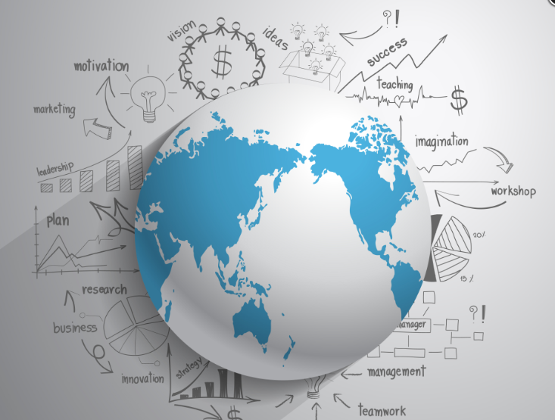
Greedy Lama
International Business Plan

Assessment 2

Assessment Due: 23.59 GMT Monday 30th April 2018 (Turnitin)

SBMA7122D – International Business

Leyla King
Student no: 1602413

Content
Page
Executive Summary of International Business Plan 2
International Business/ Organisational Structure 3
International Organisational Structure (USA) 3
Product/Service UK Profile 4
Logistics e Commerce 5
Digital Marketing 5
US Market Research 6
Demographics - USA 6
Online Grocery Shopping 6
Vegan/Plant based Food Global movement 7
‘Hofstede’ country comparison - UK and USA 8
Power Distance 8
Individualism 8
Masculinity 8
Uncertainty Avoidance 9
Long Term Orientation 9
Indulgence 9
Vegan Food Market in the USA 9
Google Search Terms Trend: VEGAN / VEGETARIAN 10
Google Search Terms: Cruelty – Free / Vegan Diet 11
Logistics facts 11
USA - Risk Assessment 13
International Business Strategy 14
International Marketing Plan 14
SWOT Analysis 14
UK Export to USA Logistics 15
Region Selection Proposal: California 15
Exchange Rates and US Taxation 16
USA Marketing 17
Case Study: GRAZE 20

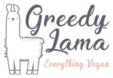

Executive Summary of International Business Plan

Greedy Lama UK is a healthy whole food online supermarket launched early 2018, cruelty free that offers impressive range of vegan/whole food products with a stress free online shopping experience. There is growing demand for plant based food not just in the UK but globally. This rapidly growing trend is driven manly by the health benefits of eating plant based food and increasing food origin awareness.

The domestic online Market is well established and the company is experiencing healthy growth. Taking advantage of the rapid growth of e-commerce trading along with the increasing demand for convenient online food shopping and rising demand for vegan produce, we have considered expansion into the US market. The company is already selling products to USA (products are shipped from the UK to USA) but we are planning to establish US domestic warehouses and establish the delivery logistics.

There are several reasons behind this idea, as this is a well established business in the UK that possesses rich knowledge of the Vegan e-commerce market and rising demands for organic whole foods/vegan food. In the past few years healthy lifestyles have become trendier. Also due to similarities in cultural and consumer behaviours of both countries, the US market would be the best expansion potential.

Main advantages of expanding to USA:
- Common culture and history
- Common language
- Relationship and economic stability between UK and USA
- Good reputation of British products/Services
- USA is Britain's biggest export market, worth about $57b in recent years

Since Greedy Lama is a newly established online retailer, the UK government offers a grant (Export Marketing Research Scheme - EMRS) to UK companies that are expanding into the international markets, with less that 250 employees, a grant of 50% of the agreed cost of market research projects is available.

Corporate Global Vision and Goals: Greedy Lama’s Vision is to become a global brand for vegan food to promote a wide variety of cruelty free plant based products that are of high quality.

Mission: Everything Vegan - To create positive consumer experience, encourage going vegan by offering large variety of plant based products and alternatives to meat and dairy products.

International Business/ Organisational Structure

Company: Greedy Lama UK
Current Organisational Structure (UK)
The current organisational structure is relatively flat, with all departments reporting directly to the CEO. All activities are controlled by the UK head office and by exporting we mean selling European based vegan food products to US customers and globally, which are mainly long shelf life products sent by air. The UK HR department is mainly confined to recruiting and planning staff for warehousing, logistics, IT, Online Marketing Finance and Operations.
UK product deliveries are done via a UK logistic Company currently. Depending on the demand in different regions the company is considering doing their own product distribution but at the moment it is financially/timely efficient to use a UK logistic company.

International Organisational Structure (USA)

Proposed Organisational structure is to keep it flat until company establish presence in US market and to keep control of the business centrally at first. The USA division would report to the UK CEO and all activities would be still controlled by the current UK CEO. The US business would have a head of the US division and he/she would be reporting to the UK CEO. All other organisational activities wold be carried by US HR division, US Logistics division and US Finance team. US Marketing reporting to UK CEO via UK Online Marketing as they will share global marketing expertise.

Product/Service UK Profile
Online Stress free shopping of large variety of vegan/meet free products via their website - https://greedylama.com:
- Single/individual items purchase
- Greedy’ s Lama Monthly Subscription Box
Offers a reward loyalty program for returning customers, by offering points rewards on purchases (one of the Marketing strategies)

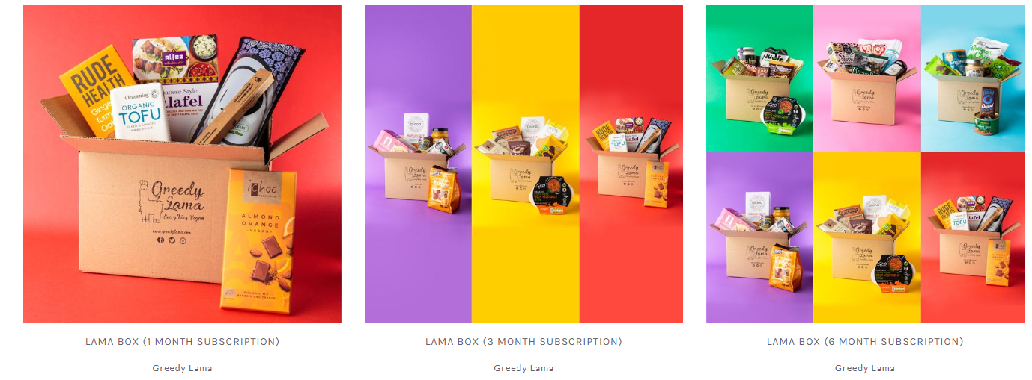

Company has a dedicated Facebook Page, Instagram and Twitter account mainly used for unpaid Marketing/Advertising.

Logistics e Commerce
Logistic of conventional retail is much more simplistic than of E-Commerce retail logistics.

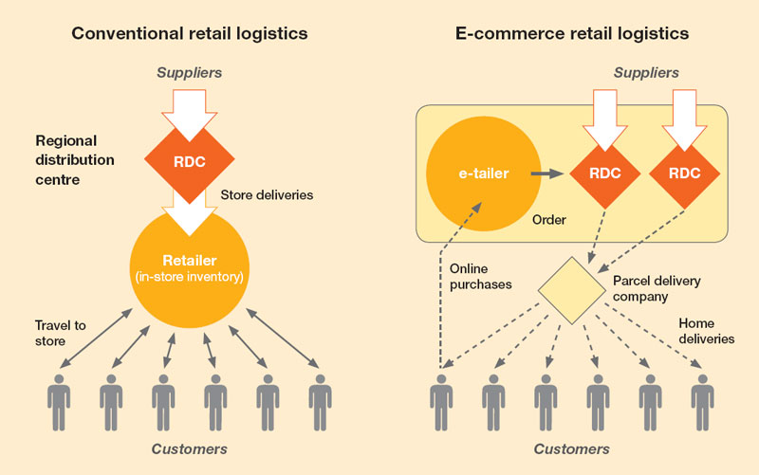

Greedy Lamas main operations are in the relatively small warehouse, where deliveries of incoming large bulk stock take place almost daily from various suppliers. There is a sorting area where internet orders are sorted then distributed via the Parcel delivery company to customers.
Payments for goods are facilitated via Pay Pal (most flexible form of payment as it applies to global customers), via normal card /American Express payments and most recently the Apple Pay facility is included in their payment methods.

Digital Marketing
Marketing excellence is essential for business success. Internet and smart phones/tablets offer great Marketing tools for customer interaction, in return these are enriched with data that can be use for better business landscape and customer profiling. At present the company doesn’t have an App and that would be something that the company should consider.
Product/Service Marketing is done via social media, Facebook, offer transaction via FB payment platform, Instagram is integrated with Shopify and Twitter has a ‘Buy Now’ option in tweets allowing purchases without leaving the app.

US Market Research (Task 1)
)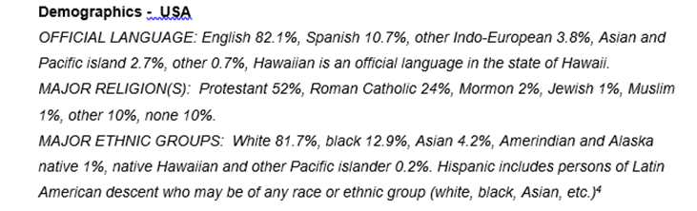
Online Grocery Shopping
2017/8 has been very significant year in the development of e-commerce, globally online grocery shopping. This segment continues to rise as it offers more convenient grocery shopping for all .
These are the most recent main trends of online shopping in the USA:
- Number of individual Online grocery shopping has doubled in over a year, 2017/18
Almost half of Americans are shopping online for groceries, according to Food Marketing Institute FMI and Nilsen. Conducted survey shows that 49% of US costumers have bought online groceries (CPGs-Customer Package Goods) and within that the majority were Millennials 61%. FMI and Nielsen forecast that 70% of US consumers could be buying online groceries by 2022.
- Annual online retail sales to reach close to $1 trillion by the end of 2018.
- Activity of US biggest grocery retailer’s are fueling the growth.
Walmart and Kroger are fast expanding their network of grocery collection, while Saams Club signed a deal with a delivery service company that would do same day delivery service (currently is one day delivery service). Recently Target acquired a delivery service company with plans to do same day delivery service.
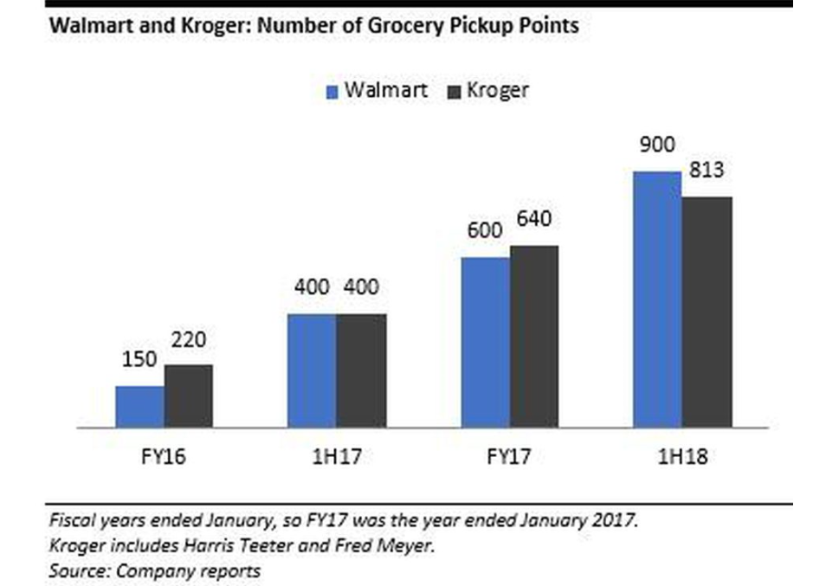

The impact on online grocery shopping trends of the recent acquisition of Whole Foods by Amazon is still unknown but Amazon is already offering online grocery and with merging amazon Fresh and Prime Now it will look to remove various overlapping existing services.

Vegan/Plant based Food Global movement.
The plant based movement is growing rapidly globally, from athletes, celebrities, large companies and even countries as big as China supporting veganism. The number of Vegan celebrities is growing, amongst which well known names are opting for animal free food, Beyonce, Brad Pitt, Natalie Portman, Jennifer Lopez, Ellie Goulding, millennial super star Arian Grande and many more. Even Google’s canteen menu that is free for its employees is shifting toward plant based food and meat/dairy alternatives as part of its sustainability initiative. The global plant based milk (Almond milk, coconut milk, hemp milk etc) is expected to reach $16bn in 2018, a significant increase since 2010 from $7bn.
In the UK number of vegan consumers have increased by 350% in the past 10 years, while in USA a staggering 600% increase in the last 3 years alone, reported by the research firm GlobalData.

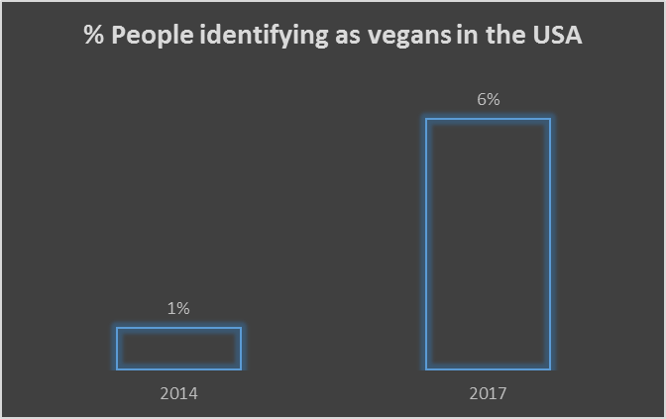
Source: GlobalData 2017

The main concern for the meat industry is rapid growth of the meat alternative/plant based meat alternative industry globally mainly in the western world. One of the successful Meat free companies, Beyond Meat Company, has developed burger alternative that looks, tastes and has a meat burger like texture that when cooked, uses beetroot juice to ‘bleed’ as real cooked burger. There is also growth in in restaurants that offers vegan/plant based food. It is estimated that a global reduction of meat consumption between now and 2050 could save 8m animals per year.

‘Hofstede’ country comparison - UK and USA

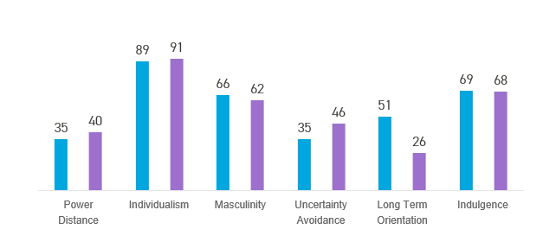

Power Distance
‘Power Distance is defined as the extent to which the less powerful members of institutions and organisations within a country expect and accept that power is distributed unequally.’

At 35 UK is the lower ranking of PDI, indicates importance of equality amongst rich diversity of people. USA is slightly higher than the UK that indicate slightly higher society inequality that is endorsed by the leaders and followers.

Individualism
‘The degree of interdependence a society maintains among its members’
UK is amongst highest of the individualist that indicates Brits are highly individual and private people. While Americans are scoring slightly higher in individualism, there is slight business cultural variation between the UK and USA. American tend to look after themselves and their immediate family, not relaying on others, and they are very direct in communication and communication is often informal. They are familiar with interacting and doing business with people they don’t know.

Masculinity
‘The fundamental issue here is what motivates people, wanting to be the best (Masculine) or liking what you do (Feminine).’
At 66 UK is a masculine highly driven and success orientated nation and that is shared with Americans but the difference is that Americans tend to show it up front while Brits will take you by surprise.

Uncertainty Avoidance
‘The extent to which the members of a culture feel threatened by ambiguous or unknown situations and have created beliefs and institutions that try to avoid these’
At 35 UK has relatively low score and it indicates that uncertainty is not and issue. While Americans are shifting bit higher than UK, but s below the average compering to rest of the world. When it comes to innovation, new ideas, trying something new is fairly welcomed with minimal rule requirements and higher tolerance levels.

Long Term Orientation
‘How every society has to maintain some links with its own past while dealing with the challenges of the present and future?’
With the score of 51 UK is sitting on the fence when it comes to Long term Orientation.
But USA is at a lower score of 26 that indicates that they are not prioritising long term orientation. In the business world they tend to lean toward short term performance measurements aiming quick results the within work environment.

Indulgence
‘The extent to which people try to control their desires and impulses.’
At a score of 69 British culture is classified as indulgent, possessing a positive attitude and optimism which is very close to the US score of 68 with a Work.hard - Play.hard attitude.

Vegan Food Market in the USA
According to Global Google search interest trend using word ‘VEGAN’, USA is in 5th place while UK is on the 2nd place.

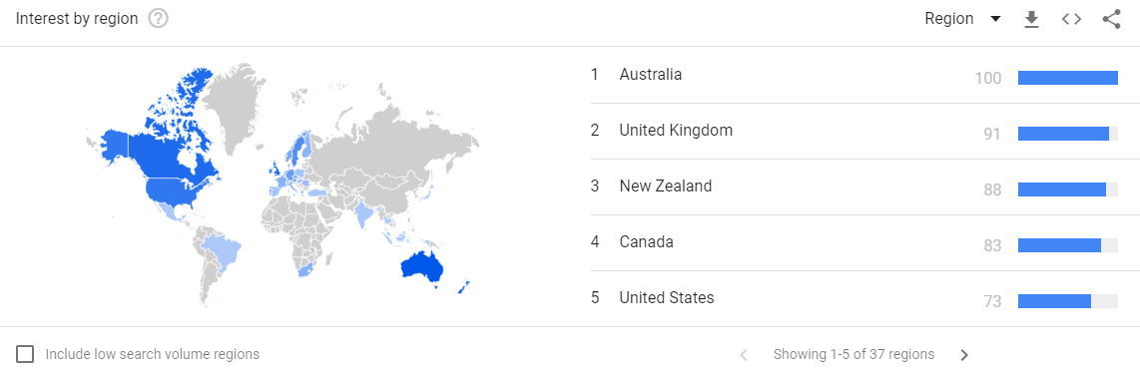
Source: https://trends.google.co.uk

Global sales of plant based food/product have experienced a stable growth over the past few years. Vegan/Organic Labeled products had a steady growth rate of 5% per year and still growing.

In the North America, veganism has become popular amongst Millennials consumers. They are main drivers of this domestic consumer preference shift is not just in USA but Globally.

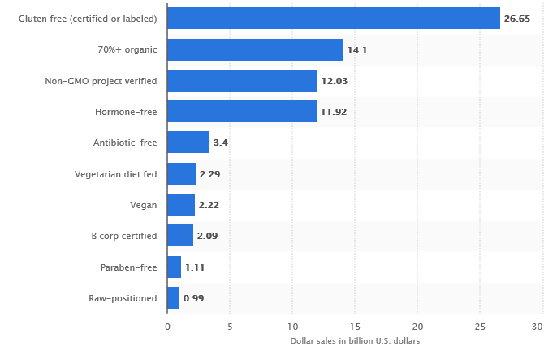

This statistics illustrates the sales of vegan based food product in the USA has amounted to $2.2bn
Additionally, an independent 2017 survey on consumer attitudes towards the plant based diet showed that more than half of U.S. consumers consider veganism healthy.

Google Search Terms Trend: VEGAN / VEGETARIAN
Region: North America

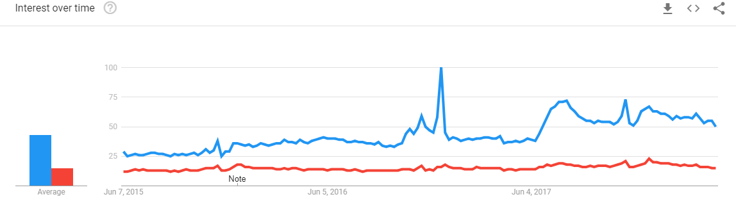
Source: https://trends.google.co.uk

Average Vegan 43 million searches per year in the past 5 years, search term VEGAN is well above search term VEGETARIAN that is 15milion searches for the same length of time, between 2015 and 2018.

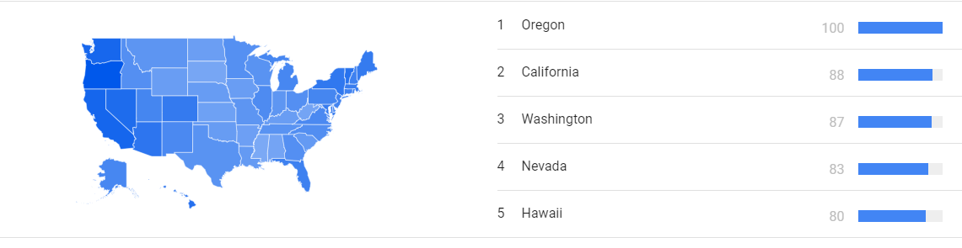
Source: https://trends.google.co.uk

Interest (search term Vegan) by sub region shows that west and East are more interested in VEGANISM than Central America.

Google Search Terms: Cruelty – Free / Vegan Diet
Region: North America

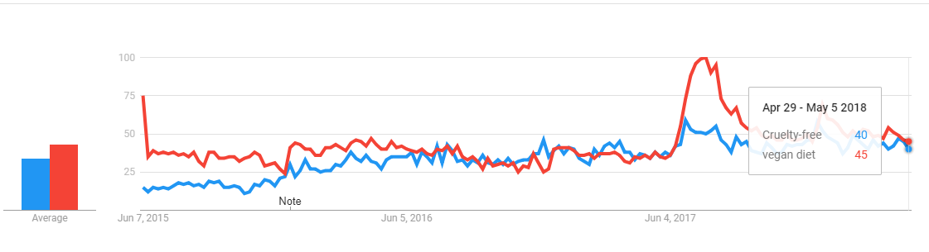
Source: https://trends.google.co.uk

The above there is a strong positive trend correlation between searches of “Cruelty-free” and “Vegan diet”.

Logistics facts:
Storing and Delivering Food – USA Order Fulfilment Services & Companies of 2018
Below is the list of top 10 order fulfillment services and companies of 2018 in USA:

- Fulfillment by Amazon – sell on Amazon platform, low cost shipping/storage.
- FedEx Fulfillment – integrated supply system solution, easy to use platform
- ShipWire – global warehousing, global logistics network
- ShipBob – same delivery service in certain cities, integration with e-com platform
- RedStag – specialise in shipment over 5 pounds in weight, low cost US based
- FulfillmentCompanies – expertise in finding wright fulfilment (logistic) company
- Fulfillify – mobile responsive technology platform
- IDS Fulfillment - provides order fulfillment, warehousing, distribution, and product transportation.
- VelocityShip – complete supply chain management
- Ships-a-lot - specifically targeted at growing eCommerce companies

Fulfilment service/Logistic companies that are providing supply chain solution (warehousing, product receiving processing and delivery service) behalf of online retailers, e-commerce and established ‘brick and mortar’ stores complying with regulatory requirements such as taxation, after sales customer care)

Benefits of Order Fulfilment service:
- Lower shipping cost
- Reduced Operating costs
- Customer service improvement
- Latest Technology
- Focus on selling
- Supply chain expertise

Order Fulfilment/Logistics service companies are well established and it is big business in USA. Employment rate in this industry is slightly less than 1 million employees in this type of industry across USA and industry is worth $22bn with growth of 46% since the last decade.

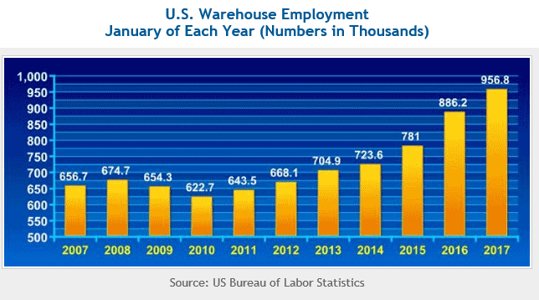
USA - Risk Assessment (Task 1)

Country Risk Rating: A2
According to global edger, the economical and political environment is stable but leaves room for improvement.
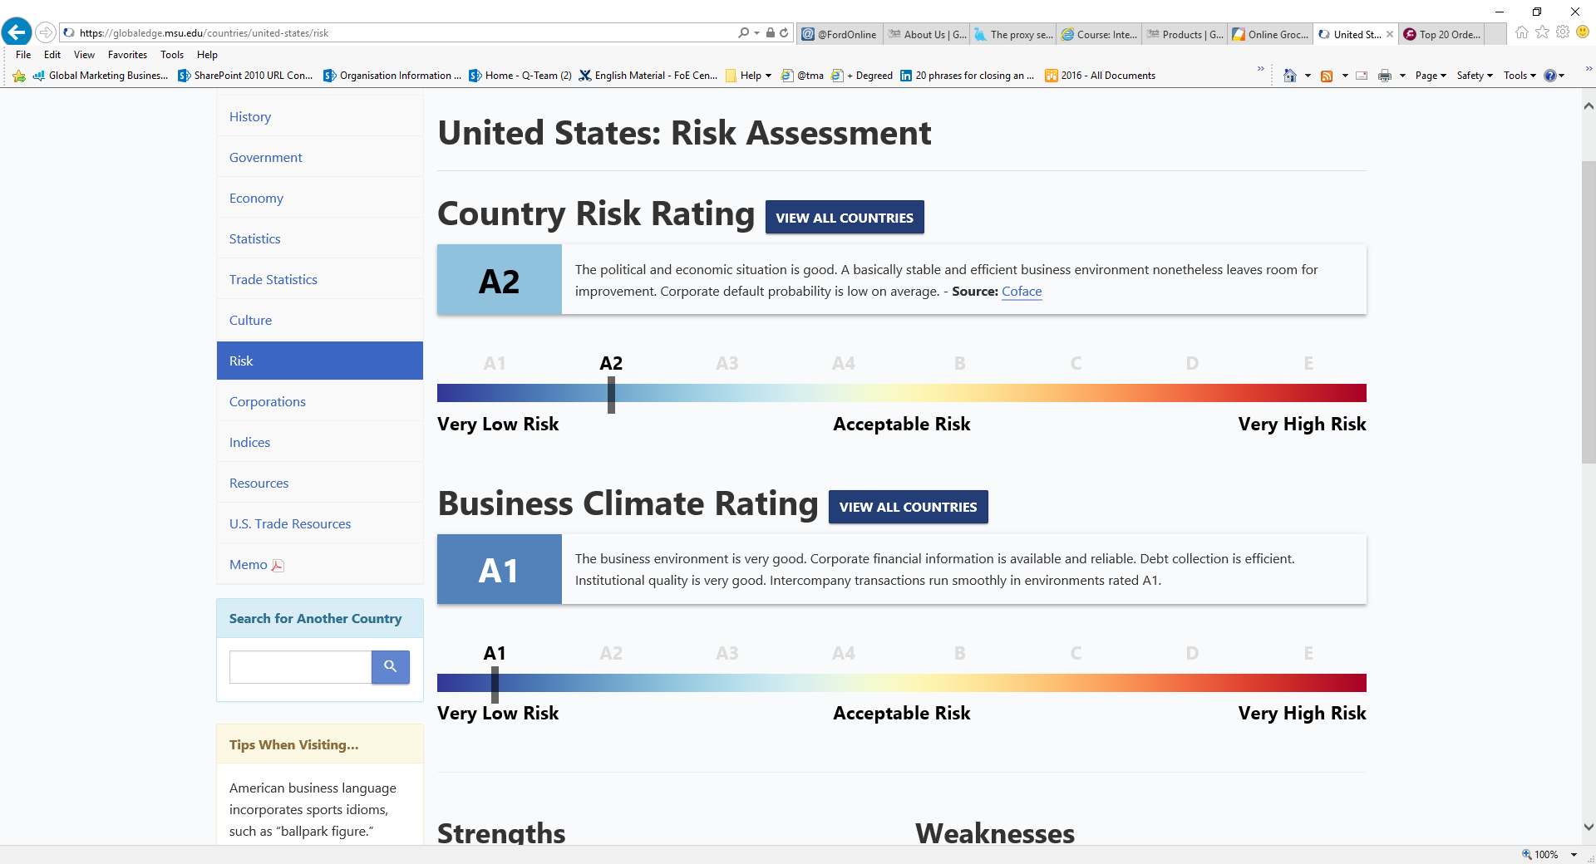
Business Climate Ratings: A1
The business environment is very good, financial institutions/corporate business regulated, efficient debt collection, intercompany transactions are efficient and run smoothly in A1 ratings.

Strengths:
- Flexible labour market, vast range of skills availability
- Global Dominance of US currency
- Lower corporate tax rates
- Wide Market expertise leading in research/technology and innovation

Weakness:
- Increasing inequalities
- Changing Political landscape, especially after Trump election
- Low labour participation rate
- High competition, large company monopoly such as Amazon

With the current political climate under Trump presidency, expanding to USA can represent a challenge and it all depends on additional costs (import duty, corporate taxes etc) to the expanding business to the USA.

Competition and corporate large corporation dominance – case study, Whole Foods Organic healthy eating supermarket chain has been overtaken by global giant Amazon. Amazon has already have firm established online business and logistic, Amazon expanding into food/online supermarket segment is at low risk as the company is already serving customers online globally. By using a logistics from Amazon Market platform (Explained later in Logistics and supply chain section), can be disadvantage as if the business in vegan grocery online selling success can be absorbed by Amazon by offering similar product/services.

International Business Strategy (exporting, joint venture, FDI, franchising/ licensing, etc.)
UK market is online vegan and organic food retailer is still relatively small and it’s growing. Greedy Lama has a growing number of international customers and international customers are mainly based in the USA. Currently the company offers only long shelf life food products, toiletries and household items. Joint venture with a small well established similar businesses could be considered.

Franchising/ Licensing – Greedy Lama is a UK trademark and has already established business systems but within UK Domestic market. The company does not have a significant global presence and expanding by offering franchise would be a challenge. Franchising can provide a good opportunity without giving up a control of its business operation of the chain. In the USA Federal Trade Commission has oversite of franchising, via FTC Franchise rule.

International Marketing Plan
Improve Online Global presence, especially in USA via social media platforms.
Product/Services –As an Online vegan/Plant based retailer, providing a large selection of products (European and US vegan products) selected for the US market for the online consumers, (vegan products with long shelf life, also plan to expand into to convenient frozen based ready meals such as OUMPH).
Market – Plant based food industry is globally fast growing segment manly driven by new millennial consumers and cruelty-free food global growing trend.

SWOT Analysis

UK Export to USA Logistics
Using a well established Fulfilment service, third party Logistic Company (that can deal with goods imports form the UK/Europe into USA) as well as build rich product portfolio of Vegan/Healthy food producers in the North America, and all aspect of ecommerce requirement. This all depend on the region selection and its infrastructure.

Region Selection Proposal: California (possible Oregon)

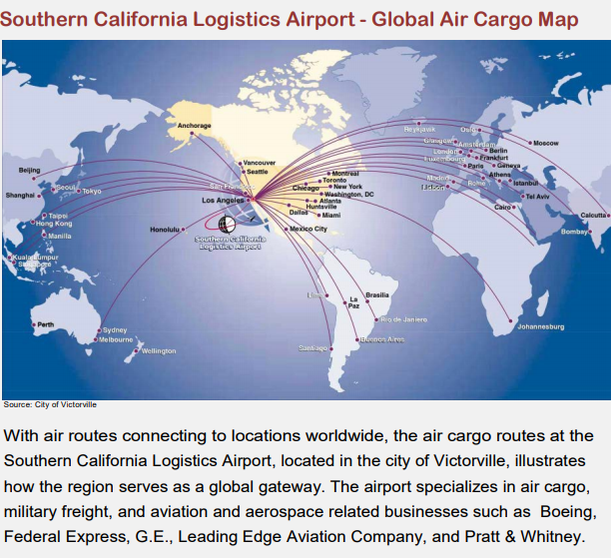

Transportation, due to high cost of transporting via Air, to consider sea Transportation.
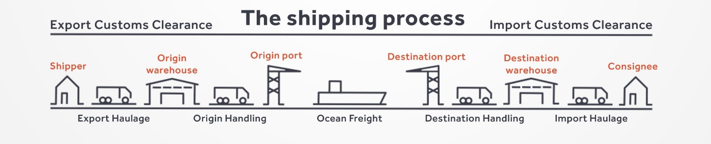

From UK Sea Ports to main California Seaports:
Port of Long Beach (largest, mega port)
Port of Los Angeles (largest, mega port)
Port of Humboldt Bay
Port of Richmond
Port of San Diego
Port of San Francisco
From the California Seaports/ to the Warehouse
California Main Seaport/Airport and close by warehouses.

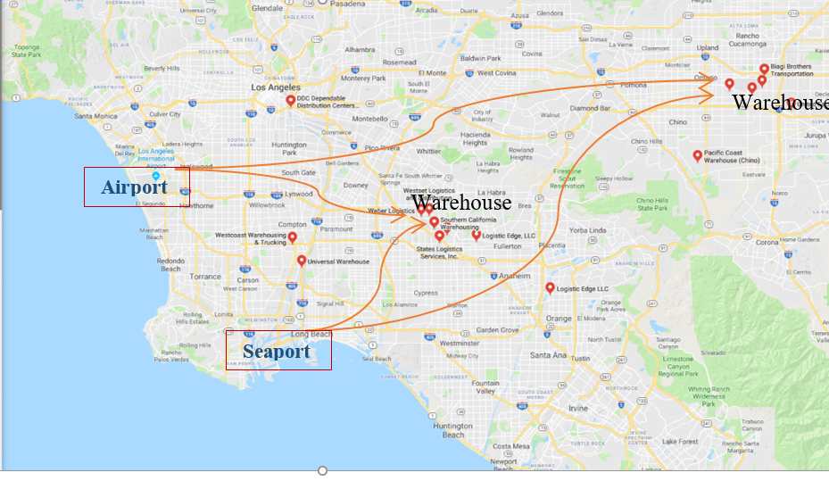
Source: Google Map

California’s Infrastructure and Transportation is constantly developing and it is considered reasonable populated areas.

Exchange Rates and US Taxation
When considering expanding to the USA, we have to consider Exchange rates between GBP and USD and taxation on income/sales tax impact on business profits generated in USA.
Currently Exchange rate GBP to USD is 1: 1.35468. Pound has been weakening since beginning of 2018 but according to JP Morgan Forecast it will slightly recover towards end of 2018. Weaker pound gives better competitiveness to UK exporters, and it has positive impact on profits earned aboard.
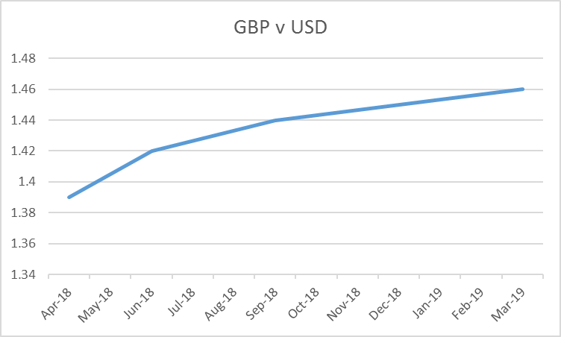

Sales Tax in USA applies to tangible items. Current sale tax rate is 6% and additional 1.25%local rate, in total 7.25% and it is collected from the buyers at the point of sales (Similar to UK VAT)
There are two layer of Corporation tax in USA, Corporate Income tax in California is flat at the rate of 8.840% of gross income. And additional Federal Corporation tax rate is 21%. All business operating in California are subject to corporate tax.
US Taxation rate is slightly higher than UK Corporation tax, Business controlling and decision making from UK can rule UK tax rates applying to the US profits.
The company Global Online Marketing is already established thru Social media, Facebook, Instagram and Twitter. Facebook is largest and used social platform that offers great tools to help business grow and reach customers. At the moment the company is keeping the cost low and has only set up a Facebook Business Page, not using its Marketing tools/Advertising. Facebook offer great business tools for businesses and we have outlined main useful features in recommendations to use when expanding into the US Market.

Recommendations

As the plant based food is predicted to have significant growth globally, the US market represents a great opportunity. UK companies trying to break into the US market should be very cautious of market complexity and competition, but if successful can be very rewarding.

Key elements to consider:
Regional selection: California, as they are investing heavily in improving their infrastructure by implementing decentralisation by locating Warehouses near to populated areas to achieve cost effectiveness.

There are large number of Third Party Logistics service companies in California, offering all in Logistic services such as Freight, forwarding, fulfilment, transportation, compliance, warehousing and supply Chain Management at competitive prices. Most the providers are well located offering access to the largest ports and airports.

It is best practice to start small and evolve from gaining and learning form operating as an online vegan/healthy retailer in one region. Also to consider partnering with smaller brick and mortar retailers for Vegan UK/EU healthy food products.

Same online shopping experience would be offered in the USA, slightly variation of Healthy Vegan European/American Products and sizing must be adapted to the American Market.
Positioning in the Vegan product market is playing a key in business success, business should not position itself just as a vegan but healthy and organic to target wider audience, such as vegetarians and part time vegetarians.

Marketing, building up a robust digital presence is a must via Social Media, such as Facebook, Instagram, Snap Chat and Twitter, targeting millennials and responding quickly to trend changes. American customers like coupons and that combined with Facebook platform features for business pages can help business to go from Local to Global within few clicks.
Below are key Facebook features to expand presence on this platform to USA:
  - Targeted Advertising Platform that offers Advertising feature allowing business to specify geographic areas, ages, education levels, etc. IE targeting Vegan/California between age 21 - 45
Disadvantage: This option can be expensive.
  - Groups – there are loads of vegetarian/vegan groups, to promote company services, gather information about trends and events that can be beneficial for the company.
  - Company profile that relates to UK and USA customers, posting daily offers, Product of the day, informative article that have positive effect on the business, new product announcements

Facebook has 1.8bn monthly active users globally is data rich and offers audience insight (paid advertising), detailed info about target audiences to help with.creating the relevant content for the.business FB profile.

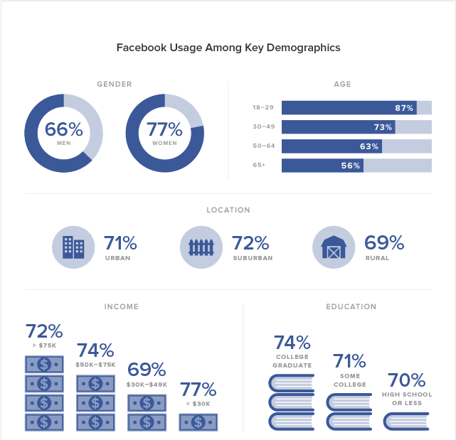
Source: Facebook Marketing

Online retailing continuation as well as consider opening/partnership with a small shops, coffee shops, also expand to healthy eating targeting and vegetarians, part time vegetarians not just vegans.

Case Study:
Success of UK base snack company Graze in USA – A business strategy to consider when expanding into North America.

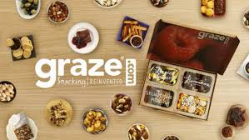

Graze begin selling healthy snacks online in 2008, the company expanded to the USA in 2013 continuing traditional Online selling/snack delivery by mail and also supplying variety products to major UK and US supermarkets. As online business Graze poses great consumer behavioural knowledge and used that to adapt product to the American taste preference and Food trends in various regions. Their Big challenge was logistics, finding Fulfilment centre with consumer easy reach.
Healthy Snack Facts: Global Healthy Snack Market $32.8bn by 2025, very popular as a healthy snack.

Reading Book References:
Deresky, H. (2016): International Management: Managing Across Borders and Cultures. 9th ed., Pearson.

Bartlett, C. and Beamish, P. (2011). Transnational Management: Texts, Cases and Readings in Cross-Border Management, 13th ed., McGraw-Hill Higher Education.

Schneider, G., 2012. E-Business International Edition. 10th ed. USA: Course Technology.

Reading Journals References:
Faramarz Damanpour, Jamshid Ali Damanpour, (2001) "E‐business e‐commerce evolution: perspective and strategy", Managerial Finance, Vol. 27 Issue: 7

Mike Peng , W. and Denis Wang, Yl. (2008). An institution-based view of international business strategy: a focus on emerging economies. Springer Journals. 39 (Issue 5), p920-936.

Charles Hill, (2008) "International Business: Competing in the Global Market Place", Strategic Direction, Vol. 24 Issue: 9

Research Website References:
Greedy Lama. 2018. Vegan Online Retailer. [ONLINE] Available at: https://greedylama.com/collections/all?page=2. [Accessed 21 April 2018].

British Chambers of Commerce. 2018. Government programmes. [ONLINE] Available at: http://www.britishchambers.org.uk/business/international-trade/already-exporting-want-to-export-more/government-programmes.html. [Accessed 21 April 2018].

BBC. 2018. How snack food firm Graze cracked the US. [ONLINE] Available at: http://www.bbc.com/news/av/business-42790900/how-snack-food-firm-graze-cracked-the-us. [Accessed 21 April 2018].

Buffer Social. 2018. 9 Little-Known Facebook Marketing Features and Hacks You Can Try Today. [ONLINE] Available at: https://blog.bufferapp.com/9-hidden-facebook-marketing-features. [Accessed 21 April 2018].

California Tax Rates. 2018. California Tax Rates 2018. [ONLINE] Available at: http://www.tax-rates.org/california/corporate-income-tax. [Accessed 21 April 2018].

Finances Online. 2018. op 20 Order Fulfilment Services & Companies of 2018. [ONLINE] Available at: https://financesonline.com/top-20-order-fulfillment-services/. [Accessed 21 April 2018].

California Department of Transportation. 2018. Seaports. [ONLINE] Available at: http://www.dot.ca.gov/hq/tpp/offices/ogm/seaports.html. [Accessed 21 April 2018].

Hofstede-insights.com. 2018. COUNTRY COMPARISON. [ONLINE] Available at: https://www.hofstede-insights.com/country-comparison/the-uk,the-usa/. [Accessed 21 April 2018].

Greedy Lama. 2018. Vegan Online Retailer. [ONLINE] Available at: https://greedylama.com/collections/all?page=2. [Accessed 21 April 2018].
British Chambers of Commerce. 2018. Government programmes. [ONLINE] Available at: http://www.britishchambers.org.uk/business/international-trade/already-exporting-want-to-export-more/government-programmes.html. [Accessed 21 April 2018].
Facebook. 2018. Greedy Lama. [ONLINE] Available at: https://www.facebook.com/pg/GreedyLama/photos/?ref=page_internal. [Accessed 21 April 2018].
Culture Crossing Guide. 2018. United States. [ONLINE] Available at: http://guide.culturecrossing.net/basics_business_student.php?id=216. [Accessed 21 April 2018].
Forbes. 2018. Online Grocery Set To Boom In 2018 (As Amazon Acknowledges Online Grocery A Tough Market To Crack). [ONLINE] Available at: https://www.forbes.com/sites/deborahweinswig/2018/03/01/online-grocery-set-to-boom-in-2018-as-amazon-acknowledges-online-grocery-a-tough-market-to-crack/#4040c18b520b. [Accessed 21 April 2018].
Hofstede-insights.com. 2018. COUNTRY COMPARISON. [ONLINE] Available at: https://www.hofstede-insights.com/country-comparison/the-uk,the-usa/. [Accessed 21 April 2018].
Finances Online. 2018. op 20 Order Fulfilment Services & Companies of 2018. [ONLINE] Available at: https://financesonline.com/top-20-order-fulfillment-services/. [Accessed 21 April 2018].
Wikipedia. 2018. FRANCHISING USA. [ONLINE] Available at: https://en.wikipedia.org/wiki/Franchising. [Accessed 21 April 2018].
California Department of Transportation. 2018. Seaports. [ONLINE] Available at: http://www.dot.ca.gov/hq/tpp/offices/ogm/seaports.html. [Accessed 21 April 2018].
California Tax Rates. 2018. California Tax Rates 2018. [ONLINE] Available at: http://www.tax-rates.org/california/corporate-income-tax. [Accessed 21 April 2018].
Buffer Social. 2018. 9 Little-Known Facebook Marketing Features and Hacks You Can Try Today. [ONLINE] Available at: https://blog.bufferapp.com/9-hidden-facebook-marketing-features. [Accessed 21 April 2018].
BBC. 2018. How snack food firm Graze cracked the US. [ONLINE] Available at: http://www.bbc.com/news/av/business-42790900/how-snack-food-firm-graze-cracked-the-us. [Accessed 21 April 2018].

