L4

Plant Operations

P and ID Diagram
Report

Max James

Context

1.1. Introduction Page -3
2.1 Explanation of a P and ID diagram Page -3
2.2 The P and ID diagram of the factory Page -4
2.3 CNC cylindrical grinder P and ID diagram Page -5
3. Examples of sensors Page -6
4. Conclusion Page 7
5. Evaluation Page 7
6. Bibliography Page 8

P and ID diagram
1. Introduction
FSG tool and die is an industrial component engineering firm which makes small components as a one off for customers ranging to entire press tools which are made from scratch or refurbished/ fixed dependant on customer requests.
The area being focused on during this report will be the grinding section which has three faze AC (alternating current) which powers the AC motors of each of these industrial grinders along with powering the extraction system and the pressurised air system. Each of the grinders was placed in one area of the factory which is located next to the extraction system.
The grinding section was placed here to ensure the extraction piping does not go across the entire factory and confines only to this area as shown in the diagram below. This area also has the most variety of piping which makes it a great place to create a P and ID diagram for.
2.1 Explanation of a P and ID diagram
A P and ID diagram is a way of showing a diagram in the simplest way to reduce the amount of over information to a spectator or manager looking to identify a variable or specific instrument which may be faulty. “The P&ID includes a graphic representation of the equipment, piping, and instrumentation.” (Lele, 2012). This shows that each P and ID diagram is created to show all piping and circuitry which runs in a factory which is easy to read and identify specifics in the factory. It is used to make information clearer and less cluttered by specific wires or pipes reducing the chance for confusion.
The P and ID diagram is also standardised meaning the same symbol will be used regardless of what actual type of component is being used. For example: if a temperature gauge for oil is being used, regardless of what make or model or size, the same symbol will be used. This ensures clarity to the reader and regardless of who reads the diagram, the reader will know this is a temperature gauge for the oil and can even locate the object from the diagram.
2.2 The P and ID diagram of the factory

Shown on previous page is the old layout of the factory in a P and ID layout. Machines have been moved around since then but the layout of the piping hasn’t changed. All the blue piping is the air compression units which provide compressed air throughout the factory. This is an essential in the factory as it is used to clean all the components. The Electricity has been extended around the factory as well which is not included in this layout of the factory. The solid black line is shown which shows where the old extraction unit was to accommodate the big grinders which have also moved and a new extraction system has been added. Below is a new layout of the grinding area.
2.3
Entry CNC cylindrical grinder P and ID diagram
Cylindrical grinder

CNC jig grinder
CNC cylindrical grinder
CNC jig grinder
CNC cylindrical grinder

CNC cylindrical grinder
CNC cylindrical grinder
Cylindrical grinder

Cylindrical grinder

This diagram shows the new layout of how the grinding section. As shown it is clear to see the electricity which is passed through the section and dispersed around the factory. Only the grinding section has an extraction system which is shown as a dotted line in the old P and ID diagram but it is a blue line on the one created by me. The grinding section is the only one with a extraction system as all other areas are ventilated well or encased in the CNC machine accompanied with coolant which grounds the swarf. The coolant itself can also rise which is why the mist must settle before opening the machine. The information on the P and ID diagram was influenced by (SA Water, 2015)

3. Examples of sensors
Due to the P and ID diagrams obtained there are no examples of sensors and other objects being used in the factory. Here are some examples of images and a brief explanation of where is could be used and what its function is.
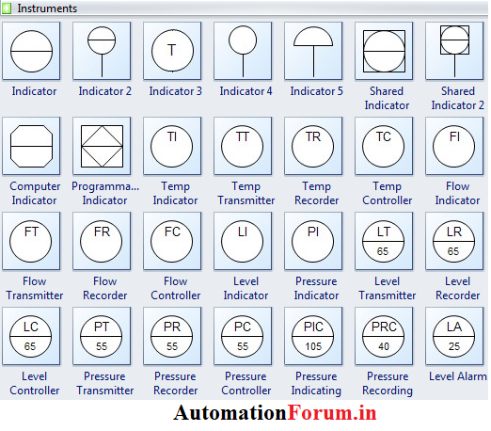
For all the instrumental symbols they are all labelled dependant on the function and a different symbol is used dependant on what type of indicator is being used and its purpose. The Lettering such as FR which stands for flow recorder shows the flow rated of the liquid which is passing through the piping it is connected to. This ensures the observers know exactly how much liquid is passing through at one time.
One sensor which is attached to the air compressor is a PC and PIC accompanied with the numbering of pressure the air compressors are working at. These air compressor indicators which is a Pressure Indicator and Pressure Controller which is checked regularly ensure the air compressor is operating within the safety limits showed on the machine.
4.Conclusion
The entire factory needs a new P and ID diagram with greater detail to show all the extra indicators and safety mechanisms attached to all of the Piping and electricity which flows through the factory. These indicators could be missed or general maintenance could miss important indicators which are hidden from sight. This could even become dangerous if not put right along with extra P and ID diagrams being easily accessible throughout the factory.
P and ID diagrams are useful pieces of paper work which can keep order to a factory while not over burdening the reader with lots of information at a time. The key areas are highlighted and made universal to all who read P and ID diagrams. It can assist with maintance and problem solving which in turn will allow machine to operate at the best efficiency and ensure all workers are safe with operational equipment working properly.
The disadvantage of having P and ID diagrams are taking up time and resources to have all the factory modelled into the diagram along with training of P and ID diagrams to yield anything from these diagrams in the first place.
5.Evaluation
The investigation went well but there wasn’t much information in the factory to give examples in my working area. If the project was done again I would focus more on a different area of the factory or even a specific machine to gather more information and greater detail in the P and ID diagrams which are made.

Bibliography
Lele, S. (2012, 04 15). P and ID Diagrams. Retrieved 05 2020, 01, from SVLELE: http://www.svlele.com/piping/pid.htm
SA Water. (2015, 12 16). Process and Instrument Diagrams. Retrieved 05 01, 2020, from Government of South Austrailia: https://www.sawater.com.au/__data/assets/pdf_file/0019/51184/TS-112-Process-and-Instrument-Diagrams.pdf
Sivaranjith. (2019, 01 25). P and ID Diagram. Retrieved 05 01, 2020, from AutomationForum: https://automationforum.co/p-id-common-symbols-how-to-read-a-pid/

