Conrod accelerations, forces and displacements
Advanced Engine Design (M6X00410) – Kyle Cummings (1700852) 02/11/2019

University of Wales Trinity St David: School of Engineering
Motorcycle Engineering

Table of Contents
1. Introduction 4
2. Calculations & Results 5
2.1 Gas, Inertia and Net Forces 5
2.2 Tensile Load and Compressive & Tensile Stresses 8
2.3 Safety Factors and Rod Stretch & Compression 9
3. Analysis & Evaluation 11
4. Conclusion 13
5. Appendices 14
5.1 Mean Torque per Engine 14
5.2 Friction & Work Done 15
6. Bibliography 16

Nomenclature
$A$ Conrod Cross Sectional Area
$d$ Cylinder Diameter
$E$ Young’s Modulus
$F_{F}$ Frictional Force
$F_{GAS}$ Gas Force
$F_{INERTIA}$ Inertia Force
$F_{NET}$ Net Compressive Force
$F_{ROD}$ Rod Force
$F_{SIDE}$ Side Force
$F_{TENSILE}$ Tensile Force
$k$ Material Stiffness
$L$ Rod Length
$m_{Piston}$ Mass of Piston Reciprocating Assembly
$P$ Average Cylinder Pressure
${Power}_{F}$ Power Loss due to Friction
$R$ Crank Radius
$S$ Piston Travel
${SF}_{comp}$ Compressive Safety Factor
${SF}_{tens}$ Tensile Safety Factor
$UTS$ Ultimate Tensile Strength
${WD}_{F}$ Work Done due to Friction
$ω$ Angular Velocity
$θ$ Crank Angle
$∅$ Rod Angle
$σ_{c}$ Compressive Stress
$σ_{t}$ Tensile Stress
${∆L}_{stretch}$ Rod Stretch
${∆L}_{comp}$ Rod Compression
$τ_{GAS}$ Gas Torque
$τ_{INERTIA}$ Inertia Torque
$τ_{INSTANT}$ Instantaneous Torque
$μ$ Coefficient of Friction

- Introduction

As part of the Advanced Engine Design module in the final year it’s a requirement to conduct a set of calculations involving components inside an engine cylinder. These calculations took the cylinder pressures from a Ford Sigma 1.6L engine and used this data to determine forces on the piston and connecting rod (conrod) as well as tensile and compression stresses on the conrod.

In order to conduct these multi-step calculations, length and area measurements of the conrod had to be taken, alongside weighing the masses of the conrod and different elements in the piston-conrod assembly. The assembly (as shown in figure 1) shows the piston, the mass of which was used in the inertia forces that act upon it. The conrod itself has to be made of a strong, high quality material to withstand these pressures and forces, which brings forward the reasoning behind doing all these calculations. The calculations were completed to analyse the quality of this specific conrod, comparing values at different RPM values and how different improvements could be made to it such as using a material such as Titanium alloy (Ti6Al4V) instead of the current powder forged steel alloy. The pressure data was also modified (increased by 15%) in a different excel spreadsheet to simulate adding a turbo to the engine and seeing how this affects the forces and stresses placed upon the conrod.
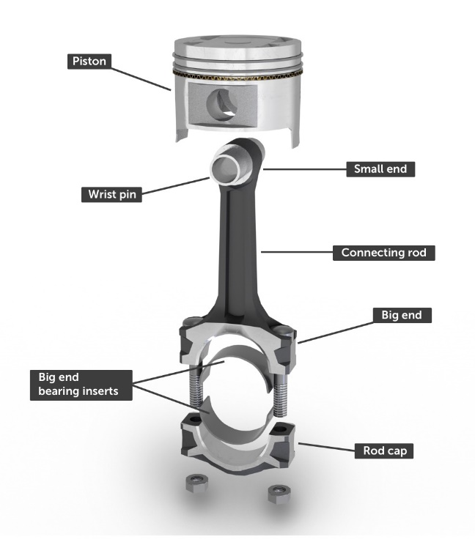

Fig. 1 – Example of a Connecting Rod and Piston Assembly
- Calculations & Results

  - Gas, Inertia and Net Forces
The first set of calculations to be completed were for Gas Force down on the rod (equation 1), the Inertia Force (equation 2) and then the Net Force of these two forces (Gas Force – Inertia Force). The Gas Force is calculated at each angle and then the peak force can be taken from a certain degree of crank angle with the highest Gas Force. The Inertia Force is then calculated and used to determine the maximum net compressive force on the rod (Net Force). The maximum values for these forces that will be used later on in other equations can be seen in the screen dumps below.
$F_{GAS}= \frac{P × π × d^{2}}{4}$ Equation 1
$F_{INERTIA}= m_{Piston}×Rω^{2}cosθ+ \frac{R}{L}Rω^{2}cos2θ$ Equation 2
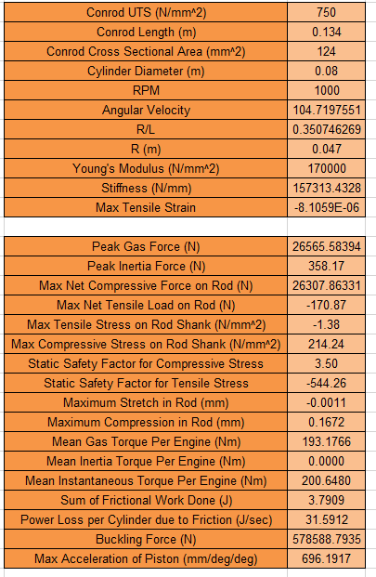

Fig. 2 - Modified Engine @ 1000 RPM
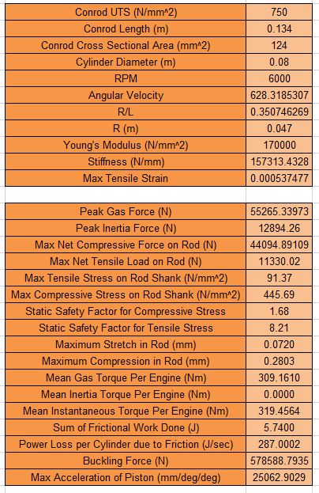

Fig.3 - Modified Engine @ 6000 RPM
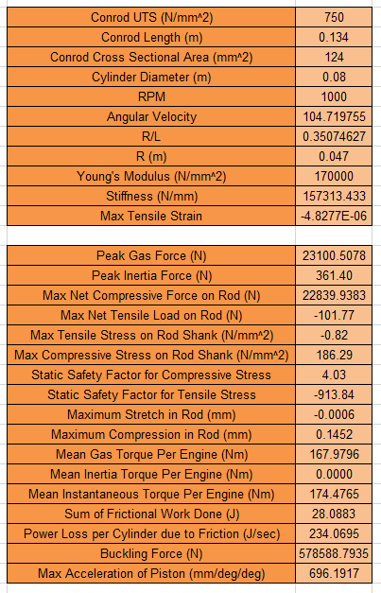

Fig.4 – Standard Engine @ 1000 RPM
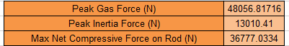

Fig. 5 - Standard Engine @ 6000 RPM

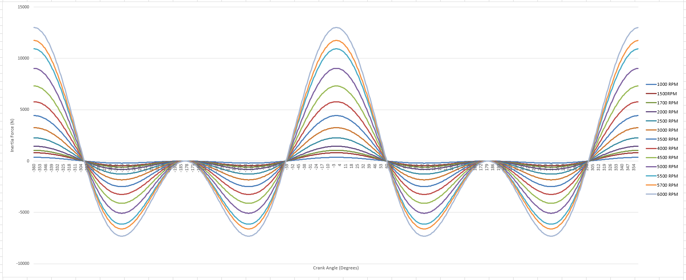

Fig. 6 – Graph of Inertia Force vs Crank Angle in Standard Engine

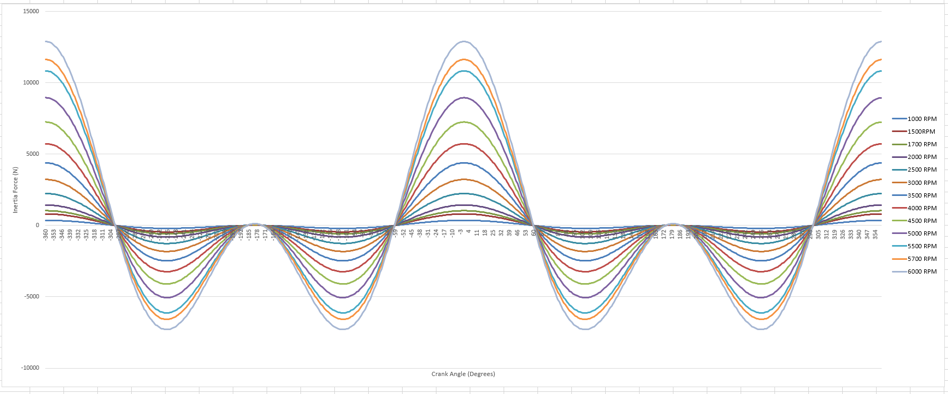

Fig. 7 – Graph of Inertia Force vs Crank Angle in Standard Engine
  - Tensile Load and Compressive & Tensile Stresses

The next steps taken are to calculate the conrod angle (equation 3), which is then used to determine the tensile load placed on the conrod (equation 4). The compressive stress (equation 5) is the stress applied downwards onto the conrod by the gas force, with the tensile stress (equation 6) value coming from the tensile load placed on the conrod. For the stress calculations only the shank section of the conrod was considered. The minimum and maximum values for these can be seen below.

${∅=sin}^{-1} (\frac{R}{L}sinθ)$ Equation 3

$F_{TENSILE}= F_{INERTIA}-F_{GAS}$ Equation 4

$σ_{c}= \frac{A}{F_{GAS}}$ Equation 5

$σ_{t}= \frac{A}{F_{TENSILE}}$ Equation 6

Fig. 8 – Modified Engine @ 1000 RPM

Fig. 9 – Modified Engine @ 6000 RPM

Fig. 10 – Standard Engine @ 1000 RPM
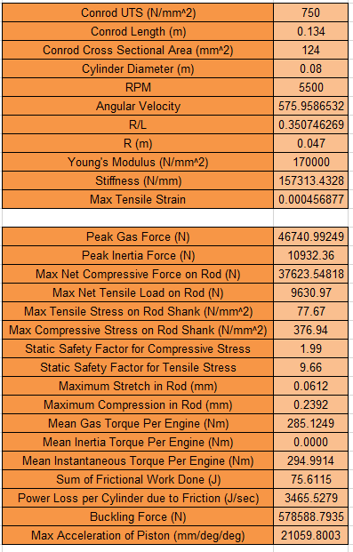

Fig. 11 – Standard Engine @ 6000 RPM
  - Safety Factors and Rod Stretch & Compression

Safety factor (equations 7.1 and 7.2) is an important consideration when designing a conrod as it determines how well the rod will cope with the stresses applied on it, which is why it is an interesting value to look into during these calculations. Stretch (equation 9.1) and compression (equation 9.2) of the rod is also important to look at as it shows how the forces distort the rod during the running of the engine. Before the stretch and compression lengths are determined, however the stiffness of the material must be calculated (equation 8).

${SF}_{comp}=\frac{UTS}{σ_{c}}$ Equation 7.1
${SF}_{tens}=\frac{UTS}{σ_{t}}$ Equation 7.2

$k=\frac{E ×A}{L}$ Equation 8

${∆L}_{stretch}=\frac{F_{TENSILE}}{k}$ Equation 9.1
${∆L}_{comp}=\frac{F_{NET}}{k}$ Equation 9.2

Fig. 12 – Modified Engine @ 1000 RPM

Fig. 13 – Modified Engine @ 6000 RPM

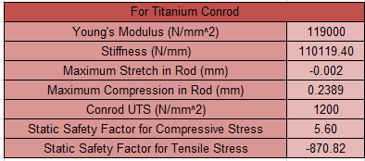

Fig. 14 – Titanium Conrod @ 1000 RPM
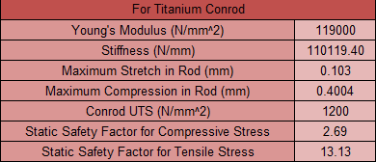

Fig. 15 – Titanium Conrod @ 6000 RPM

Fig. 16 – Standard Engine @ 1000 RPM

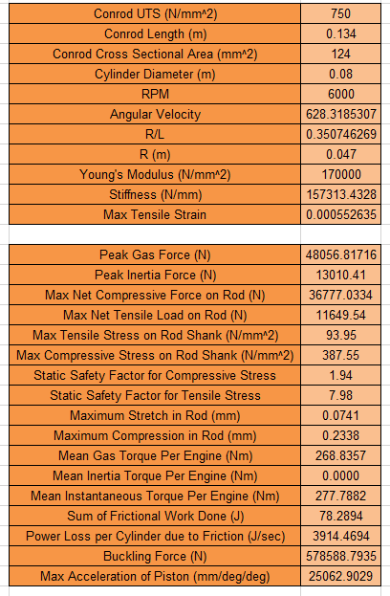

Fig. 17 – Standard Engine @ 6000 RPM

- Analysis & Evalulation

The results collected from this set of calculations can be analysed in relation to engine safety and performance compared to standard practice and quality checks. Design engineers study this similar data from their simulations carefully before a new design will be signed off ready to be put into production.

One of the most important pieces of information gathered from the calculations is the safety factor for both stretch and compression. As previously explained above the safety factor is crucial when designing a new conrod as the last thing needed is for it to break while under stress in the engine. The safety factors for both stretch and compression were calculated at a value of around 4 in the standard engine at 1000 RPM, which means it is safe for use. As expected, once the engine revs harder to a value of 6000 RPM the safety factor decreases to less than half of the value at 1000 RPM. This is due to the conrod being under more stress due to higher pressures being forced upon it and therefore is more likely to break under the stress hence making it less safe. This lower safety factor is also reflected in the modified engine (pressure increase of 15%) as due to the higher pressures it follows the previous trend. However, if the conrod material is changed to titanium alloy in the modified engine the safety factors become much higher than the 3.5 of the standard powder forged material up to around 5.60 at 1000 RPM. The reason the titanium alloy has a much higher safety factor is due to it having a much higher ‘Ultimate Tensile Strength’ (UTS), the new alloy has a UTS of 1200 N/mm² compared to the original conrod’s UTS of 750 and as seen in equations 7.1 and 7.2 with a higher UTS and the same stress values the safety factor will see an increase.

The downside to using Titanium in the conrod is that despite having a much higher UTS it has a significantly lower Young’s Modulus and hence a lower stiffness value. This allows for larger amounts of stretch and compression of the conrod compared to the original rod which clearly isn’t good as the conrod is distorting while in use at high pressures at high RPMs. As with the safety factor, the more pressure the conrod comes under the more it will deform, this can be seen in Table 2 as with the higher values for deformation coming from higher RPMs. At the lower RPMs however such as 1000, there are no values for tensile safety factor nor rod stretch. This is because the Gas Force is a higher value than the Inertia Force throughout the cycle meaning the tensile load on the rod is a negative value and so the rod is only under compressive stress at that point. As the RPM increases to 1500, the first values of tensile load begin to appear however they are very small and so basically inconsequential in the grand scheme of all the forces affecting the rod. As the load values are so small at this point the tensile safety factor is extremely large due to the lack of force and the stretch is extremely small. It’s only as the engine begins to speed up that and the inertia forces increase due to higher angular velocities that the rod stretches more and the safety factor rapidly decreases due to the higher forces closer to the compression forces.

Table 1 – Min & Max Safety Factors in Different Conrods
Conrod Type | Safety Factor Compression @ 1000 RPM | Safety Factor Compression @ 6000 RPM | Safety Factor Tensile @ 6000 RPM
Standard | 4.03 | 1.94 | 7.98
Modified Engine | 3.50 | 1.68 | 8.21
Titanium | 5.60 | 2.69 | 13.13

Table 2 – Min & Max Deformation Values in Different Conrods
Conrod Type | Compression Deformation  @ 1000 RPM | Compression Deformation  @ 6000 RPM | Stretch Deformation @ 6000 RPM
Standard | 0.1452mm | 0.2338mm | 0.0741mm
Modified Engine | 0.1672mm | 0.2803mm | 0.0720mm
Titanium | 0.2389mm | 0.4004mm | 0.1029mm

- Conclusion
Following these calculations it is clear to see that at higher RPMs the current standard conrod would not be suitable for use in the modified engine. A static safety factor for long term loads (such as long periods of force applied to a conrod) ideally require a safety factor of between 2 and 5 (Sciencedirect.com, n.d.). The minimum values for the conrod in the modified engine fall below that and so if this engine did have a turbo added to it which increased pressures by 15%, the conrod would need to have a bigger surface area to account for this. In the opposite sense, with the titanium conrod installed instead this has values which exceed the required maximum of 5 meaning this conrod could be smaller, using less material and still meet the safety factor guidelines. The standard engine, as expected, meets the required needs as it was originally signed off by Ford to be used. Although the safety factors for compression are low for both the standard and modified engine at 6000 RPM, as the engine is extremely rarely used on the road at this speed it’s very unlikely to undergo these forces and so is unlikely to break unless used extensively at this speed.
The trend for the engine in terms of rod deformation is also as expected when it comes to higher pressures leading to bigger compression of the rod under the engine firing, as shown in table 2. The bigger issue comes with titanium where both the stretch and deformation values are much larger at whichever RPM as previously explained in section 3. This is then an indication that the titanium alloy, despite giving a better safety factor, isn’t the best improvement to make in terms of a change in material due to having deformation values much higher than the original conrod. This could eventually lead to the conrod becoming damage if it is used extensively.
In conclusion, it is clear that the original conrod could not cope with the extra stresses imposed on it should the engine have a turbo added to it which increases pressures by 15%. However, it appears that the new tested titanium alloy is not the best answer for improving the rod’s ability to cope with the stresses imposed. It seems the better option would to keep the powder forged steel alloy material but increase the surface area to bring up the safety factor to within a tolerable level in order to be safe for use.

- Appendices
It is possible to go further with the calculations than just safety factor and rod deformation, which could have an effect on forces or further evaluation after the earlier calculations were completed.
5.1 Mean Torque per Engine
Before the torque created from the force can be calculated the rod force must be determined using the following formula:
$F_{ROD}=\frac{F_{NET}}{cos⁡(∅)}$ Equation 10
The calculation for different types of torque is as follows:
$τ_{GAS}=F_{GAS}×Rsin(θ+∅)$ Equation 11.1
$τ_{INERTIA}=F_{INERTIA}×Rsin(θ+∅)$ Equation 11.2
$τ_{INSTANT}=F_{ROD}×Rsin(θ+∅)$ Equation 11.3

In order to determine the mean of each torque per cylinder the value of torque per degree of crank angle is summed up and then divided by 720. To get the mean torque per engine this is then multiplied by the number of cylinders, in this case four, yielding the following results from 6000 rpm for the highest values:

Fig. 18 – Modified Engine

Fig. 19 – Standard Engine

As in other situations, the torque is larger in the modified engine due to the larger pressures in that engine, the instantaneous torque is larger than the others due to the rod force being larger than the gas force. The inertia torque is at a value of zero due to it cancelling itself out during the stroke with negative values at opposite ends of the cycle. The mean torque per engine is also known as the indicated mean torque, meaning before frictional losses are determined. Once frictional losses have been added to the indicated mean torque, the value is then called the brake torque. If the brake torque was measured by running the engine on the dynamometer then friction could be determined using the calculation done of indicated mean torque.
5.2 Friction & Work Done
Frictional losses can also be calculated by assuming a coefficient of friction, in this case 0.1 is used.
$F_{SIDE}=F_{NET}×tan⁡(∅)$ Equation 12.1
$F_{F}=μF_{SIDE}$ Equation 12.2
${WD}_{F}=\frac{F_{F1}+F_{F2}}{2}×(S_{2}-S_{1})$ Equation 13.1
${{Power}_{F}= WD}_{F} × \frac{RPM}{120}$ Equation 13.2

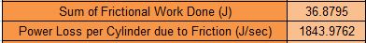

Fig. 20 – Modified Engine

Fig. 21 – Standard Engine
The side force is multiplied by the coefficient of friction to give the frictional forces to be used in the work done calculation. The work done per cylinder is then calculated and used to determine the power loss per cylinder caused by the friction between the piston and the cylinder. This can then be used in other areas to improve the accuracy of any values determined by calculations.

- Bibliography
AZoM.com. (2019). Properties: Titanium Alloys - Ti6Al4V Grade 5. [online] Available at: https://www.azom.com/properties.aspx?ArticleID=1547 [Accessed 29 Oct. 2019].

Andoko, & Saputro, Nanang. (2018). Strength analysis of connecting rods with pistons using finite element method. [online] Available At: https://www.researchgate.net/publication/327796555_Strength_analysis_of_connecting_rods_with_pistons_using_finite_element_method [Accessed 30 Oct. 2019].

Lumley, J. (1999). Engines. Cambridge, UK: Cambridge University Press.

Pravardhan, S. (2004). Dynamic Load Analysis and Optimization of Connecting Rod. [online] Steel.org. Available at: https://www.steel.org/~/media/Files/Autosteel/Programs/LongProducts/bar_connecting_rod_thesis.p [Accessed 1 Nov. 2019].

Robinson, J. (1998). Motor cycle tuning (four-stroke). 2nd ed. Oxford: Butterworth-Heinemann.

Sciencedirect.com. (n.d.). Factor of Safety - an overview | ScienceDirect Topics. [online] Available at: https://www.sciencedirect.com/topics/engineering/factor-of-safety [Accessed 30 Oct. 2019].

