
Title of Assignment: | Critical analysis of decision support
Programme name: | MSc Digital Transformation for the Health and Care Professions
Academic year: | 2025/26
Module name and code: | Decision-making in Health and Social Care Settings (BMDS7003)
Student ID: | 2409981
Total word count: | 4915
Date of submission: | 20/02/2026

Contents

Optimising Emergency Dental Care Pathways Through Improved Clinical Decision Support Systems (CDSS) 3
Introduction 3
Evidence Review 7
Preferred Reporting Items for Systematic Reviews and Meta-Analyses (PRISMA) 8
History of CDSS in healthcare 10
Evidence of CDSS in non-clinical and clinical telephone triage 12
Evidence of CDSS in dental practice 13
Evidence of CDSS in other healthcare settings 14
Implementation Issues 16
Evaluation 18
Conclusion 22
References 24

Optimising Emergency Dental Care Pathways Through Improved Clinical Decision Support Systems (CDSS)

Introduction
The deterioration in access to National Health Service (NHS) dental care across the UK is a well-documented and multifactorial crisis (Beeson et al., 2025). Contractual limitations, workforce shortages and a reduction in real-terms dental funding offer explanation for the decline in access, however all of these detrimental factors have contributed to a system in which a substantial number of people are unable to secure routine dental appointments (Health and social care committee, 2023; National Audit Office, 2024). When routine prevention and early intervention are inaccessible, dental problems progress untreated, resulting in increasing numbers of patients seeking help through urgent and emergency pathways (Curt & Samuels-Kalow, 2022).
The scale of this unmet need is considerable. A recent report by the British Dental Association (BDA) has found that 97% of new patients who did not have a dentist were unable to access NHS care (British Dental Association, 2024). Earlier evidence indicated that nearly a third of adults tended to only seek dental care when experiencing acute issues (Mayor, 2017), however more recent data suggests that this behaviour is more closely linked to access difficulties and cost of treatment (Office for Health Improvement & Disparities, 2024). Without timely assessment or treatment, dental disease may progress to infection, pain and systemic illness, ultimately generating avoidable demand on urgent and emergency health services (Owens et al., 2021). In extreme cases, some patients have resorted to self-administered dental procedures due to a lack of available care, reflecting the severity of unmet dental need across the country (Health and social care committee, 2023).
In Wales, similar pressures are evident and significant changes are expected from April 2026 as a new General Dental Services (GDS) contract is introduced to improve access to routine care (Welsh Government, 2026). This announcement follows the Dental Access Portal, a digital innovation which was introduced in February 2025 enabling patients to register their interest in receiving NHS dental care (Senedd Research, 2025). In contrast, Aneurin Bevan University Health Board (ABUHB), which currently delivers NHS dental care across 69 practices to a population of over 600,000 residents (StatsWales, 2024), is anticipating worsening access pressures in April 2026 as 10 dental practices across the borough will cease to provide NHS dental care to patients (Aneurin Bevan University Health Board, 2026). As routine access continues to decline across Wales and within ABUHB, an increasing number of patients are turning to emergency dental services as their first opportunity to receive care, amplifying demand on already constrained pathways.
It is within this context that the ABUHB Gwent Single Point of Access (SPA) plays a critical role, acting as the first point of triage for the escalating demand in urgent dental care. The contact centre is designed to support community services in ABUHB by managing patient referrals, and is staffed by non-clinical call handlers who liaise directly with patients and healthcare professionals. In practice, this requires staff to navigate multiple scripts and referral criteria, ensuring that pathways are followed appropriately while facilitating a smooth transition from referral to treatment and helping to avoid unnecessary delays in care (Aneurin Bevan University Health Board, 2025). On weekends, the SPA service provides administrative and telephony support to the Emergency Dental Service, helping to manage the caseload of patients who self-present to the emergency dental helpline requesting an appointment that weekend in clinic. The weekend clinic offers limited appointments and is reserved for emergency situations, whereby patients who are registered to a dental surgery cannot wait until Monday and those without registration need to be seen urgently (Aneurin Bevan University Health Board, 2022).
The caseload of expectant patients is managed using Adastra, a clinical patient management software hosted by external partner, OneAdvanced (OneAdvanced, 2016). The digital system allows users to store patient information safely and is interoperable, permitting the exchange of information between the SPA and emergency dental clinic. When documenting the details of the referral on Adastra, the SPA staff employ the use of a clinical decision support system (CDSS) which cross-references patient data against a digital clinical knowledge base to generate recommendations for treatment (Sutton et al., 2020). The system is built on the foundation of a clinically guided script to assess the patient’s suitability for an appointment. The script populates questions based on the patients’ symptoms and produces outcomes ranging from offering an appointment in the clinic, providing guided advice to manage symptoms or in some cases, recommends presenting to the nearest accident & emergency department.

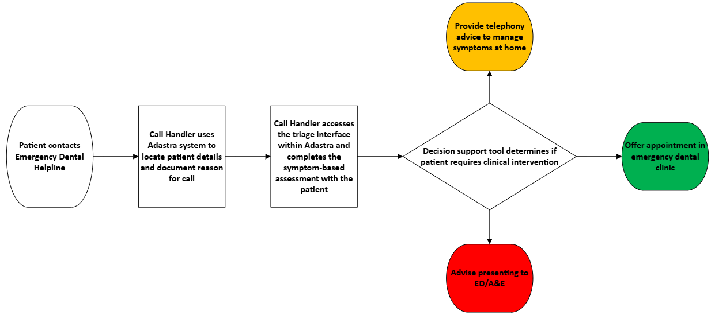
Fig.1 – Process map of the current referral and triage pathway for the Emergency Dental Helpline within the Adastra system
The CDSS script embedded within Adastra is constructed around a rigid sequence of yes/no questions, offering no flexibility for clinical nuance or deviation. This design presents significant challenges for non-clinical staff when managing patients with complex presentations, specific medical histories, or advice related queries. In the absence of an on-site dental professional, SPA staff are frequently left with no alternative but to allocate appointments for these ‘non-routine’ cases, often inappropriately and contrary to the recommendations generated by the CDSS. As staff increasingly override the system’s suggested outcomes, the intended function of the CDSS is progressively undermined and clinics are overbooked. A tool designed to streamline triage, promote consistency in patient assessment, and safeguard the limited capacity of the service instead becomes largely redundant, further intensifying pressure on an already overstretched emergency care pathway. As the volume of patients seeking urgent care increases, any limitations within the current CDSS, particularly when used by non-clinical staff, have a magnified impact on the accuracy of triage decisions. Strengthening the CDSS is therefore essential to ensure that those who most need urgent dental treatment are identified correctly and that scarce emergency appointments are allocated safely and consistently.
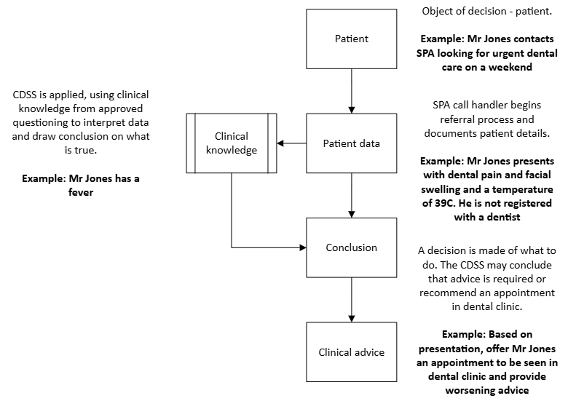
Fig.2 – Example of SPA dental triage CDSS application, adapted from the Ahituv model (Medlock et al., 2016)
When viewed collectively, these factors highlight the urgent need for a comprehensive national reform of NHS dentistry (Watt et al., 2024). However, targeted local action is nevertheless still required to alleviate the immediate pressures on urgent care pathways within ABUHB. Rising demand for care, combined with the inability of non-clinical staff to consistently adhere to the flawed procedures embedded within the CDSS, is placing an unsustainable strain on an already limited service. Targeted enhancement of the existing CDSS, implemented alongside the efforts of the new GDS contract and Dental Access Portal offers a pragmatic route to reduce inappropriate bookings, prioritise patients effectively and improve outcomes for the ABUHB population.
To understand how CDSS can be optimised within ABUHB, an evidence review was undertaken to examine the benefits, limitations, and implementation considerations of CDSS in healthcare settings.

Evidence Review
A systematic search strategy was implemented using PubMed to identify relevant literature. A combination of free-text terms and Medical Subject Headings (MeSH) was used, both individually and in combination with Boolean operators, to retrieve studies relating to “Clinical Decision Support Systems” OR “CDSS” AND “Telephone Triage” within the healthcare industry. The search was conducted between December 2025 and February 2026, and included publications from 2004 onwards. No geographical restrictions were applied, provided that the studies were relevant to the application of CDSS within healthcare settings.
Given the limited availability of peer-reviewed research examining the use of CDSS specifically for non-clinical staff or dental specific telephone triage, the scope of the review was broadened to include evidence on CDSS implementation in wider healthcare contexts. This was accompanied by an exploration of relevant grey literature to assess the benefits and limitations of CDSS in specific context. Targeted searches of reference lists from key papers were also conducted to identify additional sources and strengthen the evidence base. The results and subsequent findings have been sorted in accordance with their relevance of this study.

Preferred Reporting Items for Systematic Reviews and Meta-Analyses (PRISMA)

Included
Records assessed for eligibility:
(n = 19)
Records identified from:
Back chaining (n = 5)
Grey literature (n = 6)

Screening

Records sought for retrieval:
(n = 27)
Records screened:
(n = 27)
Identification
Records removed before screening:
Duplicate records removed (n = 2)

Identification of studies via
databases
Identification of studies
via other methods
Records identified from:
PubMed (n = 29)

Records excluded:
(n = 0)
Records not retrieved:
(n = 8)
Records excluded:
Not relevant to study (n = 5)
Not a primary research article
(n = 3)

Studies included in review:
(n = 22)

Fig.3 – Diagram of PRISMA search strategy

Table 1 – Breakdown of reviewed studies with benefits and limitations of CDSS
Study (Authors) | Setting | Description of Study | Summary of Benefits | Summary of Limitations
(Berner & La Lande, 2007) | General healthcare | Foundational overview chapter on CDSS design, components, and history | Provides conceptual grounding; clarifies core CDSS architecture and functions | Not empirical; predates modern workflows and CDSS designs
(Chen et al., 2023) | General healthcare | Review of challenges and opportunities in CDSS implementation | Highlights organisational, technical, and workflow factors influencing CDSS success | Conceptual review; no empirical testing
(El Asmar et al., 2021) | Primary care | Systematic review of knowledge-based CDSS on chronic disease outcomes | Improved guideline adherence and clinician behaviour* | *Inconclusive evidence due to bias
(Grechuta et al., 2024) | General healthcare | Targeted review of CDSS in chronic disease | Shows benefits for treatment guidance and care quality | Focuses mainly on chronic disease models
(Hak et al., 2022) | General healthcare | Systematic review of CDSS functionality and maturity | Demonstrates dominance of rule-based CDSS; identifies maturity gaps | Limited evidence on real-world impact
(Holmström et al., 2020) | Emergency care | Qualitative interview study exploring how nurses use CDSS when triaging emergency calls, focus on professional autonomy | CDSS perceived as being supportive of professional competence; prompts reflection and provides consistent baseline | CDSS can be overridden when deemed necessary by nurses; reports of workflow and time issues
(Huh et al., 2022) | Dentistry | Comparison of CDSS tools for traumatic dental injuries | Enhanced decision accuracy for dental trauma | Specialist context limits generalisation
(Islam et al., 2021) | Telephone triage | Systematic review of CDSS consistency in telephone triage (7 studies) | Evidence that CDSS can enhance triage consistency and safety | Consistency varied across studies
(Jones et al., 2021) | Digital health / CDSS development | Framework for improving trustworthiness of CDSS | Practical developer guidance for safer, trusted CDSS | Conceptual; not empirically validated
(Manns et al., 2025) | Paediatrics | Development of CDSS for telephone triage in emergency paediatrics | Implementation of CDSS in telephone triage; addresses gaps in existing CDSS | Focused on development rather than validated outcomes; generalised to issues affecting paediatrics
(Medlock et al., 2016) | Informatics | Conceptual framework for modelling information flows | Evaluation of CDSS impact across process, behaviours and decisions, not just outcomes | Conceptual; requires local operationalisation to become evaluative
(Mendonça, 2004) | Dentistry | Review of CDSS applications in dentistry | Maps potential uses of CDSS in diagnosis and treatment | Minimal empirical evidence, could be considered dated
(Michel et al., 2024) | Emergency care | Scoping review of telephone-triage CDSS design & evaluation | Identifies critical design features for safe remote triage | Evidence base variable
(Middleton et al., 2016) | General healthcare | 25-year review of CDSS | Offers a framework to analyse risks/constraints of CDSS and how to align implementation strategies against pitfalls | Requires local mapping to convert framework into actionable metrics
(Mitchell et al., 2025) | Dentistry | Study of barriers to CDSS use for post-extraction pain management | Identifies workflow, training and usability barriers | Small, context-specific sample
(Meunier et al., 2023) | Primary care | Mixed methods review of 45 CDSS across 48 studies | Evidence that workflow fit and workload can determine adoption | Large diversity in study methods
(North et al., 2014) | Telephone nursing triage | Comparison of 50 triage notes before and after rollout of nursing CDSS (ExpertnRN); | Significant improvement in documentation quality when using CDSS | Focused on documentation rather than outcomes; unclear if documentation translates to care quality
(Newman, 2007) | Dentistry | Review of CDSS as a complement to evidence-based dentistry | Suggests CDSS can strengthen treatment planning | Largely theoretical
(Turnbull et al., 2014) | NHS 111 | Mixed-methods case study on implications of a 111 SPA model | Illuminates operational impacts of SPA on access, coordination, and triage processes | Pre-COVID; findings context-specific to early 111 deployment
(Wheeler et al., 2015) | 24/7 Clinical Contact Centre | Narrative review of clinical and non-clinical decision makers in telephone triage | High relevance to study (non-clinical call handlers); Identifies system features that reduce error in CDSS | Large focus on general triage safety as opposed to performance of CDSS
(White et al., 2023) | Hospitals | Evaluation of consequences and costs across 29 hospital CDSS studies | Demonstrates economic and operational effects; identifies cost-sensitive design levers | Variable quality limits meta-inference
(Wouters et al., 2020) | Telephone nursing triage | Evaluation of working strategies used by telephone triage nurses in 9 primary care centres | Identifies real-world dilemmas whereby CDSS support or conflict with clinical reasoning | Qualitative interview outcomes very specific to topic of study

History of CDSS in healthcare
Clinical decision support systems have become an integral component of modern healthcare, offering digital tools that assist clinicians and support staff in making safer and more consistent decisions during patient assessment and treatment (Chen et al., 2023). Rather than replacing clinical reasoning, these systems complement human judgement by integrating patient data with evidence-based recommendations to improve the quality and efficiency of care (Hak et al., 2022). CDSS are now commonly embedded within electronic health record systems and point-of-care workflows, where they have been shown to enhance diagnostic accuracy, standardise practice, and contribute to improved service outcomes across a range of clinical settings (Grechuta et al., 2024).
CDSS can be broken down into knowledge-based and non-knowledge-based systems. Knowledge-based systems rely on predefined rules, logic statements, or guideline-driven algorithms to generate recommendations. These models remain widely adopted because they offer transparency and are aligned with clinical governance frameworks (El Asmar et al., 2021). In contrast, non-knowledge-based systems utilise machine learning or other computational techniques to detect complex patterns in clinical data. These approaches are gaining prominence but raise challenges related to integration, and user trust, particularly when deployed in real-world care environments (Sutton et al., 2020). Together, these categories demonstrate the evolving landscape of CDSS development, from rule-based systems that mimic structured clinical reasoning to adaptive models capable of learning from large-scale datasets.

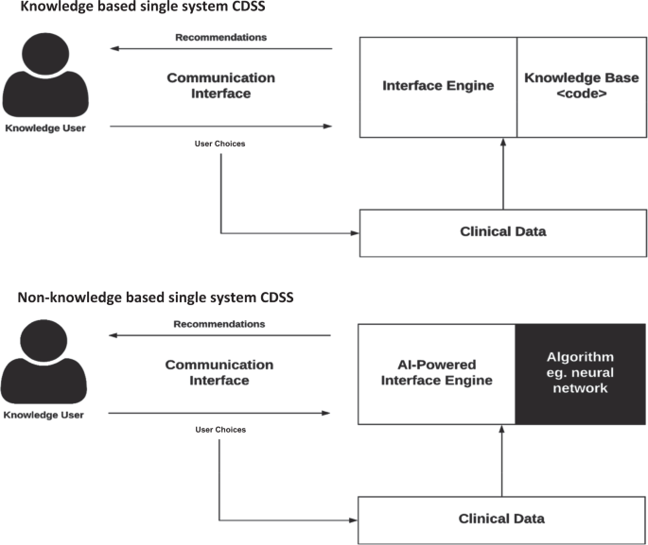
Fig.4 – Diagram of key interactions in both knowledge-based and non-knowledge based CDSS (Sutton et al., 2020)
It can be argued that the selection of three studies from 2004-07 is tenuous given recent advancements in both CDSS and technology in general, however it is appropriate to gain insight from the history of CDSS and reflect on how much has changed over time. Middleton et al. (2016) outline substantial advances in data architecture, inference methods and system design, while Medlock et al. (2016) and Hak et al. (2022) discuss how modern CDSS have become more sophisticated, interoperable and more aware of workflow. Similarly, Michel et al. (2024) and White et al. (2023) demonstrate that contemporary CDSS are increasingly integrated, data-driven and identify features for evaluation that can be applied across a wider range of clinical settings. Together, these studies highlight how technological advancements have transformed CDSS capability compared with earlier systems, which were largely conceptual and regarded as promising, but acted as stand-alone applications with little integration or interoperability (Berner & La Lande, 2007; Mendonça, 2004).

Evidence of CDSS in non-clinical and clinical telephone triage
Evidence relating specifically to telephone triage and the use of CDSS by non-clinical staff remains limited, however the studies that do exist provide valuable insight into both the potential and the risks of deploying such systems in urgent care settings. Wheeler et al. (2015) applied the use of a Donabedian model to analyse a 24/7 clinical call centre and found that non-clinical users of CDSS consistently demonstrated lower rates of appropriate referrals than clinical staff, concluding that CDSS does not compensate for the absence of clinical judgement. This was particularly prevalent during out-of-hours periods when the lowest system completeness and highest error rates were observed. This reinforces the need for on-site or readily accessible clinical oversight and regular updating of knowledge bases when CDSS are used by non-clinicians. A mixed-methods case study of NHS 111 by Turnbull et al. (2014) also established that whilst non-clinical call advisers rely heavily on CDSS, they often developed workarounds to make the software usable, sometimes due to limited trust in system logic or a perceived mismatch between the algorithm and real-world presentations. Turnbull et al. (2014) also reinforces the argument that non-clinical workers cannot be a substitute for clinicians, but instead must operate within a model that embeds clinical back-up and clear escalation pathways.
Similar findings are reflected in more recent telephone triage research. Wouters et al. (2020) and Holmström et al. (2020) both found that nurses assessing callers using telephone triage frequently reported the need to override or adjust CDSS recommendations when patient presentations did not routinely correspond to algorithmic categories, illustrating persistent limitations in the sensitivity of rule-based tools. Systematic review evidence also emphasises inconsistencies across the implementation of CDSS. Islam et al. (2021) identified seven studies examining CDSS across telephone triage settings and concluded that variability in operator experience, caller presentation and system design significantly influences decision accuracy. Michel et al. (2024) identified 12 knowledge-based CDSS in emergency telephone triage designed to support nurses or non-medical staff with severity and urgency classification. It was found that very few had been implemented in real settings, and just three were integrated with electronic health records, demonstrating wide variation in maturity and a lack of standardised evaluation.
CDSS has however demonstrated measurable benefits in telephone triage. Analysis of 50 triage documents conducted by North et al. (2014) showed a significant improvement in documentation quality, including more thorough recording of symptomatic information, warning signs and self-care. North et al. (2014) does offer the caveat however, that these systems still require careful contextualisation when used by non-clinicians. Equally, (Manns et al., 2025) noted the potential of CDSS use in telephone triage to reduce hospital admission and alleviate pressures on workload, however this was largely conceptual and based on recommendations rather than evidence-based outcomes.
Collectively, all of these studies make reference to actual or potential benefits of CDSS that can strengthen telephone triage processes, particularly around documentation, prioritisation and cognitive support. Their safe and effective use by non-clinical personnel is under researched however, and depends on clinical supervision, robust algorithms, and regular updating of system logic to manage non-routine or ambiguous presentations (Holmström et al., 2020; Islam et al., 2021; Manns et al., 2025; Michel et al., 2024; North et al., 2014; Turnbull et al., 2014; Wheeler et al., 2015; Wouters et al., 2020).

Evidence of CDSS in dental practice
Evidence gathered on CDSS in dental practice presents a mixed picture, reflecting both longstanding conceptual motivations and persistent practical barriers. Newman (2007) emphasises that CDSS were originally conceived as tools intended to complement rather than replace clinical judgement, supporting clinicians through improved consistency, transparency and alignment with established evidence bases. Newman (2007) adds the caveat that systems must be regularly updated to avoid circulating outdated recommendations, a limitation that has remained prominent as CDSS have evolved (Holmström et al., 2020; Jones et al., 2021; Mendonça, 2004; Wouters et al., 2020).
Complementing the early intended benefits of CDSS, a controlled trial involving 100 medical students and 49 paediatric dentists undertaken by Huh et al. (2022) found that CDSS significantly improved the diagnosis and management of traumatic dental injuries compared to unaided decision-making, indicating that structured digital support can enhance accuracy in scenarios where assessment criteria are standardised and evidence based. Despite this, real-world implementation and uptake remain hindered by psychological factors. Mitchell et al. (2025) reported notably low usage of a CDSS designed to reduce opioid prescribing after tooth extractions, with dental providers citing barriers such as forgetting to use the system, perceived disruption to workflow, limited value, and distrust of its functionality. The same study also suggested that expanding CDSS content beyond narrow procedural focus could help to tackle low usage by increasing its relevance and value to the clinician. These usability obstacles echo concerns documented in one of the earliest foundational analyses of dental CDSS by Mendonça (2004), who identified challenges in developing robust knowledge bases, integrating systems into clinical workflows, supporting efficient data capture and mitigating clinicians.

Evidence of CDSS in other healthcare settings
Outside of telephone triage and dentistry, in a targeted review of guideline based CDSS for chronic conditions, Grechuta et al. (2024) concluded that CDSS features such as treatment guidance and ‘flagging’ were most consistently associated with positive impact. Critically, they argued that evaluation must be explicitly tied to the decision problems at hand to make effects meaningful in practice. In primary care, Meunier et al. (2023) synthesised 48 studies (45 of which were CDSS) and reported that the single most frequently reported barrier is increased workload. It was therefore recommended that tracking cognitive load, task duration time and perceived effectiveness alongside safety would be of the most benefit to CDSS evaluation.
Accompanying this, a systematic review by Hak et al. (2022) mapped CDSS features and maturity across two decades which showed that rule-based knowledge modules and models with audit and reporting layers continue to be the most popular in use, however CDSS development is still largely restricted to standalone applications, demonstrating limited interoperability amongst CDSS and other healthcare systems. Middleton et al. (2016) explains that the application programming interface (API) necessary for data sharing and interoperability in healthcare systems and CDSS can often be handled by external providers which can result in significant financial and technical barriers. This offers key insight to the varying progress made for implementation CDSS in real-world settings.
Finally, a scoping review of 29 hospital-based evaluations undertaken by White et al. (2023) documents the frequent omission or lack of consideration for costs associated with implementing and enhancing CDSS. With regards to the literature discussed in this evidence review, there are very few references to the cost of digital architecture, clinical hours spent on knowledge base, training or other workforce factors. This coincides with the fact that a large portion of CDSS research is conceptual or theoretical (Michel et al., 2024), and exposes a notable gap in evidencing the impact of implementing or enhancing CDSS in practice. To address this, White et al. (2023) recommends that future CDSS related studies include utilising the Consolidated Health Economic Evaluation and Reporting (CHEERS) checklist which includes estimation of resources and costs. It is conceded however, that the inclusion of this framework may not always be feasible due to constrained resources.
Table 2 – Selection of CDSS tools evaluated in literature
CDSS Name | Summary | Study Reference
NHS Pathways | National rule-based decision support system used in NHS 111 by non-clinical call handlers | (Turnbull et al., 2014)
Netherlands Triage Standard CDSS | Nationally standardised CDSS used by triage nurses to assess urgency in suspected acute cardiac events | (Wouters et al., 2020)
Swedish Emergency Dispatch CDSS | CDSS used by registered nurses at a Swedish medical dispatch centre to support triage | (Holmström et al., 2020)
Medical Priority Dispatch System (MPDS) | Widely used international emergency dispatch CDSS; scripted questioning and decision pathways | (Michel et al., 2024)
Schmitt-Thompson Triage Protocols | Widely used set of telephone triage algorithms for paediatric and adult nursing advice lines | (Michel et al., 2024)
PED-IA | Paediatric emergency CDSS used via ontology-based knowledge model and rule-based inference engine. | (Manns et al., 2025)
TDI Mobile App CDSS | Mobile-based CDSS guiding clinicians through the diagnosis and management of traumatic dental injuries | (Huh et al., 2022)

Implementation Issues
In order to holistically capture the implementation risks and issues associated with CDSS historically and those that are relevant to the context of this study, the six grand challenges of CDSS will be adapted. Constructed by Middleton et al. (2016), the six axes help to frame discussions surrounding the barriers and facilitators affecting the effective use of CDSS.
- Data
Many of the studies reviewed indicate the need for standardised data capture and KPI measurement to effectively evaluate the success of CDSS (Hak et al., 2022; Michel et al., 2024; Middleton et al., 2016; White et al., 2023). Adastra is an already established system used by the SPA that is capable of running bespoke reporting to measure reduction of inappropriate bookings, duration of calls and number of calls flagged for escalation. It is proposed that baseline data is first captured or recorded to more accurately log trends in data.
- Knowledge & Inference
The limitations of the CDSS used at the SPA are felt most notably in the knowledge and inference dimensions. The core issue is that the knowledge-base underpinning the CDSS requires regular review, clinical interpretation and local calibration (Holmström et al., 2020; Turnbull et al., 2014; Wouters et al., 2020). Demonstrated by the lack of research on the matter, it is not a regular occurrence for non-clinical staff to utilise CDSS for patient assessment (Wheeler et al., 2015). The SPA staff cannot be expected to independently resolve ambiguous or atypical presentations and research shows that staff will apply workarounds to bypass the CDSS (Wouters et al., 2020), reflecting the biggest risk to improvement for the SPA and the emergency dental service.
Without a real-time dentist or dental nurse on site for escalation and safety netting, the system risks defaulting to inappropriate appointments for cases that do not fit cleanly into routine presentations (Turnbull et al., 2014). This mirrors the broader challenge that CDSS cannot remain effective if its underlying algorithms, rules and decision thresholds are not continually maintained and validated (Holmström et al., 2020; Jones et al., 2021; Mendonça, 2004; Newman, 2007). In the SPA context, this means that while the technical and organisational foundations are strong, the clinical intelligence of the CDSS, and its processes, must be strengthened to reduce inappropriate urgent bookings and ensure safe handling of non-routine cases.
- Architecture/Technology
A persistent limitation embedded within CDSS according to the literature studied refers to a lack of integration and interoperability (Hak et al., 2022; Mendonça, 2004; Newman, 2007), however the SPA is well positioned in this respect due to having an already established CDSS, albeit one that required enhancement for operational efficiency. The Adastra system used to operate the CDSS offers genuine interoperability with the emergency dental clinic, allowing a safe and time efficient transfer of patient details from the call handling environment into clinic systems without manual re-entry or loss of information.
- Implementation
The SPA’s CDSS is already fully embedded in workflow, with compulsory use across all dental referrals and an established training base among non-clinical call handlers. This aligns strongly with the implementation pillars identified in the grand challenges, demonstrating that the SPA has overcome many of the common adoption barriers highlighted in the literature such as variability in uptake, inconsistent use of CDSS, and a reliance on voluntary engagement (Jones et al., 2021; Mitchell et al., 2025). The SPA benefits from an organisational culture around CDSS use, meaning that introducing improvements is unlikely to require foundational retraining or major cultural change. Concerns are more likely to arise only if modifications disrupt workflows or are perceived by staff as increasing in complexity (Meunier et al., 2023).
- Users
Research, whilst limited, tells us that non-clinical staff cannot be a replacement for clinical judgement, and should instead be encouraged to escalate non-routine scenarios for clinical guidance (Grechuta et al., 2024; Turnbull et al., 2014; Wheeler et al., 2015). The caveat to this however, is that clinicians demonstrate more barriers to CDSS adoption due to time constraints and increased workload (Meunier et al., 2023; Mitchell et al., 2025). This lends to the ideology that SPA staff, who utilise the CDSS without fail for every patient call, should be supported with real-time presence from clinicians when non-routine callers present to the service, without burdening them with the task of utilising the CDSS themselves.
Whilst the proposed enhancements of the CDSS will not require staff to undergo training on using systems that they are already familiar with; they may require instruction on how and when to escalate an assessment to the on-site dentist or dental nurse. This will instil a confidence in the call handling team that non-routine issues can be escalated and dealt with appropriately rather than bypassing the CDSS. Clinicians may express concern of increased workload when providing support to the SPA for escalation, however this is justifiable given that research has shown the benefits of clear escalation pathways (Holmström et al., 2020; Turnbull et al., 2014; Wheeler et al., 2015), and their assistance should only be called upon for non-routine presentations.

Evaluation
The issues identified at the SPA and subsequent evidence review of CDSS conclude that the following steps should be taken to improve referral processes and alleviate the pressures on the emergency dental service:
- Escalation inferences should be added to CDSS for safety netting when dealing with callers who present with non-routine symptoms
- Real-time clinical support or presence should be provided to SPA staff on a consistent basis to compliment escalation inferences
- A reporting structure should be implemented for relevant KPIs to measure impact of changes
- Agree timeframe with all stakeholders for regular review of reporting, knowledge and inference.
Evaluating the impact of any changes made to CDSS should be done holistically, accounting for all stakeholders. In this instance, the 6i model will be utilised as an evaluation tool. The 6i model provides an appropriate and structured framework for appraising the proposed enhancements to the SPA’s clinical decision support system (NHS England, 2023). Unlike broader change management models (Table 3), the 6-i framework is specifically designed for CDSS environments and enables targeted assessment across the full decision-support lifecycle.

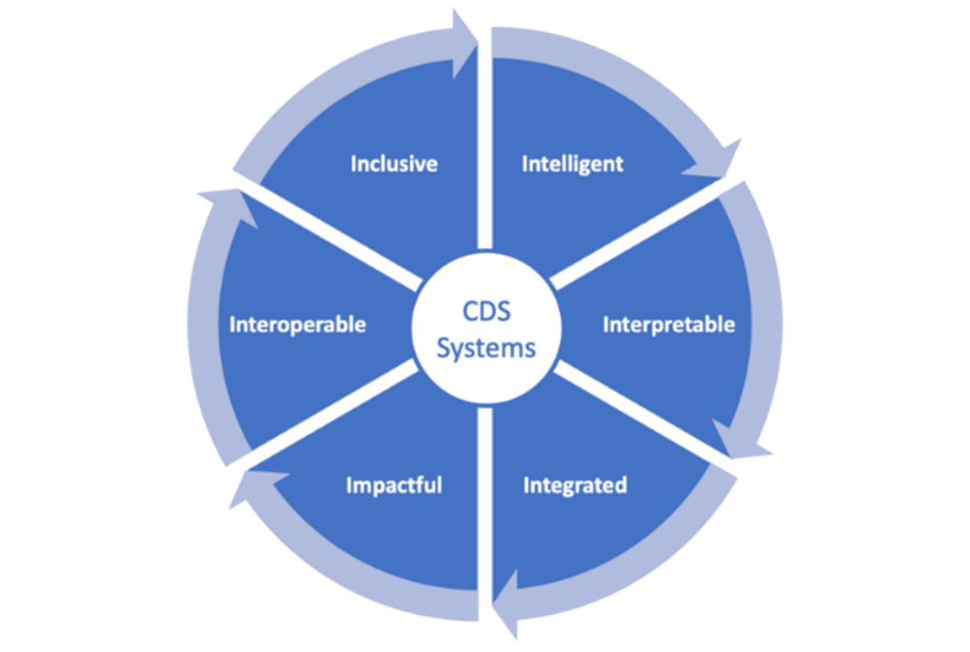
Fig.5 – The 6i model for CDSS (NHS England, 2023)
- Inclusive
To evaluate inclusivity, assessment should focus on whether the enhanced CDSS supports all stakeholders, including non-clinical call handlers, clinicians and patients who present to SPA. Evidence points towards non-clinical users finding most difficulty when callers present with non-routine symptoms and a reliance on booking appointments against the recommendation of the CDSS (Turnbull et al., 2014; Wheeler et al., 2015). Evaluation should therefore come in the form of user experience surveys, where confidence, ease of use and perceived value can be captured.
- Intelligent
The 6i model suggests that CDSS need to reflect real-world clinical decisions (NHS England, 2023), and long-standing evidence highlights that outdated or rigid rules embedded within CDSS can reduce accuracy and trust in those decisions (Holmström et al., 2020; Newman, 2007). This is certainly the case within the SPA, where rigid questioning coupled with non-routine presentation are reducing accuracy in outcomes. To determine the intelligence of the CDSS following the proposed changes, key metrics such as number of inappropriate bookings, number of times CDSS is bypassed and duration of calls should be monitored. Using these metrics ensures that the evaluation of the CDSS is ground in evidence-based performance data.
- Interpretable
Perhaps the most pertinent step to monitor, interpretability influences both user experience and patient safety. Evidence relating to telephone triage reiterates caution in terms of patient safety, especially given that CDSS being utilised by non-clinical staff is under explored (Michel et al., 2024; Turnbull et al., 2014; Wheeler et al., 2015; Wouters et al., 2020). Quality control should be undertaken in the form of regular call auditing to ensure SPA staff are following proposed changes and understand escalation pathways.
- Integrated
Whilst the SPA already benefits from a well-integrated platform in Adastra, workflow is likely to be impacted by the implementation of a new step: escalating non-routine referrals for clinical support. As evidence has shown that increased workload can impact CDSS adoption and increase likelihood of using workarounds (Meunier et al., 2023; Turnbull et al., 2014; Wouters et al., 2020), workflow should be monitored using feedback on perceived effort of new changes, and performance data of time taken to complete referral against baseline data.
- Impactful
Impact evaluation directly addresses effectiveness, safety and efficiency. The literature indicates that well designed CDSS can improve documentation and consistency (Islam et al., 2021; North et al., 2014). To assess impact, collaborative working with the emergency dental service will be required to establish whether imposed changed reduce strain on the weekend clinic.
- Interoperable
The use of Adastra means that the SPA already meets the standard of interoperability, a critical function of effective CDSS (Hak et al., 2022; Mendonça, 2004; Newman, 2007). The SPA and dental service should however be conscious of the need to regularly update the knowledge-base and inference of the CDSS (Holmström et al., 2020; Jones et al., 2021; Medlock et al., 2016; Middleton et al., 2016), and the costs associated with implementing changes to software that is hosted by an external provider (White et al., 2023).
Table 3 – Other change models considered for evaluation of CDSS (Aziz, 2017; Hussain et al., 2018; NHS England, 2015)
Change Model | Advantages | Disadvantages
Kotter 8-Step Change Model | Supports organisation-wide change; considers governance issues and trust/adoption risks identified in literature | Strong focus on leadership which may compromise user-level issues
Lewin 3-Stage Model | Simple model; useful for understanding potential behavioural resistance and trust associated with CDSS | Not suitable for systems requiring continuous updating
Plan-Do-Study-Act (PDSA) | Supports testing with real users; embedded in many NHS change studies | Depends heavily on measurement quality; May not be ideal for evaluating larger structural issues

Conclusion
There are significant and well-documented challenges affecting the delivery of NHS dental care in the UK. Contractual limitations and workforce shortages have developed into deep systemic barriers to routine dental care that require national reform and cannot be solved solely at the point of urgent or emergency care. These systemic pressures have increasingly driven patients to use emergency dental services as their primary entry point into care, further exposing the limitations of the current CDSS triage model in ABUHB.
Failure to act on this trend of demand on the emergency dental service in ABUHB will exacerbate the strain on workload, population health and associated financial constraints, eventually leading toward an untenable service. Intervention should come in the form of enhancing the already established CDSS by ensuring real-time clinical support for SPA call handlers and applying changes to escalation pathways. These key actions will strengthen the accuracy and consistency of triage whilst addressing a key vulnerability within the current model, whereby non-clinical staff are required to bypass eligibility decisions of the algorithm without the clinical knowledge needed to manage complex presentations.
Although such improvements will not resolve the national shortage of dental appointments, they hold the potential to significantly improve the functionality of emergency care pathways. A more flexible, clinically robust CDSS would allow priority patients to be identified more reliably, reduce inappropriate bookings, and better signpost patients who need routine care toward alternative routes, such as the Dental Access Portal. Therefore, CDSS enhancement becomes a targeted, practical intervention that enhances the safety, equity, and sustainability of emergency dental service delivery. Research agrees on the benefits to implementing CDSS in healthcare, even if those benefits are historically conceptual. Whilst still considered to be a relatively new concept, the fact remains that many CDSS fail to become fully adopted in practice due to a varying level of trust, a lack of interoperability and a perception of increased workload. The overwhelming conclusion from studies is that CDSS should never replace clinical judgement, but simply support or enhance it. Very little research has been dedicated to the non-clinical use of CDSS, and of the evidence that does exist, precautionary advice is offered to ensure that clinicians maintain the role of decision makers. The timely announcement of a new GDS contract across Wales in April 2026 will give impetus to this targeted local improvement at a time where change is so desperately needed to ensure service sustainability.
I confirm that this essay is my own original work and does not include text created by a generative artificial intelligence tool.

References
Aneurin Bevan University Health Board. (2022). Dentist. https://abuhb.nhs.wales/hospitals/gps-dentists-opticians-ncns/dentist/
Aneurin Bevan University Health Board. (2025). Frailty Single Point of Access (SPA). Unpublished. https://nhswales365.sharepoint.com/sites/ABB_Pulse_Primary_Care/SitePages/Single-Point-of-Access.aspx
Aneurin Bevan University Health Board. (2026). Dental Service Changes/Updates. https://abuhb.nhs.wales/hospitals/gps-dentists-opticians-ncns/dentist/dental-service-changesupdates/
Aziz, A.-M. (2017). A change management approach to improving safety and preventing needle stick injuries. Journal of Infection Prevention, 18(5), 257–262. https://doi.org/10.1177/1757177416687829
Beeson, M. J., Vernazza, C. R., & Sowden, S. L. (2025). At the Deep End of dental inequality. British Dental Journal, 239(3), 209–213. https://doi.org/10.1038/s41415-025-8503-z
Berner, E. S., & La Lande, T. J. (2007). Overview of Clinical Decision Support Systems (pp. 3–22). https://doi.org/10.1007/978-0-387-38319-4_1
British Dental Association. (2024, October 10). Dentists: 97% of new patients unable to access NHS care. https://www.bda.org/media-centre/dentists-97-of-new-patients-unable-to-access-nhs-care/
Chen, Z., Liang, N., Zhang, H., Li, H., Yang, Y., Zong, X., Chen, Y., Wang, Y., & Shi, N. (2023). Harnessing the power of clinical decision support systems: challenges and opportunities. Open Heart, 10(2), e002432. https://doi.org/10.1136/openhrt-2023-002432
Curt, A., & Samuels-Kalow, M. (2022). How Should Emergency Department Clinicians Respond to Unmet Dental Needs? AMA Journal of Ethics, 24(1), E13-18. https://doi.org/10.1001/amajethics.2022.13
El Asmar, M. line, Dharmayat, K. I., Vallejo-Vaz, A. J., Irwin, R., & Mastellos, N. (2021). Effect of computerised, knowledge-based, clinical decision support systems on patient-reported and clinical outcomes of patients with chronic disease managed in primary care settings: a systematic review. BMJ Open, 11(12), e054659. https://doi.org/10.1136/bmjopen-2021-054659
Grechuta, K., Shokouh, P., Alhussein, A., Müller-Wieland, D., Meyerhoff, J., Gilbert, J., Purushotham, S., & Rolland, C. (2024). Benefits of Clinical Decision Support Systems for the Management of Noncommunicable Chronic Diseases: Targeted Literature Review. Interactive Journal of Medical Research, 13, e58036. https://doi.org/10.2196/58036
Hak, F., Guimarães, T., & Santos, M. (2022). Towards effective clinical decision support systems: A systematic review. PLOS ONE, 17(8), e0272846. https://doi.org/10.1371/journal.pone.0272846
Health and social care committee. (2023). NHS dentistry. https://publications.parliament.uk/pa/cm5803/cmselect/cmhealth/964/report.html
Holmström, I. K., Kaminsky, E., Lindberg, Y., Spangler, D., & Winblad, U. (2020). Registered Nurses’ experiences of using a clinical decision support system for triage of emergency calls: A qualitative interview study. Journal of Advanced Nursing, 76(11), 3104–3112. https://doi.org/10.1111/jan.14542
Huh, A. J. H., Chen, J.-W., Bakland, L., & Goodacre, C. (2022). Comparison of Different Clinical Decision Support Tools in Aiding Dental and Medical Professionals in Managing Primary Dentition Traumatic Injuries. Pediatric Emergency Care, 38(2), e534–e539. https://doi.org/10.1097/PEC.0000000000002409
Hussain, S. T., Lei, S., Akram, T., Haider, M. J., Hussain, S. H., & Ali, M. (2018). Kurt Lewin’s change model: A critical review of the role of leadership and employee involvement in organizational change. Journal of Innovation & Knowledge, 3(3), 123–127. https://doi.org/10.1016/j.jik.2016.07.002
Islam, F., Sabbe, M., Heeren, P., & Milisen, K. (2021). Consistency of decision support software-integrated telephone triage and associated factors: a systematic review. BMC Medical Informatics and Decision Making, 21(1), 107. https://doi.org/10.1186/s12911-021-01472-3
Jones, C., Thornton, J., & Wyatt, J. C. (2021). Enhancing trust in clinical decision support systems: a framework for developers. BMJ Health & Care Informatics, 28(1), e100247. https://doi.org/10.1136/bmjhci-2020-100247
Manns, A., Millet, A., Campeotto, F., Vivien, B., Dupic, L., Guillard, O., Hage, C. El, Castela, F., Fogel, S., Burgun, A., Mougin, F., & Tsopra, R. (2025). Towards a decision support system for pediatric emergency telephone triage. International Journal of Medical Informatics, 203, 106012. https://doi.org/10.1016/j.ijmedinf.2025.106012
Mayor, S. (2017). Dental problems account for one in 140 emergency department visits. BMJ, j98. https://doi.org/10.1136/bmj.j98
Medlock, S., Wyatt, J. C., Patel, V. L., Shortliffe, E. H., & Abu-Hanna, A. (2016). Modeling information flows in clinical decision support: key insights for enhancing system effectiveness. Journal of the American Medical Informatics Association, 23(5), 1001–1006. https://doi.org/10.1093/jamia/ocv177
Mendonça, E. A. (2004). Clinical decision support systems: perspectives in dentistry. Journal of Dental Education, 68(6), 589–597.
Meunier, P.-Y., Raynaud, C., Guimaraes, E., Gueyffier, F., & Letrilliart, L. (2023). Barriers and Facilitators to the Use of Clinical Decision Support Systems in Primary Care: A Mixed-Methods Systematic Review. The Annals of Family Medicine, 21(1), 57–69. https://doi.org/10.1370/afm.2908
Michel, J., Manns, A., Boudersa, S., Jaubert, C., Dupic, L., Vivien, B., Burgun, A., Campeotto, F., & Tsopra, R. (2024). Clinical decision support system in emergency telephone triage: A scoping review of technical design, implementation and evaluation. International Journal of Medical Informatics, 184, 105347. https://doi.org/10.1016/j.ijmedinf.2024.105347
Middleton, B., Sittig, D. F., & Wright, A. (2016). Clinical Decision Support: a 25 Year Retrospective and a 25 Year Vision. Yearbook of Medical Informatics, 25(S 01), S103–S116. https://doi.org/10.15265/IYS-2016-s034
Mitchell, S. G., Gryczynski, J., Worley, D. C., Asche, S. E., Truitt, A. R., & Rindal, D. B. (2025). Barriers to dental providers’ use of a clinical decision support tool for pain management following tooth extractions. Implementation Research and Practice, 6, 26334895251319810. https://doi.org/10.1177/26334895251319810
National Audit Office. (2024). Investigation into the NHS dental recovery plan. https://www.nao.org.uk/reports/investigation-into-the-nhs-dental-recovery-plan/?nab=0
Newman, M. G. (2007). Clinical Decision Support Complements Evidence-Based Decision Making in Dental Practice. Journal of Evidence Based Dental Practice, 7(1), 1–5. https://doi.org/10.1016/j.jebdp.2006.12.016
NHS England. (2015). Learning Handbook: PDSA. https://www.england.nhs.uk/improvement-hub/wp-content/uploads/sites/44/2015/08/learning-handbook-pdsa.pdf
NHS England. (2023, August 16). Supporting clinical decisions with health information technology. https://www.england.nhs.uk/long-read/supporting-clinical-decisions-with-health-information-technology/
North, F., Richards, D. D., Bremseth, K. A., Lee, M. R., Cox, D. L., Varkey, P., & Stroebel, R. J. (2014). Clinical decision support improves quality of telephone triage documentation - an analysis of triage documentation before and after computerized clinical decision support. BMC Medical Informatics and Decision Making, 14(1), 20. https://doi.org/10.1186/1472-6947-14-20
Office for Health Improvement & Disparities. (2024). Adult oral health survey 2021: service use and barriers to accessing care. https://www.gov.uk/government/statistics/adult-oral-health-survey-2021/adult-oral-health-survey-2021-service-use-and-barriers-to-accessing-care
OneAdvanced. (2016). Clinical Patient Management Software - Adastra. https://www.oneadvanced.com/products/clinical-patient-management/
Owens, P. L., Manski, R. J., & Weiss, A. J. (2021). Emergency Department Visits Involving Dental Conditions, 2018.
Senedd Research. (2025). Developments in NHS dentistry in Wales. https://research.senedd.wales/research-articles/developments-in-nhs-dentistry-in-wales/
StatsWales. (2024). Population estimates by local authority and year. https://statswales.gov.wales/Catalogue/Population-and-Migration/Population/Estimates/Local-Authority/populationestimates-by-localauthority-year
Sutton, R. T., Pincock, D., Baumgart, D. C., Sadowski, D. C., Fedorak, R. N., & Kroeker, K. I. (2020). An overview of clinical decision support systems: benefits, risks, and strategies for success. NPJ Digital Medicine, 3(1), 17. https://doi.org/10.1038/s41746-020-0221-y
Turnbull, J., Pope, C., Rowsell, A., Prichard, J., Halford, S., Jones, J., May, C., & Lattimer, V. (2014). The work, workforce, technology and organisational implications of the ‘111’ single point of access telephone number for urgent (non-emergency) care: a mixed-methods case study. Health Services and Delivery Research, 2(3), 1–140. https://doi.org/10.3310/hsdr02030
Watt, R. G., Stennett, M., Redican, C., & Vernazza, C. (2024). Urgent need for transformative change in NHS dentistry. The Lancet, 403(10432), 1115–1117. https://doi.org/10.1016/S0140-6736(24)00352-0
Welsh Government. (2026, February 11). New Contract to Improve Access to NHS Dentistry. https://www.gov.wales/written-statement-new-contract-improve-access-nhs-dentistry
Wheeler, S. Q., Greenberg, M. E., Mahlmeister, L., & Wolfe, N. (2015). Safety of Clinical and Non-Clinical Decision Makers in Telephone Triage: A Narrative Review. Journal of Telemedicine and Telecare, 21(6), 305–322. https://doi.org/10.1177/1357633X15571650
White, N. M., Carter, H. E., Kularatna, S., Borg, D. N., Brain, D. C., Tariq, A., Abell, B., Blythe, R., & McPhail, S. M. (2023). Evaluating the costs and consequences of computerized clinical decision support systems in hospitals: a scoping review and recommendations for future practice. Journal of the American Medical Informatics Association, 30(6), 1205–1218. https://doi.org/10.1093/jamia/ocad040
Wouters, L. T., Zwart, D. L., Erkelens, D. C., Huijsmans, M., Hoes, A. W., Damoiseaux, R. A., Rutten, F. H., & de Groot, E. (2020). Tinkering and overruling the computer decision support system: Working strategies of telephone triage nurses who assess the urgency of callers suspected of having an acute cardiac event. Journal of Clinical Nursing, 29(7–8), 1175–1186. https://doi.org/10.1111/jocn.15168

