Project Initiation Document

Background
Street Football Wales is a social inclusion charity that helps homeless people get back into having a social life and aims to improve the lives of those who need support.
“The people we aim to support are those furthest away from mainstream support provision who are likely to be homeless and/or socially excluded because of this. Positive involvement with the project can help to benefit participants, their families and their local communities.”[1]
The charity works alongside another charity The Homeless World Cup. The participants play football for the personal benefit to increase physical and mental status, avoid drug and alcohol abuse and staying out of the criminal justice system.
The project is to create app based news feed that will allow contributions to the charity and will also have the capability to create fundraising events working alongside the charity. The app will be available on all mobile devices. The essence of this project is to raise awareness of the charity and create fans of the football teams. The desired completed app would be a news based app with integrated fundraising capabilities.
Project Definition
To create an app for all devices with peripherals to raise awareness for SFW (Street Football Wales). The project will help the charity get known and increase popularity and supporters for their cause. The app will also have functions to allow interactivity between the charity and the app. Project team consists of four team members
Steffan Davies: - User Interface Designer.
Fraser Sweetman: App Programmer.
Andrew Ridgeway: Lead Programming Designer.
Richard Hankey: Project Director.

Objectives | Create an app that will allow news feeds to show what the charity is up to at the current moment. Allow organisers to post news, these individuals would be coined as a ‘Newscaster’. The Newscaster status would need a password provided by the team or head of project to allow postings to the feed.
Objectives | Allow contributions paid by users of the app and allow funds to be paid directly to the charity. This function could also report amount raised per week, month and year.
Objectives | Create a function for creation of fundraising events and contacting the charity for clarification. This function could benefit from contact information sharing.
Objectives | Create a league table to monitor the teams around Wales and show the statistics. This may also benefit from expansion to incorporating the Homeless World Cup.
Scope | All developers would be creating the app in c++. It’s the most known amongst the team.
Scope | The App would need tables created for the implementation of the league tables and with sufficient functions to allow quick calculations.
Scope | Forms are to be created to allow accounts and creating the ‘Newscaster’ account.
Scope | Account management is to be managed throughout, using the form and app integration. Password/checker is to be created to avoid potential harmful ‘Newscaster’ accounts.
Scope | User interface would be easy and a max amount of 4 screens to minimize confusion.
Scope | Screen 1: would be the introductory screen with menus and the news feed.
Scope | Screen 2: would be the league table.
Scope | Screen 3: would be the Fundraiser information.
Scope | Screen 4: would only be for the ‘Newscaster’ to allow to post feeds and manage league tables.
Constraints |  | Time management is key. Team must ensure all deadlines are met to allow efficient delivery.
 |  | The budget for the project is Zero. Using free programs and resources around the university is necessary.
 |  | Using C++ would allow the implantation of Object Orientation Programming. This could arise some issues within the code. Creating problems with deliverables.
 |  | Using some of the home Computers would not be suitable for some of the development. Some of the development would have to be done at the university; potentially pushing the deadlines.
Using C++ would probably require some members of the team to do in Depth research and seeking help and advice from outside sources.
Pushing the deadlines.
 |  | The (app builder) would require permissions from Lee Cobley to be downloaded onto the university computers. Each computer would require a permission under the team university accounts, this would be time consuming. Pushing the deliverables and deadlines.
Authority |  | Sue Hall is the Project Sponsor; any issues regarding the implementation of the final product or any problems regarding finding resources are to be reported directly to her.
 |  | Keri Harris is the Main Stakeholder; questions regarding what the app should or could contain are to be queried to him.
 |  | Richard Hankey is the Project Manager; any questions and issues regarding the job roles and tasks are to be queried and reported directly to him. Richard is also responsible for the overall development of the app.
Resources |  | Main Stakeholder: Keri Harris, Founder and organiser of Street Football Wales
 |  | Other Stakeholders:
Steffan Davies: - User Interface Designer.
Role would include creating an adaptive news feed that would allow newscasters posts and creating forms to allow contributions to the charity.
Fraser Sweetman: App Programmer.
Role would also include integration of cloud or web based interactions between users and organisers. This would also include use of bank systems and acquiring permissions to allow transfers via useful methods or algorithms.
Andrew Ridgeway: Lead Programming Designer.
Role consists of constant merging of design and programming to ensure an efficient and
working app. The role also includes checking on connectivity of the app to the outside sources to allow perfect synergy of the applications functions.
Richard Hankey: Project Director.
Role is to oversee the app is being compiled and created within the constraints and counter problems within the development process.
The role’s mandatory purpose is monitor the development process and push the app forward into completion within the deadline. Other tasks consist of contacting the project sponsors to update and receive feedback, managing the time effectively, pursuing the outside companies, person(s) or organisations to allow certain functions of the app to be of use.
Equipment:
Software: Visual Studio 2017.
Hardware: Anything that has windows 10 and Visual Studio 2017 and can run all the code on computers at the university and home (if possible).
Finances:
The project has zero budget so availability to free software and hardware is a must.

Project Plan:
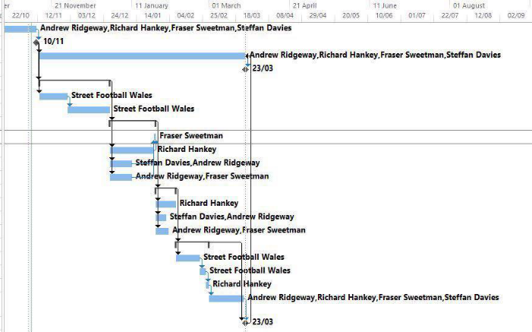
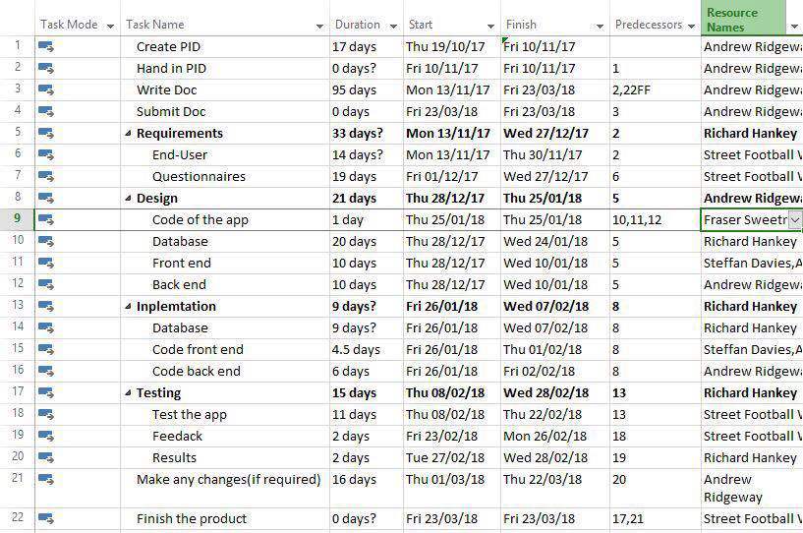
This is the proposed project plan created by Andrew Ridgeway, Lead Programming designer.

References
[1] “Street Football Wales - About - Street Football WalesMore than just football.” [Online]. Available: http://www.streetfootballwales.com/about.html. [Accessed: 29-Oct-2017].

