Task 1: ANTENATAL MIDWIFERY SERVICES COMMUNITY
Community Antenatal Midwifery Services: What Are They?
Pregnant women can get care and support from community antenatal midwifery services. Community midwives assist women in maintaining their health and getting ready for childbirth at neighbourhood clinics, GP offices, and health centres. They are responsible for keeping an eye on the mother's health and the baby's growth while offering guidance, comfort, and emotional support. The program seeks to guarantee that women receive the treatment they require during their pregnancy and to detect any possible issues early on. Additionally, midwives assist women in making educated decisions on their plans for childbirth and maternity care (NHS, 2024).
Brief history of the service:
For hundreds of years, midwifery has played a significant role in healthcare. In the past, women relied on neighbourhood midwives to help them during pregnancy and labour. However, prior to the introduction of professional training and regulation in the UK under the Midwives Act 1902, standards differed significantly. The establishment of the National Health Service (NHS) in 1948 was a significant advancement. This meant that all women, regardless of their financial situation, could now get maternity care. Maternity care gradually shifted from being primarily hospital-based to becoming more community-based. Community prenatal midwives consequently emerged as a crucial component of maternity care (NMC, 2024).

How the Service Operates Today
From the beginning of pregnancy until delivery, community prenatal midwives assist women.
Making an Appointment-Typically, the initial appointment is referred to as the booking appointment. The midwife learns about the woman's lifestyle, family history, and medical history during this consultation. This enables the creation of a customised care plan and assists in identifying any variables that may impact the pregnancy (NHS, 2024).
Routine Antenatal Care
Women attend regular appointments throughout pregnancy where midwives:
• Monitor blood pressure
• Arrange blood and urine tests
• Check the baby's growth and development
• Monitor maternal wellbeing
• Discuss any concerns or symptoms
Regular appointments are important because they help identify complications at an early stage.

Health Education
Giving guidance and information is a crucial aspect of the midwife's job. This could consist of:
• Nutrition and a healthy diet
• Pregnancy-related exercise
• Giving up smoking
• Advice on breastfeeding
• Getting ready for childbirth
Giving women this information enables them to make well-informed decisions regarding both their own health and the health of their unborn child.

Support on an emotional level-Pregnancy can be an emotional event, and some women may feel depressed or anxious. In addition to reassuring women, community midwives can direct them to specialised mental health providers if they want further assistance.

Collaborating with Other Experts
Community midwives frequently collaborate with:
Obstetricians
- general practitioners
- Health care providers
- Teams for mental health
- Social workers

This collaboration makes it possible to guarantee that pregnant women receive the best care possible.

Challenge 1: Lack of Midwives
A major issue that maternity services are currently dealing with is the lack of competent midwives. According to the Royal College of Midwives (2024), a lack of workers and rising demand are putting pressure on a number of services.
Consequently:
• Midwives frequently oversee heavier caseloads.
• During appointments, women may see different midwives.
• Stress and burnout are possible for employees.
• Care continuity may be impacted.
Because of this, it may be more challenging for pregnant women to develop trusting connections with medical personnel.
Challenge 2: Complicated Pregnancies
The growing proportion of women having complicated pregnancies presents another difficulty. Obesity, diabetes, hypertension, and mental health issues are among the more prevalent conditions that frequently call for closer observation (NHS England, 2023).
Community midwives must so collaborate closely with specialised teams and offer more individualised care. While this increases safety, it may put additional strain on already overburdened maternity care.
What Makes Community Antenatal Midwifery Services Vital?
In order to improve outcomes for both women and newborns, community prenatal midwifery services are crucial. Frequent prenatal care lowers risks during pregnancy and childbirth by identifying issues early.
Additionally, the service offers reassurance, emotional support, and knowledge to help women feel more secure during pregnancy. Additionally, because women can get assistance closer to home, community-based care increases accessibility.
In general, safer deliveries, healthier pregnancies, and better family experiences are all facilitated by community antenatal midwifery services (NHS, 2024).
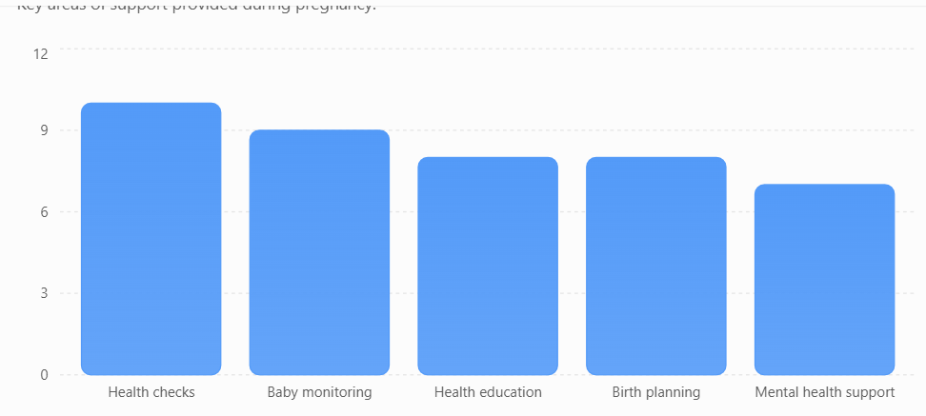


Figure 1: Key responsibilities of community antenatal midwives during pregnancy (adapted from NHS, 2024).

Task 2-Community mental health services
Community mental health services play an important role in supporting people who experience mental health difficulties while allowing them to remain in their local communities. These services provide a range of support, including mental health assessments, counselling, crisis intervention, medication management and rehabilitation. Instead of relying solely on hospital treatment, community mental health services aim to help people live as independently as possible while receiving the care they need. This essay will examine the origins and development of community mental health services, evaluate how they operate today, and discuss their importance in improving the quality of life of service users.
In the past, huge psychiatric facilities were frequently used to treat patients with mental health issues. Many people spent extended periods of time in asylums during the late 19th and early 20th centuries, cut apart from their family and the larger community. These facilities were often attacked for their congestion, subpar living conditions, and lack of individual support, despite the fact that its initial purpose was to give care. Attitudes toward mental health care started to shift once the National Health Service (NHS) was established in 1948. In an effort to lessen the need for long-term institutional care, the Mental Health Act of 1959 promoted treatment in community settings whenever feasible (Turner, 2015). The Care in the Community strategy, which concentrated on helping people in their own communities rather than in psychiatric hospitals, maintained this change throughout the 1980s and 1990s (Mental Health Foundation, 2013).
Multidisciplinary teams consisting of psychiatrists, psychologists, mental health nurses, social workers, occupational therapists, and support staff now provide community mental health care. Together, these experts offer a variety of services that are customised to meet each client's demands. Home visits, GP offices, health centres, and community clinics can all provide support. In addition to treating mental illness, the goal is to support clients in preserving their relationships, jobs, and daily activities (NHS England, 2019).
The fact that community mental health services put the patient at the center of care is one of its key benefits. Participation in decisions on treatment and recovery objectives is encouraged for service users. People may feel more valued and empowered as a result of this strategy, which could increase service engagement. Additionally, getting help in familiar settings might lessen stigma and feelings of loneliness. Being able to stay near to friends, family, and support systems makes recovery easier for many people. Effective community-based services can enhance service users' quality of life and lead to better social outcomes, according to research (Priebe et al., 2003).
Nevertheless, there are certain obstacles that community mental health services must overcome in spite of these advantages. The growing need for mental health assistance is one major problem. Existing services are under a great deal of strain as more people seek treatment for illnesses like anxiety, depression, and stress-related diseases. Because of this, there may be long wait times for treatment, and some people may find it difficult to get help when they most need it (Care Quality Commission, 2024). This may worsen mental health issues and have a detrimental effect on recovery.
The lack of skilled mental health practitioners is another issue. Services may find it challenging to deliver consistent and individualised care due to high caseloads and personnel constraints. Although the fundamentals of community mental health treatment are generally acknowledged as beneficial, their efficacy may be restricted when resources are scarce. Therefore, one could contend that adequate finance and workforce support are just as important to the success of these programs as best practices.
All things considered, community mental health services significantly enhance the lives of those who get them. They lessen the need for hospital hospitalisations while fostering rehabilitation, independence, and social inclusion. These services promote long-term quality of life and emotional wellbeing by assisting individuals in managing their mental health within their local communities. Community mental health services continue to be an essential component of contemporary health and social care delivery, despite persistent issues with staffing and demand.

Task 1 References
- Midwives Act 1902. London: HMSO.
- National Health Service (NHS) (2024) Your antenatal appointments. Available at: https://www.nhs.uk/pregnancy/your-pregnancy-care/your-antenatal-appointments/ (Accessed: 22 June 2026).
- NHS England (2023) Three Year Delivery Plan for Maternity and Neonatal Services. London: NHS England.
- Nursing and Midwifery Council (NMC) (2024) Standards of proficiency for midwives. London: NMC.
- Royal College of Midwives (RCM) (2024) The role of the midwife in antenatal care. London: RCM.

Task 2 References
- Care Quality Commission (CQC) (2024) The State of Health Care and Adult Social Care in England 2023/24. London: CQC.
- Mental Health Foundation (2013) Happy Birthday NHS: The History of Mental Health Care. Available at: https://www.mentalhealth.org.uk (Accessed: 22 June 2026).
- NHS England (2019) The Community Mental Health Framework for Adults and Older Adults. London: NHS England.
- Priebe, S., Jones, G., McCabe, R., Briscoe, J. and Wright, D. (2003) ‘Community mental healthcare in England: Associations between service organisation and quality of life’, Social Psychiatry and Psychiatric Epidemiology, 38(8), pp. 434–440.
- Turner, J. (2015) ‘The History of Mental Health Services in Modern England: Practitioner Memories and the Direction of Future Research’, Medical History, 59(4), pp. 599–624.

