Master of Business Administration

Marketing Management
Name: keshavala Nisha Lakhubhai
Student I'd:2538593

LCMB7024

Name of the student:
Student ID:
Table of Contents
1.0 Element 1: Sustainable Brand Extension Poster Presentation 3
2.0 Element 2: Develop a Segmentation, Targeting, Differentiation, and Positioning (STDP) 4
2.1 Key market segments relevant to the brand extension using geographic, demographic, psychographic, and behavioural variables 4
2.2 Detailed explanation of your chosen target audience 6
2.3 Way brand will differentiate itself from competitors in the market 7
2.4 Positioning of the brand extension 7
3.0 Element 3: Marketing Mix (4Ps or 7Ps) 8
3.1 Way each element of the marketing mix will be applied and how it aligns with and supports the overall brand extension strategy 8
4.0 Element 4: Reflection 13
4.1 Reflection on my experience developing the brand extension 13
4.2 Reflection on the experience preparing and delivering the poster presentation 13
4.3 Key skills, knowledge, and insights you have gained throughout this process 13
4.4 Way these have contributed to my personal and professional development 13
4.5 Way I could further enhance my approach and performance in similar projects in the future 14
References 15

1.0 Element 1: Sustainable Brand Extension Poster Presentation
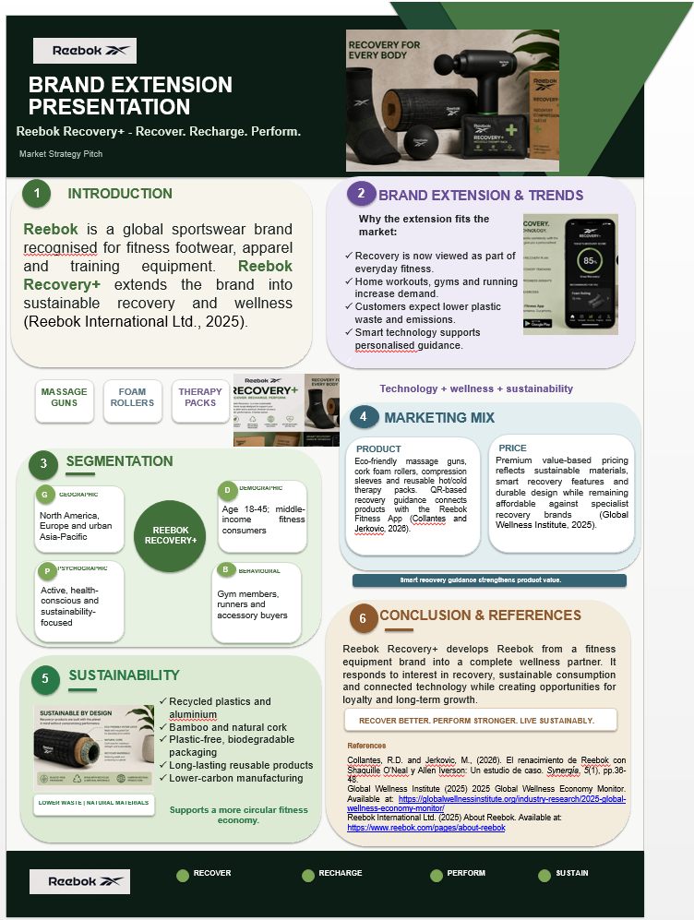

2.0 Element 2: Develop a Segmentation, Targeting, Differentiation, and Positioning (STDP)

2.1 Key market segments relevant to the brand extension using geographic, demographic, psychographic, and behavioural variables
Geographic Segmentation
Reebok Recovery+ should be targeted at consumer in North America, Europe and urban Asia-Pacific, where the participation in fitness and wellness activities is high and consumers are more likely to buy premium recovery products (PwC, 2025). North America is the biggest recovery equipment market in the world with 37.0% share of the global massage gun market in 2025, and Europe is seeing robust demand for eco-friendly sports products. The global fitness recovery services market is expected to expand from USD 8.22 billion in 2025 to USD 24.53 billion by 2035, growing at 11.6% CAGR, offering good growth prospects for Reebok Recovery+ in key regions including North America, Europe, and urban Asia-Pacific (Deloitte, 2025). These are also areas in which digital infrastructure is at a high level to enable Reebok to embed QR-based recovery advice and app connectivity into its sustainable recovery products.
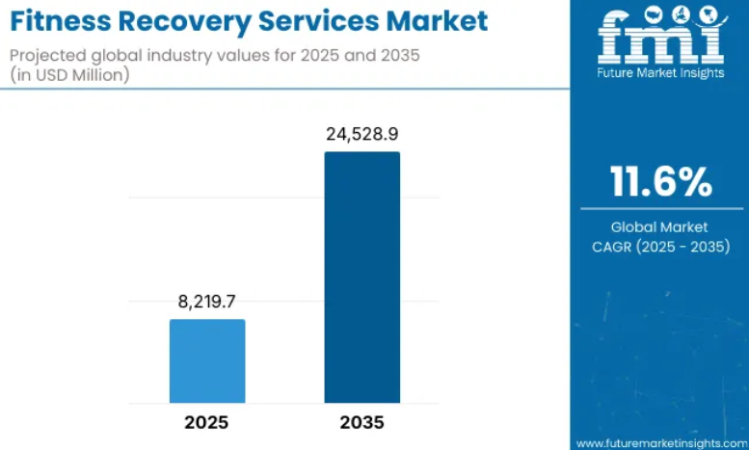
Fig 1: Fitness Recovery Service Market
Source: (Future Market Insights, 2025)
Demographic Segmentation
Reebok Recovery+ main demographic includes middle to upper income men and women between the ages of 18 and 45, who engage in a gym training program, running, CrossFit, yoga, or recreational sport every week. Adults between 25 and 44 years represent about 55% of the users of the massage gun, thus representing the largest segment of users of recovery equipment. Moreover, the global fitness recovery services market will grow from USD 8.22 billion in 2025 to hit USD 8.69 billion by 2028 (Future Market Insights, 2025). This group is not only digitally connected, but also has the economic means to buy premium value wellness products, and is also looking for brands that offer innovation, sustainability, and performance—an ideal target for Reebok Recovery+.
Psychographic Segmentation
Reebok Recovery+ is designed for consumers who seek an active lifestyle, personal wellbeing, sustainability and technology-enabled fitness experiences. These are people who consider recovery an integral part of their physical performance, and they're prepared to spend money on products that will help them stay healthy (Global Wellness Institute, 2025a). The general wellness sector represents 45.3% of the global fitness recovery market in 2025, reflecting the trend that fitness recovery products are being purchased by all fitness consumers, not just elite athletes.
Behavioural Segmentation
The Reebok Recovery+ is aimed at the regular gym-goer, runners, fitness enthusiasts and existing Reebok customers that have a habit of buying sports accessories and recovery gear to perform their workouts and to minimize the risk of injury (Statista, 2025). These consumers tend to exercise several times a week, look for new and creative wellness solutions and are open to a combined digital experience. As per the industry data, app and web bookings dominate fitness recovery services market, which is where consumers are most inclined towards digitally connected recovery ecosystems in 2025. Furthermore, massage therapy and assisted stretching make up 34.2% of the recovery market, demonstrating high consumer demand for easy recovery options (Global Wellness Institute, 2025b).

2.2 Detailed explanation of your chosen target audience
The main user base for Reebok Recovery+ are health-conscious men and women aged 18-45 with middle to upper-middle income that exercise regularly at the gym, run, engage in functional fitness or yoga, and participate in recreational sports (Reebok, 2025). By 2032, the global health and wellness market is expected to grow from USD 5.35 trillion to USD 8.38 trillion at a compound annual growth rate of 7%, highlighting the market's robust demand for sustainable wellness solutions like Reebok Recovery+ and its commitment to health-conscious and environmentally conscious consumers. In addition, 67% of Gen Z and Millennial consumers say they are impacted by sustainability when making purchasing decisions and more than 70% say they are willing to pay more for sustainable products (Global Wellness Institute, 2025c). Together with the personalised recovery information via QR codes, Reebok Recovery+ meets the functional, emotional and environmental needs of this customer type and effectively fosters customer loyalty and contributes to the brand's long-term growth strategy.
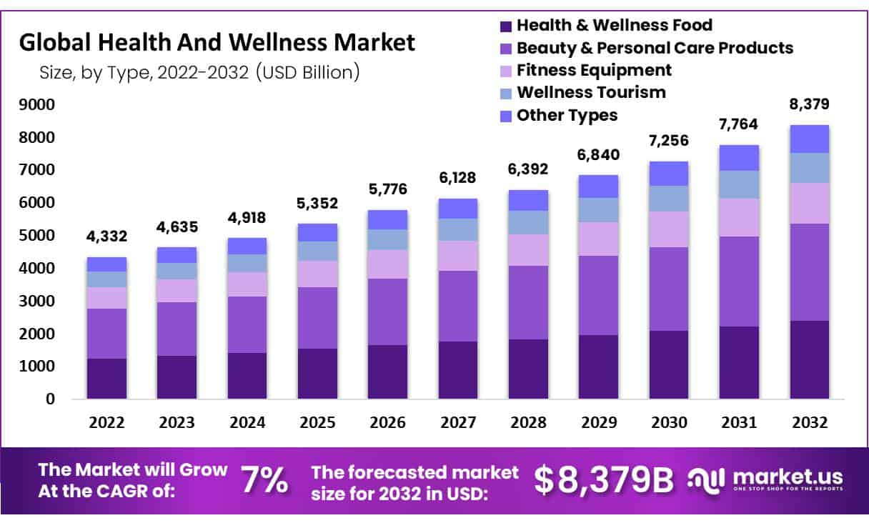
Fig 2: Global Health and Wellness Market
Source: (Market.us, 2025)

2.3 Way brand will differentiate itself from competitors in the market
The Reebok Recovery+ will stand out with its innovative use of eco-friendly materials, embedded digital recovery assistance tools and an attractive premium price that makes it accessible to the user base of recovery equipment (NIQ, 2025b). Reebok isn't just about the technology, as it uses recycled plastics, bamboo, and natural cork in its construction to create an environmentally friendly product, while continuing to incorporate QR codes into personalised recovery programmes which connect with the Reebok Fitness App. In 2023, the physical activity economy is estimated to have been worth around USD 1.1 trillion and is projected to grow as consumers grow more and more focused on recovery and wellness (Global Wellness Institute, 2025d). It is also revealed that 58% of consumers actively consider sustainability when buying sporting goods and lifestyle products. With innovation, eco-sustainability and a proven track record of establishing a global sports brand identity, Reebok Recovery+ can create a unique competitive niche and foster customer loyalty in the expanding recovery and wellness sector.

2.4 Positioning of the brand extension
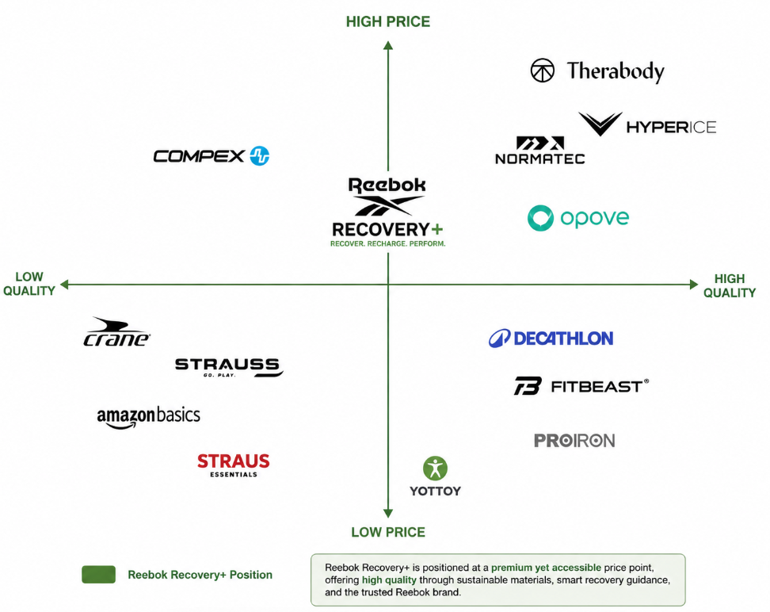
Fig 3: Positioning Map
Source: (Self-Generated)

3.0 Element 3: Marketing Mix (4Ps or 7Ps)

3.1 Way each element of the marketing mix will be applied and how it aligns with and supports the overall brand extension strategy
Product
Reebok's Recover+ product strategy is designed to take Reebok from an active wear brand to the emerging recovery and wellness market by leveraging on innovative, sustainable, and tech-enabled recovery products. Its products feature environmentally-friendly massage guns, cork foam rollers, hot and cold therapy packs (reusable), compression sleeves and mobility accessories made from recycled plastics, aluminium, bamboo and natural cork. Unlike standard recovery products, each features a QR code for personalised recovery guidance in the Reebok Fitness App, enabling members to access exercise tutorials, recovery plans, injury prevention advice and progress tracking (Grand View Research, 2025). This combination of physical products with digital services not only adds value to customers but also establishes a connected recovery system. Biodegradable packaging, durable reusable materials and lower-carbon manufacturing processes are integrated all the way from the start to the end of the product lifecycle, helping to promote environmentally responsible consumption. The global muscle health and recovery market is expected to grow from about USD 1.67 billion in 2025 to USD 3.29 billion by 2033, making it a strong indication of the demand for innovative muscle health and recovery products, and Reebok Recovery+'s goal of delivering sustainable, technology-enabled recovery solutions (HubSpot, 2025). Therefore, Reebok Recovery+ is not only product innovation, but also an indication of the company's environmental responsibility, thus creating a sustainable brand extension strategy while being different from its competitors who just aim at the performance technology without combining it with sustainability and with digital support for recovery.
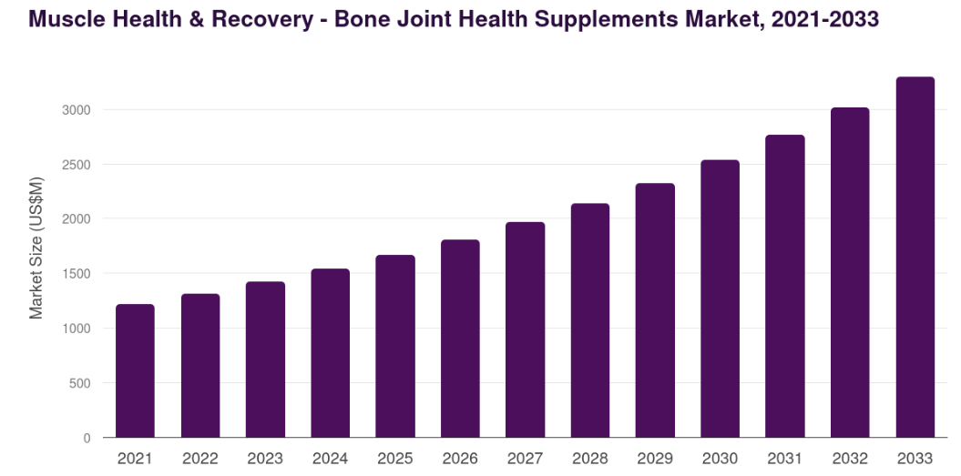
Fig 4: Muscle recovery products market
Source: (Grand View Research, 2025)
Price
Reebok Recovery+ will have a premium value based pricing strategy, sitting somewhere between low cost sports accessories and high end specialist recovery brands like Therabody and Hyperice. The brand is not just about price, it's about great value, using sustainable materials, built to last, smart digital recovery guidance and trusted brand equity (IBM Institute for Business Value, 2025). The pricing is based on how consumers are willing to spend for innovative products that provide performance, sustainably and lasting value. The pricing strategy also helps to offset the higher production or material costs of eco-friendly options and sustainable production, whilst keeping the products accessible to the middle and upper middle class fitness consumer, aged 18 to 45 years. Additional discounts for product bundles, loyalty programmes, seasonal offers, and student offers can further enhance accessibility while maintaining the premium brand image. More than 60% of consumers are willing to pay more for products with proven sustainability improvements and 58% value the durability of a product over cheaper initial costs. Moreover, it is found that 46% of consumers are willing to pay about 10% more for sustainable products (NIQ, 2025a). This therefore strengthens the positioning of Reebok Recovery+ product line as an affordable yet high quality recovery brand that can contribute to long-term profitability and help foster environmental conscious buying behaviour.
Place
Reebok Recovery+ will adopt an omnichannel approach to distribution, boosting ease of access and market reach for the brand in both online and offline channels. They will be available on the official Reebok website, Reebok's mobile app, select sporting goods stores, wellness clinics, physiotherapy centres, top fitness clubs and key online retail stores. By offering customers a multi-channel shopping experience, they can conduct research, make purchases and access after-sales services on the channel of their choice, without compromising on the brand experience. QR powered digital integration also enables the seamless integration of physical products with personalised recovery programmes delivered via the Reebok Fitness App, further integrating offline and online touch points (Influencer Marketing Hub, 2025). Initially, international distribution will focus on the North America, Europe and urban Asia Pacific region, where fitness recovery products and sustainable products are still in demand in consumers. By 2025, the value of global digital purchases is expected to surpass USD 7 trillion, with over 32% of the world's sporting goods consumers making digital purchases. Moreover, it is said that more than 70% of consumers actually do online and offline shopping before making any purchases (McKinsey & Company, 2025a). Reebok Recovery+ response to customer needs through the use of digital technologies and an omnichannel distribution strategy translates to service excellence, market expansion, convenience and a long-term goal of Reebok becoming a full wellness and recovery experience rather than just a sports accessories manufacturer.
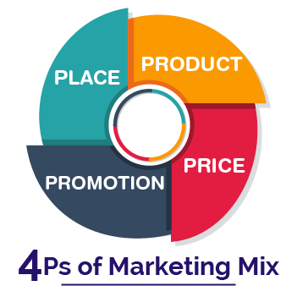
Fig 5: 4Ps of Marketing
Source: (My B2B Network, 2025)
Promotion
Reebok Recovery+ promotional approach focuses on blended digital marketing, influencers, experiential marketing, sustainable communication and education to create valuable brand awareness and consumer engagement. The marketing strategy will target social media platforms like Instagram, TikTok, YouTube, and LinkedIn, where fitness enthusiasts are looking for advice on getting back in shape, workout routines, and product suggestions (McKinsey & Company, 2025b). Sustainable recovery products can showcase the practical benefits of using these products, while also boosting brand credibility through professional athlete, physiotherapist, sports therapist, and fitness influencer collaborations. To reinforce Reebok's sustainability positioning, promotional campaigns will feature the sustainability credentials of the product materials, packaging features that are made from recyclable materials, and lower carbon product manufacturing processes. Customers will be encouraged to participate and engage in the long-term through user-generated content, fitness challenges, wellness webinars, recovery workshops, and interactive QR-linked recovery programmes. Customer retention will be further enhanced by email marketing, customised recommendations in the Reebok Fitness App and loyalty incentives. 81% of consumers find new brands through social media and businesses see a return of around USD 5.78 on every USD 1 spent on influencer marketing. Moreover, it has been discovered that 68% of buyers are more inclined to buy from brands that clearly communicate their genuine sustainability efforts (McKinsey & Company, 2025c). Thus, Reebok Recovery+'s embedded promotional strategy can help to promote the sustainable brand extension by raising brand awareness, educating customers about recovery and the importance of protecting the environment, boosting customer trust, reigniting the cycle of return purchases and building long-term customer loyalty in the ever-competitive wellness sector.

4.0 Element 4: Reflection

4.1 Reflection on my experience developing the brand extension
The Reebok Recovery+ sustainable brand extension gave me a new perspective in how a well-established brand can expand into new markets while maintaining their brand identity, values and principles. During the project, I investigated the opportunities for sustainable and successful brand extensions through digital innovation and transformation of consumer lifestyles. Researching market trends, customer needs, competitor strategies, and environmental analysis helped me to recognize the value of embracing data and evidence to guide marketing choices.

4.2 Reflection on the experience preparing and delivering the poster presentation
Creating and sharing the poster enhanced my communication skills in presenting marketing concepts in an appeal and concise way. Throughout the designing of the poster, I had to focus on the important information, the logical flow of the content, and the presentation of the academic research through the use of visual elements such as market segmentation, marketing mix, sustainability initiatives, and positioning strategies. The delivery of the presentation helped boost my confidence and ability to make marketing decisions within a given time and address questions and feedback.

4.3 Key skills, knowledge, and insights you have gained throughout this process
This project was useful in reinforcing some of the key academic and professional abilities. Enhanced the understanding of Segmentation, Targeting, Differentiation and Positioning (STDP), Marketing mix (4Ps), Sustainable marketing strategies and Brand extension planning. I also gained better research abilities, analysing academic papers, industry reports and market data to provide strategic insights and recommendations. Also, I sharpened my critical thinking abilities and benchmarked competitor strategies and market opportunities for Reebok Recovery+.

4.4 Way these have contributed to my personal and professional development
The learning and learning capabilities that have developed during this evaluation have been beneficial to my own and the professional development. For me personally, the project boosted my self-confidence in identifying business issues and presenting recommendations based on facts and knowledge of the marketing field. In professional terms, it enhanced marketing, brand management and business consultancy skills which are sought after in the industry, such as strategic planning, market analysis, communication, team working and decision making.

4.5 Way I could further enhance my approach and performance in similar projects in the future
In future projects, I would refine my approach by ensuring that I have a comprehensive primary market research to find out more about consumer preferences and purchasing behaviour through customer surveys and/or interviews. I would also improve my quantitative market analysis and data visualisation skills, providing stronger evidence to support my strategic recommendations. In addition, more time should be dedicated to research of the academic literature, further developing the visual design and practice of the presentations, which would further enhance the quality and professionalism of my work. Lastly, continuous feedback throughout the project would allow me to detect the areas needing improvement at an earlier stage, which would help me to improve my marketing strategies in the future as a student and a professional.

References
Deloitte (2025) Insights: Consumer industry. Available at: https://www2.deloitte.com/global/en/insights.html
Future Market Insights (2025) Fitness Recovery Services Market. Available at: https://www.futuremarketinsights.com/reports/fitness-recovery-services-market
Future Market Insights (2025) Fitness Recovery Services Market: Global Industry Analysis and Opportunity Assessment, 2025–2035. Available at: https://www.futuremarketinsights.com/reports/fitness-recovery-services-market
Global Wellness Institute (2025a) 2025 Global Wellness Economy Monitor. Available at: https://globalwellnessinstitute.org/industry-research/2025-global-wellness-economy-monitor/
Global Wellness Institute (2025b) Statistics & Facts. Available at: https://globalwellnessinstitute.org/press-room/statistics-and-facts/
Global Wellness Institute (2025c) The Global Wellness Economy Hits a Record $6.8 Trillion and Is Forecast to Reach $9.8 Trillion by 2029. Available at: https://globalwellnessinstitute.org/press-room/press-releases/the-global-wellness-economy-hits-a-record-6-8-trillion-and-is-forecast-to-reach-9-8-trillion-by-2029/
Global Wellness Institute (2025d) Wellness Economy Data Series. Available at: https://globalwellnessinstitute.org/industry-research/the-global-wellness-economy/
Grand View Research (2025) Massage Gun Market Size, Share & Trends Analysis Report. Available at: https://www.grandviewresearch.com/industry-analysis/massage-gun-market-report
Grand View Research (2025) Muscle Health & Recovery – Bone and Joint Health Supplements Market: Global Horizon Statistics. Available at: https://www.grandviewresearch.com/horizon/statistics/bone-joint-health-supplements-market-report/application/muscle-health-recovery/global
HubSpot (2025) State of Marketing Report. Available at: https://www.hubspot.com/state-of-marketing
IBM Institute for Business Value (2025) Research Insights. Available at: https://www.ibm.com/thought-leadership/institute-business-value
Influencer Marketing Hub (2025) The State of Influencer Marketing Benchmark Report 2025. Available at: https://influencermarketinghub.com/influencer-marketing-benchmark-report/
Market.us (2025) Health and Wellness Market Size, Share, Trends, Growth, Forecast (2023–2032). Available at: https://market.us/report/health-and-wellness-market/
McKinsey & Company (2025a) The Future of Wellness Trends Survey 2025. Available at: https://www.mckinsey.com/industries/consumer-packaged-goods/our-insights/future-of-wellness-trends
McKinsey & Company (2025b) A Turning Point Amid Tailwinds for Fitness and Wellness. Available at: https://www.mckinsey.com/industries/consumer-packaged-goods/our-insights/a-turning-point-amid-tailwinds-for-fitness-and-wellness
McKinsey & Company (2025c) Consumer Packaged Goods Insights. Available at: https://www.mckinsey.com/industries/consumer-packaged-goods/our-insights
My B2B Network (2025) 4Ps Marketing Mix for B2B Success. Available at: https://myb2bnetwork.com/blog/marketing-mix-the-4ps-of-marketing-and-how-to-use-them/
NIQ (2025a) Global State of Health & Wellness 2025. Available at: https://nielseniq.com/global/en/insights/report/2025/global-state-of-health-wellness-2025/
NIQ (2025b) 2025 Global Health & Wellness Trends. Available at: https://nielseniq.com/global/en/news-center/2025/niq-report-reveals-2025-global-health-wellness-trends/
PwC (2025) Voice of the Consumer Survey 2025. Available at: https://www.pwc.com/gx/en/industries/consumer-markets/consumer-insights-survey.html
Reebok (2025) About Reebok. Available at: https://www.reebok.com/pages/about-reebok
Statista (2025) Sporting Goods and E-commerce Statistics. Available at: https://www.statista.com/

