Application Development Report

Kai Harley Strand-Regan

Application Development

University of Wales Trinity Saint David – Swansea

Dr Kemi Ademoye

9th of December 2019

Contents
1. Application Development Concepts 3
1.2. Blockchain 3
1.3. What is Blockchain? 3
1.4. Why is Blockchain so important? 3
1.5. Security 4
Conclusion 4
2. Implementation 5
Software Requirements Specification 5
3. Website Introduction 5
Features 5
Queries 5
Audience 5
Primary audience 5
Secondary Audience 5
Tertiary Audience 6
House Style 6
Copyright 6
Ethical Considerations 6
4. Software Design and Implementation 6
Home page/ index.html 7
Home page screen cap 2 7
Discover page/discover.html 8
Instructors page/instructors.html 8
Contact page/ contact.html 9
5. Interactive Functionality 10
6. Evaluation 10
Reflection 11
Tutorials Used 11
Bibliography 11

Application Development Concepts
This section will focus on one application development trend that is being used currently, it will be something that also looks to be continuing to have a big presence in the development space for several years although that will be speculation as technology is forever evolving.
There are many trends that can be looked at [1] and they would all be relevant from virtual/augmented reality on mobile to 5G implementation and how blockchain looks to change the way businesses and individuals will trade.

Blockchain
Blockchain will be the trend that will be analysed since it is projected to become a trillion-dollar industry within the next decade. There is a plethora of evidence to suggest that it has the potential to completely change how we as humans trade with each other along with all the complications that come with that. Blockchain looks to tackle issues such as fraud, hidden transactions and product tracking by having open access for anyone with an internet connection “to identify the correct present owner of an asset” [2].

What is Blockchain?
To begin with it is important to understand what Blockchain is, it consists of multiple data packages or ‘blocks’ which consists of transactions that have taken place from start to current. This allows company’s and individuals access to have an easier experience buying and selling.
See figure 1 for an example on how transactions can be traced, it consists of transaction information, proof of work (these are the bitcoin digest) and previous reference which is the link to the block before the current.
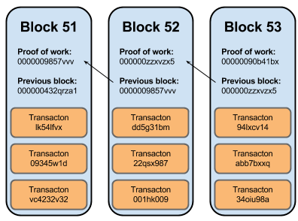

Figure 1 - https://www.ybrikman.com/assets/img/blog/bitcoin/bitcoin-block-chain-small.png

Why is Blockchain so important?
The reason Blockchain is becoming an industry standard is because multiple transactions are not traceable which isn’t always a problem as most items purchased such as food is normally produced, sold and consumed. However, as ‘Blockchain by Michael Nofer’ explains [2] that big retailers are looking for ‘technology that helps to identify precisely those batches of vegetables that in a given case, e.g., are infected by coliform bacteria’. In the UK for example, Tesco might want to be able to trace where a case of lettuce came from if they had traces of a disease on. Current ways of doing this is costly and not time effective.

Security
Security is naturally a concern when it comes to any kind of online transactions, this is one of the strong points of blockchain and why it has such potential.
The reason for this is that blockchain works chronologically by adding the blocks to the end of the blockchain which makes it very difficult for a hacker to manipulate the data e.g. if a customer places an order that hash transaction is added onto the ‘end’ of the block, if someone then tried to charge the customer again they would not be able to simply change the price of the item as that would add onto the ‘end’ thus creating a new transaction that is easily traceable. This means that if the ‘hacker’ wanted to change any block they would need to start from the beginning to change every hash value which would require a huge amount of computing power.
The way that current blockchain users ensure that no ‘bad’ users have access to the transaction process is via Proof-of-Work (PoW).

Conclusion
Blockchain is clearly a new app trend that has huge potential although it has already gained notoriety there is no doubt it will only become more significant overtime. This short overview has looked at what blockchain is capable of from the impact on markets to the use of it’s easy to track system.

Implementation

Software Requirements Specification
The website project requires a range of software, Bootstrap, HTML, JavaScript, Json and CSS. This will be utilized for different aspects of the website’s features.
Bootstrap will enable the website to be responsive giving it usability on computers, notebooks, tablets and phones. This increases accessibility for users. However, does require the developer to insure all elements of the page have been considered accordingly.
HTML is the code that all the pages will be coded in although some elements such as styles and the API’s will use other languages it will ultimately be HTML that is the main language.
JavaScript will be used to create some useful web features for example a quiz and calculator which will then be imported to the HTML web page.
Json will be used when setting up the API and will be essential to making sure the data is passed through correctly.
CSS will be used to style most of the website although some styling will be done directly in the HTML pages as Bootstrap has some features that will be used.

Website Introduction
The website focuses on being healthy and tries to include all elements of this, from taking a quiz to searching new recipes the website is designed to offer users all areas of being healthy.

Features
- The website has a quiz that can be filled out to see how healthy the user is.
- BMI calculator to give the user an understanding of how healthy they are.
- A meal planner to organize eating schedule and what to eat.
- A recipe search option to allow the user access to 1000’s of recipes.
- The website is mobile friendly by utilizing Bootstrap and @media queries.

Queries
The @media function has been used so that the website looks good on all devices, the focus was to change the font size of the carousel so that it would be larger on big devices. Unfortunately, the image is still stretched and given more time this would be fixed by creating smaller images and increasing their size.

Audience
The audience for the website will be people who want to become healthier

Primary audience
The primary audience will be people of any age who wish to be healthier, it will be assumed that the main audience is between the ages of 16 and 65. As the audience is most likely to be adults the website will look at making sure the graphics are professional with good quality pictures as they will trust a website that is more presentable.

Secondary Audience
The secondary audience would be looking at those who are trying to encourage their friends or family to live a little better and thus show them the site. This Is one of the reasons for a contact page as all users will be able to get information that they need.

Tertiary Audience
As the website looks at promoting instructors that use local gyms, the tertiary audience will be the companies that will profit from more visitors. They have a vested interest in the websites success as it should generate more people on their premises.

House Style
The house style of the website is blue and green as these symbolize water and vegetables which are typical healthy foods. Other colours will be used. However, there will be a clear theme of blue and green throughout.

Copyright
All images have their source links in the alt tag of the code, along with some (like the logo) being made in house.

Ethical Considerations
The website graphics do not contain any provocative symbols or statements as it is friendly to everyone. The all inclusive side is important as the aim of the site is to attract as many people possible so the focus will be on the house style and content.

Software Design and Implementation
Six web pages have been created using the software that was discussed above the following is a list of the main features that have been used:
- A quiz has been created in JavaScript
A BMI calculator has been added using JavaScript
- A Google maps API has been added
- The food planner has not been created but has a link that would in theory work.
- The use of external links and a ‘reveal’ button has been used.
Below are screen shots of each web page some of which have more than one so as to see all content:

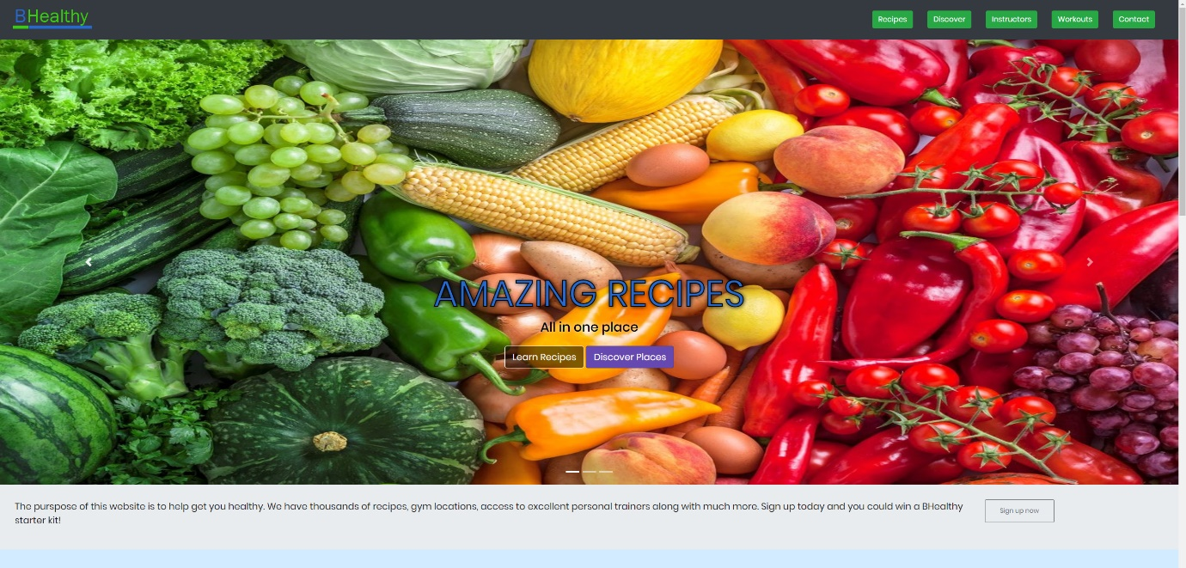
Home page/ index.html

Home page screen cap 2
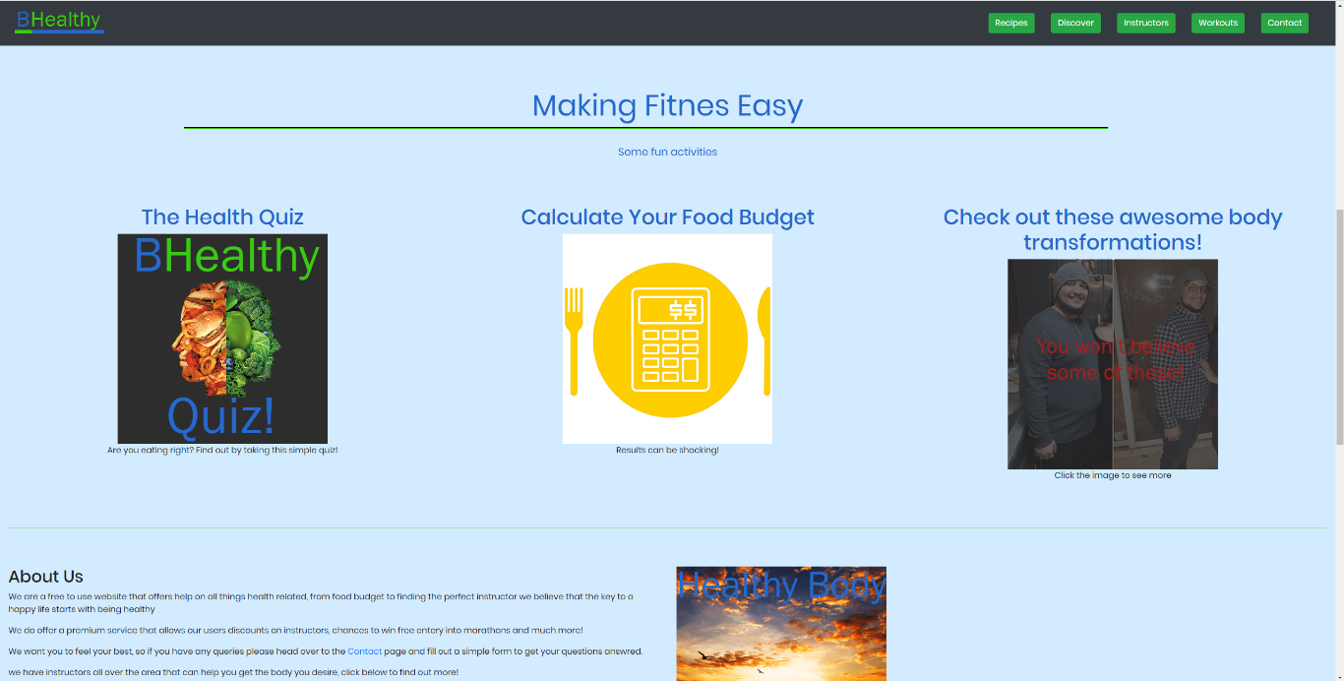

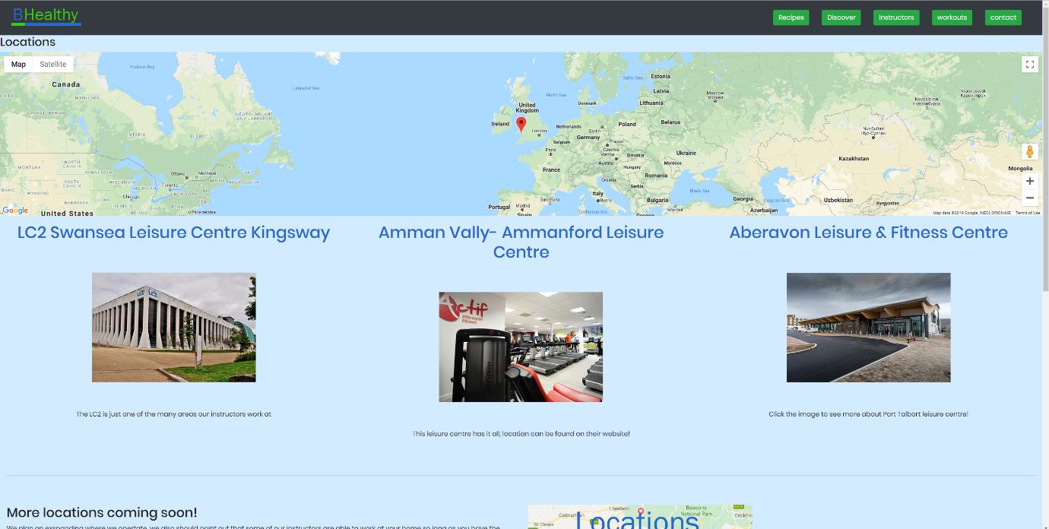
Discover page/discover.html

Instructors page/instructors.html
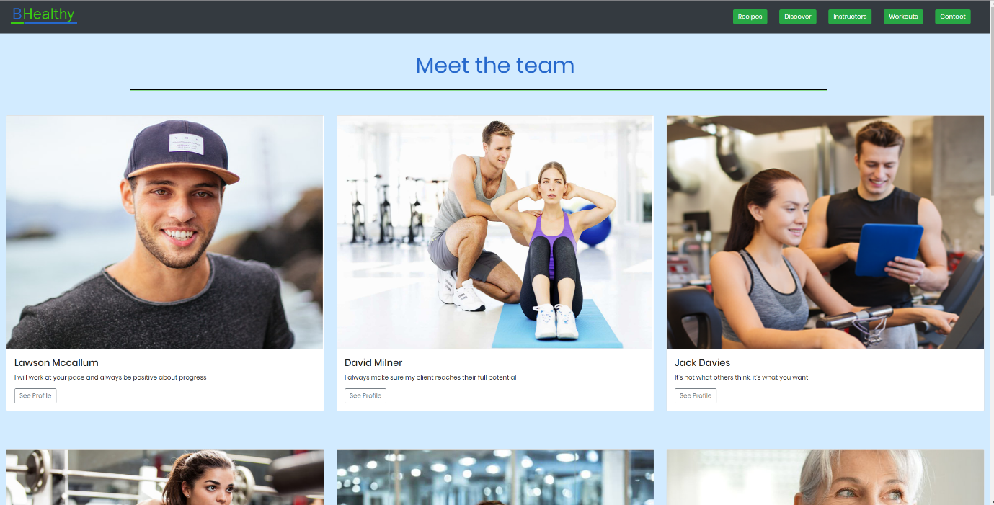

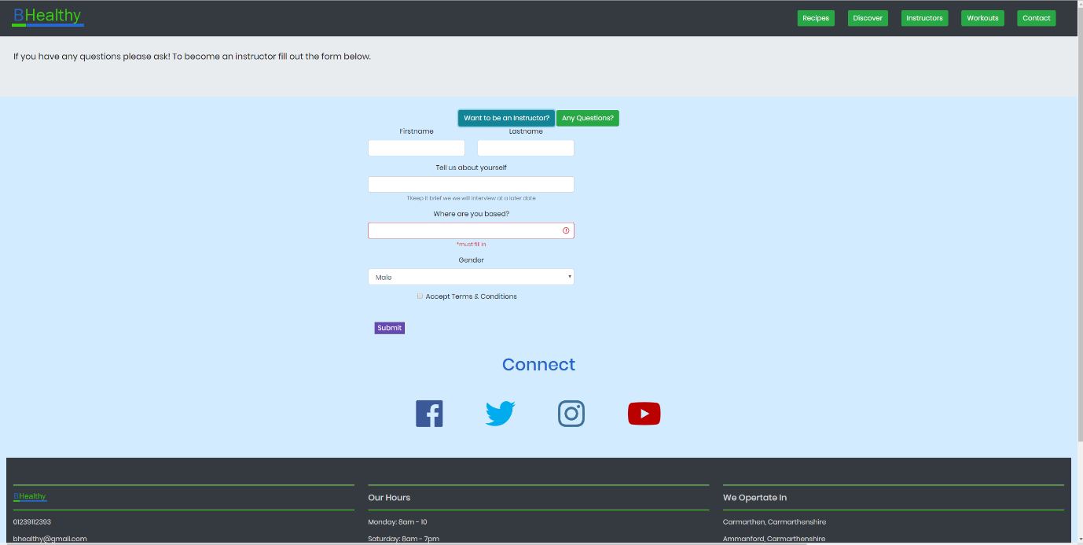
Contact page/ contact.html

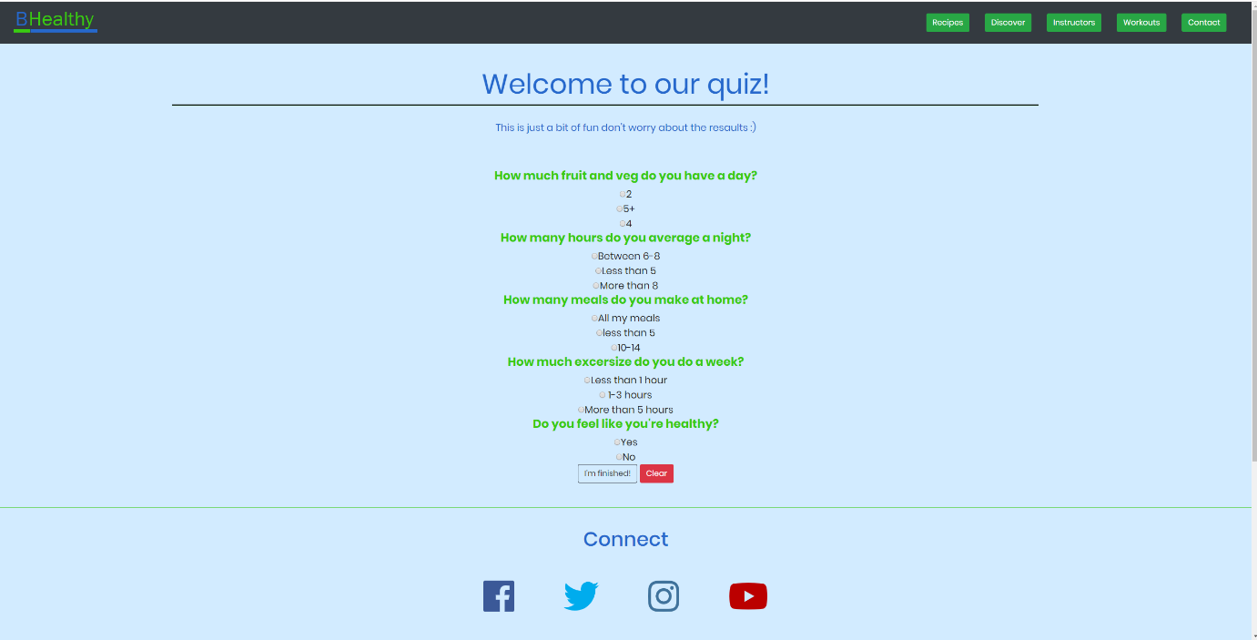
As shown, these are all the pages, the recipes page was not completed so a quiz page was made as shown below.

The layout of the pages is designed to work on most mobile platforms along with medium and small devices. The bootstrap features have been utilized such as setting the col size. One of the main advantages to this is the “the speed of development” [3] according to vmoksha which is very true as it was possible to fix the sizing issues in no time.

Interactive Functionality
A google maps API was added so that users could see the location of one of the leisure centers which added some interactive features.
There was an attempt to add a recipes API that would allow users to connect to a database of recipes through Edamam [4]. However, this was not able to be completed, there is evidence of the attempted work in the code folder for recipeScript.js and a result in the console is shown. Other interactions such as a quiz which can be located on the home page and shows use of JS along with being styled to fit a modern website design. A for example has been created, although the functionality is not there.

Evaluation
The website layout is completed yet some key functions are not working as expected, a test case table has been created to list the functions of the website.

Project Name: Application Development
Website : BHealthy
To be tested | Action | Expected Outcome | Actual Outcome | Action Required | Subject Location
Quiz | Click on quiz link in index page and test each question | That the quiz will output a different string depending on number of correct answers | The Quiz outputs the correct strings based on the results | N/A | quiz.html
Slide Show | Test that the slideshow works | That all three pictures will display correctly with corresponding buttons | All three pictures display correctly | N/A | Index.html
Calculate food budget | Test that a user can input their food budget | A user can input the food they eat each week and receive a price | Food budget calculator is not available | To design a calculator with preset commands such as ‘protein’ and then a user can enter how much they spend on protein which the calculator can add to other preset commands. | Index.html
Recipe API | Search for a food recipe | User can enter key words into search bar and receive suggestions | Search bar does not return results | To check the console and try to understand why the errors occur | Recipes.html
Contact form | To enter information | That a user can enter their information or question. | User can enter information. However, ‘submit’ only refreshes the code. | Add some SQL so that the form can send data to desired tables. | Contact.html

Reflection
The website is not functioning as desired, most notably the recipes API which despite many efforts is unable to retrieve data. Some features such as the quiz do work as intended and show use of Java Script along with styles. Another example of Java is the BMI calculator which does work as intended along with using a presentable style. There are clear examples of the 12 grid bootstrap principles being used although some pages have not made use of the ‘mobile first’ strategy. Despite functions not working the website overall has a reasonable level of usability, there are no ‘dead ends’ as the website navigation works on every page as well as external links opening in a new tab which was an intentional feature.
Improvements
The main improvement for the report would be to improve the API so that it is able to let users to search for recipes which unfortunately was something that could not be completed in the desired time. The second feature would be to have a fully working food budget that is able to give users relevant information to inform them what they are spending their money on.

Tutorials Used
To create the website some online tutorials were used as follows:
Academind [5]
Creating a quiz [6]
Web Technologies module was used to help with understanding of Java Script.

Bibliography

[1] | peerbits, "Top mobile app development trends that will dominate 2019," [Online]. Available: https://www.peerbits.com/blog/top-mobile-app-development-trends.html. [Accessed 09 December 2019].
[2] | P. G. ,. H. Michael Nofer, "Blockchain," 20 02 2017. [Online]. Available: https://link-springer-com.ezproxy.uwtsd.ac.uk/content/pdf/10.1007/s12599-017-0467-3.pdf. [Accessed 15 11 2019].
[3] | "vmoksha," [Online]. Available: <button type="button" onclick="Search();"><i class="fa fa-search"></i></button>. [Accessed 09 December 2019].
[4] | Edamam, "edama," [Online]. Available: https://www.edamam.com/. [Accessed 9 Deceber 2019].
[5] | Academind, "YouTube," 26 Feb 2018. [Online]. Available: https://www.youtube.com/watch?v=7g8Gg2QVdeU&list=PL55RiY5tL51rLqH4-8LBVlUTIFF70dxhb. [Accessed 09 December 2019].
[6] | FullOfJavaBeans, "YouTube," 20 May 2011. [Online]. Available: https://www.youtube.com/watch?v=ipLlTdOTQCY. [Accessed 04 December 2019].

marking criteria and Student FEEDBACK

This section details the extent to which the assessment criteria are demonstrated by you, which in turn determines your mark. The marks available for each category of skill are shown. Lecturers will use the space provided to comment on the achievement of the task(s), including those areas in which you have performed well and areas that would benefit from development/improvement.

Common Assessment Criteria Applied (Assignment 1) | Marks available | Marks  awarded
1. Engagement with Literature Skills

A very good introduction of the chosen application trend. The required background from a relevant peer-reviewed study is, however, missing. Expand the scope of references to further improve your research work. (Grade mark: 64.00%) | 25 | 16
2. Knowledge and Understanding Skills

3. Cognitive and Intellectual Skills

A good evaluation of the website with some relevant recommendations for improvement has been provided. A very good set of test cases has also been developed to test the functionality of the website. (Grade mark: 75.00%) | 20 | 15
4. Practical Application Skills

A very good attempt featuring a website with well-thought-out content and some good use of JavaScript to add interactive functionality. There is still room some improvements, particularly with how you structure your HTML. Please ensure that your HTML tags are properly nested and closed and note that some elements such as the <button> should not be nested within an <a> element. Also note that <script> elements must be placed within the <head> or <body> tags - preferably just before the closing </body> tag as JS can be a render blocking resource. The responsiveness of the footer was very well done, but the main section areas could be improved. Please see your report for suggestions on how to implement and improve the display of responsive images. Minor comment - remember to change the colour of the hamburger so that it is visible. For your JavaScript code, learn how to refactor repeated code and multiple if .. blocks into reusable functions with parameters for what varies. You also appear to have forgotten to link some functions of the website e.g. the quiz page. (Grade mark: 76.00%) | 50 | 38
5. Transferable Skills for Life and Professional Practice

The report is well-written and presented. (Grade mark: 80.00%) | 5 | 4

Assignment Mark (Assessment marks are subject to ratification at the Exam Board. These comments and marks are to give feedback on module work and are for guidance only until they are confirmed. ) | Late Submission Penalties (tick if appropriate) |  | 73%
 | Up to 1 week late (40% Max) |  | 73%
 | Over 1 week late (0%) |  | 73%

