Basic calculations in Python

In Python we can use arithmetic operators to do basic calculations

+ add
- subtract
* multiple
/ divide

For example:

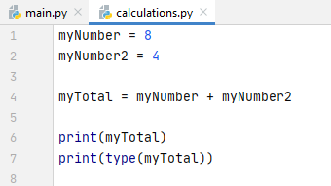

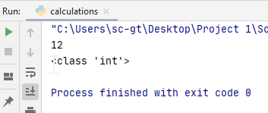

The answer to the calculation is ALWAYS on the left of the equals sign in Python (and indeed, in any other programming language!)

ie - we cannot write:
myNumber + myNumber2 = myTotal X

It must be written:
myTotal = myNumber + myNumber2

I've printed the type above to show that myNumber and myNumber2 have been correctly inferred by Python to be of type int with myTotal also inferred to be int type by Python.

Note: Python is not particularly fussy about a mixture of int and float

For example, with myNumber set to 8.5:

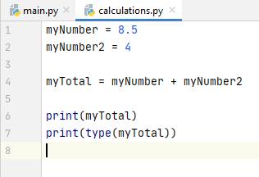

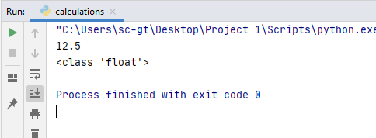

Python has automatically recognised that there is a float in the mix, made the calculation, and set myTotal as a float. Unlike some other programming languages, Python has automatically managed the required change of types.

One thing that is a little surprising in Python, is the divide operator:

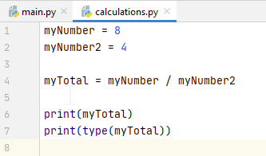

In the program above, I am dividing two integers, 8 and 4 and expecting an answer of 2 (ie all integers).

But nevertheless myTotal is set by Python to float:

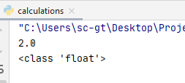

This is because Python will only do floating point division. If I really want the resulting type to be an int, I can cast (set) the type explicitly as int (as we saw before)

Other arithmetic operators in Python

Less commonly used, but still useful, at the following operators:

- Division (floor) - //

In the following programming, I am dividing 5 by 2. Normally, this would give an answer of 2.5
However, division floor (//) will round off the decimal point and set myTotal as int type:

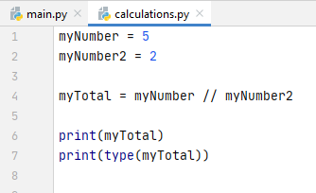

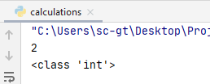

The number will be rounded down, even if the decimal point is at .9

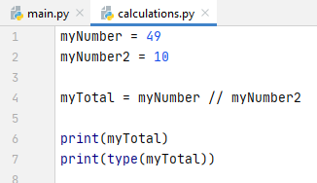

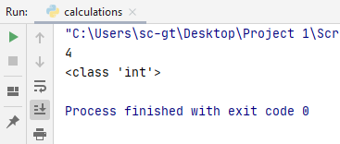

- Power - **

** is used to raise one number to the power of another number.
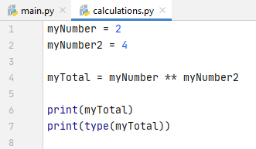
myNumber (2) is raised to the value myNumber2 (4)
ie 2⁴

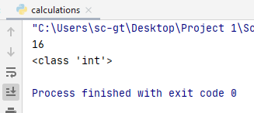
In this example. myNumber has been raised to the power of myNumber2
2⁴ = 2 x 2 x 2 x 2 = 16

This does not have to be done with a variable, you can also hardcode the number you wish to raise to the power of: (4³ below)

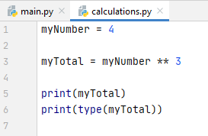
myNumber is raised to
the hard-coded value 3

Modulus - %

Modulus will show you the remainder of a division as a whole number. You may have calculated modulo in primary school without even knowing it!

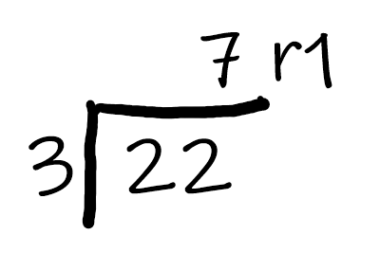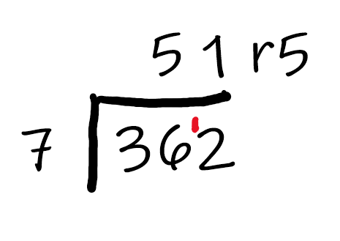
Side note: apparently the above is known at the "bus stop" method!

The most important thing here though is the remainder – this is the modulus

In code, to find the modulus, we use the % symbol

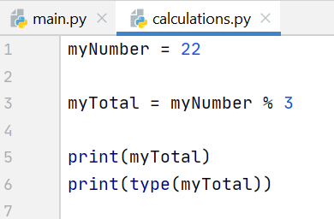

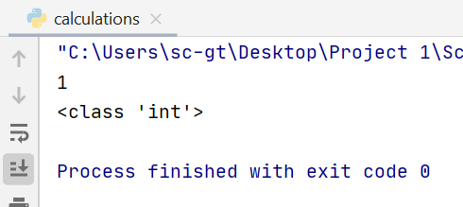
the remainder (modulus) is 1
and modulus is always whole number, so Python has inferred an int type

One more example:



