CertHe S4BA Assignment 1
TURNITIN Submission Template

CERTHE Software & Apps for Business

Task 1: e-Portfolio.
- https://sites.google.com/view/e-portofolio-of-bg-2229727
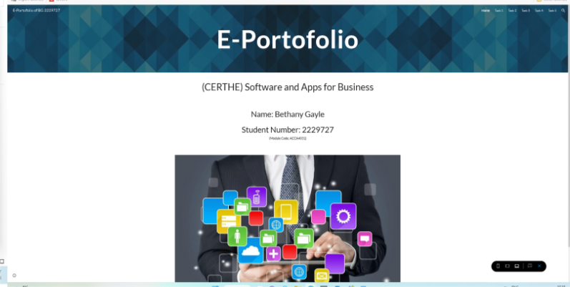

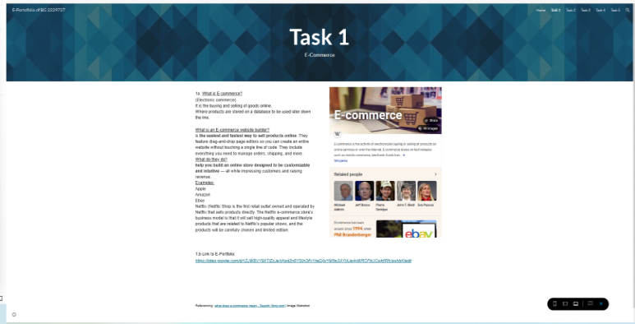

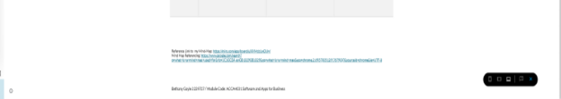
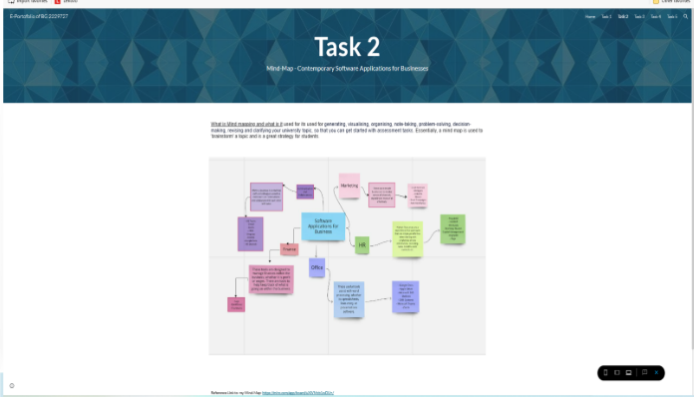
Task 2 – Mind-map. https://miro.com/app/board/uXjVMcb1wDU=/#tpicker-content

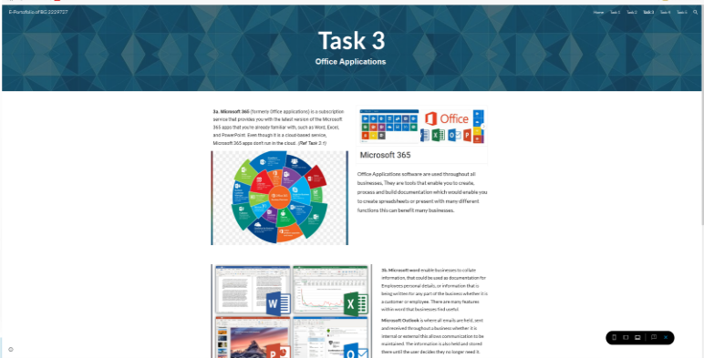
Task 3 – Office Applications.
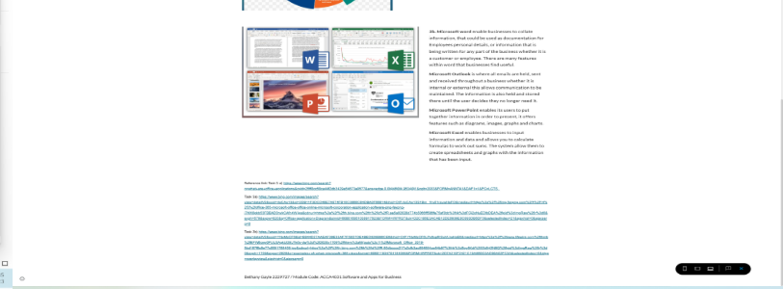

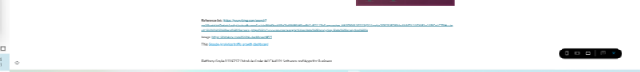
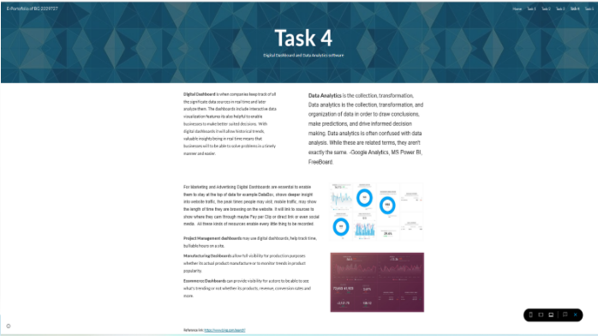
Task 4 – Digital Dashboard and Data Analytics software.
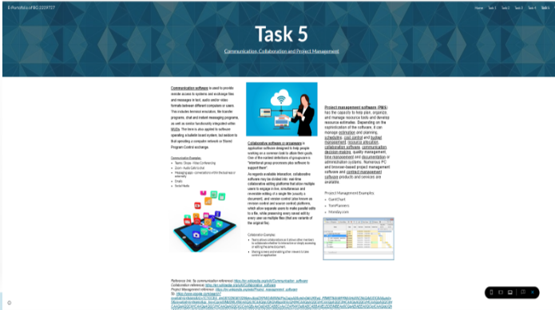
Task 5 - Communication, Collaboration & Project Management

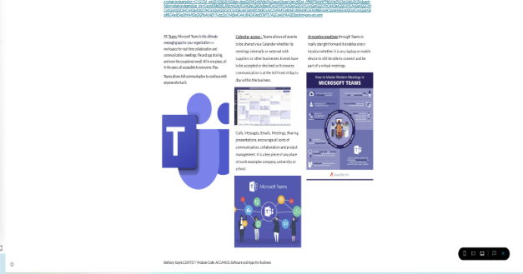

IMPORTANT LINK TEST REMINDER: to ensure your work is accessible by the module tutors for marking, it is very important to sign out of the online application used to create your e-portfolio and to try accessing it with the link you are providing in this document. For the work to be marked, it must be available to the module tutors for marking.

