Jocasta Napier
Student Number : 2316860
ACBA5019
Building Evaluation

Table of Contents
Introduction 2
History 2
Development Location Site 3
Borehole 3
New Development 4
Building Structure 6
Foundation 6
Timber piles 6
Steel Piles 6
Concrete piles 7
Pre-cast 7
Cast-in-place 8
Building Structure 8
Fireproofing 9
Building Envelope 9
Conclusion 10
In conclusion the best foundation for this development will be a concrete piling foundation poured on site, with a concrete structure to allow the best noise proofing and wear of the building. 10
References 11

Figure 1- Edition of 1919, showing railway tracks 2
Figure 2 - development site location, (google maps, 2025) 3
Figure 3 - mock up drawing of accommodation layout 5

Introduction

This report is going to look into a new development on King’s Road in SA1, Swansea on the former dockland. It will discuss the ground conditions in the area, which type of building foundation would best be suited in the area, as well as they structural frame and which materials would be best suited for the exterior of the building. Along with what the building is going to be used for.

History

The Swansea Docks area was originally used for a lot of the transportation of goods, from the docks. This meant that a lot of the land was covered in railway lines to help the use of this transport. Please see the below image, figure 1. This area was like this from in the early part of the eighteenth century, which overtime then caused a lot of the area to become contaminated with any over spill from the cargo, such as aggregates.
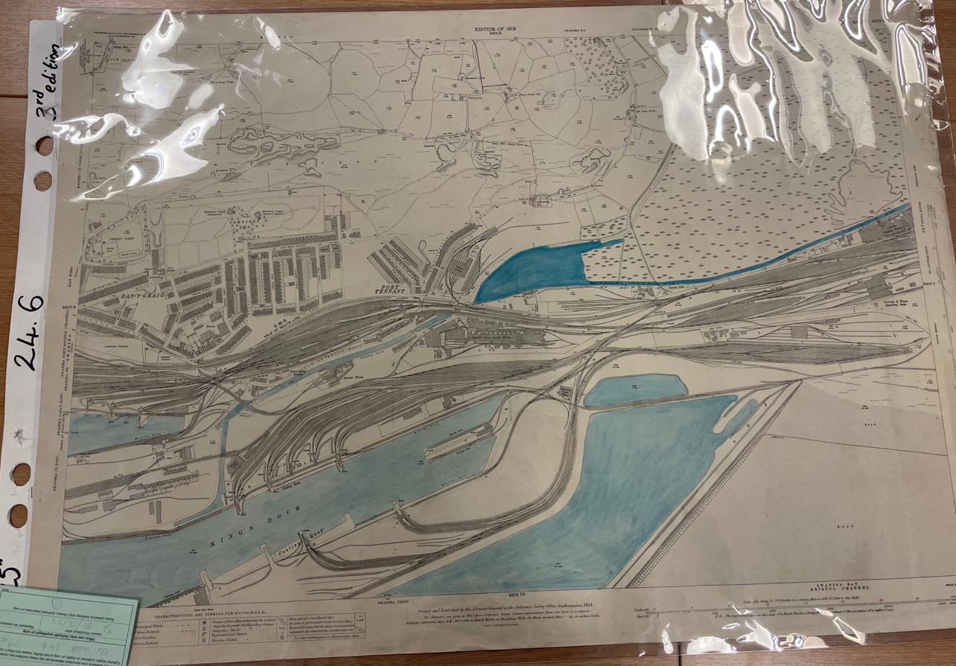

Figure 1- Edition of 1919, showing railway tracks
Although, there has not been enough contamination for the land to become unusable, so there is still the ability for development and redevelopment on the area.

Development Location Site

The location chosen for the development site, is in Swansea Dock, which is located on the Southeast side of the city centre. The developed is located off Kings Road in SA1, running along the side of the River Tawe to the West and the Prince of Wales Dock to the East. As shown in the image below.

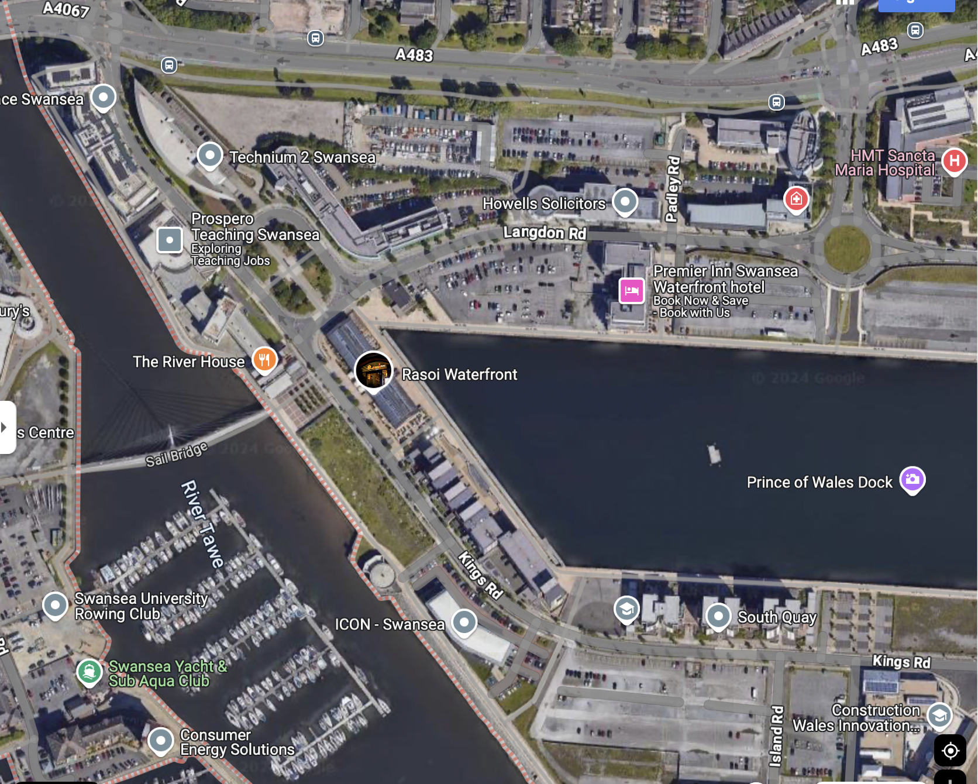
Development site
Figure 2 - development site location, (google maps, 2025)

Borehole
When looking at the borehole logs, there aren’t any available on the land which the development is taking place, so instead there are studies which have been carried out on similar areas of land, the record being used is on Swansea harbour East docks 1, this test was ran along 6.7m in 1880.

The layers shown in the logs are written down as, made ground containing clay and ash stone which was at a thickness of 12 ft, next it went to sand and gravel, which goes down 15 ft 6inch, black silt and stone, followed by loose gravel, sand and shingles at 41 ft, 81 inches to dark grey silt at 42 ft. The ground then changes into brown sand cobbles at 50 ft with yellow shales down to 75ft.

From looking at the log, it shows that the ground in the area has a lot of soft materials, meaning that when building any high rise, it is important that the right foundation in laid to ensure that the stability of the building. (British Geological Survey, 2020)

New Development

The building is going to be a student accommodation but with a difference. The accommodation will allow student to not only have home comforts but allow them to have independent living which they will be able show off proudly to family and friends. The building will include, a commercial area, for both the public and students to use on the ground floor and then from the first floor up, will only be able to have access for the students, where they can enjoy facilities, such as a 24-hour gym, cinema, games room, student union, and social areas.

Over the space of the development there will be two buildings across the area, there will be a courtyard separating the buildings which will only be accessed by the students, so they are able to have outside space. On the roadside of building one, will be where the coinvent store is located and then on the River Tawe the first building will be glassed fronted and open for coffee shops and restaurants, to allow the best scenery for the customers.

In the local area there are a few bars and restaurants already in the area, so not only will it allow the existing bars and restaurants to have more business from the students, it will also not spoil the existing restaurant’s being over ran with student and causing the locals to stop attending these establishments. The second building will have a cinema, the student union and gym. There will also be an in-house laundry room in both buildings.

Above this floor, there will be five floors of accommodation in each building, there will be 10 bedrooms consisting of single and double sized room, to give the student a choice of size and how much they would like to pay, each room will have an en-suite bathroom. Then each floor will have a shared living room and kitchen area. An example of this is shown in figure 3.
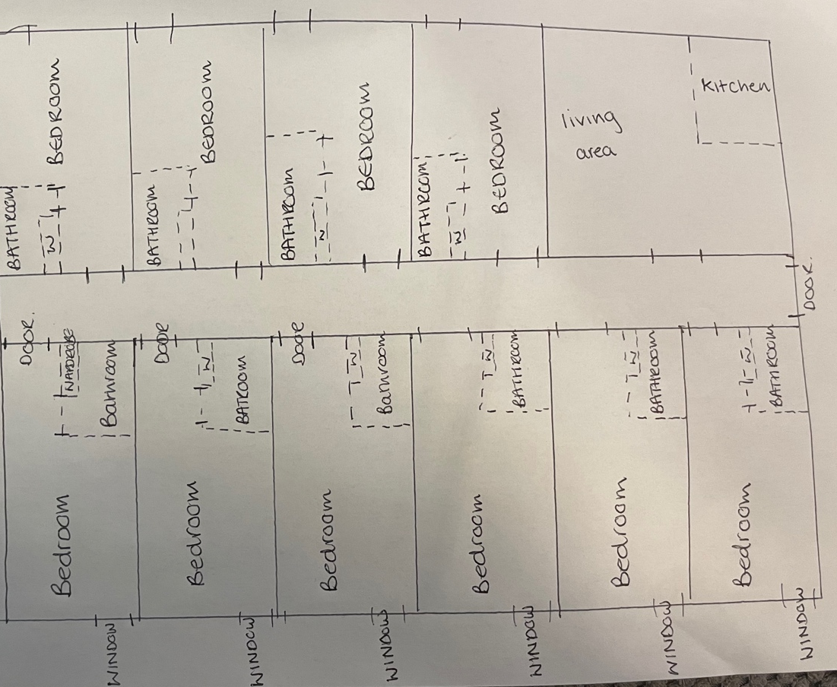

Figure 3 - mock up drawing of accommodation layout

Building Structure

Foundation
After looking at the borehole logs and seeing the ground condition has a lot of lose and soft elements. It is better to have a more established foundation, which will support the weight the of the building and avoid any future unsettlement occurring.

Therefore, the most suitable option for the foundation, would be a piling foundation, when looking at pile foundation types there are three types which are used which are load bearing. These include Timber, Concrete and Steel piles.

Timber piles

These piles are usually placed underwater and can have a life span of up to 30 years, they can take 15 to 20 ton in weight, they can take more weight if they have been reinforced. They are easy to install, cut to the desired length, economical and when needed they are easy to remove.

Although there are a few negatives to using timber piles, longer lengths are not always available and not always available straight and need to be treated before use in order to preserve the wood.

Even though timber piles are used under water and can be preserved, they would not be a practical choice when it comes to any building type, as they would need to last longer than 30 years to be sustainable.

Steel Piles

Steel piles are often a popular choice of as they are easy to install, they can be made into with a hollow pipe or I-section which can be filled with concrete and can take a weight of a heavy load, they are able to reach a great depth than other piling and can penetrate through hard layer due to a smaller cross section.

The disadvantage to using steel piles, is they can go off course when being driven into the ground, which could cause problem in the stability of the structure at a later date, the steel piling is also prone to corrosion. Although steel piles may seem like a good choice for the building structure, due to the building being in close proximity to the sea, there is a high chance these piles would corrode quickly, even with a protective paint covering them and without the ability to reapply the paint, there would be costly problem in the future.

Concrete piles

There are two types of concrete pilings, pre-cast and cast-in-place. The difference between these two types of piling is one is made off site and the other is poured on-site.

Pre-cast
The pre-cast are usually made with reinforced steel to prevent with breakage during transport. There are many positives to using pre-cast piles they have a high resistance to chemical and biological cracks, they can increase the pace of work by coming to the site pre-casted as there is no time wasted on waiting for them to cure, there quality can be controlled when making the piles and are able to be used on land and underwater.

When using a pre-cast concrete piling there can be disadvantages, such as the piling is made to a premeasured size, if there has been any miscalculation then there is no easy way to fix this afterward at the site, as it is difficult to increase or decrease the structure and can cause delays. Due to the size of the piling, it can be difficult to take to site and then difficult to mobilize once it has arrived, this can also be expensive due to the equipment which is needed. As the piling is not premade, it can cause time delays and cost to the project. There is also a chance for breakage or damage to happen to the piles on handling.

Cast-in-place

Due to the location of the site would use cast-in-place concrete piles also know as cast-in-situ piling. This is where holes are bored into the ground removing the content and then replaced with freshly mixed concrete which will then cure in place, a metallic shell is placed to make sure the concrete stays in place. In this instant the metallic shell would be removed to avoid corrosion. There is also no excess enforcement required and will prevent any damage for happening during handling.

The benefits of using this cast in place foundation, is that it allows the more stability and help take the spreading the weight of the building more equally. Before the piles are placed into the ground, the area will be cleared and flattened to ensure that the ground is level to ensure the piles are place correctly into the ground.

There are also disadvantages to use this type of piling such as, there is a need to be an ample amount of space on site to hold the materials, there also needs to be careful supervision for insulation to ensure quality control. There is no guarantee that the bottom of the pile will be symmetrical. Despite this, it has been the chosen method for the building foundation. (Civil today, n/a)

Building Structure

When thinking about what type of materials will be best suited for the building, due to the size the first structural choice to be used would be steel, as it is cheaper to use, quicker to build, it will also be a lighter weight for the foundation. But due to the location of the site being located next to the sea, meaning there will be a high chance for corrosion to occur to the building. Even though the steel can be coated in a special paint to protect the structure, there would need to be upkeep on the building, which may be hard apply once the building is complete.

It would be more beneficial for the student accommodation to have a concrete structure; it has a high durability when it comes to weathering, which is important as the building is going to have a lot of exposure to the elements due to it location and will have a much lower need for maintenance over the years.
It will also be more beneficial for the tenants as there will be less chance of wear and tear to the building. Each year there will be new people entering the building, due to accommodation mainly being used by students in their first year. There will also be minimal sound transfer through each room and each floor.
(McCownGordon Construction, 2025)

When designing the building it is also important to take consideration the design of the building compared to its surrounding, even though it is a new build, if the design of the building is very modern, it won’t fit into the area. Therefore, the building will how a red brick façade, which will comply with the building envelope.

Fireproofing

In any building it is important that the correct safety regulations be put into place to ensure that all pedestrians and residence using the building are protected. As the building is going to be made from concrete building will meet the fire safety standards. All rooms will be issued with a fire safety door, with sprinkler system in communal area, these areas will also be fitted with extinguishing equipment. There will also be clear escape route. These standards will follow the building regulations approved document B (The building regulations, 2010)

Building Envelope

The building envelope is just as important structural wise as the internal structure, as it protects the internal structure from the elements as well as anyone using the building. As the building is made from concrete there is already has a poor thermal performance due to the heat not flowing freely between each room, it will be helpful for the building to have a more efficient seal, to keep in as much heat as possible, as well as allowing protection from the heat absorbing into the building during the hotter months. This should also have an positive effect on the buildings overall efficiency. Due to the amount of people living in the building as well, it can cause a lot of moisture in the air. Therefore, it is important to have a tight building seal, to provided more comfort for the students living in the building.

To ensure the energy thermal energy control, it is important the wall have insulation, a resistance for water and condensation by having an interior sheathing and vapour barrier as well as an external sheathing and cladding to allow essential control and support to exterior wall. (BigRentz, 2021)

Conclusion

In conclusion the best foundation for this development will be a concrete piling foundation poured on site, with a concrete structure to allow the best noise proofing and wear of the building and helping fireproof the building. By doing these measure it should allow a safe and vibrant place for student to live freely and independently.

References

Civil Today (n/a) ‘What is Pile Foundation? Types of Pile Foundation’, Available at:
https://civiltoday.com/geotechnical-engineering/foundation-engineering/deep-foundation/176-pile-foundation-definition-types [accessed 01/01/25]

Welsh Government (2023) ‘A guide to making your guest accommodation safe from fire’ Available at:
https://www.gov.wales/sites/default/files/publications/2023-07/guide-to-making-your-guest-accommodation-safe-from-fire.pdf [accessed – 04/01/25]

Google maps (2025) Available at: https://www.google.co.uk/maps/place/Swansea+SA1/@51.6193723,-3.9299777,621m/data=!3m1!1e3!4m6!3m5!1s0x486e5e2be2fb1ec7:0x7f5ec1736e16ef26!8m2!3d51.6291204!4d-3.9065562!16s%2Fg%2F11ckqk1g7m?entry=ttu&g_ep=EgoyMDI1MDExNC4wIKXMDSoASAFQAw%3D%3D [accessed 05/01/25]

British Geological Survey (2020) Swansea harbour east doc 1 Available at: https://api.bgs.ac.uk/sobi-scans/v1/borehole/scans/items/370193 [accessed 05/01/25]

HM Government (2010) ‘The building regulations 2010, Fire safety B’ Available at: https://assets.publishing.service.gov.uk/media/639ae876e90e0721839ea637/Approved_Document_B__fire_safety__volume_2_-_Buildings_other_than_dwellings__2019_edition_incorporating_2020_and_2022_amendments.pdf [accessed 05/01/25]

McCownGordon (2024) ‘The pro and cons of various structure types fro student housing’ Avaiable at: https://mccowngordon.com/the-pros-cons-of-various-structure-types-for-student-housing/#:~:text=Takeaway%3A%20Concrete%20construction%20is%20a,focus%20on%20long%2Dterm%20investment. [accessed 05/01/25]
Welsh Government (2022) ‘Fire Safety Act 2021’ Available at: https://www.gov.wales/fire-safety-act-2021-html [accessed 05/01/25]

Big Rentz (2021) What is a building envelope and why is it beneficial? Available at: https://www.bigrentz.com/blog/building-envelope?srsltid=AfmBOoraWHz3kuQbNGL8jqZKJP8FzxDK6mJ7I0NQgUcMT6IxrsXXccsq [accessed 05/01/25]

