3/24/2025
University of Wales Trinity Saint David
London campus
E-Portfolio Link: https://2512400.wixsite.com/my-site-2/privacy-policy
Module Name: Learning In the Digital Era
Module Code: ACCA 4025

Student Name: Ahmed Ismail Ali (2512400)
Student ID: 2512400
Group: 1

Lecturer’s Name: Koushik Modak

LDE Assignment 1
E-Portfolio
Table of Contents
Introduction 2
Main Body 2
Task 1: Essential Academic and Employment Skills for the future career Path 2
Task 1 (a): Report on Essential Academic and Employment Skills 2
Task 1 (b): Evaluation of Task 1 (a) based on Similarity report 2
Task 2: Collaborative Mind Map and Individual Poster 2
Mind Map (Collaborative) 2
Poster (Individual) 2
Task 3: Virtual Collaboration and RefWorks 2
Report on Virtual Collaboration 2
Step-by-step process of using RefWorks with visuals 2
Task 4: E-Portfolio Creation and Evaluation 2
Task 4 (a): E-Portfolio Creation 2
Task 4 (b): Illustrative Review of E-Portfolio tool Selection 2
Conclusion 2
References 2
Task 1 References: 2
Task 3 References: 2

Introduction

Main Body

Task 1: Essential Academic and Employment Skills for the future career Path

Task 1 (a): Report on Essential Academic and Employment Skills
Academical skills
In the digital era, the skills needed for academic success and employment have changed significantly. Today students and employees need more than basic literacy and numeracy skills they also need digital skills, critical thinking skills. This is because technology has now developed [1] and digital tools are used in both education and work. Digital literacy is not only about knowing how to use technology, but also about problem solving, time management and working with others. In education these skills are now a priority, students regularly use online tools both in their day-to-day life but also in their learning life for example research purposes. Students must be able to analyse data, solve problems, think creative and understand basic technical concept for academic achievement. This will also help students in the long run for their future careers. Students also need to have good communication skills to be able to express their ideas, communicate with other students and participate in discussions. Teamwork is another crucial skill, many academic tasks require group work where student must be talking to each other and finding solutions together, present ideas and respect different opinions [2] [3] [4]
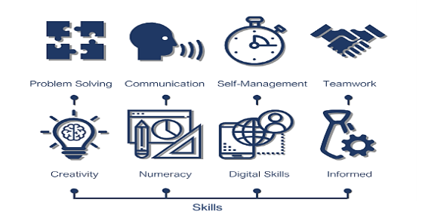
Figure 1: Several skills for Employment [5]

Digital competence is just as important in the workplace Employers expect their workers to be confident using digital tools and to be able to adapt quick to new technologies. Employers with strong digital skills have been proven to be better at working as a team and solving problems. However, this alone is not enough they need to combine all the skills together to become the best employee. This is why both universities and employers are combining digital skills with traditional academic learning. Time management and adaptability is essential for the workplace; Employers are expected to be in time and to be able to adapt around new situations that come up [ in the workplace. Another key skill needed in the workplace is communication, employers are expected to communicate with their team, customers, present new ideas in the workplace and to reduce misunderstanding in the workplace [4] [5].

Task 1 (b): Evaluation of Task 1 (a) based on Similarity report
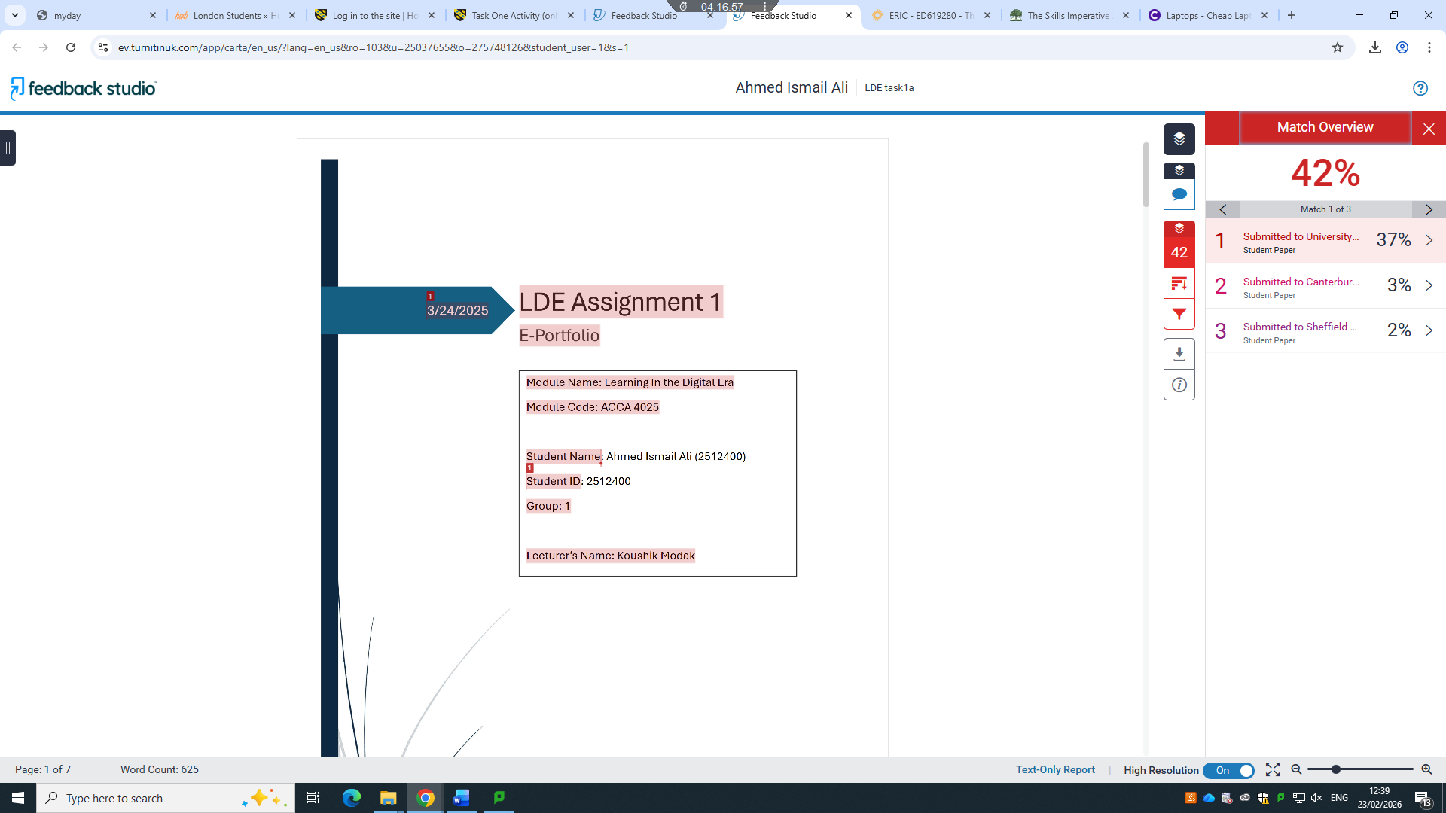
The similarity report for Task 1(a) shows a 42% match. One main reason for this is that all students used the same assignment template, so headings, structure, and some standard phrases are identical. This caused the system to flag sections as similar even though they are not copied. Some parts of my text also matched previously submitted papers, but most of the similarity comes from common academic phrasing and the shared format. I included my own analysis and examples wherever required, and the report reflects structural overlap rather than plagiarism. To reduce similarity in future work, I could paraphrase more carefully, use more original wording, and ensure all references are formatted consistently.
What I could improve is my writing style and clarity. Some sentences are long or slightly unclear, and paraphrasing could be stronger in some sections. In-text citations could also be formatted more consistently. Overall, I put effort into understanding and explaining the topic, so I would give myself a grade of 75% for reflecting a good effort and comprehension while acknowledging room for improvement in writing style, originality, and clarity.

Task 2: Collaborative Mind Map and Individual Poster

Mind Map (Collaborative)

Poster (Individual)

Task 3: Virtual Collaboration and RefWorks

Report on Virtual Collaboration
Riding The storm
Virtual collaboration allows us to work together by using digital tools. It has been proven to be very effective and helpful because it offers flexibility, however it has also caused missunderstanding and conflicts between team members [1]. We need to understand how conflicts develop and how we can manage it to keep up a good teamwork.

Conflict occurs due to multiple reasons for example communication barriers, speaking through a phone/computer because that means tone and body language are missing which could lead to misunderstanding 3.[1] Technincal issues, delayed responses can cause frustration and rise tension in a team 4[2]

In a team there a different type of conflicts that occur it could be for example disagreements about how work should be completed and it could also be related to personal issues that is calls relationship conflict [2]. We also have something called process conflict which occurs when the roles and responsibilities in the team are unclear [3]. However, some conflict can improve decision making but unresolved conflict leads to a reduced team performance.

Avoiding conflict is not something easy it often leads to bigger problems as unresolved issues often grow over time which leads to reduced trust, low productivity and poor communication in the team. Team members may feel less worthy which negatively affects collaboration [3].

To deal with this problem and attack conflict early and effectively teams should set high expectations and communicate clearly to address issues as soon as possible. Listening actively to others and using video calls to help reduce the misunderstandings. These strategies will help the team to resolve conflict in a constructive way [4].

To summarize conflict is a natural part of virtual collaboration but avoiding it can be harmful. By addressing issues early and communicating effectively teams can work more successfully together.[4]

Step-by-step process of using RefWorks with visuals
Step 1 Search up refworks

Step 2 Log in with your student account

Step 3 Go to google scholar find your source and the press cite and choose refworks your source will now automatically go to refworks
Step 4 Create a folder where you can save all your sources for your task, this way it will be easier for you to find the relevent sources for the task

Step 5 go to refworks and add your source to your folder

Step 6

Step 7 go to your document on the right corner tap the red icon that says add ins and choose RefWorks

Step 8 add your source by choosing the one you want and press insert citation

Task 4: E-Portfolio Creation and Evaluation

Task 4 (a): E-Portfolio Creation

Task 4 (b): Illustrative Review of E-Portfolio tool Selection

Conclusion

References

Task 1 References:

References

[1] | ahmed and a. i. ali, Lerning in the digital era, London: Ahmed, 2026.
[2] | Feng Li, Liang Cheng , Xi Wang, Lingxia Shen, The casual relationship between digital literacy and student academic achivment: a meta analysis, Humanities and social sciences communications, 2025.
[3] | N. Khamdamov, “The impact of digital literacy on students academic succsess and career rediness,” International journal of artificial intelligence, 1(5), pp. 755-758, 2025.

Task 3 References: ￼
[4][3][5][1][2]

