Assignment 1: Blog.
What is the Panopticon and why are some intellectuals so fascinated by it?


The panopticon is a type of institutional building designed by the philosopher Jeremy Bentham in the late 18th century (Foucault, 1991). Jeremy Bentham is commonly known for his moral theory of utilitarianism, which states that the aim of human action is to maximize utility, which to Bentham was pleasure/happiness, therefore whether an act is moral or not depends on the amount of happiness that comes from it. Bentham was very much interested in maximization of utility, efficiency, economy, production, etc. The panopticon stems from this idea of maximizing utility. The primary panopticon design was that of a prison, however Bentham saw the model as equally applicable to other institutions such as schools, hospitals or asylums. This blog will describe the prison variant of the panopticon, as it is the most well-known one.
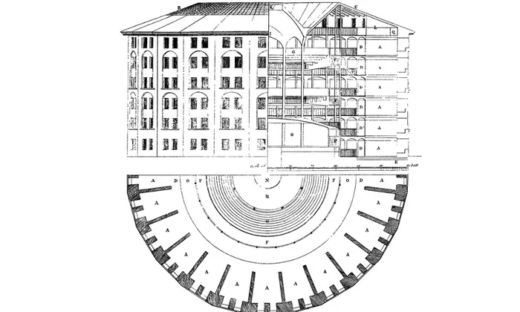
Figure 1: Bentham’s Felicific (or hedonic) calculus which is used to quantitively measure the morality of an action. This calculus demonstrates the principles of efficiency, maximization and quantification which Bentham was highly fond of.

The basic premise of the panopticon is to allow a single watchman to observe all the inmates of the prison. It achieved this by its specific design. The panopticon was a circular building which consisted of the central tower in the centre of the structure from with the watchmen observed the inmates, and the cells of the inmates which were on the outside circumference surrounding the tower. Each cell was divided, and the structure was often several floors high. From the tower, a single watchman can see into any cell, however, certain architectural nuances such as 360-degree mirrors, lights or blinds and shutters make the prisoners unable to see the watchman in the tower. What this means is that even when there is no one watching the inmates from the tower, the inmates cannot be sure whether there is someone watching them or not. This threat of constant surveillance causes the prisoners to regulate themselves, since the fact that they do not know whether they are being watched or not is equivalent to them being watched all the time.
Figure 2 – Bentham’s panopticon diagram. The original design shows the basic structure of the building: circular shape, central tower, cells on the outside of the circle, and the height of several floors.

But what could so interesting about an efficient prison? Well, Foucault (1991) argued that the panopticon is the ideal metaphor for the disciplinary society in which we live. Disciplinary power is a way in which individual bodies and populations are controlled and manipulated through discipline. Discipline has existed in the 17th century in various institutions scattered around society such monasteries barracks, however during by the end of 18th century and the beginning of 19th century it has spread throughout society (Foucault, 1991). The basic assumption behind discipline is that the body is seen and treated as a machine; the body is compartmentalized into separate parts (like cogs in a machine), these parts are then analysed, and the individuals are coerced into specific postures and movements which aim to mould their bodies according to the desires of those who exercise this power (Ibid). The technique of normalization is one of the main ways in which disciplinary power is exercised, normalization is the setting up of an ideal conduct, an ideal way of performing tasks, and subsequently punishing or rewarding individuals to the degree in which they conform to these specifications Foucault, 1991). A good example of this can be seen in how soldiers are trained, soldiers are taught to assume an upright and stiff posture, marching in a bold and systematic way with big steps, or look steadily in front of them and not be distracted by whatever is in front of them. Whilst in training, the soldiers are punished for not obeying orders and not fulfilling the tasks they are assigned to do.
Figure 4: The queen’s guard are examples of bodies which were made docile through strict discipline and meticulous control. The queen’s guards are expected to perform the standardized posture down to every minute detail (outward pointing feet, straight body and back, looking straight ahead, holding gun in particular way.
Figure 3: An abandoned prison built in the panopticon style. This image gives a sense of the visibility of every cell from the central viewing tower.

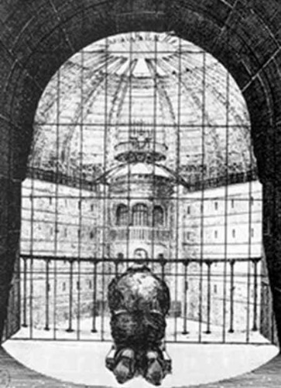
So, the panopticon could be seen as an epitome of discipline, but how does it do it? Foucault (1991) argues that it does this by being an ideal form of power which is “abstracted from any obstacles, resistance or friction” (Foucault, 1991, p.205). Whereas in the past, for the king to exercise his power over his subjects, he would need a whole system of intermediaries who would carry out the operations of his power, for example the executioner, tax collectors or the army, and there would always be a strong dichotomy between the person from which power is exercised and the person onto whom power is exercised. In the panopticon, power is being exercised directly at all times and is passed over to its surface of application (the inmates), without the possibility of resistance; the prisoner assumes responsibility for the constraints of power, “he inscribes in himself the power relation in which he simultaneously plays both roles; he becomes the principle of his own subjection” (Foucault, 1991, p.202-203). The prisoners regulate and control themselves without even the need for there to be anyone on the other side exercising power onto them. There is no need for any violence, force, or even supervision, as the structure of the panopticon ensures the inmates internalize their own subjection; the prisoners become their own oppressors. This is what Foucault meant when he talked about the panopticon as a system of complete and unresisted total domination.
Figure 5: The panoptic prison from the inmate’s perspectives, the inmate cannot see other prisoners, his main view is that of the tower, which is mysterious to him, because he doesn’t know whether it is watching him or not. This shows the prisoners hopelessness in the situation, he is under complete control.
Because the panopticon is not restricted to a building but is rather a set of principles which maximizes power by reducing the number of people who exercise it while increasing the number of those on whom its exercised, Foucault (1991) argues that the panoptic principles were destined to spread all over the social body (schools, barracks, hospitals, asylums, sports) as power attempts to further its reach and increase its efficiency; that we are living in a sort of panoptic society in which we are perpetually regulating ourselves to the needs and desires of those who run the show, not in a sort of a secret cabal of a few powerful and hidden individuals, but rather to a network of individuals who are in positions to exercise power, but who also cannot escape power being exercised onto them at certain times. Scholars such as Foucault have found that the very existence of the panopticon gives rise to all sorts of questions about the nature of the societies that we live in, how they came to be, how power is exercised, and the role in which we as individuals play in it.

References:
Army, 2018. Queen’s guard. [imagine online] Available at: https://www.army.mod.uk/news-and-events/events/2018/ceremonial/the-queens-guard/ [Accessed 08 March 2019].
Foucault, M. 1991. Discipline and Punish: The Birth of the Prison. Penguin Books: London.
The Guardian, 1995. The abandoned presidio modelo complex. [image online] Available at: https://www.theguardian.com/technology/2015/jul/23/panopticon-digital-surveillance-jeremy-bentham [Accessed 08 March 2019].
[The Panopticon] n.d. [image online] Available at: https://www.utilitarianism.com/panopticon.html [Accessed 08 March 2019].
[The Use Of Benthams Hedonistic Calculus in Daily Life Research Paper] n.d. Available at: http://hola.ibmdatamanagement.co/hedonistic-calculus/the-use-of-benthams-hedonistic-calculus-in-daily-life-research-paper.html [Accessed 08 March 2019].
Willey Reveley, 1791. Jeremy Bentham’s panopticon diagram. [image online] Available at: https://www.theguardian.com/technology/2015/jul/23/panopticon-digital-surveillance-jeremy-bentham [Accessed 08 March 2019].

Assignment 2: Gobbet
The source analysed in this gobbet is an excerpt from Angelique Hagerund’s book No Billionaire Left Behind: Satirical Activism in America. This analysis will be threefold: Firstly, it is imperative to contextualize the source in the book which it originates from and the discourse that surrounds it; secondly, provide a description of the content; and thirdly, analyse the main arguments in the source and its significance to anthropology.
The author, Angelique Hagerund, is the professor of Anthropology at Rutgers University who specializes in topics such as the cultural politics of wealth inequality, economic neoliberalism, globalization, satirical political activism and social movements. The book is an investigation of a group of satirical activists called ‘The Billionaires’ who, through ostentatious displays of billionaire stereotypes in public spaces, use satire as their preferred method of activism. Hagerund used typical Anthropological methods such as participant observation in the form of attending rallies, interviews, and speaking to bystanders and the media, to investigate who ‘the Billionaires’ were, and what they were about (Vimeo, n.d.).
The book begins by setting the scene of the modern US where income inequality is continually rising and is at the highest point in almost a century. In this economically precarious climate, Hagerund (2013) likens the Billionaires to “canaries in a mineshaft, emitting warning signals ahead of dire troubles”, and adds to this that “the Billionaires spotlight plutocracy”. The Billionaires are part of a wider discourse on the issues with Neo-liberalism and income inequality, to which they add a unique and positive take. Hagerund outlines what she takes to be the ‘core message’ of the Billionaires:
“So, at its core, I think that the billionaires story illustrates how irony can open up spaces of hope, and [that] humours gift is in a sense to show us that today’s world can be made differently, and that I think is the billionaires core message” (Vimeo, n.d.).
The chapter of the book from which the source originates is concerned with the “Great Compression” from 1945 to mid-1970s which saw a strong middle class and was the time of the lowest income inequality thanks to measures such as the New Deal, and the change in the 1980s, where the political centre of American politics shifted decisively to the right (Hagerund, 2013). Hagerund (2013) terms this subsequent era as the “gilded age”, driven by the ideology of neo-liberalism, in which the wealth of the nation becomes increasingly concentrated in the upper economic echelons, whilst the wealth of the middle and working classes is either stagnant or dwindles. Whilst the political spectrum has shifted, the public opinion hasn’t, people do not have the aversion to government services and spending that the media might portray, which leads us into the pertinent source and the example of the people expecting more governmental intervention post hurricane Katrina.
The excerpt analysed consists of three paragraphs, it begins with the longest paragraph, followed by the slightly shorter second, and finishes with a significantly shorter final one. The first paragraph opens up with an observation of the discrepancy between the people’s expectation of help from the government for the victims of hurricane Katrina, and the historical shift of the perception of ‘the market’. Hagerund (2013) notes that people expected the government to provide more help for the victims. However, she argues that this response was in contradiction to this historical shift, where in the 1980’s and 1990’s there has been a “romanticization of the market, an emphasis on self-reliance as “freedom,” and a demonization of government”. The paragraph ends with a quote by Grover Norquist who sarcastically said that he doesn’t want to “kill the government”, but rather “drown it in a bathtub”. To Hagerund, this quote epitomizes this demonization.
The second paragraph expounds on this contradiction by noting the great irony of late-twentieth and early-twenty-first century irony, that is that the dismantling of the New Deal safeguards and market fundamentalism benefit mainly large corporations and the rich, but the proponents portray it as “the route to riches for ordinary citizens”.
Hagerund (2013) uses two terms that deserve some clarification, and those are: ‘the New Deal’ and ‘market fundamentalism’. The New Deal was a series of economic reforms and regulations post 1930’s economic depression in the US, which was put in place to provide a much-needed recovery from the depression. Hagerund (2013) also uses the term ‘market fundamentalism’, a term commonly used by economist Stiglitz (2009) that refers to the belief, or arguably almost blind faith, in the ability of the free market to solve most economic and social problems.
The final paragraph argues that the use of irony by ‘the billionaires’ activist group elucidates this discrepancy in which individuals are expected to ‘sink or swim on their own’ whilst the corporations get generous tax breaks and government subsidies.
The excerpt can be reduced to three main assertions: firstly, the observation that many ordinary people don’t necessarily support a strictly free market with little to no government interaction, they merely react to buzzwords and phrases such as ‘estate tax’ or tax in general with contempt because of the negative connotations they have been laden with; secondly, a critique of Neo-liberalism and market fundamentalism by pointing out the contradiction between the claims of market fundamentalism and the reality of the situation of the free market benefiting the rich instead of the poor; and thirdly, the place of the Billionaires in relation to this contradiction.
The analysis of the components of the source reveals the way in which the ordinary people, market fundamentalists, Neo-liberalism and its benefactors, and the Billionaires activists, are all embedded within a discourse on the tension between the free market and government regulations, and the financial crises that arise from untrammelled capitalism.
Hagerund’s anthropological study of the Billionaires provides us with a number of astute insights into activism and the discourse around Neo-liberalism. Through the use of irony, the billionaires elucidate the ludicrous nature of some of the discourses. Hagerund (2013) argues that ironic humour, like rebranding the estate tax as “dynasty tax”, sometimes registers in the public and stimulates them to think critically about familiar economic narratives. Thus, the Billionaires not only criticize the presumptuous and arrogant nature of market fundamentalists, but also educate and stimulate the public to open-minded and critical examination of concepts within the discourses. Hagerund’s study illustrates the fecundity of anthropological investigation in the domain of activism.
Another untapped potential of Anthropology suggested in the analysis of the pertinent source is that of providing insight into people’s nuanced opinions. Following in the assertion that people can be confused between their explicit and uttered stances and their actual beliefs given proper information. Anthropological investigation could find out what people really believe and feel, and how the power structures operate to disseminate information and mould public opinions. All of these analyses provide an argument for the fruitfulness of the anthropological investigation of and participation in activism.
References:
Hagerund, A. (2013) No Billionaire Left Behind. Stanford University Press: Stanford.
[No Billionaire Left Behind] n.d. [video online] Available at: https://vimeopro.com/user22454323/no-billionaire-left-behind [Accessed 08 March 2019]
The University Of Edinburgh, 2009. Prof. Joseph Stiglitz: Globalisation and the 21st Century Enlightenment, The University Of Edinburgh Enlightenment Lecture Series. [video online] Available at: https://www.youtube.com/watch?v=FpYcJ4ljVuI [Accessed 08 March 2019].

