What are the current challenges that the hospitality industry is facing that is affecting business performance
BMIH5005 - Personnel Resourcing and Development
Student: Alexandra Popa
Lecturer’s name : Emma Roberts
(Research Proposal)

Table of Contents
Introduction and Background 1
Literature Review 3
Effects of Current Affairs on Recruitment and Retention 3
Review of Relevant Literature and Research 4
Industry Examples 5
Potential Solutions 6
Evaluation, Conclusion, and Recommendations 7
Reference 9
Appendix 11
SWOT analysis for Travelodge in Luton 11
PESTLE Analysis 13

Introduction and Background
Travelodge is a privately owned company that operates in the hospitality sector across the United Kingdom, Ireland, and Spain. Known as Travelodge, it holds the title of being the largest independent hotel brand in the UK with over 570 no-frills service hotels scattered throughout the country (Travelodge UK, 2023). Its reputation is built on providing comfortable and affordable accommodation for travellers, business people, and families alike (Travelodge UK, 2023). However, the author focuses specifically on Travelodge in Luton as the case for this research proposal. Luton is a city known for full of a diverse cultural background and as a booming commercial center in the UK which offers various opportunities for Travelodge as well as some challenges. By gaining more insights in the context of Luton for Travelodge, it is possible to identify some unique recruitment and employee retention issues faced by the hotel in this specific location.
Moreover, despite its success, Travelodge UK faces several challenges that require strategic attention in today's ever-changing business environment. The hospitality industry has been hit hard by the COVID-19 pandemic, causing significant disruptions to operations and financial resources (Ntounis et al., 2021), and Luton is not immune to such disruptions as already a profound impact has been found in this locality. Brexit has also brought about major challenges such as labour shortages due to changes in free movement rules and increased operational costs (Burnett & Johnston, 2020). These factors have contributed to economic instability like inflation, which has further complicated matters for Travelodge and other hotels in Luton.
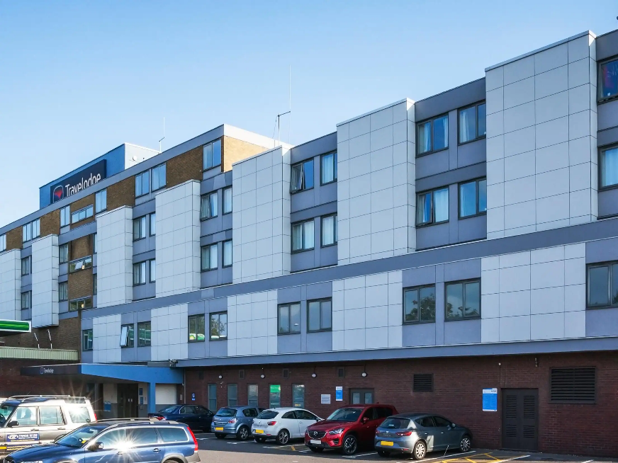
Figure 1: Travelodge in Luton
Employee retention is one of the most pressing issues facing Travelodge in Luton at present. The hospitality industry in this city already struggles with high employee turnover rates, which have been exacerbated by current challenges (Marinakou & Giousmpasoglou, 2019). Retaining competent and committed staff is crucial for ensuring sustainable operations and delivering excellent customer service (Johnston et al., 2012). Several factors could be impacting retention at Travelodge in Luton, including staff shortages leading to burnout and job dissatisfaction; inadequate training that restricts career growth; and instances of poor management practices. By addressing these concerns head-on through targeted solutions aimed at enhancing employee retention rates, Travelodge in Luton can build resilience amid ongoing industry challenges. This proposal aims to explore these issues further by developing evidence-based recommendations that will help optimise human resource practices at Travelodge in Luton.

Literature Review

Effects of Current Affairs on Recruitment and Retention
The hospitality industry, specifically Travelodge in Luton, has been significantly affected by current events such as Brexit, the COVID-19 pandemic, and inflation. These external factors have caused turbulence in recruitment and retention practices within the industry.
Brexit's implications have caused a seismic shift in the UK's hospitality sector, with Travelodge in Luton being no exception. The overlal UK industry previously relied heavily on EU workers who constituted approximately 12.3% of the workforce (Burnett and Johnson, 2020). Since the end of free movement, there has been reduced access to this vital demographic resulting in a labour shortage that has put pressure on existing staff leading to burnout and job dissatisfaction which negatively impacts retention (Niedermayr, 2022).
The COVID-19 pandemic has had a devastating impact on the global hospitality industry with mandatory lockdowns and travel restrictions causing mass redundancies and furloughs in hotels including Travelodge in Luton. The pandemic's unpredictable nature has made forecasting business operations challenging leading to uncertainty among employees which directly affects employee retention (Ntounis et al., 2021). Furthermore, stringent health and safety protocols have added new criteria for recruitment while reducing occupancy rates has decreased demand for certain roles while increasing demand for others such as housekeeping due to increased sanitation standards (Sharma et al., 2021).
Inflation rates rising in the UK have further compounded challenges faced by hotels such as Travelodge and other hotels in Luton, with increased operational costs putting financial pressure on businesses leading to less budget available for competitive salaries and benefits which are key to attracting and retaining employees (Polat and Sevil, 2022). Additionally, wage dissatisfaction can arise if salaries do not adjust accordingly leading to employee dissatisfaction affecting their decision to stay with the company hence impacting retention (Michael and Fotiadis, 2022).
These external factors present complex challenges for human resource management at Travelodge in Luton requiring them to find a balance between maintaining operational viability while ensuring employee satisfaction amidst turbulent times.

Review of Relevant Literature and Research
The hospitality industry has long been plagued with recruitment and retention issues that have prompted numerous research studies to explore the matter. These studies have yielded valuable insights that can be applied to Travelodge in Luton's case.
One recurring theme in the literature is the relationship between employee engagement, satisfaction, and retention. Marchington et al. (2016) stated that a satisfied and engaged workforce is crucial for maintaining high retention rates. They posit that factors such as a positive work environment, development opportunities, and competitive remuneration packages significantly influence an employee's decision to stay with a company. Besides this, effective leadership and management practices also play a critical role in retention. Armstrong and Taylor (2020) argue that strong leadership practices, including supportive supervision, regular feedback, and fair treatment, contribute to higher employee retention rates. These findings are consistent with concerns raised at Travelodge in Luton regarding management practices.
In terms of recruitment efforts, employer branding has emerged as an increasingly important factor in attracting talent. In a competitive labour market, organizations need to differentiate themselves by communicating an attractive organizational culture and values (Itam et al., 2020).
Research specifically focused on COVID-19 suggests that organizations should prioritize employee well-being initiatives along with flexible work arrangements during crises to retain staff (Aldridge, 2023). Similarly, Kuppuswamy (2022) suggests creative compensation strategies should be adopted during inflationary times.
Overall it is clear that complex internal & external factors affecting recruitment & retention in the hospitality industry which requires proactive HR strategies like effective leadership practices; employer branding; adaptability in the face of external disruptions etc. These insights provide a solid foundation for examining Travelodge in Luton's specific context and proposing targeted solutions.

Industry Examples
The current recruitment and retention challenges in the hospitality industry have prompted several prominent hotel chains to adopt innovative strategies. These examples provide valuable lessons that Travelodge in Luton can learn from.
Marriott International responded to the labour shortage following Brexit by investing in local talent development. In the UK, they launched the 'World of Opportunity initiative, which includes apprenticeships, internships, and management training programs aimed at attracting and developing local talent (Selin, 2022). This approach not only addresses the recruitment challenge but also improves retention by providing clear career progression pathways. Their strategy is a perfect example of how innovation can help solve workforce challenges (Selin, 2022).
Intercontinental Hotels Group (IHG) has placed a strong emphasis on employee well-being during the COVID-19 pandemic. They implemented flexible working policies and provided mental health support for their employees. IHG also communicated transparently about the company's situation and plans, fostering a sense of security and belonging among employees that is crucial for retention in uncertain times (Song, 2023).
The Radisson Hotel Group's commitment to employee well-being serves as a testament to how companies can balance their business objectives while prioritizing their employees' welfare. Despite facing inflation and cost-cutting pressures, the company managed to retain its staff by implementing creative compensation strategies. Apart from offering competitive salaries, the hotel group provides non-monetary incentives like discounted hotel stays, meal allowances, and recognition programs that enhance employee satisfaction (Nitin et al., 2023). These benefits are a prime example of how organizations can inspire their workforce even with limited financial resources.
In the hospitality industry of Luton, there are some notable efforts are being seen as local hotels are tackling the difficulties of recruiting and retaining employees in effective ways. One example worth mentioning here is the outstanding initiative taken by Hilton Luton (Portes, 2022). The company have established a smart alliance with nearby hospitality schools and colleges while offering students of the relevant organisations some opportunities to gain hands-on training and internships in their hotel. This partnership provided budding professionals with practical experience at the same time established a talent pool for Hilton Luton, guaranteeing a consistent influx of skilled individuals.
These instances demonstrate that despite the prevailing recruitment and retention challenges in the hospitality industry, specifically in Luton, innovative methods that cater to employee needs can help hotels navigate these concerns with ease. By prioritizing staff welfare through various perks and benefits, companies can foster an engaged and motivated workforce while achieving their business goals.

Potential Solutions
The hospitality industry is a challenging one, and Travelodge in Luton is no exception. The hotel in this city are currently grappling with the intricate and diverse problems of recruitment and retention. Nevertheless, there are a variety of potential solutions that could be employed to effectively tackle these issues.
One potential solution to consider for Travelodge in Luton is the approach successfully implemented by Marriott, which involved investing more in employee development. In Luton, for example, Hilton Luton and other local hotels have established comprehensive training programs in collaboration with nearby hospitality schools and colleges. Such programs offer students hands-on training opportunities and internship programs (Song, 2023). Taking inspiration from these, Travelodge UK in Luton can also start similar initiatives to cultivate a strong sense of loyalty and commitment among its employees at the same time simultaneously attracting local talent. Such an approach has the potential to elevate the workforce by producing more skilled and dedicated workers (Inman, 2017).
Another solution lies in prioritizing employee well-being amidst the ongoing pandemic-induced stress and uncertainties. The International Hotel Group (IHG) provides an excellent model for this by offering flexible working arrangements, mental health support initiatives, and transparent communication about company plans (Song, 2023). By adopting similar strategies, Travelodge in Luton can create a supportive work environment that prioritizes its employees' mental and physical health while boosting staff morale and retention.
Creative compensation strategies can also be employed to address inflation-related challenges. For example, Radisson has successfully offered non-monetary benefits such as discounted hotel stays, meal allowances, and recognition programs as part of its compensation package (Nitin et al., 2023). These benefits add value to the package while improving employee satisfaction and retention by showing appreciation for their contributions (Johnston et al., 2012).
Finally, improving leadership and management practices can greatly enhance retention rates at Travelodge in Luton. Adequate training for managers should be provided alongside regular feedback sessions with employees institutionalized to ensure fair treatment of employees in an empathetic manner that promotes growth within an inclusive workplace culture (Torrington et al., 2020).
In conclusion, prioritizing proactive employee-centric approaches is key to mitigating recruitment and retention challenges faced by Travelodge in Luton during these turbulent times successfully. Despite external environmental turbulence caused by the ongoing pandemic crisis or other factors like inflation rates etc., valuing employees' needs remains crucial for navigating through these adversities effectively.

Evaluation, Conclusion, and Recommendations
The analysis conducted on Travelodge in Luton has revealed some significant findings. External challenges such as Brexit, the COVID-19 pandemic, and inflation have created considerable obstacles in the hospitality industry's effective recruitment and retention. These challenges have further complicated the human resource landscape, which has already inherent issues.
Due to Brexit, there is a labour shortage because of the cessation of free movement. This has made recruitment more challenging and expensive (Burnett and Johnston, 2020). The COVID-19 pandemic has disrupted business operations and caused uncertainties around job security, negatively impacting employee retention (Ntounis et al., 2021). Inflation has led to increased operational costs and wage dissatisfaction, further affecting both recruitment and retention (Michael and Fotiadis, 2022).
These findings have implications that cannot be ignored for Travelodge in Luton. If these challenges are not addressed, they could lead to high turnover rates, low employee morale, and declining service quality at the hotel negatively impacting its reputation and financial performance.
Based on these findings, several recommendations are proposed:
- Invest in Employee Development: Implement training programs and apprenticeships to attract local talent while addressing labour shortages due to Brexit. Provide clear career progression pathways to foster employee loyalty.
- Prioritize Employee Wellbeing: Develop a robust employee wellbeing program providing support through ongoing uncertainties like mental health support, and flexible working arrangements.
- Implement Creative Compensation Strategies: Consider non-monetary benefits like discounted hotel stays or meal allowances to counteract inflation's effects.
- Improve Management Practices: Address concerns over management by providing regular feedback sessions while ensuring fair treatment of employees at Travelodge in Luton.
- Benchmark Successful Practices: Learn from industry examples like Marriott or IHG who have successfully navigated similar challenges in the hospitality industry in Luton.

In conclusion, while these current challenges are formidable for Travelodge in Luton; however with proactive human resource management strategies such as investing in employee development programs or prioritizing employee well-being can help navigate these turbulent times leading to a strong workforce committed towards Travelodge in Luton's success.

Reference
Aldridge, K., 2023. Increasing Employee Retention and Satisfaction in a Post-COVID-19 World.
Armstrong, M. and Taylor, S., 2020. Armstrong’s Handbook of Human Resource Management Practice. London, United Kingdom: KoganPage.
Boella, M.J. and Goss-Turner, S., 2019. Human resource management in the hospitality industry: A guide to best practice. Routledge.
Burnett, M. and Johnston, T., 2020. Brexit anticipated economic shock on Ireland’s planning for hospitality and tourism: resilience, volatility and exposure. Tourism Review.
Hall, D., 2020. Brexit and tourism: Process, impacts and non-policy (Vol. 86). Channel View Publications.
Inman, M., 2017. Unlocking human resource management. ROUTLEDGE.
Itam, U., Misra, S. and Anjum, H., 2020. HRD indicators and branding practices: A viewpoint on the employer brand building process. European Journal of Training and Development, 44(6/7), pp.675-694.
Johnston, R., Clark, G. and Shulver, M., 2012. Service Operations Management: Improving Service Delivery. Harlow, England: Pearson.
Kuppuswamy, D., 2022. Changing Skills of Human Resource Professionals and Challenges in Employee Retention in the Age of Great Resignations: An Analysis of Trends and Factors. Journal of Positive School Psychology, 6(2), pp.6190-6194.
Marchington, M. et al., 2016. Human Resource Management at Work. London: Chartered Institute of Personnel and Development.
Marinakou, E. and Giousmpasoglou, C., 2019. Talent management and retention strategies in luxury hotels: evidence from four countries. International Journal of Contemporary Hospitality Management.
Michael, N. and Fotiadis, A.K., 2022. Employee turnover: The hotel industry perspective. Journal of Tourism, Heritage & Services Marketing (JTHSM), 8(1), pp.38-47.
Niedermayr, J., 2022. Brexit and COVID-19: An analysis of two challenges in the starting years of an internationally operating start-up.
Nitin, S., Ramesh, R. and Joseph, K., 2023. An Analysis of Human Resource Practices: A Comparison between the Hospitality Industry and Other Sectors. i-Manager's Journal on Management, 17(3), p.30.
Ntounis, N., Parker, C., Skinner, H., Steadman, C. and Warnaby, G., 2022. Tourism and Hospitality industry resilience during the Covid-19 pandemic: Evidence from England. Current Issues in Tourism, 25(1), pp.46-59.
Polat, A. and Sevil, T., 2022. The Impact of Economic Variables on the Travel and Leisure Industry of Japan, the USA, Germany, and the UK. Business and Economics Research Journal, 13(3), pp.403-415.
Portes, J., 2022. The economics of Brexit: what have we learned. CEPR Press.
Selin, J., 2022. More than Just a Workplace: A Case Study of Diversity, Equity, and Inclusion in Marriott International Inc. Hotels.
Sharma, G.D., Thomas, A. and Paul, J., 2021. Reviving tourism industry post-COVID-19: A resilience-based framework. Tourism management perspectives, 37, p.100786.
Song, X., 2023. Employee Satisfaction during the Pandemic: A Content Analysis of Online Reviews on Full-Service Hotel.
Torrington, D. and Hall, L., 2020. Human Resource Management. 10th edn. Harlow: Pearson Education.
Travelodge UK, 2023. Our company, Travelodge. Available at: https://www.travelodge.co.uk/about/our-company/ (Accessed: 14 May 2023).

Appendix

SWOT analysis for Travelodge in Luton
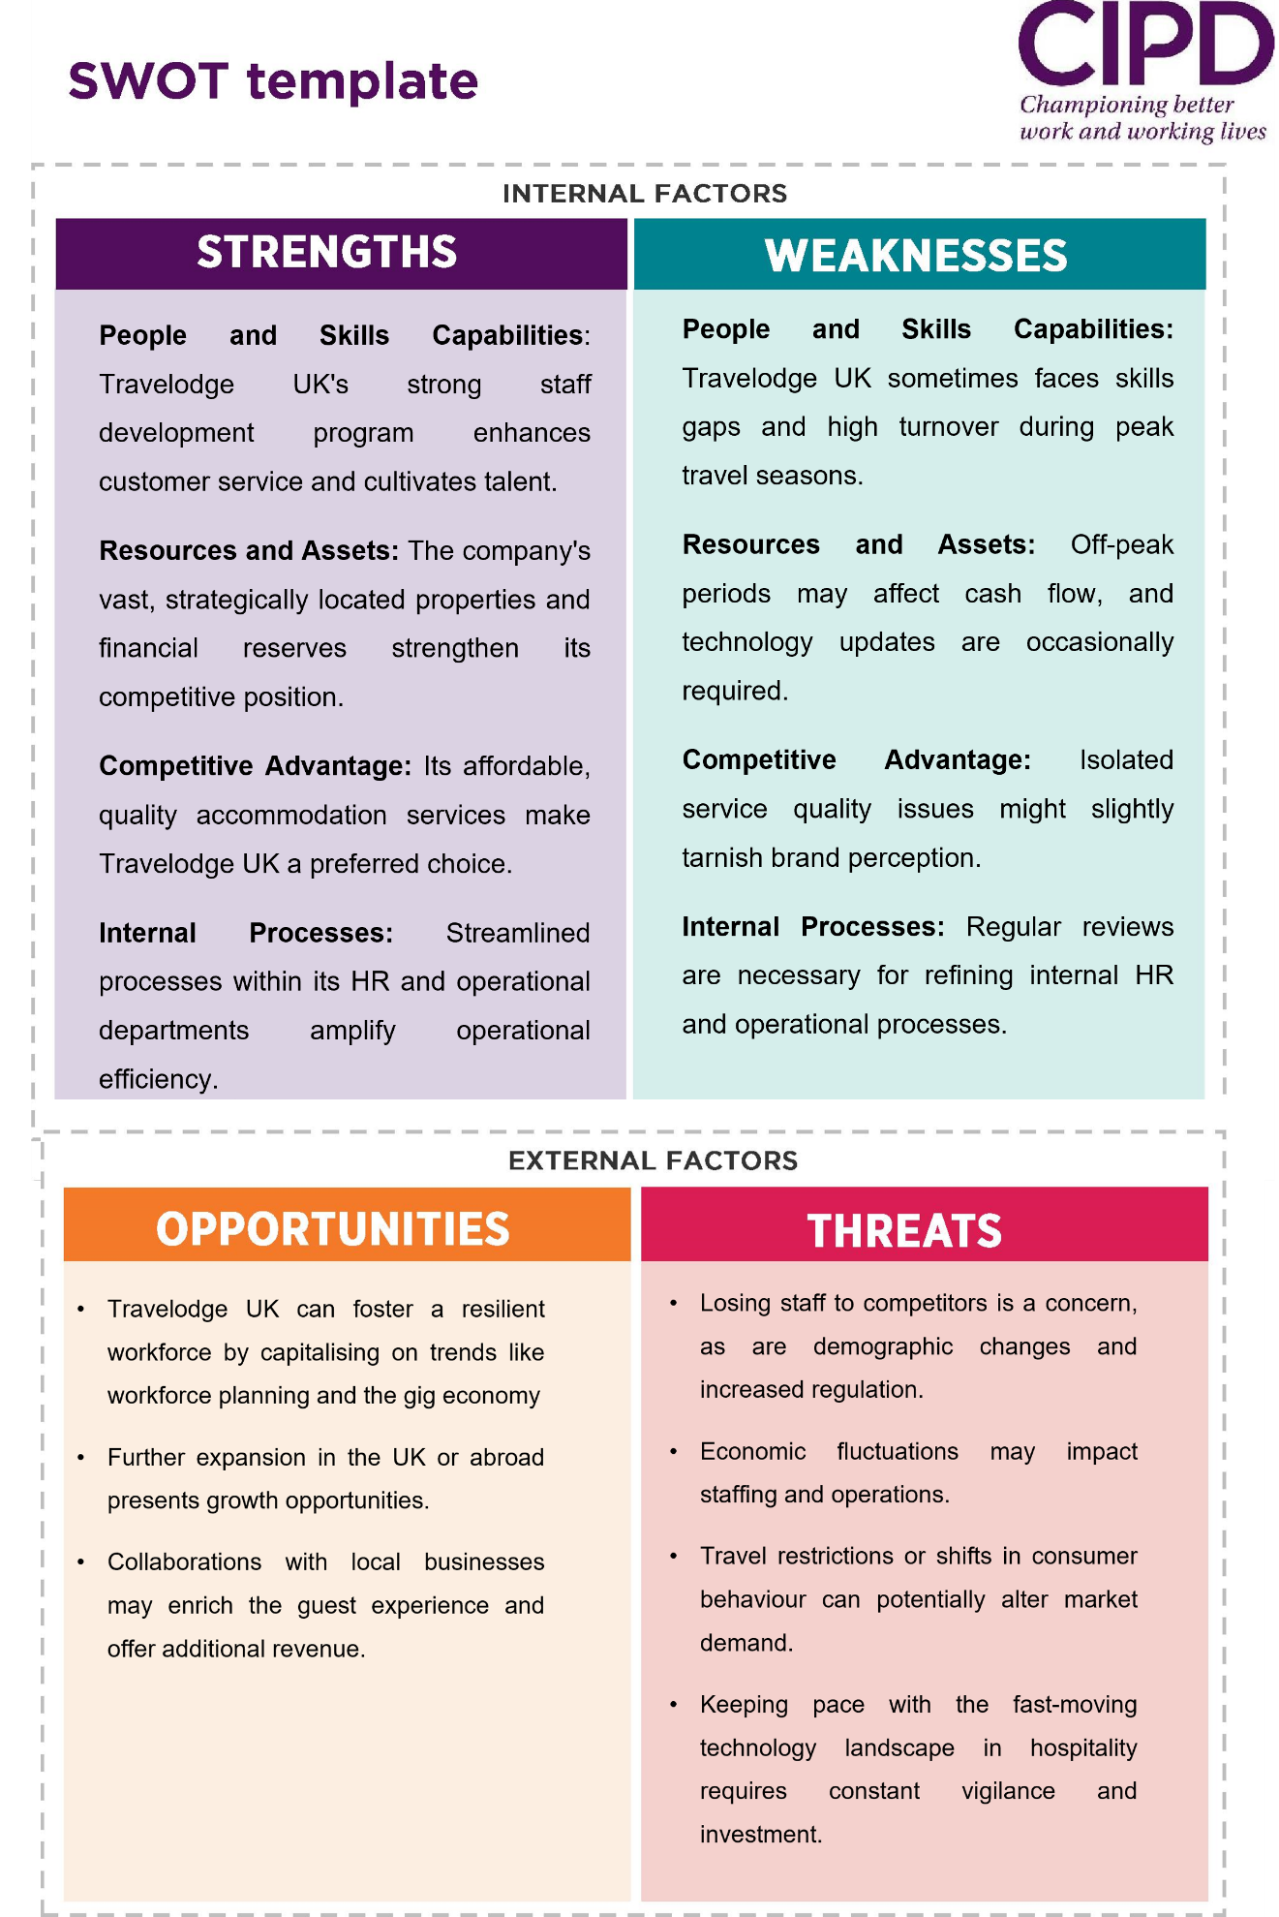

PESTLE Analysis


