Encouraging more young women to attend their cervical screening tests
Throughout the planning and reflection of our campaign I chose to use Gibbs reflective cycle. The Gibbs reflective cycle is used to think systematically about specific phases of an experience (Oxford Brookes University, 2019), which is then divided into sections to compose an in depth reflection (Gibbs, 1988). The order in the cycle is the description of what happened, your feelings throughout the experience, the evaluation of the positive and negative points, analysis of the experience, a conclusion, and finally what your action plan is if the opportunity arose again (Gibbs, 1988).
Our group decided that a health issue which is currently affecting our local communities, is the lack of young women attending their cervical screening appointments, otherwise known as smear tests. We decided that we would therefore plan a campaign where we would educate and promote the importance of cervical screening, with the hope that more young women would attend appointments. The National Health Service (2019) defines cervical screening as a test that helps prevent cervical cancer by checking for abnormal cells, which enables doctors to treat them before the risk of developing into cancer. According to Donnelly (2018), last year, the rate of women attending smear tests had fallen to its lowest in twenty one years, meaning that despite campaigns already existing, there is a gap for our campaign to encourage positive awareness of cervical screening.
We decided to present this information via Google slides as it was an application that everyone could access and update at our own convenience.
Description
Within our group, we were all assigned an area of research, ensuring that between us we would cover all aspects of our planned campaign. I chose to research the impact of social media, as we all agreed that I held the most knowledge in this area and would be able to reach the target audience without creating an ecological footprint. As for the rest of the group, Kemi discussed scare tactics, Codie discussed how we would measure the effectiveness of our campaign, Cerys discussed the impact on the community, and Vicky discussed how our campaign compares to other campaigns with the same aim. Finally, Niomi discussed to pro’s and con’s of our entire campaign, while also covering the introduction to our presentation.
I started my research on the impact of social media and the benefit it could have on our campaign. Dubras (2019) highlighted that social media is part of everyday life for the majority of individuals who has access to it, which could prove to be a valuable way to promote our campaign, as opposed to promoting it in a doctors surgery where the average amount of individuals only visit their General Practitioner (GP) six times a year (British Medical Association, 2017). Wakefield et al (2010) review would support these comments as it concludes that mass media campaigns can produce positive changes in health-related behaviours across large populations from using the form of media as appropriate promotion, with one of the most common examples being the decreasing use of tobacco. Wakefield et al (2010) does however highlight that campaign messages can fall short if the information is portrayed “boring”, hindered by inadequate funding, or if the messages are not persuasive enough for more opinionated audiences. From this research it was clear that one of my main objectives to promote our campaign via media, was to ensure it was engaging, consistent, and incorporated lighthearted humour to relate more to our target female audience aged 16-30. Beard (2008) comments would support my objective above as he suggests using humour in advertising can help attract more attention and create awareness of the brand. It is also important that the humour included is designed around your brand context (Beard, 2008). With this in mind I decided to create quotes, such as “Don’t be a diva, it’s only a beaver” and “Spread your knees, let’s beat this disease”. I also created quotes with less humour to ensure our page was consistent in design and to ensure serious information is presented. An example of this is “A smear test lasts 5 minutes, the impact of cervical cancer lasts a lifetime”. This quote in particular also tied in with Kemi’s idea of using scare tactics to educate our target audience of the type of risks they face from not attending their tests.
I went on to identify what techniques would work best for our campaign. The group discussed a range of methods which we could use to broadcast our information, to which we agreed the social media platform “Instagram” would be the most ideal for our target group. Clement (2019) distribution of instagram users findings would support this decision, with 16-34 year olds using the platform more than any other age groups.
I then designed our logo to ensure it was relatable to our brand and cost efficient, while being designed with simplicity as I wanted our logo to be remembered easily such as the pink breast cancer awareness ribbon. Airey (2015) states that logos which include symbols are understood easier by those who may not know what your brand is about. I also took the time to plan out our instagram posts to make them consistent with our logo, engaging, and be appealing to the eye.
Feelings
I was pleased when the group agreed that I would research the impact of social media, as knowing my strengths I believed I would excel with this topic and complete this section to a high standard. I was pleased to see how professional the instagram page turned out, including the logo and the consistent design throughout the posts. It is possible that I spent too much time designing the page and including such little details as when I showed the group, they did not notice them at first glance. An example of this is where I created six logos and discussed with the group what we felt worked best to consider their opinions, where as I could have just designed one and saved time. Wheelan (2013) does however state that considering different perspectives helps consider any possible issues that have not already been considered. It is also a way to consider what is valuable to your campaign members, to create something that is of similar understanding to your target audience (Ingram et al, 2008).
Evaluation
At the start of our presentation it was unfortunate that while trying to set up our slides, the computer was displaying a message that it could not connect to Google due to “cookies not being allowed”. This was an unexpected scenario which we had no control over. It was fortunate however that I was able to fix the issue and the panel was not waiting too long for us to get this fixed.
In personal evaluation, I feel that I did well to cover all aspects of my section and took it upon myself to include extra details, which I feel complimented the overall presentation of my work. I believe that as a result of me being well informed of the topic I had a positive experience where I could focus on my presentation skills. This experience therefore helped me develop my own personal skills such as communication and teamwork.
I believe that as a majority, our group worked well together and regularly communicated throughout our planning, however there were some group members who contributed less and I believe this became apparent in the actual presentation.
Analysis
To analyse my above evaluation of our group work, Wheelan (2013) states that within group work all members have to interact with one another in order to have a successful outcome as a group, and this is a factor where our group may of fallen short. Buckingham (2007) supports this statement as he proclaims that groups who collaborate together are more effective than groups who have disconnected individuals. I believe that due to this it resulted in our campaign missing important information, and may of mislead panel viewers as to what our campaign was about.
Conclusion
On reflection, I could have included more information on why we used instagram, while highlighting features of the app in more detail. I also could have presented our campaign on other platforms, however I initially chose not to do this as the group decided that instagram matched the age demographic we were targeting. There were other sections in the campaign which left areas for improvement and where important information was lost or missed out, which could have been added by other group members.
Action Plan
On receiving feedback, I am pleased with the overall result and agreed with the feedback. I was happy to receive positive comments recognising my effort throughout our presentation. I was disappointed to read the negative comment on me wearing a hat during the presentation as I did not think that my attire would be taken into consideration. Had I been aware of this prior, I would have removed it as I now understand this could be considered as unprofessional, and I now know for future presentations going forward. If I were to change anything else it would be to present my information without hesitation as prior to our presentation the group emphasized how we only had a short amount of time to present. This resulted in me rushing my part and not including certain information. This was made apparent when questioned about individuals who would not be informed of our campaign due to them not using instagram, to which I had originally planned to cover in my section.
Overall I believe our choice of using instagram was the best possible tactic we could use to reach our age demographic, and other methods would not of been as successful. I think our campaign could go on to be valuable to young women, however I am not certain on how we could effectively measure this going forward, other than using features already present on the Instagram app.
References
Airey, D. (2015). Logo, Design, Love. 2nd Edition. New Riders, United States of America. Pages 1-16.
Beard, F.K. (2008). Humour in the Advertising Business. Rowman and Littlefield Publishers, Maryland. Page 128.
British Medical Association. (2017). General Practise in the UK. Published PDF (Page 3) available at https://www.bma.org.uk/connecting-doctors/search?q=general%20practice%20in%20uk%202017#serpq=general%20practice%20in%20uk%202017&serp=2 [Accessed on 02/12/19]
Buckingham, M. (2007). Go Put Your Strengths To Work. Free Press, New York. Page 50-64.
Clement, J. (2019). Distribution of Instagram users worldwide as of October 2019, by age group. Available online at https://www.statista.com/statistics/325587/instagram-global-age-group/ [Acessed on 08/12/19]
Donnelly, L. (2018). Cervical cancer screening rate falls to lowest for at least 21 years. Available online at https://www.telegraph.co.uk/news/2018/11/27/cervical-cancer-screening-rate-falls-lowest-least-21-years/ [Accessed on 02/12/19]
Dubras, R. (2019). Digital in the UK: data and learnings for 2019. Available online at https://wearesocial.com/uk/blog/2019/03/digital-in-the-uk-data-and-learnings-for-2019##targetText=Overall%2C%20the%20penetration%20of%20social,everyday%20life%20in%20the%20UK.
Gibbs, G. (1988). Learning by Doing. Further Education Unit, Great Britain. Page 1-129.
Ingram, T.N., LaForge, R.W., Avila, R.A., Schwepker, C.H., and Williams, M.R. (2008). Professional Selling. 4th Edition. Thomson South-Western, United States of America. Pages 1-287.
National Health Service. (2019) What is cervical screening. Available online https://www.nhs.uk/conditions/cervical-screening/ [Accessed on 02/12/19]
Oxford Brookes University. (2019). Reflective Writing. Available online at https://www.brookes.ac.uk/students/upgrade/study-skills/reflective-writing-gibbs/ [Accessed on 04/12/19]
Wakefield, M. A., Loken, B., & Hornik, R. C. (2010). Use of mass media campaigns to change health behaviour. Lancet, London. 376(9748), 1261–1271. doi:10.1016/S0140-6736(10)60809-4
Wheelan, S.A. (2013). Creating Effective Teams. 4th Edition. SAGE, London. Pages 1-103
Appendices
Appendix 1 - Logo
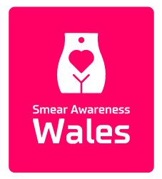
Appendix 2 - Instagram Page
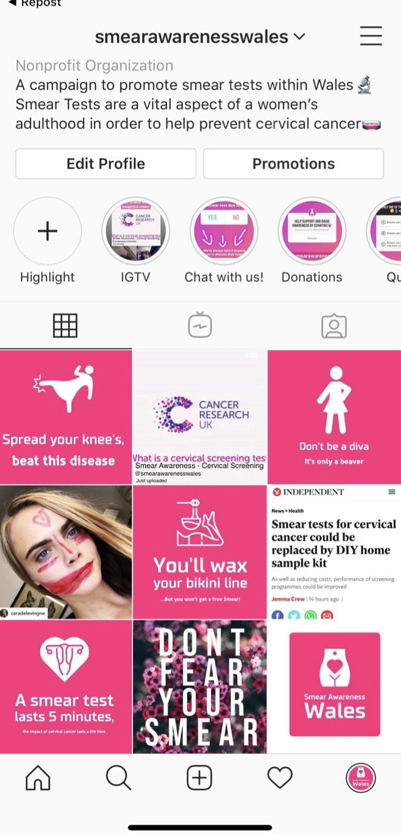
Appendix 3 - Example of our posts on instagram using multiple different features
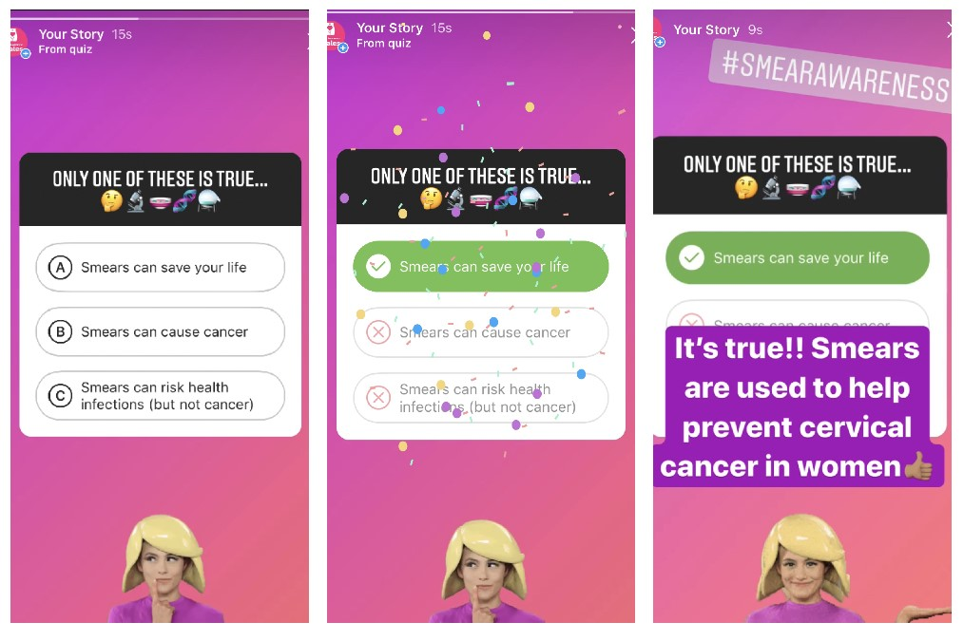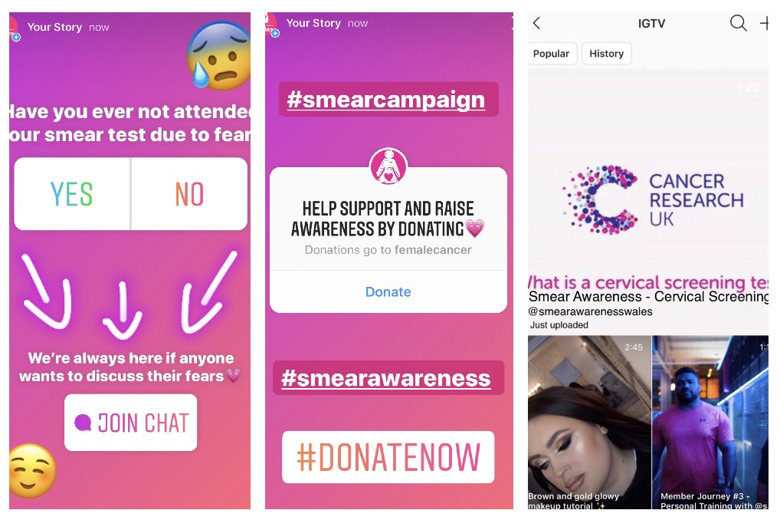
Appendix 4 - Example of how we could manage funding to promote our campaign, while still targeting our age demographic.


