3/24/2025
University of Wales Trinity Saint David
London campus
E-Portfolio Link: https://2542914.wixsite.com/e-portfolio-hub
Module Name: Learning In the Digital Era
Module Code: ACCA 4025

Student Name: Mohammed Saleem
Student ID:2542914
Group: 2

Lecturer’s Name: Suneth Ferdando

LDE Assignment 1
E-Portfolio
Table of Contents
Introduction 2
Main Body 2
Task 1: Essential Academic and Employment Skills for the future career Path 2
Task 1 (a): Report on Essential Academic and Employment Skills 2
Task 1 (b): Evaluation of Task 1 (a) based on Similarity report 2
Task 2: Collaborative Mind Map and Individual Poster 2
Mind Map (Collaborative) 2
Poster (Individual) 2
Task 3: Virtual Collaboration and RefWorks 2
Report on Virtual Collaboration 2
Step-by-step process of using RefWorks with visuals 2
Task 4: E-Portfolio Creation and Evaluation 2
Task 4 (a): E-Portfolio Creation 2
Task 4 (b): Illustrative Review of E-Portfolio tool Selection 2
Conclusion 2
References 2
Task 1 References: 2
Task 3 References: 2

Introduction

Main Body

Task 1: Essential Academic and Employment Skills for the future career Path
Essential Academic Skills

Academic skills are essential for students because they encompass a wide range of abilities required for success in higher education. These skills enable students to engage effectively with disciplinary content, think critically, communicate ideas clearly, and solve complex problems. Academic skills also support self-regulated learning and encourage active participation in scholarly communities.
Mastering academic skills is closely linked to student achievement in higher education. These skills include literacy, critical thinking, analysis, problem-solving, and effective communication. They help students construct meaning from information, develop independent ideas, and demonstrate a deeper understanding of their subject areas. Furthermore, academic skills allow students to participate actively in academic communities and reach their full academic potential.
Research has shown that academic skills play an important role in student wellbeing and mental health. Not only do they improve academic performance, but they also enhance students’ sense of belonging and reduce feelings of anxiety. For students from diverse backgrounds, academic skills support both social and emotional development, helping them succeed in higher education. However, studies have found that students often experience significant stress and anxiety when they are expected to develop academic competencies without adequate support. This highlights the importance of providing timely and accessible academic skills assistance, particularly during the transition into the first year of university.
Wellbeing refers to positive psychological functioning, while mental health encompasses both the presence of positive emotional states and the absence of mental illness or distress. The relationship between academic skills and student mental health has become an increasingly important area of higher education research. Evidence suggests that possessing strong academic skills can reduce levels of stress, anxiety, and depression while promoting positive mental health outcomes. Conversely, students who struggle to meet academic expectations may experience increased psychological distress.
To address these challenges, universities should integrate academic skills support with mental health services. Holistic programmes that address both the cognitive and emotional aspects of learning can help students manage the demands of higher education more effectively. By providing students with the tools, strategies, and support they need, universities can create learning environments that promote both academic success and psychological resilience. [1]

Employability Skills

Employability is about making connections between study, personal development and other activities in order to find, gain and be successful in your chosen career, and contribute to society. Developing a strong employability profile will make you much more employable and successful in your career.it play very important role in your career.
Employability in the 21st century has changed significantly, especially in the digital era. Many experienced employees have been replaced by newer workers because they lacked digital literacy skills. The COVID-19 pandemic further transformed employability requirements and workplace practices. New ways of working, such as remote working and hybrid working, became common after the pandemic. Today, many companies allow employees to work from home either full-time or through hybrid arrangements, combining office-based and remote work.
he importance of developing a set of essential skills for individuals to thrive in education, employment and entrepreneurship has been long documented. Technical Skills: skills that are specific to a particular sector or role, sometimes drawing from a particular body of knowledge. These skills are not easily transferred beyond the sector or role to which they relate.
These skills are very developed across a lifetime which makes using an accessible term important. If, say, language of employability teaches or introduced to parents or teachers of children as age of 3 years old. it would be inappropriate for that stage of their development. But when we use the term ‘essential’ from a young age and then continue this into Further and Higher Education and into employment, essential skills can be understood by all.

The implications of this gap in employability skills extend beyond academia and directly impact graduates' employability prospects and long-term career trajectories. The disconnect between what universities impart and what the labour market demands underscores the urgency to bridge this gap. Failure to address this issue could lead to prolonged periods of unemployment, reduced workforce productivity, and the economic stagnation, impacting both regional and global contexts. Consequently, there is a compelling need for comprehensive research to explore and understand the intricacies of this mismatch and propose viable solutions to align employability skills with current and future workplace demands. [2]

References

[1] | J. d. Henau, “University of Oxford,” October 2024. [Online]. Available: https://www.ctl.ox.ac.uk/sites/default/files/ctl/documents/media/academic_skills_literature_review.pdf. [Accessed 18 June 2026].
[2] | Hasanuzzaman Tushar;Nanta Sooraksa, “Sciencedirect.com,” November 2023. [Online]. Available: https://www.sciencedirect.com/science/article/pii/S2405844023082312. [Accessed 18 June 2026].

https://www.ctl.ox.ac.uk/sites/default/files/ctl/documents/media/academic_skills_literature_review.pdf

https://www.sciencedirect.com/science/article/pii/S2405844023082312

Task 1 (a): Report on Essential Academic and Employment Skills

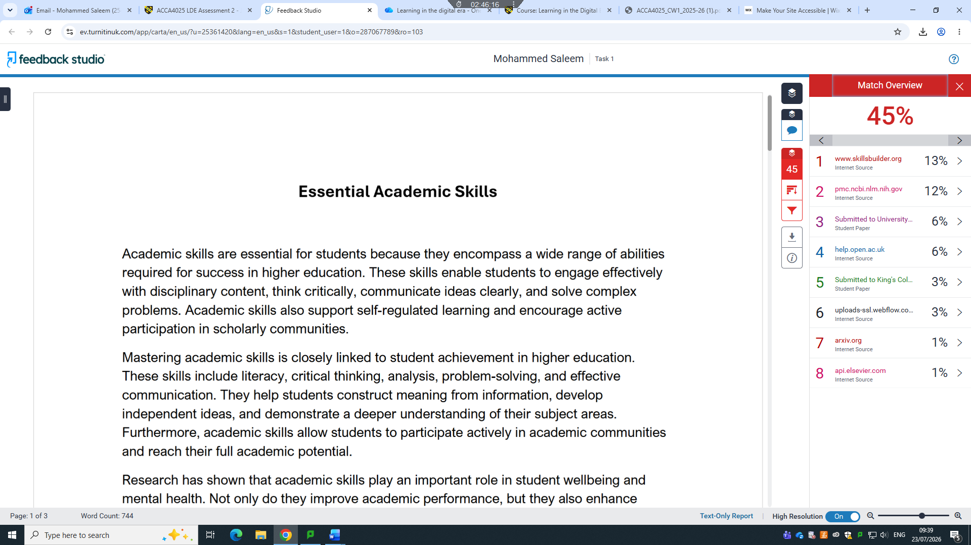

Task 1 (b): Evaluation of Task 1 (a) based on Similarity report

Regarding my similarity score: I can't honestly state that this text has a 45% similarity score because this is my first time to submit the assignment to Turnitin. I was using some tools get ideas, might have same wording in article. I don't have access to plagiarism detection databases or software that calculates verified similarity percentages. If you check this paragraph in a tool such as Turnitin, the reported score will depend on that tool's database and matching criteria. I instructor specifically requires a target similarity percentage, I need to verify it with the required plagiarism checker rather than relying on an estimated value.

Task 2: Collaborative Mind Map and Individual Poster

Mind Map (Collaborative)
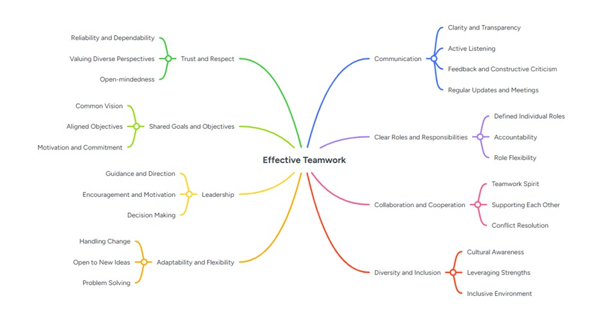

Poster (Individual)
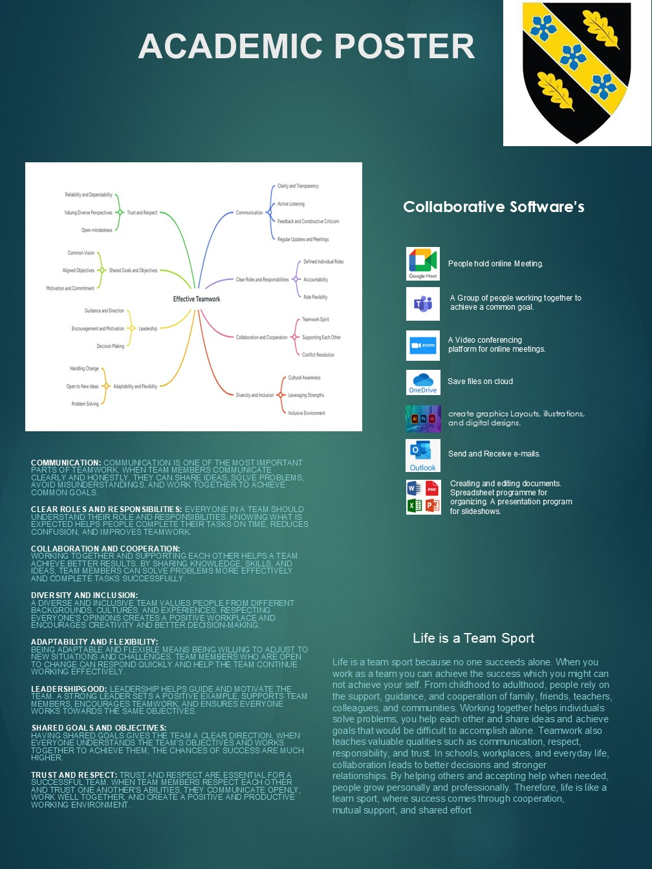

Task 3: Virtual Collaboration and RefWorks

Report on Virtual Collaboration

Riding the storm
Financial advisors play a vital role in helping households make informed financial decisions and manage their investments. However, unethical behaviour among financial advisors remains a significant concern, negatively affecting both individual investors and the broader economy. This study investigates whether experiences with natural disasters influence the likelihood of financial advisor misconduct. Using a panel dataset of U.S. investment advisors combined with data on natural disaster occurrences, the findings reveal a significant positive relationship between disaster experiences and advisor misconduct. Interestingly, exposure to less severe disasters is more strongly associated with unethical behaviour than exposure to severe disasters.
Possible explanation surviving less severe disasters increases advisors’ confidence in managing uncertain situations. Confidence may can involve high risk-talking or increasing likelihood of professional misconduct. Study showed the advisors with more disaster experiences try to work in branches overall misconduct rates. Suggesting that individual experiences might contribute to broader organizational behaviour.
Financial advisory industry is essential for support household financial planning and tell how to manage substantial investment assets. Despite industry face widespread challenges undermine investor trust. Whether natural disaster experiences increase or decrease. To address this issue, the study exploits variations in disaster across advisors, firms, cities, and years to identify the relation between disaster experiences and misconduct.
Previous researched showed how advisor characteristics such as age, gender, political ideology, and professional qualifications influence misconduct. Other studies have explored the effects of workplace culture, colleagues' misconduct, criminal history, training programs, and regulatory oversight. However, little attention has been given to the role of unexpected external events such as natural disasters. This study addresses that gap by demonstrating how exogenous natural shocks can shape professional behaviour.
This research has also showed broader literature natural disasters and decision-making. Because studies showed focused on corporate executives and their responses to the disaster experiences, study extends the analysis to financial advisors. While earlier studies have primarily focused on corporate executives and their responses to disaster experiences, this study extends the analysis to financial advisors, whose recommendations directly influence investment decisions and financial market outcomes. By highlighting the relationship between disaster experiences, risk-taking, and unethical conduct, the study provides new insights into how external shocks can affect professional behaviour within the financial services industry.

Step-by-step process of using RefWorks with visuals
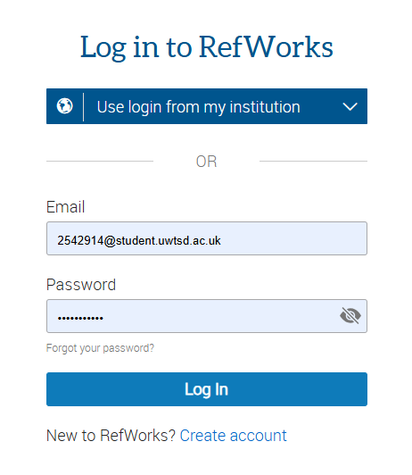
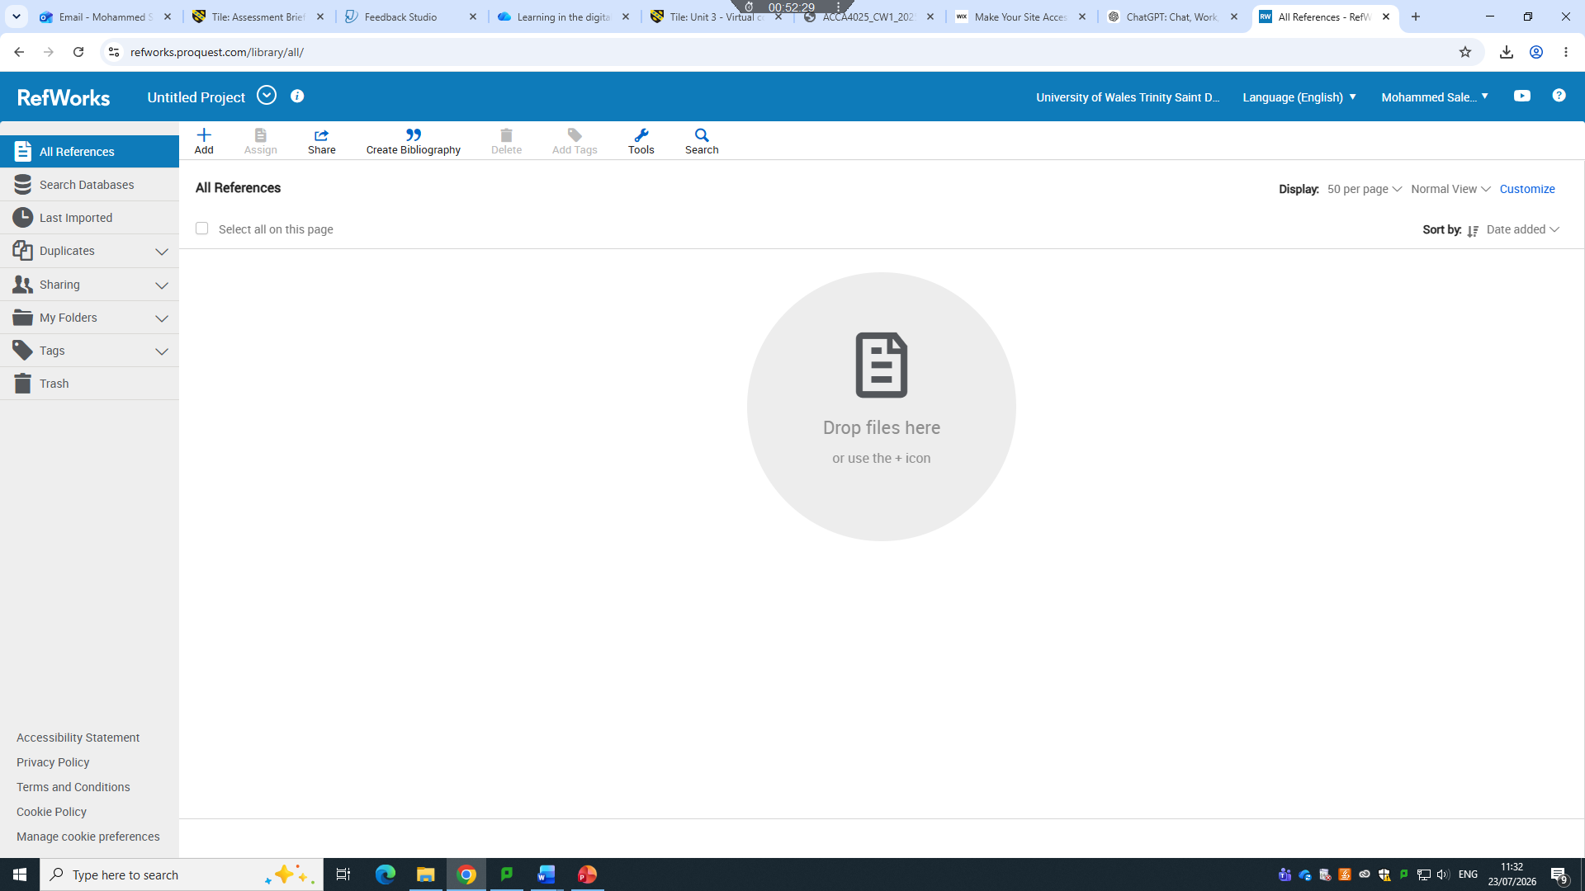

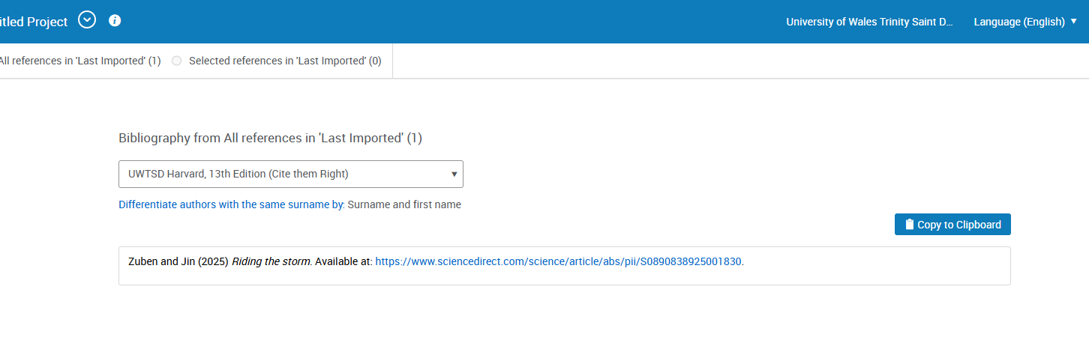
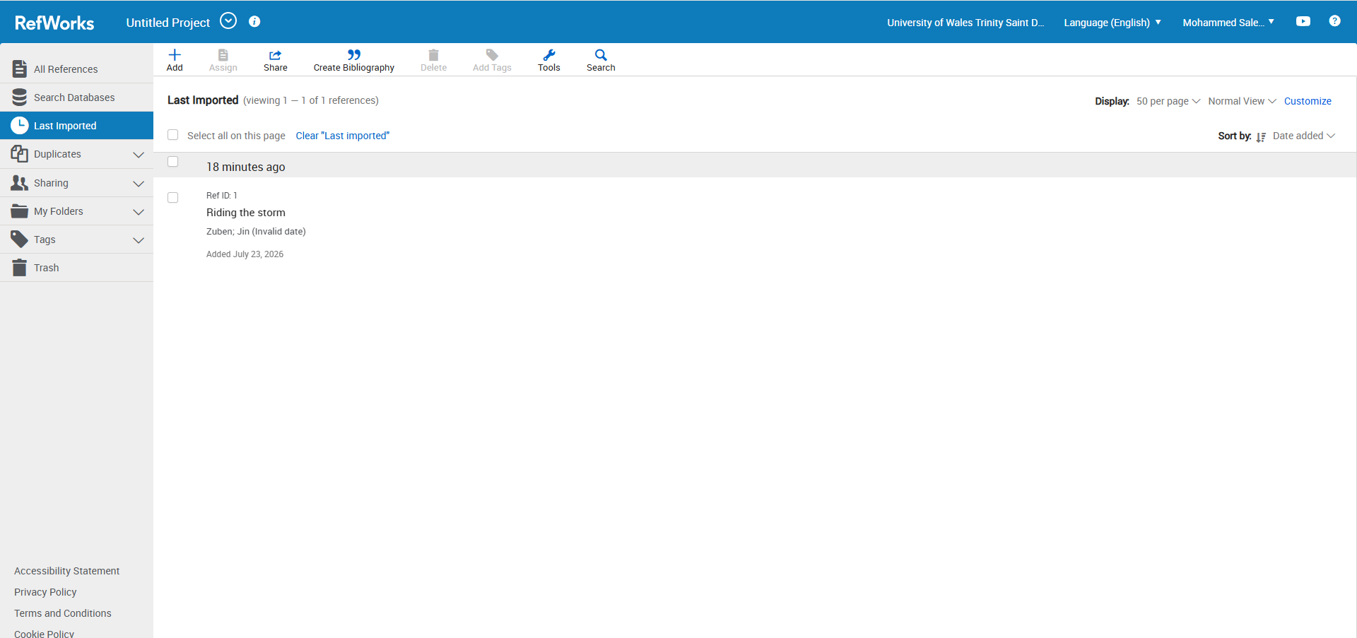
Zuben and Jin (2025) Riding the storm. Available at: https://www.sciencedirect.com/science/article/abs/pii/S0890838925001830.

RefWorks is a cloud-based reference management software used by students, researchers, and academics to organize research sources and create citations and bibliographies automatically. It helps simplify the research and writing process. RefWorks Support
Main features of RefWorks:
- Stores and organizes references (books, journal articles, websites, etc.).
- Imports references directly from online databases and library catalogs.
- Generates citations and bibliographies in many styles, such as APA, MLA, Harvard, and Chicago.
- Integrates with Microsoft Word to insert in-text citations and automatically update the reference list.
- Allows users to attach, organize, and annotate PDF articles.
- Supports sharing and collaboration on reference collections with other users.

Task 4: E-Portfolio Creation and Evaluation

Task 4 (a): E-Portfolio Creation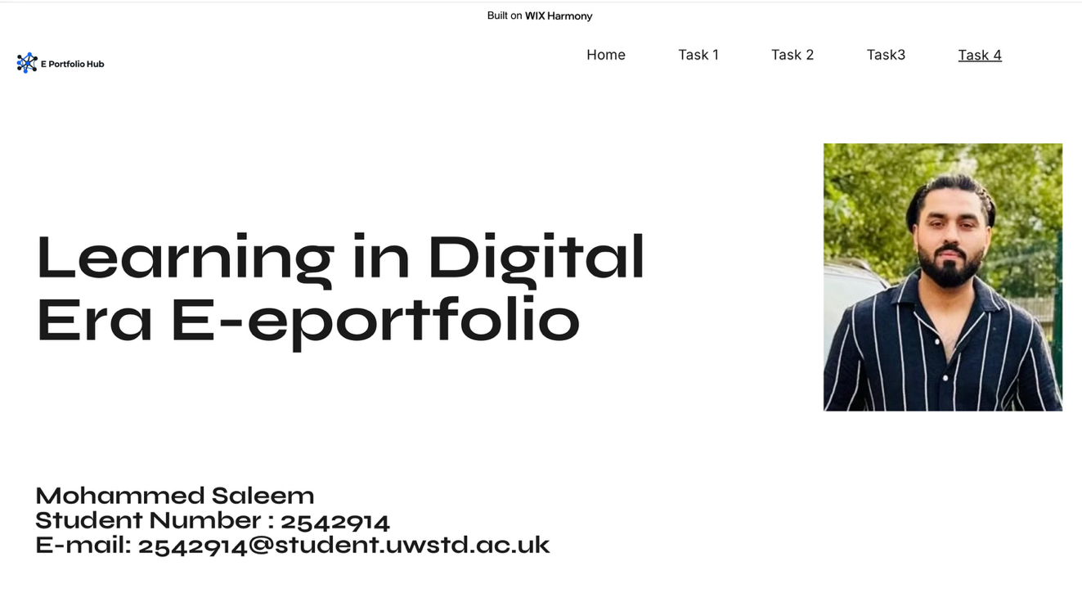

Task 4 (b): Illustrative Review of E-Portfolio tool Selection

Conclusion

References

Task 1 References:

[1] | J. d. Henau, “University of Oxford,” October 2024. [Online]. Available: https://www.ctl.ox.ac.uk/sites/default/files/ctl/documents/media/academic_skills_literature_review.pdf. [Accessed 18 June 2026].
[2] | Hasanuzzaman Tushar;Nanta Sooraksa, “Sciencedirect.com,” November 2023. [Online]. Available: https://www.sciencedirect.com/science/article/pii/S2405844023082312. [Accessed 18 June 2026].

https://www.ctl.ox.ac.uk/sites/default/files/ctl/documents/media/academic_skills_literature_review.pdf

https://www.sciencedirect.com/science/article/pii/S2405844023082312

Task 3 References:
Zuben and Jin (2025) Riding the storm. Available at: https://www.sciencedirect.com/science/article/abs/pii/S0890838925001830.

