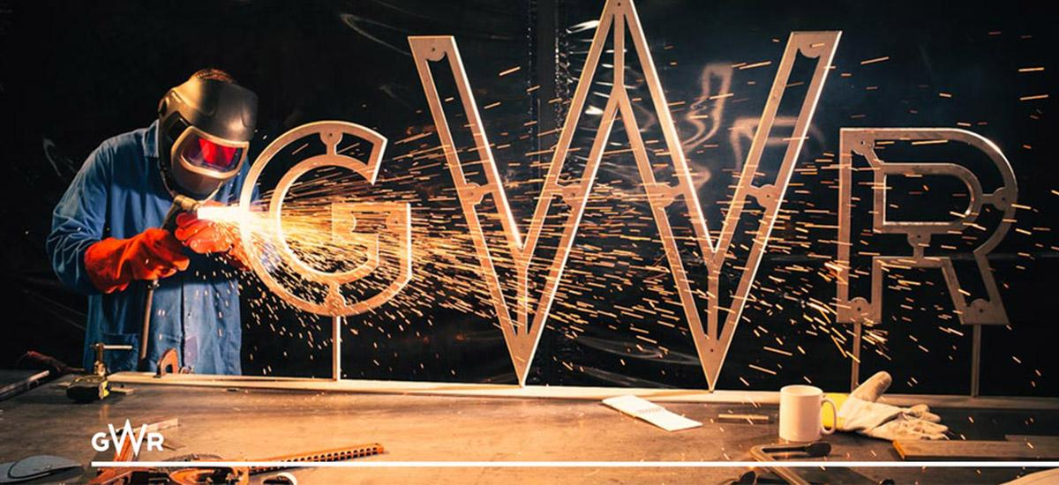

The Future of Great Western Rail
  - How Great Western Rail are strategising for the future
Daniel Stokes | Logistics and Supply Chain Management | 19/02/2018
1. Introduction
1.1. Distribution
1.2. Important Characteristics of Logistics
2. Strategy
2.1. Functional Strategic Plans
2.1.1. Marketing
2.1.2. Finance.
2.1.3. Logistics
3. Distribution Functions
3.1. Primary Transport
3.1.1. Class 800 IET
3.1.2 Electrostar
3.2. Local Delivery
3.2.1 Station Improvements
3.2.2. PlusBus
4. Conclusion
References
Images and Video Links

1. Introduction
The aim of this report is to evaluate the important characteristics of the logistics function as a key part of strategic planning, within a distribution function, whilst mentioning some factors of PESTEL.
1.1. Distribution
Although defined as “The action or process of supplying goods to retailers” (Oxford Dictionaries, 2018), distribution can also be used to describe commercial logistics, “The movement of goods and services from the source through a distribution channel, right up to the final customer, consumer, or user, and the movement of payment in the opposite direction, right up to the original producer or supplier” (Businessdictionary.com, 2018). The important word in that definition is service. Rail distribution is not only about carrying freight containers from A to B, but also delivering a service to people wishing to travel, a service that GWR provide. However, what is their strategy when it comes to the characteristics of logistics?
1.2. Important Characteristics of Logistics
The characteristics of the distribution function of logistics are:
- Primary Transport
- Distribution depot
- Local delivery (Rushton, Croucher and Baker, 2017).
Even though these characteristics are seen as important, for GWR they are essential in the service they provide. Trains being their primary transport, and train stations being the distribution depots and local delivery characteristics. But what strategy does GWR have for these characteristics?
2. Strategy
2.1. Functional Strategic Plans
There are four main strategic plans, Marketing, Production, Finance and Logistics (Rushton, Croucher and Baker, 2017). GWR however only use three of these, Marketing, Finance, and Logistics (Production being a third party, e.g. Hitachi producing the IET’s (Intercity Express Trains)) (Fisk, 2017).
2.1.1. Marketing
The current marketing campaign for GWR is The Famous Five (created by Enid Blyton in 1942) traveling across the rail network with GWR (Kiefer, 2017). GWR’s Head of Marketing, Amanda Burns said “As part of our modernisation programme and commitment to revaluing rail in the hearts and minds of the travelling public, we wanted a campaign that would focus on inspiring journeys and a more inspiring way to travel. We want to showcase our great product and the wonderful destinations on our network, to encourage more customers to travel with us and reconsider the benefits of rail travel with GWR” (Keifer, 2017). The commercial shows this as the four children chase Timmy the dog across the South-West on one of GWR’s new IETs*.
2.1.2. Finance.
Like all businesses, rail is no different. According to Karlee Weinmann, 2012, one of the seven fundamental factors to a successful business is investment. GWR know this and have recently spent £5.7bn on a new train fleet which will “deliver better journeys for passengers.” (Gwr.com, 2017). GWR are also spending £7.5bn electrifying routes from London to Oxford, Bristol, and Newbury, and also on station improvements.
2.1.3. Logistics
As previously mentioned, passenger distribution can be a key function of logistics. GWR, being part of FirstGroup plc, realise this. Due to this GWR are making it easier for passengers to travel once their train journey ends. In an article, written for the CILT, in April 2017, GWR was to launch what they called a smartcard, branded ‘touch’ for the Severn Beach Line. The article says it is “part of a pilot which could see combined rail and bus travel in a single ticket offered across Bristol” (CILT(UK), 2017).
Rail passengers will be able to purchase season tickets, weekly to annually, on to their smartcard, either online or at a smartcard vending machine, designed for local rail travel. Although currently the touch smartcards do not integrate rail and bus travel, FirstGroup have the system for local buses within their Bristol, Bath and West services. However there is hope that it will soon be integrated as former Bristol North West MP Charlotte Leslie said “This could be another step towards creating an all-Bristol-transport smart payment and will make rail travel easier and more passenger friendly. I sincerely hope that the results of the trial will be successful and that the project can soon be rolled out across the city.” (CILT(UK), 2017).
3. Distribution Functions
3.1. Primary Transport
As the name suggests, the primary transport for Great Western Rail is trains. However, although primary transport is their main source of income, there are factors GWR need to think about in order to make plans for the future of rail, such as political plans and passenger numbers, which have doubled in the last twenty years (Railtechnologymagazine.com, 2018).
3.1.1. Class 800 IET (Figure.2)
Since it was first put into service, the Intercity 125 HST (High Speed Train), has been in traffic on the Western Rail Network from August 1976 (Clinnick, 2016). With a call to end all diesel-only trains in the UK by 2040, made by Rail Minister Jo Johnson (Calder, 2018), the Intercity 125 will be a thing of the past. However, four months before Mr. Johnson’s announcement, GWR carried passengers in four new IETs in October 2017 (Gwr.com, 2017).
These new Class 800 IETs, designed by Hitachi, will not be affected by any laws terminating the use of diesel-only engines, as they are a bi-modal train. This type of train is what GWR needs as not all of its routes are electrified (See Figure.1). Even though these laws have been called for GWR say that even though they are having their largest fleet replacement in 40 years, replacing 36 of their 53 125s with the new IET 800 (Clinnick, 2017), they will still run the 125s on the Paddington-Cornwall service (Castella, 2015).
GWR state that the IETs will be able to seat 24% more passengers on their 10-car train than the old 125s (an increase of 126 passengers per train) (Rowland, 2018) and decrease journey times by 11% by December 2018 (Rowland, 2018), due to the higher acceleration of the IET (Gwr.com, n.d.).
“In total Hitachi will deliver 36 x 5 carriage and 21 x 9 carriage Class 800 trains, and 22 x 5 carriage and 14 x 9 carriage Class 802 trains, with the full fleet due in service by December 2018” (Mark Langman, Network Rail’s Route Managing Director Western (Gwr.com, 2018)).
3.1.2 Electrostar (Figure.3)
For the last generation, GWR have been running 6-carriage turbos, Class 165/166. While replacing two thirds of their 125s, GWR are also replacing the majority of their 165/166s with 8-carriage to 12-carriage Electrostar Class 387 trains across the Thames Valley network. The extra carriages will provide an extra 30% seats during “key journeys” (Gwr.com, n.d.). Mark Hopwood, Managing Director of GWR says “Electric trains will run under the wires between Didcot and London for the first time, delivering real improvements for our passengers in London and the Thames Valley and enabling us to make further improvements throughout our network, supporting the communities we serve” (Gwr.com, 2018).
3.2 Distribution Depots
Distribution depots for rail can be one of two things, the rail station, as that’s where the passengers get distributed, or the actual company depots, where trains are maintained. With this chapter, this paper will concentrate on company depots as rail stations can also come under local delivery (See chapter 3.3).
As part of their £7.5bn improvement, GWR are building a new state of the art depot in Exeter, costing £40million, to be put in place of their current Exeter Olds View depot. GWR look to use the new depot to be able to facilitate an increasing fleet within the Devon and Cornwall routes, which is hoped to bring more seating and frequent services (Gwr.com, 2017).
GWR Regional Development Manager West, Dan Okey says that “With brand new electric trains coming to suburban London services and bi-mode Intercity Express Trains on the mainline in Devon and Cornwall, this will allow us to move part of our existing regional fleet to Exeter - providing more carriages, and more frequent services to the area.”
In a presentation given by Richard Rowland, GWR Customer Service and Transformation Director, it was mentioned that a closure of the GWR depot in Landore, Swansea could be happening and to be replaced by the new Hitachi Depot just 0.7 miles away (Rowland, 2018).
3.3. Local Delivery
Local delivery is just as it sounds, delivered locally. This could mean to the item, or person, is delivered to the designated address, or even to an area specified by the customer. An example of this is Amazons Local Collect. Customers can either have their item delivered to their home, or business address, or to a local amazon pickup point, whether it is a pickup locker or Royal Mail office (Amazon.co.uk, n.d.).
GWR essentially do just that. GWRs local delivery service is delivering customers to their intended destination. And while running services along 1360 miles of track to 276 stations, while managing 195 (Rowland, 2018), GWR intend to do this as efficiently as possible, hitting 98% reliability between 7 January and 3 February 2018 (Gwr.com, 2018)
3.3.1 Station Improvements
Part of local delivery for rail companies, are the stations they manage, and ensuring customers feel there needs are satisfied whilst using them. In October 2017, FirstGroup unveiled their plans for Cheltenham Spa station. GWR will be working alongside Network Rail, Cheltenham Borough Council and Gloucestershire County Council on this project.
A statement from GWRs Regional Development Manager, Lewis Ward says “Cheltenham Spa now sees over 2.5 million passenger journeys each year - a number which is steadily increasing. Our challenge is to ensure we balance the overall character of the station with the need to make the improvements we and our customer would like to see” (Firstgroupplc.com, 2017).
MP for Cheltenham, Alex Chalk, stated, while attending an event held by GWR, “I was delighted when the Government agreed to a multi-million pound improvement fund for Cheltenham Spa railway station. But we really do need to see some progress, not least to increase station parking capacity. Upgrading the facilities for the 2.5 million passenger journeys is vital for Cheltenham's future success, and I will continue to press for the earliest possible delivery of these key improvements."
Although proposed in 2017, work will not start until 2018, and expected to be finished in 2019. Plans for the improvement of the station include**:
- “Improving the interchange for buses and taxis
- Creating a pedestrianised public space in the forecourt with more cycle parking space
- Increasing car parking space by adding a single deck to the existing car park
- Adding a walking and cycling link to Lansdown Road” (Firstgroupplc.com, 2017)
3.3.2. PlusBus
Although not directly linked with GWR, PlusBus, who works with FirstGroup and others, is a service which operates with 290 rail stations across the UK (Nationalrail.co.uk, n.d.), who’s target is to help people get around towns and cities after arrival on a train. This means for as little as £2, on top of their rail fare, customers can conveniently get closer to their intended destination. For example, a person travelling from Bristol wanting to go to The Mumbles, Swansea, would pay an extra £3 on top of their rail fare to have unlimited access on Swansea buses (PLUSBUS, n.d.).

4. Conclusion
Although a passenger transport company, GWR have to do business like any other distribution company such as DHL or FedEx. Although pretty much unchanged in 25 years, GWR are now in the middle of company-wide refurbishment, from their vehicles to depots and stations. They also have to use factors of a PESTEL analysis. All factors have been touched upon in this paper:
- Political and Legal, with the call to end all diesel-only engines by 2040
- Environmental and Technological, with the development of the new IET 800s and Electrostar 387s
- Social and Economical, with GWRs new marketing campaign, and improved services and stations in the hope that more people will ride with GWR.
Extracted from a letter, The Rt. Hon. Patrick McLoughlin, Secretary of State, Department for Transport, 23 March 2015, stated that “This is a fantastic deal... Reaching this agreement with FGW marks a new chapter for the Great Western railway and a step change in capacity, frequency and the quality of service”(Rctcbc.gov.uk, n.d.).

References
Amazon.co.uk. (n.d.). Amazon.co.uk Help: About Local Collect. [online] Available at: https://www.amazon.co.uk/gp/help/customer/display.html?nodeId=202009600 [Accessed 20 Feb. 2018].
BusinessDictionary.com. (2018). What is distribution? definition and meaning. [online] Available at: http://www.businessdictionary.com/definition/distribution.html [Accessed 19 Feb. 2018].
Calder, S. (2018). MPs to probe East Coast rail franchise debacle. [online] The Independent. Available at: http://www.independent.co.uk/travel/news-and-advice/east-coast-rail-franchise-debacle-collapse-virgin-trains-stagecoach-transport-select-committee-a8205676.html [Accessed 19 Feb. 2018].
Castella, T. (2015). What are the UK's new trains like?. [online] BBC News. Available at: http://www.bbc.co.uk/news/magazine-31831603 [Accessed 19 Feb. 2018].
CILT(UK). (2017). Great Western Railway to launch smartcard. [online] Available at: https://ciltuk.org.uk/News/Latest-News/ArtMID/6887/ArticleID/11819/Great-Western-Railway-to-launch-smartcard [Accessed 20 Feb. 2018].
Clinnick, R. (2016). GWR celebrates 40th anniversary of iconic HST. [online] Railmagazine.com. Available at: https://www.railmagazine.com/news/network/2016/05/04/gwr-celebrates-40th-anniversary-of-iconic-hst [Accessed 19 Feb. 2018].
Clinnick, R. (2017). New trains - coming to a line near youâ€¦. [online] Railmagazine.com. Available at: https://www.railmagazine.com/news/rail-features/new-trains-coming-to-a-line-near-you [Accessed 19 Feb. 2018].
Exeter, N. and Exeter, N. (n.d.). New 40 million rail depot planned for Exeter. [online] Gwr.com. Available at: https://www.gwr.com/about-us/media-centre/news/2017/february/new-40-million-rail-depot-planned-for-exeter [Accessed 20 Feb. 2018].
Firstgroupplc.com. (2017). Plans unveiled to upgrade Cheltenham Spa station. [online] Available at: http://www.firstgroupplc.com/news-and-media/latest-news/2017/05-10-17a.aspx [Accessed 20 Feb. 2018].
Fisk, S. (2017). New Hitachi trains for GWRâ€™s Devon and Cornwall route a step closer to entering service. [online] Mynewsdesk. Available at: http://press.hitachirail-eu.com/pressreleases/new-hitachi-trains-for-gwrs-devon-and-cornwall-route-a-step-closer-to-entering-service-1805662 [Accessed 19 Feb. 2018].
Gwr.com. (2017). First new trains in a generation launched by GWR. [online] Available at: https://www.gwr.com/about-us/media-centre/news/2017/october/first-new-trains-in-a-generation-launched-by-gwr [Accessed 19 Feb. 2018].
Gwr.com. (2018). Our Performance | Great Western Railway. [online] Available at: https://www.gwr.com/about-us/performance [Accessed 20 Feb. 2018].
Gwr.com. (n.d.). New Electrostar Commuter Trains | Great Western Railway. [online] Available at: https://www.gwr.com/about-us/modernising-gwr/electrostar [Accessed 20 Feb. 2018].
Gwr.com. (n.d.). New Intercity Express Trains | Fast Trains with Great Western Railway. [online] Available at: https://www.gwr.com/about-us/modernising-gwr/iet [Accessed 19 Feb. 2018].
Kiefer, B. (2017). Famous Five go on a rail adventure in nostalgic GWR campaign. [online] Campaignlive.co.uk. Available at: https://www.campaignlive.co.uk/article/famous-five-go-rail-adventure-nostalgic-gwr-campaign/1445373 [Accessed 19 Feb. 2018].
Nationalrail.co.uk. (n.d.). National Rail Enquiries - PLUSBUS. [online] Available at: http://www.nationalrail.co.uk/times_fares/ticket_types/plusbus.aspx [Accessed 20 Feb. 2018].
Oxford Dictionaries. (2018). distribution | Definition of distribution in English by Oxford Dictionaries. [online] Available at: https://en.oxforddictionaries.com/definition/distribution [Accessed 19 Feb. 2018].
PLUSBUS. (n.d.). Swansea PLUSBUS. [online] Available at: http://www.plusbus.info/swansea [Accessed 20 Feb. 2018].
Railtechnologymagazine.com. (2018). Committed to improving customer experience. [online] Available at: http://www.railtechnologymagazine.com/The-Last-Word/committed-to-improving-customer-experience [Accessed 20 Feb. 2018].
Rctcbc.gov.uk. (n.d.). Cite a Website - Cite This For Me. [online] Available at: https://www.rctcbc.gov.uk/EN/Resident/ParkingRoadsandTravel/Travel/Relateddocuments/FGWFranchiseUpdateBrochure.pdf [Accessed 20 Feb. 2018].
Rowland, R. (2018). The Future of GWR.
Rushton, A., Croucher, P. and Baker, P. (2017). The Handbook of Logistics and Distribution Management, Sixth Edition. 6th ed. London: Kogan Page, pp.15, 103.

Images and Video Links
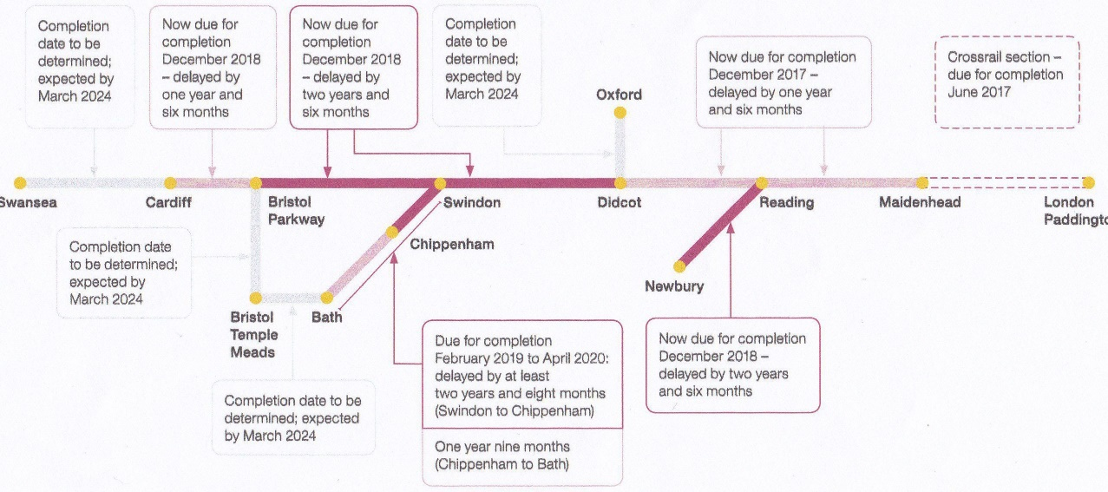
Figure.1 Electrification of GWR Plan
Extracted from https://i0.wp.com/www.21stcentury-rail.com/wp-content/uploads/2016/11/IMG_20161115_0001-e1479225504721.jpg?ssl
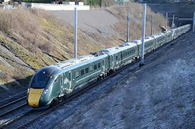
Figure.2 GWR IET 800
Extracted from https://www.gloucestershirelive.co.uk/news/cheltenham-news/shiny-new-trains-used-cheltenham-657819
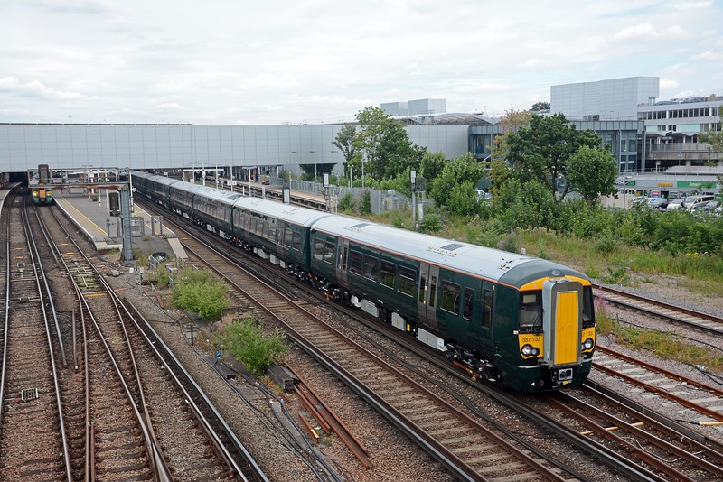

Figure.3 GWR Electrostar 387
Extracted from https://nick86235.smugmug.com/Trains/Motive-Power/The-class-375-377-Electrostars/i-t8nMrVm/

Cover photo extracted from http://www.jamesgood.co.uk/blog/ready-for-the-renaissance-of-rail
* https://www.youtube.com/watch?v=2sQvlBPFZgE
** Full documentation of plans available at https://www.gwr.com/about-us/modernising-gwr/cheltenham-spa

