
Digital Innovation and Professional Practice
Assessment Portfolio

May 30, 2023
Angela Lewis
2208379

Table of Contents

Page 2 – 8 -------------------- Digital Innovation and how emerging technologies will be used in the future.

Page 9 – 11 -------------------- Selection and Justification of Vevox as an Appropriate Teaching Tool.

Page 12 – 19 -------------------- Application of Vevox in the classroom.

Page 20 - 23 -------------------- Reflection and evaluation of Vevox in the revision lesson.

Page 24 – 28 -------------------- Reference list.

Page 29 – 33 -------------------- Appendices: Lesson plan.

Page 34 – 37 -------------------- Appendices: Power-point presentation used in the lesson.

A critical evaluation of the role of digital innovation in professional practice in higher education.
The role of digital innovation within professional practice in Higher Education Institutions seems to be gaining pace, especially so, during and since the pandemic, in the form of educational technology (EdTech) (Cowling, et al., 2022). During the years 2020 to 2022 universities were forced into providing their services through online platforms due to the lockdown period, with the initiation of Emergency Remote Teaching (ERT) involving the uploading of lessons, lectures, instructional materials, assessments and learning activities (Cowling, et al., 2022). The use of digital technologies grew exponentially due to the unprecedented situation (O'Dea & Stern, 2022). Even though many HE institutions prior to the pandemic were slow in implementing their digital strategies for the future, the forced situation encouraged them to implement these technologies sooner than predicted (Cowling, et al., 2022), which they did in order to continue to meet professional standards of encouraging student participation, even during a crisis (UKPSF, 2011). Also, in line with professional standards the institutions needed to develop learning strategies which could be implemented during this time, which they did through forced use of digital technologies such as online classes, through platforms like Teams or Zoom (Beardsley, et al., 2021). This literature review sets out to evaluate the role of digital innovative tools within professional practice with the main focus on how emerging technologies could be used in the future. This will be done by discussing two main areas of innovation; online/hybrid learning and Artificial Intelligence AI tools such as ChatGPT and robot teachers. In order to determine the success of possible future predictions, research prior to the pandemic was studied to give perspective to the progression of digitalisation in a higher education setting during, and post pandemic (Criollo-C, et al., 2023).
The digitalisation of the classroom has been developing since the 1990s when lecturers switched from using overhead projectors to computers to display the lesson content (Rusk, 2008). However, since the pandemic the steady march of digitalisation seems to have become a fast-flowing river of technology and innovative digital tools like Vevox and Mentimeter, all intended to aid the teacher in their teaching strategies and facilitate effective learning for the students of the 21st century (Kwok-Wing, 2011). Prior to the pandemic a report by the World Economic Forum WEF stipulated the urgent need for higher education to respond to the predicted, profound and rapid changes that will ensue through technological advancements in the science and technology curriculum, as part of the Fourth Industrial Revolution 4IR (Penprase, 2018). According to research conducted by Price Waterhouse Coopers PWC (McCusker & Babington, 2018) universities needed to develop their digital innovation strategies to stay relevant in the digital age (McCusker & Babington, 2018). This involved the facilitation of improved digital infrastructure which would enhance teaching and learning, optimise administrative processes and admissions procedures and generally increase and develop digital learning resources while creating flexible teaching programmes, which, as well as assessments are the main pedagogies underpinning education (McCusker & Babington, 2018). According to Beetham and Sharpe (2019) pedagogy needs a rethink in order to align with the masses of information available to the learner through online platforms, which encourages learners toward a more self-directed approach (Beetham & Sharpe, 2019).
In the years following the above research during 2020 – 2022 the pandemic has escalated the use of such digital innovations as online lectures and online courses, some in the form of Massive Open Online Courses, MOOCs which are often free and available through universities. In the USA, Harvard and MIT Massachusetts Institute of Technology offer online courses as part of come of their Master’s degrees (Ford, 2016). However, while MOOCs were booming in 2013, flaws were found in their use, due to the amount of students registered for the courses not corresponding with the actual student participation figures and there were questions about student identity, which could not be properly monitored in an online classroom, so MOOCs did not disrupt the higher education domain in the way that was first expected (Ford, 2016) . However, this is predicted to change in the future (Ford, 2016). According to many research papers, prior to the pandemic, there seemed to be a reluctance with teachers to adopt to some technical innovations, incorporated into the higher education sector (Siegel, et al., 2017; Duhaney, 2005; Rogers, 2000; Siegel, et al., 2017; Watty, et al., 2016; Burbules & Callister, 2000; and Scherer & Teo, 2019) which were intended to revolutionise the system (Burbules & Callister, 2000). Could this reluctance speed up the infiltration of MOOCs or other online resources within the university setting? Possibly, but not until they are taken seriously by employers as avenues to employment (Brynjolfsson & McAfee, 2016). The teacher reluctance changed during the pandemic with a rapid shift to digital teaching and learning (Universities UK, 2022). These changes are set to continue in higher education not just in the UK but around the world and in order to continue to move ahead PWC are encouraging a full digital system, whereby every department within the university embraces digital innovations (PSRC, 2018). Again, this report was produced pre pandemic and was initiated and further developed during the years of the pandemic, in the form of ERT through online platforms (McCusker & Babington, 2018). One common theme on emerging technologies within higher education is the need for continuing upskilling of current teachers (Ngoc, et al., 2020; Yesner, 2020 & Grajek, 2020) and the development of concrete digital strategies or the initiation of digital transformation (Benavides, et al., 2020). CISCO who are a US company providing software and hardware for computer network building (2020) have produced a report and in it they see universities as large complex businesses which need to be digitised, they want to place digital technology at the very heart of modern universities creating the ‘Digital Campus’ whereby everything is connected by the Internet of Things, IoT; people, processes, data and things, through wireless technology, which is already happening at University of New South Wales in Australia (CISCO, 2020).
The predicted digital future sounds all-encompassing but what happens when the digital systems fail? This can happen at different times for various reasons including such things as power cuts, servers going down, computer malfunctions, the internet freezes in the middle of an online quiz etc. etc. (Race, 2015). Most well-prepared teachers will always have a plan B built into their teaching strategies (Race & Pickford, 2007) these will align to professional standards of designing and planning of learning activities, and the use and value of learning technologies (UKPSF, 2011). There are gaps in research comparing education with or without technology and no reports for how a fully digital university would manage if the technology were to fail, especially in fully digitally immersive scenarios as the ‘digital campus’ (CISCO, 2020).
JISC has produced a Horizons report for what they call Education 4.0 in line with the 4IR in which they envision many emerging technologies up to the year 2030, some of those technologies involve 5G and the enablement of The Internet of Things IOT/Intelligent campus, AI and chat bots and Robots taking over all administrative jobs (JISC, 2019). It seems that as these new educational technologies continue to emerge, they will increasingly be incorporated into MOOCs where adaptive learning systems could provide what amounts to a robot teacher (Ford, 2016). However, there is some research on the role of robots within education but so far mostly in a supportive role (Spolaor & Vavassori Benitti, 2017). Although a function of AI has been the possibility of using robot teachers to address teacher shortages, according to research conducted in 2018 (Edwards & Cheok, 2018). It seems that there was a global shortage of teachers during the time of the research and it had previously been established that robots had already been used in various capacities including classroom companions and care home companions in Japan and China (Robinson, et al., 2013) so it was suggested that robots take over the role of the teacher, however, further research argues that robots lack the unique qualities that human teachers possess such as critical thinking, creativity and emotions which make teachers irreplaceable (Tegos, et al., 2013).
Artificial Intelligence in the form of ChatGPT (Chat Generated Pre-Trained Transformer) provides the biggest challenge to higher education currently and possibly in the future, in that the disruptive nature of its algorithms are creating new threats and challenges for education in that it is not only involved in ‘content creation and design but also the refinement of feedback phrasing and dialogue strategies’, which means it learns and improves every time it is used (Lo, 2023, p. 2). ChatGPT is an Artificial Intelligence chat bot launched in November 2022. It has the potential of being an assistant to teachers in that it could generate course materials and for the student it could become a virtual tutor (Lo, 2023). ChatGPT passed four separate exams in a test in Minnesota which makes it very possible that it could pass its own degree. If it is capable of doing this for itself, it could be used by students to pass exams for them in certain situations (Lo, 2023). According to the Guardian newspaper, universities are being urged to update their marking systems in order to detect if the student has produced the assessment or if it has been AI generated (Weale, 2023). It is no surprise then that in its first two months of use ‘it became the fastest growing user application in history reaching 100 million active users by January 2023’ (Lo, 2023, p. 1).
When the digitisation of the higher education system started in the 1990s, some educators believed that with the insistence of setting up an email account, began the enforcement of longer working hours and increased workloads for which there was no remuneration (Johnston, et al., 2019). Johnston, et al (2019) argue that the oppressive forces of advanced capitalism have shaped the way that digital innovation has been adopted by university and society on the whole. It seems that there was no choice in adopting the capitalist approach to education but they feel this was at the expense of true pedagogy (Johnston, et al., 2019). While these concerns were prevalent back in the 1990s with the initiation of technology, the possible problem now seems much worse in that the growth of AI and machine learning has transformed many tasks at the core of teaching practices, which are being taken over by ‘…AI software built on complex algorithms designed by programmers that can transmit their own biases or agendas in operating systems’ (Popenici & Kerr, 2017, p. 11). It also seems that AI could have profound effects on all employment, and one of the key innovators of artificial intelligence Elon Musk says ‘there will be mass unemployment, there will be few jobs that robots cannot do better’ (Musk, 2018). Conversely, a study conducted in 2018 predicted that AI and machine learning would have a positive impact on education within the next 2 to 5 years (UCISA, 2018). Universities and Colleges Information Systems Association UCISA seem to be a not-for-profit charity organisation who represents the whole higher education system and most of the further education system in the UK in the administration and adoption of digital technology (UCISA, 2023). It seems that many of its corporate partners seem to be companies that produce the technology being incorporated into the higher education institutes, companies like Adobe Systems Europe Ltd, Akari Software Ltd, Academic Software and Microsoft, to name but a few (UCISA, 2023).
It’s fair to say then, that the future use of emerging technologies is being predicted by companies and organisations such as UCISA, JISC, and CISCO who seem to be connected to the very companies who produce the digital technology like Google and Microsoft with complete digitisation being predicted for 2030. (UCISA, 2023; JISC, 2019 & CISCO, 2020) however, the higher education institutions and teachers will not use technology at the expense of pedagogy (Kirkwood & Price, 2013). Innovations like online learning will continue, especially now with hybrid classes adopted during the years of the pandemic (Triyason, et al., 2020). AI tools like Vevox and Mentimeter will continue to be used in an augmentation way to enhance learning and can be used in a hybrid learning environment and ChatGPT will need regulations of some kind or more AI to monitor its use in student assessments (Rudolph, et al., 2023). However, it doesn’t look like robot teachers will replace human teachers as yet, but if Elon Musk’s prediction comes true about mass unemployment, will there be students who want to study in higher education if there is no future for their skills? Only time will tell.

Selection and Justification of Vevox as an appropriate teaching tool.
The setting within which I have done my placement has been on the Change Management module as part of the Master’s degree in Business Administration, however, the module ended before I had the chance to implement my tool. I have chosen Vevox as it is considered a method of AI gamification which is part of one of the most innovative pedagogical approaches in recent years (Lopez-Martinez, et al., 2022). Vevox stands for Value Every Voice, the VE being the first letters and vox being Latin for voice (Vevox, 2023). The application was developed in order to encourage every voice, ensuring that everyone who uses the application within a classroom environment has the opportunity to contribute to the conversation in a way that is easy, interactive and engaging. The intention of Vevox is to ‘represent the power of technology to bring everyone together and amplify their voices, creating a more inclusive and collaborative world’ (Vevox, 2023, p. 1). Vevox can be used for live polling, Q & A sessions, word-clouds, surveys, quizzes and one of its most important features in its selection is the anonymity it affords the students (Vevox, 2023).
In recent research Vevox was found to be effective at eliciting high levels of participation (Greenwood, 2023). This fits in with professional standards in higher education of ensuring student participation, good supported learning, while helping to develop effective learning environments (UKPSF, 2011). The high levels of participation seem to be attributable to the anonymity factor, which, since the pandemic seems to have made students more nervous in a classroom environment (Greenwood, 2023). The anonymity creates a safe environment where students feel safe to ask a question or contribute to a poll in the knowledge that nobody will know who asked the question, which can be especially beneficial for shy students who don’t like to speak up for fear of making a mistake (Doyon, et al., 2000), this creates an environment of inclusivity, respecting individual learners, another criteria of the professional standards (UKPSF, 2011).
Under the SAMR framework for embedding technology in the classroom, Vevox would be an enhancement to the lesson in the form of augmentation as it adds something to the teaching strategies rather than transforming the lesson (Keane, et al., 2016). It seems that students need broader skills than the traditional 3Rs in the 21st century educative landscape, they need the 4Cs, these include creativity, communication, collaboration and critical thinking and in order to develop these skills, technology is needed, not as a standalone teaching strategy but as part of the cognitivist pedagogical strategies that we know enhance traditional learning (Keane, et al., 2016). It is also believed that the use of technology in the classroom can lead to a more self-directed way of learning, because information and communication technologies ICT shift control of learning to the learner (Papert, 1993). Although Papert (1993) foresaw the use of technology in the classroom, as all students having access to computers, which seems now to be mostly the case, it is also important to ensure that the teachers’ use of digital tools as part of the pedagogical landscape can encourage the self-directed use of digital technology (Cook & Gregory, 2018). It seems it’s not what educators do nor how they depart knowledge to their students, but it’s more about what the students see them doing, what they have the opportunity to participate in and ‘how they have actively participated in the doing of learning’ (Cook & Gregory, 2018) that is important. This is what helps them to become more self-directed learners and encourages a heutagogical approach, which it is believed will be necessary to produce learners who are well-prepared for the complexities of future learning through the use of Web 2.0 and employment in future technological workplaces (Blaschke, 2012). Although the use of Vevox as part of the teaching strategies is not exactly ground-breaking, it could lead the students to explore their own use of technology in a self-directed way and encourage the use of technology to enhance their learning, especially in distance learning. It could be argued that heutagogy could guide the use of new technologies in distance education (Blaschke, 2012).
Another great value of using digital technology as part of your teaching strategies is the fact that in some instances you can use it as an informal assessment tool without the students realising they are being assessed (Yorke, 2003), for example, when using word-clouds, while asking the students to answer a question, placing their answers within that word cloud enables the teacher to see how much information has been retained by the students and this can elicit a class discussion. These class discussions can also be used as a type of formative assessment which can be used periodically as part of the learning process which can measure understanding and application (Race, 2019). Another way that Vevox can be used as a formative assessment tool is by using the quiz facility or can be used to enable shy students to ask questions in a Q & A session which can help the students reach the lower levels of remembering and understanding in Bloom’s Taxonomy (Rodrigues & Oliveira, 2014). Formative assessment and feedback are essential in the development of learning and should be incorporated into any learning activities or programmes of study as part of professional standards for higher education (UKPSF, 2011). Ongoing assessment through classroom discussion can help to feedback to the student, which can help them with their learning (Wallace, 2005) which again aligns with professional standards in assessing and giving feedback to learners (UKPSF, 2011).
The selection of Vevox was made due to the tool being very simple to use for the student teacher as well as the students in the class. It fits the Active learning adoption level on the TIM Technology Integration Matrix (TIM, 2021).

Application of Vevox in the classroom.
My intention was to use Vevox to create a quiz for assessment purposes in the placement that I have previously been attending, however, that placement came to an end before I had the chance to implement my tool. A group of fellow students came together on May 15th in room 102 in the IQ building and presented a micro lesson to each other for the purpose of using the tool. The tool I have chosen is Vevox for reasons I have explained above in the essay. I have taken screen shots of both word-clouds, the survey and the feedback from the survey.
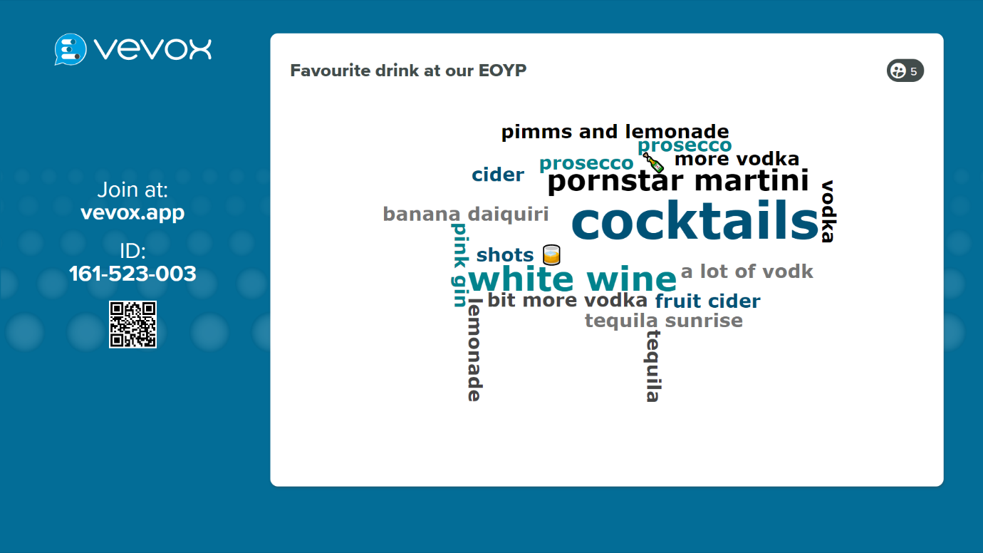
This is the first word-cloud that was created from the question; Favourite drink at our End of year party? The reason I started with this was to get people familiar with the application and have a light-hearted chat about our night out to break the ice before the revision started.
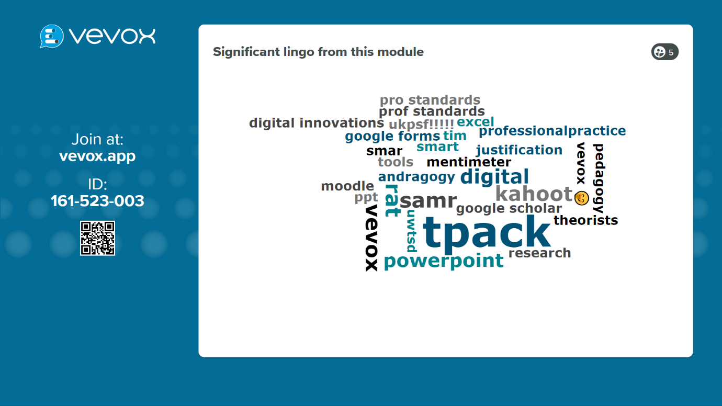
This word-cloud was developed from asking for the students to try and remember significant words or phrases they remembered from this module, things they might be using in their essay. We then discussed some of the words/phrases.
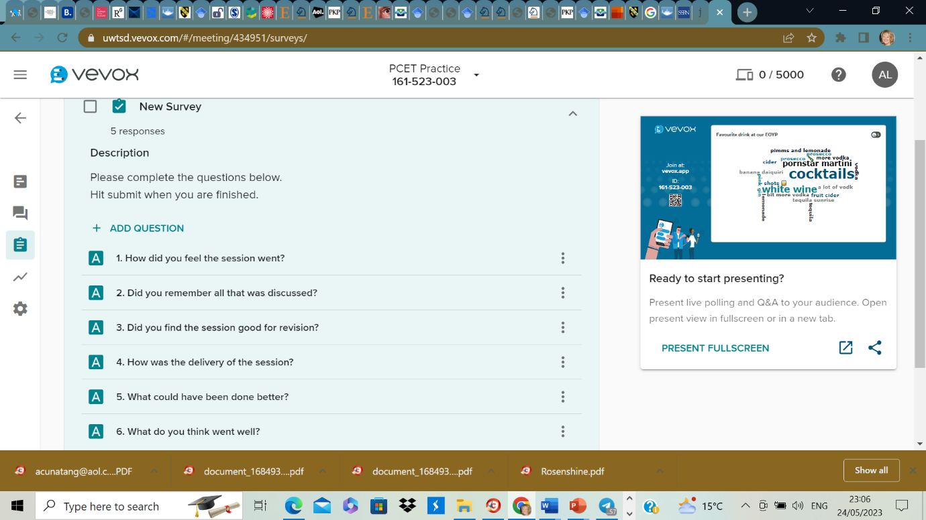
These are the questions I asked in the survey at the end of my presentation.
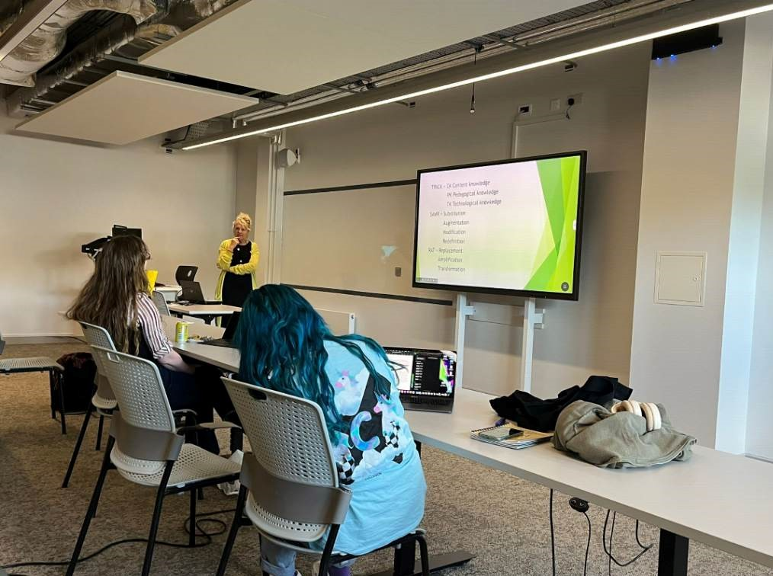
Photo taken during the lesson on May 15th 2023. Room 102 IQ Building.
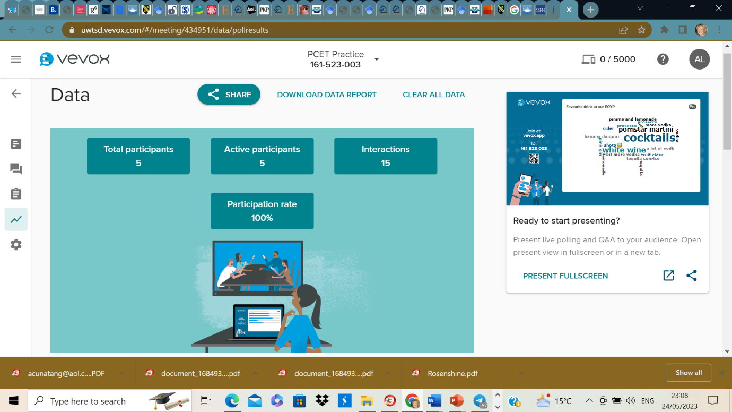
This is a screenshot of the data provided by Vevox which shows 100% participation rate, this tool would enable you to monitor class engagement.
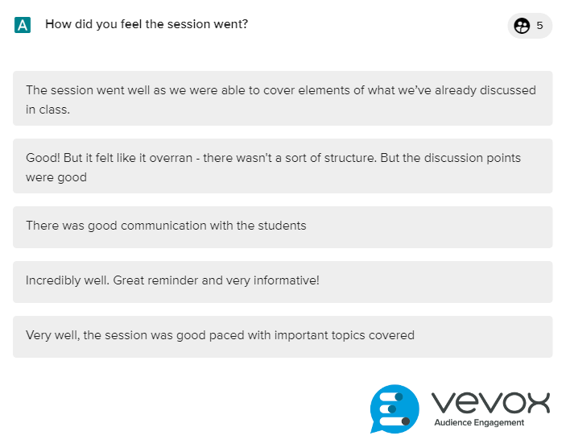
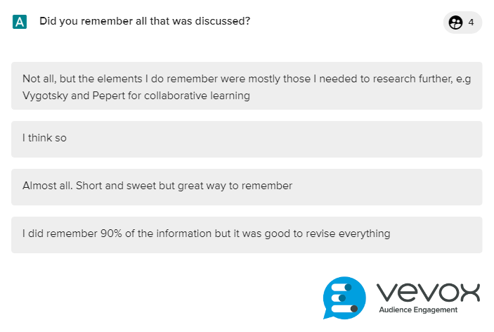
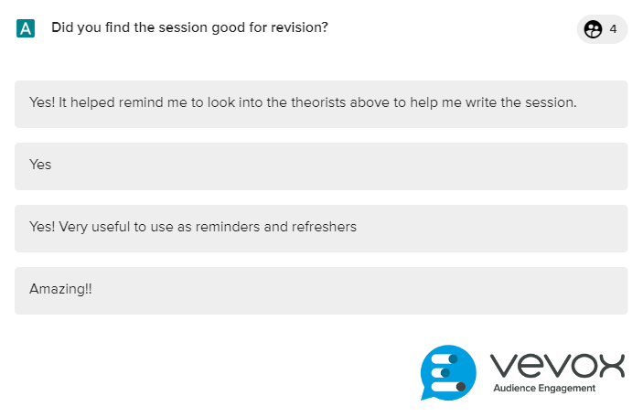
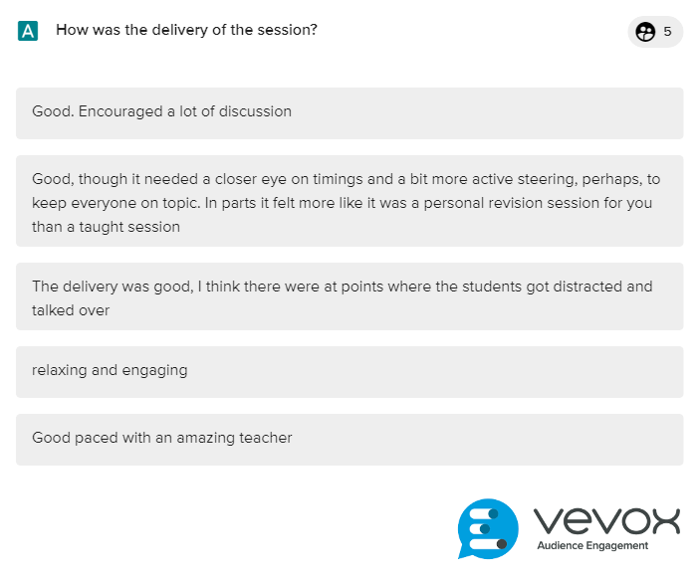
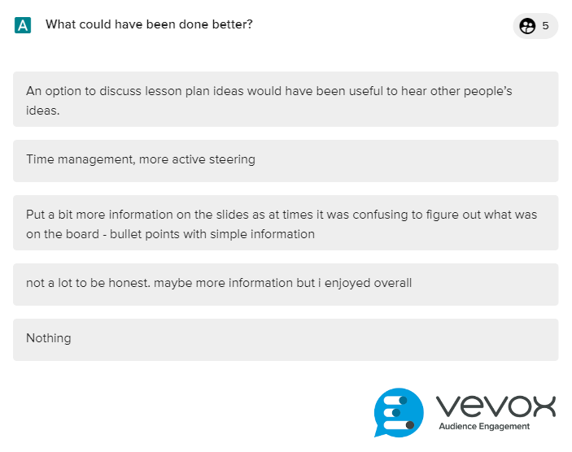
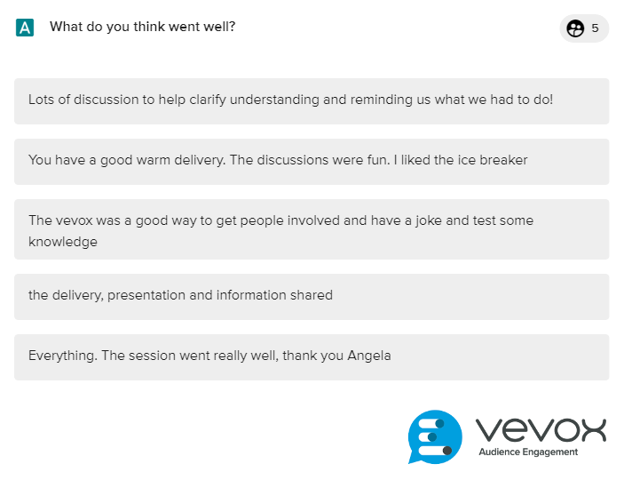
All of the six screenshots above are copies of the feedback received from my peers on my lesson which have been used to inform my reflection.

Reflective and evaluation of the use of Vevox in a revision lesson.
In order to critically evaluate the decision to use the chosen digital tool which was Vevox, I will be using the ERA Experience, Reflection and Action reflective cycle (Jasper, 2003).
Originally the plan was to devise a quiz or Q & A session which could be used in a lesson which I would deliver on my placement, involving students on a Master’s degree in Business Administration, a hybrid session with students attending the classroom and many other students on Teams, however, the module came to an end before I had the chance to use the tool. I redesigned the lesson to develop a revision lesson for fellow students using the same application, as it is a good tool for ongoing assessment (Vevox, 2023). According to Ebbinghaus’s forgetting curve, students forget 76% of what they have learned within a week so it is a good idea to regularly review and revise (Stewart & Venter, 2018).
Experience
Due to my fellow students not having a placement lesson to use their tool, a group of us came together and organised our own session in the IQ building on May 15th 2023 in room 102. There were five other students and myself. The lesson plan entitled Revision for Digital Innovation and Professional Practice (see ppt in appendix) incorporated the digital tool Vevox, which can be used in the classroom for eliciting participation and can be effective for formative assessment (Rodrigues & Oliveira, 2014), while also meeting professional standard requirements of student participation (UKPSF, 2011). There were 5 other students involved and my presentation was third. The power-point presentation was created for revision purposes displaying key theorists and concepts related to the module. I explained to the class that this was as much for my revision as it was for theirs. I started with a word-cloud and asked the question about favourite drinks planned for our end of year party just to break the ice and to familiarise everyone with the application. I then introduced the application, mentioning that one of the reasons it was chosen was because the inventors said that Vevox stands for Value Every VE and vox is Latin for voice (Vevox, 2023). We then proceeded with a word-cloud asking everyone to type into the system through their mobile phones or laptops by entering a joining code, any words or phrases that they remembered within the module relating to information to be included in our assessment. After we had quite a full word-cloud we then discussed the words within the cloud. The power-point presentation was then introduced with many of the words mentioned in the word-cloud on display in the presentation which we discussed further. At the end I asked the group to fill out a survey on Vevox where I had asked questions about my presentation in order to obtain feedback.
Reflection
The presentation was short due to the limited time involved for each of us yet I still went slightly over the time allowance. I feel that the presentation went well and I enjoyed using the tool, even though I needed The Digital Learning Technologist for UWTSD to help me set up the application on the university system. This particular tool was chosen due to it being able to be used anonymously which I think was beneficial for me when it came to the feedback, as the feedback was very honest and mostly constructive, peer feedback can enhance student learning (Liu & Carless, 2007). The first word-cloud was about drinks, just to familiarise everyone with the tool and I think it worked well, we then moved onto the word-cloud about words or phrases used in the current module with some discussion followed by the introduction of the PowerPoint presentation. I asked the students to pick a word or phrase and explain what it meant, however, one of the students laughed and said that she didn’t understand what I meant so I tried to explain it again by explaining one of the words myself. One piece of feedback mentioned this and they felt that the presentation was more about my revision than an exercise in revision for them, which it also was. I mentioned at the start that it was about revision for us all. I deliberately only put bullet pointed information on the slides in order to elicit conversations around the suggested words and phrases which was part of the lesson plan and aligns with professional standards of creating learning activities and supporting student learning and I believed it was an effective way of evaluating the effectiveness of the learning that had taken place throughout the module (UKPSF, 2011). The main objective of the exercise was to test the tool which was developed for the lesson. I feel this went well but I am not especially good with technology and had help from the digital learning technologist from UWTSD, which gave me the confidence to possibly use it again. I liked that it was anonymous which again aligns with professional standards of inclusivity (UKPSF, 2011) and I like that is can be used as a form of formative assessment where the students are being assessed without really knowing as part of ongoing assessment and checking understanding (Rodrigues & Oliveira, 2014).
Action
My action will involve the use of the SMART goals framework to help me develop realistic goals for my future development and is time bound which can be very motivational S = Specific; M = Measurable; A = Attainable; R = Realistic: T = Timely (Lawlor & Hornyak, 2012).
- S = I will use Vevox more in my future lesson planning, such as eliciting class discussions through word clouds and will definitely use it for formative assessment through quizzes. I aim to learn about other gamification tools through sessions organized by the Digital Learning Technologist at UWTSD.
- M = I will try and create a Vevox quiz for my next placement if it is allowed. I will also research other digital tools and make sure I obtain feedback.
- A = Setting short term goals will be more attainable initially but it will all contribute to my long-term goal of becoming a better teacher. Working collaboratively with my peers and the Digital Learning Technologist at UWTSD will also help me gain knowledge in the short term.
- R = Realistically, once my short-term goal of learning more about digital technologies has been achieved a new action plan can be formulated. Even though short-term goals seem more achievable, they all contribute to the long-term outcome.
- Timely = I will use the knowledge gained to develop strategies for my next lesson which will be next week on 24th May.

References
Beardsley, M., Albo, L., Aragon, P. & Hernandez-Leo, D., 2021. Emergency education effects on teacher abilities and motivation to use digital technologies. British Journal of Educational Technology, 52(4), pp. 1455 - 1477.
Beetham, H. & Sharpe, R., 2019. An Introduction to Rethinking Pedagogy. London: Routledge.
Benavides, L. M. C. et al., 2020. Digital Transformaiton in Higher Education Institutions: A Systematic Literature Review. Sensors, 20(3291), pp. 1 - 22.
Blaschke, L. M., 2012. Heutagogy and lifelong learning: A review of heutagogical practice and self - determined learning. The International Review of Research in Open and Distributed Learning, 13(1), pp. 56 - 71.
Brynjolfsson, E. & McAfee, A., 2016. The Second Machine Age. New York: W. W. Norton and Company.
Burbules, N. C. & Callister, T. A., 2000. Universities in Transition: The Promise and the Challenge of New Technologies. Teachers College Record, 102(2), pp. 271 - 293.
CISCO, 2020. Digitizing Higher Education, to enhance experiences and improve outcomes, Amsterdam: CISCO.
Cook, V. S. & Gregory, R. L., 2018. Emerging Technologies: It's not what YOU say - it's what THEY do. Online Learning, 22(3), pp. 121 - 130.
Cowling, M. A. et al., 2022. The EdTech Difference: Digitalisation, digital pedagogy and technology enhanced learning. Journal of University Teaching and Learning Practice, 19(2), pp. 1 - 13.
Criollo-C, S. et al., 2023. Towards the Integration of Emerging Technologies as Support for the Teaching and Learning Model in Higher Education. Sustainability, pp. 1 - 18.
Doyon, P., Daigaku, A. & Gifu, 2000. Shyness in the EFL Japanese class: Why It Is a Problem, What It Is, What Causes It and What To Do About It. The Language Teacher, 24(1), p. 3.
Edwards, B. I. & Cheok, A. D., 2018. Why Not Robot Teachers?: Artificial Intelligence for Addressing Teacher Shortage. Applied Artificial Intelligence, 32(4), pp. 345 - 360.
Ford, M., 2016. The Rise of the Robots. London: Oneworld Publications.
Greenwood, J., 2023. Ready player one: Using Vevox to elicit student participation in lectures. Journal of Learning Development in Higher Education, Issue 27, pp. 1 - 17.
Jasper, M., 2003. Beginning Reflective Practice. Cheltenham: Nelson Thornes Ltd.
JISC, 2019. Horizons report on emerging technologies and education, Bristol: JISC.
Johnston, B., MacNeill, S. & Smyth, K., 2019. Conceptualising the Digital University: The Intersection of Policy, Pedagogy and Practice. London: Springer International Publishing AG.
Keane, T., Keane, W. F. & Blicblau, A. S., 2016. Beyond traditional literacy: Learning and transformative practices using ICT. Education and Information Technologies, Volume 21, pp. 769 - 781.
Kirkwood, A. & Price, L., 2013. Missing: Evidence of a scholarly approach to teaching and learning with technology in higher education. Teaching in Higher Education, 18(3), pp. 327 - 337.
Kwok-Wing, L., 2011. Digital technology and the culture of teaching and learning in higher education. Australasian Journal of Educational Technology, 27(8), pp. 1263 - 1275.
Lawlor, K. B. & Hornyak, M. J., 2012. Smart Goals: How the Application of Smart Goals can Contribute to Acheivement of Student Learning Outcomes. Developments in Business Simulation and Experiential Learning: Proceedings of the Annual ABSEL Conference, Volume 39, pp. 259 - 267.
Liu, N.-F. & Carless, D., 2007. Peer Feedback: The learning element of peer assessment. Teaching in higher Education, 11(3), pp. 279 - 290.
Lo, C. K., 2023. What is the Impact of Chat GPT on Education? A Rapid Review of the Literature. Journal of Education Sciences, 13(410), pp. 1 - 15.
Lopez-Martinez, A. et al., 2022. Using Gamified Strategies in Higher Education: Relationship Between Intrinsic Motivation and Contextual Variables. Sustainability , Volume 14, pp. 1 - 14.
McCusker, C. & Babington, D., 2018. The 2018 Digital University: Staying Relevant in the Digital Age, London: Public Sector Research Centre.
Musk, E., 2018. Dario Villirilli on Youtube. [Online]
Available at: https://www.youtube.com/watch?v=f45Lqucko-4
[Accessed 16 May 2023].
O'Dea, X. C. & Stern, J., 2022. Virtually the same?: Online higher education in a post covid-19 era. British Journal of Education Technology, 53(3), pp. 437 - 442.
Papert, S., 1993. Mindstorms, Children Computers and Powerful ideas. 2nd ed. London: Basic Books.
Penprase, B. E., 2018. The Fourth Industrial Revolution and Higher Education. Davos, Soka University of America.
Popenici, S. A. D. & Kerr, S., 2017. Exploring the impact of artificial intelligence on teaching and learning in higher education. Research and Paractice in Technology Enhanced Learning, 12(22), pp. 1 - 13.
PSRC, 2018. The 2018 Digital University: Staying relevant in the digital age, London: Price Waterhouse Coopers.
Race , P. & Pickford, R., 2007. Making Teaching Work. London: Sage Publishing.
Race, P., 2015. The Lecturer's Toolkit. 4th ed. Abingdon: Routledge.
Race, P., 2019. The Lecturer's Toolkit: A Practical Guide to Assessment, Learning and Teaching. 5th ed. London: Routledge.
Robinson, H., Macdonald, B., Kerse, N. & Broadbent, E., 2013. The Psychosocial effects of a companion robot: A randomised controlled trial. Journal of the American Medical Directors Association, 14(9), pp. 661 - 667.
Rodrigues, F. & Oliveira, P., 2014. A System for formative assessment and monitoring of students' progress. Computers and Education, Volume 76, pp. 30 - 41.
Rudolph, J., Tan, S. & Tan, S., 2023. Chat GPT: Bullshit spewer or the end of traditional assessments in higher education. Journal of Applied Learning and Teaching, 6(1), pp. 1 -22.
Rusk, M. D., 2008. Video Projectors. Community and Junior College Libraries, 9(3), pp. 55 - 59.
Spolaor, N. & Vavassori Benitti, F. B., 2017. Robotics applications grounded in learning theories on tertiary education: A systematic review. Computers and Education, Volume 112, pp. 97 - 107.
Stewart, A. J. & Venter, M., 2018. Regular Self- Assessments in a Learning Management System Negates the Ebbinghaus 'Forgetting Curve'. Gordon's Bay, University of Capetown, pp. 322 - .
Tegos, S., Demetriadis, S. & Tsiatsos, T., 2013. A Configurable Conversational Agent to Trigger Students' Productive Dialogue: A Pilot Study in the CALL Domain. International Journal of Artificial Intelligence Education , Volume 24, pp. 62 - 91.
TIM, 2021. The Technology Integration Matrix. [Online]
Available at: https://fcit.usf.edu/matrix/matrix/
[Accessed 10 May 2023].
Triyason, T., Tassanaviboon, A. & Kanthamanon, P., 2020. Hybrid classroom: Designing for the New Normal after Covid -19 Pandemic. Proceedings of International Conference on Advances in Information Technology (IAIT 2020), Volume 30, pp. 1 - 8.
UCISA, 2018. Digital Leadership in HE: Improving student experience and optimising service delivery, Bristol: JISC.
UCISA, 2023. UCISA is the member-led professional body for digital practitioners within education. [Online]
Available at: https://www.ucisa.ac.uk/
[Accessed 15 May 2023].
UKPSF, 2011. The UK Professional Standards Framework for teaching and supporting learning in higher education, London: Advance HE, Guild HE, Universities UK 2011.
Universities UK, 2022. Lessons from the pandemic: Making the most of technologies in teaching. [Online]
Available at: https://www.universitiesuk.ac.uk/what-we-do/policy-and-research/publications/lessons-pandemic-making-most
[Accessed 15th May 2023].
Vevox, 2023. We are Vevox. [Online]
Available at: https://www.vevox.com/about-vevox
[Accessed 15 May 2023].
Wallace, S., 2005. Teaching & Supporting Learning in Further Education. 2nd ed. Exeter: Learning Matters Ltd.
Weale, S., 2023. Lecturers urged to review assessments in UK amid concerns over AI tool. [Online]
Available at: https://www.theguardian.com/technology/2023/jan/13/end-of-the-essay-uk-lecturers-assessments-chatgpt-concerns-ai
[Accessed 10 May 2023].
Yorke, M., 2003. Formative assessment in higher education: Moves toward theory and the enhancement of pedagogic practice. Higher Education, Volume 45, pp. 477 - 501.

Appendices

Lesson Plan May 15th 2023



Lesson Plan

Topic: Revision for Tech module |  | Class: Fellow PCET students
Date: May 15th 2023 | Length of lesson: half hour |  | Number of students: 5
Resources required: computer and screen to display ppt. My laptop for reference. My notes in journal on information provided in the ppt.
Students will need their phones or laptops for the Vevox part of the lesson.
Paper and pens in case the technology does not work.
Aim of Lesson
Help fellow students to revise significant terms and theorists relevant to the Digital Innovation and Professional Practice module.
Learning Outcomes – The Learners Should Be Able To:
Consider common theorists and significant frameworks:
- Which framework is best for their chosen technology tool.
- Which theorists would they use for reflection.
- How they feel about the march of technology within their teaching.
- Challenges arising.

Be able to discuss themes within the classroom environment.
Learn from fellow students, different aspects they might have missed.
Previous student knowledge required for the session:
Student knowledge is essential as this is a revision lesson. However, the aim is to bring all opinions into the class which could help students to see their choices from a different perspective which will enhance their learning.
Anticipated difficulties (if applicable):
Subject knowledge gaps. The technology not working. If it does not work plan B is to do something similar but with pens and paper.
Professional Standards (where are these being met within the session)
I will make the lesson inclusive by making the quiz anonymous which means that students who are not keen to take part in general, might feel comfortable taking part in an anonymous environment.
I will try to play a part in the development of an effective learning environment by trying to make the lesson interesting.
I will read as much information as is possible prior to the lesson to ensure my own subject knowledge.
I will try to use appropriate methods for learning and teaching.
I will use appropriate technologies.
I will try to ensure my lesson is up to the standards already established by the university.
I will respect individual learners and their cultures.
I will use evidence informed approaches and use research-based information.

Lesson Detail:
Stage | Focus | Strategy | Time
Introduction  Development  Plenary/conclusion | PPT already prepared.  Talk about learning objectives for the lesson.  Sound cloud discussion.  Reiterate the learning objectives for the lesson. Ask if they felt any benefit from the lesson. | A sound cloud will be introduced through Vevox platform. The first sound cloud will be an ice breaker to get everyone used to using the technology.  The second sound cloud will be on the topic of Digital innovation and professional practice. After participation I will ask the students to identify one of the words or phrases in the sound cloud and ask them to explain what it is. If no students answer I will introduce the ppt with the information required.  Strategies used will involve  Technology platform VEVOX.  Discussion at various stages of the lecture.  Introduce quick feedback questions at the end. | Individual times not planned.

Assessment Strategies, when and how are they included with the lesson?
Discussions will take place throughout the lesson to determine student opinions and experiences regarding what has been revised. The opportunity to ask questions will be given whenever needed. Objectives will be revisited at the end of the lesson with the opportunity for the students to go over any necessary gaps in learning.

Informal reflection (to be completed after the session)
The time was limited and I felt pressure to hurry. I was nervous of delivering to my peers and it felt rushed in parts and my nervousness was evident. Some elements of the slides were forgotten, the students discussed amongst themselves the revision topics provided. I had help with using the chosen tool, due to me not having a one-drive account active and it was needed to send my ppt to the system in order to display it on the university system. I also needed help with the use of Vevox which I had from Emma who is the digital learning technologist in the college. The run of the lesson went according to plan but again due to the lack of time I went too fast in parts. I was pleased with the way the tool was used and the results gained.

Power-point presentation used as part of the lesson plan.
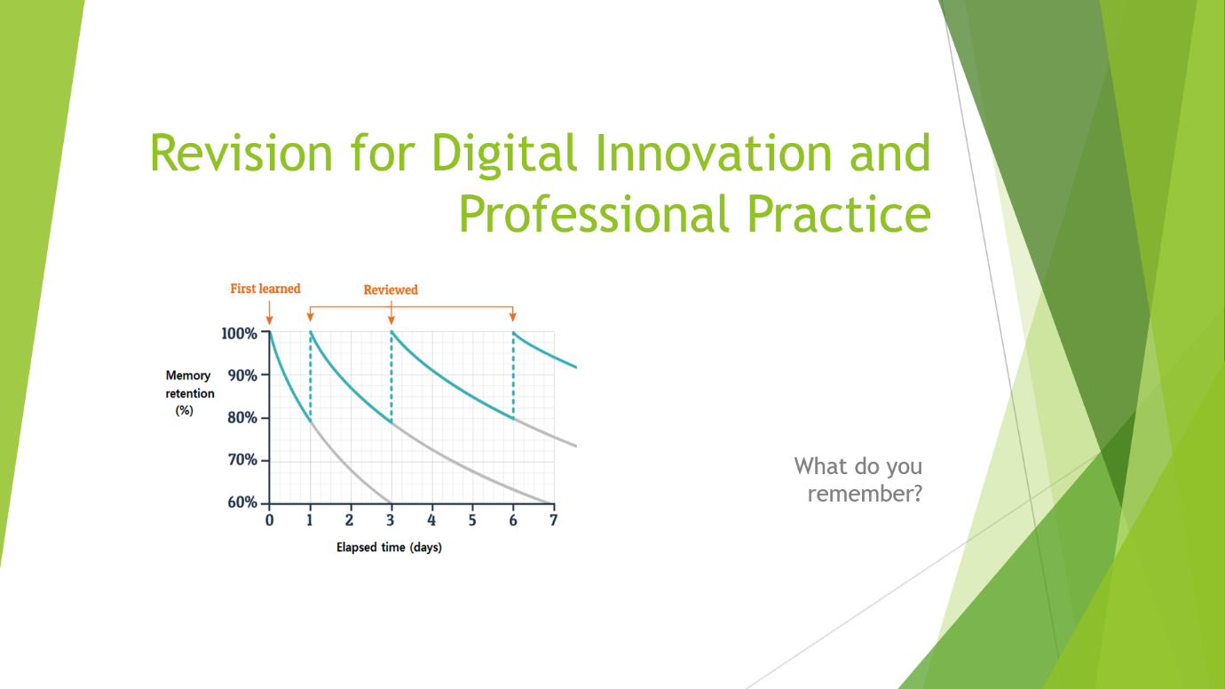
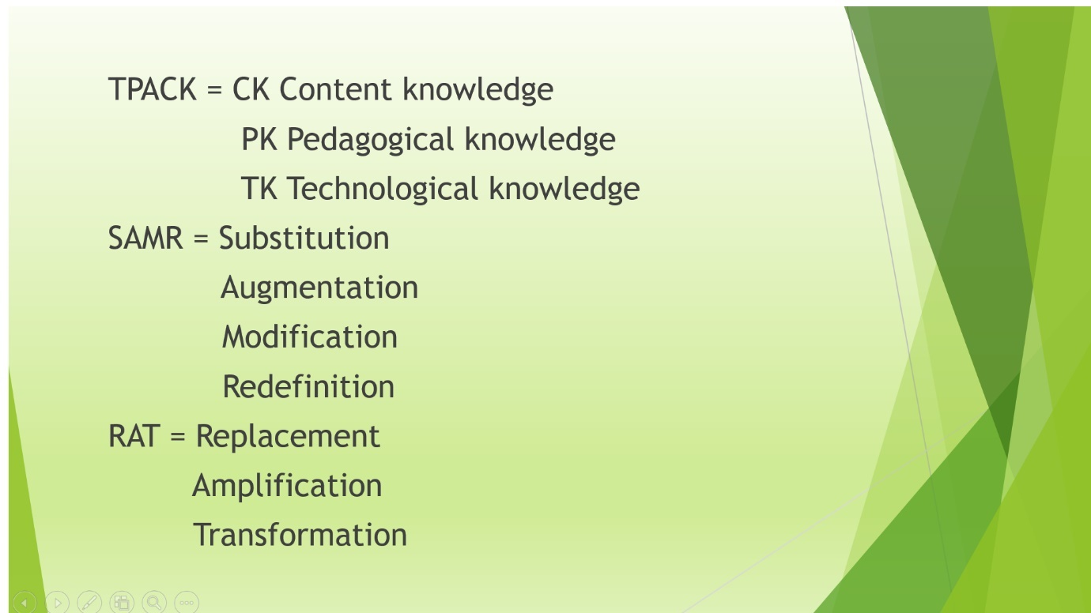
The slides used in the presentation were intended to jog student’s memory on some of what we had learned during the Digital Innovation and Professional Practice module.
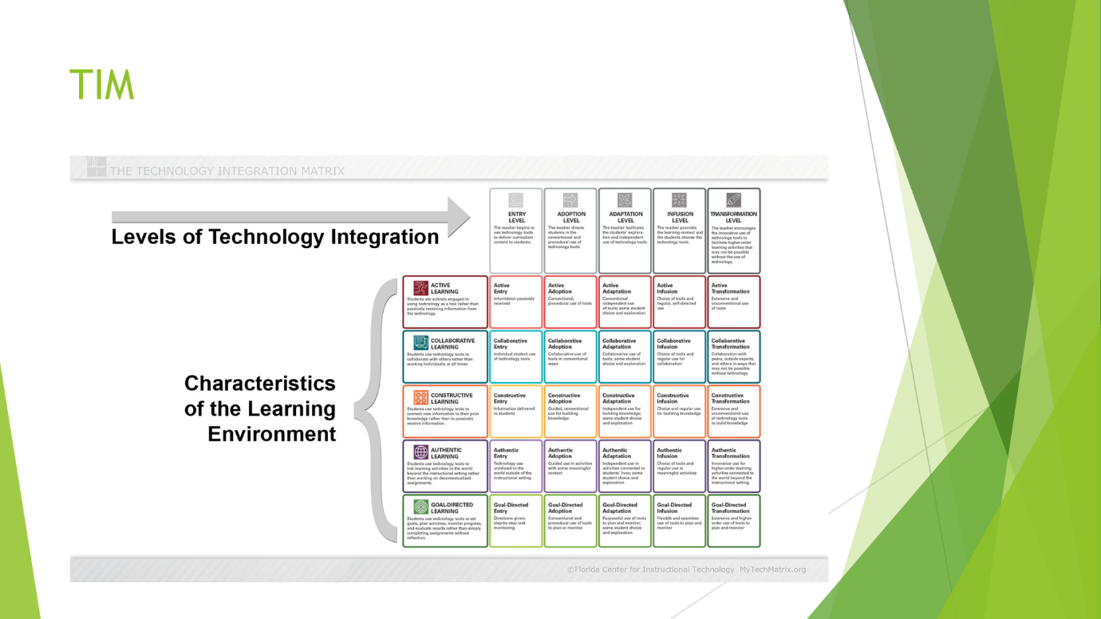
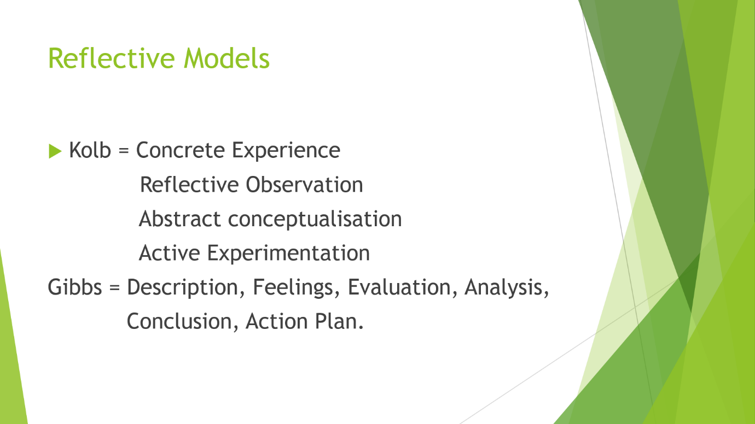
These slides were used to jog student’s memory on what we had learned in the Digital Innovation and Professional Practice module.


These slides were used to jog student’s memory on what we had learned in the Digital Innovation and Professional Practice module.


This slide was deliberately left blank as there is so much information regarding ethics but it was meant as a reminder for anyone who might be approaching their essay from an ethics perspective. Professional Standards were mentioned as “it goes without saying that professional standards should be included in all assessment work”.

