

Assessment 1 – Reading Task Template
PART 1: Upload your photo of your A3 in-class notes here:
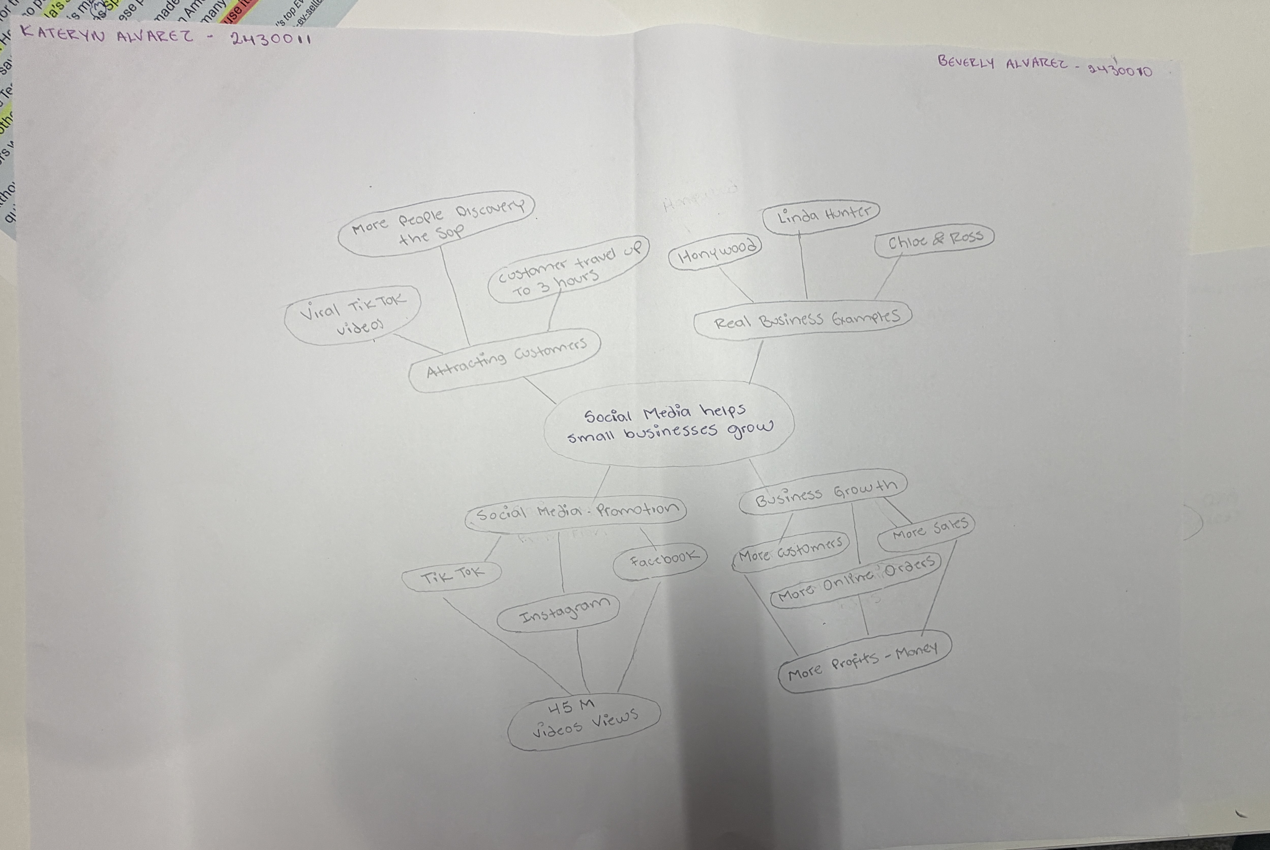

PART 2:
- Answer every question below in 1-3 full sentences.
- Use your own words. Do not use generative AI to answer these questions.
- Include a specific detail from the text when asked.
REMINDER
- The main idea is the overall message of the whole text.
- A key point helps to explain the main idea.
- A specific detail or example from the text shows that the key point is true.

- What is the main idea of the whole text?

Social media is very important for small businesses because many people use it every day. It helps businesses promote their products and reach people around the world. This helps them get more customers, increase sales and make more money.

- What is one key point that supports the main idea, and which specific example from the text shows this?
Social media has a big influence on people because videos and adverts make them curious about new businesses. When something becomes popular, people want to visit the place and try it. For example, some customers travelled three hours to Honywood Sandwich Shop to try its famous chicken burger.

- What is a different key point that supports the main idea, and which specific example from the text shows this?

Social media helps small businesses grow because they can reach more people around the world. For example, Linda Hunter now sells her clothes online and sends orders across the UK and even to Australia.

- Which part of the text do you think is most important, and why?
I think the most important part of the text is Linda Hunter’s story because she had a small business and faced a big challenge during the pandemic. She decided to use social media to promote her business and reach more people. Thanks to this, her business grew, and now she sells her clothes online and sends orders to different countries, even Australia.

Reflection:
- What did you find difficult in this task (including in-class components), and why was it difficult?
I found two things difficult during this activity. First, there was too much information, and it was difficult to choose the most important points. Second, we had to work in pairs to create the mind map, and it was difficult to agree because we had different ideas and opinions.

- What helped you with this difficulty, and how did it help you?
My partner shared her ideas, and I shared mine, but most of the time we had different opinions. We discussed our ideas to decide which ones were more suitable for the topic. Finally, we combined both ideas into one and worked together to complete our mind map.

