REPORT ON SUBCONTRACTORS (STAGE 1)
Task Required:
Describe what conditions are relevant to consider for subcontractor selection. Quotation is also one relevant aspect to analyse. In this case, explain what factors are relevant to consider in a subcontractor’s quotation. Write a report of about 2000 words describing both issues and impacts they have in the contract conditions.
CONDITIONS:
As we are being given the conditions as following which depicts that the commercial building is being divided into further sub-blocks of certain different heights;
Sub-block A: 5 floors
Sub-block B: 7 floors
Sub-block C: 11 floors
Sub-block D: 15 floors
Selecting the correct subcontractor is significant as our company will be ultimately responsible for that work performed by the subcontractor, hence, we should not take the selection very lightly. The subcontractor that a company selects represents that company’s work in front of the client and the client does not differentiate between the work done by the contractor himself or that done by the subscontractor. Poor selection could result in bad quality, delay in project completions, unsatisfied work etc. The sub contractor’s way of working, errors made, job performance and professionalism or non-professionalism is all going to reflect on your organization and its reputation.
A considerable proportion of work is done by subcontractors. The main contractor offers the contract to the subcontractor submitting the lowest price in lowest bid practice or most suitable. They are influential contributors to the project and their performance affects the stakeholders such as consultants and owners. Selecting the right man for the job is very important to ensure the reliability of work. In the same way, when a subcontractor should be hired, a series of steps should be followed which includes prequalification, evaluation based upon economic and technical aspects, past experience, work quality standards and many other aspects should be checked. However, it is common practice to hire subcontractors based upon their prequalification alone. It does not enough to decide whether this person is best for a job or not, so for hiring a subcontractor for work, it is important to take care of these basic steps.
Each individual owner sets up requirements for a subcontractor to put threshold for removing uncompetitive candidates from the list. The prequalification process help in the screening process of candidates for this contract. Now after screening and filtering, the remaining candidates are evaluated on basis of qualification, fundamental aspects, and project characteristics.
The qualification of required subcontractor must have a convincing record of degree, financial status, experience, technical assistance, standards, and quality. These are the basic common points which should be convincing enough for the client. (Nerija, Audrius, 2006)
The factors which influence the selection criteria of a subcontractor the most are cost, quality, insurance and safety, risks, time, tender, and experience of the company. Cost includes the tender price, flexibility in payments, financial stability and to cover up in case of cost overruns. Safety and insurance include a safe environment for workers provided by the subcontractors, job site cleanliness awareness, and insurance policies for machines and workers. Quality includes material quality and quality work of workers. Time includes the time required to complete the project, to work according to a timeline provided by the clients while assuring quality work. Risks include dispute among workers and subcontractors due to late payments or any safety compromise. The reputation of a company is also in consideration during selection process as experience builds up the reputation for companies to push their name at top of the list, which is why having experience is important as it describes knowledge, the volume of work performed, and the scale of work done by the company. (Mohamed M.Marzouk, 2013)
The client doesn’t care about problems with the subcontractor nor will they be sympathetic towards hired subcontractor if there are delays in the project or cost overruns or scheduling conflicts or incomplete work and then comes the question of whose fault is it if the subcontractor delays or a project has to be duplicated because of the subcontractors error.
To avoid such situations from occurring, we need to assess whether a subcontractor is competent or not and we can do so in a number of ways. We can look for evidence of experience in designing, erecting, dismantling scaffolds before hiring a subcontractor. A subcontractor can be a single person or a whole company. However, where scaffolds are concerned he should at least have in and outfield knowledge and should be a keen observer. He should carry out his responsibilities associated with multi-phase design projects, on-site supervisory presence including observation, supervision and direction, active participation in construction projects as well as being responsible for working closely with electricians and plumbers. Then there’s the control issue. If a contractor is controlling party than he is more responsible for the project rather than the subcontractor and hence they need to make sure that the subcontractor hired has the necessary experience on his or their resume’.
We can also ask for references from previous clients to aid us in our decision-making process on whether or not we should hire a particular subcontractor. If a contractor is able to provide us with correct and legal references then it is a plus point that will aid us in our selection process. If by any chance he or they are unable to do so we can look at other alternatives for assessing their viability. Secondly, the subcontractor should keep a record of recent activities, projects and contracts with all the previous clients' telephone numbers and addresses so if the need arises a contractor or client can re-verify the works that were carried out by the subcontractor. If for instance their track record was overall good but we saw a certain negative reference, it could result in losing tender. Further to assess any shortfalls and risks that might have occurred in the client’s projects and whether or not the subcontractor had provided a way to overcome them.
Health and safety records and accidents percentage is a useful way of determining whether a particular contractor should be hired or not as in any relationship between two businesses both parties have their respective duties under the health and safety regulation. The contractor should identify the requirements of the job and the risks involved, decide what information and training are required, the health and safety policies of the subcontractor being hired, their level of competence and the way in which a sub-contracting firm works before hiring them. Corporation and co-ordination between the two parties and their workforce together with proper management and supervision should be ensured at all times by providing the necessary information, instructions, and training on anything that may affect health and safety of the subcontractor’s work.
Other factors affecting the hiring of a subcontractor also includes looking closely at their accidents percentages and how many times have they been fined for failing to adhere with the health and safety laws such as failure to prevent contact with live equipment, failure to provide information on the existence of asbestos, failure to assess risks from exposure to high vibration levels, not exercising a duty of care towards his or their employees and workforce and their failure to provide a formal site induction or method statement.
Insurance issues also play a vital role when it comes to hiring a subcontractor for the job and we should consider public liability insurance as well before making any decisions especially concerning the contractors. We should obtain the necessary documentation regarding the insurance status of the subcontractor and ask to be named as an additional insured party in their insurance contract so that we can protect our intellectual property i.e. the material and equipment especially if the subcontractor is going to use them. We should also aim to ask for a non-disclosure agreement in an insurance contract and get the contractor to sign it to protect and safeguard the confidentiality of your business, a project schedule for performance targets and deadlines, penalties for poor workmen ship or late deliveries and the following of at least the minimum quality standards. We can also consult a legal advisor before agreeing to sign an agreement or hire a subcontractor.
We should also check the contractor’s previous works by going to their clients as recommendations from personal as well as business associates are very useful indicators of the subcontractor’s previous works. A follow up on the references and recommendations provided is very important we should contact the references in good time so that our work is not delayed and ask about the subcontractor’s personal qualities as well as the work standards and any legal cases the contractor might have been involved in. We should also check the authenticity of the voice references provided.
There are three causes which undermine inadequate subcontractor selection. These include poor verification of qualification regarding the subcontractor, the priorities set for selecting were inappropriate (focus on tender bid rather than quality assurance) and lastly the wrong methodology applied to evaluate its performance based on experience and workload capacity. These all and many other issues could result in inappropriate selection which effects timeline of project, performance and work quality. (Thomas E. Uher, 2006)
Factors affecting quotations proposed by the subcontractor are also important in terms of dealing between the subcontractor and client. Quotations are the estimated sum of cost proposed by the subcontractor based on the calculation of type of work, laborers required, time estimation and much more. It is not fixed amount to be paid as it can vary a great deal due to various reasons like additional work, delayed time due to some problems, modification in building plan upon client’s requirement or better building option.
In the matter of quotation, it is highly recommended to get at least three different quotes with the detailed list including labor and building cost. This helps to understand the difference between the actual price in the market rather than just relying on the words of the subcontractor hired. The cost of additional material required, delayed time and labor adds up into the proposed quotation as the requirement exceeds beyond the proposed deal. It is better to know about the subcontractor’s hourly rate to know how much additional work will cost if it is required. It is also recommended to see that if quotes are provisional or prime cost sum, this information should be verified by the subcontractors as the provisional sum of cost covers only specific building work including the quality of material and work which is expected. As prime cost sum depends upon the cost of particular items which are to be selected according to the client’s choice. Like the type of glass required for windows or design of ceiling, etc.it does not include installation charges, unlike provisional cost sum.
Compare the quotes of different subcontractors also helps in the selection of an eligible candidate for a subcontractor. This provides us the idea to deal with the cost and moving on with the plan which is effective for you in terms of project completion. The comparison tells us about the difference between subcontractors based upon cost charges and past experience and performance. There should be clarification in the quotes as once a deal or a contract is signed, variation in the proposed solution could cost more.
Quotes could also differ in payment methods or schemes involving more than one type of contracts in quotation proposing different deals for full building contract, labor contract which can further be divided into monthly laborers and daily based laborers working on a wage that is negotiated between the client and subcontractor.
The type of material also affects the quotation of a subcontractor. If the architect proposes special material for building a certain portion of the building process, it can vary the cost of the building process. Influence of a subcontractor is also important in this matter as the past experience and buying materials at wholesale price rate from a particular source should be questioned in order to assure quality along with any price reduction in such matters. Benefits of such matters should be discussed in the quotation with the subcontractor. (Peter Frimpong Manso, 2015)
Conclusion
The conditions we have discussed so far for selecting subcontractors based on pre-qualification and experience. Other than these conditions, there are a number of ways to select the right candidate on the basis of financial condition, professional attitude, competent applicant, quality worker, insurance and safety protocols, risks avoider, timely work completion, lower tender bid etc. Inadequate applicant is selected when screening procedures are not appropriate to select the right man for the job. These decisions are very important and risky at the same time as selecting the inadequate subcontractor would lead to loss of money and time of the company. Quotations of subcontractors can also be considered as selection criteria. It is important as it portrays subcontractor’s demand comparative to its experience in dealings in the market. It is important to verify quotes from two or three external sources so that it is convenient to select which plan is most effective according to the client’s requirement. Once official contract should be signed with that party. You should send written notifications to all other subcontracting companies who are left out during the selection process. All these factors described should be the part of selecting criteria list to select the most effective subcontractor for your construction project.

Stage two. Equipment purchases
Introduction
This part of course work I would like to discuss the most important piece of equipment which is contribute significantly to improve the mostly activity of building and different hight of sub-block building project with safety way and to handover without major delay and that piece of equipment is Tower crane.
Secondly, I would to make assess for this equipment either to purchase or to rent during my construction project and have to do differ type of calculation to find out Depreciation, Annual investment, Total ownership cost, Maintenance and repair cost, Electricity and lubricate oil cost and Total operation costs. Before I got the crane I have start getting an advice the best economic way to get that piece of equipment,
Tower crane
Tower cranes are usually used for large construction projects buildings where significant lifting limit is required more than half a month, years or for novel conditions which require a mix of vast lifting limit and stature. Tower cranes are regularly the most vital things of
plant on a site and to guarantee that site activities continue in a protected and proficient way, extraordinary care must be taken in the during the equipment installation for in use
According to the coursework I have to make a choice to either my Tower crane be purchasing or renting after I asses my budget and the length of my project I need one crane and two operators because it is not long-term project I will go for renting.
Hiring for Tower Crane
Leasing of a tower crane is a suitable option for construction site, it's best just in a predetermined number of situations, firstly I would suggest tower crane hiring when you don't anticipate more than one project, and long term or worth of work for the crane leasing will spare a cash. This permits me not to have the issue of buying a crane, transport it to my site area and keep up and benefit it at your own particular cost. These works will and ought to be completed as a component of the rental understanding for the agreement of the undertaking. The second situation when tower crane procure is best option is you deal and hire with specialist crane hire company for instance, Crane Hire in Swansea and Contract Lifting Services crane would be unique to the point that it is required for an extremely restricted time nearby and in this manner it's more efficient to lease it as opposed to buying it.
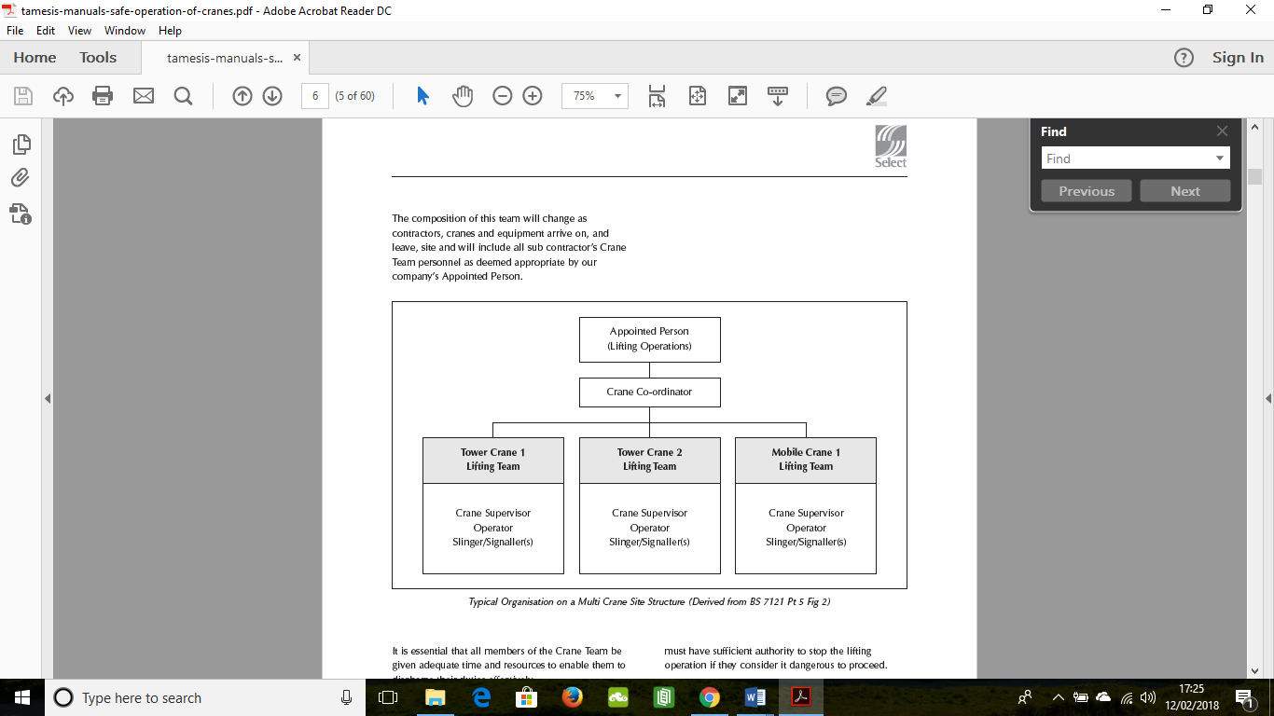Figure 1. Shows Tower Crane Site Structure (Derived from BS 7121 Pt 5 Fig 2)
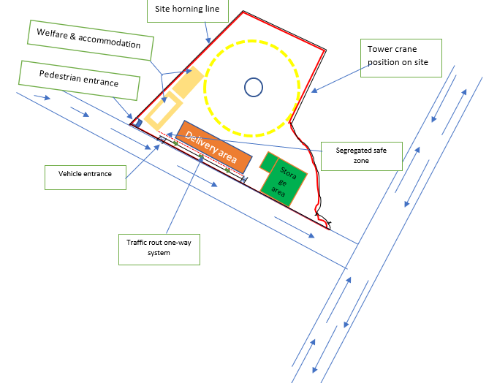 Figure 2. Shows site logistic plan for project

Price Cost for Purchasing

Overall I don’t need to pay this huge money in that long term plan for purchase crane and paid in 8 years period because my network diagram for this construction project is only last 18 months I work out the first part of the assignment so the alternative option which I have is Hiring base on my calculations the above to find out the suitable price , so I want to hire the crane I need that period of time in order to use loading and preload the material I need.

Conclusion
cranes are appreciated resources for the construction projects because they ended things peaceful for any type of building construction. All that contribution by cranes give a helpful technique for construction project of high-rise structures as well as in areas unreachable
finally I want to hire Tower crane in my construction project not to purchase so, i have to keep eye in all main hidden cost which is on top the cost the crane such as,
- They have high cost for fuel consumption and oil change which is not include rent fee or the extra hidden cost for plant
- They need experience crane operator which is come extra cost for labours on the site
- The security of the loading and lifting is very important during construction by using the correct PPE according to health and safety act
- Reduce need to employ maintenance staff and operate facilities

References
- Mohamed M.Marzouk, 2013. Factors influencing subcontractors selection in construction projects. HBRC Journal, 9(2), pp. 150-158.
- Nerija , Audrius, 2006. ANALYSIS OF CRITERIA FOR CONTRACTORS' QUALIFICATION EVALUATIONANALYSIS OF CRITERIA FOR CONTRACTORS' QUALIFICATION EVALUATION. TECHNOLOGICAL AND ECONOMIC DEVELOPMENT OF ECONOMY OPMENT OF ECONOMY, 12(4), pp. 276-282.
- Peter Frimpong Manso, 2015. Examining the Effects of Post Tender Negotiation in UK’s Public. s.l., ScienceDirect.
- Thomas E. Uher, 2006. Risks in subcontracting: Subcontract conditions. onstruction Management and Economics, 9(6), pp. 495-508.
- BUILDING CONSTRUCTION HANDBOOK Fifth edition R. Chudley MCIOB and R. Greeno BA (Hons) FCIOB FIOP FRSA
- http://www.constructionmanagermagazine.com/management/roles-and-responsibilities-construction-logistics-/(Accessed 5 July 2018)
- BUILDING CONSTRUCTION HANDBOOK Fifth edition R. Chudley MCIOB and R. Greeno BA (Hons) FCIOB FIOP FRSA

- Article (Select Plant Hire Company Limited)
- Barford Road, Little Barford, St.Neots, Huntingdon, Cambridgeshire PE19 6WB (Accessed 7 July 2018)
- Smith, N. (2000) Engineering Project Management, Oxford, Blackwell Science Ltd.
- https://vandoorntcc.co.uk/2013/06/14/tower-crane-hire/ (Accessed 2 July 2018)
- https://brynthomascranes.com/crane-hire-swansea/(Accessed 9 July 2018)

