

Assessment Component 2
Written Essay

Student’s Name: Aidah Becky Namuli
Student Number: 1912621
Module Name: Children, Young People and Families
Module Code: (BMHP5004-LON)
Lecturer Name: Bianca Sanfilippo

Contents
Vulnerability Case Study 3
Definition of the term child 4
Case Study 5
Analysis 6
Evaluation 8
Conclusion 9
References 10

Vulnerability Case Study

The selected family for purposes of this case study essay is about the social structure of childhood and the background of the John and Bridget’s family from Sheffield, the two are in their late twenties and early thirties, respectively. This essay provides a clear essence of the vulnerabilities faced by some of the children living in UK with a disadvantaged background. The family comprises of two young children. One of them, Jayden, suffers from ADHD, and he is of junior school age, Erin is the younger one and is of primary school age. The life of the family shows that its members, particularly the children, have been exposed to various vulnerabilities that have put them at risk for various reasons. The children’s father, John, has a history of offending, and he left school without having any type of qualification, which further puts him at risk of offending and reduces the quality of life he should possess due lack of disadvantaged history.
Having come from a family that bears a history of domestic violence, John is a father who poses a risk to the children. Being this type of a father is a risk for the entire family because John is apparently not able to take full responsibility as a father and partner.
Jayden and Erin face significant vulnerability in relation to their family situation. Their offending father, who puts them at increased risk of abuse, is a danger to their upbringing because he cannot raise them appropriately. This prompted the intervention of social services to help protect the children.

The children also face the risk of offending and antisocial behaviour, and this leaves them vulnerable because the family is not able to give them the right guidance owing to its attitudes to offending.
With a father who has no qualifications, the financial situation of the family is in dire need, and this means that the wellbeing of the children is also at risk.
Combined with the offending nature of John, the children are faced with a situation where they need to be protected. This protection, as seen by the involvement of social services, proved necessary to ensure their wellbeing and ensure that they did not fall into crime and possibly end up in the juvenile system.

Definition of the term child

According to (UNCRC,1991), a child is legally everyone under the age of 18, biologically a child is termed as a state between infancy to puberty and socially according to Kehily,2013) a child is defined as vulnerable and needs protection.

Childhood can be defined as a social constructed concept whereby it can be affected by the socio-economic and cultural influences according to Kehily, 2013). See below the proper illustration of child and childhood definitions.

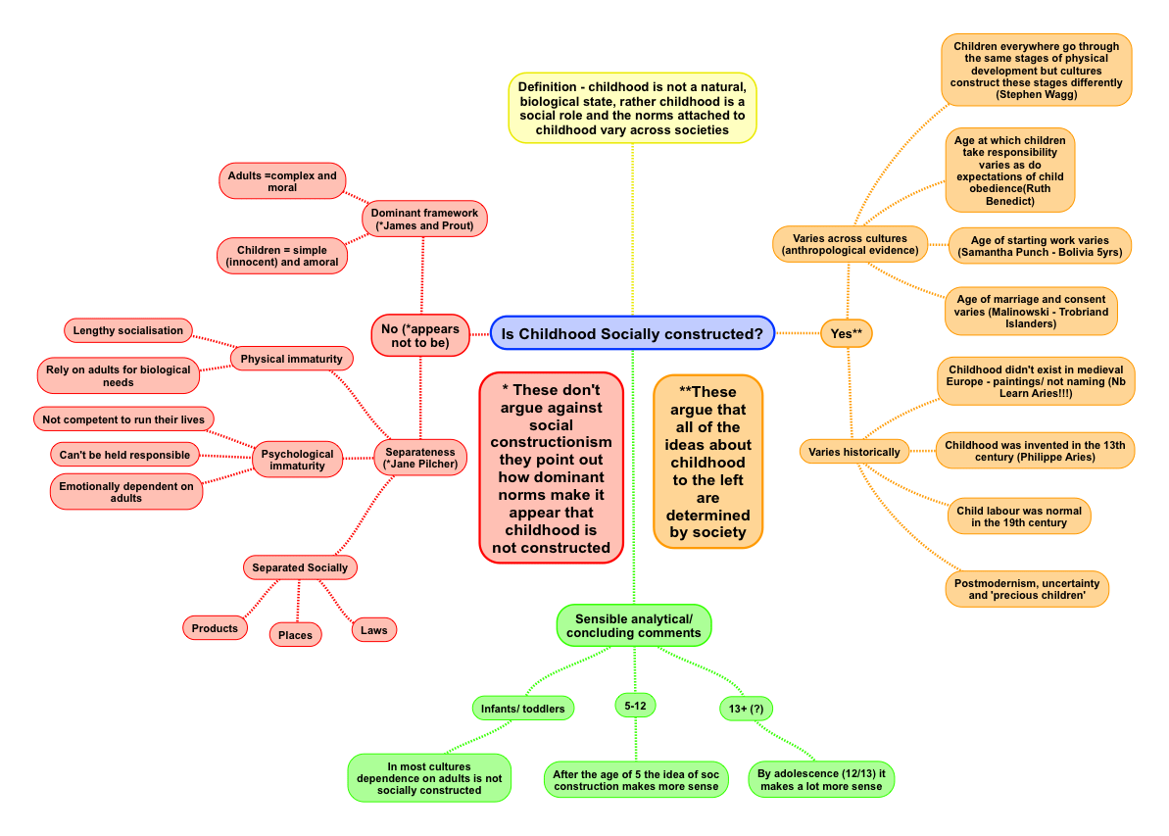

Figure 1 The Social Construction of Childhood

Case Study

The case under consideration is one in which vulnerability is evident in the family, and there are certain risk factors that exist to indicate this vulnerability. John left school without any qualifications, and he has not been able to stay in employment. Thus, one of the risk factors that are the source of vulnerability is his level of education.
The level of education of a parent has the potential to influence the educational attainment of children (Idris et al., 2020, p. 87). This is so because of the perception towards education and the decisions that are made in relation to their schooling. John has also been out of employment, and this means that his economic status is another risk factor that is worth considering.

Given the position John was in, it is likely that the children could not live their best lives with Bridget being the primary caregiver. John’s history of family domestic violence and reoffending exposes the children and the family at large to greater risk. The resulting risk of being abused physically prompted social services to act with the aim of protecting the children. On their part, the children are at a greater risk of offending and antisocial behaviour because of the offending nature of their father and the family’s attitudes to offending.
Early intervention was needed by John’s family, given the situation it was in. The basis of early intervention is preventing the occurrence of problems or dealing with them when they occur before they can get worse (Early Intervention Foundation, 2021).
The social worker involved undertook different forms of intervention to help the family deal with its problems. While John was still in prison, the social worker visited him and met with relevant agencies, and upon his release, the worker also met the entire family.
Parenting proved to be a major issue in the family, and intervention was necessary. It is for this reason that the social worker arranged to meet the couple to discuss their parenting and agree on the best way forward in relation to the children’s upbringing after John was released from prison.

Getting parenting wrong can lead to adverse impacts on the children, and through early intervention, parenting practices can be improved, and pressures of the family eased.
The two children in the family, Jayden, and Erin, are very young because they are only in their early ages of school life. Issues affecting the family make them vulnerable because of the risks they face.

Analysis

The case study of John’s family indicates a real situation of vulnerability where the children are the most affected. The need for mitigating this vulnerability is evidenced by the intervention of social services in the issues affecting the children.
After recognizing that the children faced the risk of physical abuse, social services put them on their “at-risk register” with the aim of protecting them. Local authorities have an important role when it comes to the protection of children from harm that they might face. Section 47 of the Children Act gives local authorities this obligation. The law requires local authorities to conduct investigations if it suspects that a child in their area suffers or is at risk of suffering significant harm and make an enquiry that seeks to determine the need for safeguarding or promotion of the child’s welfare (Children Act, 1989). Therefore, when social services got involved with the family for a period of one year, the authority involved acted within the confines of the law to protect the children from the harm they could possibly face.

Supporting families that are vulnerable is a key intervention strategy for the government. In 2011, the government launched the Supporting Families in the Foundation Years initiative, which was aimed at ensuring that parents accessed quality parenting programmes, and on top of classes, a website to help parents (CANParent) was established (Powell, 2019, p. 37). In the case study, it is noted that the worker assigned to John’s family talked to the two parents about the issues surrounding the raising of the children.
The role of the worker in assisting the family amid the challenges it faced aligns with the government’s objective under the Troubled Families Programme, which is aimed at supporting families that face various challenges among them crime, antisocial behaviour, and mental health problems among others (Powell, 2019, p. 39). Upon identifying a family that is troubled within its jurisdiction, a local authority assigns a key worker who acts as the family’s single contact point. Apparently, the intervention of the relevant local authority in the Sheffield area identified the family as troubled and took action to mitigate the issues affecting it.
The government has the responsibility to take care of vulnerable children, and in line with this, it has provided due process through the Working Together to Safeguard Children guidance by identifying families and children to whom early intervention can be useful. Local authorities have the responsibility to identify the children needing help and use a wide range of services to provide early help covering universal services, health, and domestic abuse with the overall objective of improving outcomes for the children involved (DfE, 2018, p. 13). Section 17 requires that the complex needs of children must be provided (Children Act, 1989).
In protecting the children, the relevant government agencies such as social services work together with parents to enhance outcomes in terms of addressing the needs of children.
John is a vulnerable father who puts his family, especially the children, at risk. He has a risk of reoffending and served time recently. Therefore, his individual wellbeing needs to be addressed to be mitigated to ensure that he lives a better life and contributes significantly to society.
Local authorities are mandated under Section 1 to perform roles that are aimed at promoting individual wellbeing (Care Act, 2014). Section 2(1) of this Act requires the local authority to consider if there is an intervention that can work towards preventing harm or reduce the aggravation of needs.
John’s wellbeing is affected negatively in terms of his social and economic status and his ability to contribute to society, and this makes a case for his need for support. The concern of the worker assigned to his family helps him prepare for life after prison, and it helps the children too because they can receive increased care from their father following the intervention. The plight of the children in terms of the risk they face depicts them as in need of intervention, and the actions of social services are appropriate in mitigating the risks that the children faced and preventing harm.

Evaluation

The intervention of social services in the case of John’s family involved different activities that were aimed at mitigating the problems that the family faced. The family was vulnerable given its financial and social state, and this required the involvement of a relevant government agency, and this is where social services came in.
The handling of John’s case was done in a comprehensive manner to address all underlying issues that put the family at risk. From visiting John in prison and meeting with agencies that were involved to meeting the family, the social worker did everything possible to help the family and ensure that their wellbeing was improved as mandated by Section 1 of the Care Act. At first, John was apprehensive of what would become of dealing with the worker but given that the worker was straightforward and honest in their approach to the family, a good relationship was created.

In providing support, individuals need to be provided with all relevant information in line with the government’s guidance, and they should be advised accordingly (Care and Support Statutory Guidance, 2014). Given the way the worker handled the case, all necessary safeguards were ensured, and the family was guided appropriately on what needed to be done to alleviate its wellbeing.

The intervention of social services bore fruits and achieved significant change in the case of John and his family to the extent that the family could normally live without social services intervening. John’s behaviour has been changed, and he has worked towards earning a qualification that would see him get employed on a full-time basis. His partner, Bridget, has become increasingly confident and independent and has continued working. As for the children, they can now afford to attend school without getting interrupted. By and large, intervention in the family of John was helpful, and all the parties involved received the necessary help they needed to help them move forward.
Based on policy and the actions taken by social services, one thing that could have been done differently is conducting a needs assessment for John and Bridget. The two qualify for such an assessment for being adults as provided under Section 2 (Care Act, 2014). Conducting a needs assessment is very important for a local authority that seeks to improve the welfare of its people because it would ensure that specific needs are met, and nothing is left unresolved in the process of providing care and support.
Given that the worker would be expected to respect the views and beliefs of those involved, the process would ensure that an ideal working relationship is established and thus, better outcomes are more likely to be achieved.
John had a history of offending and domestic violence was reported in their family. The case highlights that the children faced the risk of physical abuse but did not address Bridget in this regard. As such, it is important that the local authority involved in handling his case ensures that the necessary safeguards are put in place to ensure that she does not face the risk of such abuse should John fall back into offending. The local authority is mandated by Section 42 to conduct an enquiry if it reasonably suspects that there is a risk of abuse, and the individual is unable to protect themselves from the said risk (Care Act, 2014). The Care and Support Statutory Guidance provides necessary regulations that should be adhered to in protecting adults from abuse.

Conclusion

The case study on John’s family is a testament to the positive role of early intervention in families. The early intervention aims at identifying potential problems before they occur and preventing them or finding solutions to problems before they get worse. In the case of John, the intervention of social services was key to mitigating the risk factors that made the family vulnerable. Through the different activities, positive outcomes were realized, including behavioural change and economic improvement on John’s part.
The children’s education was ensured, and the wife’s confidence and independence received a huge boost. The application of different policies and legal provisions is evident in how the case was handled, and these include the Children Act and the Care Act. Through a needs assessment, the intervention of social services would have been able to obtain better outcomes.

In addition, the local authority should have ensured that it puts in place necessary safeguards in relation to Bridget to avoid any risk of abuse that she could face in future. Considering how the social worker handled John and his family, significant effort was made to address the challenges that this vulnerable family was facing. The outcome is a better family whose wellbeing has been improved.

References
DfE. (2018). Working together to safeguard children: A guide to inter-agency working to safeguard and promote the welfare of children [PDF]. Retrieved 21 July 2021, from https://assets.publishing.service.gov.uk/government/uploads/system/uploads/attachment_ data/file/942454/Working_together_to_safeguard_children_inter_agency_guidance.pdf.
Early Intervention Foundation. (2021). Parenting & families. [Online]. Retrieved 22 July 2021, from https://www.eif.org.uk/what-its-about/parenting-families.
https://www.legislation.gov.uk/ukpga/2014/23/contents/enactedare Act 2014. https://www.gov.uk/government/publications/care-act-statutory-guidance/care-and-support-statutory-guidance
https://www.legislation.gov.uk/ukpga/1989/41/schedule/2

Idris, M., Hussain, S., & Ahmad, N. (2020). Relationship between parents’ education and their children’s academic achievement. Journal of Arts & Social Sciences (JASS), 7(2), 82-92.
Powell, T. (2019). Early Intervention [PDF] (pp. 37-39). House of Commons Library. Retrieved 21 July 2021, from https://researchbriefings.files.parliament.uk/documents/CBP-7647/CBP-7647.pdf.

