

University of Wales Trinity Saint David
School of Engineering

Project Planning

Sam Alun Williams

1701794

BEng Motorsport Engineering
Management, Innovation and Sustainability
M5X01176

Contents

Abstract 3
Team Roles and Responsibilities 4
Table of Team Roles and Responsibilities 4
Table showing Belbin’s Scoring System 5
Table Comparing My Score against Average Score 5
Group Tasks and Associated Timings 6
Table of Recorded Masses 6
Group meeting schedule 6
Table of Group Tasks 7
Personal Tasks 8
Table of Preliminary Bill of Materials 8
Table of Personal Tasks and Associated Details 9
Milestones and Gateway 10
Table of Group Milestones 10
Gateway 10
Risk Analysis 13
Summary 15
Group Gantt chart 15
15
Bibliography 16

Abstract

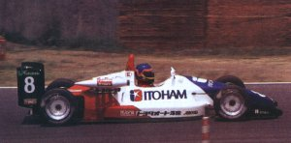
The objective of this project planning report is to reflect on the progress made thus far on this year’s group project and strategize for future endeavours regarding the task. The report will include a description of each of the Chassis and Suspension team member’s roles and responsibilities, along with a more detailed list of my own tasks. A summary of Belbin’s self-assessment inventory is contained within the report along with both personal and average scores, including explanations on how the results can be used to improve individual and collective performances. Significant milestones, cause for concerns and a personal gateway make up the remainder of the report, as well as two Gantt charts to highlight personal and group activities. As a class, students were given the task of designing an electric hillclimb/sprint vehicle capable of competing in the British Hillclimb and Sprint Championship. The vehicle is based on the carbon fibre monocoque chassis of TOM’s 032F-Toyota raced in the Japanese Formula 3 championship raced by Jacques Villeneuve in 1992 (pictured below).
Jacuqes Villeneuve in the TOM’s 032F-Toyota, 1992 (Collins, 2019)

Team Roles and Responsibilities

As groups, the students split into four teams of powertrain, chassis and suspension, aerodynamics and simulation. The chassis and suspension team is made up of six individuals. Team roles were delegated to each student to cover significant topics. The topics include but are not limited to steering, suspension, brakes, tyres and the design of powertrain/power storage cradle to be mounted to the rear of the monocoque. The design must adhere to Motorsport UK 2019 Regulations along with FIA appendix J article 253 art 18 which relates to the vehicle’s safety cages. A selection of parts accompanied the tub including wishbones, uprights and suspension components. It is assumed that these parts are fabricated from T45 steel. An extensive list of each member of the chassis group’s roles and responsibilities is displayed in table below.

Table of Team Roles and Responsibilities
TEAM MEMBERS | TEAM ROLES | DESCRIPTION OF ROLES
Sam Williams | Suspension Geometry and Design Engineer | - Measurement of front suspension and steering components, mounting brackets and mounting points on the body  - CAD models of components and pick up points with full CAD assembly of components and tub  - Research into brake component mounting  - Research and input into brake and tyre selections
Michael Heys | Chassis Engineer | - CAD of rear chassis frame  - Research into single seat open wheel chassis  - Tyre and wheel research and selection  - Material selection of rear chassis frame
Joshua Lewis | Brake and Cockpit Engineer | - Research and selection of brake setup  - Interior spec – steering wheel, seat, harnesses  - Pedal box research and selection
Richard Osborne | Project Manager and Co-Chassis Engineer | - CAD design of powertrain cradle and battery packaging  - Suspension mounting points for rear  - Damper mounting on rear
Elis Hopkins | Damper Engineer | - Research and selection of rear suspension components  - Completion of damper dyno test on front dampers with damper curve data  - CAD model of wheels and tyres
Zihao Liu | Safety and Regulations Engineer | - Research into applicable regulations  - Research and selection of fire extinguishers  - Research into power supply isolators

During a lecture conducted by Mark Sanford, the class completed Belbin’s self-perception inventory. Developed by Dr R Meredith Belbin, the questionnaire involves 7 questions with eight answers for each. Ten points are allocated to answer each question, with more points being appointed to the most appropriate answer to one’s personality. It can be an effective tool in highlighting the strengths and weaknesses of members of a team, which is a key insight so that improvements can be made (University of Cambridge , 2019). It was discovered that there are 9 types of behavioural groups, each of which is shown in the table below along with a guide of the scoring system.

Table showing Belbin’s Scoring System

 | IMPLEMENTER | COORDINATOR | SHAPER | PLANT | RESOURCE  INVESTIGATOR | MONITOR  EVALUATOR | TEAM WORKER | COMPLETE  FINISHER
LOW  0-33% | 0-6 | 0-6 | 0-8 | 0-4 | 0-6 | 0-5 | 0-8 | 0-3
AVERAGE  33-66% | 7-11 | 7-10 | 9-13 | 5-8 | 7-9 | 6-9 | 9-12 | 4-6
HIGH  66-85% | 12-16 | 11-13 | 14-17 | 9-12 | 10-11 | 10-12 | 13-16 | 7-9
VERY HIGH  85-100% | 17-23 | 14-18 | 18-36 | 13-29 | 12-21 | 13-19 | 17-25 | 10-17

The results of my personal Belbin model highlighted three areas where scores were above average, one area of average scoring and the remaining five areas below average. My scores specify that I am strongly linked towards the resource investigator, shaper and complete finisher roles. A resource investigator is a people oriented role, whereas the remainder are action oriented. Belbin’s resource investigator role describes attributes of being enthusiastic, outgoing and exploratory, but can show signs of overenthusiasm or losing interest once initial novelty wears off. Belbin declares that a shaper ‘provides the necessary drive to ensure that the team keeps moving’ (Belbin, 2019). Strengths include challenging, dynamic and thriving on pressure (University of Cambridge , 2019). The complete finisher role states a conscientious, anxious attitude to deliver on time, with a tendency to worry unduly and a reluctancy to delegate jobs to others. I believe this to be a truthful representation of my personality and can aid myself and my team members to consistently complete tasks and maintain momentum. However, I do possess a tendency to worry unduly and sometimes take on a large workload. Although, this can have a positive effect when it comes to finishing jobs in a set timeframe, which relates to thriving under pressure and a constant demand for success. Although I may sometimes lose interest in subjects, this self-prescribed pressure acts as a huge motivator and compels me to take action accordingly. Displayed below is a table of my recorded scores along with equivalent average scores.

Table Comparing My Score against Average Score

 | IMPLEMENTER | COORDINATOR | SHAPER | PLANT | RESOURCE  INVESTIGATOR | MONITOR  EVALUATOR | TEAM WORKER | COMPLETE  FINISHER
MY SCORE | 8 | 5 | 18 | 4 | 10 | 8 | 7 | 10
AVERAGE SCORE | 10 | 8.8 | 11.6 | 7.3 | 7.8 | 8.2 | 10.9 | 5.5

Group Tasks and Associated Timings

After our first team meeting on October 2nd, the chassis group decided to use electronic weighing devices to measure the mass of the tub, along with existing parts that could be integrated into the design. This data is useful in building a theoretical model of the vehicle and valuable for the group to complete a mass distribution spreadsheet. A table of the recorded data is displayed below.

Table of Recorded Masses

ITEM | MASS (kg)
Tub | 66
Front upright | 3.1
Rear upright | 4.45
Bottom wishbone (front) | 1.25
Top wishbone (front) | 0.6
Front damper with spring | 1.4
Nose cone | 4.35

Each group must work in conjunction with each other so that significant progress may be made both individually and collectively. For example, the simulation team needed 3 definite tyre choices along with the rolling radius and contact patch from chassis group by the group meeting on October 28th. So that this request could be supported, we as a group had to define wheel diameter and width. However, for us to make a suitable choice, groups had to agree upon an approximate value for the power produced by the electric motors. Once defined, the simulation group could provide groups with more accurate test data which help refine subsequent choices such as an adequate wheelbase range. Both increasing and decreasing the length of wheelbase has benefits and flaws. As wheelbase is shortened, acceleration traction increases but so does the height of the vehicle’s centre of gravity. Its centre of gravity also moves towards the rear. This means that once the lower limit of wheelbase is reached, the front wheels will be elevated from the ground due to the rearward centre of gravity (Van Valkenburgh, 1992). As a group, we have held a one-hour meeting on every Monday since the start of term in which our project coordinator Abi Summerfield has been present. Additionally, students have met regularly between these weekly meetings to discuss ongoing tribulations and conduct future-planning. The dates on which these meetings took place and durations of each meeting can be viewed in the list below. A table of overall group tasks and timings are also shown below.

Group meeting schedule
- 4/11/19 – 1 hour
- 11/11/19 – 1 hour
- 18/11/19 – 1 hour

- 30/9/19 – 1 hour
- 7/10/19 – 1 hour
- 14/10/19 – 1 hour
- 17/10/19 – 1 hour
- 21/10/19 – 1 hour
- 24/10/19 – 2 hours
- 28/10/19 – 1 hour
- 30/10/19 – 3 hours

Table of Group Tasks

GROUP TASKS | TIMINGS
- Research existing electric hillclimb vehicles, events and regulations | 30/9/19 – 4/11/19
- Weigh existing chassis and parts | 7/10/19
- Measurement and CAD modelling of suspension components | 3/10/19 - 31/10/19
- Three specific tyre choices | 21/10/19 - 6/11/19
- Wheel choice | 23/10/19 - 6/11/19
- Brakes (discs, callipers, lines, servos, master/slave cylinders etc) | 21/10/19 – 27/11/19
- Rear wishbones and uprights | 20/11/19 – 24/1/20
- Design powertrain cradle | 11/10/19 – 4/11/19
- Material choice for chassis | 25/11/19 – 7/2/20
- Track width and wheelbase | 23/10/19 – 14/2/20
- Measure distances between mounting studs on rear bulkhead | 09/10/19
- Driver controls and interior | 28/10/19 – 21/2/20
- Safety devices and power isolation switches | 28/10/19 – 28/2/20
- Measurement of from suspension coordinates for input in WinGeo software | 21/11/19 – 22/11/19
- Group Project Vivas | 4/12/19
- Group Project Report and Vivas | 23/3/20 – 26/3/20

Personal Tasks

My personal role in the team is ‘Suspension Geometry and Design Engineer’. As part of this title, my tasks include the dimensional measurement of front wishbones, uprights, suspension push rod and track rods and the subsequent replication and assembly of these items using Solidworks CAD software. In order to complete this, I spent time in the workshop measuring the components with specialist measuring equipment. Suitable research has also been carried out by myself and other team members into tyre, wheel and braking choices for the team. To date, it has been assumed that the parts of the vehicle are ample to reuse, because they have already been used in professional motorsport. While this assumption may be correct, the forces acting on these parts must be calculated and resolved before one can be sure.
Due to most of my work to date being involved with parts that are already in our possession, I have not had to gain prices on many objects. However, below is a Bill of Materials table for objects that I have been involved with so far.

Table of Preliminary Bill of Materials

ITEM | QUANTITY | PRICE
M5 top hat washers | Minimum of 16 (4 for each upright) | Between £5-£30 (estimated)
Forged AP racing 4 pot calliper | 4 | £1760 (including 20% student discount)
Brake pads | 1 set front. 1 set rear | £161.20

Table of Personal Tasks and Associated Details

PERSONAL TASK | TIME TAKEN | TASK DETAILS | COMPLETION | EQUIPMENT
Measure suspension parts | 10/10/19-14/10/19  3 hours | Remove, measure and take notes of fully defined dimensions of upper and lower wishbones, uprights, damper push rods and track rods | COMPLETE | Steel ruler  Vernier gauge  Micrometer  Protractor  3/8 socket set and ratchet  Spanners
Create CAD model of parts | 10/10/19-31/10/19  Approx 20 hours | Create dimensionally accurate models of each part to input into assembly | COMPLETE | Solidworks 2019
Research into brake choices | 4/11/19  4 hours | Research into possible brake disc and calliper choices. AP racing seem most feasible choice. | COMPLETE
Investigate brake disc mounting | 22/11/19  2 hours | Visual inspection and discussion completed. Decided that top hat washers and dowels can be used to dissipate forces. Sandwich plate likely needed to adjust PCD for disc mount | COMPLETE
Measure wishbone mounting points | 20/11/19  2 hours | Measure distances between mounts along x, y and z axis aiding cad assembly and wingeo model. Construct models of mounting brackets. | COMPLETE | Flatbed (to use as datum)  Steel rule  Digital angle gauge  Vernier gauge  Allan key set  3/8 sockets set and ratchet
CAD assembly of tub and parts | 10/11/19-4/12/19  Approx 4 hours | Make full CAD assembly of tub with modelled suspension parts | ONGOING  To be completed by 4/12/19 | Solidworks 2019
Investigate ultrasound scanning | 11/11/19 | Find a company locally based to use ultrasound equipment to observe hollowness of parts for more accurate prototypes | ONGOING | Ultrasound equipment
Resolve front wheel forces | 14/11/19 | Calculate estimate values for forces through upright. Results will determine whether uprights suffice. | ONGOING | Scientific calculator

Milestones and Gateway

Table of Group Milestones

MILESTONE | DATE
Weighing existing components and tub | 7/10/19
Measurement of chassis mounting studs on rear bulkhead | 9/10/19
Front suspension components measured and modelled in CAD | 31/10/19
CAD model of rear chassis structure | 4/11/19
Tyre selection | 6/11/19
CAD model of powertrain cradle | 6/11/19
Wheel size selection | 6/11/19
First Group Project Viva | 4/12/19
Second Group Project Viva and Report | 23/3/20 - 26/3/20

Gateway

For my own area of study, my gateway objective is to calculate and resolve the forces that are acting on the front uprights. These calculations are imperative to the team’s progression and a change in choice of upright can influence many aspects such as brake mounting, steering and wheel track. There are many different forces acting upon these components at any given time. Thus, there are many different calculations to be considered. Because of the theoretical nature of the project, many values are to be assumed with reference to actual data and figures. Forces to be calculated include the frictional forces between the road surface and tyre, braking force, cornering force as well as lateral and longitudinal load transfer. The weight acting on each wheel depends on the weight ratio between front and rear. Assuming even weight distribution, the weight acting on each hub would equal the total mass of the vehicle divided by the number of wheels. An assumed figure of 1.6 is the Mu value for the tyres (on dry asphalt). Once the necessary calculations are complete and forces are resolved, we can decipher whether the uprights are suitable for use. The magnitude of forces is a combination of vehicle weight, tyre load transfer and aerodynamic forces. A safety factor of three times the maximum of the other known forces is used to approximate forces transmitted through bumps on the road surface (Van Valkenburgh, 1992).

$$coefficient of friction, μ=\frac{wheel load}{braking force}$$
(Sandford, 2019)

$$maximum g in any direction=\frac{\left(weight+aero downforce\right)×tyre coefficient of friction}{weight}$$
$$lateral load transfer=\frac{\left(g\right)×\left(weight\right)×\left(CoG height\right)}{track width}$$
$$longitudinal load transfer=\frac{\left(g\right)×\left(weight\right)×\left(height of CoG\right)}{wheelbase}$$

(Van Valkenburgh, 1992)

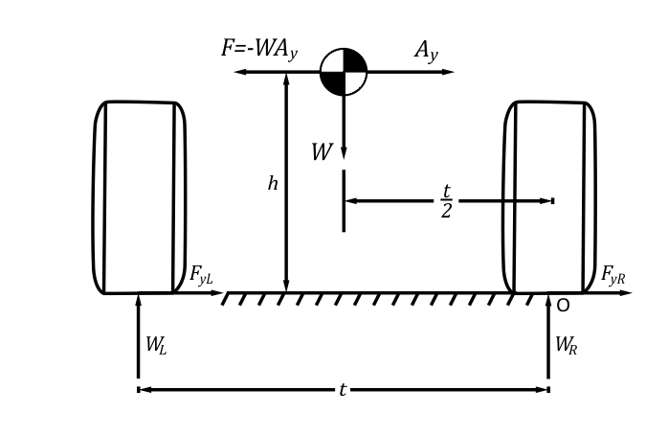

Assuming symmetrical weight distribution;
$$Total lateral load transfer ∆W=\frac{W×A_{y}×h}{t}$$
(Santos, 2015)

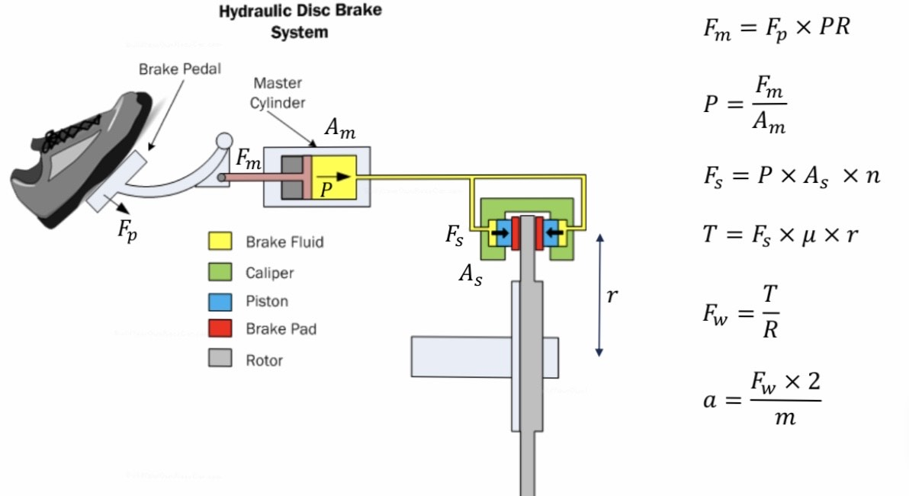
(Tudor, 2019)

Risk Analysis

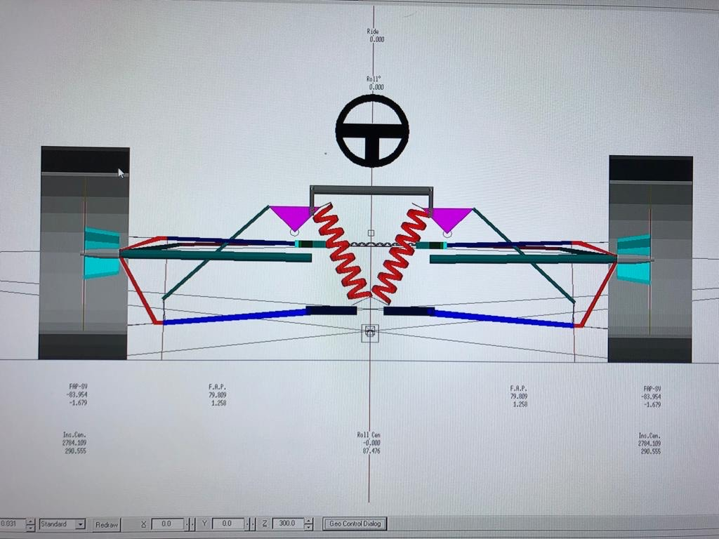
There were many areas of concern and unfamiliarity’s that the group faced while undertaking this task. I have chosen two areas of concern that directly impacts my own responsibilities. The first of my concerns was utilizing CAD software properly and efficiently in order to make CAD models of the potentially reusable components like wishbones, uprights and suspension push rods. This is something that I have had no prior experience of, therefore, a lot of time and effort initially went into studying the appropriate processes and techniques. As well as using my own initiative to learn, designs and concepts can be inspected by competent members of staff at the university to be enhanced to mitigate risk before testing is completed. Like many aspects of life, a certain degree of investigatory work and trial and error is observed before significant progress can be made. Firstly, the components’ dimensions must be measured accurately using suitable measuring tools. The geometric dimensions are vital so that the components to be accurately created so that adequate testing can be carried out with real life stress testing as well as within the Solidworks software. In addition, the measurements taken can aid in creating a three-dimensional, kinematic model of the vehicle using WinGeo3 software. This can be essential in helping the team understand the effect of steering input and roll on factors like roll centres and wheel camber (WinGeo3: Autosport International, 2019). To aid in replicating the parts to a high degree of accuracy, the team is also exploring the possibility of using an ultrasound scanner to check the hollowness of the parts. The procedure would aid the team in modelling a three-dimensional, cross-sectionally accurate parts.
Image of the kinematic model using measured suspension coordinates inputted into the WinGeo software
A second concern of mine was how to mount the new brake discs to the existing uprights. Currently, there are no brakes and there hasn’t been any for the duration of the project thus far. There are four M5 threads which were determined to be the mounting bolts for the brake disc (see picture below). However, the forces that would be acting through the bolts would surely sheer them if fitted incorrectly. Through visual inspection and conversing with technicians, recesses were discovered around the thread. It was decided that by using a nylon or polyurethane top hat washers that would fit into said recesses, the forces acting through the bolts would be dissipated. Furthermore, the remaining holes could be used to incorporate dowels that would also dissipate braking forces and increase the overall strength. It is possible that an adapter plate would be needed to alter the Pitch Circle Diameter (PCD) necessary to sandwich between the brake disc and upright. This would also boost the strength between the components.
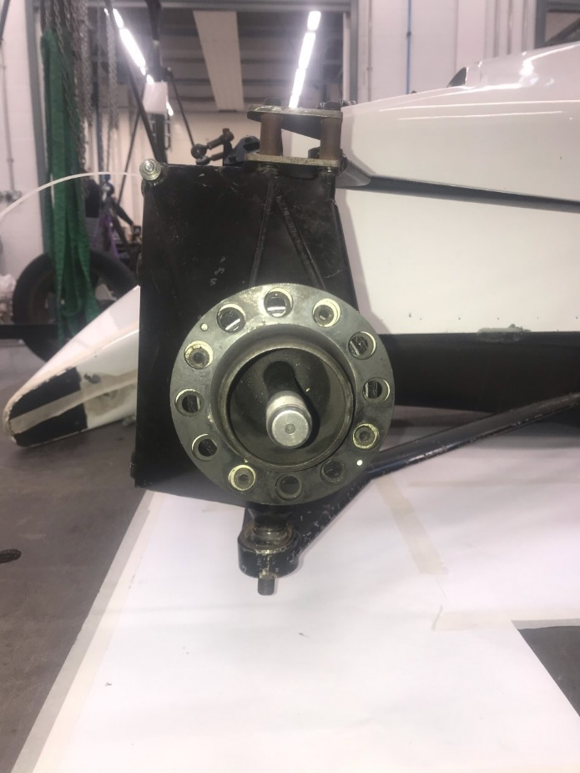

Image of the existing near-side front upright with brake disc mounting holes

Summary

Group Gantt Chart
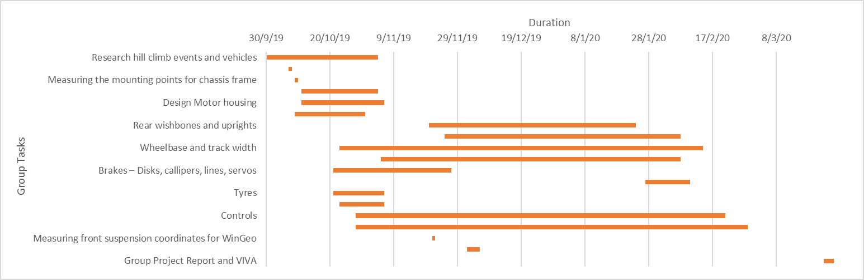

Personal Gantt Chart

Bibliography

Belbin. (2019, November 18). The Nine Belbin Team Roles: Belbin. Retrieved from Belbin: https://www.belbin.com/about/belbin-team-roles/
Collins, A. (2019, November 10). Five Drivers you didn’t know that raced in Japanese F3: essaar. Retrieved from essaar.co.uk: http://essaar.co.uk/five-drivers-didnt-know-raced-japanese-f3/
Sandford, M. (2019, October). Vehicle Dynamics lecture. Swansea, Wales: University of Wales Trinity Saint David.
Santos, R. d. (2015, June 9). Weight Transfer: Racing Car Dynamics. Retrieved from Racing Car Dynamics: https://racingcardynamics.com/weight-transfer/
Tudor, T. (2019). Brake Calculations. Swansea: University of Wales Trinity Saint David.
University of Cambridge . (2019, November 18). Belbin's team roles: Institute for Manufacturing. Retrieved from Institute for Manufacturing: https://www.ifm.eng.cam.ac.uk/research/dmg/tools-and-techniques/belbins-team-roles/
Van Valkenburgh, P. (1992). Race Car Engineering And Mechanics. Los Angeles: HP Books.
WinGeo3: Autosport International. (2019, November 12). Retrieved from Autosport International: https://www.autosportinternational.com/marketplaceproducts/wingeo3

