Study skills assignment

University of Wales Trinity Saint David
School of Engineering
Motorsport engineering
Oliver godon
P150782
8/12/17

Table of Contents
Abstract 3
1 Introduction 4
2 Background research 5
3 Methodology 6
4 Results 7
5 Discussion & conclusion 8
5.1 Discussions 8
5.2 Conclusions 8
6 Recommend further work 9
7 References 10

Introduction
In this report I shall be looking at/discussing the forces that a con rod undergoes inside an car or motorbike engine of my choice, my choice being the lsx454r made by Chevrolet performance department, within this report I shall be using an excel table provided for me that I will use to input information about the engine I have chosen. Following on from this, I will input the values into the table so I can calculate the results and analyse them. These values include the con rod length, the crank radius, rpm and the mass of the piston. This will produce many different tables for me to analyse, from these tables I will experiment with values like rpm (for example) too see the different forces the con rod undergoes at different rpm.

Background research
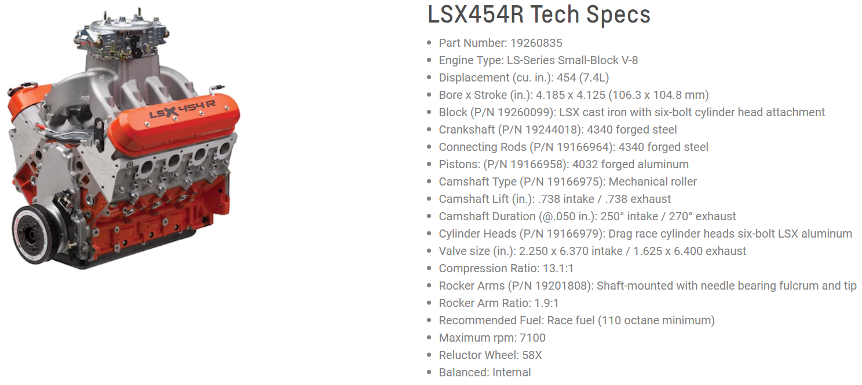
The LSX454R v8 7.4L is the engine I’ve decided to take the information from, which includes, the mass of the piston, the crank radius, max rpm and the connecting rod length, this is so I can conduct the test of the forces the con rod undergoes inside the engine at a series of different rpms. Using the Chevrolet performance website, I managed to find out the engine’s tech specs, this allowed me to do the research required and find the values needed for the tables on excel.
Figure 1-lsx-454r engine, http://www.chevrolet.com/performance/crate-engines/lsx-454r
As stated on the Chevrolet website-“quite simply, the lsx454r drag racing engine is the most powerful ls engine ever from Chevrolet performance- and its designed to do one thing: help you win races with great durability.” (Chevrolet, 2013)
When looking at the tech specs of this engine I was able to determine the connecting rod used inside this ls engine, 4340 forged steel connecting rod was used and to find out the lengths, I did some googling and found this connecting rod is an I-beam 4340 forged steel con rod, with a length of 6.000” inches. (racing performance maximum, 2014)
The con rods are the same as the ls1 and ls2 engines made by Chevrolet. So getting information was fairly simple, it’s a similar story when researching about the pistons, they are 4032 forged steel ls pistons, which have a mass of 0.38kg. Hurricane speed and performance are the company that make these racing pistons, with extreme high quality and precision. (Hurricane Rods, 2014)

When looking for the crankshaft radius online, I took evidence from the tech spec list on Chevrolet’s website, the material being 4340 forged steel, finding the information I required on competition products website, I was able to find the stroke length, 4.000” inches. Already knowing that the stroke radius is half that of the stroke length, I’m then left with 2.00” which I can now input into my table on my excel document.
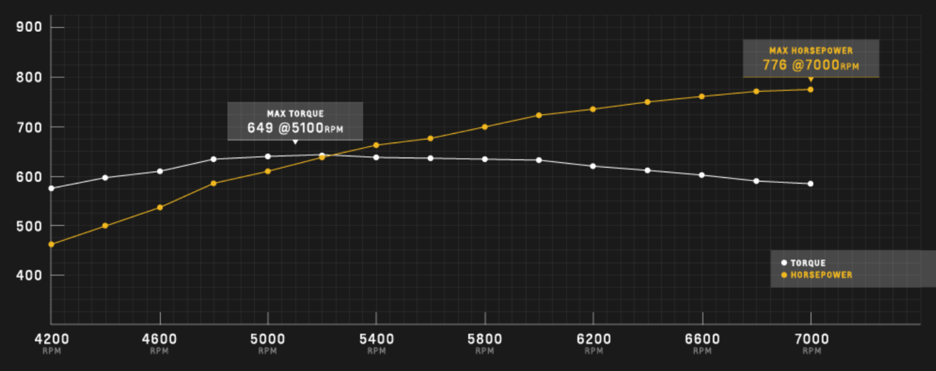
The lsx454r crate engine was originally made too be a cheap too maintain, extremely reliable race engine for the customer, they (Being Chevrolet) never realised that they were making the most powerful engine they had ever produced. (Big Power Numbers from GM’s LSX454R, but Reliability is the Focus, 2014, pp. http://www.dragzine.com/tech-stories/engine/big-power-numbers-gms-lsx454r-reliability-focus/).
Figure 2-https://www.chevrolet.com/performance/crate-engines/lsx-454r
This is a small graph made by Chevrolet on their website to show the torque and hp (horse power) as the engine goes through the rpm up to its maximum. With this graph showing how powerful this engine is, it makes it clear how truly amazing and satisfying that a naturally aspirated engine is this powerful.
This engine is extremely popular in the drag racer community, after some research its, the most popular car that seems to have the engine fitted is a Chevrolet Camaro, in particular the older ones for example Camaros from the 60s and 70s.

Methodology
This is a step by step guide for how I got my information and my results and things that needed to be done for this assignment.
- Found out the information that was required for the table in excel. (The max rpm, crank radius, con rod length and the mass of the piston).
- Use relevant websites to find out the tech specs of the chosen engine.
- Then use them to find out the individual components information required.
- Insert into the excel document so it can calculate the results. Making sure the correct figure is going into the correct slot.
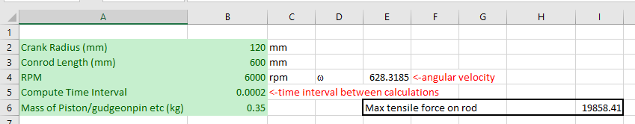
- Once that has been done then you should have three tables produced. One for height, one for velocity and one acceleration and force.
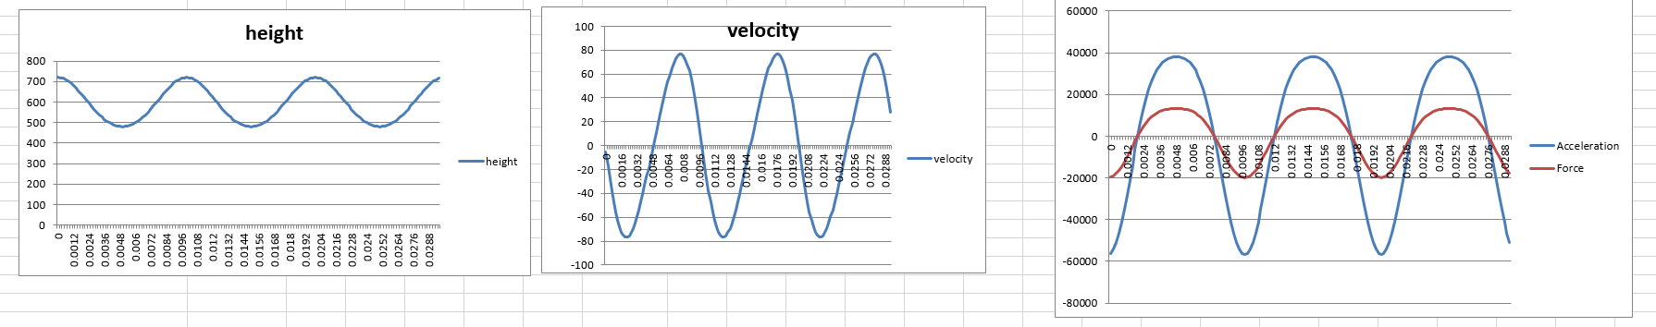
- Using these graphs/tables and analyse them. Play around with the values and discuss how the table changes.

Results
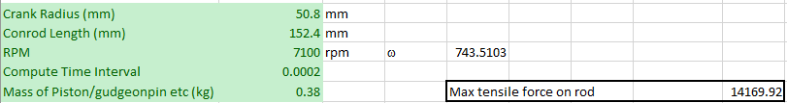
Once entering the figures. Excel has been set up to make three tables one for height between the top of the con rod and the crank. Then one for the velocity. The last being for the acceleration and force.

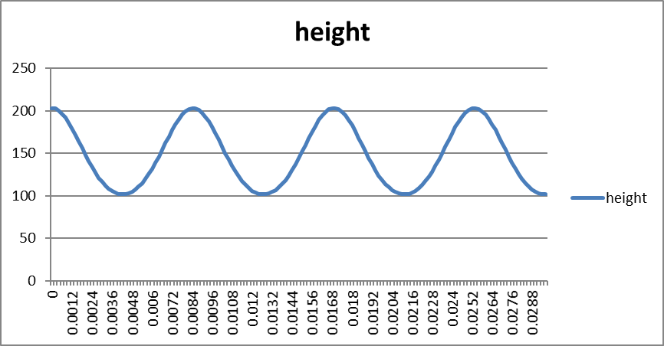
The height graph shows how much travel there is for the con rod and how frequently it travels up and down, with it travelling up by the crank radius and down by the crank radius, this in the y axis, and the x axis is time (seconds).
The table above is at max rpm, 7100rpm. And the table below is at idle which is 3700rpm.
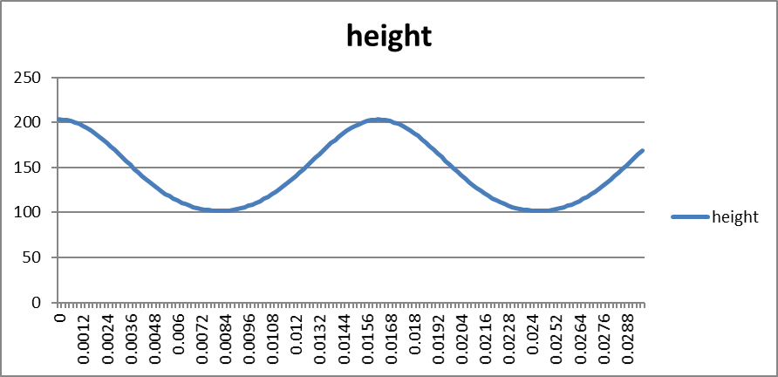
So as you can see with the height graphs, the higher the rpm the quicker the connecting rod is being pulled and pushed up and down.
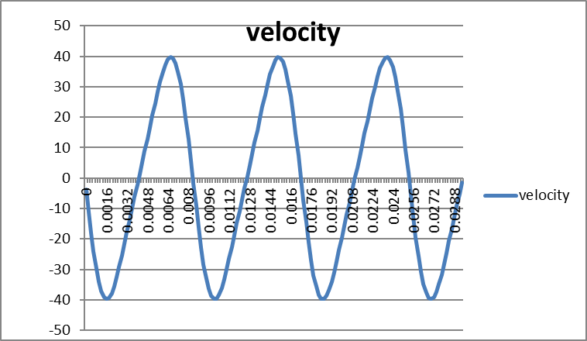
Down below is the table for velocity, m/s by time (seconds).
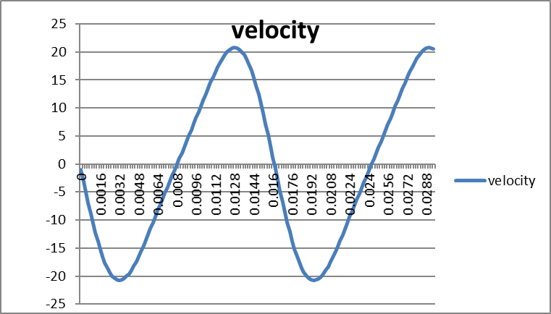
The difference between these two tables is again the top being max rpm and below being at idle.
With the velocity graphs, this show the travel in a negative and a positive movement in m/s.

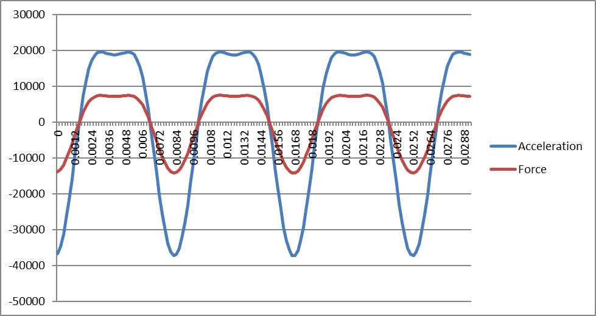
This table is for the forces caused and acceleration over the time taken.

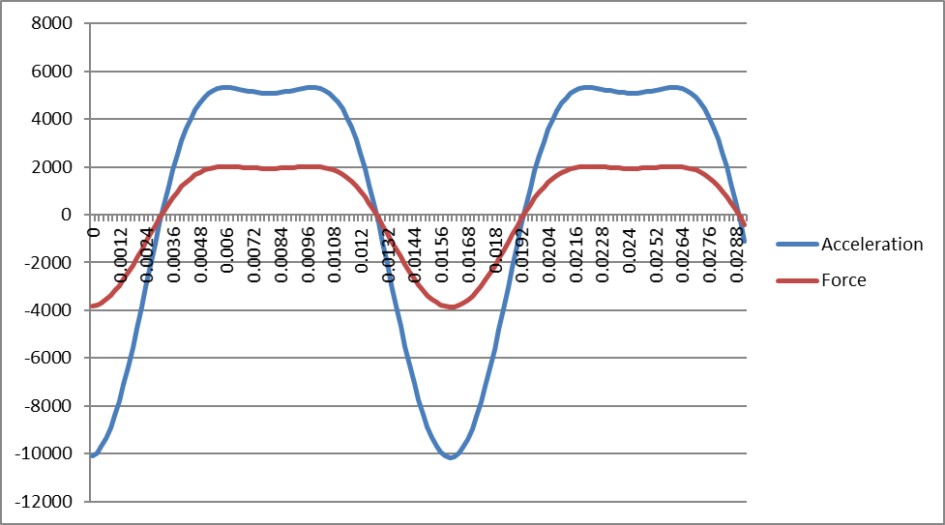
And again the difference between them if max rpm and idle.

Something that I’ve noticed is that the forces caused is roughly a quarter of acceleration. The pulling and pushing forces the con rod has too undergo at idle rpm is under half that at max rpm. Show that there isn’t much room of movement in the forces as it accelerates.

Conclusion
In conclusion, the lsx3454r drag racing engine is extremely durable let alone the fastest engine ever built by Chevrolet. After researching the components required, I learnt a lot about the piston, crankshaft and the connecting rods, i.e. the mass, the crank radius, the con rod length and the max rpm and the idle rpm. With the examples of the graphs I’ve shown what the con rod undergoes as the engine accelerates and the engine builds up in the revs per minute. The graphs also show the movement the con rod goes through in height/travel, and also in what it undergoes in velocity.

Further research

The engine I had chosen for this assignment used I-beam connecting rods, but there are arguably better and lighter and stronger ones out there like for example H-beam and +beam con rods.
This is what each one looks like, the difference between then is the shape and where they have excess material removed too save weight. But each one has different stress points, with the I-beam’s and + beams having there stress points in the middle bending side to side before breaking, the H-beams have a different stress point this being on the front and back, the H-beams don’t have the worrying of bending side to side because they have two supporting walls compared to the others one. H-beams also have a thicker beam down the middle which does unfortunately mean they are heavier but its so minuet it doesn’t make a difference and I think the difference it makes in the strength of these con rods makes it worth the slight added weight.
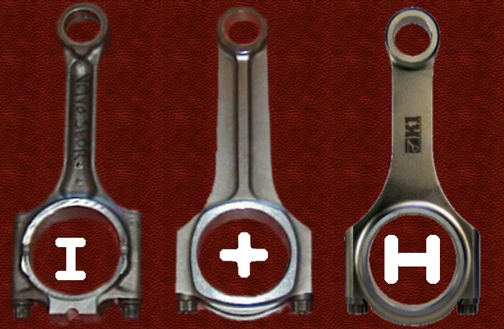
Figure 3-http://forums.vwvortex.com/showthread.php?7145507-FAQ-Connecting-Rods

References
These are the website I used as referenced during this essay.
http://www.racingpartsmaximum.com/sae4340ibeam-2.html
http://www.hurricanerods.com/products/Chevy-ls1-4.030-0.927-4032-Forged-Pistons-Flat-Top-with-Valve-Reliefs-Piston.html#.Wh7coVVl-Um
http://www.competitionproducts.com/Power-Products-Forged-4340-Steel-Crankshaft-Chev_GM-LS-Gen-III-Main-4000-Stroke-Reluctor-Wheel-Included/productinfo/PVT346400-58/#.WhlmQ1Vl-Uk
http://www.dragzine.com/tech-stories/engine/big-power-numbers-gms-lsx454r-reliability-focus/
http://forums.vwvortex.com/showthread.php?7145507-FAQ-Connecting-Rods

