Component 2 - Research Report
Student Name: Noreen Shasta
Student Number: 2029247
Lecturer Name: Sayed Nasirpourosgoei
BMSW4003_BIRM
Digital Skills and Research Methods.

Abstract

The purpose of this report is to summarise the topic below.
“How do we use technology to 2 at USTSD”
Aim: Is there a need to provide training on how to use technology to collaborate at UWTSD
The method we chose to use to collect data was a questionnaire.
Date was collected

Contents
1. Abstract 2
2. Introduction 4
3. Research design 4
3.1. Research Question 5
3.2. Method 5
3.3. Ethical Considerations 6
4. Results 7
5. Discussion 7
6. Conclusion 7
7. Reference List 8
8. Appendix A – A blank copy questionnaire. 8

Introduction

In this research project the question “How do we use technology to collaborate at UWTSD” is what we researched with the aim to understand “Is there a need to provide training on how to use technology to collaborate at UWTSD”. To do this we decided to use a questionnaire to gather data and understand the question outline above. In this report the main aim will be to explain the research that was completed to design the questionnaire content and data collection method detailing the questions that were used and who the target audience is, and the method used to collect data. I will also discuss the ethical considerations when asking the questions and who the questions are aimed at. The results of the questionnaire and the findings will be discussed to help understand what we found as a result of the questions asked and how the method, we used to be a success. Having digital skills provides students the capability to develop into lifelong learners, having the capability to examine information, evaluate sources, and use critical thinking skills to evaluate information. (Build digital space, 2022).

Research design
As part of our research, a questionnaire was used to gather information.
Questionnaires need to be designed carefully to be effective for its purpose in order to understand the objectives of the questionnaire to make sure that the right questions are being asked to the right people. Questions must be easy to understand for the target audience. We must then decide how the questions will be asked and what method is easiest for the target audience. Face to face or electronic. We should also decide what type of answer we require for the questions asked. Is it a yes, no answer, multiple choice or do we need more information and then decide how the questionnaire will be performed?
We propose a model that explains the change of information and behaviours of students in this digital age and the effect this has on their learning outcomes. Questionnaires are used to find out information on the subject being researched, from students. The study confirms that the digital information has significant effects on college experience of students. Technology has become a common practice due to its ability to reduce barriers in traditional learning environments. (Ransome Epie Bawack, 2020). A research proposal is a relevant brief document that contains an online plan for research project. (Denscombe, 2012)

Research Question

In our research project we researched the following question
How do we use technology to collaborate at UWTSD
Aim:
Is there a need to provide training on how to use technology to collaborate at UWTSD
A research proposal is a relevant brief document that contains an outline plan for a research project, (Densombe, 2012). In this question we try and understand the need for training on how to use technology to collaborate.
Students these days are very different to what the study system was originally setup for. Being able to use technology and the new way of working is key to being able to study these days. Information is collected and shared using technology rather than printed hard copies these days. Meaning information can be collected and shared much quicker than before. We must also consider data sharing laws to ensure the data we collect, and share is appropriate for the right audience and no confidential information is shared to the wrong audience. (Saleem T Shah professional psychology, 2022). When asking the question to gather information we must also consider the learning barriers such as language barriers, disabilities, time to respond.

Method
In our group we decided to use a questionnaire as our research method. This is one of the best ways to collect data easily and quickly compared to other methods such as interviews and observation.
We chose to ask questions with a yes, no or maybe answer using MS forms quiz, because it is accessible to all and not expensive to setup.
The target audience was staff and students.
Questions were designed to be simple and easy to understand so that students can easily answer the questions quickly making it more appealing for students to take part. If questionnaires are quick and easy students are more likely to take part and answer questions truthfully because the y understand the question and it won’t take up too much time to take part.
The questions we asked in our questionnaire are: -
- Do you feel able to use MS teams to collaborate?
- Would you prefer to have training on how to collaborate on MS?
- Would you like to know which other platforms you can use to collaborate?
- Do you think we can do more to help students with MS?

Ethical Considerations
Ethics helps us decide what we should do & why”, (Barett Et Al, 2016).
Ethical considerations in research are a set of principles to guide your research designs & practices
These considerations work to:
- Protect the rights of research participants
- Enhance research validity
- Voluntary Nature of Participation & Right to withdraw
- Respect for others
Things that we considered when carrying out research.
- Voluntary Participation
We wanted to ensure all questionnaires were filled in voluntarily so that participators were happy to take part.
- Confidentiality and Anonymity
Keeping details of the people who responded confidential entices students and staff to be open and honest when answering questions. We do not want to embarrass anyone when asking questions or sharing the results of the data collection.
- Conflict of interest
Considering ethical problems in advance of asking the question shows that we have understood the questions we want to ask and who we are asking them to with a plan to deal with problems if they happen. (Wendy Walker Nurse Researcher, 2007)
In 2001, 2005 increased responsibility on researchers to demonstrate continuous quality improvements in research practice to understand the truth and understanding of every individual person.

- Results
Number | Question | Yes | No | Maybe
1 | Do you feel able to use MS teams to collaborate? | 15 | 0 | 0
2 | Would you prefer to have training on how to collaborate on MS? | 5 | 10 | 0
3 | Would you like to know which other platforms you can use to collaborate? | 5 | 1 | 9
4 | Do you think we can do more to help students with MS? | 10 | 0 | 5

Discussion

Our questionnaire had a total of 15 responses.
The questionnaire was shared to staff and students via email and the UWTSD website.
What do your results appear to show?
The results appear to show that in question 1, 43% of students feel that more can be done to help students use MS. Which means students may be struggling to study because they need more support with MS and this may be a barrier for them to succeed in their chosen subject.
Question 2 shows that most students do not need further training to use platforms. They may just be happy to read and watch online videos to train themselves to use the platforms. With increasing knowledge and technological progress of society our country requires learning skills that could help it keep pace with the development of science and technology. (Hamidi Meshkat, 2011)
Question 3 shows that students would like to know what other platforms are available to collaborate and help students and staff work together. It may be that other options are easier and more effective for students and staff.
Question 4 – 29% of students feel that we can do more to help them use MS this shows there is a need for training. By offering training this can potentially help students pass their chosen subjects.
  - Is there any result which surprised you?
I am not surprised with the results because I personally feel that I would like some training using MS. Not being a confident user of technology being expected to use MS without any training did have a knock-on effect to my confidence in studying.
  - How many participants took part in total?
A total of 15 students and staff took part in the questionnaire.

- Conclusion
Overall, from the finding and the results from the questionnaires that were completed I believe that overall people did state that they needed more guidance when using Microsoft teams and for the people that did not receive any report, even using myself as an example I feel that it had a big knock-on effect on my studying. I do believe that over the age of 35 if technology has not been used or taught for a long period of time it does become difficult to engage and access it at a certain age. The main important points made were that firstly people need more help and support with Microsoft teams in order to understand what to do.

- Appendix A – A blank copy questionnaire.
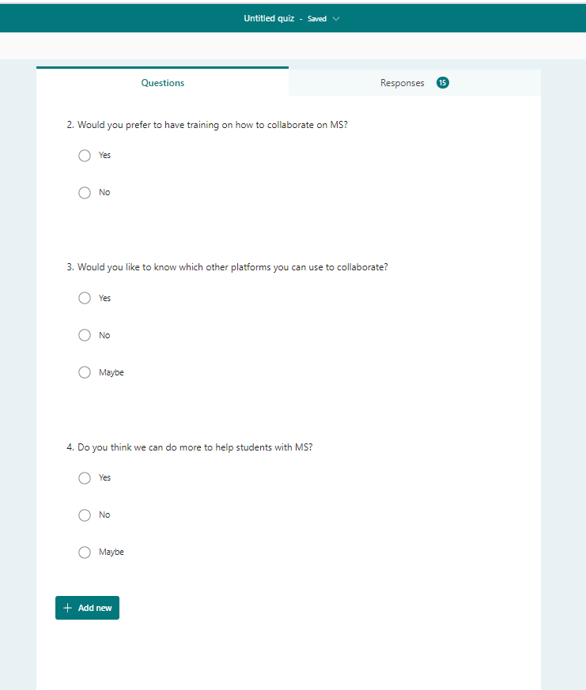

References:

Carter, Stacy M, et al. “A Definition and Ethical Evaluation of Overdiagnosis.” Journal of Medical Ethics, vol. 42, no. 11, 8 July 2016, pp. 705–714, 10.1136/medethics-2015-102928. Accessed 1 Apr. 2022.
Denscombe, Martyn. “The Role of Research Proposals in Business and Management Education.” The International Journal of Management Education, vol. 11, no. 3, Nov. 2013, pp. 142–149, 10.1016/j.ijme.2013.03.001. Accessed 1 Apr. 2022.
Einstein, A., et al. “Can Quantum-Mechanical Description of Physical Reality Be Considered Complete?” Physical Review, vol. 47, no. 10, 15 May 1935, pp. 777–780, link.aps.org/doi/10.1103/PhysRev.47.777, 10.1103/physrev.47.777. Accessed 1 Apr. 2022.
Hamidi, Farideh, et al. “Information Technology in Education.” Procedia Computer Science, vol. 3, 2011, pp. 369–373, www.sciencedirect.com/science/article/pii/S1877050910004370?via%3Dihub, 10.1016/j.procs.2010.12.062. Accessed 1 Apr. 2022.
Shah, Saleem T. “Privileged Communications, Confidentiality, and Privacy: Confidentiality - ProQuest.” Www.proquest.com, 2022, www.proquest.com/openview/6898619bd1080c031dd961fb2efa3991/1?pq-origsite=gscholar&cbl=60984. Accessed 1 Apr. 2022.

