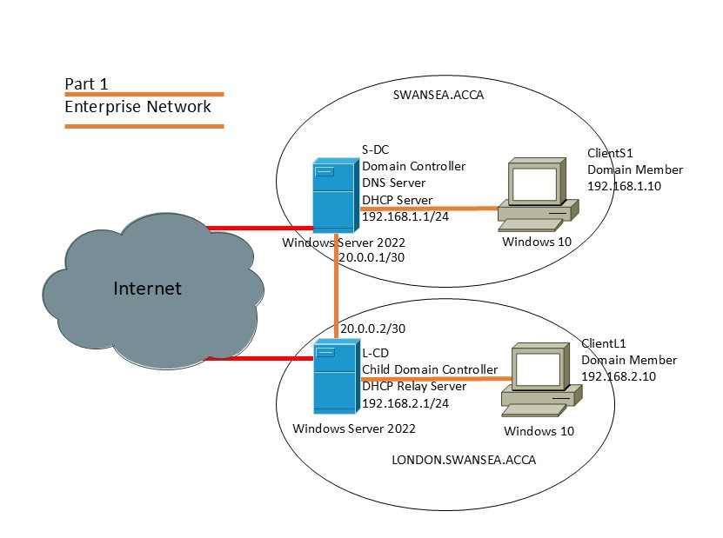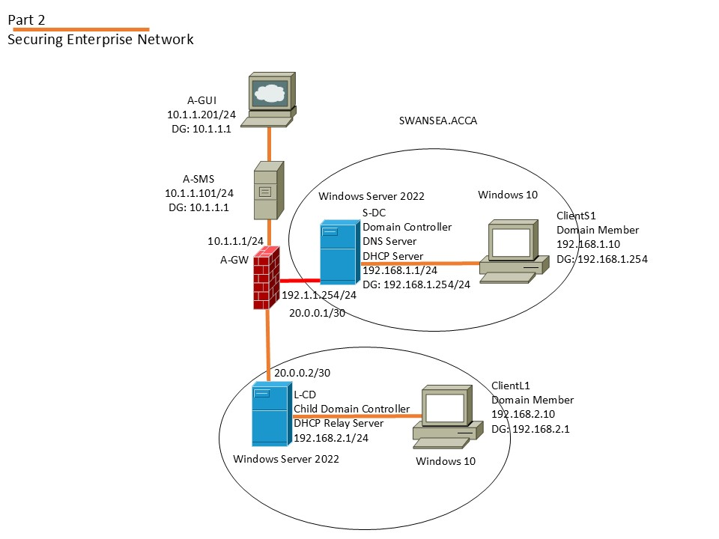

Introduction
This worksheet outlines the requirements for Part 1 of the Enterprise Network Security module. The objective is to configure a functional enterprise network environment comprising two domains: swansea.acca and london.swansea.acca. You will work with a provided Open Virtual Appliance (OVA) file containing seven virtual machines (VMs).
Part 1 focuses on establishing core network operations, which is a prerequisite for Part 2 (securing the enterprise network). You are expected to demonstrate technical proficiency in configuring Windows Server services, including Active Directory, DHCP, VPN, and IIS, while adhering to best practices for network administration.
This task is designed to develop your understanding of enterprise network functionality and prepare you for advanced configurations in subsequent parts of the module.
- Ensure your PC has at least 32 GB of RAM, 6+ cores (physical or logical), and 200 GB of free storage to accommodate all VMs without performance degradation.

- Configure Windows Firewall to enable secure network communication.
- Create and manage domain users with administrative privileges in Active Directory.
- Establish a persistent site-to-site VPN for inter-network connectivity.
- Configure a child domain within an Active Directory forest.
- Implement DHCP services with a relay agent for dynamic IP allocation.
- Deploy a web server using IIS with internal authentication, ensuring accessibility across multiple networks.

Lab Environment Setup
- Virtual Machine Deployment
- Within SOAC Network, open //192.168.135.200/accb6000$ and click VM Folder. (Do not Delete any files in this folder – Do not cut and paste the files – Copy the ENS_Topology_2501.ova File to your Local Folder)
- OVA File: Import this file into Oracle VirtualBox on your PC.
- Resource Management: The OVA file is large, and multiple backups may consume significant disk space. Use snapshots judiciously to save configurations and avoid running out of storage. It is your responsibility to manage disk space effectively.
- VMs Provided: (All Passwords are NotebooK@123)
  - Swansea Network:
    - S-DC: Windows Server 2022 (Domain Controller for swansea.acca)
    - ClientS1: Windows 10 Client : Username: Swansea\Administrator
  - London Network:
    - L-CD: Windows Server 2022 (to be configured as a child domain controller) Username: Administrator
    - ClientL1: Windows 10 Client: Username: Admin
  - Other VMs (A-GUI, A-SMS, A-GW): Do not power on these VMs in Part 1.

Important: Use only one PC throughout the module to maintain consistency. Ensure your PC meets the hardware requirements for running multiple VMs simultaneously.
Pre-Installed Configurations
The following configurations are pre-installed in the VMs:
- Swansea.acca:
  - S-DC:
    - Computer Name: S-DC
    - Domain: swansea.acca
    - IP Address: 192.168.1.1/24
    - DNS: 192.168.1.1
    - Credentials: Username: Administrator, Password: NotebooK@123
    - Roles Installed: IIS, DHCP
    - Firewall: Disabled
  - ClientS1:
    - IP Address: 192.168.1.10/24
- London.swansea.acca:
  - L-CD:
    - Computer Name: L-CD
    - IP Address: 192.168.2.1/24
    - Firewall: Disabled
  - ClientL1:
    - IP Address: 192.168.2.10/24
- Connectivity:
  - S-DC to ClientS1: 192.168.1.0/24 (successful)
  - S-DC to L-CD: 20.0.0.0/30 (successful)
  - L-CD to ClientL1: 192.168.2.0/24 (successful)

Tasks
You are required to complete the following configurations on the provided VMs. Each task must be thoroughly tested and verified to ensure functionality across both networks.
Task 1: Configure Windows Firewall
Enable the default Windows Firewall on S-DC and L-CD, allowing ICMP and necessary services to support network operations between swansea.acca and london.swansea.acca.
Instructions:
- Enable the Windows Defender Firewall on S-DC and L-CD.
- Create inbound rules to allow:
  - ICMPv4 (ping).
  - DNS (TCP/UDP, Port 53).
  - DHCP (UDP, Ports 67, 68).
  - Active Directory services (TCP, Ports 88, 135, 389, 445, 464, 3268–3269).
  - VPN (If using L2TP/IPSec: UDP, Ports 500, 4500; Protocols 50 and 51 etc).
- Apply rules to all profiles (Domain, Private, Public).
- Test connectivity using ping from ClientS1 to S-DC and L-CD, and from ClientL1 to L-CD and S-DC.

Task 2: Create a Domain User
Create a domain user in swansea.acca with administrative privileges, using a specific naming convention.
Instructions:
- On S-DC, open Active Directory Users and Computers.
- Create a new user with:
  - Full Name: [Your First Name] [Your Surname] (e.g., Munya Murira).
  - Logon Name: [First Initial].[Surname Initial]@swansea.acca (e.g., m.m@swansea.acca).
  - Password: Choose a secure password (e.g., P@ssw0rd123).
- Add the user to the Domain Admins group.
- Test the account by logging in to S-DC using the new credentials.

Task 3: Configure Site-to-Site VPN
Establish a persistent site-to-site VPN between swansea.acca and london.swansea.acca.
Instructions:
- On S-DC, install the Remote Access role and configure a VPN with L2TP/IPSec.
- Create a demand-dial interface named Swansea-to-London, using L-CD’s IP (192.168.2.1) and a pre-shared key (e.g., VPNKey123).
- Add a static route for the London network (192.168.2.0/24).
- Repeat on L-CD, creating a demand-dial interface named London-to-Swansea, using S-DC’s IP (192.168.1.1).
- Set both connections to be persistent.
- Test connectivity by pinging between S-DC, L-CD, ClientS1, and ClientL1.

Task 4: Configure Child Domain
Promote L-CD as a child domain controller for london.swansea.acca under swansea.acca.
Instructions:
- On L-CD, set the DNS server to S-DC’s IP (192.168.1.1).
- Install the Active Directory Domain Services role.
- Promote L-CD to a domain controller, selecting Add a new domain to an existing forest and specifying london as the child domain under swansea.acca.
- Use the Domain Admin credentials from Task 2.
- Verify the child domain in Active Directory Domains and Trusts on S-DC

Task 5: Configure DHCP Server and Relay
Configure S-DC as a DHCP server for both networks, with a DHCP relay agent on L-CD for london.swansea.acca.
Instructions:
- On S-DC, configure two DHCP scopes:
  - Swansea Scope:
    - Range: 192.168.1.11–192.168.1.240
    - Subnet Mask: 255.255.255.0
    - Gateway: 192.168.1.1
    - DNS: 192.168.1.1
  - London Scope:
    - Range: 192.168.2.11–192.168.2.240
    - Subnet Mask: 255.255.255.0
    - Gateway: 192.168.2.1
    - DNS: 192.168.1.1
- On L-CD, install the Remote Access role and configure a DHCP relay agent, pointing to S-DC (192.168.1.1). Alternatively, you may configure L-CD as a DHCP Server as well.
- Test DHCP by setting ClientS1 and ClientL1 to obtain IPs automatically and verifying assigned IPs.

Task 6: Configure IIS Server and Website
Create a website (swansea.acca) on S-DC’s IIS server with Windows Authentication, accessible to all domain users.
Instructions:
- On S-DC, create a folder C:\Websites\Swansea and add an index.html file (you may use Generative AI to design a simple webpage).
- In IIS Manager, create a new website:
  - Name: Swansea.acca
  - Path: C:\Websites\Swansea
  - Binding: HTTP, Port 80, Host Name: swansea.acca
- Disable Anonymous Authentication and enable Windows Authentication.
- In DNS Manager, create an A record for swansea.acca pointing to 192.168.1.1.
- Test access from ClientS1 and ClientL1 using http://swansea.acca and domain credentials.

Reference Youtube
https://www.youtube.com/playlist?list=PLddfEpDxAoTvxJeyA0rRg9DL5t2EuZVEg

