Fundamentals of electrical and electronic systems (ACDA4018) level 4 Report



David Tolhurst (2222916)

Contents
Abstract 2
Introduction 2
Definitions/Background knowledge 2
Theoretical Calculations (Task 1 & 2) 3
Task 1 methodology: 7
Results – Task 1 8
Discussion – Task 1 9
Task 2 methodology: 10
Discussion – Task 2 10
Conclusion 10
Table of Figures 10
References 11

Abstract
The aim of this report is to demonstrate the capability to carry out software simulation-based tasks provided by the university. In this case two separate tasks were given, the first being to determine the internal resistance and load current for a given circuit using theoretical calculations which can then be compared to actual values gained throughout the use of simulations. This data gathered in the practical simulations will then be used to construct a table and a graph to observe the maximum power output during the simulations and the corresponding resistor values. The second task required the student to determine the resonant frequency of a given circuit using signal generators within the simulations on Proteus professional 8. This will be referred to as “peak-to-peak” frequencies during this report. The data gathered from doing so will then be plotted and compared to theoretical calculations on a graph made from a suitable spreadsheet software, in this case Microsoft Excel.

Introduction
This report requires the student to create two electrical circuits on Proteus 8 Professional software, from which the results gained from the simulations can be compared to theoretical calculations carried out by the student. An electrical circuit is a combination of electronic components that are connected to create a functional circuit. Electrical circuits are everywhere in our day-to-day lives and play a huge role in supporting modern technology/infrastructures. Without electrical circuits the world would most likely come to a standstill. Electrical engineers draw circuits using various symbols for components which will be mentioned throughout this report. This method of drawing allows for problems to be solved such as the generation of new electrical energy, Transmission of electrical energy and the output of electrical energy to the user.
To achieve the above mentioned aim the student will have to used previous knowledge acquired from lectures and personal research. The student will apply this knowledge to various mathematical equations to calculate theoretical values which can be compared to values gained from carrying out simulations within Proteus 8 Professional software.

Definitions/Background knowledge
What is voltage?
Electrical voltage is defined as electric potential difference between two points of an electric field. [1]
What is frequency?
Frequency is the rate at which current changes direction per second. It is measured in hertz (Hz), an international unit of measure where 1 hertz is equal to 1 cycle per second. [2]
What is current?
Current is the flow of electrons through a complete electrical circuit.
What is resonance?
Resonance is when current reaches is maximum level within a circuit.
What is Thevenin voltage?
Thevenin theorem (also known as the Helmholtz–Thévenin theorem) states that any linear circuit containing only voltage sources, current sources, and resistances can be replaced by an equivalent combination of a voltage source (VTh) in series with a single resistance (RTh) connected across the load. This simplified circuit is known as the Thevenin Equivalent Circuit. [3]
What is maximum power transfer theorem?
The maximum power theorem, better known as the maximum power transfer theorem, is an essential tool for ensuring successful system design. Put simply, this theorem states that the maximum power that can be transferred from source to load is 50%, which occurs when source impedance is exactly matched to load impedance. [4]

Theoretical Calculations (Task 1 & 2)
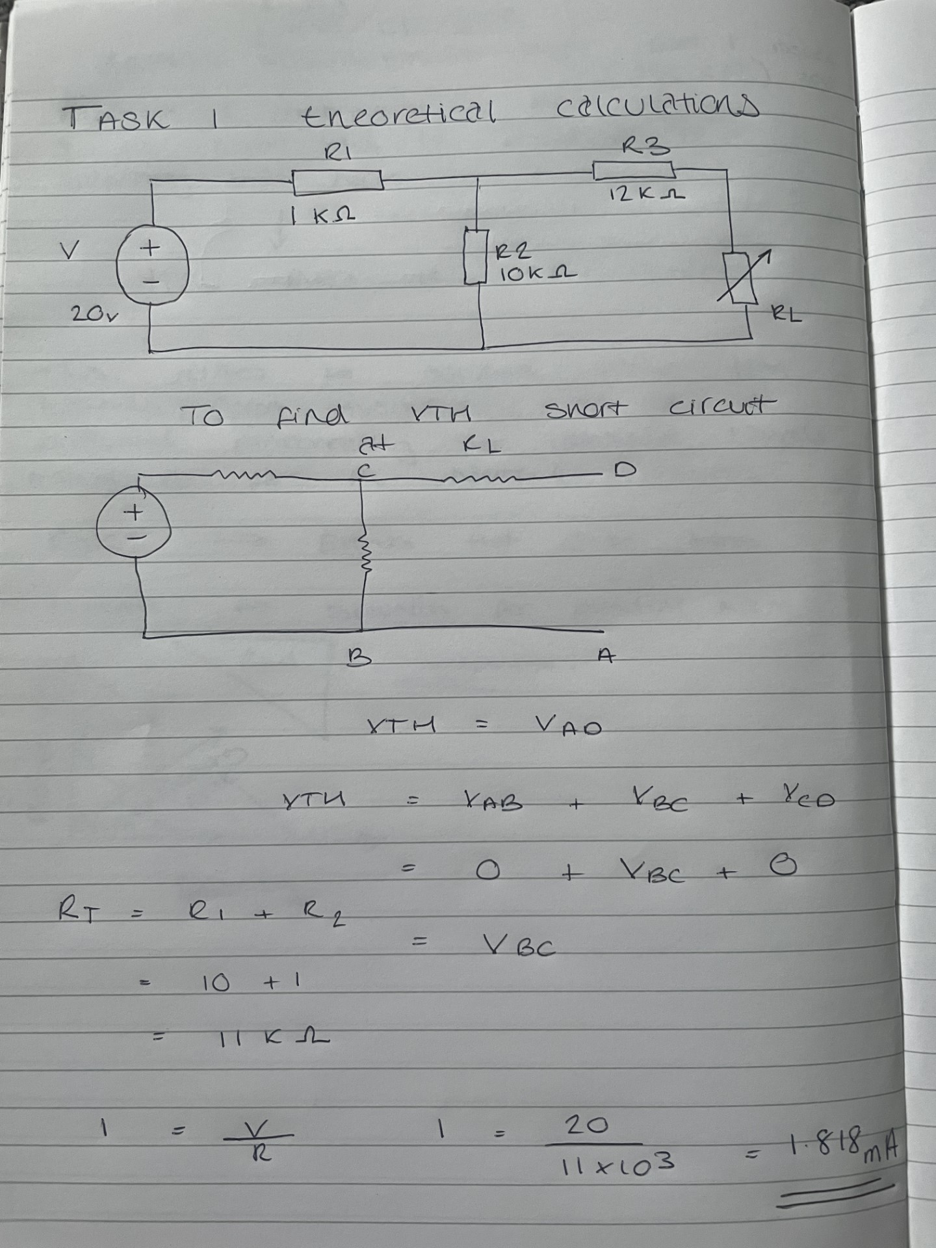
Figure 1 - Theoretical calculations (Task 1)
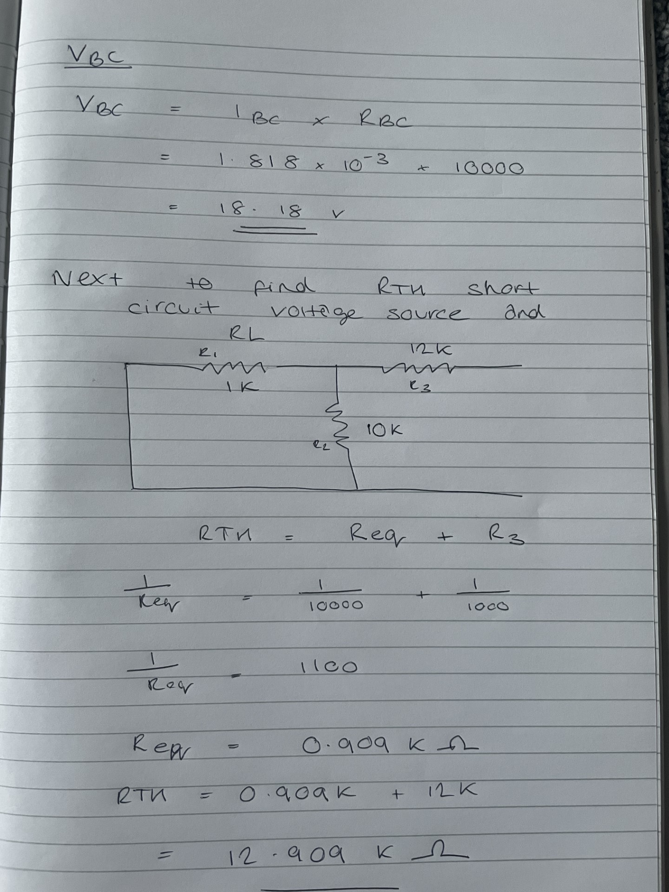Figure 2 - Theoretical calculations (Task 1)
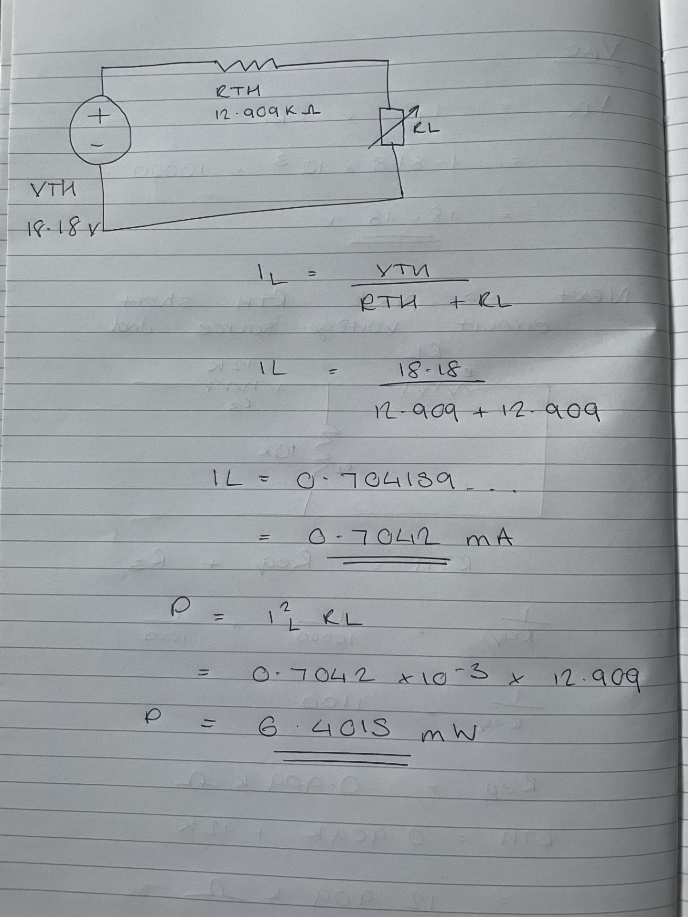
Figure 3 -Theoretical calculations (Task 1)
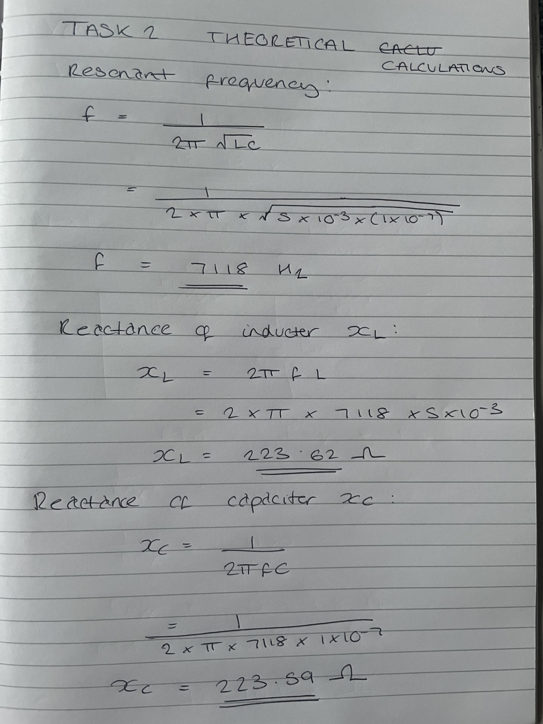Figure 4 - Theoretical calculations (Task 2)

Task 1 methodology:
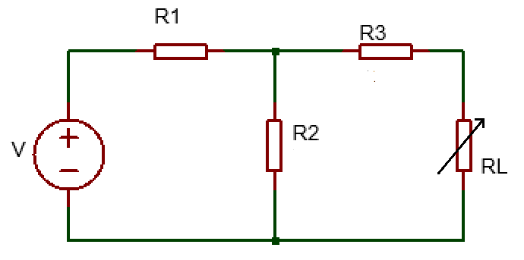
Figure 5 - Task 1 Circuit

The above diagram was provided by the university along with the values for each resistor. R1 = 1KΩ R2= 10KΩ R3= 12KΩ
Maximum power transfer was applied to this circuit. This was done by removing the load resistor which created and open circuit to which a voltmeter could be added to. This allowed the Thevenin Voltage to be determined. Once the Thevenin Voltage had been obtained the Equivalent Resistance could now be acquired by removing the single cell power source and adding an Ohmmeter to the circuit.
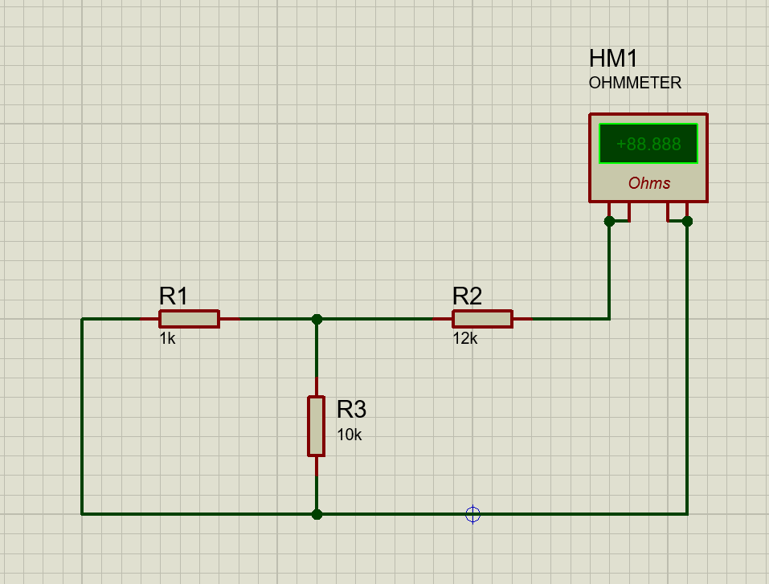
This presented the student with a value that is known as the Thevenin resistance. Next a basic circuit was created using the values obtained in the above steps along with an Ammeter to gain a value for the current within the circuit.
The load resistor value was then changed multiple times ranging from 1KΩ-20KΩ and the results were recorded and entered in a table. Current values observed on the ammeter were very small values, so the user changed the detection range to milliamps to aid the result acquisition process.
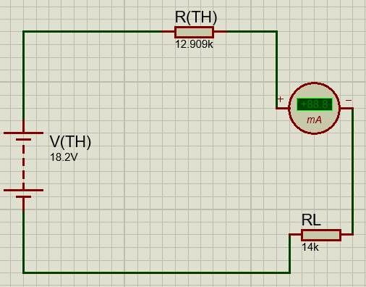
Figure 6 - Thevenin Equivalence Circuit
Now that all the above had been completed the power could be determined using the below equation.
$$P= I^{2}R_{L}$$
The results gained were compiled into a table which completed the process for task 1. Extra simulations were ran surrounding the maximum power area which can be observed below.

Results – Task 1
Resistance (K Ohms) | Current (A) | Power (mW)
1 | 0.00131 | 1.72
2 | 0.00122 | 2.98
3 | 0.00114 | 3.90
4 | 0.00108 | 4.67
5 | 0.00102 | 5.20
6 | 0.00096 | 5.53
7 | 0.00091 | 5.80
8 | 0.00087 | 6.06
9 | 0.00083 | 6.20
10 | 0.00079 | 6.24
11 | 0.00076 | 6.35
12 | 0.00073 | 6.39
12.2 | 0.00072 | 6.32
12.4 | 0.00072 | 6.43
12.6 | 0.00071 | 6.35
12.8 | 0.00071 | 6.45
12.9 | 0.00071 | 6.45
13 | 0.0007 | 6.37
14 | 0.00068 | 6.47
15 | 0.00065 | 6.34
16 | 0.00063 | 6.35
17 | 0.00061 | 6.33
18 | 0.00059 | 6.27
19 | 0.00057 | 6.17
20 | 0.00055 | 6.05

Power v Resistance graph constructed from above table.

Figure 7 - Power & Resistance graph

Discussion – Task 1
After successfully carrying out task 1 on the simulation software it can be observed that there were some differences between the theoretical calculations and the actual simulation. The theoretical calculations done for task 1 gave a value of 18.18v for Vbc (Open circuit voltage) when in the simulation it was observed to be 18.2v. However, the Equivalent resistance that can be seen in figure 7 was calculated to be 12.909KΩ and this was also the case in the simulation that was ran on proteus. It can be stated that the power peaked at 12.9KΩ producing 6.5mW of power. These results are concurrent with the maximum power transfer theorem as it states that the power within the circuit should peak when the load resistor is equal to the Thevenin resistance. Upon comparing the theoretical and practical values obtained for maximum power its can be seen that there was a slight difference in the results. The theoretical value was 6.4015mW which differs to the simulated value of 6.5mW. These differences can most likely be a result of rounding errors on behalf of the student whilst carrying out the calculations.

Task 2 methodology:
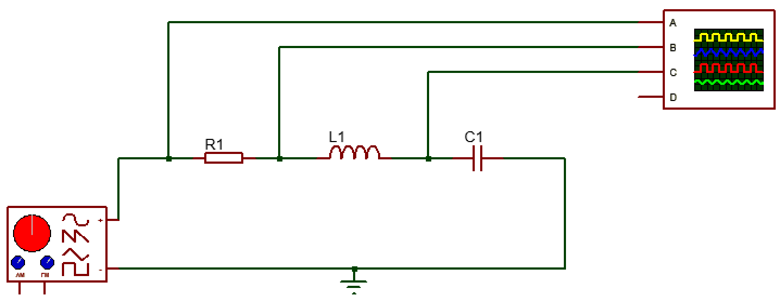
Figure 8 - Task 2 circuit

The above circuit was provided by the university alongside the values for the components. $R_{1}=100Ω$, $L_{1}=5mH$ and $C_{1}=0.1μF$.
Firstly, a suitable circuit was constructed, and the signal generator output was set to 10v at 1KHz. This allows the user to start to analyse the peak-to-peak voltage. Next using the interface that was presented on the screen values for V resistor, V Inductor and V capacitor were obtained at a 1KHz range. The results were then entered into a table. This step was repeated multiple times between a range of 1KHz – 20KHz and more simulations were focused between 6.5KHz- 7KHz. This was done to gain a more accurate value for the peak capacitor voltage. The oscilloscope was also adjusted to make it easier to read.

Results – Task 2
Frequency (KHz) | V (Resistor) | V (Inductor) | V (Capacitor)
1 | 10 | 10 | 10.2
2 | 10 | 10 | 10.7
3 | 10 | 9.7 | 12
4 | 10 | 9.2 | 13.6
5 | 10 | 8.2 | 17
6 | 10 | 5.7 | 21.2
6.5 | 10 | 3.1 | 22.5
6.6 | 10 | 2.6 | 22.5
6.7 | 10 | 2 | 22.5
6.8 | 10 | 1.3 | 22.5
6.9 | 10 | 0.75 | 22.2
7 | 10 | 0.15 | 22.2
7.1 | 10 | 0.5 | 22
7.2 | 10 | 1.1 | 21.5
7.3 | 10 | 1.7 | 21
7.4 | 10 | 2.3 | 20.5
7.5 | 10 | 2.8 | 20
8 | 10 | 5 | 16.6
9 | 10 | 7.5 | 11.5
10 | 10 | 8.6 | 8.3
11 | 10 | 9 | 6.2
12 | 10 | 9.2 | 4.8
13 | 10 | 9.4 | 3.9
14 | 10 | 9.6 | 3.2
15 | 10 | 9.6 | 2.7
16 | 10 | 9.7 | 2.3
17 | 10 | 9.8 | 2
18 | 10 | 9.8 | 1.7
19 | 10 | 9.8 | 1.6
20 | 10 | 9.8 | 1.4

Figure 9 - Frequency v Capacitor voltage graph

Discussion – Task 2
Upon carrying out the above methodology and evaluating the data observed in both the theoretical calculations and the simulations it can be said that the 7.118KHz theoretical value closely matched the practical value of 7KHz that can be seen in the above table. Again, it can be said that the different values could be a result of error on behalf of the user (Rounding etc.) and improper use of the software due to lack of experience. The user also found that adjusting the oscilloscope in Proteus made carrying out the task much easier and presented more accurate and concurrent data.

Conclusion
In conclusion both tasks were completed and gathered conclusive data. However, some issues during the simulation process were encountered as this was the users first encounter with Proteus 8 professional software. These issues boiled down to a lack of experience with the software, yet confidence was built overtime as the user continued to use it and experiment with its features. The university also provided exercises that were to be completed in the student’s free time to familiarise themselves with the software. These exercises were found to be very effective and aided the learning process. The tasks carried out on Proteus also highlighted that performing simulations on a computer software offers a much higher degree of accuracy than physically constructing the circuits in a laboratory. Problems such as faulty components, poor circuit design and power failure can all contribute towards inaccurate results. Proteus eliminates the chance for error as the simulations are ran at the exact values entered by the user therefore only leaving room for user error.

Table of Figures
Figure 1 - Theoretical calculations (Task 1) 4
Figure 2 - Theoretical calculations (Task 1) 5
Figure 3 -Theoretical calculations (Task 1) 6
Figure 4 - Theoretical calculations (Task 2) 7
Figure 5 - Task 1 Circuit 8
Figure 6 - Thevenin Equivalence Circuit 9
Figure 7 - Power & Resistance graph 10
Figure 8 - Task 2 circuit 11
Figure 9 - Frequency v Capacitor voltage graph 12

References

[1] | Rapid Tables, “Home>Electricity & Electronics>Electrical terms> Electrical voltage,” Rapidtables.com, [Online]. Available: https://www.rapidtables.com/electric/Voltage.html. [Accessed 1 July 2023].
[2] | G. A. Mazur, “Fluke.com,” American technical publishers, [Online]. Available: https://www.fluke.com/en-us/learn/blog/electrical/what-is-frequency. [Accessed 01 July 2023].
[3] | Electrical 4 U, 19 April 2019. [Online]. Available: https://www.electrical4u.com/thevenin-theorem-and-thevenin-equivalent-voltage-and-resistance/?utm_content=cmp-true. [Accessed 29 06 2023].
[4] | B. dull, “Understanding the Maximum Power Theorem,” Triad magnetics, 10 April 2018. [Online]. Available: https://info.triadmagnetics.com/blog/maximum-power-theorem. [Accessed 30 06 2023].

