Module: Changemakers: Creativity and Value Creation

Module code: BMHP5014
Assessment: Online portfolio
Student Name: Teodora Papazova
Student Number: 2114277

Lecturer: Eleni Koutsogeorgou

Introduction
In this portfolio are present two artefact- Poster and leaflet. The artefact used will help to raise awareness about what is domestic abuse, how to recognise the signs and witch organization we can seek help from. Domestic violence is a big problem in our society nowadays, especially during and after Covid pandemic, when most of the family members being all together in one house 24h a day. Domestic violence is defined as "any incident or series of incidents of controlling, coercive, threatening behaviour, assault, or abuse involving 16-year-old or older sexual partner or household members." Abuse can be psychological, physical, sexual, financial, coercive, and controlling behaviour, emotional abuse, digital/online abuse. (Victim Support, 2021). Domestic violence is not our fault, and there is no shame in getting assistance if you are frightened or dominated by a partner, ex-partner, or close relative.(Home Office,2018)

Artefact 1- Poster
The creation of this poster is to support national campaign to raise awareness about domestic violence. This artefact is intended to highlight the seriousness of the issue and inform others who desire to aid but do not know how. Due to the overall affluence of the society in which we live, the subject is crucial. The purpose of this seminar is to attract a varied audience, including those who have been directly affected and those who desire to show their support.
Among these are social marketing initiatives designed to educate both perpetrators and victims of abuse about the severity of the problem and the availability of resources. The purpose of these campaigns is to empower victims to flee abusive relationships and to persuade abusers to seek help in altering their behaviour. Typically, these programmes disseminate information about the warning signs of domestic abuse and community services for victims and perpetrators through public service announcements and ads.
Numerous domestic violence awareness campaigns, such as the one detailed in this article, aim to bring attention to the brutality of abuse, increase vulnerability to abuse, inform members of the public about support services, and dispel stereotypes that blame victims or deny abuse. (Victim Support, 2021)
These are the goals of the domestic violence awareness campaign that is being discussed in this article. With the help of this campaign, we hope to educate the general public, as well as professionals, victims, and their friends and family members, about the warning signs of abuse and where they may go to obtain assistance. In order to generate greater interest in this campaign, the poster for it will be distributed widely across general practitioners' offices, leisure centres, and other high-traffic public areas.
The speaker for this campaign is Doctor Kelly Smith, who is a well-known expert in the field of treating victims of domestic violence and CEO of Women`s Aid. She assists these individuals in working through the trauma that they have experienced in their lives and assists them in putting their lives back together again.
The most significant organisations in the United Kingdom that aid victims and the relatives of victims have come together to sponsor this campaign. Domestic violence may affect anyone of any gender, age, race or ethnicity, religion or socioeconomic class, sexual orientation, or background, and it can happen to anybody.
This conference will begin by discussing the signs of abuse, some of which include the following: having bruising, burns, or bite scars on your body; having your finances controlled, medication, or pay bills; being on your own and being cut off from your family and friends; being prevented from leaving your home or being prevented from travelling to college or your place of employment; having someone monitor your usage of the internet or social media; having someone else read your private messages, emails, or letters; being verbally abused on a regular basis or being informed that one's abilities are lacking; being forced to engage in sexual activity or have sexual contact: being informed that the abusive behaviour was your fault or that you reacted too strongly to it.


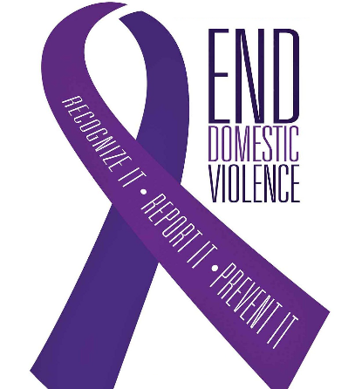
DOMESTIC VIOLENCE
SEMINAR 25 JUNE 2022
From 10am-4pm

’Domestic Violence is a serious crime, and we do not want anyone to suffer in silence’
To learn more or get help, join us at the
Domestic Violence awareness seminar use the link for free registration

domestic@help.co.uk/awareness


-CEO OF WOMEN`S AID


Location: Middlesex library 572 Avenue Liberty For more information Call:0277889966
IF YOU ARE IN IMMEDIATE DANGER CALL 999
Domestic violence seminar provided by NHS Visit us at: domestic@help.co.uk/awareness
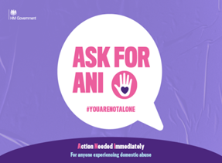



SPONSORED BY

Artefact 2 -Leaflet
The aim of this leaflet is to encourage anybody who is experiencing domestic violence or who is afraid that someone they know may be experiencing domestic abuse to get assistance. The primery audience for this leaflet are women.
According to crime statistics, the great majority of domestic violence is perpetrated by males and experienced by women, especially when there is a pattern of recurrent and severe physical attacks, when it includes rape or sexual assault, or when it culminates in injury or death. However, the information in the leaflet will also be of use to male victims of domestic violence. (Domestic Abuse Help and support for women who might be facing domestic abuse, 2016)
The police department is sponsoring the national campaign "You Are Not Alone," which attempts to disseminate the notion that you are not alone. Despite the current limits imposed due to the Covid-19 outbreak, domestic violence victims and survivors continue to have access to help. Domestic violence takes various forms, it can entail physical violence, but it can also be psychological. This sort of abuse does not leave signs or scars, but can lead victims to endure everyday terror and loss of independence.
If your spouse causes you to feel fear, intimidation, or dominance, you may be in an abusive relationship. Abuse cannot be justified; it is a crime. We would want to remind domestic abuse victims and survivors that they are not alone and that the police and specific support agencies are there to aid and support them.(You Are Not Alone -Police launch domestic abuse campaign to victims and survivors to seek help, n.d.)
The purpose of this leaflet is to reassure victims that they are not alone and to teach them how to recognise the signs of abuse. Signs of abuse- Emotional violence - Your partner or someone with whom you share a home humiliate or put you down. Separate you from your family and friends. Stoping you to attend college or work. Accuse you of engaging in flirtation and affairs. Tell you how you should dress, whom you should see, where you should go, and how you should feel. Control your finances, share photographs and videos of you without your consent, and monitor your location. Threatened you with bodily harm or death. Read your emails, texts, and letters. The abuser may do you pain in a number of ways- slap, hit, or punch, bite or kick you, burn you, suffocate you or suppress you. Sexual abuse - Sexual abuse may affect anybody. Does your significant other or a household member: They touched you in a way that you did not want, make improper sexual demands, damage you during sexual activity. Who is encouraging you to engage in sexual activity without a condom? If you are being forced to have sex. If someone engages in sexual intercourse against your will, this is considered rape. It is still a crime to rape one's spouse. Have you ever feared your significant other? Have you ever adjusted your conduct in anticipation of your partner's actions? (NHS, 2022)

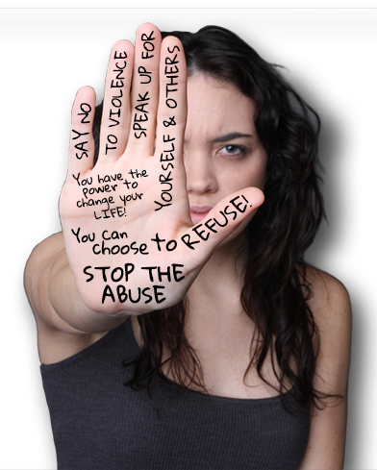
Domestic violence IS any kind of control or abuse by a current or former intimate partner, ex-partner, or family member. Domestic abuse: Will affect 1 in 4 women and 1 in 6 men in their lifetime
DO YOU KNOW THE SIGNS?
WE ARE HERE TO HELP YOU.

YOU ARE NOT ALONE

FREE CALL 088800223

EMAIL:HELPLINE@OGR.UKSAFE PLACE;BP2 8AA

Domestic Violence awareness
Conclusion
The artefact presented in this E-portfolio will help raise awareness about domestic violence. These campaigns aim to educate potential victims about support services to bring increasing perceived sensitivity to the risk of abuse by drawing attention to the intensity of abuse. The poster for this campaign will be distributed widely across general practitioners' offices, leisure centres, and other high-traffic public areas. Domestic Violence is a serious crime, and we don't want anyone to suffer in silence. This conference will begin by discussing the signs of abuse. The aim of the leaflet is to reassure victims that they are not alone and to teach them how to recognize the signs of abuse. Abuse has no justification; it is a crime.

Reference list
Domestic Abuse Help and support for women who might be facing domestic abuse. (2016). [online] Available at: https://www.usdaw.org.uk/CMSPages/GetFile.aspx?guid=24c98939-4521-401a-a02d-46358ee50bb0#:~:text=This%20leaflet%20is%20primarily%20aimed/ [Accessed 17 Nov. 2022].
DOMESTIC ABUSE Information from Victim Support. (n.d.). [online] Available at: https://www.victimsupport.org.uk/wp-content/uploads/2022/02/P2714_08-Domestic-Abuse-leaflet.pdf [Accessed 17 Nov. 2022].
Domestic Violence Intervention. (n.d.). Home. [online] Available at: https://www.dvifallon.org/ [Accessed 17 Nov. 2022].
Google.com. (2022). Redirect Notice. [online] Available at: https://www.google.com/url?sa=i&url=https%3A%2F%2Fwww.gov.uk%2Fguidance%2Fdomestic-abuse-how-to-get-help&psig=AOvVaw1hEKqNPmV78EL56KDSPBt1&ust=1668769015834000&source=images&cd=vfe&ved=0CAwQjRxqFwoTCLDE3-eHtfsCFQAAAAAdAAAAABAa [Accessed 17 Nov. 2022].
NHS (2022). Getting help for domestic violence and abuse. [online] nhs.uk. Available at: https://www.nhs.uk/live-well/getting-help-for-domestic-violence/ [Accessed 18 Nov. 2022].
People’s History of the NHS. (n.d.). Branding. [online] Available at: https://peopleshistorynhs.org/encyclopaedia/branding/ [Accessed 17 Nov. 2022].
Victim Support (2021). Domestic abuse. [online] Victim Support. Available at: https://www.victimsupport.org.uk/crime-info/types-crime/domestic-abuse [Accessed 18 Nov. 2022].
Warrington Housing Association. (n.d.). Warrington Housing Association. [online] Available at: https://www.wha.org.uk/helpful-information/domestic-violence-protection-from-abuse [Accessed 17 Nov. 2022].
Women's Aid (2015). Womens Aid. [online] Womens Aid. Available at: https://www.womensaid.org.uk/ [Accessed 17 Nov. 2022].
www.castlehaven.org.uk. (n.d.). Support for Domestic Abuse Victims | Castlehaven Community Association. [online] Available at: https://www.castlehaven.org.uk/news/support-for-domestic-abuse-victims [Accessed 17 Nov. 2022].
You Are Not Alone -Police launch domestic abuse campaign to victims and survivors to seek help. (n.d.). [online] Available at: https://www.avonandsomerset.police.uk/media/32957590/you-are-not-alone.pdf [Accessed 17 Nov. 2022].

