Case Study - Sainsbury’S
MIhaela fodor (1905830)
UNIVERSITY OF WALES TRINITY SAINT DAVID |
Building a Sustainable Marketing Relationship
2022

Executive Summary
Contents
Executive Summary 1
1.0. Introduction 3
2.0. Main Findings 3
2.1. Sainsbury History and Data 3
2.2. Data collection 3
2.3. Data analysis and evaluation 3
2.3.1. Segmentation 3
2.3.2. Pricing strategies 3
2.3.3. Differentiation 3
2.4. Ethics and Sustainability 3
3.0. Conclusion 4
References 4

- Introduction

Customer Supplier Relationship refers to the business relationship that exists between customers and suppliers in terms of product quality, services, complaint handling, delivery, and so on. Customers and suppliers are essential business cogs. Both have the same purpose in mind: to please end users.

It is critical in quality management throughout the organization and should be maintained at all stages of the supply chain. To ensure a long-term and trustworthy relationship, it should ideally be a win-win arrangement for all sides.

From the supplier's perspective, the relationship is based on the following factors:

1. Awareness of customer demands

2. Extensive business satisfaction

3. Development and innovation

4. Effective financial management

Customers' relationships are founded on the following factors:

1. On-time payments

2. Relationship personalization

3. Adaptability

4. Disseminate information

Customer Supplier Relationship Principles

The following are some key principles:

1. Quality is critical for both the client and the provider.

2. Despite their commercial connection, both parties should maintain their independence.

3. The customer should offer the exact needs to the supplier.

4. The customer supplier contract should explicitly state the price, quantity, payment terms, and delivery date, among other things.

5. The supplier should ensure that the products are of high quality.

6. The supplier and client should agree on a quality audit. (Team, 2020)

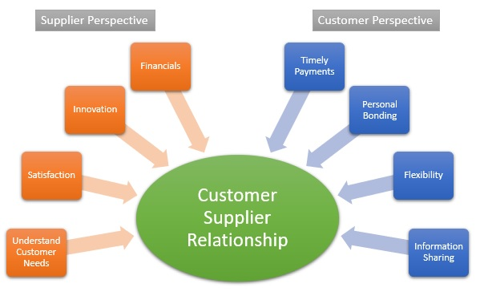

- Main Findings
  - Sainsbury History and Data

Established in 1869 in London, by John James and Mary Ann Sainsbury, it had the purpose of providing accessible items to the customers. The trading philosophy was “Quality perfect, prices lower”. The start was so successful that in by 1975 it already had 3 shops and added to its products other products like cheese, ham and bacon. By 1900, there were 4 shops in Central London, one in Croydon which will be expanded in 1896 and a branch in Watford. The chain continued the expansion through the beginning of the 20th century reaching 128 carefully located shops by 1928 when the founder died. His son continues the expansion to 250 shops by the 1950. Before World War II, the brand became more and more customer but also employees friendly with multiple facilities being added to the branches and a fund for the employees. But the real innovations would start in 1950 when self-services was introduced in Sainsbury, as well with a computerized stock-control systems (Sansom, 2010).
In 1973, the company went public at a value of £495 million with 14.5 million shares. Many employees became shareholders. All the shops were modernised and become self-service supermarkets by 1980 and joint ventures were established with different brands, expanding the diversity of products to energy (Sainsbury Energy), financial services (Sainsbury Bank - (Sainsbury's Bank, 2022)), mobile services (Mobile by Sainsbury's), pharmaceutical (Sainsbury’s Pharmacy), auto parts (Sainsbury's Euro Garages Partnership), and many other.. While the SavaCentre was absorbed in Sainsbury format in 1999, other ventures, like Homebase, were sold (Homebase generating £969 million). (Homebase, 2022),
In the 90’s due to the competition growing from ASDA and Tesco which were opening larger shops, Sainsbury started converting the stores in the format of the Sainsbury supershop. This period was also marked by mistakes like a deteriorating relation with its suppliers which favorited by Tesco because of the attitude. Trying to respond to the expansion strategies of Tesco and other supermarket chains but dismissing innovation and solely reacting made Sainsbury lose his position as the market leader. While Tesco was introducing the a loyalty club card in 1995, introduced new shop formats and expanded in the non-food retailing sector, Sainsbury management dismissed these innovations would bring new customers. However these would be implemented soon after and Sainsbury introduced also the new concept of home delivery in 1996. The first profit fall was reported in 25 years which was followed by leadership changes and a rebranding of the company which started to become more involved in building a strong customer relation.
In 2002, Sainsbury’s joined NECTAR loyalty scheme together with BP, Barclaycard and Debenhams which they completely purchased in 2018, as part of their marketing strategy, gaining access to data about customer behavior, needs, and preferences of 18 million customers in UK. (Vandevelde, 2018).
In 2004, Sainsbury created TU, a brand dedicated for clothing retail, with a diverse range of products. In 2017 TU launched online on TU platform and on Argos platform and by 2022 it became the 6th largest clothing retailer by volume, with more than 3000 items and present in over 400 Sainsbury stores (Sainsbury's, 2022)
The expansion of Sainsbury continued in 2016 by the purchase of Home Retail Group, the owner of the brands Argos and Habitat, attempting to create a “multi-product, multi-channel retailer” (BBC Business, 2016). In the offering statement it was specified “an attractive proposition for the customers and shareholders of both companies, establishing a platform for long-term value creation. The combination is an opportunity to bring together two of the UK's leading retail businesses, with complementary product offers, focused on delivering quality products and services at fair prices, through an integrated, multi-channel proposition.” (Sainsbury(J) PLC, 2016).
In the Strategic Report issued for the year 2021/2022 (J Sainsbury plc, 2022), (Sainsbury PLC, 2022) the following performance markers were made public:
- A 3.4% retails sales growth
- 104% increase of underlying profit before tax to £730m
- 36,9% retail operating profit growth compared with the previous year and 6.9% against 2 years prior
- £854m statutory profit before tax compared with a loss of £164m in the prvious year and profit of £278m 2 years prior
- Growth of TU Clothing sales by 3.1% compared with the previous year
- 80% of Argos sales are made online
- Increase of online groceries sales from 23% in 2019/2021 to 39% in 2021/2022
In 2022/2023 Interim Financial statement (Sainsbury PLC, 2022), for the first half of the year 2022/2023, Sainsbury PLC reported the following highlights
- An increase of groceries sales with 9.3% in the first half of the year compared with the first half of the previous year
- A decrease of general merchandise sales in the first half of 2022/2023 with 6.1% but an increase in 2nd quarter with 1.2 compared with the similar periods of the financial year 2021/2022.
- Underlying profit before tax £340 million
- Financial services profit of £19 million

  - Data collection

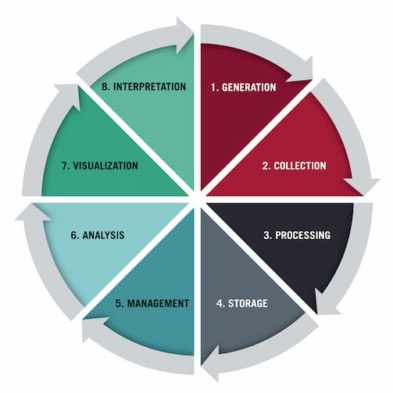

Sainsbury's is using machine learning to predict and stock products that customers will want to buy, while its Nectar customer loyalty scheme has launched a new app and website this week that promises more relevant and personalized offers. (School, 2018)

Predicting what customers will buy...

Sainsbury's uses predictive analytics and machine learning to detect emerging grocery trends. Accenture and Google Cloud have collaborated with the retailer to ensure that it is up to date on the latest food trends. They collaborated on the development of machine learning solutions on the Google Cloud Platform to demonstrate what customers want and the trends influencing their eating habits.

"The food industry and customer shopping habits are rapidly changing." Customers want to stay connected to the latest trends, from foodie hashtags on Instagram to the latest cooking fads, and Sainsbury's is empowering them to do so," said Alan Coad, managing director, UKI at Google Cloud, in a blog. He stated that the solution cleaned and classified data from both structured and unstructured sources using cloud-based analytics. Users can then use filters and categories to learn more about how shoppers want to shop.

Sainsbury's has then developed predictive analytics models to detect trends and adjust product stock accordingly. (Rigby, 2019)

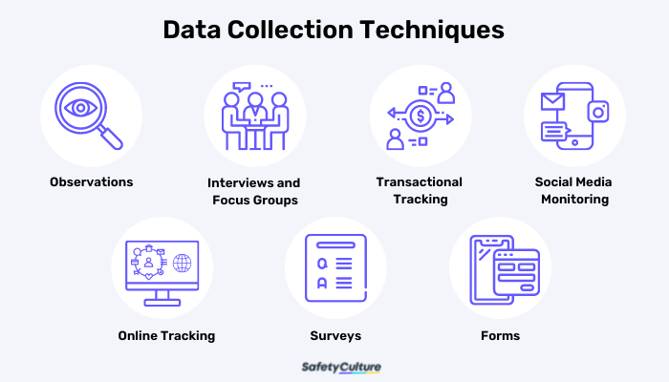

Sainsbury rapidly simplifying operations and advancing their cost-cutting initiatives in order to invest in enhancing food quality, expanding choice and innovation, and constantly providing value to customers. Argos, Habitat, Tu, Nectar, and Sainsbury's Bank are portfolio brands that complement their core food business while also delivering for customers and shareholders. They continue to seek collaborations and outsource when appropriate, benefiting from third parties who can help their clients.

  - Data analysis and evaluation

In global market from today, Customer relationship management (CRM) is an important approach for establishing relationships between consumers and organisations. Customer relationship management will increase the organization's popularity in the worldwide market. Many organisations in today's market are implementing customer relationship management since the client is the focal point of any business. Based on historical data, organisations arrived to a single conclusion: which organisations have solid relationships with their customers will endure in the market for a long time. (Bell, 2007)

According to (Mike Hoots), most firms use customer relationship management to get to know their future consumers and what they anticipate from the organisation.

Customer interactions and satisfaction may define an organization's standing in the global market. In today's world, the customer is king, and he is the only choice for earning revenue for the firm. Customers play an important role in practically all service and manufacturing businesses. The organisation that has good customer satisfaction and exceptional customer relationships will get business from the market, and its growth will be greater than that of other firms that place less emphasis on customer relationships. (White, 2007)

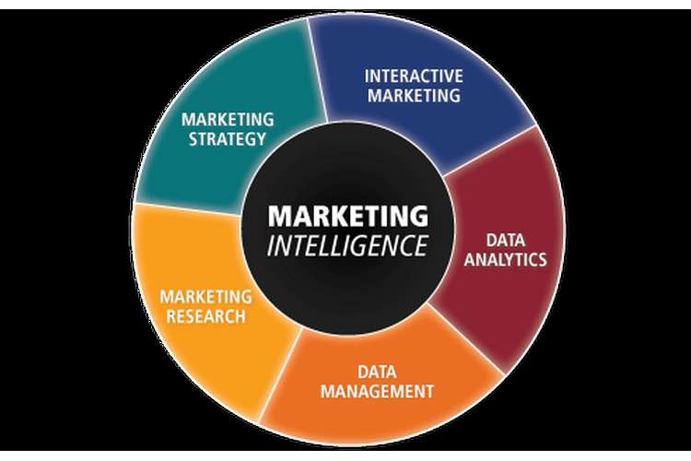

Pest Analysis of Sainsbury –
Political Factors –
Sainsbury will be taxed according to the taxation code issued by the regulatory organisations of taxation.
Salary - When compared to other supermarkets, the employees are well compensated.
Working hours - They will only grant 2 hours to schoolchildren and 20 hours to those over the age of 18.
They adhere to the Equal Employment and Wage Act and provide improved employee health and safety.
Economical Factors-
- Inflation Rates
- Unemployment Levels
- Income
- Labour laws
- Skill level of work force
Social Factors –
- Demographic Trends
- Level of education
- Culture & living styles
- Lifestyles and Attitudes
Technological factors –
- Online shopping facility
- Self checkout tills
- Widespread availability and high speed broadband internet
- Electronic Data Interchange

    - Segmentation

Market segmentation has shown to be extremely beneficial to Sainsbury. Many advantages have resulted from segmentation, including the following, among others: the company has been able to improve on its customer service standards, thereby increasing sales volume and, ultimately, profits; the company has also been able to concentrate its resources on the chosen segments, as well as review developments and anticipate changes in the segments from competitive activities.

    - Pricing strategies

The pricing of the various products has been discovered to be affordable. Sainsbury's prices are quite low when compared to other retailers in the UK, such as Tesco and Asda. The corporation has participated in pricing awareness programs, in which it educated clients on various price adjustments and discounts for new products.

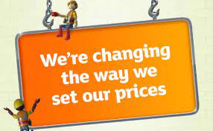

Sainsbury guarantees that the items of this target group are easily accessible and that customers may obtain them at their leisure, as evidenced by the growth projects in which many locations have been constructed; these stores are primarily located near bus stations or residential areas. (Anon., 2020)

Sainsbury has been involved in various promotional operations in order to raise customer awareness of its products, such as the latest advertising advocating healthy eating. One of the best chefs was used in this advertisement.
The retailer uses vouchers or coupons as another marketing promotion tactic. The distribution of vouchers and discounts to customers promotes both customer retention and sales. However, these vouchers can sometimes cost millions of pounds. (Barney, 2006)
Marketing segmentation may be quite costly for a company because the corporation must develop numerous marketing tactics to match the criteria or wants of each sector of the market.
For example, products aimed at children must be promoted differently from those aimed at teenagers, who must be promoted in a different manner. We have also seen Sainsbury vouchers worth millions of pounds being given to customers while the company is losing money. (Anon., 2010)
Sainsbury's still has a variety of chances. The company should think about expanding internationally and opening stores on different continents. (web, 2020)

    - Differentiation

Sainsbury's can distinguish itself from competition by providing quality products at a premium pricing. In order to remain competitive, we will need to develop new items.

To gain the upper hand in quality differentiation, Sainsbury's would have to rethink the value proposition in UK food retailing. The monstrously distorted phrase "value" is, indeed, at the center of this entire discussion. Many UK consumers appear to have forgotten that value is a combination of quality and price.

Nobody is better positioned than Sainsbury's to show that more expensive food can be exceptional value if the quality is manifestly and consistently higher. As a result, the supermarket sector would enter a strange new world of polarised value strategies, with price-led multiples seeking to create as much shareholder value as quality-led operators. (Farnham, 2019)

  - Ethics and Sustainability

How does Sainsbury's provide value to their consumers' lives?

Offering high-quality products and services at reasonable rates is part of our commitment to assisting our clients in living well for less. In the value offer, both quality and price are crucial, and our consistent lower pricing reassure customers that they can always find good value at Sainsbury's.

Sainsbury are committed to protecting human rights throughout our value chain by giving training, sharing our experience, and participating in industry collaboration projects. It highlights the employment practises and standards they are expect from their suppliers, no matter where they are in the world.

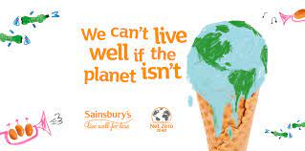

Also, Sainsbury executing a change program that focuses on lowering carbon emissions, food waste, plastic packaging, and water usage while promoting recycling, biodiversity, and healthy and sustainable eating.

- Conclusion

According to the findings of this Sainsbury critical evaluation, marketing strategies will provide the organization with a competitive edge will also aid in the development of products and services with the highest profit potential. Furthermore, it aids in determining the appropriate charge for a company organization's goods and services based on information gathered from market research.

After we start using CRM to collect information about customers and analyze the data acquired to provide an accurate picture of consumer perceptions, we had as a result growth of client happiness and loyalty. Another marketing strategy with a good impact was implementation of omnichannel marketing focus across all of its marketing channels. In addition to successfully integrating its diverse product lines with its shopping experience, we have successfully innovated in-store and online purchasing possibilities.

Please, find below the statistical data:

Digital sales currently account for 42% of overall sales.

90% of its Argos division's sales are now made online.

The company currently provides over 850k weekly grocery order slots, which is more than twice as many as last year.

The digital Nectar rewards scheme currently has over 7.4 million participants.

And internet sales continue to rise even as COVID rates fall. They were up 87% year on year in Q1; by the end of Q4, that figure had risen to 147%. (Lauchlan, 2021)

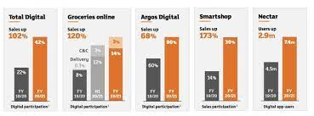

The business strategy developed by Sainsbury will assist in making the most use of Sainsbury's resources in order to provide a sales message to its target market. This method also ensures departmental collaboration in the company and build a strong approach of the customers. You can see that in this Sainsbury case study, a thorough investigation is being carried out, which has aided us.

References
Anon., 2010. www.rgis.com, 2010, Sainsbury overview. [Online]
Available at: http://www.rgis.com/assets/pdfs/casestudies/Sainsbury_Case_Study.pdf
[Accessed 17 11 2022].
Anon., 2020. www.thisislondon.co.uk, 2008, Sainsbury defies the City with yet more sales growth, (Online). [Online]
Available at: http://www.thisislondon.co.uk/standard-business/article-23496207-sainsbury-defies-the-city-with-yet-more-sales-growth.do
[Accessed 17 11 2022].
Barney, J. a. W. H., 2006. Strategic Management and Competitive Advantage Concepts. New Jersey: Pearson prentice Hall. 2006 ed. New Jersey: Pearson prentice Hall: s.n.
BBC Business, 2016. BBC - Sainsbury's wins battle to buy Argos. [Online]
Available at: https://www.bbc.co.uk/news/business-35941233
[Accessed 2022].
Bell, A. B. &. E., 2007. Business Research Methods. second edition ed. uk: Oxford University press.
Farnham, J., 2019. https://www.marketingweek.com. [Online]
Available at: https://www.marketingweek.com/sainsburys-will-win-out-if-it-focuses-on-quality/
[Accessed 17 11 2022].
Homebase, 2022. Homebase - Our History. [Online]
Available at: https://www.homebase.co.uk/about-us/our-history.list
[Accessed 2022].
J Sainsbury plc, 2022. Results, Reports and Presentations - Sainsbury PLC. [Online]
Available at: https://www.about.sainsburys.co.uk/investors/results-reports-and-presentations#2022
[Accessed 3 November 2022].
Lauchlan, S., 2021. https://diginomica.com. [Online]
Available at: https://diginomica.com/sainsburys-challenge-build-lasting-omni-channel-retail-model-vaccine-economy
[Accessed 16 11 2022].
Rigby, C., 2019. https://internetretailing.net/. [Online]
Available at: https://internetretailing.net/strategy-and-innovation/two-ways-sainsburys-is-using-data-to-give-shoppers-what-they-want-20335/
[Accessed 17 11 2022].
Sainsbury PLC, 2022. About Sainsbury - Preliminary Results for the 52 weeks ended 5 March 2022. [Online]
Available at: https://www.about.sainsburys.co.uk/news/latest-news/2022/28-04-22-preliminary-results
[Accessed 3 November 2022].
Sainsbury PLC, 2022. Interim Results for the 28 weeks ended 17 September 2022. [Online]
Available at: https://www.about.sainsburys.co.uk/~/media/Files/S/Sainsburys/documents/reports-and-presentations/2022/Interims%202223/J%20Sainsbury%20plc%20Interim%20Results%202223_Statement.pdf
[Accessed 3 November 2022].
Sainsbury(J) PLC, 2016. InvesteGate. [Online]
Available at: https://www.investegate.co.uk/sainsbury-j--plc--sbry-/rns/statement-re-possible-offer/201601051222528770K/
[Accessed 2022].
Sainsbury's Bank, 2022. Sainsbury's Bank - about us. [Online]
Available at: https://www.sainsburysbank.co.uk/jobs/aboutus
[Accessed 2022].
Sainsbury's, 2022. Tu. [Online]
Available at: https://www.about.sainsburys.co.uk/brands-that-deliver/tu
[Accessed 2022].
Sansom, I., 2010. Great dynasties of the world: The Sainsburys. [Online]
Available at: https://www.theguardian.com/lifeandstyle/2010/oct/16/sainsburys-great-dynasties-ian-sansom
[Accessed 2022].
School, H. B., 2018. https://online.hbs.edu/blog/post/data-collection-methods. [Online]
Available at: https://online.hbs.edu/blog/post/data-collection-methods
[Accessed 17 11 2022].
Team, M. S., 2020. https://www.mbaskool.com. [Online]
Available at: https://www.mbaskool.com/business-concepts/operations-logistics-supply-chain-terms/15217-customer-supplier-relationship.html
[Accessed 16 11 2022].
Vandevelde, M., 2018. Financial Times - Sainsbury’s buys Nectar reward scheme from Aimia for £60m. [Online]
Available at: https://www.ft.com/content/584f106e-0766-11e8-9650-9c0ad2d7c5b5
[Accessed 2022].
web, 2020. “J Sainsbury plc / Business strategy & objectives.”. [Online]
[Accessed 16 11 2022].
White, M. B. &., 2007. Research methods. eighth edition ed. USA: wadsworth cengage learning.

