Study Skills Report

Lucy Henson
Student No: 2418593

L4 – Study Skills
ACDA4022
Embedded Electronic systems Engineering Degree Apprenticeship

Table of Contents
Section 1.1 3
Introduction 1.2 3
Presentation skills 1.3 3
Section 2 2.1 6
High education skills 2.2 6
Transferable skills 2.3 6
Section 3 3.1 7
action planning 3.2 10
Section 4 4.1 16
Looking after data 4.2 16
Time management 4.3 16
Section 5 5.1 18
Conclusion 5.2 18
Evaluation 5.3 18
Section 6.1 19
References 19
Section 7.1 21
Appendices 21

Section 1.1

Introduction 1.2
This report is about the skills the author needs to succeed at university and at her job. The reports start with feedback on a presentation the author Lucy did and how it links into skills required for both higher education and at her job. It is then followed up by self-evaluation and an action plan on how to achieve goals set for both work and personal life. The report then goes into detail about how she manages her data and time effectively at university and in her job.

Presentation skills 1.3

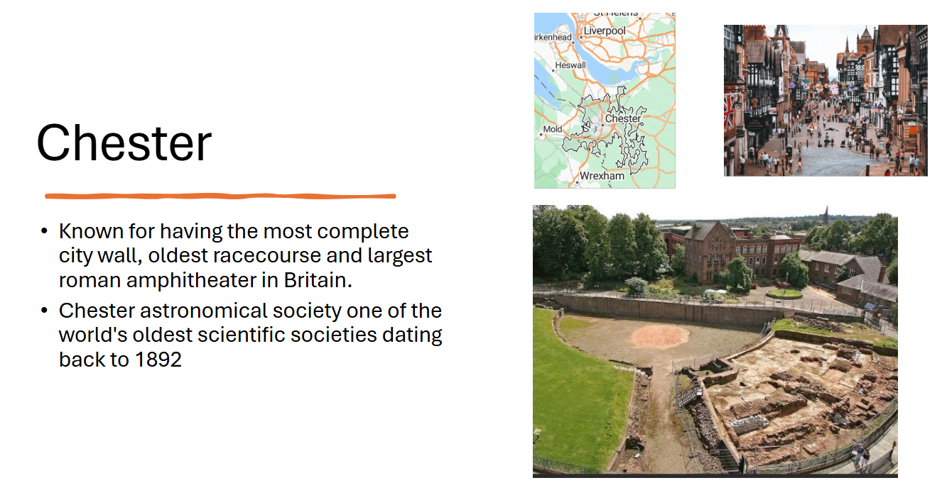
Figure 1 Screenshot from presentation

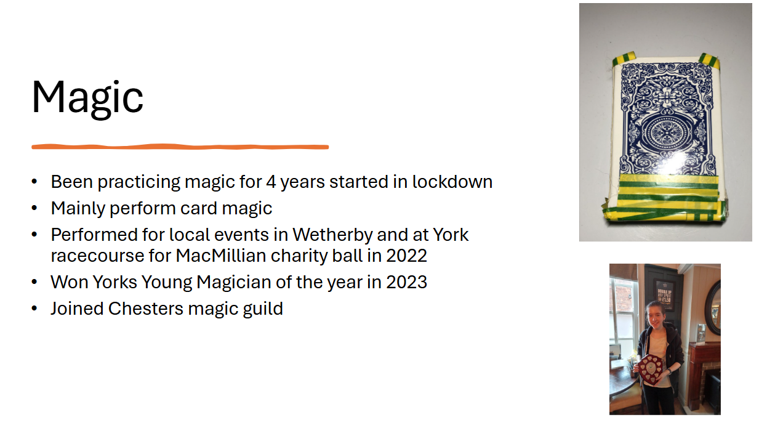
Figure 2 Screenshot from presentation
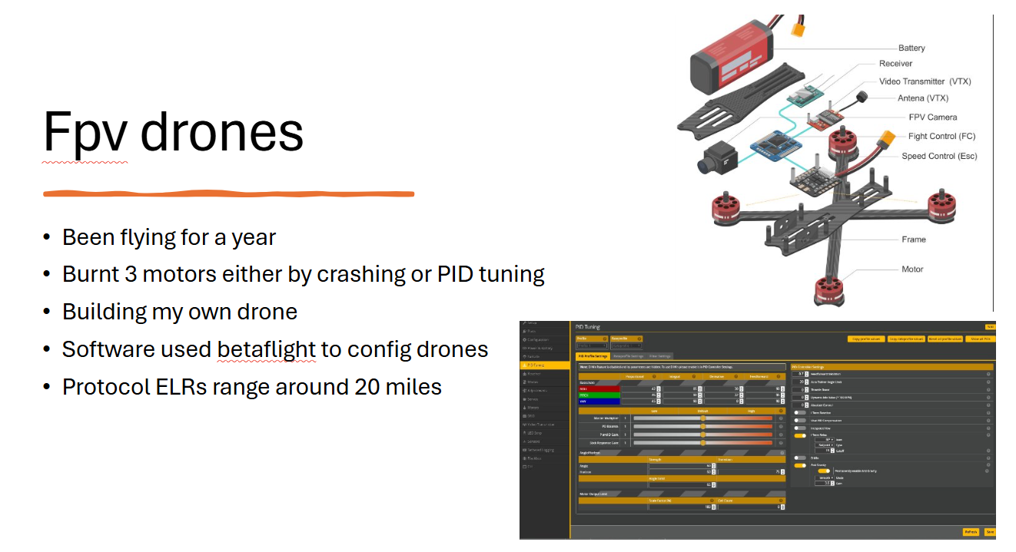
Figure 3 Screenshot from presentation
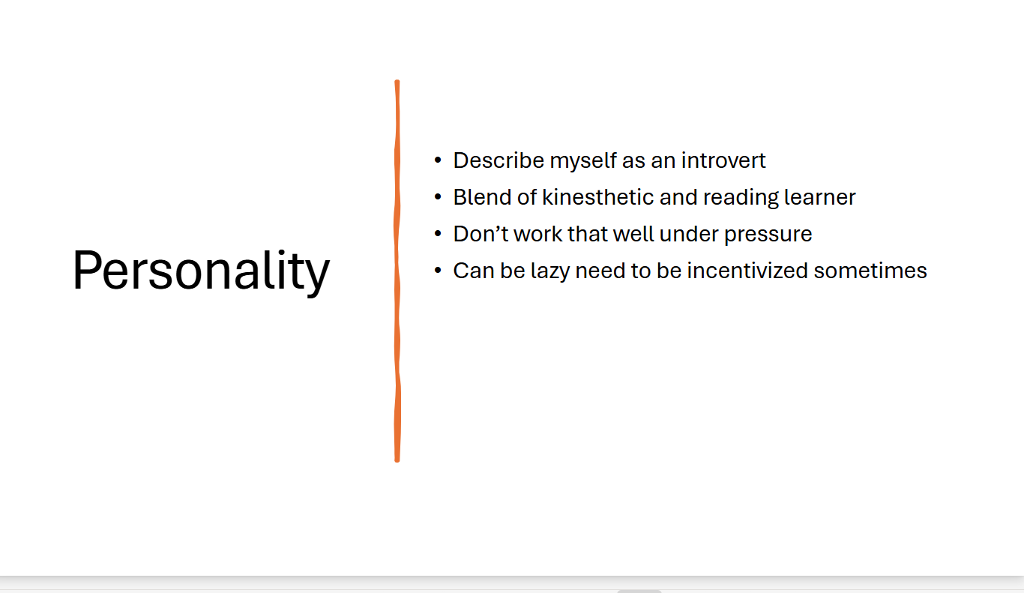
Figure 4 Screenshot from presentation

The author of the presentation, Lucy, describes herself as a quiet introverted individual whose main hobbies are performing card magic and drone flying. She mentions that she originally lived in a small town called Wetherby near Leeds. She has moved to Chester for her job working for the civil service in an engineering department. This can be seen above in the screen grabs from the presentation.
Key points taken from presenting
- PowerPoint slides must be readable on larger screens when presenting.
- Slides must contain a balance between picture and text.
- The speaker needs to have the presentation memorized
- When delivering the presentation, the presenter noted how unprepared they felt
Feedback from both spectators and the lecturer showed that they enjoyed the presentation. People liked the balance between images and text in the presentation and that the presentation seemed well prepared, however it was mentioned the presentation was slightly too short and that the speaker needed to be louder and more confident in their delivery as some people found it harder to hear the speaker near the back of the room. For future presentations the speaker will spend more time working on the oral part of their presentation as that was the common cause of some of the negative feedback.

Section 2 2.1

High education skills 2.2
Lucy went on to research skills needed to be successful in higher education. Looking at bob Smales a teacher in education for 31 years and who received an award for excellence in faculty and empowering education from Kent university wrote a book how to succeed at university, he believes that motivation and the willingness to learn are important skills needed to be able to successfully learn in a higher education environment. “Succeeding in higher education will require you to hold on to your dreams” [1]. Other important skills Bob believes are needed to succeed in higher education are being adaptable, organized, communicative and willing to do independent research. The English and literacy department of the university of Nigeria states that “listening skills and note taking skills are imperative skills for university students [2].Looking at the Uni admission website it lists 6 essential skills to succeed at university [3]. These skills being academic writing, communication, reading, critical thinking, time management and soft skills. Comparing these to the other statements they are all very similar with both bob and the website agreeing that communication and many of the other points like academic writing and being able to effectively note taking are similar. The author felt these views were closely related to what skills she previously believed were needed to succeed at university. It was noted she didn’t realize before how important it was to be organized at university.
When looking at the different sources of information the main skills needed for higher education are motivation, time management and communication skills as all the other skills can be learnt when at university. The author feels they demonstrate some of the key skills, particularly time management and reading skills, however they noted that their communication and academic writing skills could be improved.

Transferable skills 2.3
She also looked at required transferable skills. When looking at this she noted how similar both skills sets were.
Indeed’s, career advice page states that there are 10 essential transferable skills being effective communication, motivation, leadership, reliability, teamwork, self-management, emotional intelligence, analytical, quick learner and administrative skills. [4]. the NFER (national foundation for education research) and Sheffield Hallam joint report on skill shortages in the workforce which predicted that transferable skills such as communication, problem solving and decision-making being vital for the economy in 2035 as they would be harder to automate. [5] The report identified 6 skills expected to be in demand these are collaboration, communication, creative thinking, information processing, problem solving and organizing. When speaking to colleagues they described the ideal job candidate as someone who is motivated and has good teamwork skills. Comparing the sources of evidence they are all nearly identical to each other and to the skills required to succeed in higher education, showing that there is a link between being able to succeed at university and working in a job.

Section 3 3.1
Self-evaluation
The author of the report performed a variety of personality tests to assess their personality type. Starting with the Carl Jung personality test which was invented by Carl Jung a Swiss psychiatrist. Who is best known for his research into psychological types inventing the term introvert and extrovert. [6] This test involved having two personality attitudes extrovert and introvert while having four functions/modes of orientations thinking, sensing, intuition and feeling. [6] The results are shown below in figure 1
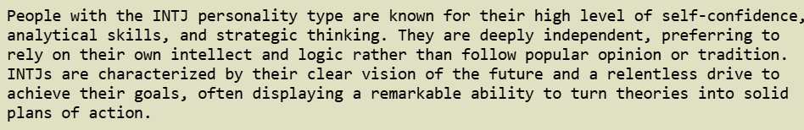
Figure 5 Results from Carl Jung personality test
The results in figure 1 show that the author displaces more introverted tendencies. Figure 2 below shows the results of the big 5 personality test. The big 5 test is based off the big 5 personality traits which are the most common model used in academic psychology. The test uses the big five markers from the international personality item pool developed by Goldberg in 1992 [7].
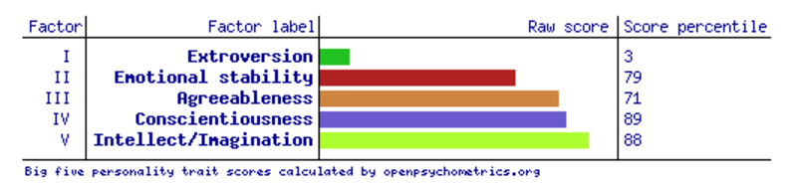
Figure 6 Big5 personality test results

The results of both tests indicate that the author displaces introverted tendencies. When comparing the results to how she perceived herself they align quite closely as before doing the tests she perceived herself as being a goal-orientated driven individual who works better on their own, which matches up closely the Carl Jung results of being highly independent and relentless drive to achieve their goals. However, in the Carl Jung result where it mentions having a high level of self-confidence did contrast with her view of herself being less confident in her approaches compared to her colleagues.
After the personality tests the author performed a careers test. The 123-career test is based on Dr john hollands (who was a psychologist and professor at john Hopkins university who developed the holland codes) [8] theory of career choices known as hollands codes the six personality types can be seen below
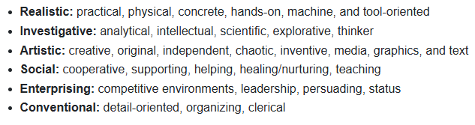
Figure 7 123 career test results
The 123 careers test the results can be seen below
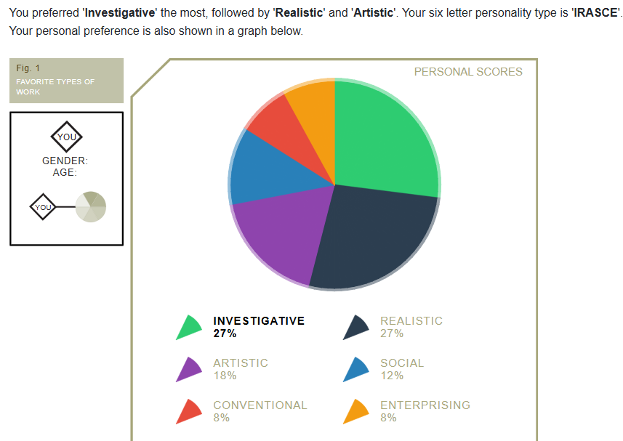
Figure 8 123 career test results
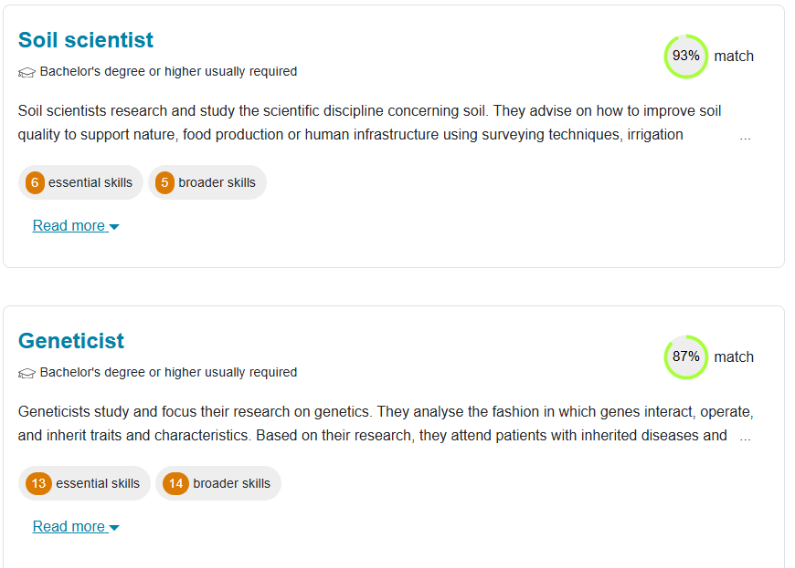
Figure 9 123 career test careers
The tests indicated that the author is more suited towards a STEM career than a more arts based one. The personality types which she most closely aligned with being the investigator and realistic types were both more closely related to STEM careers than the others. This, along with the fact that she is working in the STEM field and pursuing an engineering degree, shows that she is more suited towards STEM subjects. This is backed up by the results in the personality tests big5 and Carl Jung as their personality types were very similar.

action planning 3.2
The author’s main long-term goal for the next few years is to complete the electronic engineering degree and to qualify for incorporated engineer status. The author’s shorter-term goals include swimming 64 lengths in 45 minutes to become fitter, building a drone to race with to improve her soldering skills and to get better at using KiCad PCB software for work purposes. The author has created 4 action plans that conform to the SMART guidelines to achieve these goals the plans can be seen below. 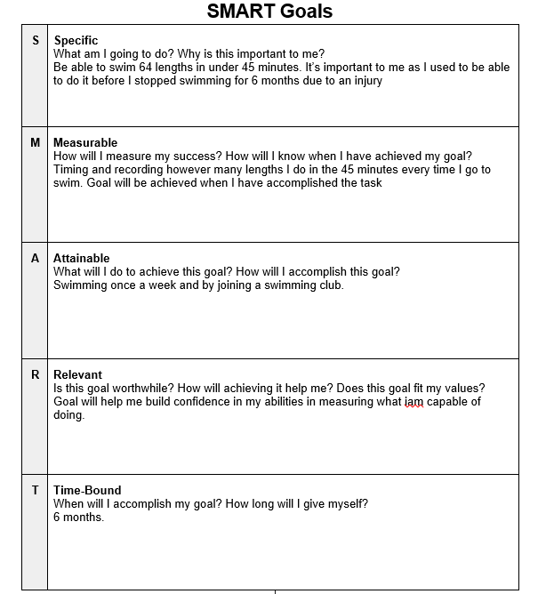
Figure 10 Smart goal swimming
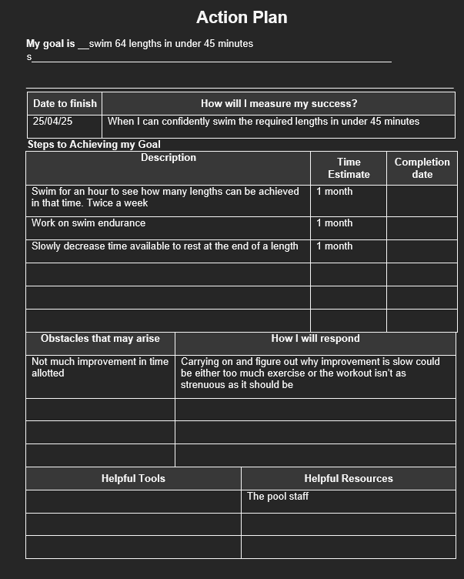
Figure 11 Action plan swimming
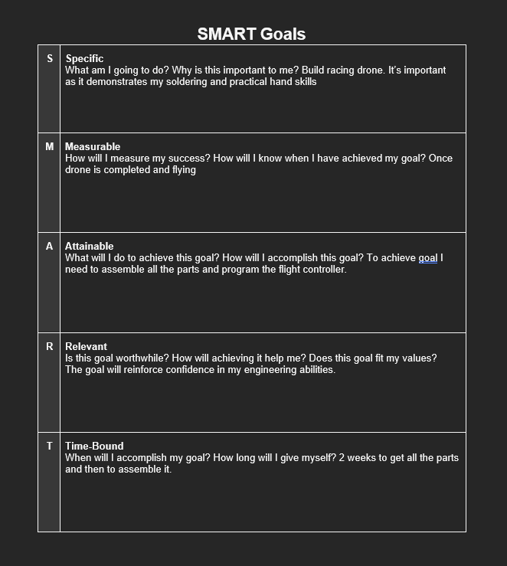
Figure 12 Smart goal Drone
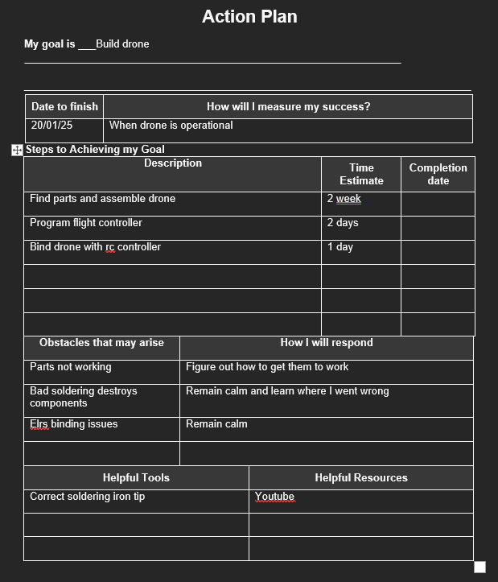
Figure 13 Action plan drone
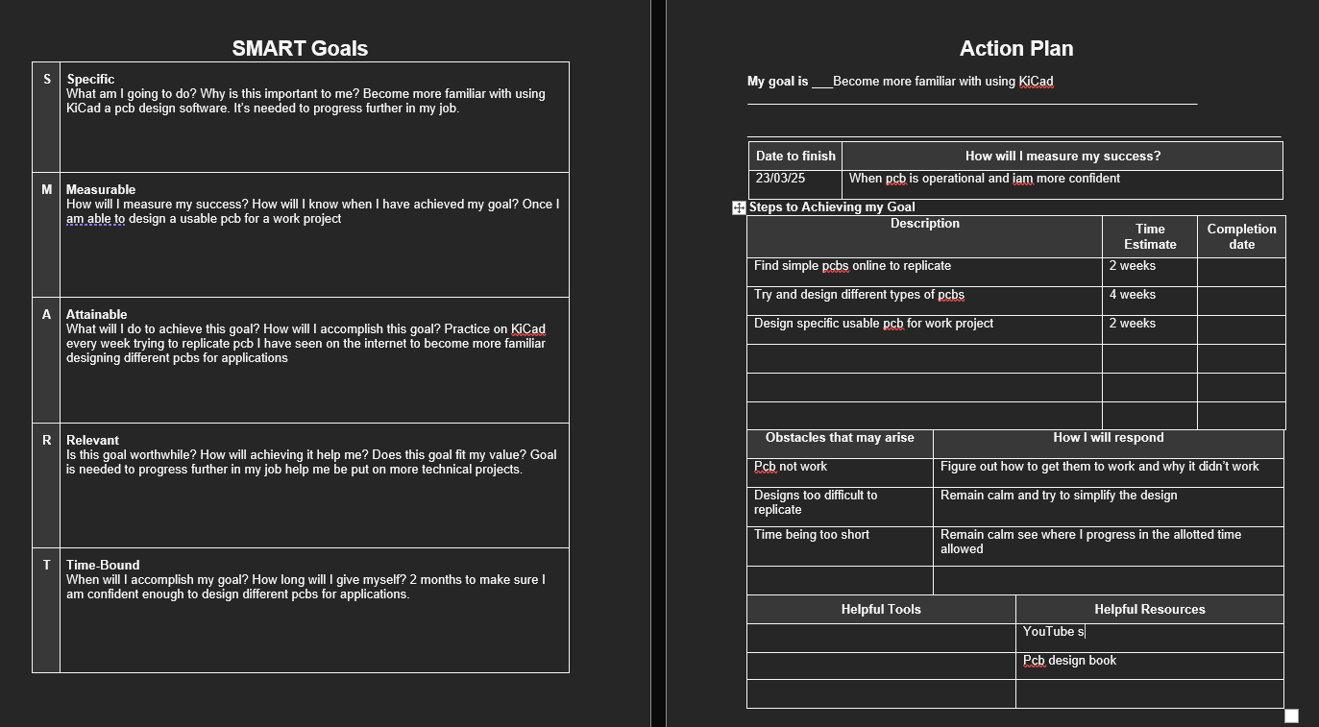
Figure 14 Smart and Action plan for KiCad
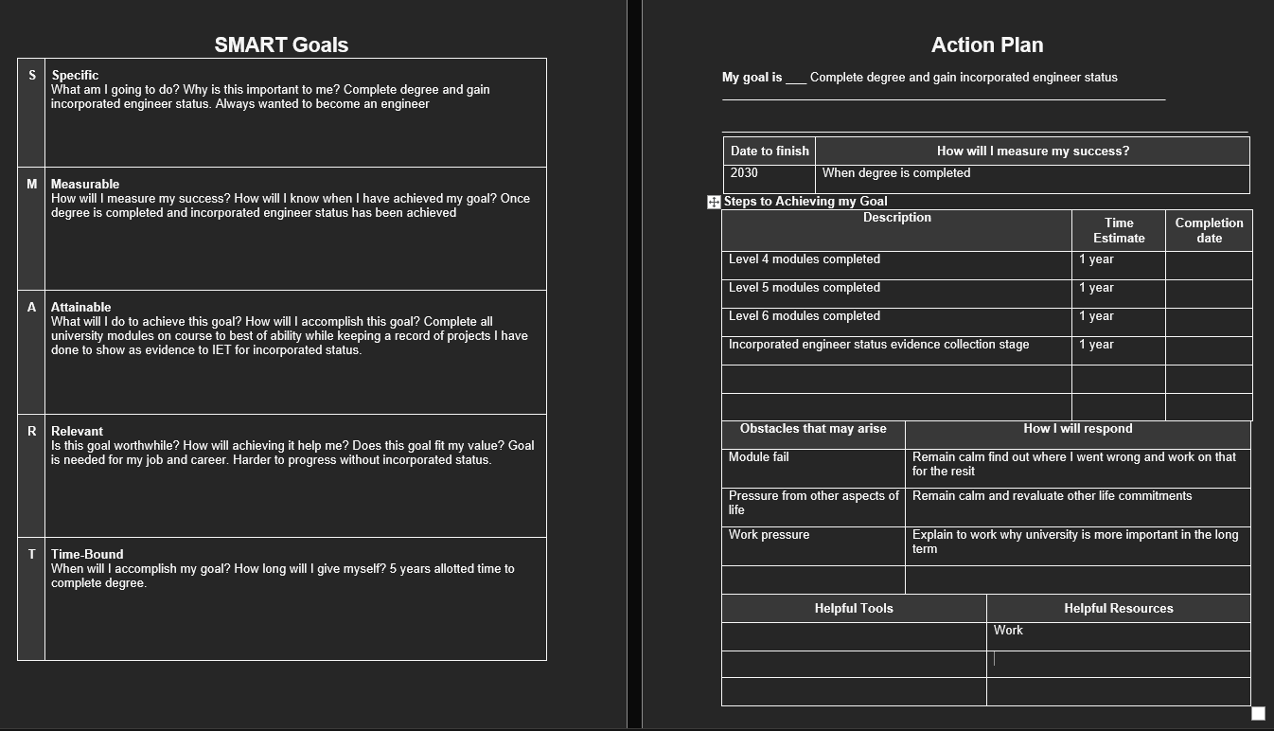
Figure 15 Smart goal and Action plan for degree

Section 4 4.1

Looking after data 4.2
The author has used the 3 different places approach to storing data. This involves saving data locally on the device and then backing it up to the cloud using OneDrive. This approach allows greater flexibility if the device malfunctions as she can access her data on another basis. It also means she could access previous versions of the data if she needed to in the case of an emergency like being the victim of a ransomware attack. She also uses a usb drive to store Uni work as it can be taken anywhere, and the data can still be accessed if the internet went down or if Microsoft stopped supporting OneDrive servers. The Author then uses a larger SSD to backup Uni and personal work once a month. She only does this once a month as some ransomware attacks will stay hidden and inactive on a system for a few weeks to see if the user has any other ways of storing data like on an SSD. Lucy researched the ransomware in her report, Petya only waits an hour before activating on the victim’s computer and then it would reboot the system with the text being displayed that the file system is being repaired while it encrypted the user’s data. Petya ransomware is an encryption-based malware which was first discovered in 2016. [9]. Lucy’s approach to storing data would fend off ransomware attacks like Petya as Petya will only wait an hour before activating which means it would not be able to infect the SSD. Her approach would mean the loss of some data if the ransomware was present. Unfortunately there are some ransomwares this method cannot protect against as Not Petya a ransomware which first appeared in 2017 will stay hidden for months at time on the users machine this approach means it has a better chance of infecting other data storing devices if they are plugged in it also doesn’t encrypt the victims data but instead destroys it completely meaning there would be no hope in recovering the files. [10] This approach is not able to be defended against if the user's devices have been infected. Ransomware isn’t the only way data can be lost as mechanical failure can happen in any device and cloud-based solutions will not be supported forever.

Time management 4.3
To manage herself at work Lucy creates and maintains a weekly calendar which has a daily plan of what she needs to get done in a day. The calendar contains important business meetings and deadlines for assignments she needs to get done. In the evening the calendar is updated to include any work she was not able to finish in the day or to add any new personal goals she wants to add to. This strategy has helped to reduce her stress and has enhanced her productivity as she is able to know exactly what she is going to work on before every day. It also means she doesn’t have to think about work until she gets to the office allowing her to start the day with a clear head which makes her less stressed. The calendar also provides clear evidence of what she worked on every week, allowing her to track her progress and see where she needs to improve. She also has a personal calendar which contains deadlines for university work and the dates she needs to be at university. This can be seen in figure 16 below. As she has only been with her organization since September, she has not made any significant contributions to increasing the productivity at her organization. 
Figure 16 Work calendar
Figure 17 Personal university calendar
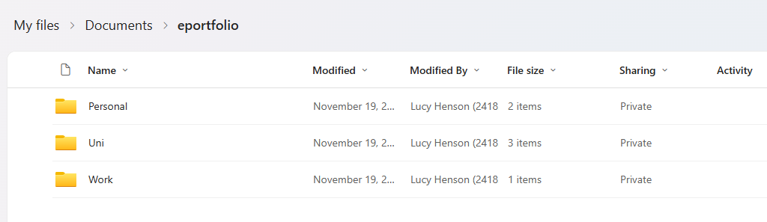
Figure 18 E Portfolio
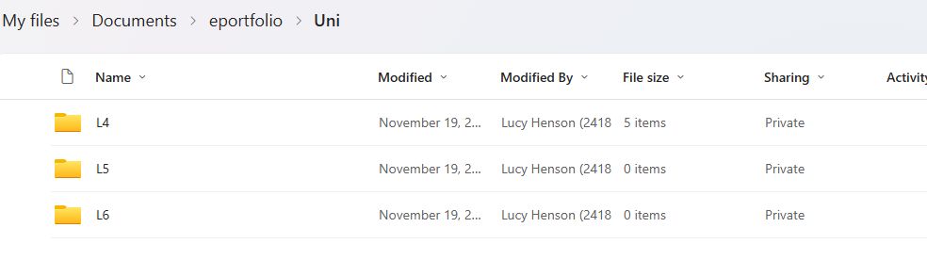
Figure 19 E portfolio

Lucy has organized her electronic portfolio into 3 different sections which are Work, University and Personal. This structure she has used is the easiest way for her to quickly access any of her data whether it be Personal or Uni work without difficulty. The structure is organized so that the 3 different areas of her life, work, personal and university work are all separated and organized into either years for work or levels for university so she can clearly see the progress she makes in a year and so that it’s clearer to find evidence for a qualification.

Section 5 5.1

Conclusion 5.2
In conclusion, the report’s key findings are that the author has clear introvert characteristics and that this is reflected in the feedback from the presentation she did and how she perceived herself to be. The report also showed her methods of managing both time and her data effectively and how these methods correlated with the skills required to be successful at university and at her job.

Evaluation 5.3
The author will look more into academic writing and communication skills for future projects as the author noted that these skills are vital for both educational and work environments. The author felt that they lacked these skills. The author is also going to research more into personality types for a better understanding of how other people interact with the world.

Section 6.1

References

[1] | S. B. a. F. Julia, How to Succeed at University: An Essential Guide to Academic Skills and Personal Development, london: SAGE publications, 2009.
[2] | B. O. Nwokolo, "Refocusing on Listening Skills and Note-Taking: Imperative Skills for University Students’ Learning in an L2 Environment," July 2022. [Online]. Available: https://research-ebsco-com.ezproxy.uwtsd.ac.uk/c/onvpsy/viewer/pdf/crsqnq7sbf?route=details. [Accessed 4th January 2025].
[3] | R. needleman, "uniadmissions," 11 december 2024. [Online]. Available: https://www.uniadmissions.co.uk/application-guides/6-essential-skills-for-university-students/. [Accessed 2025 01 04].
[4] | i. e. team, "indeed career advice employment skills," indeeed, 7th september 2023. [Online]. Available: https://uk.indeed.com/career-advice/finding-a-job/employability-skills. [Accessed 2025 january 4th].
[5] | "NFER Urgent action needed to prevent skills shortages and potential impact on the economy and employment," 25 may 2023. [Online]. Available: https://www.nfer.ac.uk/press-releases/urgent-action-needed-to-prevent-skills-shortages-and-potential-impact-on-the-economy-and-employment/#. [Accessed 2025 01 04].
[6] | "wikapedia Carl Jung," 2017. [Online]. Available: https://en.wikipedia.org/wiki/Carl_Jung. [Accessed 05 01 2025].
[7] | "open source pscchometric project big 5," 2 august 2019. [Online]. Available: https://openpsychometrics.org/tests/IPIP-BFFM/. [Accessed 4 january 2025].
[8] | "wikapedia John Hollland," 2016. [Online]. Available: https://en.wikipedia.org/wiki/John_L._Holland. [Accessed 05 01 2025].
[9] | L. Henson, "Petrya ransomware report," 2024 .
[10] | "Cloudfare what are Petya and NotPetya," [Online]. Available: https://www.cloudflare.com/en-gb/learning/security/ransomware/petya-notpetya-ransomware/. [Accessed 05 January 2025].
[11] | "Indeed Careers advice," 17 May 2024. [Online]. Available: https://uk.indeed.com/career-advice/career-development/transferable-skills. [Accessed 03 January 2025].
[12] | J. Herrity, "Indeed Cover page and resumes," 30 July 2024. [Online]. Available: https://www.indeed.com/career-advice/resumes-cover-letters/transferable-skills. [Accessed 03 January 2025].

Section 7.1

Appendices


