Programming I
  - Name: Sarann Elizabeth Strange

Student No: 1701763

Email: 1701763@student.uwtsd.ac.uk

Course: BSC (Hons) Software Engineering

Module Name: Programming I

Module Code: ACCA4004

Lecturer: Mike Dacey

Table of Content
Table of Contents
1. Introduction 1
2. Understanding of programming 2
2.1 What is a variable 2
2.2 For-loop 3
2.2.1 Example of the use of a for-loop 3
2.3 The use of arguments within functions 4
2.4 The purpose of class within Object Orientated Programming 4
2.4 Class in Object Oriented Programming 5
3. Explanation of Implementation of the Code 1
3.1 Flowchart of exercise 6 Debugging the code 1
3.2 Functions used within exercise 6 2
3.2.1 ProcessMenu 2
3.2.2 GetNumbers 3
3.2.3 ReadNumbers 3
3.2.4 FindingSmallest 4
3.2.5 FindingLargest 4
3.2.6 IsQuiting 5
3.3 Bugs within exercise 6 code 6
3.3.1 Case 4 is incorrect 6
3.3.2 Different options to quite 6
Numbers not being removed 7
3.3.3 COORD error 7
3.3.4 Enter the numbers, allows characters to be entered 8
3.3.5 The user can enter a number too large for the variable to store 8
4. Programming Exercises 9
4.1 Exercise 1 Declaring and displaying variables 9
4.1.1 Results of working code 9
4.2 Exercise 2 calculating the shaded are of a shape 10
4.2.1 Results of working code 12
4.2.2 Bugs within the code 13
4.3 Exercise 3 calculation of gravel 14
4.3.1 Results of working code 15
4.3.2 Bugs within the code 2
4.4 Exercise 4 printing a cross 3
4.4.1 Result of working code & bugs 3
4.5 Exercise 5 Enter price of 5 products 7
4.6 Exercise 7 Slot machine 8
4.6.1 Result of working code 9
4.6.2 Bugs within the code 10
5. Appendices 15
5.1 Appendix 1 Data types 15
5.2 Apendix 2 Code Creation 16
5.2.1 Exercises 1 16
5.2.2 Exercise 2 finding the shaded area of a shape 17
5.2.3 Exercise 3 gravel calculator 18
5.2.4 Exercise 4 printing a cross 19
5.2.5 Exercise 5 Class creation 20
5.2.6 Exercise 6 Debugging the code 21
5.2.7 Exercise 7 Slot Machine 23

Introduction
The assignment explains for loops, while loops, variables, functions and the use of arguments to advance and create new values that can be used within a program and Object Orientated Programming (OOP) with an explanation on classes and their use within programming.

A number of programming exercises a brief explanation on each programming task with the breakdown of the requirements needed for each exercise. Flowcharts of how the code runs and bugs found and solutions for those bugs are also discussed.

Understanding of programming

What is a variable
Variables are an address block within memory of a computer that hold data which is accessed and used within a program, they have a given name that is used instead of the address location where the variable is stored. Giving a variable a name makes it readable for programmers who can gain better understanding on what a block of code is doing and how it runs and what data is being held there.
Variables are assigned a memory size and legal operations which are dictated by the data type that they are assigned with [1][2]. For instance the data type integer, float and double can be used within a sum, but the float and double allow for decimal numbers while the integer can only contain a single number value, the float data type is also smaller than the double allowing more values to be held within the variable (See Appendix1 Data Types) [3].

Variables are required to hold a value whether it is a hard-coded value such as the right hand image or allowing a user to input a value. If variables are not assigned a value they are wasting a memory address and are there for useless.
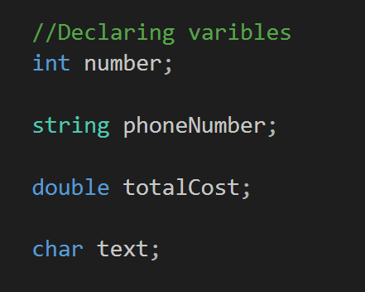
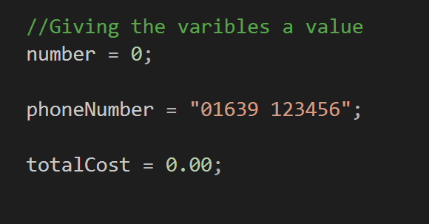
Figure 1 Images of the declaration and assignment of values to variables

For-loop
The for loop is known as a counting loop as it carries out a block of code that it repeats for a set number of times. The way it achieves this is with an index variable set to zero. The index is then compared to the number of times the loop is set to repeat with a comparison condition such as < 5 if that condition is true the code is executed and the index increases by one with the use of index ++. The for loop is used when there is an understood and established number of times that the loop will run before it will stop. If the exact number is not established a while loop is used instead as it will run until a condition is met that will stop the loop.
The for loop can be used to carryout a task that will repeat a number of times such as a user inputting a value into a variable, printing a message, or calculating a sum. The for loop is used so the programmer does not have to continually type repeated code into a program.

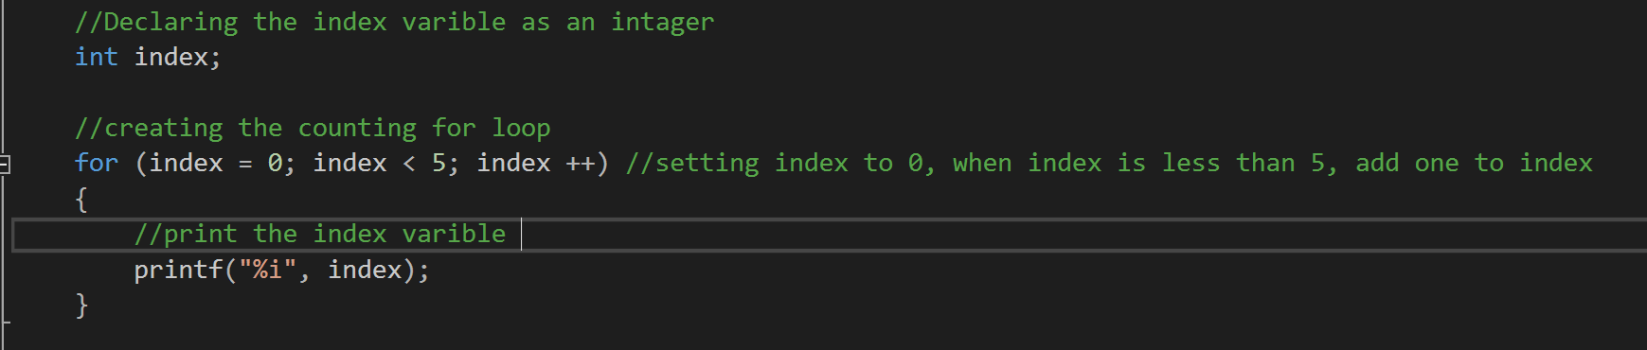
Example of the use of a for-loop
Figure 2 Example of the for counting loop

The use of arguments within functions
Arguments are used as a placeholder for variables within functions to copy previously established variables with assigned values. A function uses the values from an argument to preform calculations or modify another variable with a different value. The new value or returned result from the functions can be used to enhance code as it allows a programmer to easily maintain, alter and amend code as blocks of code will be segmented into suitably named functions which are kept separately from the main .cpp.
An example of an argument being used is in the calculation of two numbers. First the function is declared and requires two arguments to be passed through, it will then use the copied values from the arguments, run the code and return the result of both arguments.
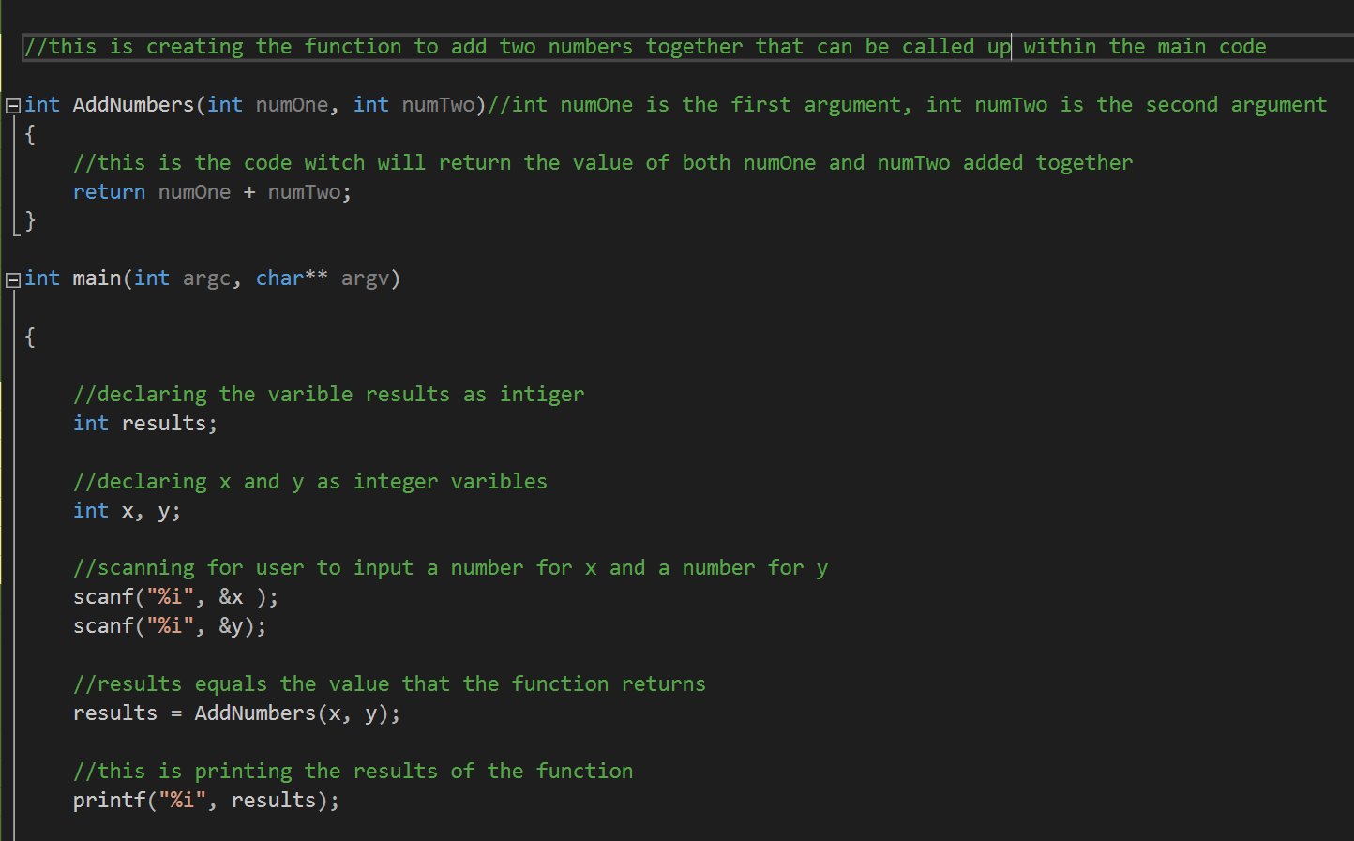

The purpose of class within Object Orientated Programming
Describe the purpose of a class in Object Oriented Programming.

Figure 3 Argument being used within a function to add two numbers together.

2.4 Class in Object Oriented Programming
Object orientated programming is a form of programming that uses objects to create applications. When OOP is being implemented many objects are created to work together to preform basic to complex tasks within a program.
Classes are used to group recurring data together to build a template for the creation of objects. The objects use the template of the class such as the attributes which are the variables that have been established for the use of the objects, the properties which are the functions within the class that provide a structure on what the object knows and methods which provide instructions on what the objects do and how they use attributes and the properties of the class [4].
Classes are used to prevent the repetitive creation of code that will be used more than once, they allow the programmer to manage recurring data and easily amend and update code that would otherwise be time-consuming to alter and update.

Explanation of Implementation of the Code

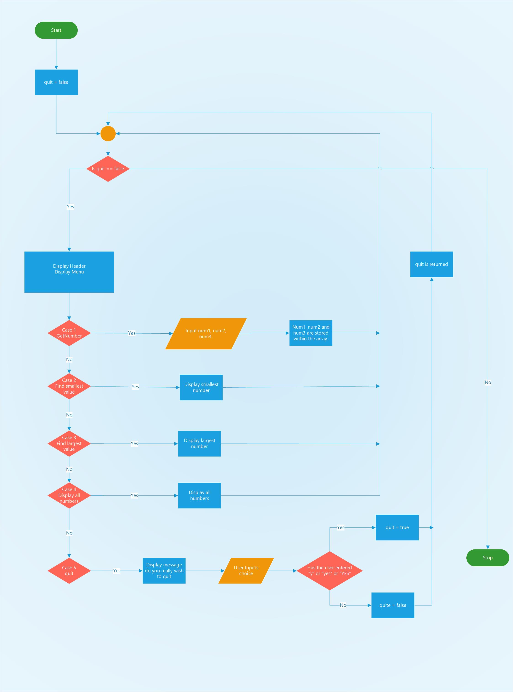
Flowchart of exercise 6 Debugging the code

- The program declares the quit variable which is initially set to false.

- The program opens a loop which checks if quit is equal to false.

- When inside the loop, the display header and the menu options available for the user are shown on the console.

- The user can choose between five different cases within the switch code.

- Case 1: GetNumbers when chosen allows the user to input three numbers which are stored within an array.

- Case 2: Find smallest value displays the smallest value that is held within the array. If the user does not input a value, the default value of the array which is zero is displayed, as it is the smallest value.

- Case 3: Find largest value displays the largest value that the user entered, If the user does not input a value, the default value of the array which is zero is displayed, as it is the largest value.

- Case 4: Displays all numbers from the array.

- Case 5: presents the user with the message “do you really wish to quit?” the user enters different forms of yes to quit, the function returns true if YES, yes or y are entered. If they are not, quit returns false, allowing the loop to continue running.

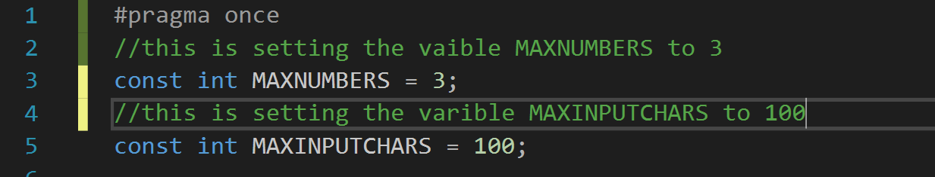
Functions used within exercise 6
Figure 4 Within the .h file the variable MAXNUMBERS is set to 3 and MAXINPUTCHARS is set to 100.

ProcessMenu
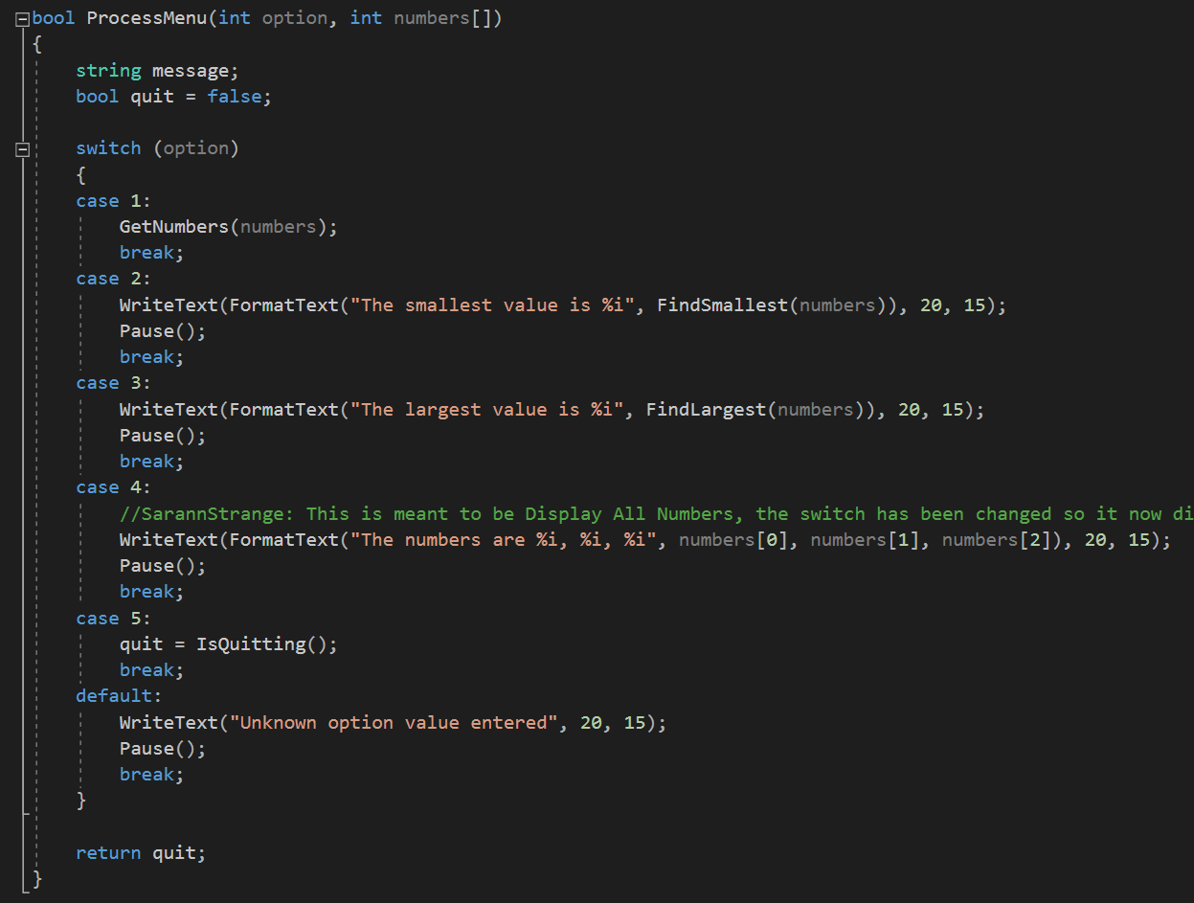

GetNumbers
The GetNumbers function is using the numbers array within a for loop which sets a for loop which sets an index to 0 as long as the index is less than the MAXNUMBERS variable which is set to 3 it will add one to index. While the loop is being carried out it will use the index to set the numbers array to the value which is returned by the read numbers function and it keeps asking the ReadNumbers function until the loop ends.
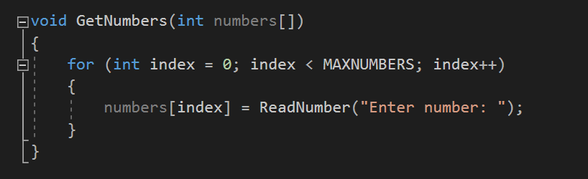

ReadNumbers
The readNumbers function prompts the user to enter a number which it then returns. It also does a check that the input number is not a minus number or an invalid character.
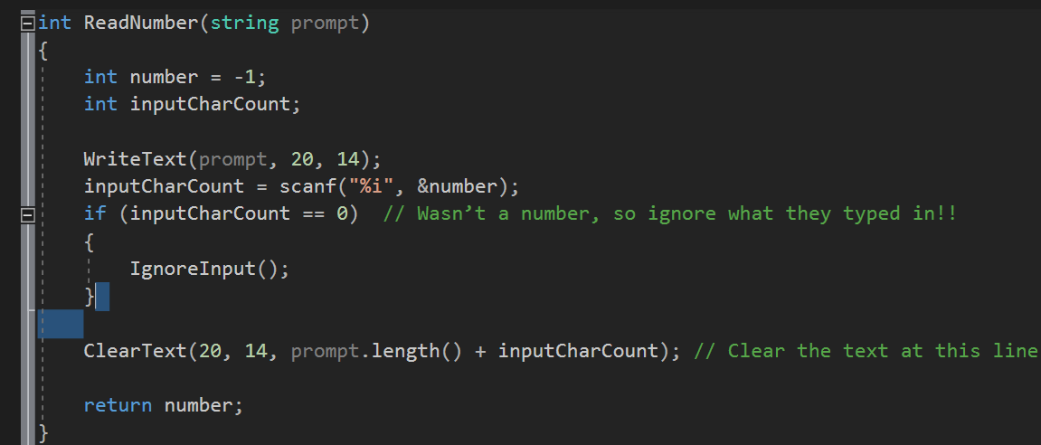

FindingSmallest
The numbers array is passed in as an argument a placeholder int variable is then declared and used to hold the value in the first address of the array.
To check if it is smaller than the other two addresses in the array, a for loop is opened which loops twice ( < MAXNUMBERS – 1 ) is used as the condition on each iteration of the loop, it checks if the placeholder has a smaller number than the next address in the array. If it doesn’t then it replaces its current value for the smaller value. Once the loop ends, the smallest value is returned
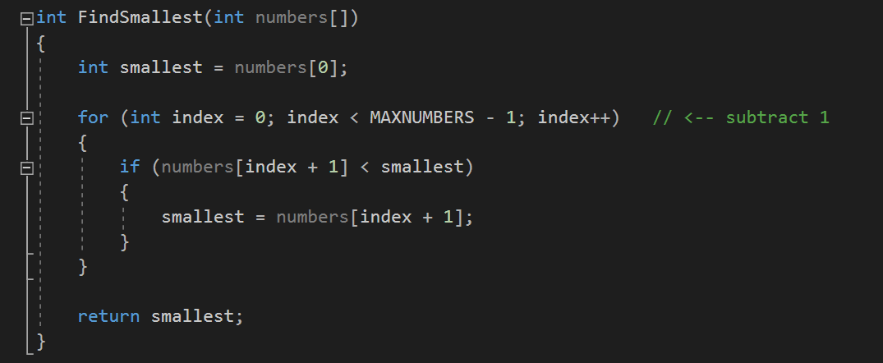

FindingLargest
The numbers array is passed in as an argument a placeholder int variable is then declared and used to hold the value in the first address of the array.
To check if it is larger than the other two addresses in the array, a for loop is opened which loops twice ( > MAXNUMBERS – 1 ) is used as the condition on each iteration of the loop, it checks if the placeholder has a larger number than the next address in the array. If it doesn’t then it replaces its current value for the smaller value. Once the loop ends, the largest value is returned.
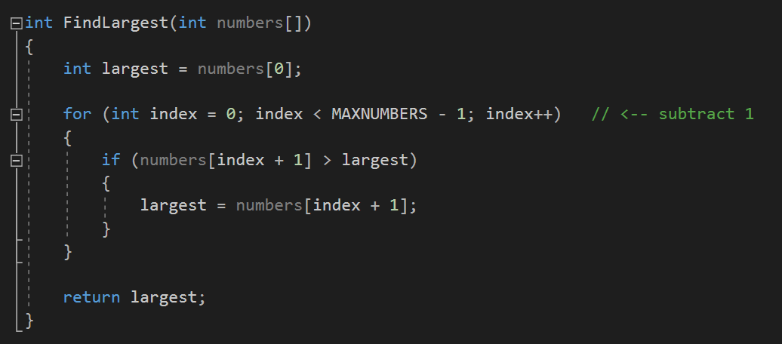

IsQuiting
Within the IsQuiting function a bool quite variable is set to false and the string response variable is declared. The user is then prompted to enter a response which is stored within a char input array, response then equals input. There is an if check within the function checking is response is equal to “YES”, “yes” or “y” if it is, quit equals true. Quit returned.
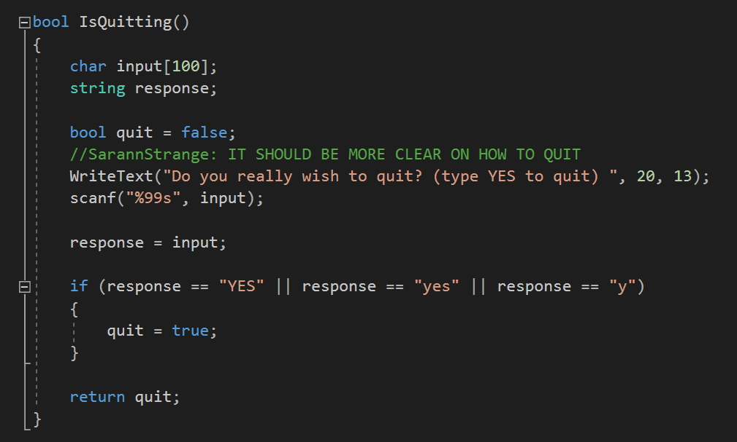

Bugs within exercise 6 code

Case 4 is incorrect
Within the switch statement Case 4 originally repeated the Case 5 section to quit. It was altered using the writeText function to display each of the numbers within the array to the console.
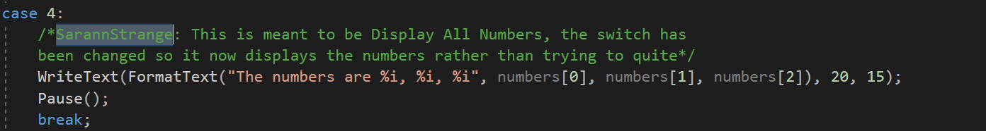

Different options to quite
case 5 for quitting the program can be easily misconstrued by a user as it is not very clear what the user must input to quit the program, below is an image of the altered code displaying a message for the user on how to quite with different variations on the word yes.
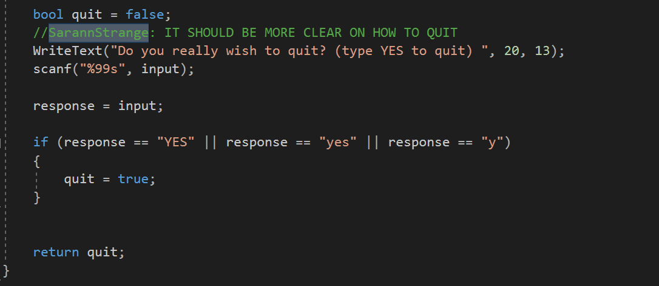

Numbers not being removed
when the option Enter the numbers is chosen, the program allows the user to enter multiple numbers for each of the sections of inputting numbers, but after the user presses enter the program only removes the first digit and not all the numbers. The program should clear all of the numbers to display and empty console screen. This problem is not solved.
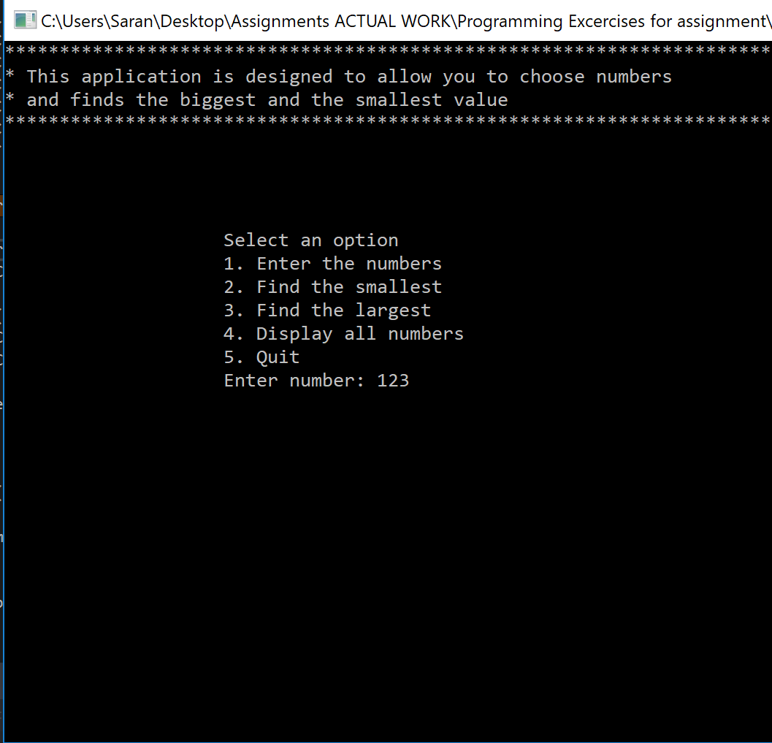
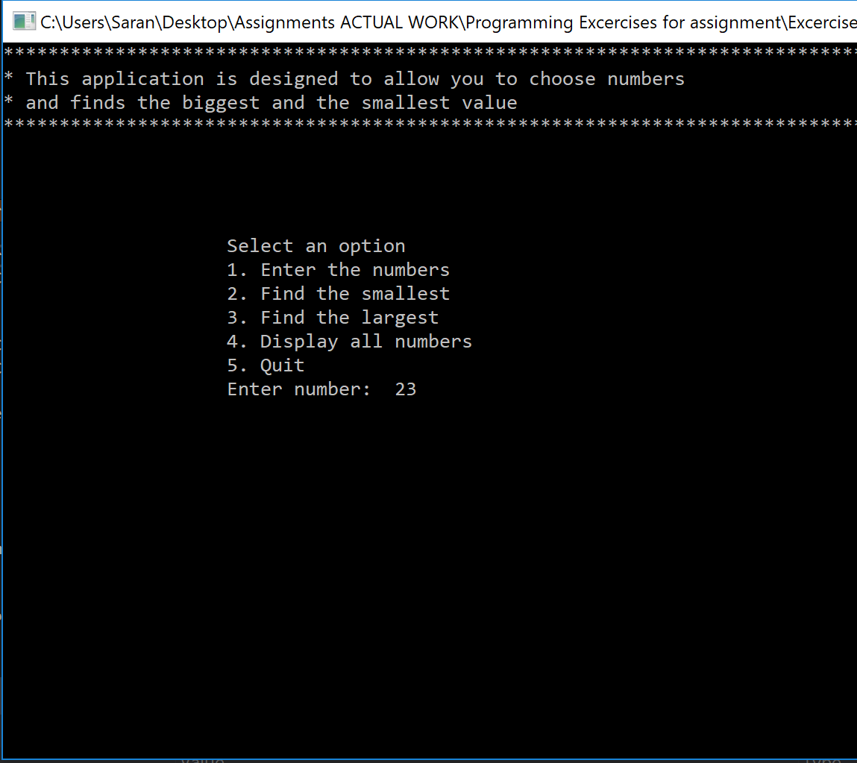

COORD error
There is also a warning for the use of COORD the int values should be altered to fix this warning. The warning has not been fixed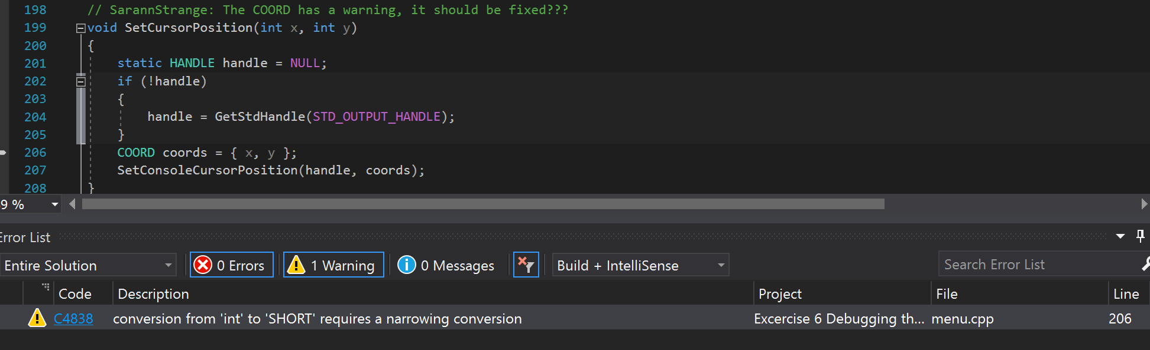

Enter the numbers, allows characters to be entered
After selecting option 1 Enter the numbers, the user can enter characters, the user should not be capable of entering anything but numbers, this section of code would need to be amended where it performs a check on the input of the user to ensure that only numbers are entered and provides a clear message to the user of the mistake that they made. This problem is not solved.
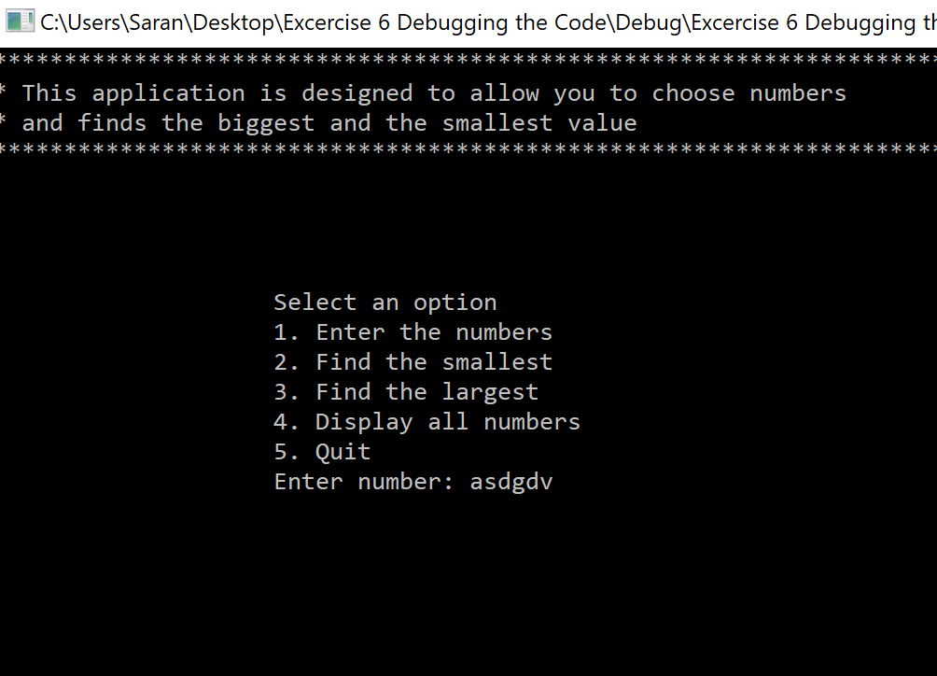

The user can enter a number too large for the variable to store
The user can enter more numbers than the integer array can store. The user should only be capable of entering a certain amount of numbers per each input. The program should preform a check and display a message to the user explaining that they have entered to many numbers. This problem is not solved. 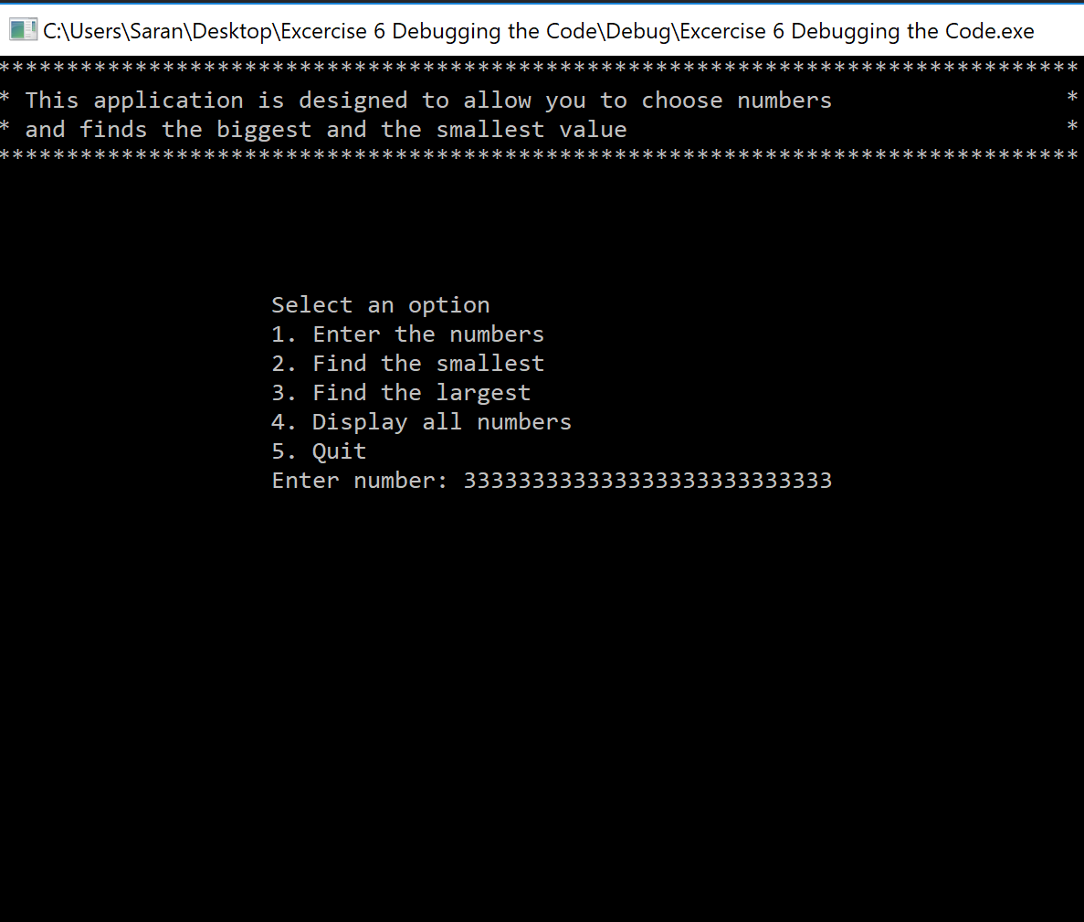

Programming Exercises

Exercise 1 Declaring and displaying variables
The first exercise required a program that declares different variable types with different values and displays them.

List of requirements
- A double, string and int variable to be declared.
- For the user to enter a value for the double, string and int variables.
- For the user to enter the values for each variable.
- For each of the input values to be displayed.

4.1.1 Results of working code
The image displays the working code of the program returning the input of the user successfully. 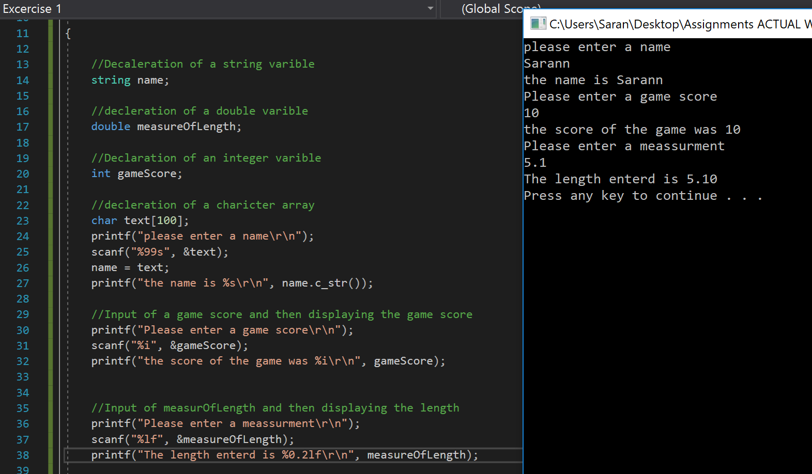

Exercise 2 calculating the shaded are of a shape
Exercise 2 requires the user to enter the dimensions of a circle and a triangle, then the shape of the triangle is subtracted from the shape of the circle to give the overall area of the shaded shape.
The program requires variables that use the double data type as the program will be preforming mathematical equations and only the same data types can be used.

List of requirements
- The value of pie$(π=3.14$) (to be stored as a double.)
- The ability for a user to input the value for the radius of the circle. (scanf)
- The ability for a user to input the base and the height of the triangle. (scanf)
- The area of the circle to be calculated using the formula $A=πr^{2}$ (Area = 3.14 * radius * radius).
- The area of the triangle to be calculated using the formula $A=\frac{\left(b×h\right) }{2}$ Area of Triangle = $\frac{\left(base * height\right)}{2}$.
- Calculate the shaded area of the shape by subtracting the area of the triangle from the area of the circle.
- Displaying the results of the shaded area of the overall shape to the consol. (printf)

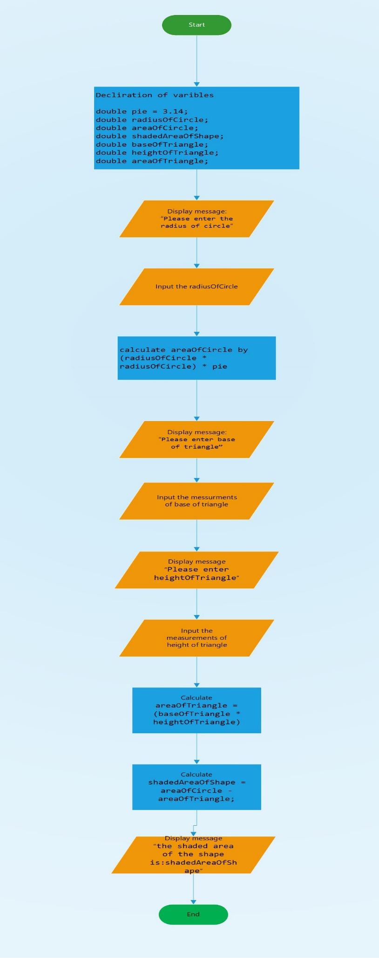

Results of working code
The left-hand image shows the working code displaying the shaded area of the shape to two decimal points. The right-hand image displays a calculator testing the values entered in the program.
Due to the results not displaying the same values further analysis of the code highlights that the result within the code is being rounded up due to the result being coded to display to two decimal places. This could cause issues as the code is not displaying the exact results of the calculation but a rounded-up result. 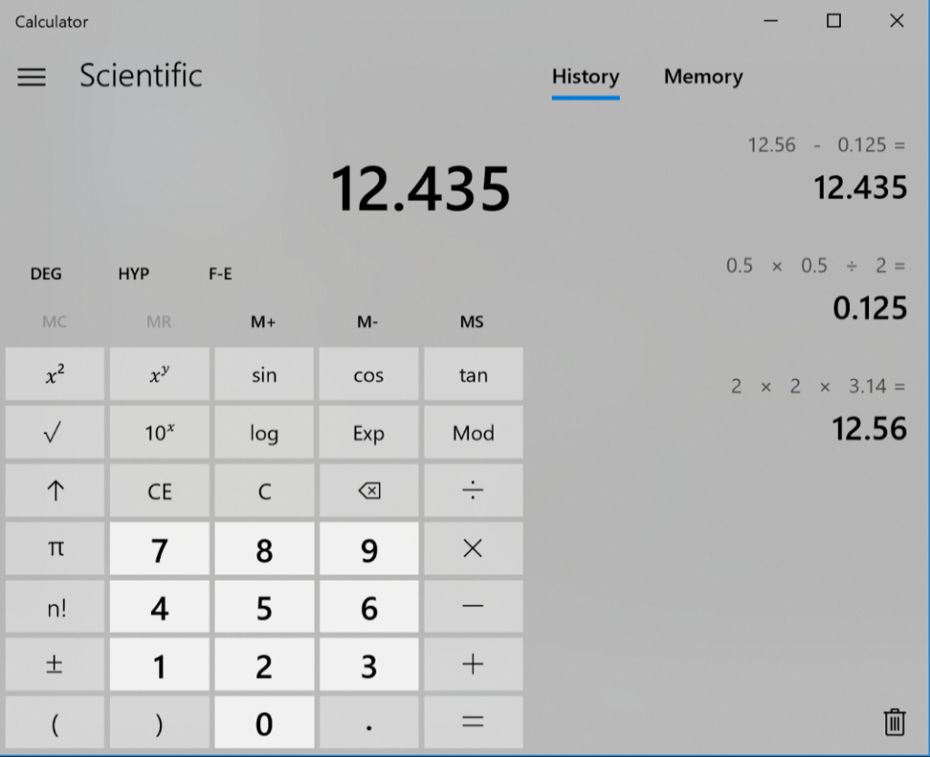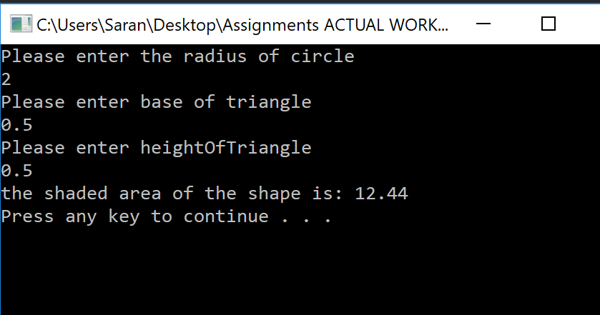

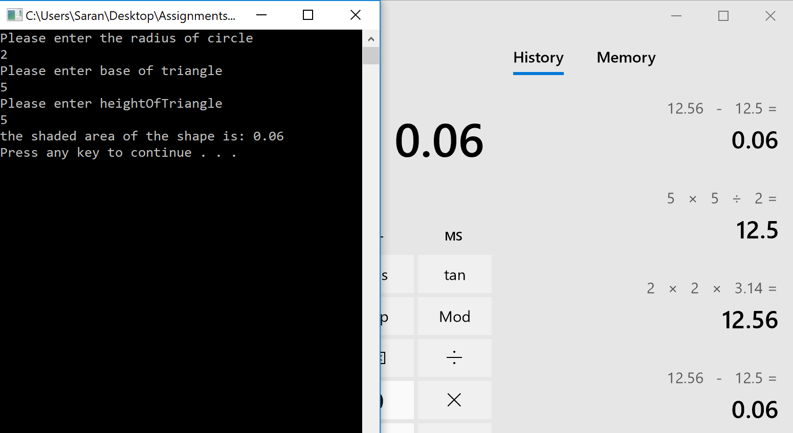
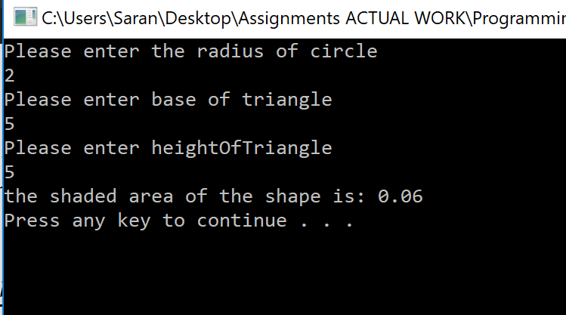
The image below displays the program being tested with integer values the right-hand image of the calculator displays the same result as the running program to the right. Both the results are a match indicating that the code is working as expected.

Bugs within the code
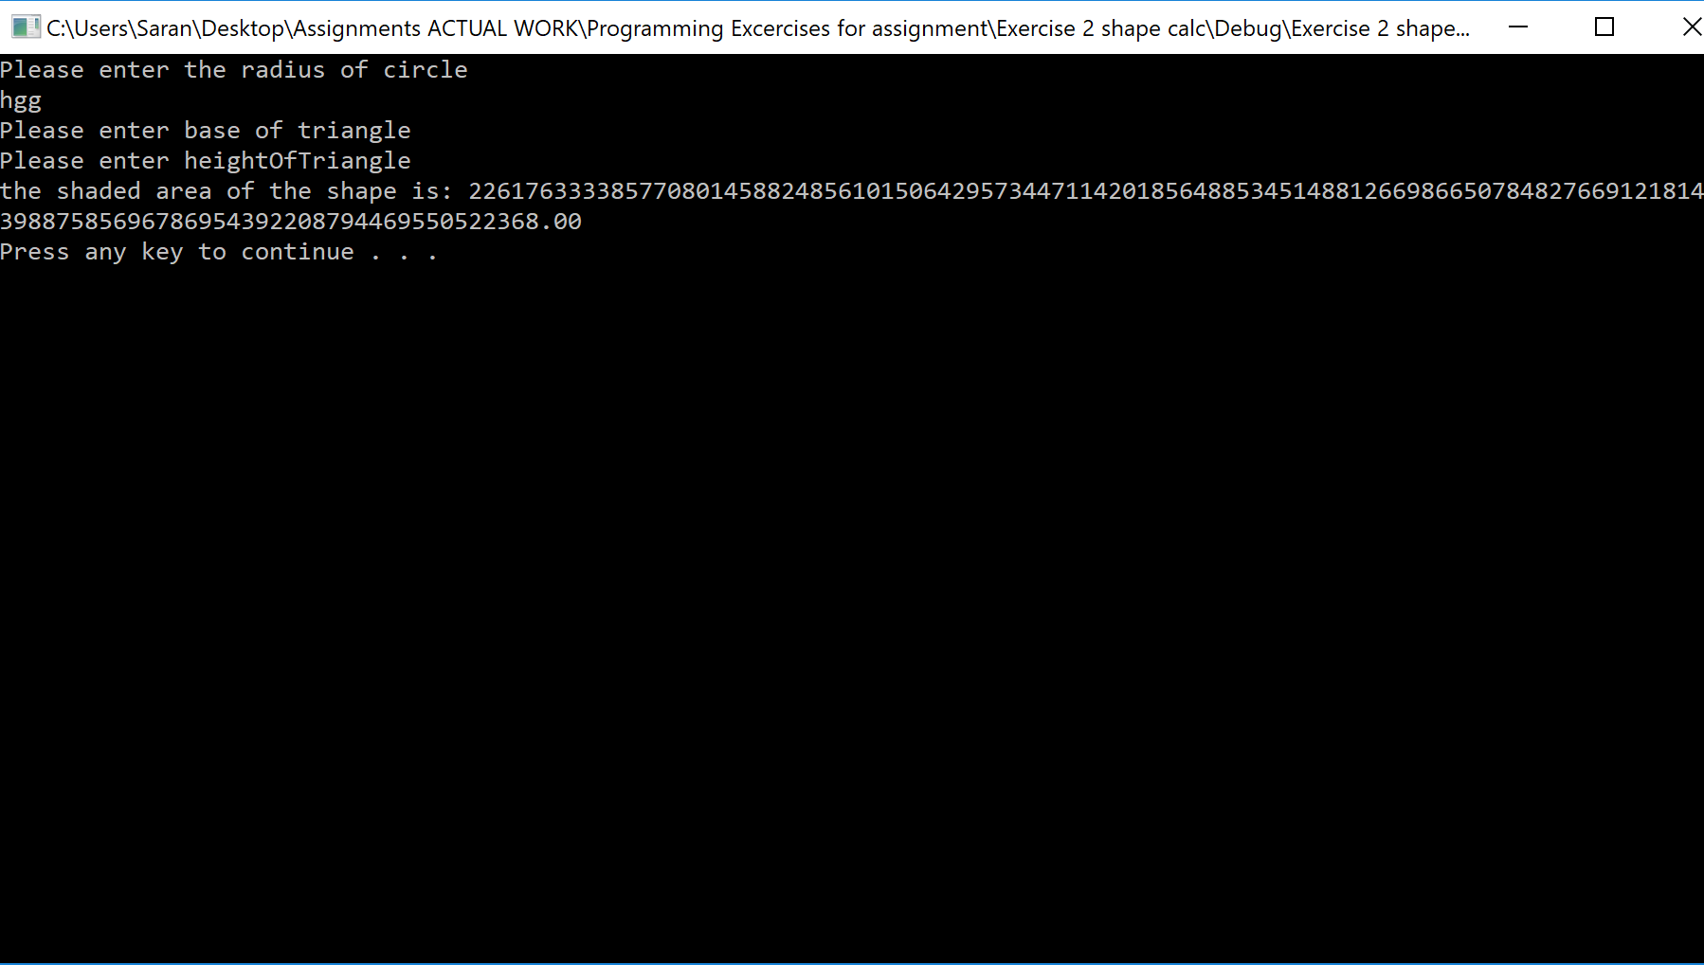
The code requires a check for inputs from the user that are not numbers. Currently if the user enters characters the code fails. This problem is not solved.

Exercise 3 calculation of gravel
Exercise 3 requires the user to calculate the quantity of gravel being purchased and the discount that it receives based on the tonnage.

Tonnage | Discount
Between 5 and 8 | 2%
Between 9 and 40 | 4%
Above 40 | 6%

List of requirements
- The ability for the user to input the amount of gravel purchased. (scanf)
- The program to store the value entered of gravel purchased. (double variable for gravelpurchased)
- The ability for the user to input cost of the gravel. (scanf)
- The value of the cost of gravel to be stored. (double for the variable for the cost of the gravel)
- For the discount of 2%, 4% and 6% to be stored. (double data types for each individual discount).
- For the total cost to be calculated and stored. (double variable type).
- To check if the total gravel purchased qualifies for one of the discounts. (branching if checks the total cost if it qualifies for the different discount)

Results of working code
The images below display the mathematical results for the working code, each of the input values and their results have been tested using a calculator to prove that the discounts have been correctly calculated and applied to the correct amount of gravel purchased in tonnes. The test results indicate that the percent discount is being checked correctly for the amount of gravel in tonnes entered, and that the percentage discount is also being subtracted correctly.

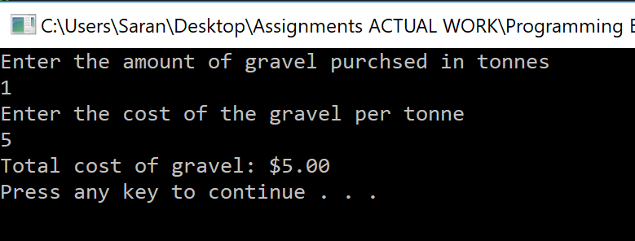
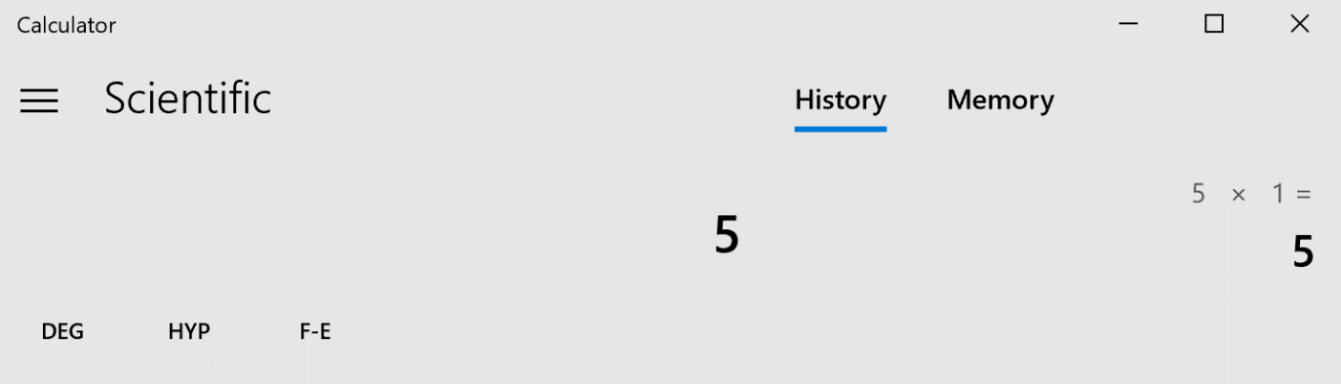
No discount

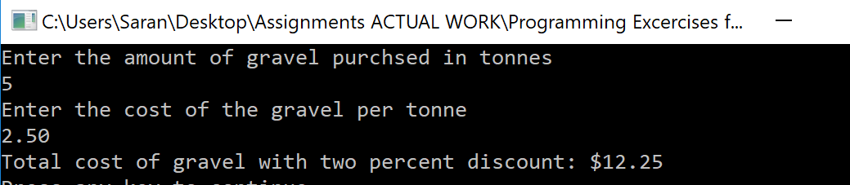
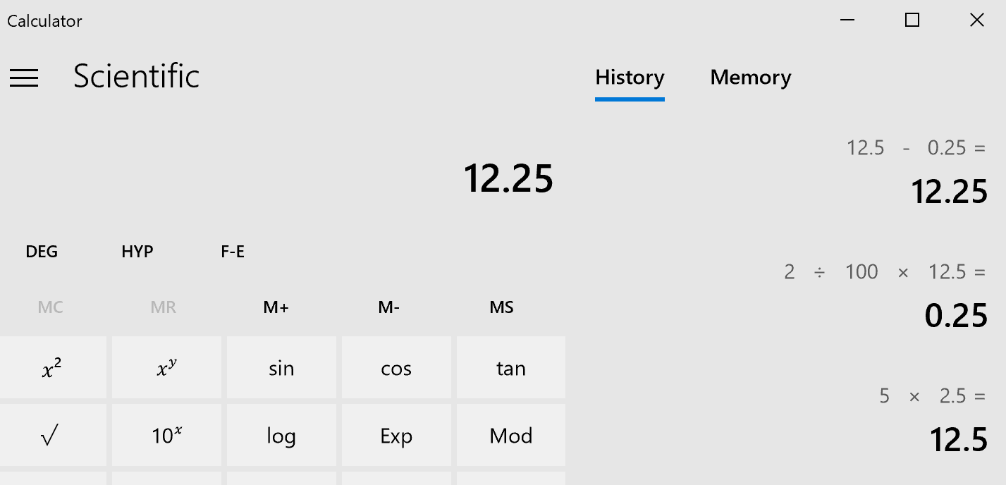
2% discount

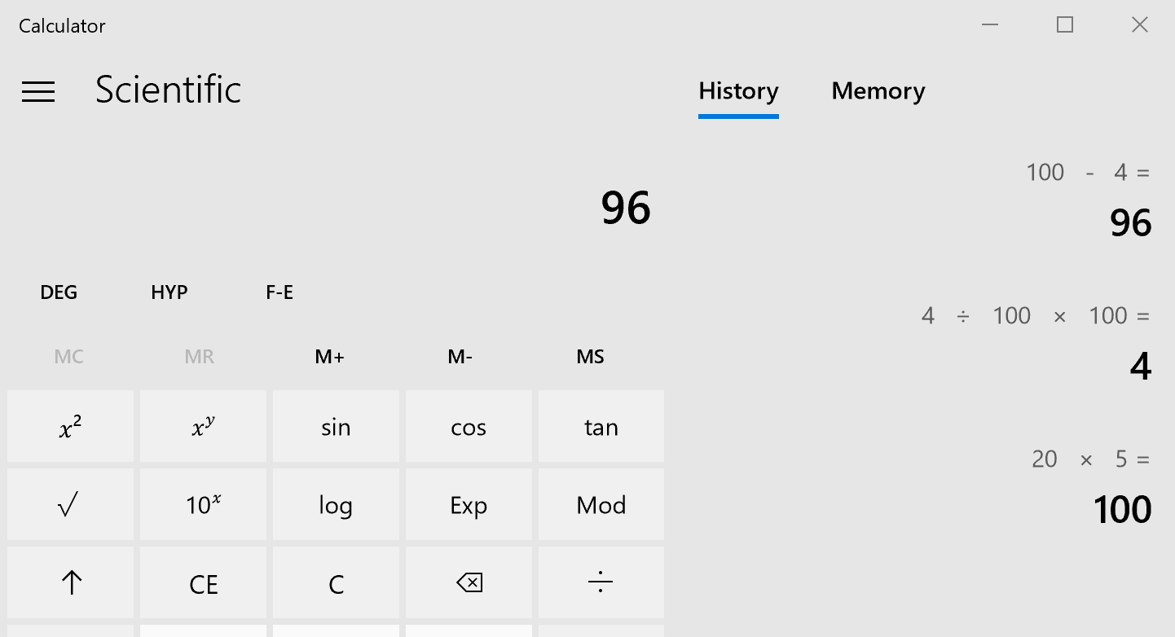
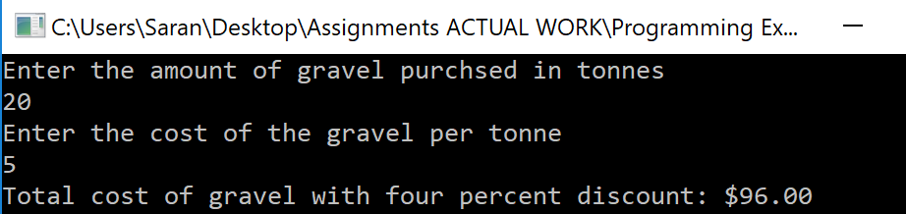
4% discount
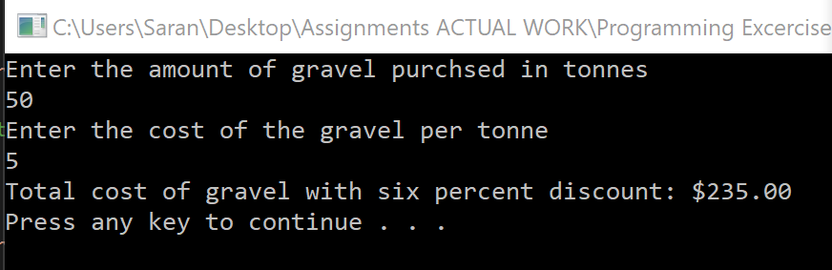
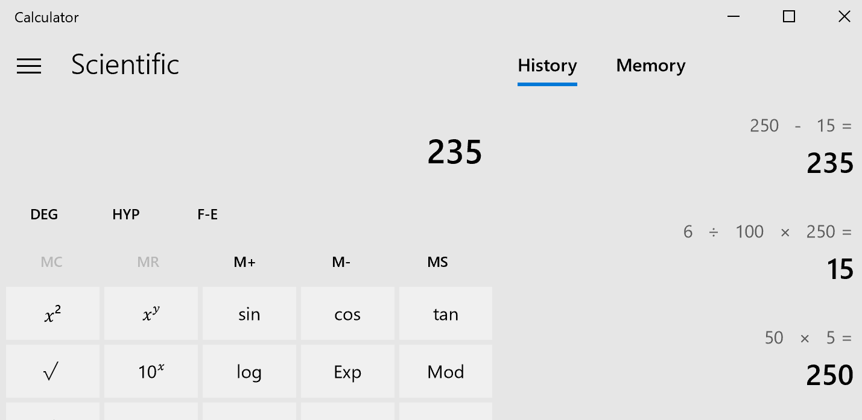
6% discount

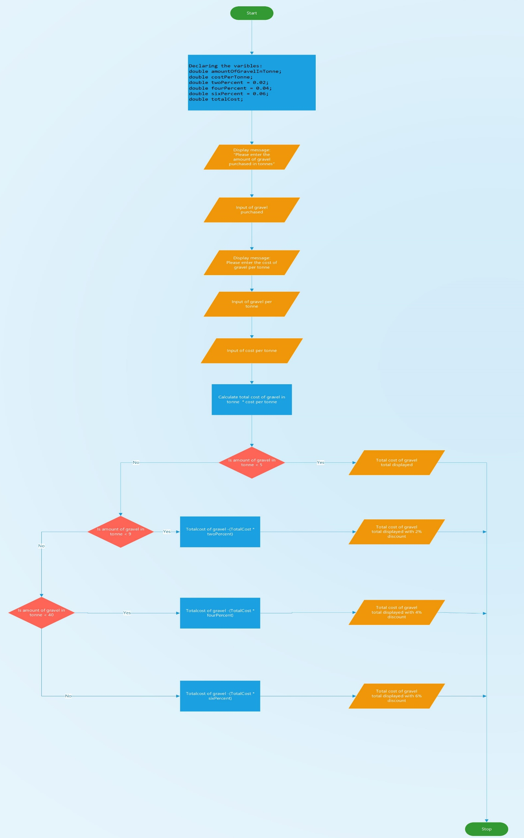

Bugs within the code
The code allows the user to enter negative numbers for the amount of gravel in tonnes and the cost of the gravel per tonne. As this is a program for calculating the costs of purchasing something, the program should not allow the user to enter negative numbers.
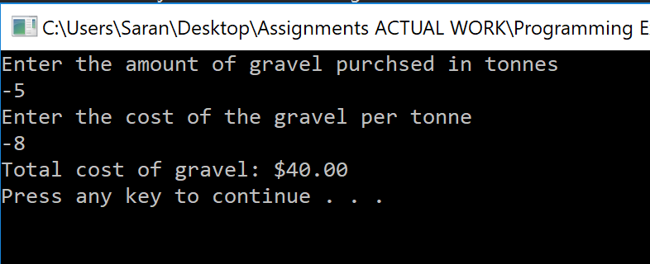

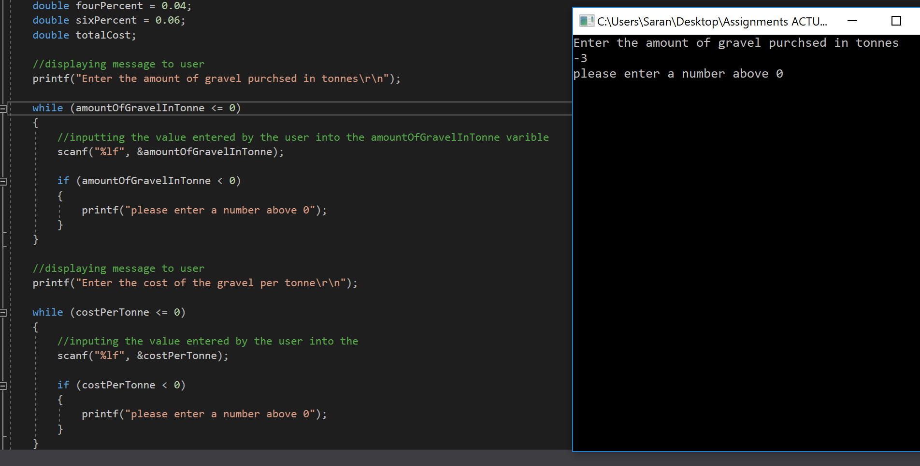
To fix the bug the variables amountOfGravelInTonne and costPerTonne are both set to 0 and placed within a while loop which states that while both variables are 0 the scanf code will run, and an if is used to check if a minus value is entered, if it is the code displays a message to the user expressing they must enter a value above 0.

Exercise 4 printing a cross
Exercise 4 requires the user to input an integer number to indicate the size of a cross that will be printed on screen.

Requirements of task
- User input of a number. (scanf)
- Use user input to define size of cross.
(loop that uses the number that the user enters, the cross needs rows and columns that are the same size as the users input)
- Draw the cross using “X” and “_”. (printf)
- Decide when to draw a “X”. (printf with a check to check if a “X” is printed or if a “_” is printed)
- Decide when to draw a “_”.
- Print message asking user to input number. (printf)

Result of working code & bugs
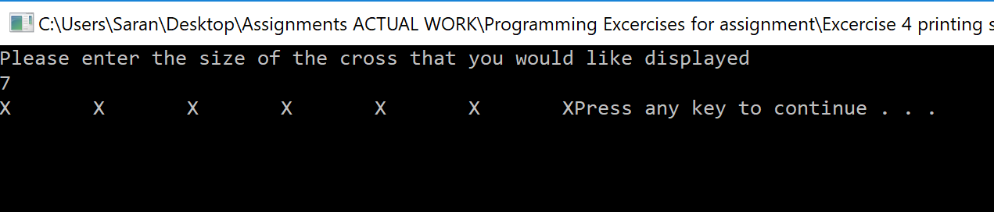
The program successfully prints a message to the user requesting a number, the image below displays the correct number of “X” being displayed with the correct number of spaces between them. But the code is not printing the “X” diagonally down the screen, the second set of mirroring diagonal “X” have not been printed to the screen.

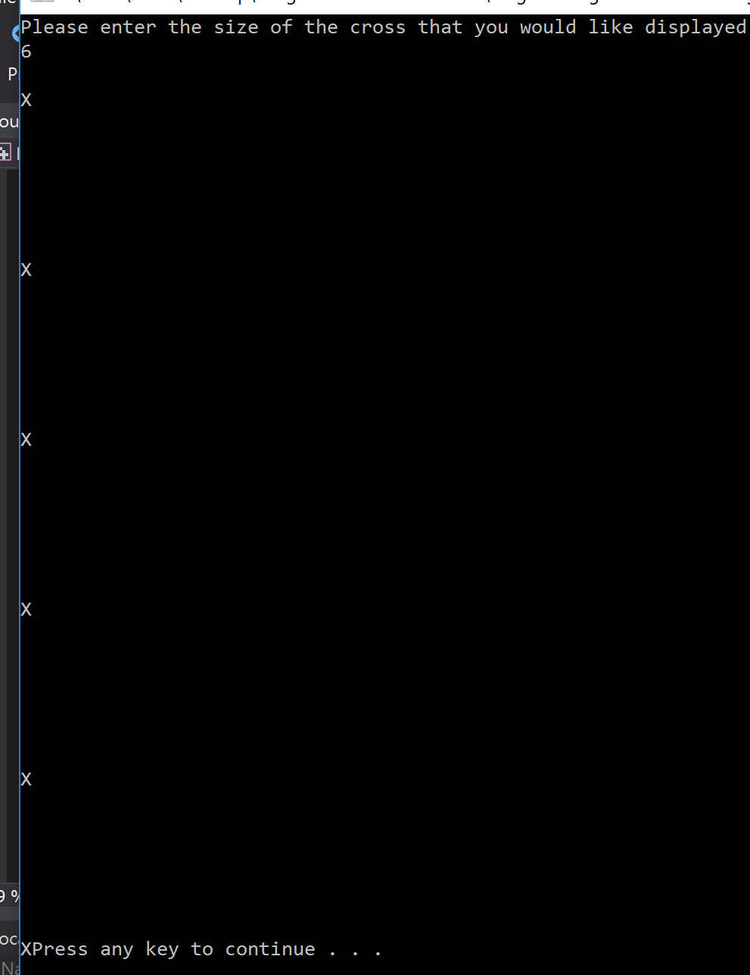
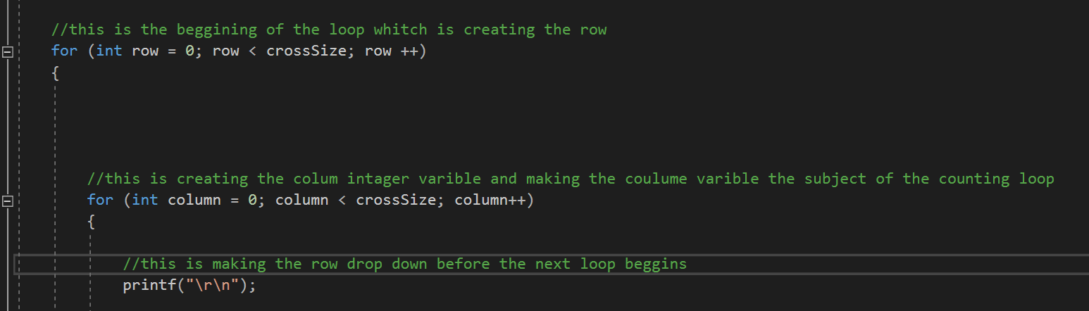
A printf(”\r\n”) was included within the code to input a brake and begins the code on a new line, the image below displays an attempted fix to display the “X” diagonally down the screen. The “X” are successfully dropping down on a new row but are not being displayed diagonally. Every iteration of the column was entering a new line because of the \r\n.

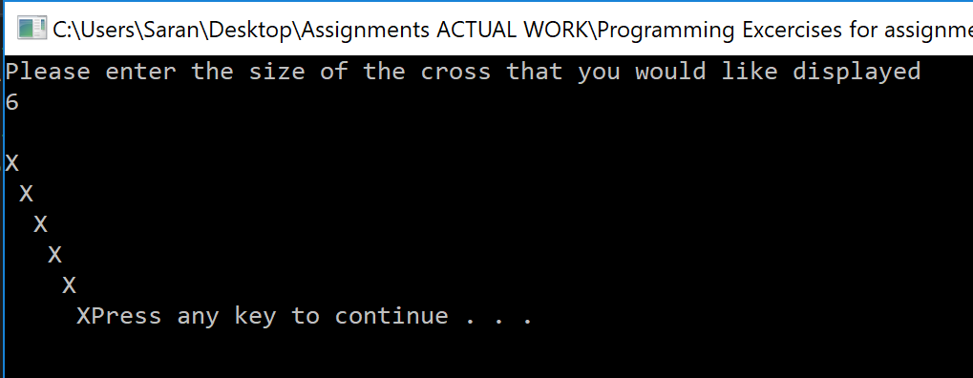
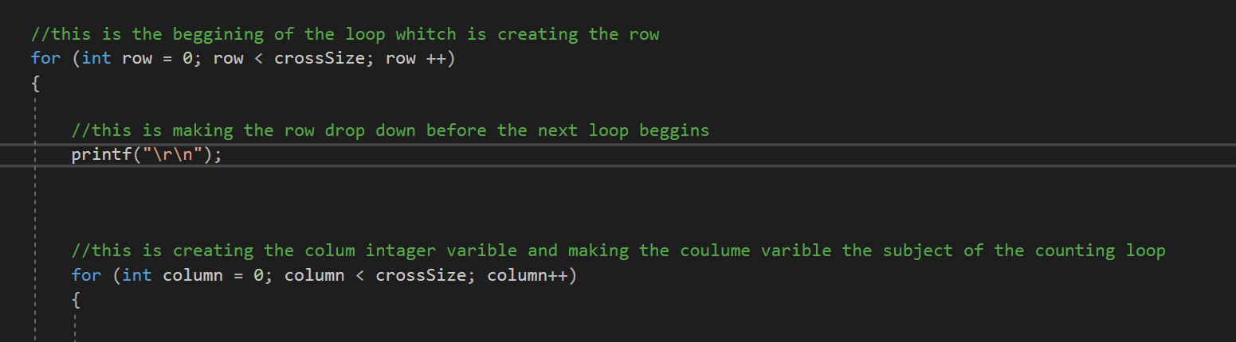
The image below displays the \r\n removed from the column loop and inserted into the row loop as the image displays the “X” are being displayed diagonally as intended. This works because the code begins a new line when there is a new row and not a new column as it was being presented in the previous image.
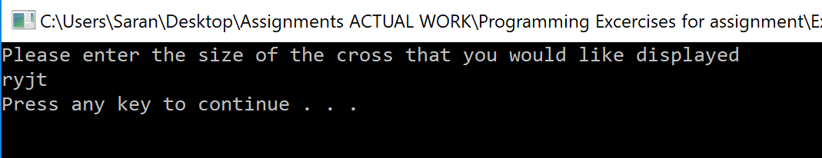
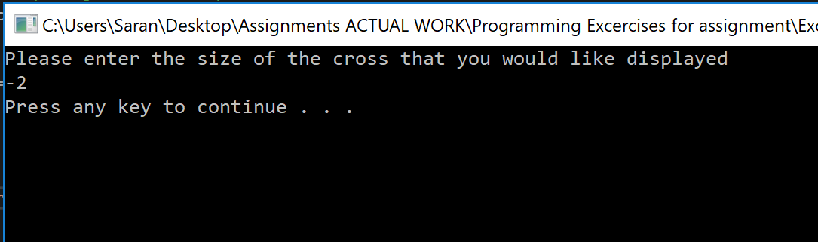

The final image displays the insertion of the code (colum == crossSize – 1 – row) this is inserting the second diagonal line of “X” mirroring the first, it checks if the colum is equal to the crossSize (the number entered by the user) when it is subtracted by 1 and the number within the row, it then prints an “X” within that location.
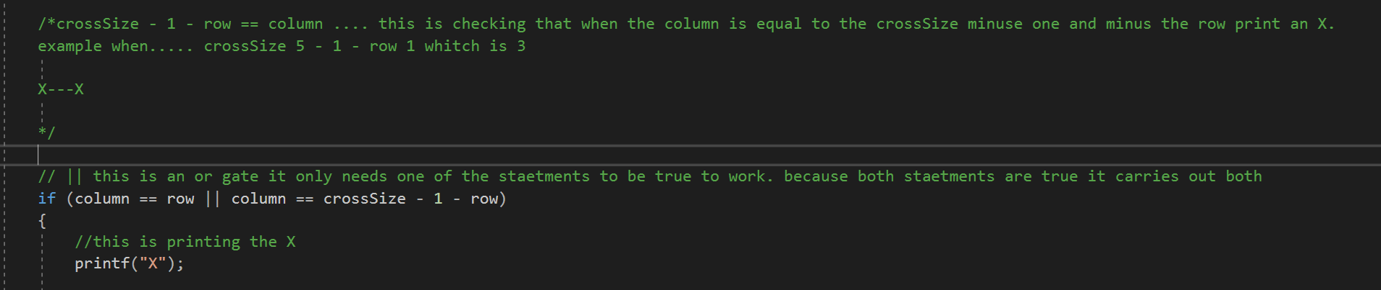
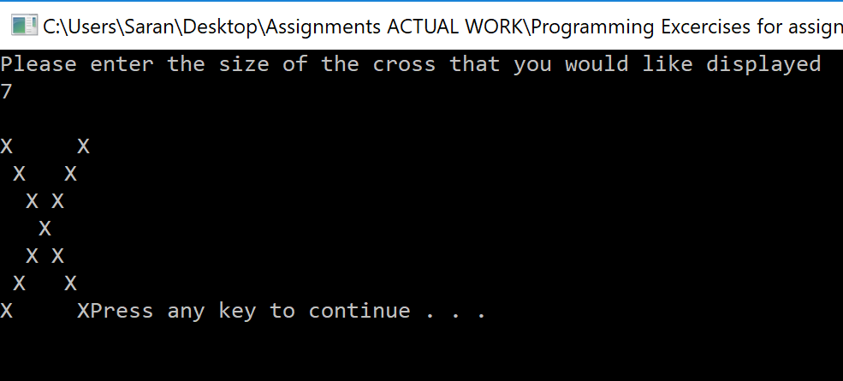
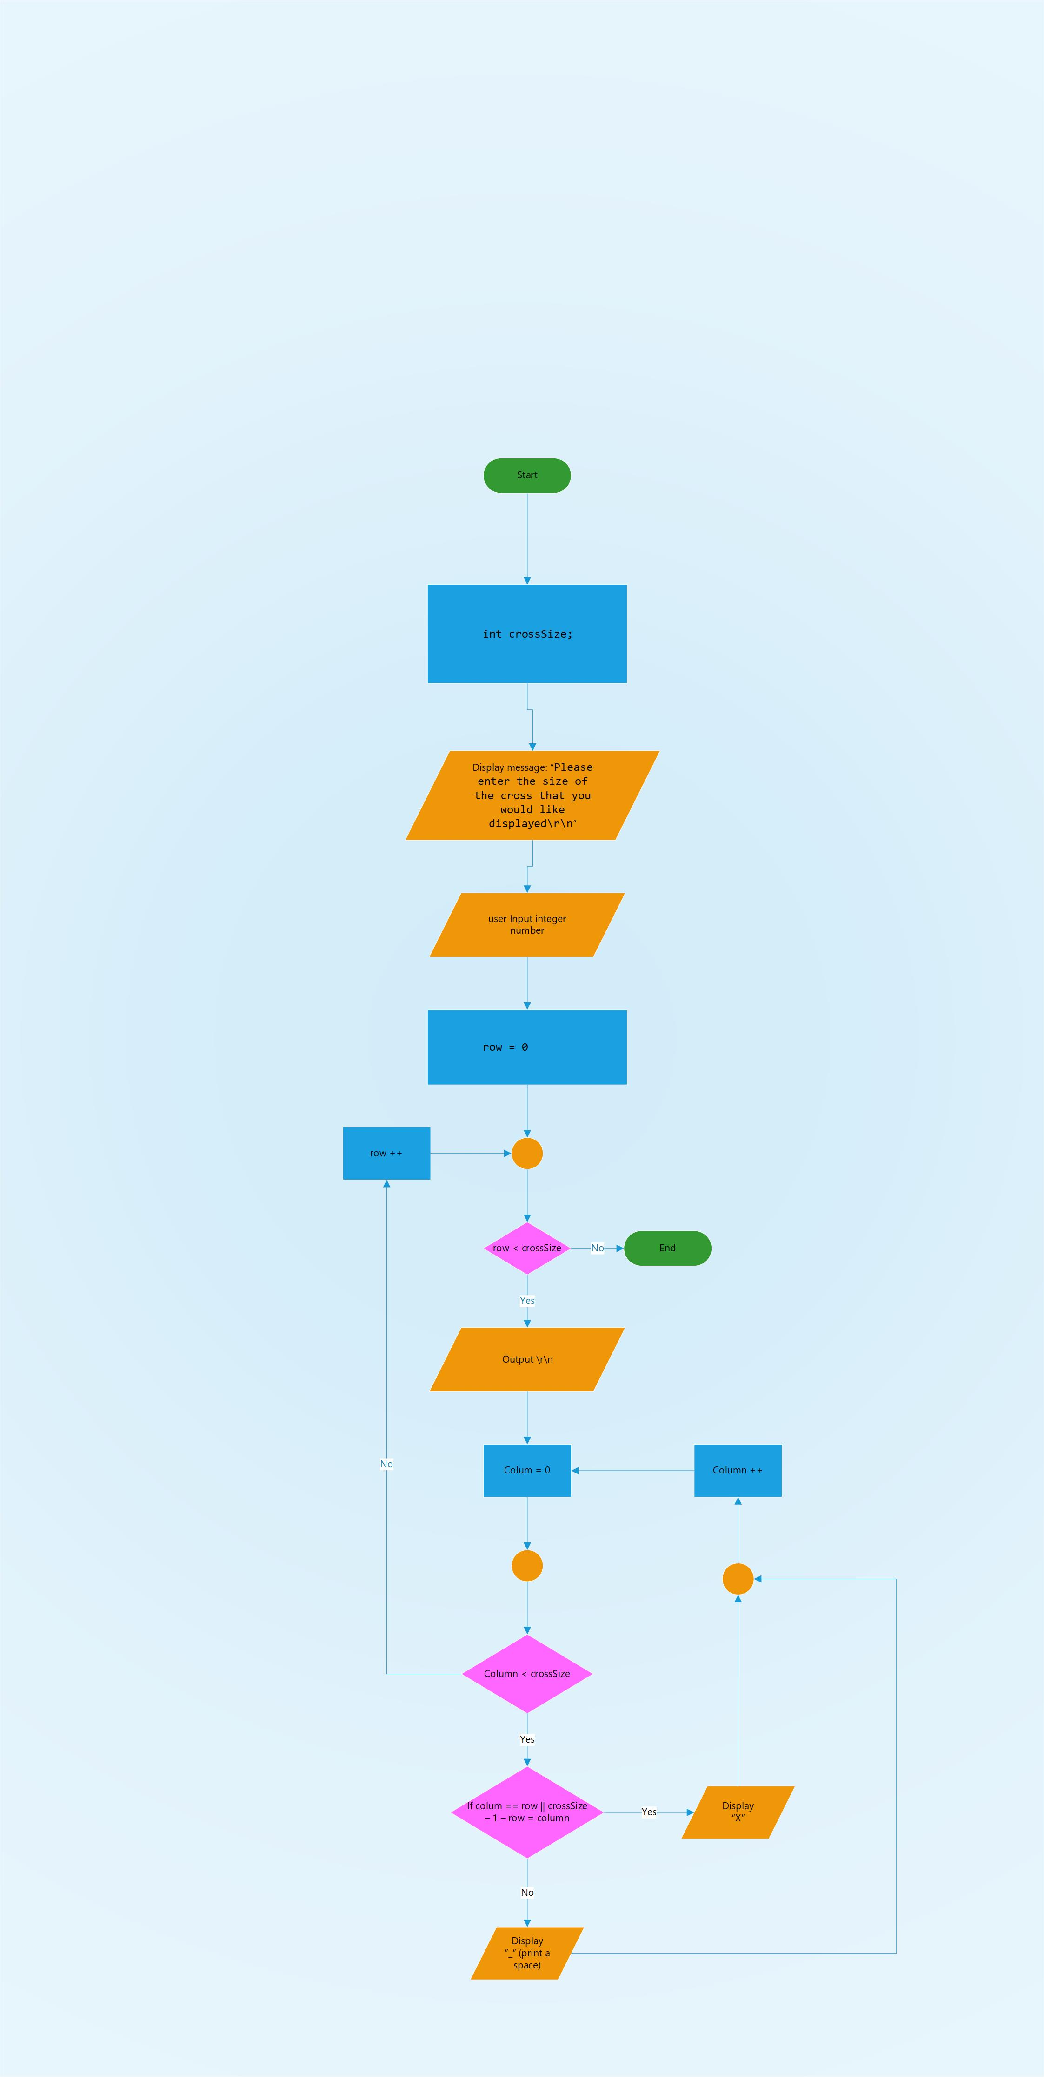

Exercise 5 Enter price of 5 products
A program must allow a user to enter the price of five different products which are summed to a total. The products must be displayed along with total tax is to be displayed.

List of requirements
- Creation of a class to hold template for products.
  - Product Price (double).
  - Product Name (string).
  - Tax (double).
- User to enter the price of each product (scanf).
- Tax to be displayed (scanf the normal tax before a calculation).
- All product prices to be suned to a total.
- Average tax payable to be displayed (printf).
- Calculation of total tax of all calculated products (total tax / number of products)

The code was not successfully created.

Exercise 7 Slot machine
Create a fruit machine with 3 reels that have 5 different symbols that are randomly chosen. Different combinations provide different scores as shown within the grid.
Combinations | Example | Score
Triple 5 | 5 5 5 | 2000
Triple number (1 - 4) | 3 3 3 | 20
Double 5 | 1 5 5 | 100
Double number (1 - 4) | 4 4 3 | 10
Mixed combination | 1 3 2 | 0

List of requirements
- For a randomiser to select numbers between 1 – 5.
- For the randomised numbers to be displayed.
(printf of the randomised numbers)
- For a message to ask the player if they wish to play or quit.
(printf to display message to the user)
- For the input of the players answer to quite to check if the player entered yes to quit.
(scanf to check for user input, yes or y to be stored and used to continue playing the game)
- For the console to display a word in place of the numbers generated.
(switch statement that holds all of the words which feeds in the randomized number that then selects the switch statement of the corresponding number for the word to be returned to the main and displayed instead of the number)
- For the total to add the results.
(for an integer total variable to store the increasing total of the user)
- For the total to be displayed
(printf of the total varible)
- For a win and a lose message to be displayed.
(printf of a win or loss message)
- For a check to check if a triple 5 or a triple number between 1 – 4 is randomly chosen or if a double 5 or double number between 1 – 4 is chosen or if no triple or doubles are chosen.
(Branching if tree of checks beginning with a check of the triple, then checking for a double finaly returning 0 if there are no triples or doubles)

Result of working code
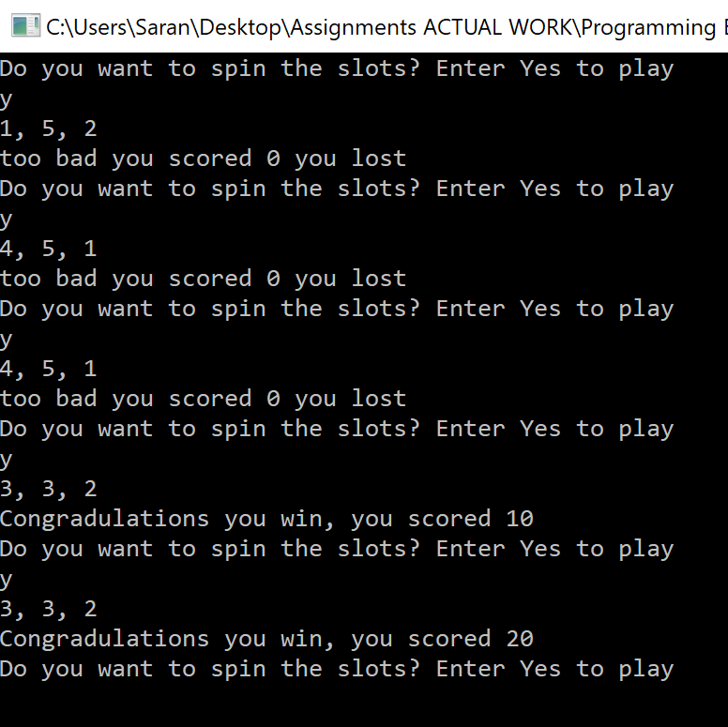
the program successfully displays the three randomised numbers along with a score and a message stating if the player has lost or won. The game also allows the user to enter “yes” and “y” to continue playing the game. The numbers have not been converted to words that would that would be displayed to the user.

Bugs within the code

Issues with quitting program
The while loop for the quit function was not working correctly and the user was capable of entering any value and the program would not close.
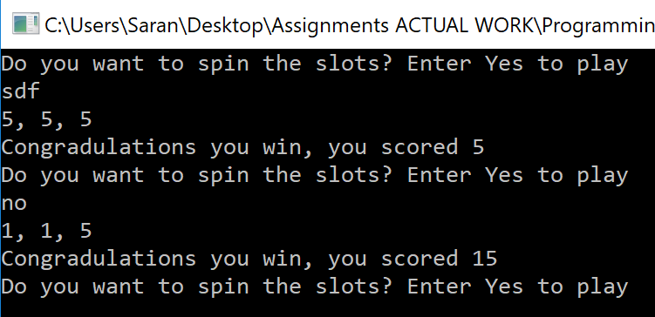
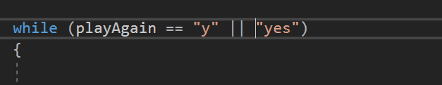

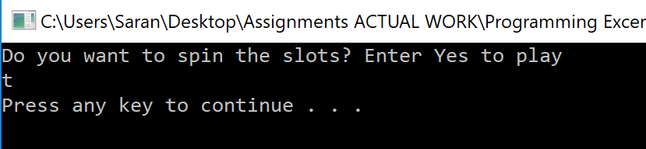
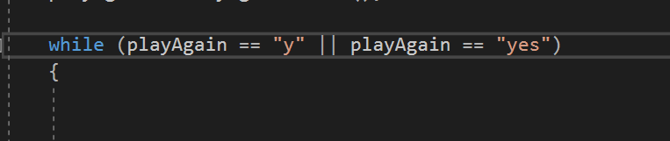
To fix the code the (playAgain == ) function was entered as it is stating that while playAgain is equal to “yes” the program will run.

Number 5 is not being randomized
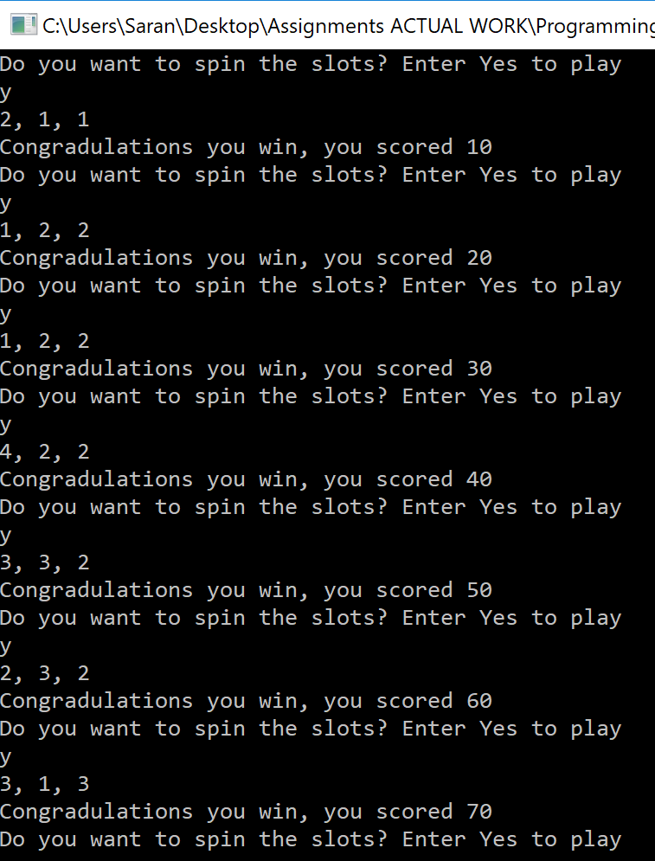
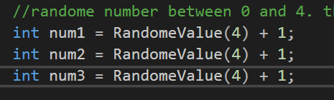
The number five is not being randomized during the running of the program, this is due to the RandomeValue only being set to 4, this means that the randomizer will only randomize values up to 4 different values, 0, 1, 2, 3. therefore it was only randomising up to 4.

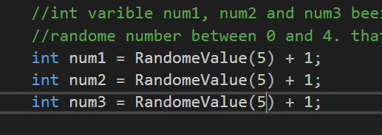
The value of 4 was altered to 5 to allow the randomizer to randomize 5 values. This fixed the code.
Total score being calculated incorrectly
The total score being calculated is incorrect when the slots do not display a double or triple of any kind the total is meant to remain the same, this but doubles the score.
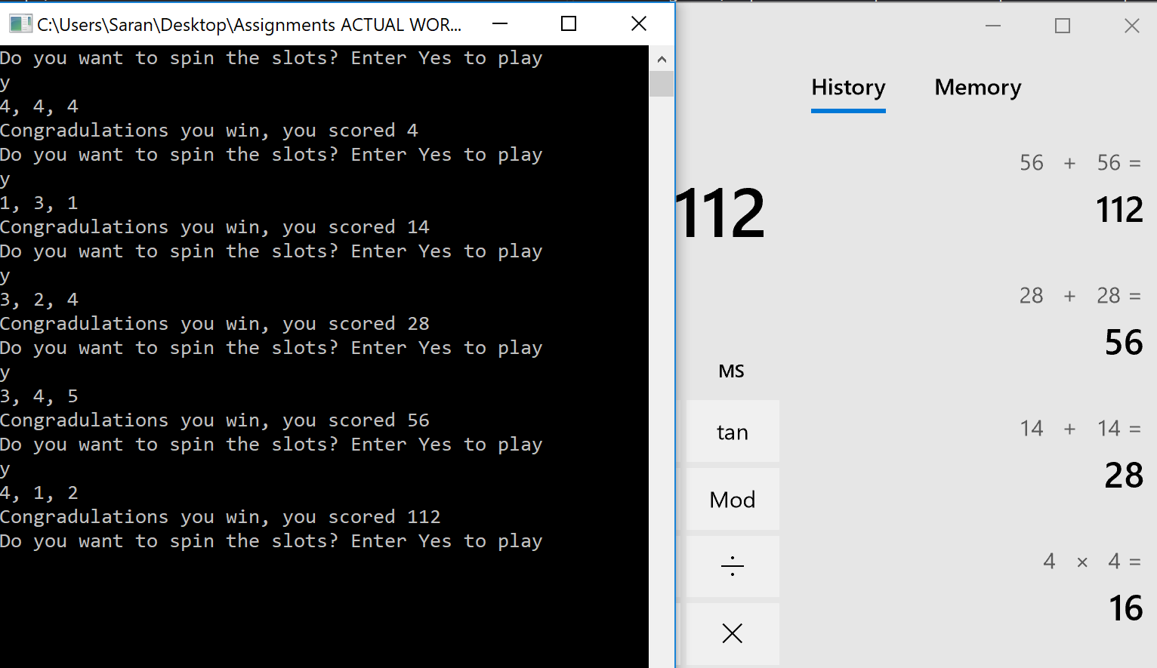
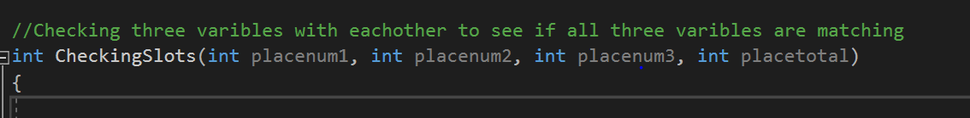
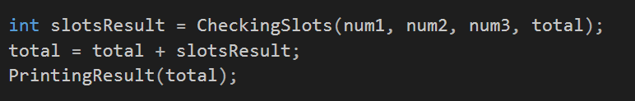
The score is doubling due to the total being passed into the checkingSlots as an argument, the total score from the main is being used instead of a zero. The score is doubling because after all the checks are made if there are no doubles or triples the total with the original value is being returned to the main witch is being added to the total in the main.

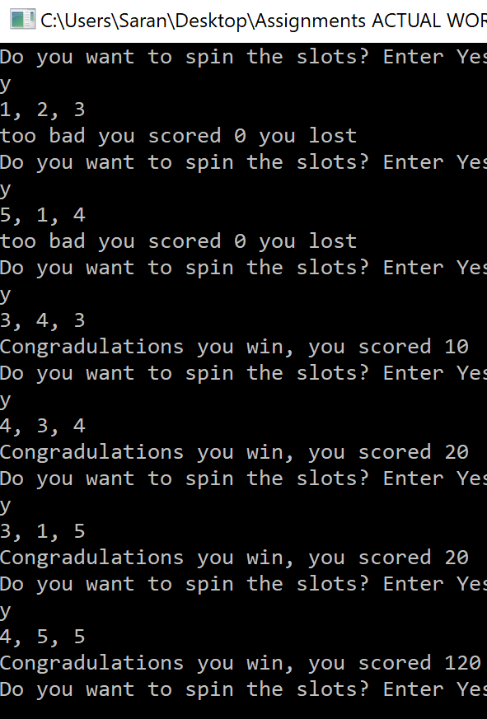
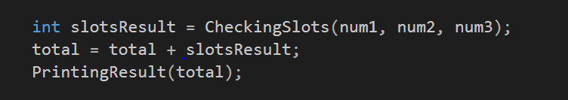
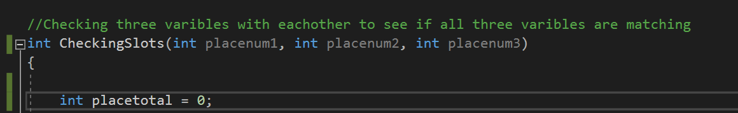
To fix the bug the argument total was removed form the CheckingSlots frunction, and the total was entered as a temporary integer variable within the function itself. This allows for the total witch is set to 0 within the function to be returned to the main, which means that when the total is adding the slotsResult if the double and triple criteria was not met the slotsResult is 0 adding 0 to the overall total within the main.

The image below displays the code working correctly.
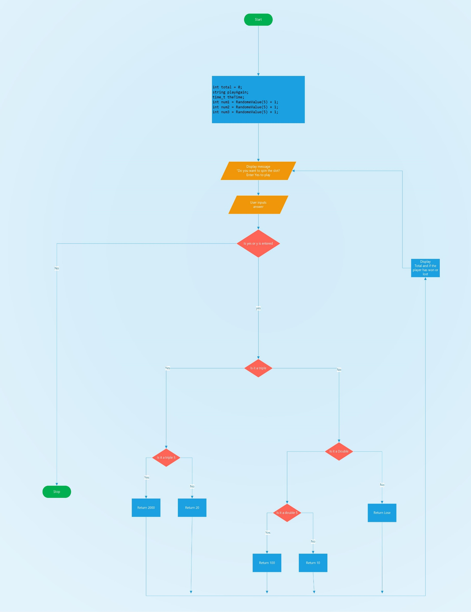

Appendices

Appendix 1 Data types
The image below displays some of the different data types that are available for use, it also displays their size giving an indication on the amount of data that they can store.
The overall size of different variables that are being declared and used alter the overall size of the program that is being created, it can also impact the accuracy of the data that is being held within for instance due to a float being smaller in size than a double the number of decimal accuracy is lower than that of a double, this could impact the returned value of a sum.
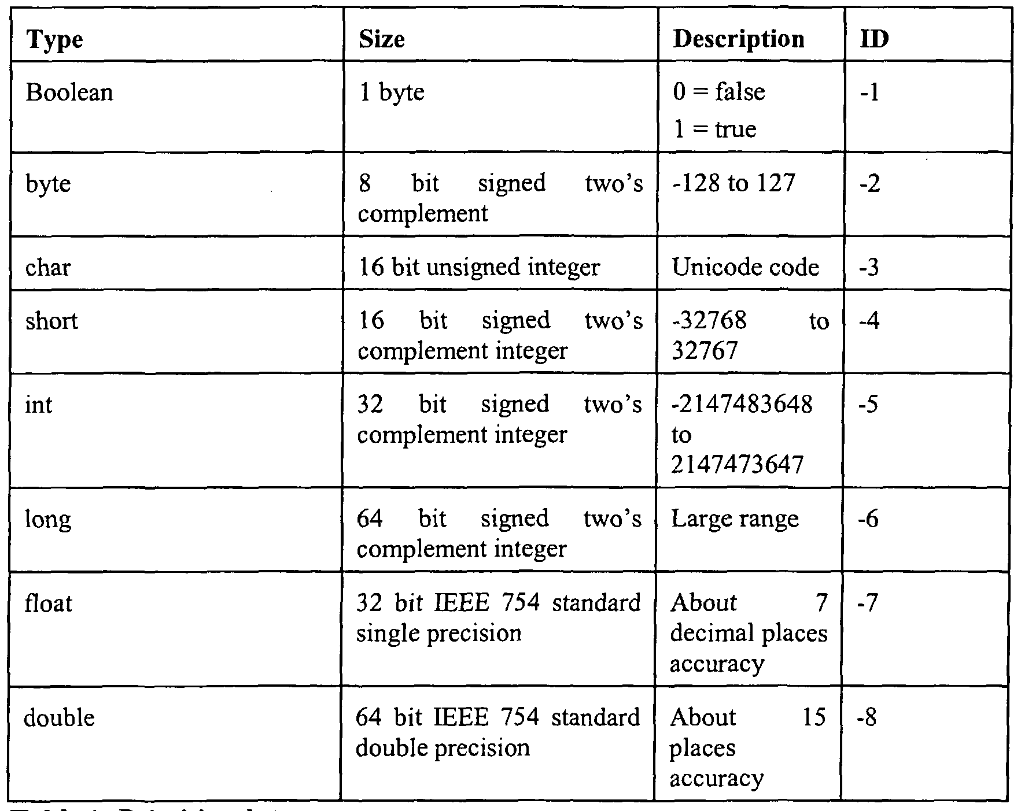

Apendix 2 Code Creation

Exercises 1
#pragma warning(disable:4996)
#include <stdio.h>
#include <string>
#include <stdlib.h>

using namespace std;

int main(int argc, char** argv)

{

//Decaleration of a string varible
string name;

//decleration of a double varible
double measureOfLength;

//Declaration of an integer varible
int gameScore;

//decleration of a charicter array
char text[100];
printf("please enter a name\r\n");
scanf("%99s", &text);
name = text;
printf("the name is %s\r\n", name.c_str());

//Input of a game score and then displaying the game score
printf("Please enter a game score\r\n");
scanf("%i", &gameScore);
printf("the score of the game was %i\r\n", gameScore);

//Input of measurOfLength and then displaying the length
printf("Please enter a meassurment\r\n");
scanf("%lf", &measureOfLength);
printf("The length enterd is %0.2lf\r\n", measureOfLength);

system("pause");
return 0;

}

Exercise 2 finding the shaded area of a shape
#pragma warning(disable:4996)
#include <stdio.h>
#include <string>
#include <stdlib.h>

using namespace std;

int main(int argc, char** argv)

{
//Decleration of varibles
double pie = 3.14;
double radiusOfCircle;
double areaOfCircle;
double shadedAreaOfShape;
double baseOfTriangle;
double heightOfTriangle;
double areaOfTriangle;

//Asking the user to enter radius of circle
printf("Please enter the radius of circle\r\n");

//Putting the input value from the user into the radiusOfCircle varible
scanf("%lf", &radiusOfCircle);

//Multiplying the radius of circle with itsself then multiplying the results with the pie varible
areaOfCircle = (radiusOfCircle * radiusOfCircle) * pie;

//Asking the user to enter radius of circle
printf("Please enter base of triangle\r\n");

//Inputting the value from the user into the baseOfTriangle varible
scanf("%lf", &baseOfTriangle);

//Asking the user to input height of the triangle
printf("Please enter heightOfTriangle\r\n");

//Inputting the value from the user into the heightOfTriangle varible
scanf("%lf", &heightOfTriangle);

//Multiplying the baseOfTriangle varible value with the heightOfTriangle then devided by 2
areaOfTriangle = (baseOfTriangle * heightOfTriangle) / 2;

//areaOfCircle minus areaOfTriangle
shadedAreaOfShape = areaOfCircle - areaOfTriangle;

//Displaying the shadedAreaOfShape value to two decimal points
printf("The shaded area of the shape is: %0.2lf\r\n", shadedAreaOfShape);

system("pause");
return 0;

}

Exercise 3 gravel calculator
#pragma warning(disable:4996)
#include <stdio.h>
#include <string>
#include <stdlib.h>

using namespace std;

int main(int argc, char** argv)

{
//Declaring the varibles
double amountOfGravelInTonne = 0;
double costPerTonne = 0;
double twoPercent = 0.02;
double fourPercent = 0.04;
double sixPercent = 0.06;
double totalCost;

//displaying message to user
printf("Enter the amount of gravel purchsed in tonnes\r\n");

while (amountOfGravelInTonne <= 0)
{
//inputting the value entered by the user into the amountOfGravelInTonne varible
scanf("%lf", &amountOfGravelInTonne);

if (amountOfGravelInTonne < 0)
{
printf("please enter a number above 0");
}
}

//displaying message to user
printf("Enter the cost of the gravel per tonne\r\n");

while (costPerTonne <= 0)
{
//inputing the value entered by the user into the
scanf("%lf", &costPerTonne);

if (costPerTonne < 0)
{
printf("please enter a number above 0");
}
}

//Multiplying the amountOfGravelInTonne with the costPerTonne varible with no discount
totalCost = amountOfGravelInTonne * costPerTonne;

//Checking if the varible amountOfGravelInTonne is less than 5
if(amountOfGravelInTonne < 5)
{
//displaying the total cost of gravel in tonnes to the user
printf("Total cost of gravel: $%0.2lf \r\n", totalCost);
}
else
{
//checking if the amountOfGravelInTonne varible is less than 9
if (amountOfGravelInTonne < 9)
{

//displaying the total cost of gravel with two percent discount
printf("Total cost of gravel with two percent discount: $%0.2lf \r\n", totalCost - (totalCost*twoPercent));
}
else
{
//checking if the amountOfGravelInTonne varible is less than 40
if (amountOfGravelInTonne < 40)
{
//displaying the total cost of gravel with four percent discount
printf("Total cost of gravel with four percent discount: $%0.2lf\r\n", totalCost - (totalCost*fourPercent));
}
else
{
//displaying the total cost of gravel with six percent discount
printf("Total cost of gravel with six percent discount: $%0.2lf\r\n", totalCost - (totalCost*sixPercent));
}

}
}

system("pause");
return 0;

}

Exercise 4 printing a cross
#pragma warning(disable:4996)
#include <stdio.h>
#include <string>
#include <stdlib.h>

using namespace std;

int main(int argc, char** argv)

{

//Creating the intager crossSize varible
int crossSize;

//printing a message to the user
printf("Please enter the size of the cross that you would like displayed\r\n");

//scanning and inputing the users input into the crossSize varible
scanf("%i", &crossSize);

//this is the beggining of the loop whitch is creating the row
for (int row = 0; row < crossSize; row ++)
{

//this is making the row drop down before the next loop beggins
printf("\r\n");

//this is creating the colum intager varible and making the coulume varible the subject of the counting loop
for (int column = 0; column < crossSize; column++)
{

/* column == row .... this is checking to see if the colum is equal to the row and if it is,
it then prits an X to the console. exmple when row = 1 colum = 1 print an X .... this is printing the X in a horazontal fassion from left to right*/

/*crossSize - 1 - row == column .... this is checking that when the column is equal to the crossSize minuse one and minus the row print an X.
example when..... crossSize 5 - 1 - row 1 whitch is 3

X---X

*/

// || this is an or gate it only needs one of the staetments to be true to work. because both staetments are true it carries out both
if (column == row || column == crossSize - 1 - row)
{
//this is printing the X
printf("X");

}
else
{
//the space is sprinted if the first part of the if is not true
printf(" ");
}

}

}

system("pause");
return 0;

}

Exercise 5 Class creation
//this is hard coading the tax percentage
double taxPercent = 20;
double totalTax = 0;
char text[100];
string name;
double price;

Product* Product[MAXNUMBERS];

for (int index = 0; index < MAXNUMBERS; index++)
{
Product[index] = new Product();
}

//aking user to enter 5 product names
printf("Please enter 5 products names and prices");

for(int index = 0; index < MAXNUMBERS )

system("pause");
return 0;

}
.h
#pragma warning(disable:4996)

#pragma once
#include <string>
using namespace std;

class Product
{
//attributs
private:
double _productPrice;
string _productName;
double _tax;

public:
//Constructor
Product();

//Properties

void SetproductPrice(double price);
void SetproductName(string name);
double Gettax();

//Method
void calculateTax(double taxPercentage);

.cpp
#include "Product.h"

//this is the constructor
Product::Product()
{
}

//this is the properties
//setting productprice
void Product::SetproductPrice(double price)
{
_productPrice = price;
}

//this is naming the product
void Product::SetproductName(string name)
{
_productName = name;
}

//this is getting the tax
double Product::Gettax()
{
return _tax;
}

//this is the method
//this is calculating the tax based on the price of the product and the tax percentage
void Product::calculateTax(double taxPercent)
{
taxPercent = _productPrice * (taxPercent / 100);
}

Exercise 6 Debugging the code
// AssignCode_Menu.cpp : Defines the entry point for the console application.
//

#define _CRT_SECURE_NO_WARNINGS
//SarannStrange: there is no "stdafx.h" file
//#include "stdafx.h"
#include <conio.h> // For pause
#include <string>
#include <stdarg.h>
#include <Windows.h> // To change cursor position

using namespace std;

#include "Main.h"

int main()
{
int theNumbers[MAXNUMBERS];
int chosenOption = 0;
bool quit = false;

InitialiseNumbers(theNumbers, MAXNUMBERS);

while (quit == false)
{
DisplayHeader();
DisplayMenu();
chosenOption = ReadNumber("Please choose an option: ");
quit = ProcessMenu(chosenOption, theNumbers);

ClearConsole();
}

return 0;
}

void InitialiseNumbers(int numbers[], int size)
{
for (int index = 0; index < size; index++)
{
numbers[index] = 0;
}
}

void DisplayHeader(void)
{
WriteText("*******************************************************************************", 0, 0); // Top left hand corner of screen is x = 0, y = 0
WriteText("* This application is designed to allow you to choose numbers *", 0, 1); // Next line down is x = 0, y = 1, etc
WriteText("* and finds the biggest and the smallest value *", 0, 2);
WriteText("*******************************************************************************", 0, 3);
}

void DisplayMenu()
{
WriteText("Select an option", 20, 8); // Display menu at at x = 20, y = 8
WriteText("1. Enter the numbers", 20, 9);
WriteText("2. Find the smallest", 20, 10);
WriteText("3. Find the largest", 20, 11);
WriteText("4. Display all numbers", 20, 12);
WriteText("5. Quit", 20, 13);
}

int ReadNumber(string prompt)
{
int number = -1;
int inputCharCount;

WriteText(prompt, 20, 14);
inputCharCount = scanf("%i", &number);
if (inputCharCount == 0) // Wasn’t a number, so ignore what they typed in!!
{
IgnoreInput();
}

ClearText(20, 14, prompt.length() + inputCharCount); // Clear the text at this line

return number;
}

void IgnoreInput(void)
{
char ch;
while ((ch = getchar()) != '\n' && ch != EOF);
}

void ClearText(int x, int y, int length)
{
// Write space ' ' characters starting at x, y for 'length' times
string spaces(length, ' ');
WriteText(spaces, x, y);
}

bool ProcessMenu(int option, int numbers[])
{
string message;
bool quit = false;

switch (option)
{
case 1:
GetNumbers(numbers);
break;
case 2:
WriteText(FormatText("The smallest value is %i", FindSmallest(numbers)), 20, 15);
Pause();
break;
case 3:
WriteText(FormatText("The largest value is %i", FindLargest(numbers)), 20, 15);
Pause();
break;
case 4:
//SarannStrange: This is meant to be Display All Numbers, the switch has been changed so it now displays the numbers rather than trying to quite
WriteText(FormatText("The numbers are %i, %i, %i", numbers[0], numbers[1], numbers[2]), 20, 15);
Pause();
break;
case 5:
quit = IsQuitting();
break;
default:
WriteText("Unknown option value entered", 20, 15);
Pause();
break;
}

return quit;
}

void GetNumbers(int numbers[])
{
for (int index = 0; index < MAXNUMBERS; index++)
{
numbers[index] = ReadNumber("Enter number: ");
}
}

int FindSmallest(int numbers[])
{
int smallest = numbers[0];

for (int index = 0; index < MAXNUMBERS - 1; index++) // <-- subtract 1
{
if (numbers[index + 1] < smallest)
{
smallest = numbers[index + 1];
}
}

return smallest;
}

int FindLargest(int numbers[])
{
int largest = numbers[0];

for (int index = 0; index < MAXNUMBERS - 1; index++) // <-- subtract 1
{
if (numbers[index + 1] > largest)
{
largest = numbers[index + 1];
}
}

return largest;
}

bool IsQuitting()
{
char input[100];
string response;

bool quit = false;
//SarannStrange: IT SHOULD BE MORE CLEAR ON HOW TO QUIT
WriteText("Do you really wish to quit? (type YES to quit) ", 20, 13);
scanf("%99s", input);

response = input;

if (response == "YES" || response == "yes" || response == "y")
{
quit = true;
}

return quit;
}

void WriteText(string text, int x, int y)
{
SetCursorPosition(x, y);
printf(text.c_str());
}

// JUST USE THIS FUNCTION
// This function positions cursor in Console window,
// and you DON'T need to understand it!!!

// SarannStrange: The COORD has a warning, it should be fixed???
void SetCursorPosition(int x, int y)
{
static HANDLE handle = NULL;
if (!handle)
{
handle = GetStdHandle(STD_OUTPUT_HANDLE);
}
COORD coords = { x, y };
SetConsoleCursorPosition(handle, coords);
}

// JUST USE THIS FUNCTION
// This function does creates a string
// using a format string and values i.e.
// FormatText("Number is %i", 5) returns "Number is 5",
// and you DON'T need to understand it!!!
string FormatText(const char *c_format, ...)
{
char ch[100];
va_list args;
va_start(args, c_format);
vsnprintf(ch, 100, c_format, args);
va_end(args);
return string(ch);
}

// JUST USE THIS FUNCTION
// This function clears the screen,
// and you DON'T need to understand it!!!
void ClearConsole(void)
{
system("cls");
}

void Pause(void)
{
// Pause
while (1) { if (_kbhit()) break; }
_getch(); // Clear the keypress
}

Exercise 7 Slot Machine
#pragma warning(disable:4996)
#include <stdio.h>
#include <string>
#include <stdlib.h>
#include <time.h>
using namespace std;

//function for printing playagain message
void PlayAgainMessage()
{
printf("Do you want to spin the slots? Enter Yes to play\r\n");
}

//function for win message
void WinMessage(int placetotal)
{
printf("Congradulations you win, you scored %i\r\n", placetotal);
}

//function for loss message
void LoseMessage(int placetotal)
{
printf("too bad you scored %i you lost\r\n", placetotal);
}

//function for the randome number generated
int RandomeValue(int maxValue)
{
return rand() % (maxValue);
}

//function for scanning players play again answer
string PlayAgainAnswer()
{
char text[100];
scanf("%99s", text);
string reply;
reply = text;

return reply;
}

//Checking three varibles with eachother to see if all three varibles are matching
int CheckingSlots(int placenum1, int placenum2, int placenum3)
{

int placetotal = 0;
// this if checks if a triple is scored
if (placenum1 == placenum2 && placenum1 == placenum3)
{ // If a triple is scored checks if it was a triple 5
if (placenum1 == 5)
{ // if it is a triple 5 jackpot is scored
placetotal = 2000;
}
else
{ // if it isnt a triple 5, then standard triple is scored
placetotal = 20;
}
}
else
{ // if a triple isnt scored then this if checks if a double was scored.
if (placenum1 == placenum2 || placenum1 == placenum3 || placenum2 == placenum3)
{ // if a double was scored then it checks if it was a double 5
if (placenum1 == 5 && placenum2 == 5 || placenum1 == 5 && placenum3 == 5 || placenum2 == 5 && placenum3 == 5)
{ // if a double 5 was scored then it gives the following score.
placetotal = 100;
}
else
{ // if it was not a double 5 then it must be a standard double which will give the following result.
placetotal = 10;
}
}
return placetotal;
}

}

void PrintingResult(int placetotal)
{
if (placetotal == 0)
{
LoseMessage(placetotal);
}
else
{
WinMessage(placetotal);
}
}

int main(int argc, char** argv)

{
int total = 0;
string playAgain;

PlayAgainMessage();
playAgain = PlayAgainAnswer();

while (playAgain == "y" || "yes")
{

//inclusion of the randome time function
time_t theTime;
srand((unsigned)time(&theTime));

//int varible num1, num2 and num3 beeing created and calling the RandomeValue function witch will return a
//randome number between 0 and 4. that number is increased by 1 so the value is between 1 and 5
int num1 = RandomeValue(5) + 1;
int num2 = RandomeValue(5) + 1;
int num3 = RandomeValue(5) + 1;

printf("%i, %i, %i\r\n", num1, num2, num3);

int slotsResult = CheckingSlots(num1, num2, num3);
total = total + slotsResult;
PrintingResult(total);

PlayAgainMessage();
playAgain = PlayAgainAnswer();

}

system("pause");

return 0;

}

