MESSY PLAY ACTIVITIES
Children discover the world through the senses. One way of getting your child to explore different textures is through the touch sensation. According to the NHS (2017), messy play activities help children to develop their fine and gross motor skills plus it enhances hand and eye coordination. It also helps to develop their social and emotional skills.

Make a mud pie kitchen area in your garden and encourage your child to mud play! You’d be surprised what children can create with a bit of water and soil. Collect leaves and twigs from the garden and let their imagination takeover. This will help them to build confidence and self-esteem.

Let your child explore and experience texture is through play dough. Get them to use tools such as rolling pins, cutters, spoons, blunt knifes and scissors to aid creativity. The acts of squishing, rolling, flattening can help children gain strength in the small muscles in their fingers and hands aiding areas physical development for writing, drawing, and other purposes. Engage with your child and help develop their social skills; talk to them about the colours, the texture and what they are making and also ask them to describe their process while they play.

Support Your Childs Development
The Effective pre-school, primary and secondary education project (EPPSE) report (2015) published by Department for Education found that what happens to young children between the ages of 3-5 could have ‘long term implications for children as learners.’ One of the key findings were that children who attended a high, quality pre-school, where adults provided plenty of encouragement and scaffolding, development was nearly 8 months ahead compared to children who had not attended pre-school. These children performed better in their GCSEs later in life. Vygotsky and Erikson put forward theories that sheds light on how we can support our children’s development so that their experiences can shape their future.

“A CHILD’S EXPERIENCE BETWEEN THE AGES OF 0 – 5 YEARS WILL AFFECT THE REST OF THEIR LIVES”
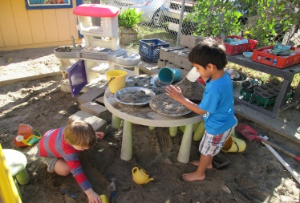
MUD PLAY
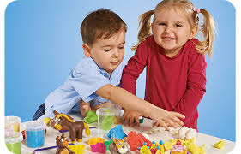
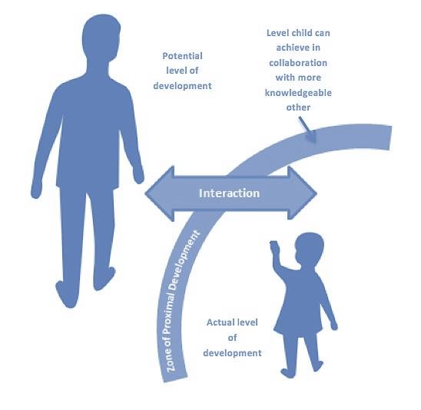
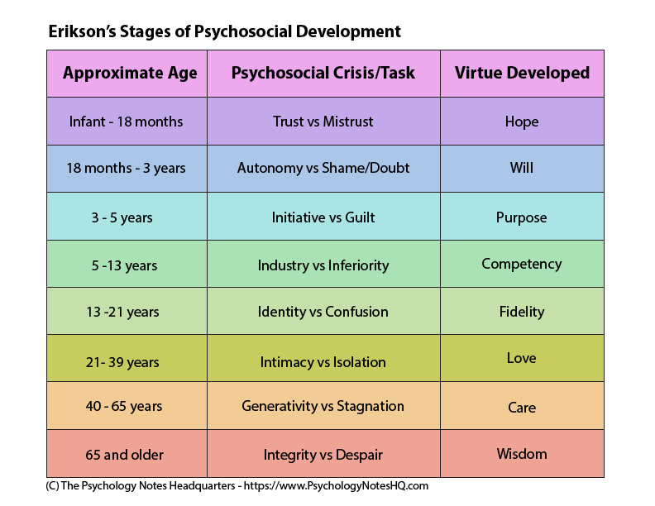
PLAY DOUGH
(Paine, 2017)
(The Psychology Notes Headquarters, 2019)
Erik Erikson (1902-1994)
According to Boyd and Bee (2013) Erikson identified 8 stages of development. He emphasised that a child’s ‘earliest relationships with its caregivers’ were very important in ensuring that they developed positive characteristics at each stage. The first few stages of development were the most crucial in forming the foundations of ‘adult personality’.
Trust vs mistrust (Birth-12 months)
At this stage babies need to feel cared for and safe in order to be able to develop trust. If trust is successfully established then the child develops a strong feeling of ‘hope’ and will feel confident that any obstacles can be overcome and their needs will be met.
Autonomy vs shame and doubt (12 months – 3 years)
According to Gillibrand, Lam and O’Donnell (2016) Erikson argued that at this stage, a child learns to exert control and independence but within the boundaries that parents set. Parents may encourage socially acceptable behaviour through use of positive phrases such as ‘be a good boy/girl for mummy’. A child learns to do things independently or it can lead to them doubting their abilities. If they are successful at this stage then the child will feel empowered and will become secure and confident. As a result, they will develop determination and ‘will’.
Initiative vs Guilt (3-6 years)
At this stage, a child may want to push their boundaries and test the waters. A caregiver may discourage or stop the child from venturing out in the fear of their safety. Erikson claimed that with the right balance of ‘parenting and instruction’, a child could express ‘initiative’ safely. If successful at this stage then they will develop the basic strength of ‘purpose’ which would allow for them to have the courage to persevere with their aspirations and be effective leaders.

Vygotsky (1896-1934)
According to McLeod (2018), Vygotsky’s sociocultural theory emphasised the importance of culture and social interactions in cognitive development. He considered the community to be crucial in the process of “making meaning” and sense of the world. He stressed that the environment in which children grew up in would affect how they would think and for Vygotsky, adults played an important role towards cognitive development. Interaction with adults and peers was a valuable way of developing skills and strategies. Vygotsky’s theory highlighted individual development and could be applied to all ages.
Zone of Proximal Development (ZPD)
Vygotsky discussed the zone of proximal development; what the children could do independently and what they couldn’t do at all. The zone of proximal development was when an adult would get involved. This is when development progressed through scaffolding by a ‘more knowledgeable other’. According to Shabani, Khatib and Ebadi (2010) the zone of proximal development (ZPD) is crucial in defining a ‘learner’s immediate and future learning’
What is scaffolding?
According to Wood, Burner and Ross (1976) Scaffolding is a process that enables a child to develop through the help of an adult. Vygotsky refers to this adult as the more knowledgeable other (MKO). This is someone who has a higher intelligence or ability level than the learner and can support them with understanding and development. The MKO gives the child a ‘helping hand’ with their learning. This could be a teacher, peer, sibling or even a family member.

In conclusion, messy play activities are a great way for children to develop their physical, social and emotional skills. When ‘a knowledgeable other’ leads the activity, a child can benefit socially and intellectually with the support of parents helping the child make links to understanding the world around them. Parents can help children develop the characteristics that Erikson discussed. Through messy play, they will develop ‘will’ and ‘purpose’ only if parents allows the child to express independence and initiative. Let the child be messy and don’t reprimand them otherwise it could lead to them developing feelings of guilt and shame. These experiences will affect the rest of a child’s life.

By Farida Parvin 1918346

Annotated Bibliography

Boyd, D. G. and Bee, H. L. (2013) Lifespan Development: Pearson New International Edition.
- This book talks about the different theories of development and my main focus was gaining information on Erikson’s theory. Boyd and Bee (2013) discus how Erikson believed that growth and development was a consequence of social interaction and the role of culture played a crucial part in personality development. He also highlighted that a child’s ‘earliest relationships with its caregivers’ were very important. He identified 8 stages of development but the first 4 stages of development were the most important in forming the foundation of ‘adult personality’.
- I used this book to obtain in depth knowledge of the 8 stages of development that Erikson described. In my poster I described 3 stages because my poster refers to the development age up to 5.
- This book is credible and reliable because it was recommended by the lecturer. Additionally, it was accessible from the university library where books would be assessed by the staff.

Gillibrand, R., Lam, V., and O’Donnell, V., L. (2016) Developmental Psychology, Pearson Education, Limited. ProQuest Ebook Central.
- This book explains Erikson’s 8 stages of development. According to Erikson, one must succeed at each stage of development in order to successfully build strength and be able to adapt to the next stage. If they were unsuccessful then they would struggle to keep up in the next stage of development. Focussing on the first three stages, this book goes on to explain the ‘Trust vs mistrust’ stage applicable from birth to 12 months, ‘Autonomy vs shame and doubt’ from 12 months – 3 years and the ‘Initiative vs Guilt’ stage from the ages 3-6 years. I found this book to be very informative and clear. The first four stages were the foundation of adult personality and his theory linked in well when explaining how child development and their experiences were important from 0-5 in shaping the rest of their lives.
- I used this book to explain the first three stages of Eriksons developmental stages in my poster. It is a credible source because it was deemed reliable by the academic tutor.

McLeod, S. A. (2018). Lev Vygotsky. Simply Psychology. [Google scholars]
Available at:
https://www.simplypsychology.org/vygotsky.html
(Accessed 07/02/2021)
- This website gives an explanation on the main points of Vygotsky’s theory. His work focuses on culture and social interaction as playing a crucial role in cognitive development. This website is very informative and clear.
- The information is credible and reliable because the author is a renowned researcher and his area of expertise is Psychology.

NHS Greater Glasgow and Clyde,(2017) Child Development Timeline [Website]
Available at:
https://www.nhsggc.org.uk/kids/child-development/interactive-child-development-timeline/
(Accessed 12/02/2021)
- This website shows the developmental areas of a child through the different age stages. It is reliable because it is produced and managed by the NHS. I used this site to give me ideas on what activities could encourage physical, social and emotional development. I chose to talk about how messy play activities could be a good activity to support a child’s development.

Paine, A. (2017). Explaining the Influence of Younger Siblings on Firstborns' Understanding of Minds in Middle Childhood: A Longitudinal Investigation of the Mother-Firstborn Relationship. 10.13140/RG.2.2.13043.43044. [image]
Available at:
https://www.researchgate.net/figure/Illustration-of-the-Zone-of-Proximal-Development_fig21_319651624
(Accessed 15/02/2021)
- The image explains what a child can achieve with the help of a more knowledgeable other. Through social interaction, guidance and encouragement, a child has the potential to accomplish any task and eventually be able to develop competence and independence.
- I used the image in my poster because it shows a very good representation of the ZPD and it is credible because Psychology is the authors area of expertise.
- This website seems reliable as it has been developed for psychology students.

Shabani, K., Khatib, M. and Ebadi, S., (2010) Vygotsky's zone of proximal development: Instructional implications and teachers' professional development. English language teaching, 3(4), pp.237-248. [Google scholars] Available at:
https://files.eric.ed.gov/fulltext/EJ1081990.pdf
(Accessed 11/02/2021)
- Shabani, Khatib and Ebadi (2010) discuss the zone of proximal development (ZPD) as crucial in defining a ‘learner’s immediate and future learning’. They stress the importance of the skills and abilities that a learner acquires through working together with a knowledgeable other which in turn helps the learner to perform the task independently. They outline Vygotsky’s theory and discuss the ZPD from a teaching perspective.
- I found this article to be valuable in explaining the ZPD in my poster. The source is credible because it is available on ERIC (Education Resources Information Center) which is a respected database for education literature and resources.

Taggart, B., et al.(2015) Effective pre-school, primary and secondary education project. Department for Education. [Website]
Available at:
https://assets.publishing.service.gov.uk/government/uploads/system/uploads/attachment_data/file/455670/RB455_Effective_pre-school_primary_and_secondary_education_project.pdf.pdf
(Accessed 22/02/2021)
- The Effective Pre-school, Primary and Secondary Education Project (EPPSE) report published in 2015 found that the experiences of a young child in pre-school between the ages of 3 and 5 were important and had long term implications to their learning. I used this report because I believed it showed a link to the poster title. A child’s experiences do affect their adult life. One of the key findings of this report found that children who attended a high-quality preschool were nearly 8 months ahead in their literacy development. They also found that the children who went to preschool obtained higher GCSE grades compared to those who didn’t attend. Preschool provided plenty of opportunities and experiences for physical, emotional and social development.
- This report is credible because it is published on the Department for Education website.

The Psychology Notes Headquarters (2019) Erik Erikson’s Theory of Psychosocial Development. [image]
Available at: https://www.psychologynoteshq.com/erikerikson
(Accessed 15/02/2021)
- I have used this colourful image as it is helpful in breaking up the stages of Erikson’s Psychosocial development and it displays the crisis and the virtue developed.

Wood, D., Bruner, J.S. and Ross, G., (1976) The role of tutoring in problem solving. Journal of child psychology and psychiatry, 17(2), pp.89-100. [Google scholars] Available at:
https://acamh.onlinelibrary.wiley.com/doi/epdf/10.1111/j.1469-7610.1976.tb00381.x
(Accessed 13/02/2021)
- Wood, Burner and Ross (1976) talked about the term ‘scaffolding’ in their study of thirty children aged 3-5 years old. They discussed scaffolding as a process that enabled a child to solve a problem and accomplish a task successfully through the assisted efforts of adults. In the end, it would result in a child developing ‘task competence’ thus being capable to perform the task independently.
- I used this article because a lot of Vygotsky’s work referred to the knowledgeable other helping children but Wood, Burner and Ross actually term this process as scaffolding which is used widely by a lot Vygotsky followers.
- This source is credible and reliable because their research was conducted at the Center for Cognitive Studies at Harvard University and it was first published in 1976. The journal is available from the Association for Child and Adolescent Mental Health which comprises of many professionals such as clinicians, practitioners and world-leading child mental health researchers.

Albany PreSchool (2021) Mud Kitchens [Image]
Available at:
https://albanypreschool.org/2016/05/mud-kitchens/
(Accessed:21/02/2021)

Canji, I.(2020) The benefits of playdough and clay for child development. Fun Childhood.[Image]
Available at:
https://funchildhood.com/the-benefits-of-playdough-and-clay-for-child-development/
(Accessed:21/02/2021)
- I used the images from these websites because they reflect messy activities and show the children interacting socially which was the message I want to get across in my poster.

