

Name: Shamaila Sakhawat
Student ID:2309140
Lecture : Martin Svejda
Module code : BMHP6026
Module: Digital Transformation in the Health and Social Care Professions
Assignment Title: component 1: Written Report

Contents Page
1. Introduction ……………………………………………………………………… 3
2. Workforce ………………………………………………………………………… 4
3. Service Delivery ………………………………………………………………… 5
4. Patient/Service User ………………………………………………………… 7
5. Conclusion and Recommendations …………………………………… 9
6. Reference List …………………………………………………………………. 10

The NHS App: A Digital Innovation in UK Health Care
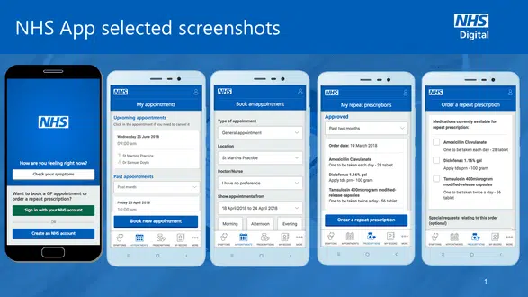
Figure 1: Overview of the NHS App as a digital innovation in UK healthcare. (Source: Digital Health, 2023) www.digitalhealth.net).

Introduction

According to NHS App (2018). The increasing demand for accessible, efficient, and patient-centred healthcare in the United Kingdom has driven rapid investment in digital technologies. Among these innovations, the NHS App, launched in England in December 2018, represents one of the most significant developments in recent years. Designed as a “front door” to NHS services, the app enables patients to book general practice (GP) appointments, order repeat prescriptions, view personal medical records, organ Donation preferences, and secure access control over data (Digital Health, 2023). More recently, access COVID-19 vaccination certification (NHS Digital, 2021). Unlike earlier NHS digital tools such as NHS Choices (2007) or NHS 111 online (2017), the NHS App was developed as a national, unified platform intended to streamline service access and empower patients to engage more actively with their health management (Marshall et al., 2021).
This report critically evaluates the impact of the NHS App across three key domains: workforce, service delivery, and patient/service user. Drawing upon academic research, policy documents, and UK-based evaluations, it considers both the benefits and limitations of this digital innovation. Particular attention is given to issues of digital exclusion, staff adaptation, and the implications for health inequalities. The report concludes with recommendations for practice and policy to strengthen the equitable integration of the NHS App in the future.

Workforce

The introduction of the NHS App has had significant implications for the healthcare workforce, particularly within general practice settings. One of the most notable changes has been the shift of administrative tasks from staff to patients. The ability to book and cancel appointments, request repeat prescriptions, and view test results online has reduced the administrative burden traditionally managed by reception and clerical staff. This has freed capacity for staff to focus on more complex or sensitive interactions, contributing to improved efficiency (NHS Digital, 2021). However, this shift has not been uniformly positive. Some GPs report that the app has generated additional workload pressures, particularly where digital requests result in higher consultation demand or where patients misinterpret medical records and require clarification (Bakhai et al., 2022). This highlights the unintended consequence of “digital demand inflation,” in which technology makes services easier to access but can simultaneously strain already stretched workforce resources (Greenhalgh et al., 2020; Salisbury, Murphy, and Duncan, 2020).

Staff training and digital competency development have been essential for successful implementation. Healthcare professionals and administrative staff needed upscaling in digital literacy, troubleshooting, and supporting patients in navigating the system. For some professionals, this represented an opportunity for career development and skill diversification; for others, it was experienced as an additional burden, particularly during the pandemic when digital adoption accelerated (NHS Confederation, 2021). Resistance to change was also clear, with some staff expressing concerns about the reliability of digital tools and the potential for technology to undermine the human aspects of care.

From a broader workforce perspective, the app has also facilitated new models of remote and digital-first care. Integration with online consultation systems, such as eConsult, has enabled GPs to triage patients more efficiently and manage demand in novel ways (Marshall et. al., 2021). Yet, this integration has been inconsistent across regions, contributing to disparities in workforce experience.

critical analysis: Beyond the immediate workload redistribution, questions remain about the sustainability of digital-first practices. demonstrates that while online consultations initially save time, they often generate additional follow-up work. This raises concerns about (NHS,2023). whether the NHS App is genuinely reducing staff burden or simply displacing it into new forms. Moreover, shifting administrative responsibility to patients raises ethical concerns about equity, particularly for those unable to navigate digital systems.

The Topol Review (2019) further highlighted the urgent need for systematic digital skills training in the NHS workforce. Without this, the adoption of tools like the NHS App risks embedding inequities between staff who are confident in digital care and those who are not. Thus, while the NHS App is often presented as a technological efficiency, its workforce implications are deeply complex, balancing opportunities for innovation against risks of professional burnout and inequity.

Further reflection: Another overlooked issue is the impact on inter-professional relationships. Some administrative staff report feeling displaced by automation, while clinicians note that digital tools can undermine the sense of teamwork within practices. If technology is seen as replacing rather than supporting staff, morale and collaboration may suffer, reducing the very efficiency gains the app seeks to deliver.

Overall, while the NHS App has relieved certain administrative pressures, it has also created new challenges (Abernethy et.al., 2022). Its impact on the workforce demonstrates the complexity of digital transformation: efficiencies are gained, but only when adequately supported by resources, training, and cultural change.

2.Service Delivery
The NHS App has had a transformative effect on the delivery of health services, reshaping workflows, communication, and patient pathways. By enabling patients to self-manage appointments, prescriptions, and access to records, the app has streamlined several aspects of primary care delivery. Digital repeat prescriptions have reduced delays, minimised errors, and contributed to improved medicines optimisation (Nelson and Allkins, 2020).

During the COVID-19 pandemic, the NHS App played a pivotal role in public health service delivery. Its integration with the COVID Pass enabled individuals to demonstrate vaccination status for travel and access to venues, leading to a dramatic surge in uptake: user numbers rose from 2.3 million in April 2021 to over 22 million by September 2021 (NHS, 2021). This demonstrated the scalability of digital solutions and the capacity of the app to support national health priorities. By enabling wider access to healthcare services, improving data sharing across regions, and allowing for rapid adoption in different clinical settings. Its adaptable design means it can be expanded to serve larger populations while maintaining efficiency and quality of care, aligning with goals such as reducing health inequalities and enhancing preventative healthcare nationwide (NHS England, 2022).
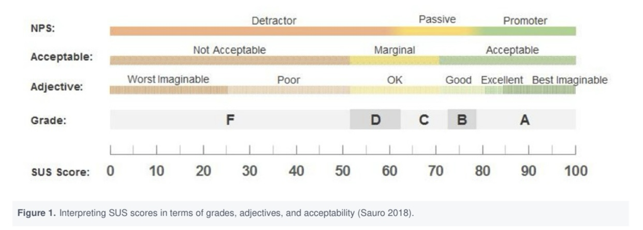
Figure 2: An Adapted Model for the Interpretation of System Usability Scale (SUS) Scores in Relation to Grading, Adjective Ratings, and Acceptability Levels (Sauro,2018).
healthcare nationwide
Despite these successes, service delivery has faced several challenges. Integration with existing GP systems has been inconsistent, with some practices experiencing technical delays or struggling to align the app with local workflows (Honeyman et. al., 2020). This has contributed to variability in patient experience and highlighted the complexity of implementing a national digital platform across diverse service environments.

Short-term financial Support: Substantial investment was required to upgrade IT infrastructure, enhance cybersecurity, and ensure interoperability with local systems. While these costs are expected to yield long-term efficiency savings, they represent a barrier to adoption, particularly in under-resourced practices (Greenhalgh et.al., 2020).

operational perspective, the app has improved communication between patients and services but has also introduced new demands. Easier access to services has, in some cases, increased demand for GP consultations, challenging the assumption that digital transformation automatically reduces workload (Bakhai et. al., 2022; Salisbury, Murphy, and Duncan, 2020).

Nevertheless, the NHS App illustrates how digital technologies can redefine service delivery models. Its success during COVID-19 suggests potential for further integration with remote monitoring, telehealth, and personalised care pathways. However, without careful management, the risks of fragmented implementation and exacerbated inequalities remain substantial.

critical analysis: A further issue relates to the cost-effectiveness of the NHS App. While often framed as a tool for long-term efficiency, studies highlight hidden costs, including technical support, patient troubleshooting, and uneven regional integration (Public Accounts Committee, 2021). These suggest that digital services may not always deliver the promised savings, particularly when viewed across Integrated Care Systems (ICS), where fragmentation remains a barrier.
Additionally, while the app streamlines access for many, it risks creating a two-tier model of service delivery according to (Mossialos et. Al., 2019). one for digitally literate patients who can engage with rapid services, and another for those reliant on traditional access routes. This could undermine NHS commitments to universalism. The lesson is clear: service delivery cannot be evaluated purely in terms of technical potential; it must be assessed in relation to system-wide sustainability, equity, and value for money.

Further reflection: Regional inequalities also remain a challenge. Evidence shows that uptake of the NHS App is higher in urban and affluent areas compared to rural or deprived communities. This uneven distribution risks amplifying the North-South health divide and undermines national commitments to “levelling up” healthcare access. Without targeted strategies, digital transformation may entrench geographical inequalities rather than resolve them.

3.Patient/Service User

For patients and service users, the NHS App has represented a substantial shift towards greater accessibility, convenience, and empowerment. By providing 24/7 access to appointment booking, prescription management, and health records, the app has given patients more control over their interactions with healthcare services (NHS Digital, 2021). This aligns with broader NHS policy goals of fostering self-management and patient-centred care.
Research highlights that many patients value the convenience and autonomy offered by the app. For individuals managing long-term conditions, access to medical records and test results supports more active self-care and reduces reliance on in-person consultations (Greenhalgh et. al., 2020). Additionally, the COVID Pass functionality enabled millions to travel, work, and take part in social life, underscoring the app’s role in safeguarding both individual freedoms and public health (NHS, 2021).

However, significant challenges exist. Digital exclusion has emerged as one of the most pressing issues. Older adults, individuals with limited English proficiency, those lacking digital literacy, and people in deprived communities are less likely to use the app (NHS Confederation, 2021). These risks deepening health inequalities by privileging digitally literate populations while marginalising vulnerable groups. Efforts such as digital skills training and community outreach have attempted to address this gap but remain unevenly implemented.

Privacy and trust are additional concerns. Some patients (older adults) worry about the security of sensitive medical data, especially given increasing public awareness of cyberattacks on healthcare systems (Honeyman et.al., 2020). Furthermore, not all patients welcome increased access to medical records, as information may be misinterpreted, leading to anxiety and unnecessary consultations (Bakhai et. al., 2022).

User experience has also been mixed. While the majority report satisfaction with core functions, others highlight technical difficulties with registration, login processes, and navigation. These usability issues underscore the need for ongoing co-design with patients to ensure the app remains intuitive and accessible (Marshall et.al., 2021).

In summary, the NHS App has provided patients with unprecedented digital access to health services. Yet, its potential to enhance patient empowerment is counterbalanced by persistent risks of exclusion, miscommunication, and privacy concerns.

Additional critical analysis: Beyond technical usability, there are psychological dimensions to consider. Lupton (2021) argues that constant digital access to health information can foster a “surveillance” mindset, where patients feel pressure to monitor their health data excessively. This can generate anxiety rather than empowerment. For some, the availability of detailed medical records may blur the line between informed patient engagement and medical overconsumption.

Furthermore, digital exclusion has broader implications than access alone. Abraham et al. (2024) highlight that self-management technologies disproportionately benefit those already skilled and confident, potentially widening the “inverse care law,” where those in greatest need gain the least. Unless targeted interventions address these imbalances, the NHS App may entrench inequities rather than reduce them.

Further reflection: A critical barrier lies in health literacy. While the app provides information, not all users have the skills to interpret complex medical terminology or test results. Misinterpretation can lead to unnecessary worry, self-diagnosis, or misuse of services (Chan and Kaufman, 2011). This suggests that the NHS App may empower some patients while overwhelming others, highlighting the importance of tailoring digital health tools to diverse literacy levels.

Conclusion and Recommendations
Since its launch in 2018, the NHS App has appeared as a cornerstone of digital transformation in UK healthcare. It has streamlined administrative tasks, enhanced service delivery, empowered patients, and contributed to public health outcomes during the COVID-19 pandemic. Its potential to support more sustainable, patient-centred models of care is significant.

However, the app has also highlighted the challenges inherent in digital health innovations. Workforce adaptation, inconsistent service integration, digital exclusion, and privacy concerns remain persistent barriers to equitable implementation. Without targeted interventions, the risk is that the app will widen health inequalities rather than reduce them.

Recommendations include:

Area | Recommendation
Digital Literacy | Enhance training for healthcare staff and patients to improve confidence and capability in using digital tools.
Inclusive Access | Develop targeted inclusion initiatives for older adults, deprived communities, and non-English speakers.
Proxy Access | Improve proxy access features to better support carers and dependents.
Cybersecurity | Continue investing in cybersecurity to strengthen patient trust and protect data.
Co-production | Maintain ongoing co-production with patients and communities to refine usability and ensure systems meet user needs.

The NHS App demonstrates the promise of digital health innovation, but its long-term success will depend on addressing these barriers and embedding equity, accessibility, and trust at the heart of digital transformation.

Reference
Abraham, C., Conner, M., Jones, F. and O’Connor, D., 2024. Health psychology. Routledge.
Bakhai, M. and Coombes, R., 2021. Digital health in primary care: shaping the future. British Medical Journal, 372, n214.
Cave, E., Charlesworth, A., Dacre, J., Francis, R., Pearson, D., Baker, M., Davies, C., Gordon, N., Hussain, W., Patterson, H. and Perrin, N., 2023. Evaluation of Government commitments made on the digitisation of the NHS Fourth Special Report of Session 2022–23.
Chan, C.V. and Kaufman, D.R., 2011. A framework for characterising eHealth literacy demands and barriers. Journal of medical Internet research, 13(4), p.e1750.
Greenhalgh, T., Wherton, J., Papoutsi, C., Lynch, J., Hughes, G. and A’Court, C., 2020. Beyond adoption: A new framework for theorising and evaluating nonadoption, abandonment, and challenges to the scale-up, spread, and sustainability of health and care technologies. Journal of Medical Internet Research, 22(11), e22474.
Honeyman, M., Maguire, D., Evans, H. and Davies, A., 2020. Digital technology and health inequalities: a scoping review. Cardiff: Public Health Wales NHS Trust.
Lupton, D., 2021. Critical perspectives on digital health technologies. Sociology Compass, 15(2), e12809.
Lewis, J.R. and Sauro, J., 2018. Item benchmarks for the system usability scale. Journal of Usability studies, 13(3).
Marmot, M., Allen, J., Goldblatt, P., Herd, E. and Morrison, J., 2020. Build back fairer: the COVID-19 Marmot review. The pandemic, socioeconomic and health inequalities in England.
Marshall, M., Howe, A., Howsam, G., Mulholland, M. and Leach, J., 2021. COVID-19: a danger and an opportunity for the future of general practice. British Journal of General Practice, 71(705), pp.176-177.
Mossialos, E. and Le Grand, J. eds., 2019. Health care and cost containment in the European Union. Routledge.
NHS, 2021. The NHS COVID Pass and the NHS App. London: NHS.
NHS Confederation, 2021. Digital inclusion in health and care: Lessons learned from the pandemic. London: NHS Confederation.
NHS Digital, 2021. NHS App statistics. Available at: https://digital.nhs.uk (Accessed: 25 September 2025).
NHS Digital. (2023). Mental health of children and young people in England, 2023: Trends and characteristics.

Nelson, S.J. and Allkins, S., 2020. Technology in healthcare: The NHS app. British Journal of Cardiac Nursing, 15(1), p.3.
Public Accounts Committee, 2021. Digital transformation in the NHS. London: House of Commons.
Reidy, C., Papoutsi, C., Kc, S., Gudgin, B., Laverty, A.A., Greaves, F. and Powell, J., 2025. Qualitative evaluation of the implementation and national roll-out of the NHS App in England. BMC Medicine, 23(1), p.20.
Salisbury, C., Murphy, M. and Duncan, P., 2020. The impact of digital-first consultations on workload in general practice: modeling study. Journal of Medical Internet Research, 22(6), p.e18203.
Shaw, S.E., Hughes, G., Wherton, J., Moore, L. and Greenhalgh, T., 2021. Achieving spread, scale up and sustainability of video consulting services during COVID-19: findings from a comparative case study of policy implementation. BMJ Global Health, 6(1), e005267.
Topol, E., 2019. The Topol review. Preparing the healthcare workforce to deliver the digital future, pp.1-48.

