

BA (Hons) Business Management

Student Name: Kostadinka Chirosca
Student Number: 2309383
Module Title: Strategic Management and Sustainability
Assignment Title: Component 2: Coursework: Written Report on Aston Martin
Lecturer Name: Mr Nadeem Mirza

Executive Summary
The present study has focused on the automotive sector through the lens of the organisation Aston Martin. The organisation tend to be one of the important organisations operating in the UK automotive segment. The financial performance of the organisation has been declining in recent times. The organisation is also losing its competitive edge to their peers. The inflation in the UK tends to be a major problem, and apart from that, it can be mentioned that the government has been encouraging the transition towards sustainable vehicle options in the UK. It can be observed that the organisation is also witnessing an operating loss in their overall business operations. In terms of the recommendation to Aston Martin, it can be said that the business will need to focus on the differentiation focus strategy in their business process. One of the major reasons for this is that it will help the business to tap into the growing sustainable vehicle market in the UK and achieve strategic agility in its business operations. The consideration of the recommended strategy will help the organisation to achieve long-term growth in its business and sustain in its market effectively.

Table of Contents
1.0 Introduction 4
2.0 Firm’s Background 4
3.0 Strategic Intent 5
4.0 The company’s Current Performance 5
5.0 Strategy Analysis 7
5.1 External Environmental Audit 7
5.2 Internal Environmental Audit 8
6.0 Strategy Formulation 10
6.1 Strategic Choices for Aston Martin 10
6.2 New Strategy for Aston Martin 10
7.0 Conclusion and Recommendations 11
7.1 Conclusion 11
7.2 Recommendations 11
Reference List 12

1.0 Introduction
Strategy is an important aspect of business. As per Boyles (2022), business strategy tends to be the strategic initiatives that a firm will be pursuing for value creation for the firm as well as its stakeholders. The essence as well as the benefits of strategic management tend to be quite broad in nature. The study of Sundström and Svärdsten (2025) stated that strategic management tends to be the process for linking the strategic planning with its realisation. It helps in the development of a competitive edge for the business, provides long-term direction and helps in achieving long-term sustainability in the market. The purpose of the report is to develop a strategy formulation plan. The overall study has been segmented into various components. In the initial stage, the background of the firm has been provided. The strategic intent of the firm has been discussed. The present performance of the firm is described. The strategic analysis of the organisation has been discussed. Apart from that, the conclusion as well as the recommendation regarding the work have been presented in the work. Overall, the study has given an overview of the strategic management in the organisation, Aston Martin.

2.0 Firm’s Background
The organisation that has been considered is Aston Martin. The organisation tend to operate in the automotive sector of the UK. In terms of the location, it can be said that the organisation is a UK-based business entity. The headquarters of the organisation is situated in Gaydon, Warwickshire (Astonmartin, n.d). In terms of the products of the organisation, it can be said that they produce luxury sports cars for their consumers. Because the organisation operates in the luxury segment, the overall pricing of the organisation tends to be on the higher side.
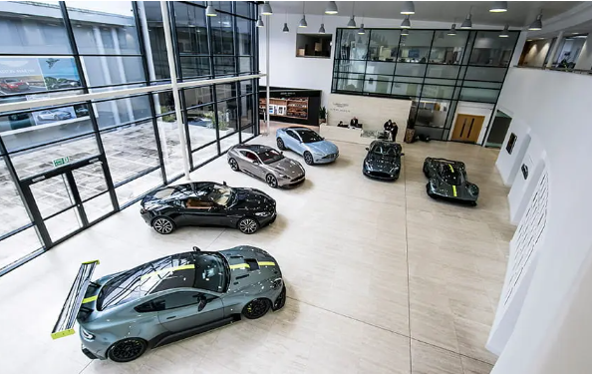
Figure 1: The cars of the organisation Aston Martin
(Source: Astonmartin, n.d)
It can be said that the organisation tend to be one of the major players in the market in which they operate. The organisation has a strong legacy, and it is renowned for the exclusive sports cars that they make. DBX, Vanquish, Vantage and DB12 tend to be some of the car models that are manufactured by the organisation (Astonmartin n.d.b). Overall, it can be interpreted that the organisation has a strong presence in their market place of operations in an effective manner.

3.0 Strategic Intent
In order to understand the strategic intent of the organisation, consideration of the vision, mission, and objectives of the organisation is discussed. The organisation has a stated vision. However, they do not have a stated mission and objectives of the organisation. The vision of the organisation is to become the world's ultra-luxury as well as most desirable British brand that will be creating addictive performance cars (Astonmartin, n.d.c). It can be inferred that the mission of the organisation is to develop high-end, high-performance cars for their consumers that will offer an exclusive experience. The objectives of the brand can be considered to differentiate themselves with high quality and performance, and develop a strong reputation among their consumers. In the present times, one of the core objectives of the organisation has been to integrate sustainability into its overall business process in an effective manner.
In terms of the overall strategy of the business, it can be inferred that the brand tries to ensure that it can differentiate itself from its peers with the help of extraordinary performance cars. The organisation aspires to be the top company in its market segment.

4.0 The Company’s Current Performance
The present performance of the organisation can be considered to be quite significant in nature. It can be said that the organisation has a significant amount of financial resources in their operational process.
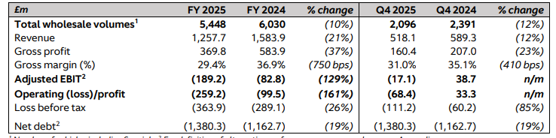
Figure 2: The financial results of Aston
(Source: Astonmartin, 2025)
The financial results of the organisation, Aston Martin, can be taken into account. In 2024, the total wholesale volumes of the organisation were 6,030. This had decreased to 5448 in 2025 (Astonmartin, 2025). The revenue of the organisation had dropped by the 21% in 2025. There has been a 37% drop in the gross profit of the organisation. The Gross margin of the organisation has dropped from 36.9% in 2024 to 29.4% in 2025 (Astonmartin, 2025). The organisation has seen a decline in their performance in comparison to its 2024 performance. As per Qamar, Collinson and Green (2023), Aston Martin had negative profit margins. The figures of the organisation need significant improvement. This means that the organisation is still struggling with its operations. The study of Mansikkamäki (2023) mentions that initial profitability is more than initial growth for high performance. In the case of the organisation, it can be seen that the organisation has been maintaining significant revenue in their operational process effectively.
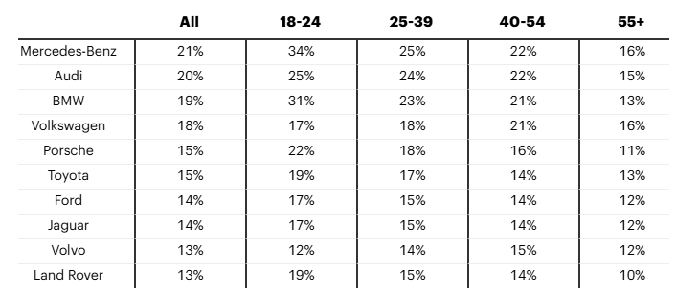
Figure 3: The most desired car brands in the UK
(Source: YouGov, 2025)
It can be said that the organisation has been failing their objective of becoming the most desirable car brand. They are not even in the top 10 when it comes to most desirable brands in the UK [Refer to Figure 3]. Mercedes-Benz tend to be the most desired brand in the UK, as 21% people have expressed interest in having such a car (YouGov, 2025). This means that the performance of the brand needs to be improved. It can be mentioned that the performance of the organisation still requires significant improvement.

5.0 Strategy Analysis

5.1 External Environmental Audit
The consideration of the PESTLE analysis is done for understanding the external environment of Aston Martin. As per Olayiwola et al. (2025), PESTLE tend to be a management framework that helps in understanding the external factors that can shape strategy and decision-making in business. The different components of PESTLE are provided below.
PESTLE Factors | Description | Opportunity/ Threat
Political | There are chances that the ICEVs can be banned in the UK (Law, Martinez-Botas and Blythe, 2023). The government has been focusing on sustainable options. It can be an opportunity for Aston Martin to tap into the sustainable vehicle market. | Opportunity
Economical | As per Castle Hendry and Martinez (2023), in the UK, inflation has become persistent. This is a threat to the business as the cost of production will be increasing in a significant manner. | Threat
Social | In the UK, there are about 33.2 million cars, and 78% of households tend to have one car (Haines-Doran, 2024). This is an opportunity for Aston Martin, as car consumption is high. | Opportunity
Technological | In the UK, efforts are being made for digitalisation in the automotive industry, and attempts are being made to connect the manufacturers with their broader supply chain (Ghadge et al., 2022). This is a good element for Aston as they can connect with their wider supply chain. | Opportunity
Environmental | Esfahbodi et al. (2023) conducted their work on 189 UK automotive firms and mentioned that GSCM can reduce profitability. This is a challenge for Aston Martin to maintain a balance between profitability and sustainability. | Threat
Legal | A ZEV mandate is created in the UK, which sets a target for UK manufacturers where a certain percentage of their annual sales needs to be zero emission (Gov, 2023). This creates pressure on Aston Martin to enhance the percentage of their sustainable vehicles. | Threat
Table 1: PESTLE Analysis of Aston Martin

5.2 Internal Environmental Audit
SWOT Analysis
Strengths  - The revenue of the organisation had been 1,257.7 million GBP in 2025 (Astonmartin, 2025).  - The organisation has good brand recognition.  - The organisation sold more than 5,000 wholesale volumes in both 2024 and 2025 | Weaknesses  - The gross profit of Aston Martin has decreased in 2025 in comparison to their 2024 figures (Astonmartin, 2025).  - The wholesale volume of the organisation has decreased in comparison to its 2024 figures (Astonmartin, 2025).  - The desirability of the brand among its consumers is lower.
Opportunities  - The volume in the UK had been robust, which accounted for about 19% of the overall wholesale volume (Astonmartin, 2025).  - The organisation can facilitate digital transformation.  - Tap into the sustainable vehicle segment. | Threats  - Mercedes-Benz is among the most desirable brands in the UK (YouGov, 2025).  - Geopolitical frictions are a threat to the business  - Inflation is a challenge for the business.
Table 2: SWOT Analysis
VRIO Analysis
Resources | Valuable | Rare | Inimitable | Organised | Competitive
Brand legacy | Yes | Yes | Yes | Yes | Competitive benefit
Skilled craftsman and engineers | Yes | Yes | Yes | Yes | Competitive benefit
Supply chain | Yes | Yes | Yes | Yes | Competitive benefit
Technology | Yes | Yes | Yes | Yes | Competitive benefit
Financial | Yes | Yes | Yes | No | Partial advantage
Consumer demand | _ | _ | _ | _ | No advantage
Table 3: VRIO Analysis
It can be said that the brand legacy, technology, supply chain and skilled engineers and craftsmen are the company’s competitive advantage, as long-term operation has helped the organisation develop these capabilities. The report of Astonmartin (2025) highlights that in 2025, the organisation incurred an operating loss of 259.2 million GBP. This is the reason the financial resource is a temporary advantage. Because the brand does not even fall in the top 10 most desirable brands, it can be said that there is no advantage to the brand.

6.0 Strategy Formulation

6.1 Strategic Choices for Aston Martin
There are various strategic choices available to the company. For example, in the present times, trends such as vertical integration, strategic alliance with technology companies, data, as well as AI integration are some of the strategic choices that are being made in the automotive sector. The transformation of safety features is being done in the automotive industry with the help of AI (Madhavaram et al., 2024). Flexible manufacturing as well as extensive customer experience are being given importance. The cost leadership, differentiation and focus tend to be the three strategic choices for competitive advantage as per Porter’s generic strategies. As per Acar (2024), in the focus strategy, a specific target market is served with the help of a differentiation or cost leadership strategy. Overall, there are certain strategic choices for Aston Martin

6.2 New Strategy for Aston Martin
It can be said that for the new strategy, the organisation can focus on the differentiation focus strategy rather than the differentiation strategy. Penetrating the larger market will be difficult for the firm. This is the reason high-end sustainable luxury cars need to be developed by the organisation. Kempston et al. (2025) in their study have mentioned that the demand for electric vehicles will be growing in the upcoming years. This is the reason the focus of the organisation needs to be centralised in the sustainability sector.
Activity | Time
Invest in R&D for a sustainable vehicle | 4 months
Strengthen the supply chain for sustainable vehicles | 3 months
Recruit skilled craftsmen and engineers | 3 months
Strengthen the distribution network for the delivery of the vehicles | 5 month
Table 4: Plan for the new strategy of Aston Martin

7.0 Conclusion and Recommendations

7.1 Conclusion
In the conclusion of the work, it is inferable that in the UK, the ICEVs will become obsolete, and it will be necessary for the organisations to transition to the sustainable options. In terms of Aston Martin, it can be seen that they have been falling behind companies such as BMW and Mercedes-Benz when it comes to popularity among consumers. The financial performance of the organisation has seen a decline in recent years. These are the areas that will require importance to be given by the organisation. In the present times, the organisation is losing its competitive edge over their peers

7.2 Recommendations
In terms of the recommendation, it can be mentioned that the differentiation focus option will need to be given priority by the organisation. The organisation will be required to target the specific sustainability-driven consumers in their business process. One of the main reasons for this is that the demand for sustainable vehicles in the UK is growing, and the government has been encouraging the transition towards sustainable vehicles in the sector. This is the reason, it can be said that transitioning towards the sustainable vehicle sector early will help the organisation to have a long-term strategic advantage in their business operations effectively.

Reference List
Acar, S. (2024) ‘A review of Porter’s generic strategies: Strategy examples in international firms’, International Social Sciences Studies Journal, 10(11), pp.1902-1918.
Astonmartin (2025) Aston Martin Lagonda Global Holdings plc. Available at: https://www.astonmartin.com/-/media/corporate/documents/fy-results-2025/aston-martin-lagonda-fy-2025-results.pdf?rev=cfee91d19eda4499b80f930b2012072c (Accessed: 10 March 2026).
Astonmartin (n.d) Aston Martin Lagonda Global Headquarters. Available at: https://www.astonmartin.com/en/corporate/about-us/locations/gaydon (Accessed: 8 March 2026).
Astonmartin (n.d.b) All models. Available at: https://www.astonmartin.com/en/models (Accessed: 8 March 2026).
Astonmartin (n.d.c) About Us Strategy. Available at: https://www.astonmartin.com/en/corporate/about-us/strategy (Accessed: 12 March 2026).
Boyles, M. (2022) What Is Business Strategy & Why Is It Important? Available at: https://online.hbs.edu/blog/post/what-is-business-strategy (Accessed: 8 March 2026).
Castle, J.L., Hendry, D.F. and Martinez, A.B. (2023) ‘The historical role of energy in UK inflation and productivity with implications for price inflation’, Energy Economics, 126, p.106947.
Esfahbodi, A., Zhang, Y., Liu, Y. and Geng, D. (2023) ‘The fallacy of profitable green supply chains: The role of green information systems (GIS) in attenuating the sustainability trade-offs’, International Journal of Production Economics, 255, p.108703.
Ghadge, A., Mogale, D.G., Bourlakis, M., Maiyar, L.M. and Moradlou, H. (2022) ‘Link between Industry 4.0 and green supply chain management: Evidence from the automotive industry’, Computers & Industrial Engineering, 169, p.108303.
Gov (2023) Zero emission vehicle (ZEV) mandate consultation: Summary of responses and joint government response. Available at: https://assets.publishing.service.gov.uk/media/6537c6821bf90d0013d8450b/zev-mandate-consultation-summary-of-responses-and-joint-government-response.pdf (Accessed: 12 March 2026).
Haines-Doran, T. (2024) ‘The financialisation of car consumption’, New Political Economy, 29(3), pp.337-355.
Kempston, S., Coles, S.R., Dahlmann, F. and Kirwan, K. (2025) ‘UK electric vehicle battery supply chain sustainability: A systematic review’, Renewable and Sustainable Energy Reviews, 210, p.115216.
Law, A.J., Martinez-Botas, R. and Blythe, P. (2023) ‘Current vehicle emission standards will not mitigate climate change or improve air quality’, Scientific Reports, 13(1), p.7060.
Madhavaram, C.R., Sunkara, J.R., Kuraku, C., Galla, E.P. and Gollangi, H.K. (2024) ‘The future of automotive manufacturing: Integrating AI, ML, and Generative AI for next-Gen Automatic Cars’, International Multidisciplinary Research Journal Reviews-IMRJR, 1, p.010103.
Mansikkamäki, S. (2023) ‘Firm growth and profitability: The role of age and size in shifts between growth–profitability configurations’, Journal of Business Venturing Insights, 19, p.e00372.
Olayiwola, K., Perera, S., Kagioglou, M., Jin, X. and Sharafi, P. (2025) ‘A PESTEL Analysis of Problems Associated with the Adoption of Offsite Construction: A Systematic Literature Review’, Buildings, 15(13), p.2146.
Qamar, A., Collinson, S. and Green, A. (2023) ‘Covid-19 disruption, resilience and industrial policy: the automotive sector in the West Midlands’, Regional Studies, 57(6), pp.1156-1170.
Sundström, A. and Svärdsten, F. (2025) ‘Modes of strategic control: shifting dynamics between planning and control tools in strategy implementation’, Public Management Review, pp.1-25.
YouGov (2025) Top car brands UK consumers want to drive and expect to last. Available at: https://yougov.com/en-gb/articles/51631-top-car-brands-uk-consumers-want-to-drive-and-expect-to-last (Accessed: 11 March 2026).

