Siobhan Aspland

1901059

ACMA4005:

The Use of Digital Tools to Optimise Manufacturing Conditions

- Optimisation exercise

Using matlab, it is possible to find out the maximum volume of the bucket. Pictured below is a graph showing the volume when the edge angle is changed with a range of 0° to 90°. By plotting the graph it was found that the maximum volume is 4.0323m^3, 4032.3l and the angle alpha is equal to 47.0960°.
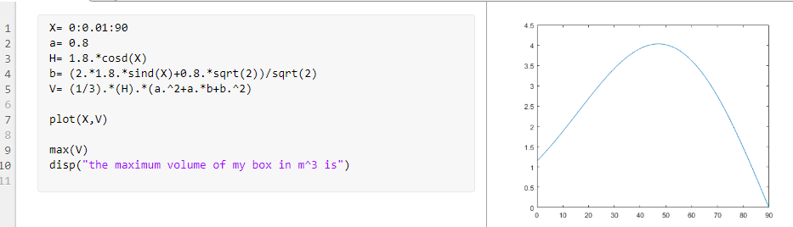
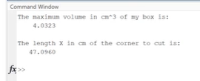
b= 2x1.8xsinα+0.8√2/√2
=2 x 1.8 x sin(47.0960) + 0.8√2 / √2
=2.66

H=1.8xcosα
=1.8xcos(47.0960)
=1.23
Area of plate=(a+2 x s)^2
=(0.8+2 x 1.23)^2
=10.62

- design and manufacturing processes
The first step to making the bucket is to cut the steel sheet to size. This can be done by shearing, laser or flame cutting with oxy acetylene. The best option is to use oxy acetylene. Oxy acetylene is cheap to buy. The process is quick and simple. When used correctly, a clean cut can be made which will require minimal clean up.
Next step is to fold the metal. This can be done by manually heating and bending or using a bending machine like a power press. A power press uses rolls of steel, which are cut to appropriate lengths using a laser cutter. The sheet steel is put into the power press machine using a robotic arm. The power press has two parts, one top and one bottom, these two come together to press the sheet material into its required form. The sheet metal is progressively pressed into a final shape as doing this in once press can cause the material to tear. Each press will add extra features to the shape.
We must then prep the metal ready to be welded. This can be done by grinding, sometimes this is required in order to have a successful weld.
There are two types of welding, MIG, metal inset gas and TIG, tungsten inert gas. MIG welding is when a solid wire is constantly fed through a welding gun and creates a spark, melting the wire and allowing a weld to form. TIG welding uses long rods to fuse two metals together directly.

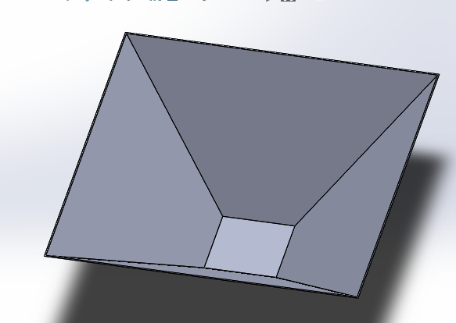
Using solid works we are able to create the bucket.

III. manifesting capacity and costing
PROCESS FLOW CHART
START

CUT
FINISHED
NO
DOES THE SIZE MATCH THE DESIGN?

PAINT
YES

PAINT PREP
FOLD

WELD PREP
CLEANUP

HEAT TREAT
WELD

ARE ALL SIDES JOINED
YES

NO
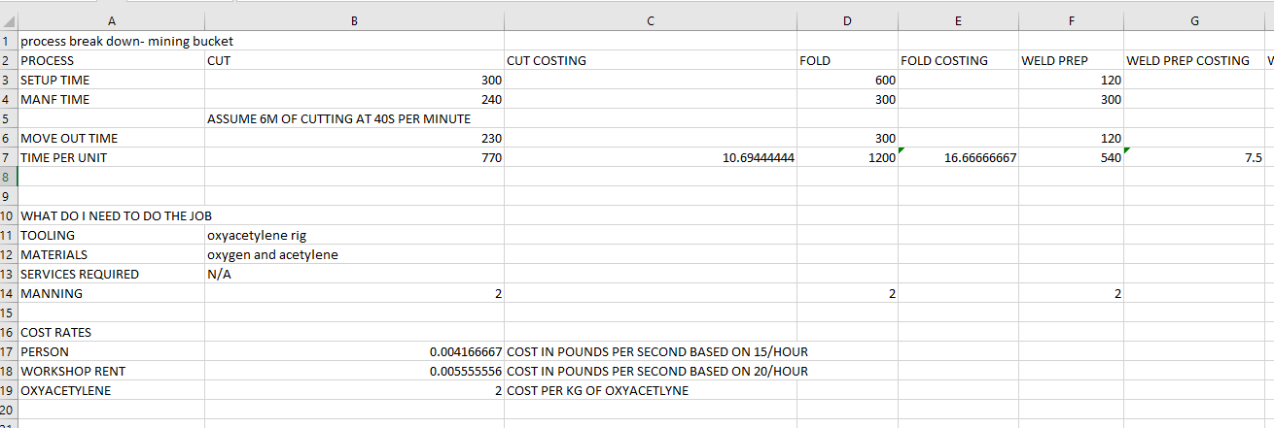
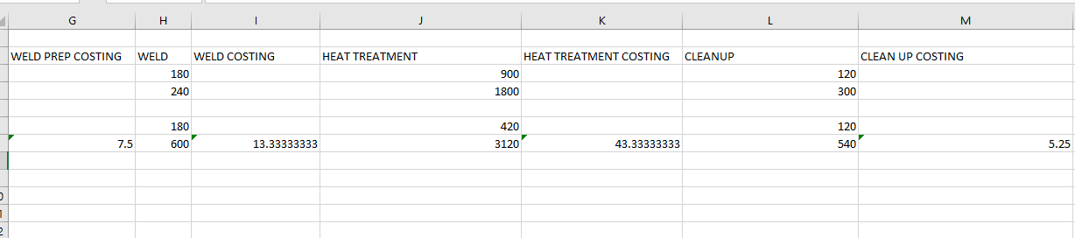
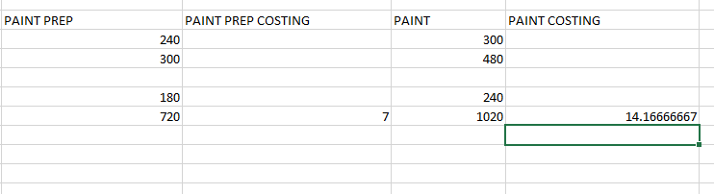

Delivery in
Metalwork shop
Bending
Cutting shop

Weld prep and cleanup
Angle grind
Paint
Delivery out
Store room
WIP
Weld
Paint clean up

