Professional Practitioner Portfolio
Component 1- Personal Development Plan
Component 2- Briefing paper- reflective practise
Component 3- Written Essay
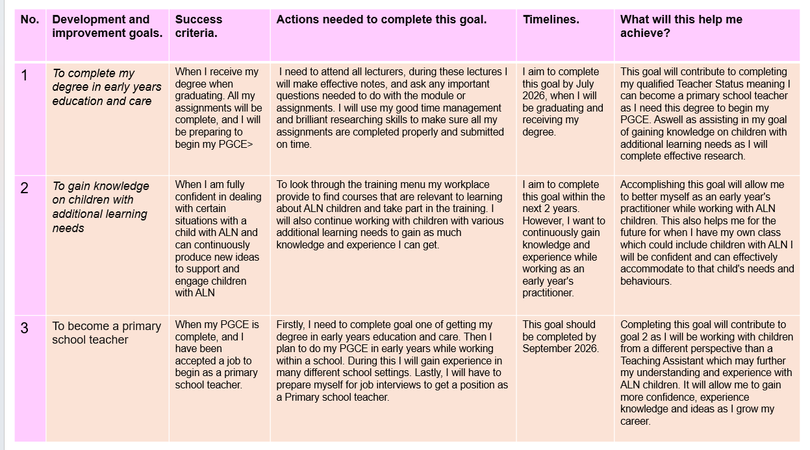
component one- personal development plan.
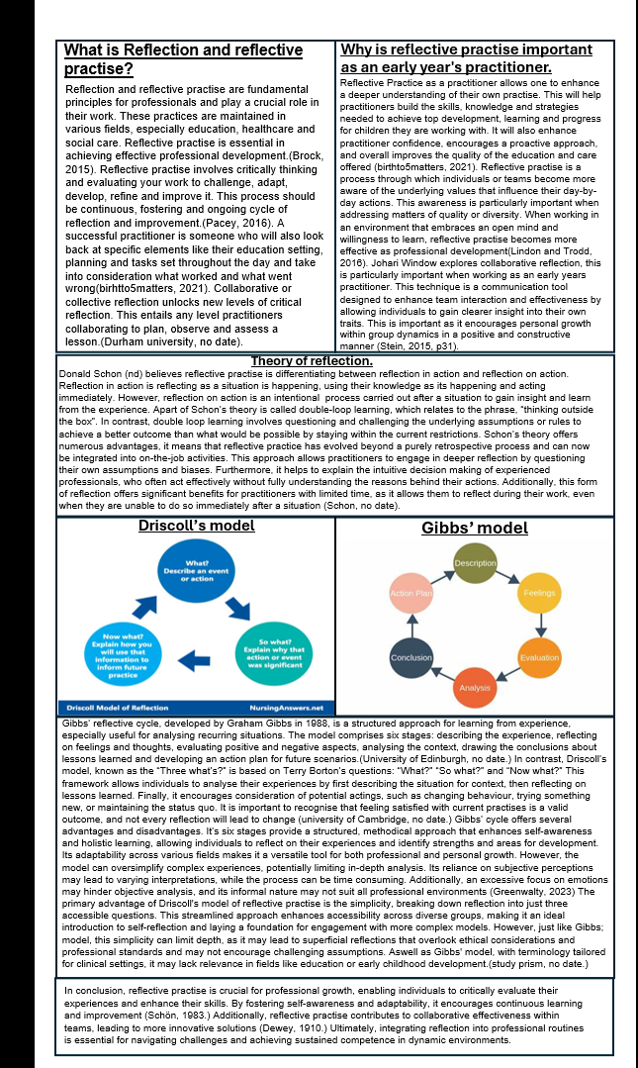
component two- briefing paper.
Reference List- briefing paper
Birth to 5 matters. (2021) Professional reflective practice. Available at: https://birthto5matters.org.uk/wp-content/uploads/2021/03/PDF-20-Professional-Reflective-Practice-1-1.pdf (Accessed: 14th October 2024).
Brock, A. (2015) The early years reflective practice handbook. London: Routledge.
Dewey, J. (1910) How we think by John Dewey. Boston: D.C. Heath & Co.
Gibbs’ reflective cycle (1970) The University of Edinburgh. Available at: https://www.ed.ac.uk/reflection/reflectors-toolkit/reflecting-on-experience/gibbs-reflective-cycle (Accessed: 24 October 2024).
Greenwalty, C. (2023) What is Gibbs reflective model pros and cons, Medium. Available at: https://medium.com/@chrisgreenwalty/what-is-gibbs-reflective-model-pros-and-cons-5c0c98e5a835 (Accessed: 27 October 2024).
Libguides: Reflective Practice Toolkit: Models of Reflection (no date) Models of reflection - Reflective Practice Toolkit - LibGuides at University of Cambridge Subject Libraries. Available at: https://libguides.cam.ac.uk/reflectivepracticetoolkit/models (Accessed: 24 October 2024).
Lindon, J and Trodd L. (2016) Reflective practise and early years professionalism. 3rd edition. UK: Hachette.
PACEY (2016) Developing Self Reflective Practice. Available at: https://www.pacey.org.uk/Pacey/media/Website-files/PACEY%20member%20practice%20guides%20(PDFs)/PG04-self-reflective-practice.pdf (Accessed: 14th October 2024).
Schön, D.A. (1983) The reflective practitioner: How professionals think in action. New York: Basic Books.
Schön’s model of Reflection (no date) StudyPrism. Available at: https://studyprism.co.uk/reflective-practice/models/schons-model-of-reflection/ (Accessed: 21 October 2024).
Stein, S. (2016) Creative Techniques Handbook. 1st edition
What? so what? now what? model of reflection (no date) StudyPrism. Available at: https://studyprism.co.uk/reflective-practice/models/what-so-what-now-what-model-of-reflection/ (Accessed: 27 October 2024).

Component Three - written essay.
Recognise and analyse the significance of different aspects of professional practise and why these are important in meeting the individual and inclusive needs of children.
Professional practise in early years education refers to the application of specialised knowledge, skills and ethical standards required to support young children’s learning and development effectively. A professional in early childhood education not only possesses expertise in teaching practises and child development but also demonstrates a commitment to the wellbeing, rights and diverse needs of each child. As defined by Taggart (2011, p.86), professionalism in early years is about “being reflective, autonomous, and responsible with a focus on improving children’s outcomes”. This means early childhood professionals must be thoughtful, adaptable, and accountable, continually refining their practices to foster a positive and nurturing environment. This essay will explore the essay will explore the essential qualities of professional practise in early years education and why these standards are vital for fostering safe, inclusive, and developmentally appropriate learning environments.
Values play a crucial role in professional practice, guiding practitioners in their interactions and decision-making processes. Social justice, which emphasises equal economic, political, and social rights for all, underpins the ethical responsibilities of professionals to advocate for equitable opportunities (Rawls, 1971). Trust and respect foster authentic relationships, demonstrating care for the needs and feelings of others while honouring the finite resources of our natural world (Covey, 2003). Integrity is fundamental, as it reflects a commitment to honesty and adherence to strong moral principles, ensure g that practitioners act ethically and responsibly (Kernis, 2003, p.1-26). Additionally, a professional commitment to ongoing learning and to the improvement of learner aligns with the goal of creating a sustainable and equitable future (Senge, 2006). Together, these values not only enhance the quality of professional practice but also contribute to the overall well-being of individuals and communities.
According to Dunhill et al. (2009), communication and relationships are essential to professional practice, forming the foundation for understanding and meeting the unique needs of children and young people. Effective communication fosters trust and collaboration, enabling practitioners to actively listen and address concerns. Strong relationships with children, families, and colleagues enhance the overall support system, ensuring that interventions are tailored and effective, which ultimately leads to better outcomes. Research by Hattie (2009) emphasizes that parental and carer involvement in children’s learning is crucial for success, regardless of socio-economic background. In the Early Years Foundation Stage, collaboration with parents often begins with visits to the educational setting, offering insights into how to help children settle in. Prioritizing the perspectives of parents allows practitioners to understand each child's distinct context and encourages the sharing of family and community culture. Recognizing parents as the child’s first educators enhances the educational journey. Actively involving parents fosters ownership and teamwork, especially when they participate during the settling-in process. This collaborative approach enables sharing insights about children’s interests and learning styles, leading to tailored support that meets individual needs and goals, ultimately creating a nurturing environment for holistic development. (Department for Education, 2021). Effective communication and strong relationships with children are also vital components as they play a crucial role in meeting the diverse needs of young learners. Research shows that positive interactions between educators and children foster emotional security, which enhances engagement and learning outcomes (Pianta et al., 2009). When children feel understood and valued, they are more likely to participate actively in their education and explore their interests (Hattie, 2009). Furthermore, establishing a rapport with children enables educators to identify individual needs and tailor their teaching strategies, accordingly, thereby supporting each child’s developmental journey (McWayne et al., 2008). By prioritising communication and building trusting relationships, educators create a nurturing environment that not only promotes academic success but also supports children’s social and emotional development.
Having an in-depth knowledge and understanding of child development, educational practices and safeguarding is crucial to professional practice in early childhood education. This expertise enables educators to recognise and address the diverse needs of children effectively, ensuring their safety and well-being. The department for education (2022), suggests a thorough understanding of safeguarding policies is vital for identifying signs of abuse or neglect, which is essential for protecting vulnerable children. Expanding on this, the welfare of children is of paramount importance, and those in need of support and protection deserve timely and effective assistance. A responsive system should prioritise the needs and interests of children and families, rather than the other way around. The children acts of 1989 and 2003 outline these responsibilities: section 17 mandates that local authorities provide services for children in need, while section 47 requires inquires when there is concern about significant harm to a child. Effective delivery of these duties relies on the cooperation of various partners, as outlined in section 10, which emphasises the need for collaborative arrangements to enhance the well-being of children in the community. The children act 2004, amended by the children and social act 2017, further reinforces this collaboration among key agencies, ensuring that all professionals play a vital role in safeguarding children (HM Government, 2018.) Furthermore, knowledge of developmental milestones allows practitioners to create tailored learning experiences that foster each child’s growth (early years foundation stage, 2002). Ultimately, comprehensive knowledge not only enhances teaching strategies but also safeguards children’s rights, ensuring a nurturing and secure educational environment.
Partnerships and multi-agency working are essential components of professional practice in early childhood education and safeguarding, as they facilitate a holistic approach to meeting the diverse needs of children and families. Effective collaboration among various professionals, such as educators, health practitioners, social workers and local authorities, ensures that support is comprehensive and coordinated (department for education, 2021). This integrated approach promotes timely information sharing, which is crucial for identifying risks and implementing appropriate interventions (Ofsted, 2020). The children act 2004 mandates local authorities to foster cooperation among agencies, highlighting the importance of working together to improve childrens well-being (HM government, 2021). Furthermore, multi-agency collaboration enhances the expertise available to practitioners, allowing them to address complex issues more effectively (Fauth et al., 2019). Research indicates that such partnerships lead to improved outcomes for children, as services are better aligned to their needs (Henderson et al., 2022). By building strong relationships among professionals and engaging with families, multi-agency working not only supports childrens development but also empowers parents and caregivers, ultimately fostering a nurturing environment that promotes growth and well-being.
Practitioners working with children must understand child development and individual needs. By carefully observing childrens progress, involvement and enjoyment, educators can create a tailored curriculum that supports each child’s growth. These observations reveal how childrens skills are developing and provide insights into their knowledge, preferences and abilities. While not all observations have a predetermined aim, daily monitoring yields valuable information for future planning. The data collected helps practitioners highlight individual strengths and identify areas for progress, including those who may require additional support under the Special Educational Needs framework. Furthermore, the planning phase allows practitioners to set clear objectives based on their observations, facilitating the creation of inclusive environments that support diverse learning styles (Department of education, 2021). Moreover, regular reflection on the effectiveness of planned activities helps practitioners refine their strategies and improve outcomes for children (Nutbrown, 2012). Overall, the observation and planning cycle promotes a responsive educational framework, ensuring that practitioners effectively meet the evolving needs of children in their care.
The principles of the United Nations Convention on the Rights of the child profoundly inform professional practice in early childhood education by establishing a framework centred on children’s rights. These principles emphasise the inherent dignity and worth of every child, highlighting their right to participation, protection, and provision (UNICEF, 2021). By integrating these principles into practice, professionals can create inclusive environments that respect children’s voices and promote their active involvement in decision-making processes. This approach is essential as it empowers children, fostering their confidence and sense of agency (Davis, 2017). Moreover, adherence to the UNCRC supports the safeguarding and welfare of children, ensuring that their rights are upheld and that they are protected from harm (department of education, 2021). The importance of these principles extends beyond legal compliance, they shape a culture of respect and understanding, enhancing the quality of care and education provided. By prioritizing childrens rights, practitioners not only contribute to their holistic development but also help cultivate a society that values and respects the rights of all children.
In conclusion, professional practice in early years education is fundamentally guided by a commitment to the rights and needs of children, as encapsulated in frameworks such as the United Nations Convention on the Rights of the Child. Understanding child development, fostering strong relationships, and maintaining ethical standards are vital for creating inclusive and nurturing learning environments. By actively observing and planning tailored curricula, practitioners can effectively address each child’s unique strengths and challenges. Additionally, the emphasis on collaboration through multi-agency working enhances the support available to children and families, ensuring comprehensive care. Ultimately, a focus on these principles not only promotes children’s well-being and development but also cultivates a society that upholds and respects the rights of every child, laying the foundation for their future success.

Reference list- Essay.
Covey, S. R. (2004). The 7 habits of highly effective people. Free Press.
Davis, J. (2017). Children's Rights in Education: A Guide for Teachers. Abingdon: Routledge.
Department for Education (DfE). (2021). Working Together to Safeguard Children. London: Department for Education
Department for Education. (2022). Keeping Children Safe in Education.
Dunhill, A., Elliott, B., & Shaw, A. (2009). Effective communication and engagement with children and young people, their families and carers. Learning Matters. Available at: https://search-ebscohost
Early Years Foundation Stage. (2021). Statutory Framework for the Early Years Foundation Stage.
Fauth, B., et al. (2019). ‘The Role of Multi-Agency Working in Supporting Families.’ Children & Society.
Hattie, J. (2009) Visible learning: A synthesis of over 800 meta-analyses relating to achievement. London: Routledge.
Henderson, L., Smith, R., & Jones, T. (2022). ‘Effective multi-agency working: A review of the evidence’. Childhood, 29(2) Sage Publications.
HM Government (2018) ‘Working together to safeguard children’ A guide to inter-agency working to safeguard and promote the welfare of children. pp 6- 18
HM Government. (2021). Children Act 2004. Available at: https://www.legislation.gov.uk/ukpga/2004/31/contents (Accessed 30 Oct. 2024)
Kernis, M. H. (2003). Toward a conceptualisation of optimal self-esteem. Psychological inquiry, 14(1), pp.1-26
McWayne, C. M., Hampton, V. F., Fantuzzo, J. W., and Cohen, H. L. (2008). A multi-dimensional; approach to understanding preschool depression: the role of family and classroom contexts. 30(5). Pp. 568-582.
Nutbrown, C. (2012). Foundations for Quality: The Independent Review of Early Education and Childcare Qualifications. Available at: https://www.gov.uk/government/publications/foundations-for-quality-the-independent-review-of-early-education-and-childcare-qualifications (Accessed 31 Oct. 2024).
Ofsted. (2020). The importance of multi-agency working. Available at: https://www.ofsted.gov.uk/resources/importance-multi-agency-working (Accessed 30 Oct. 2024).
Pianta, R. C., La Paro, K. M., and Hamre, B. K. (2008). Classroom assessment scoring system (CLASS). Paul H: Brookes Publishing.
Rawls, J. (2022) A theory of justice. Revised edition. Cambridge, MA: Harvard University Press.
Reference list
Senge, P. M. (2006). The fifth discipline: the art and practice of the learning organisation. Crown Business.
Siraj-Blatchford, I. & Manni, L. (2007). Effective Leadership in the Early Years Sector: The Evidence Available at: https://www.researchgate.net/publication/228723107_Effective_Leadership_in_the_Early_Years_Sector_The_Evidence (Accessed 31 Oct. 2024).
Taggart, G. (2011). ‘Don’t we care?: The ethics and emotional labour of early years professionalism.’ Early years, 32(1), pp 85-95
UNICEF. (2021). UN Convention on the Rights of the Child. Available at: https://www.unicef.org.uk/what-we-do/un-convention-child-rights/ (Accessed 31 Oct. 2024).
Welsh assembly government, (2008). ‘Observing children’ Department for Children, Education, Lifelong Learning and Skills. Pp 4-6.
Working in partnership with parents and Carers (2021) Help for early years providers: Working in partnership with parents and carers. Available at: https://help-for-early-years-providers.education.gov.uk/get-help-to-improve-your-practice/working-in-partnership-with-parents-and-carers (Accessed: 30 October 2024).

