An Evaluation of the Environmental Factors Impacting the Organisation and its HR strategy.
Contents
1.Introduction 1
2.Evaluation of the environmental factors impacting Amazon and its HR strategy 1
3. Conclusion and recommendations 4
REFERENCES 5

1. Introduction

This report presents an evaluation of central environmental factors, which the CEO and senior management team of Amazon must focus upon. Positioned at a strategic level, this report seeks to discuss the nature of environmental factors present within the macro environment but also the impact of such on the organisation. This discussion in turn cumulates with recommendations directed towards the senior management team with regards to future HR strategy. Throughout the report, strategic tools and appraisal are used in order to determine the nature of the environment faced by the global, technological giant Amazon.

2. Evaluation of the environmental factors impacting Amazon and its HR strategy

Amazon is a technological giant founded in 1994 by Jeff Bezos who remains the current CEO to date. Despite being the largest online retailer in the world with revenues of $136 billion, Amazon is not immune to changes in the macro environment, which require a continual strategic focus. With current projections seeing Amazon’s move into cloud technology soaring 42%, Amazon are an example of an organisation who continually sense, seize and reconfigure based on opportunities present in the external business environment (Novet,2017). Conducting a strategic environmental assessment, antecedents and performance outcomes of the strategic environment need to be considered in order to account for the complexity that exists (Schoenherr et al, 2014). Using a traditional strategic framework of Political, Economic, Social and Technological (PEST) this traditional framework is used in order to shape discussion. This is in turn supported by a range of additional frameworks utilised to draw out the complexity and inter-connected nature of the external environment (Breja, Banwet & Iyer, 2016). Figure 1 illustrates the growth of the company and their continued rise.
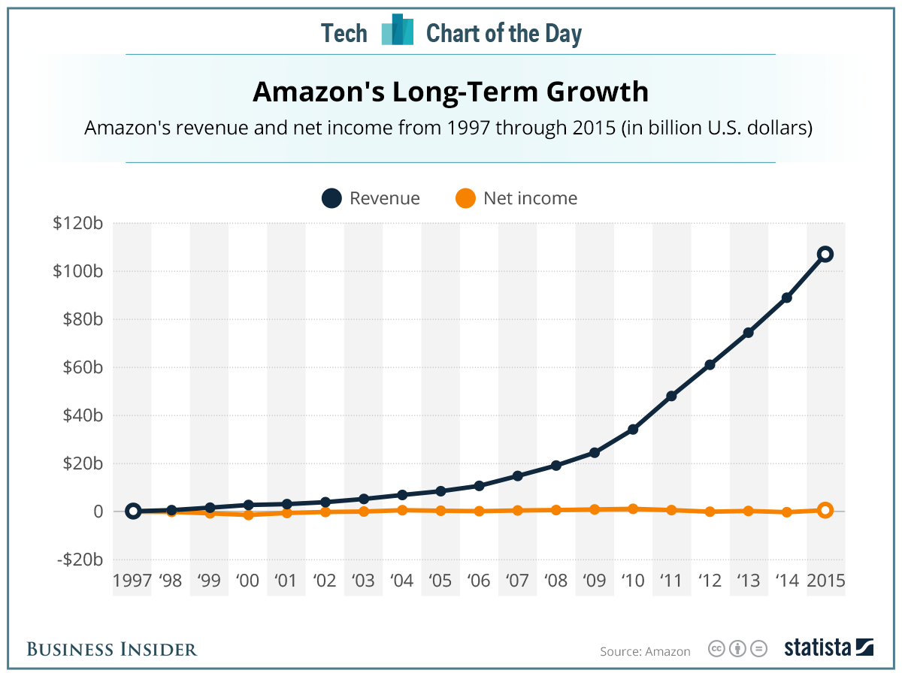
Figure 1: Amazon's Growth (Rosoff, 2016: 1)

To begin, the dynamic capabilities framework provides a useful platform upon which it is possible to illustrate the dynamic nature of the external business environment (Teece, 2014; Wilden et al, 2013). Dynamic capabilities are those capabilities, which extend beyond traditional capabilities and value and draw from dynamism present in the external business environment. Shaped around Teece, Pisano and Shuen’s (1997) original framework, three processes exist which guide and direct such action: sensing, seizing and reconfiguration. Of these, the starting point rests with the ability of an organisation such as Amazon to sense opportunities within their wider environment and then seize such before their competitors. Regularly positioned as a superior company, which sets trends as opposed to following them, Amazon orchestrate their strategic action to deal with environmental turbulence to their advantage (Wilden & Gudergan, 2015). This aligns to the thinking of Wilden and Gudergan (2015) who highlight the importance of developing technological capabilities despite environmental turbulence.

Changes and trends within the political environment have an impact on Amazon largely due to their multinational status. Political influence largely focuses upon governmental activity and Amazon must be able to respond to governmental activity in order to align to cultural and political dynamics. Considerations in the political environment include the extent to which the country is politically stable (the more stable it is the potentially more opportunistic it is as a strategic move). Other political environment factors to be taken into consideration include the extent to which governments are receptive and supportive of the moves of Amazon and the extent to which attention is increasingly directed towards security. A current trend thus aligns to a focus on cyber security and this has been driven in recent years by a number of high profile hacking attempts (Cavelty & Mauer, 2016). Existing across a range of countries, Amazon have to deal with dynamism and turbulence across different economies and thus whilst they may face increased competition from the Chinese government following investments in Chinese firms, in the UK, the government are widely encouraging Amazon to develop and invest to support economic stability.

The expansion into new markets is an important strategic consideration and one that is increasingly shaped by the identification of the BRICS economies (Brazil, Russia, India, China and South Africa). Whilst these economies offer opportunity they also offer threats with varying levels of political stability and support. China is of particular interest to Amazon due to it being predicted to be the world’s largest economy in terms of wealth, power and influence by 2050 and thus this is a market Amazon cannot afford to engage with (Wilson & Purushothaman, 2003). However, the Chinese government are restricted in their approach to some technological developments i.e. social media and thus this may influence the strategic direction Amazon take within China. Relating to political influence and the interconnectedness of such, a change management framework can be applied here to understand the dimensions of the strategic environment. McKinsey’s 7s framework (See figure 2) depicts a thinking similar to that of the butterfly effect where one small change can have a big impact elsewhere (Hanafizadeh & Ravasan, 2011). Thus, relating this to political influence, any political uncertainty in one part of the world can substantially impact decisions made elsewhere. A current consideration for example is the impact of BREXIT on Amazon’s operations in the UK. Whilst the full impact is still to be seen, it has been considered that BREXIT will have an impact on data rules and policies between the UK and the EU, which is likely to result in a renegotiation of terms taking place regarding Amazon’s cloud computing business (Eversheds-Sutherland, 2017). Relating this to the HR strategy of the organisation, cultural competence becomes central to understand the importance of different countries and their projections, something that is also inter-related to social considerations in the wider external business environment (Whitman, 2016).
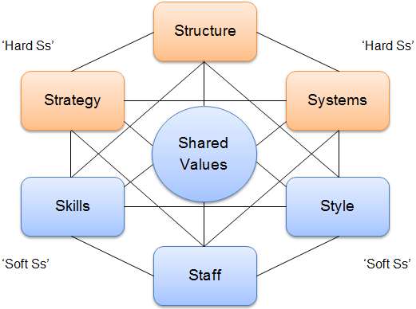
Figure 2: McKinsey 7s (Hanafizadeh & Ravasan, 2011: 1)

Economic factors contribute to environmental conditions that can make the difference between a strategic opportunity and a strategic threat. Performance is thus dependent upon economic success and growth and there are a number of significant factors that can be identified which influence strategic tactics (Gawer, 2011). Economic stability is a central environmental factor and one that supports Amazon’s own stability. Amazon’s actions in developed markets form a stable basis that allows them to invest in other markets, which may be less economically, stable but perhaps provide more opportunities. Aligned to this, rising wealth in developing economies such as the BRICS economies presents substantial opportunity to Amazon and their ability to tap into and seize such opportunities is important for competitive success. However, aligned to this way of thinking, a threat of a recession/economic downturn in China for example could greatly indicate a threat to the organisation and thus they are susceptible to change fuelled by economic differences. An element of risk thus comes into play when considering strategic implications of decisions made. Amazon as a company need to take opportunities in riskier markets and balance this with firmer, more stable decisions in developed economies. Strategy formulation thus relates to a balance between the two. A consideration of economic factors is more than just the extent to which an economy is developed/developing in relation to its stability but also in relation to its exchange rates. The online nature of Amazon can mean the company save money on exchange rates and yet, rate fluctuations can cause an instability which requires continuous monitoring. This monitoring of the economic environment in terms of inflation, exchange rates and interest rates support a commitment to taking risks when the time is optimum (Chen et al, 2016). Aligned to their HR strategy, Amazon must focus upon hiring those individuals who are able to continuously change and thus respond to dynamism present. Thinking about the micro-foundations of strategic success, Amazon need to invest in their employees to equip them with the skills needed to respond confidently to changes, which may take place in the external business environment (Morris, Hammond & Snell, 2014).

Social environmental factors perhaps provide the most difficult environmental factors in terms of their impact and potential response to such. Increased consumerism across the global economy drives a great opportunity for Amazon but this opportunity may be met with social concern surrounding the impact Amazon can have e.g. in terms of their treatment of workers across the supply chain (Bauer et al, 2012). In the past, Amazon have faced criticism for their treatment of workers and thus this is an environmental condition they must be able to openly respond to and thus feed into their HR strategy. Further, socio-cultural factors relate to the extent to which Amazon adept with emphasis largely being placed on standardisation due to the business model Amazon follow. Expansion in this vein lies with the ability to gain economies of scale and support growth/standardisation across the e-commerce platform. With this in mind, cultural adaption at a personal level is needed especially from employees but perhaps not from the business model itself. The social environment is driving a move towards the online environment and as a result of this, a substantial opportunity exists for Amazon to lead the way. Leading however requires an understanding of people and the need for Amazon to consider people in their decision-making. Engagement with stakeholders could thus support success here with Hayes (2014) highlighting the importance of determining the power and influence of stakeholders and feeding this into the strategic appraisal of the organisation. Amazon has a great deal of stakeholders and their sociocultural foundation supports strategic decision making here.

As a technological company, it can be argued that the external environmental condition, which has the most impact, is that of technological factors in the external business environment. Technological advancement and progression led by Amazon has the power to influence competitor action and yet in addition, Amazon is also susceptible to technological changes elsewhere. Rapid technological development offers both opportunity and threat to Amazon, and importantly, Amazon have to be able to feed this into their HR strategy to gain the technological competence and capabilities needed to stay ahead of competition. This is however coupled with the threat of cybercrime and the threat this may cause to technological stability. Significant investment in both people and technology is needed to support the long-term viability of Amazon and their ability to remain as market leader. Change here relates to continuous, adaptable change. In relation to the thinking of Porter (2008) and his five forces model, Amazon are able to limit the threat of new entry due to the sheer power they have in the market thus making entry costs for others difficult. Brand expectations align to this competitive strength and therefore as a result, Amazon has to ensure that they are focused upon remaining one step of others. Relating this back to the development of dynamic capabilities, the seizing of technological opportunities becomes central to growth to maintain competitive position. Amazon must therefore invest in individuals who have the capacity to take on knowledge, but to also transfer this across the workforce (Anitha & Begum, 2016).

3. Conclusion and recommendations

Stemming from the strategic analysis conducted above, the final part of this essay focuses upon recommendations directed towards the senior management team in terms of their HR strategy. The first recommendation considers the importance of emotional intelligence and the need to develop this not only in the Senior Management Team but also in employees within the firm. Emotional intelligence (Goleman, Boyatzis, McKee, 2013) sees a commitment to the recognition of emotions and different feelings across the firm. This type of capability can support an organisational culture capable of dealing with environmental factors and dynamism faced. For Amazon, technological competence, the sharing of knowledge and the creation of a work environment where change is the norm is central to strategic success and thus this essay argues this comes down to individuals within the firm. Individuals must therefore be fostered to have the emotional intelligence and the capacity to deal with change and be responsive to changes around them.

A second recommendation refers to the need to be one-step ahead in terms of their talent management strategy. Amazon needs to have a forward thinking talent management strategy in place in order to remain competitive. An understanding of what skills are needed must be considered but importantly cultural fit must also exist. For example; whilst skills may be able to be developed, cultural fit with Amazon is important to ensure that this is where their competitive advantage can come from. This aligns to the original thinking of Barney (1991) who supports the need to compete on the basis of something, which is valuable, rare, inimitable and non-substitutable. Developing this through the workforce is critical to future success.

REFERENCES

Anitha, J., & Begum, F. N. (2016). Role of organisational culture and employee commitment in employee retention. ASBM Journal of Management, 9(1), 17.

Barney, J. (1991). Firm resources and sustained competitive advantage. Journal of management, 17(1), 99-120.

Bauer, M. A., Wilkie, J. E., Kim, J. K., & Bodenhausen, G. V. (2012). Cuing consumerism: Situational materialism undermines personal and social well-being. Psychological Science, 23(5), 517-523.

Breja, S. K., Banwet, D. K., & Iyer, K. C. (2016). Towards sustainable excellence: strategic analysis of Deming Prize winning companies. The TQM Journal, 28(3), 390-410.

Cavelty, M. D., & Mauer, V. (2016). Power and security in the information age: Investigating the role of the state in cyberspace. Routledge.

Chen, P. F., Lee, C. C., Lee, C. C., & Huang, J. X. (2016). A Dynamic Analysis of Exchange Rate Exposure: The impact of China's Renminbi. The World Economy, 39(1), 132-157.

Eversheds-Sutherland, (2017) Brexit: the impact on general data protection regulation. Available at: https://www.eversheds-sutherland.com/global/en/what/articles/index.page?ArticleID=en/Data-Protection/brexit_impact_on_gdpr_170616 Accessed on 2/12/2017

Gawer, A. (Ed.). (2011). Platforms, markets and innovation. Edward Elgar Publishing.

Goleman, D., Boyatzis, R. E., & McKee, A. (2013). Primal leadership: Unleashing the power of emotional intelligence. Harvard Business Press.

Hanafizadeh, P., & Ravasan, A. Z. (2011). A McKinsey 7S model-based framework for ERP readiness assessment. International Journal of Enterprise Information Systems (IJEIS), 7(4), 23-63.

Hayes, J. (2014). The theory and practice of change management. Palgrave Macmillan.

Morris, S., Hammond, R., & Snell, S. (2014). A microfoundations approach to transnational capabilities: The role of knowledge search in an ever-changing world. Journal of International Business Studies, 45(4), 405-427.

Novet, J (107) Amazon cloud revenue soars 42%, topping analyst estimates. Available at: https://www.cnbc.com/2017/10/26/aws-earnings-and-revenue-q3-2017.html Accessed on 2/12/2017

Porter, M. E. (2008). Competitive strategy: Techniques for analyzing industries and competitors. Simon and Schuster.

Rosoff, M (2016) Simple chart that shoes Amazon’s relentless focus on long-term growth [online]. Available from:
http://uk.businessinsider.com/amazon-revenue-vs-profit-2016-1?r=US&IR=T [Accessed 26.11.17].

Schoenherr, T., Modi, S. B., Talluri, S., & Hult, G. T. M. (2014). Antecedents and performance outcomes of strategic environmental sourcing: an investigation of resource‐based process and contingency effects. Journal of Business Logistics, 35(3), 172-190.

Teece, D. J. (2014). A dynamic capabilities-based entrepreneurial theory of the multinational enterprise. Journal of International Business Studies, 45(1), 8-37.

Teece, D. J., Pisano, G., & Shuen, A. (1997). Dynamic capabilities and strategic management. Strategic management journal, 509-533.

Wilden, R., Gudergan, S. P., Nielsen, B. B., & Lings, I. (2013). Dynamic capabilities and performance: strategy, structure and environment. Long Range Planning, 46(1), 72-96.

Whitman, R. G. (2016). Brexit or Bremain: what future for the UK's European diplomatic strategy?. International Affairs, 92(3), 509-529.

Wilden, R., & Gudergan, S. P. (2015). The impact of dynamic capabilities on operational marketing and technological capabilities: investigating the role of environmental turbulence. Journal of the Academy of Marketing Science, 43(2), 181-199.

Wilson, D., & Purushothaman, R. (2003). Dreaming with BRICs: The path to 2050 (Vol. 99). New York, NY: Goldman, Sachs & Company.

