Student Name: | Olakayode Awoliyi
Student Number: | 1812591
Module Name: | Digital Skills and Research Methods
Module Number: | BMSK4003
Lecturer Name: | Balendran Kandasamy

School: University of Wales Trinity Saint David. London Campus
Submission date: 30/08/2019

Executive Summary
The advent of the internet has revolutionised the way small and medium businesses used to operate in the conventional markets. The literature review in this regard highlights that e-commerce is emerged as one of the efficient new chanel of sales and the internet has also assisted the business to better reach to their targeted market with lowest possible cost. In this regard, this paper has reviewed the impact of the internet on the high street clothing shops in London. An analysis of data represents that the internet is majorly contributing towards the marketing and sales activities of these shops.
Table of Contents
Executive Summary 1
Introduction 3
Aim 3
Objectives 3
Literature review 3
Primary research 4
Methodology 4
Ethical consideration 5
Results 5
Impact of the internet on sales 5
Impact on the advertisement 5
Market data and benchmarking 6
Customer complaint handling 7
Price based competition 8
Limitations of the research 8
Conclusion and recommendations 8
References 10
Appendix – Survey questionnaire 11

Introduction
The internet has revolutionised businesses in several ways from development of products to their marketing and sales. For instance, with an advent of the internet, e-commerce has emerged as one of the efficient and cost-effect channel of sales (Falk & Hagsten, 2015). According to the statistics, a sale of $2.8 trillion through this channel has been observed in 2018 and it will increase up to $4.5 trillion by 2021 (European commission, 2018). Amid this incline, the impact on small and material retail shops could be a question.

Aim
The aim of the research under consideration would be to explore the impacts of the internet on High Street clothing shops in London. Through a survey, the point of view of shop owners and retailers will be taken, to recommend on how the internet can be effectively used for these small and medium set-ups.

Objectives
The objectives of the research are as follows:
- To understand the impacts of the internet on High Street clothing shops in London through a survey.
- To evaluate the gaps in effective usage of the internet and recommend a way-forward to create value for these shops.

Literature review
As demonstrated earlier, the internet is a revolutionary invention for businesses as it has changed the way business used to operate in the past. As highlighted by Gabrielsson and Gabrielsson (2011), the internet has provided an advantage to the retailers to reach their targeted customers in an efficient and cost effective way. Instead of spending a lot on the physical retail shops, e-commerce solutions have been adopted which are equally convenient for the retailers as well as the shoppers. In addition, the marketing channels have also been simplified, i.e. the businesses can now communicate with their targeted profiles using social media and their websites (Balocco, Mogre, & Toletti, 2009; Fernandes et al., 2016; Niehm, Tyner, Shelley, & Fitzgerald, 2010). Information related to the products and services are now available to the customers on the internet, which, according to Hohnhold, O’Brien, and Tang (2015), is helpful for the customers to take purchase decision. As highlighted by Celuch and Murphy (2010), the advantages of the internet are not limited to the large retailers; rather, the positive impacts are more visible for small retail shops. For this business operating with relatively lesser capital, spending too much on promotion and advertisement is not possible. In this scenario, the internet is not less than a blessing for such businesses where they can communicate with a wider audience using the minimum cost and this with an even enhanced output (Doherty & Ellis-Chadwick, 2010). Similarly, the small retail shops may also open their online retail channels using the e-commerce platform, which would certainly enhance the revenue to new heights.
While exploring the impacts of the internet and social media on small retail shops, Shankara, Mahanta, Arora, and Srinivasamurthy (2015) has argued that social media is being adopted as an effective means of communication with the customers. Some of the retailers are getting the sale opportunities through their social media pages. In addition, the social media platforms are also being used to understand the customer’s requirements and to address their complaints as well. This has also been advocated by Patil (2017) and according to the authors, the internet and social media have collectively digitalised the conventional business operations of small retailers with a greater lead and visibility. Another major advantage of the internet on small retail businesses has been explored by Ofek, Katona, and Sarvary (2011), who stated that the internet has piles of information related to the market and competitors of small businesses. The retailers operating in this space can use this information to benchmark their own performance and to improve their operations.
Aside from numerous advantages, the internet may also affect the growth and competitiveness of the businesses negatively. According to Shahjee, (2016), excessive use of the internet for several business operations has resulted into limited face-to-face contact with the communication, which may make it complex to translate the actual consumer requirements. Moreover, the customer feedback, specifically if this is negative would be more sensitive for the companies as it will spread in seconds on the social media to negatively affect the growth of the company. Lastly, it has also enhanced the competition based on the price point, which may result into lower margins for the businesses.
A brief overview of the relevant literature highlights several dimensions of the internet and its impact over the businesses in generic sense. Research, specifically on the clothing shops in High Street of London, has not been conducted and this gap would be filled by this paper.

Primary research
In order to achieve the desired research objective, a quantitative primary research would be conducted. Specific details of methodology and ethical considerations are given below:

Methodology
For the purpose of this research, a primary research using the quantitative method will be conducted. The rationale of selecting this methodology can be linked with the research objectives that demands a quantification of the impacts of the internet on the clothing shops in the area under consideration. From the chosen population, based on the random sampling 20 owners of the shops has been selected for an online survey. The survey is based on 10 questions that quantify the impacts of the internet on the businesses based on a Likert scale. The link for the survey on Survey Monkey has been sent to the selected sample through email and response has been provided by 14 individuals. Response against the surveys has been downloaded from the internet and subsequent data analysis using Microsoft Excel has been performed to extract the meaningful results.

Ethical consideration
Ethical considerations are important requirements of the research in a primary methodology. For the case under consideration, the privacy and confidentiality of the data of the shops is one of the critical ethical requirements. In addition, for a survey, the permission of the shopkeepers would also be required. To meet this, the permission has been taken from all shopkeepers before sending an email with the survey link and this survey was completely voluntarily and anonymous, i.e. no information related to the shop has been asked in the survey. Moreover, the purpose of the survey has also been written at the top of the survey along with a statement of confidentiality. The data collected from the survey has been saved in the encrypted drivers and would solely be used for the purpose of academic research.

Results
This section will present the response against the survey questionnaire. Based on the nature of the questions, this section has been divided into various sub-sections to identify the impact of the internet on various dimensions of the business:

Impact of the internet on sales
As far as the impact of the internet on the sales has been considered, a close-ended question had been included in the survey. Based on the responses, 90 percent of the respondents said that the internet has positively enhanced their business and overall sales (Figure 1):
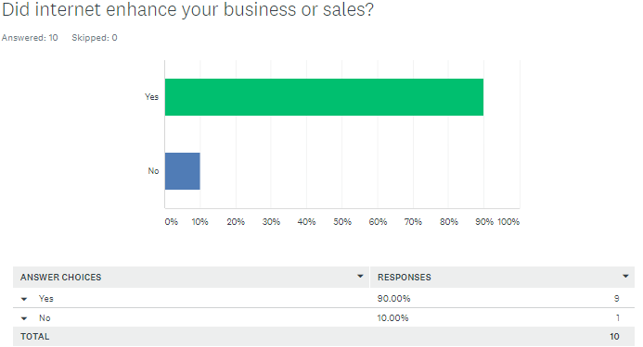
Figure 1: Impact of the internet on sales

Impact on the advertisement
In the literature review, it has been explored that the internet is specifically being used for the purpose of advertisement and marketing. For the area under consideration, in order to understand the use of the internet for the purpose of business, various questions related to this has been added in the questionnaire. The response highlights that 60 percent of the respondents agree with the statement that the internet has helped them to better advertise their business, 30 percent strongly agree while 10 percent disagree with this. For another question related to the communication with the targeted market, 60 percent and 10 percent respondents agreed and strongly agreed respectively that the internet has improved their communication with the customers, while 20 percent disagreed with this. While exploring the marketing expenses for the internet market, the following chart present the response against a statement, “I spend at least 70% of my marketing budget on the internet marketing”:
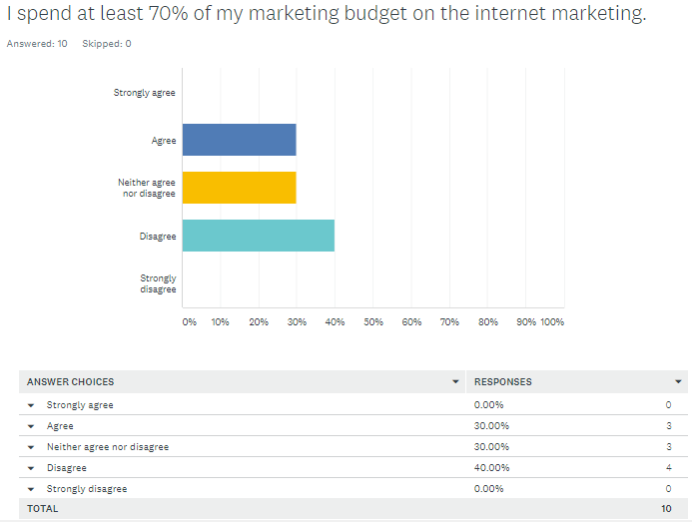
Figure 2: Budget allocation for the internet marketing

Market data and benchmarking
In the survey, the respondents from the High Street clothing shops of London have also been asked if the internet has helped them with a market data collection and competitor’s benchmarking. For this, 70 percent respondents agreed with the statement as represented in the graph below (Figure 3):
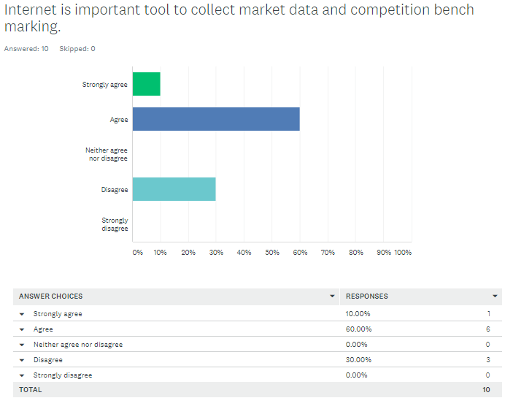
Figure 3: Internet for market data and benchmarking

Customer complaint handling
The literature review also identified that the internet is being used for customer complaint handling. To assess this for the targeted population, a statement related to the use of the internet and social media for this purpose and the response highlights that most of the shopkeepers do not use this as a customer complaint handling tool (Figure 4):
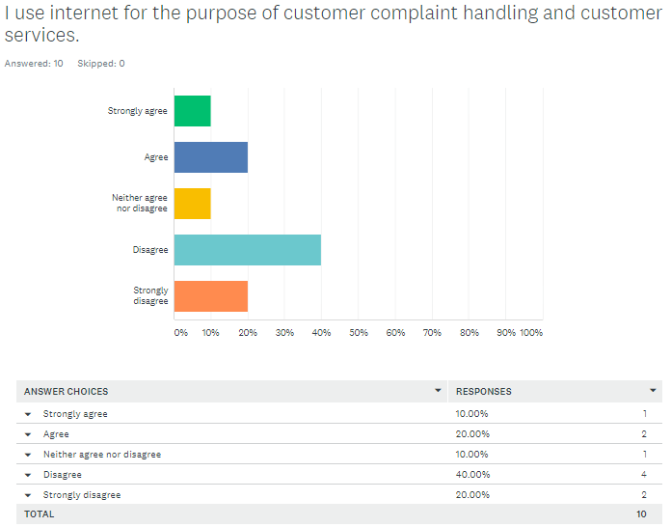
Figure 4: Internet as a complaint handling tool

Price based competition
To assess if the internet has increased the price based competition in the targeted market, the views of the respondents have been explored through a statement. The following figure presents the response which indicates that the internet has contributed towards a price-based competition (Figure 5):
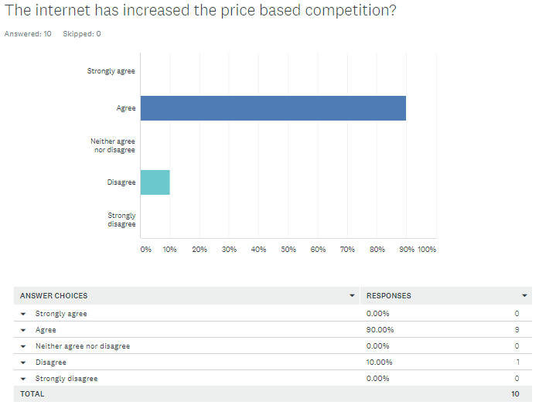
Figure 5: Impact of the internet on price-based competition

Limitations of the research
Although the primary research that has been conducted has revealed an important insight about the impact of the internet on the targeted population, it was limited in various ways. Firstly, the response rate was quite low and only 10 respondents provided their point of view. Based on this, the results might not be effectively generalised for the whole population. Secondly, the research results might not be applicable to all clothing shops in retail sector because of different external factors influencing the performance and strategies of these businesses.

Conclusion and recommendations
Based on the literature review and results of the survey questionnaire, it can be concluded that the internet has substantially affected the dynamics of the clothing shops in the high street area of London. From their sales to the marketing communication, the internet has provided a new channel to contact the customers and better engage them for a higher revenue. Nonetheless, at the same time, the internet has increased the price-based competition, which would certainly affect the margins of these shops. Also, from the results of the survey, it is evident that they are not using the full potential of the internet for their business as only few shops are spending 70 percent of their marketing budget on the internet marketing. Moreover, the internet is also not being used as a tool to resolve the customer complaints and there could be various reasons behind this that can be explored in the future research.
Considering the data, further use of the internet for improvement of the business can be recommended to the clothing shops, e.g. these shops can increase their spending on the internet marketing in order to generate positive results with relatively lesser cost. In addition, the internet in general and social media in specific can be used as an important tool to listen to and resolve the queries and complaints of the customers. This will help to build a better reputation in the targeted market and will increase an engagement over social media, which will certainly be beneficial for the company. Also, the internet may also be used for collection of market data and competitor benchmarking, which will certainly help to improve the internal operations as well as the strategy of the shops.

References
Balocco, R., Mogre, R., & Toletti, G. (2009). Mobile internet and SMEs: A focus on the adoption. Industrial Management and Data Systems. https://doi.org/10.1108/02635570910930127
Celuch, K., & Murphy, G. (2010). SME Internet use and strategic flexibility: The moderating effect of IT market orientation. Journal of Marketing Management. https://doi.org/10.1080/02672570903574296
Doherty, N. F., & Ellis-Chadwick, F. (2010). Internet retailing: The past, the present and the future. International Journal of Retail and Distribution Management. https://doi.org/10.1108/09590551011086000
European commission. (2018). E-commerce statistics for individuals - Statistics Explained. December 2018.
Falk, M., & Hagsten, E. (2015). E-commerce trends and impacts across Europe. International Journal of Production Economics. https://doi.org/10.1016/j.ijpe.2015.10.003
Fernandes, S., Belo, A., Castela, G., Dahnil, M. I., Marzuki, K. M., Langgat, J., … Beck, R. (2016). Small Business Use of Internet Marketing: Findings from Case Studies. Procedia - Social and Behavioral Sciences. https://doi.org/10.1016/j.sbspro.2014.07.016
Gabrielsson, M., & Gabrielsson, P. (2011). Internet-based sales channel strategies of born global firms. International Business Review. https://doi.org/10.1016/j.ibusrev.2010.05.001
Hohnhold, H., O’Brien, D., & Tang, D. (2015). Focusing on the long-term: It’s good for users and business. In Proceedings of the ACM SIGKDD International Conference on Knowledge Discovery and Data Mining. https://doi.org/10.1145/2783258.2788583
Niehm, L. S., Tyner, K., Shelley, M. C., & Fitzgerald, M. A. (2010). Technology Adoption in Small Family-Owned Businesses: Accessibility, Perceived Advantage, and Information Technology Literacy. Journal of Family and Economic Issues. https://doi.org/10.1007/s10834-010-9197-0
Ofek, E., Katona, Z., & Sarvary, M. (2011). “Bricks and clicks”: The impact of product returns on the strategies of multichannel retailers. Marketing Science. https://doi.org/10.1287/mksc.1100.0588
Patil, K. (2017). Retail adoption of Internet of Things: Applying TAM model. In International Conference on Computing, Analytics and Security Trends, CAST 2016. https://doi.org/10.1109/CAST.2016.7915003
Shahjee, R. (2016). The Impact of Electronic Commerce on Business Organization. International Journal of Management and Applied Science.
Shankara, P., Mahanta, P., Arora, E., & Srinivasamurthy, G. (2015). Impact of internet of things in the retail industry. In Lecture Notes in Computer Science (including subseries Lecture Notes in Artificial Intelligence and Lecture Notes in Bioinformatics). https://doi.org/10.1007/978-3-319-26138-6_9

Appendix – Survey questionnaire


